Supplementary material
The dose-response of urban noise to human mobility measured with a city-scale IoT sensor network in Seoul
Hyun In Jo

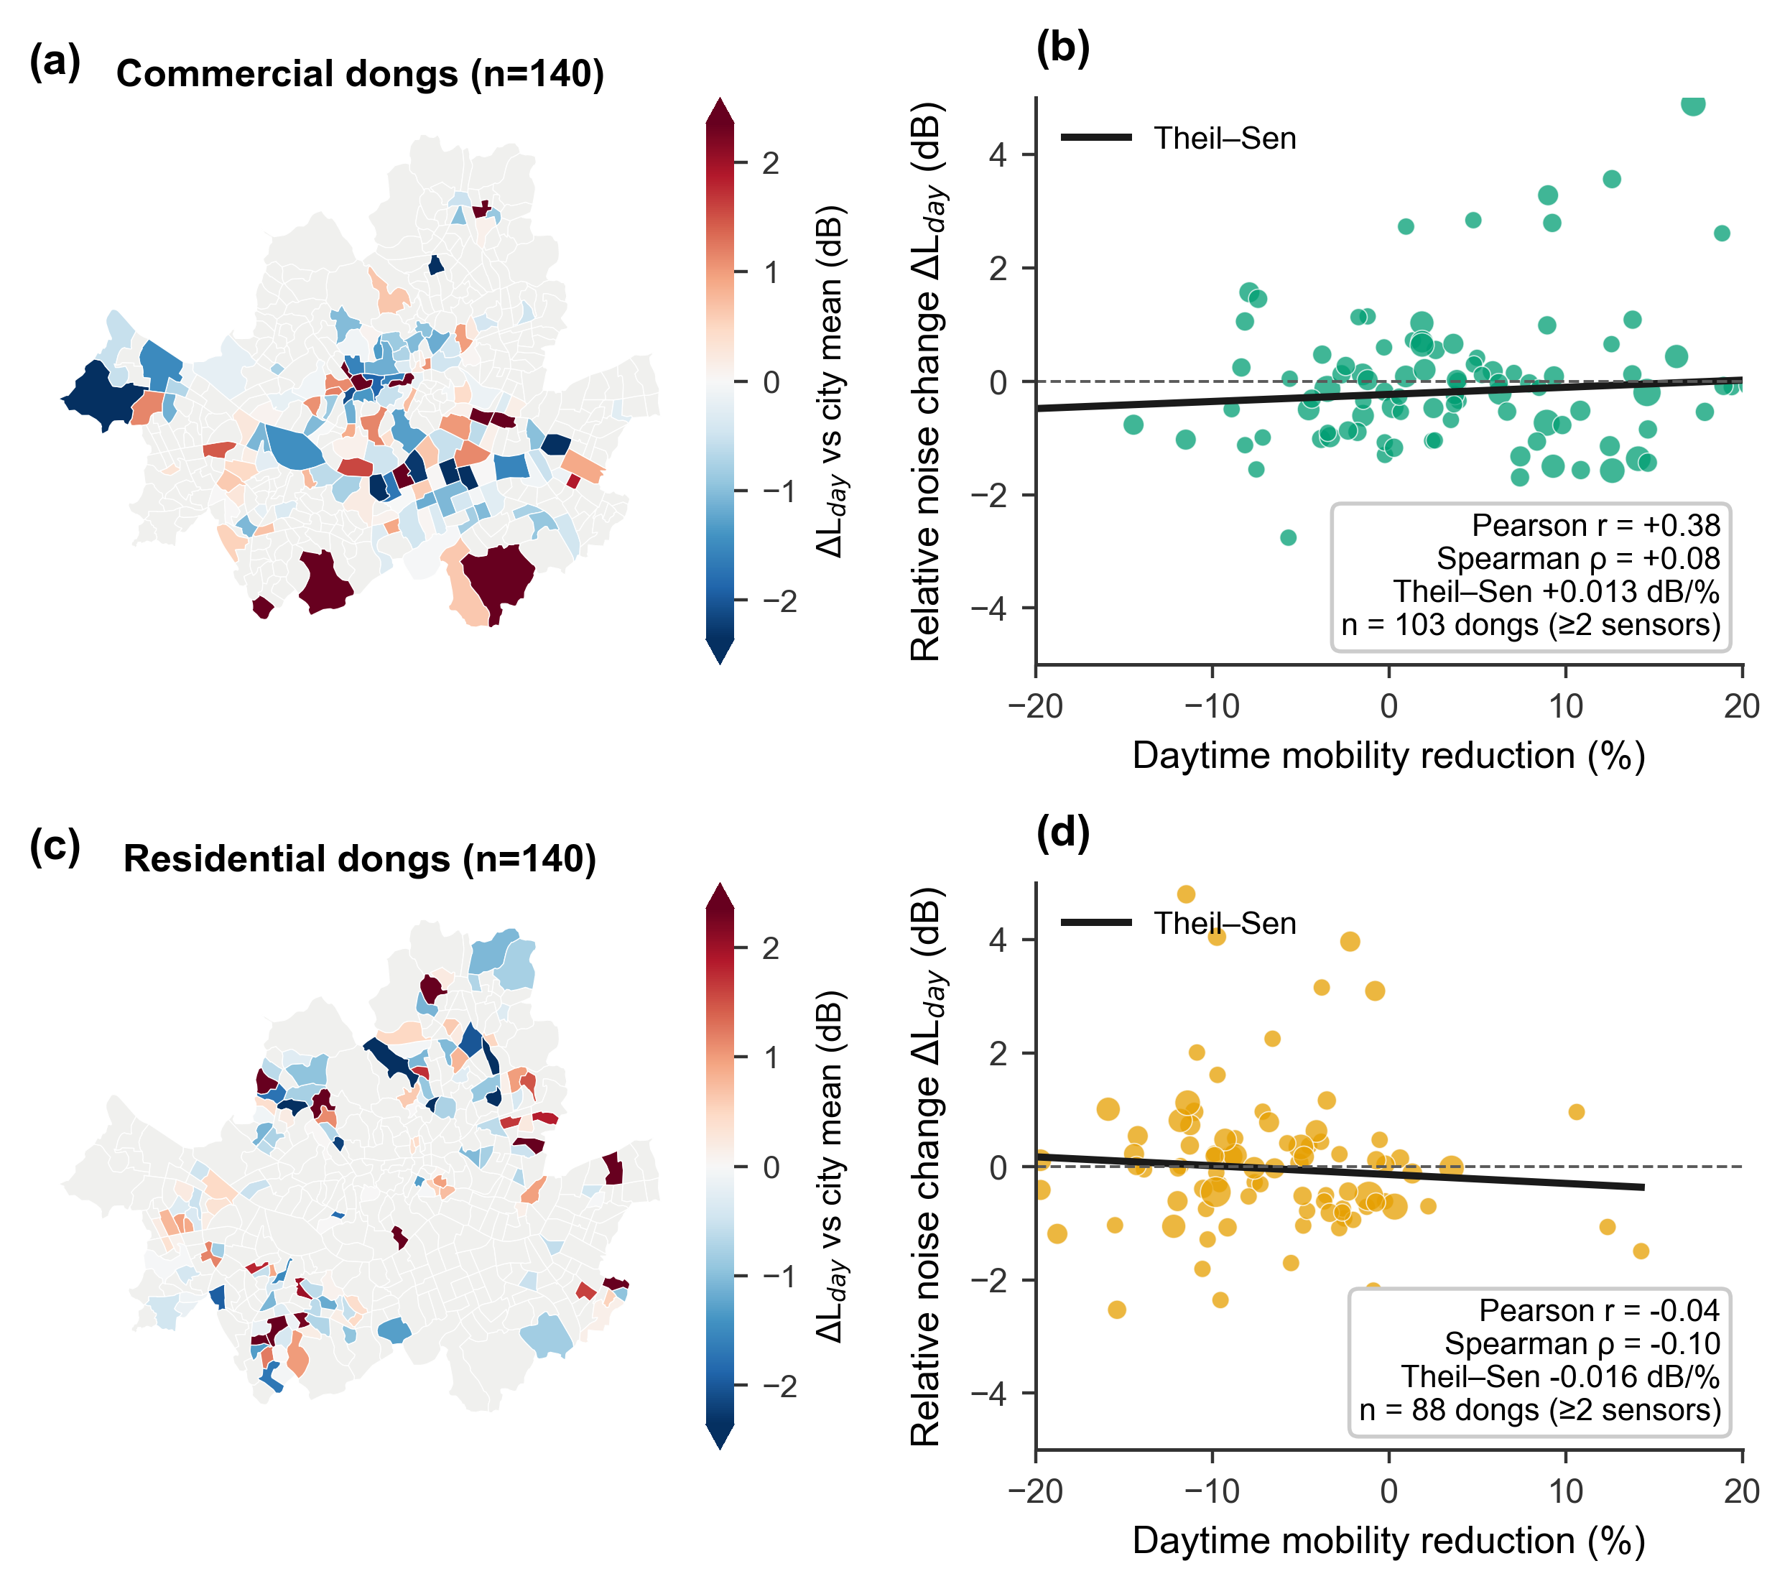
Supplementary Fig. S1. Commercial versus residential detail of the long-run spatial cross-section. (a, c) Drift-removed relative noise change for commercial and residential dongs (all classified dongs mapped). (b, d) Neighbourhood-level association between distancing-era mobility reduction and relative noise change (dongs with >= 2 sensors): the commercial Pearson correlation (+0.38) collapses to rho = +0.08 under rank-based statistics, and residential dongs show no association either.

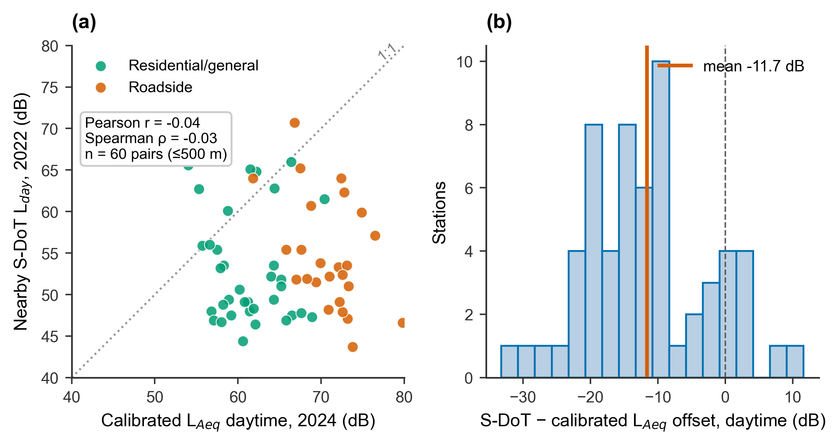
Supplementary Fig. S2. Absolute-level validation detail. (a) Calibrated L_{Aeq} (2024 survey) versus nearby S-DoT L_{day} (2022): no cross-sectional correlation (r = -0.04), reflecting sensor-specific calibration offsets. (b) Distribution of the S-DoT minus calibrated L_{Aeq} offset (mean -11.7 dB; n = 60 pairs within 500 m).

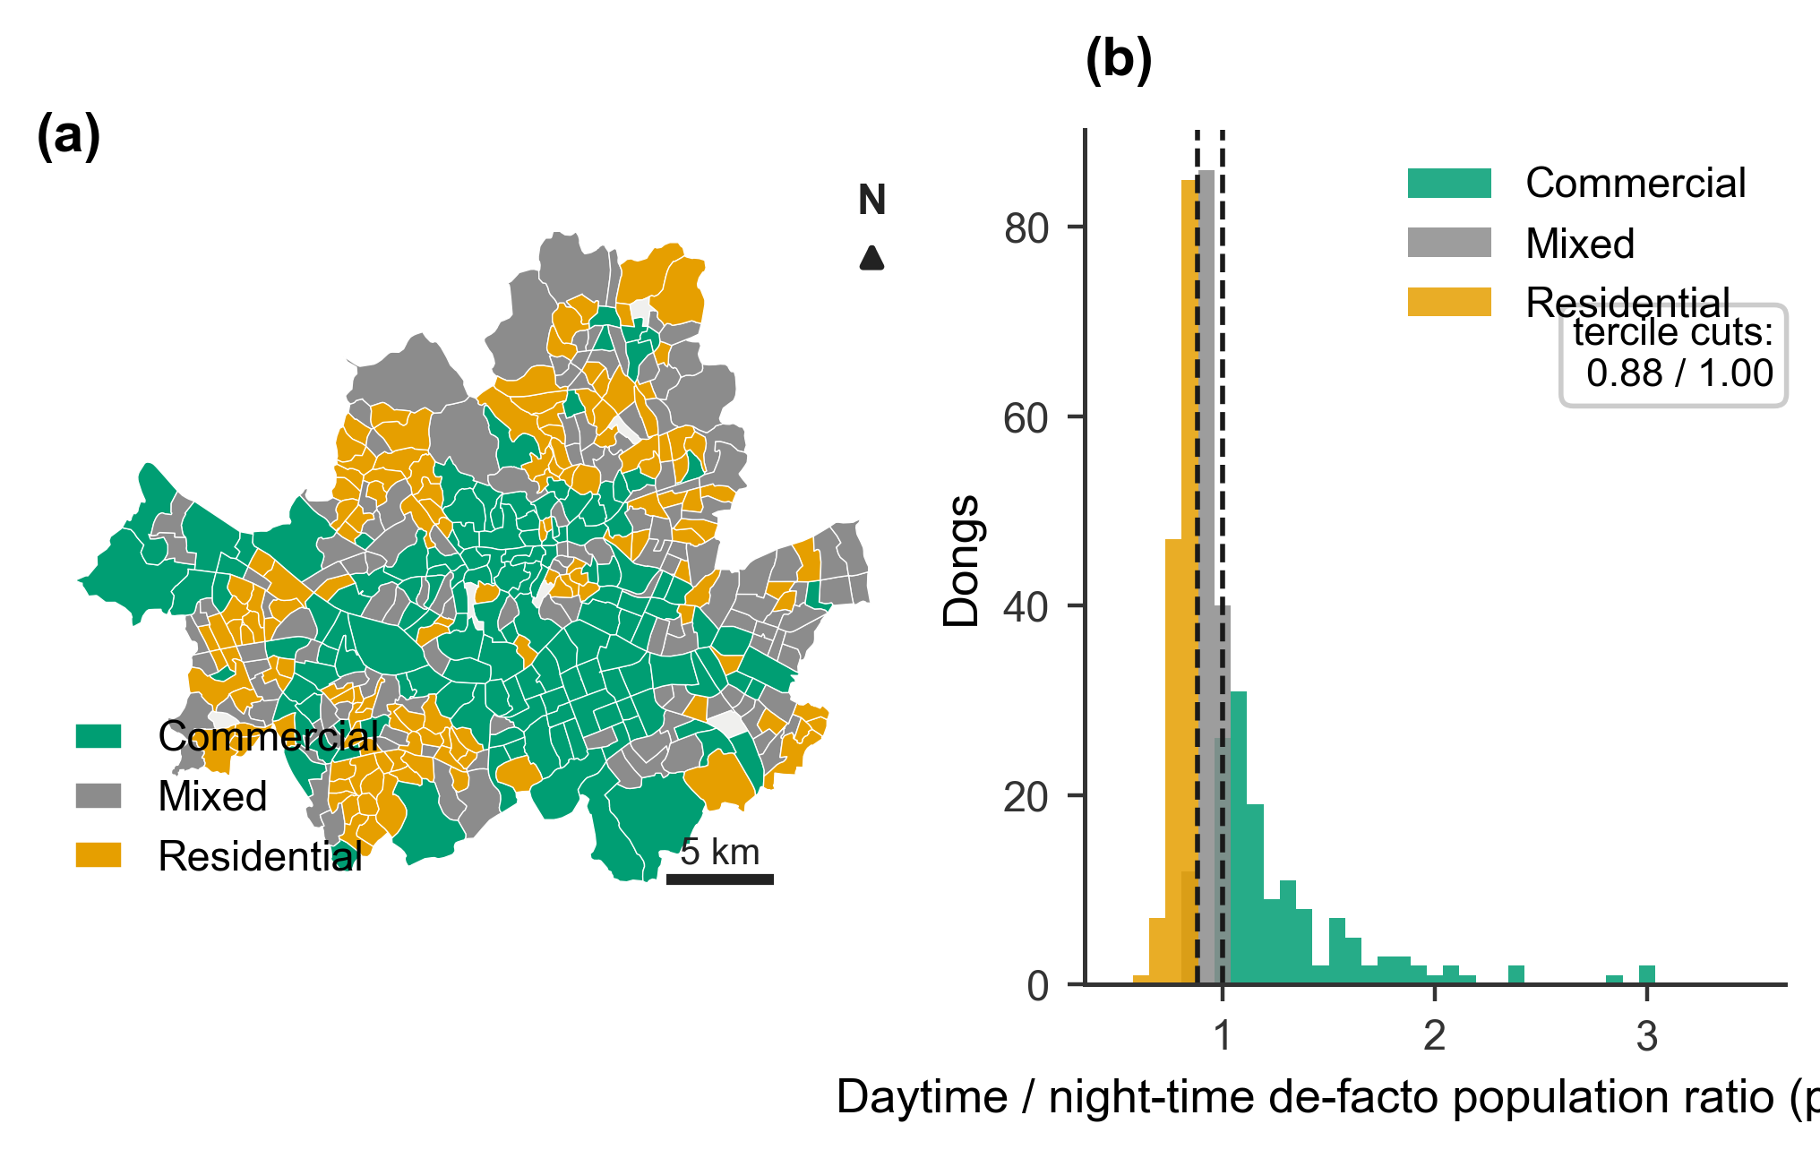
Supplementary Fig. S3. Neighbourhood activity-type classification. (a) Commercial / mixed / residential terciles of the post-lifting daytime/night-time de-facto population ratio. (b) Distribution of the ratio with tercile cuts (0.88 / 1.00).

