Jorge Ibarra
CSD325
Assignment 4.2
Flowchart 1
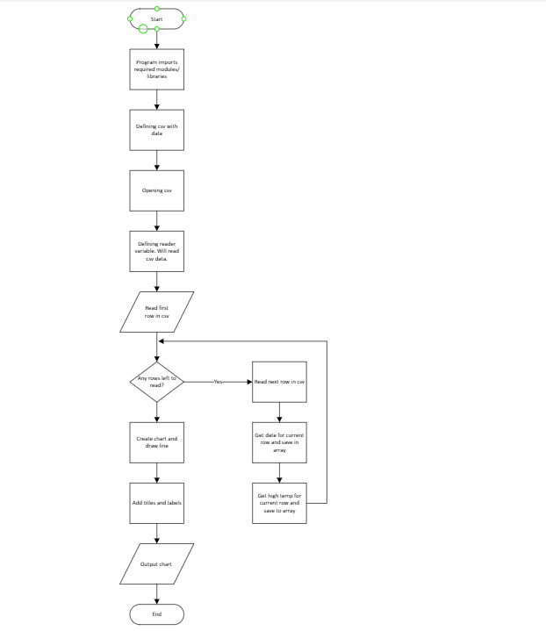

Edited flow
