Evidence document

|  |  |  |
| --- | --- | --- |
| Project | Execution time | Final Result |
| Test Automation Framework | 8s | Status.passed |

# InvalidLogin__1.1

21_26_08_Login.png

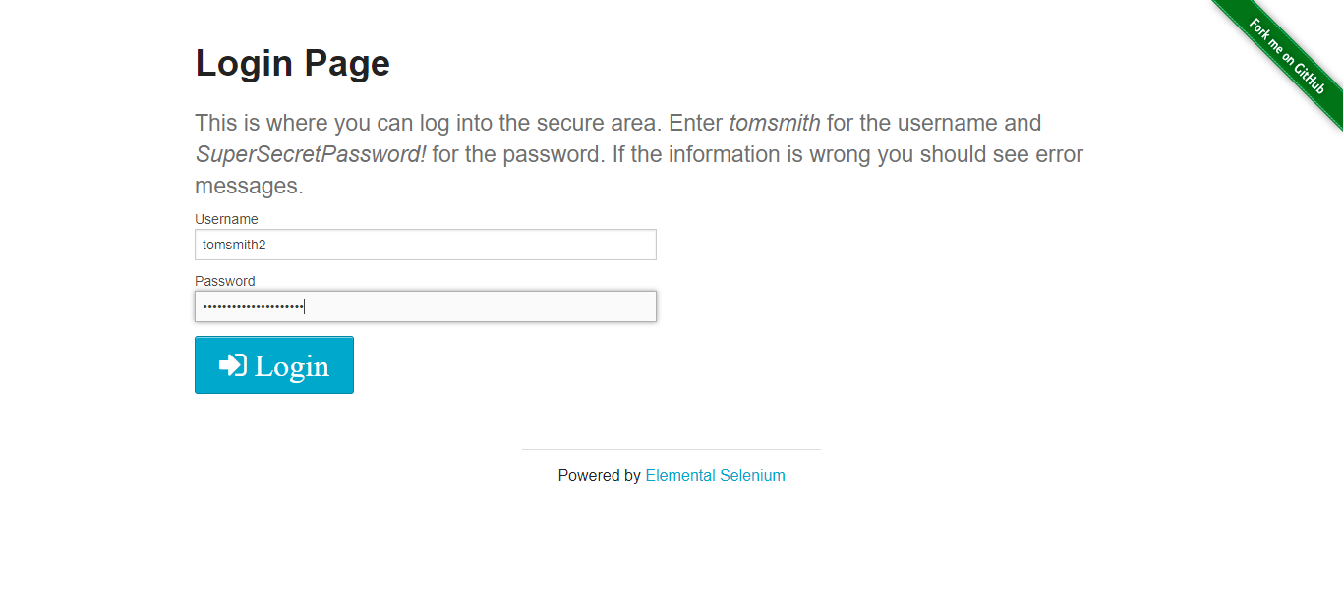

# InvalidLogin__1.1

21_26_09_Check_if_is_logged.png

