Evidence document

|  |  |  |
| --- | --- | --- |
| Project | Execution time | Final Result |
| Test Automation Framework | 8s | Status.passed |

# ValidLogin__1.1

22_06_57_Check_if_is_logged.png

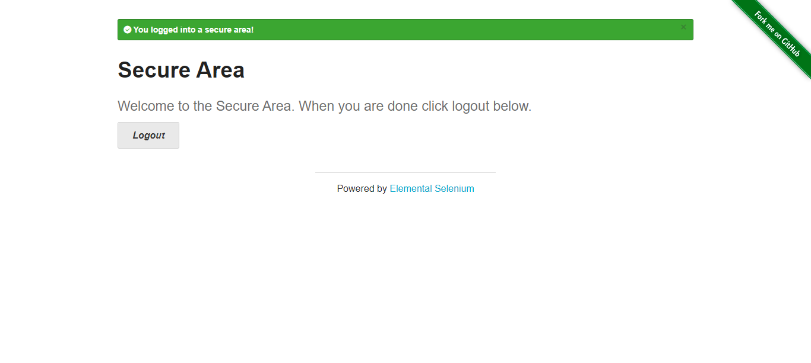

# ValidLogin__1.1

22_06_57_Login.png

