




MCS - 044
Medicine Store System
By
Dharmendra Singh Tomar
Enrolment No: 190749154

Under Guidance
of
Amit Ganguli

Submitted to the School of Computer and Information Sciences, IGNOU in partial fulfilment of the requirements
for the award of the degree

Master of Computer Applications (MCA) 2020-21
Indira Gandhi National Open University Maidan Garhi
New Delhi – 110068

2020-21

School of Computer and Information Sciences

CERTIFICATE

This is to certify that students of MASTER OF COMPUTER APPLICATION Dharmendra Singh Tomar (4th semester) at IGNOU Regional Center, BHOPAL have done “Medicine Store System “ as their minor project for partial fulfillment for the degree of MCA from IGNOU Bhopal (M.P.) This report is up to the standard both in respect of its contents & it’s literally presentation for being referred to the examinees.

GUIDED BY Coordinator
Amit Ganguli Mrs. Shashi Tiwari

ACKNOWLEDGEMENT

With a deep sense of gratitude we express our humble thanks to Mrs.Shashi Tiwari, Coordinator of M.C.A Bhopal, for giving us an opportunity to undertake our project work on “Medicine Management System”. Special notes of thanks to our project guide Mr. Amit Ganguli for his precious guidance and encouragement to accomplish our project.

We would like to thank our Parents. Our University and those who rendered their help at various phases of our project work.

Dharmendra Singh Tomar
En. No. : 190759718

CONTENTS

- Objective

- Introduction

- Organization

- System Analysis & Design

- E-R Model

- Data Flow Diagram

- Tools and Technique used
- Form Layout

- Coding

- Testing

- Conclusion

- References

OBJECTIVE OF THE PROJECT

A medicine store stores information of all the medicines that are being sold by the medicine store. The medicines are supplied to the store by the registered suppliers on receiving the orders from the medicine store. Some of the important information given by the suppliers include the batch number of medicine, manufacturing company name, date of manufacture, date of expiry, price and the type of medicine. The medicine company sells the medicines as per the prescription of the doctors. It generates bill for its customers through this system. The bill includes information on the medicines, its quantity, price, discount, if any and total amount. The bill is issued in the name of the customer and the name of prescribing doctor is also recorded. Create a system, which performs the tasks as above. The system should also maintains the stock of medicines at the medical store. Analyse the system requirements, and design the system.

- Easy to use Interface

This is among one of the most critical features, responsible for the survival of the software in the market. Actually what happens, the software created with huge amount of functionality could not attract the customer, just because of the poor graphical interface. The reason is quite simple, a client feels bewildered in such a complicated environment.

The Application for Medicine Store System, on the contrary provides a simple and easy to maneuver sort of an environment. It has mastered simplicity so that the user can learn by him or by making some experiments. The Graphical interface is created accordingly what we usually use while using any Microsoft application such as calculator, notepad, etc.

- Global Platform

The Medicine Store System is an expert application for providing a Global platform for all sort of user, who can interact through this application.

- Faster Accessibility
The Application use the most important accessibility functionality As a result of this accessing the application for fetching the information, responding to the user could be easily and efficiently been done.

- Effective Process Model

The application is designed using the Iterative Process model. This provides the application project to enhance itself pretty quickly and easily. This process model also provides better testing facility resulting in error free environment.

INTRODUCTION

In this world of computer everything is been computerized so as to fulfill the need of fast processing, accurate result producing and better performance. Thus I have also tried to inculcate these things and develop software for “Medicine Store System”

Feature of Medicine Store System:-
- User Creation
- View Medicine Details
- Add Supplier
- Add Medicines
- Manage Stock
- Bill Generation

Systems Development Life Cycle

The Systems Development Life Cycle (SDLC) or Software Development Life Cycle in systems engineering and software engineering is the process of creating or altering systems, and the models and methodologies that people use to develop these systems. The concept generally refers to computer or information systems.
In software engineering the SDLC concept underpins many kinds of software development methodologies. These methodologies form the framework for planning and controlling the creation of an information system the software development process.
Systems Development Life Cycle (SDLC) is any logical process used by a systems analyst to develop an information system, including requirements, validation, training, and user ownership. A SDLC should result in a high quality system that meets or exceeds customer expectations, reaches completion within time and cost estimates, works effectively and efficiently in the current and planned Information Technology infrastructure, and is inexpensive to maintain and cost-effective to enhance. Computer systems have become more complex and often (especially with the advent of Service-Oriented Architecture) link multiple traditional systems potentially supplied by different software vendors. To manage this level of complexity, a number of system development life cycle (SDLC) models have been created: "waterfall," ,"spiral” and V-Model.
SDLC Stages :
The six stages of the SDLC are designed to build on one another, taking the Outputs from the previous stage, adding additional effort, and producing results that leverage the previous effort and are directly traceable to the previous stages. This top-down approach is intended to result in a quality product that satisfies the original intentions of the customer.

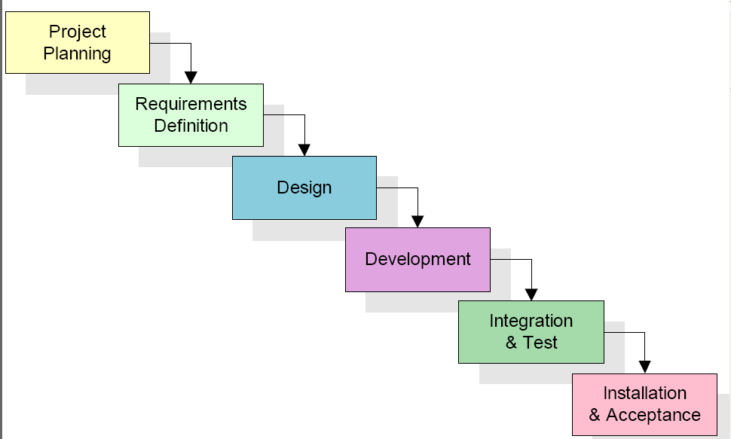

Too many software development efforts go away when the development team and Customer personnel get caught up in the possibilities of automation. Instead of focusing on high priority features, the team can become mired in a sea of “nice to have” features that are not essential to solve the problem, but in themselves are highly attractive. This is the root cause of a large percentage of failed and/or abandoned development efforts, and is the primary reason the development team utilizes the Waterfall SDLC.

Planning Stage :

The planning stage establishes a bird's eye view of the intended software product, and uses this to establish the basic project structure, evaluate feasibility and risks associated with the project, and describe appropriate management and technical approaches.

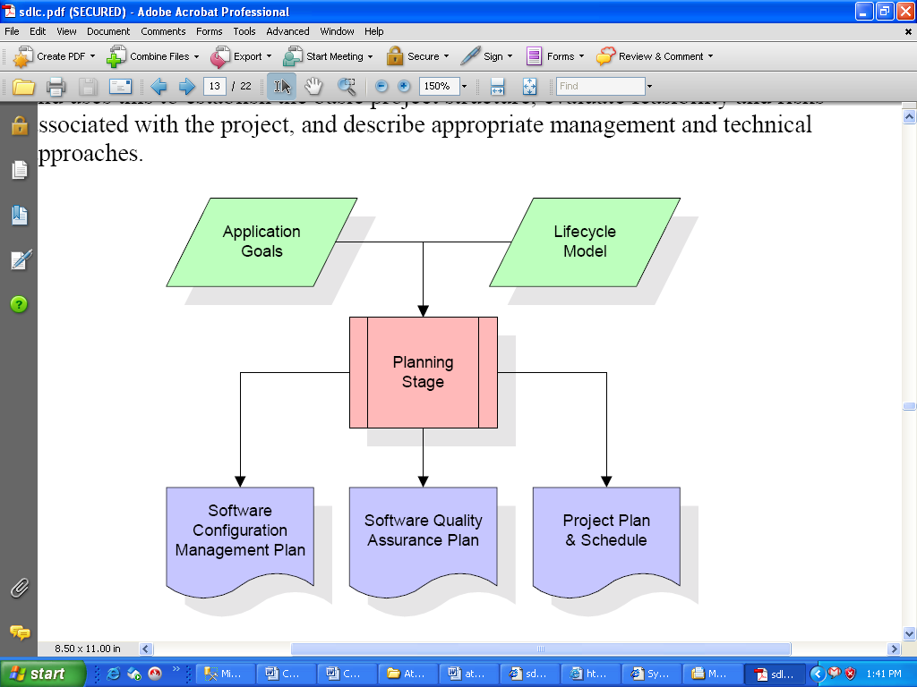

The most critical section of the project plan is a listing of high-level product requirements, also referred to as goals. All of the software product requirements to be developed during the requirements definition stage flow from one or more of these goals. The minimum information for each goal consists of a title and textual description, although additional information and references to external documents may be included.

The outputs of the project planning stage are the configuration management plan,
the quality assurance plan, and the project plan and schedule, with a detailed listing of scheduled activities for the upcoming Requirements stage, and high-level estimates of effort for the out stages.

Requirements Definition Stage :

The requirements gathering process takes as its input the goals identified in the high-level requirements section of the project plan. Each goal will be refined into a set of one or more requirements.
These requirements define the major functions of the intended application, define operational data areas and reference data areas, and define the initial data entities. Major functions include critical processes to be managed, as well as mission Critical inputs, outputs and reports. A user class hierarchy is developed and associated with these major functions, data areas, and data entities.
Each of these definitions is termed a Requirement. Requirements are identified by unique requirement identifiers and, at minimum, contain a requirement title and textual description.

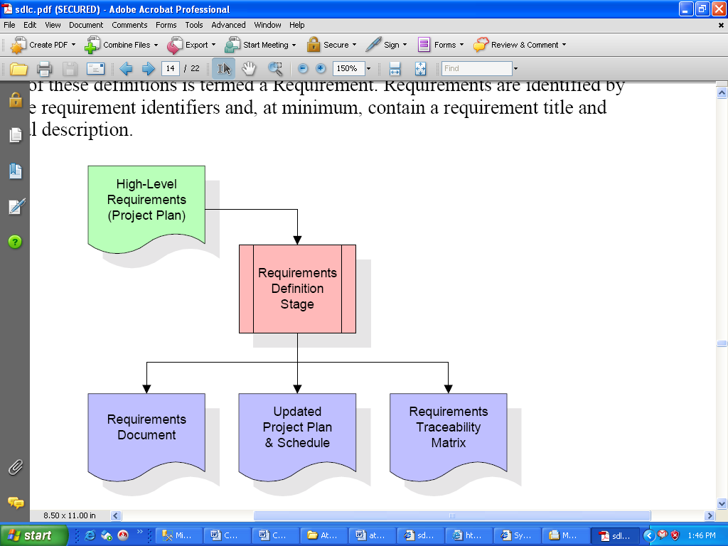

These requirements are fully described in the primary deliverables for this stage: the Requirements Document and the Requirements Traceability Matrix (RTM). The requirements document contains complete descriptions of each requirement, including diagrams and references to external documents as necessary. Note that detailed listings of database tables and fields are not included in the requirements document.

Design Stage:

The design stage takes as its initial input the requirements identified in the approved requirements document. For each requirement, a set of one or more design elements will be produced as a result of interviews, workshops, and/or prototype efforts.

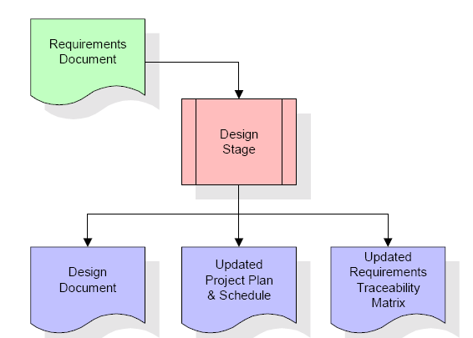

Design elements describe the desired software features in detail, and generally include functional hierarchy diagrams, screen layout diagrams, tables of business rules, business process diagrams, pseudo code, and a complete entity-relationship diagram with a full data dictionary. These design elements are intended to describe the software in sufficient detail that skilled programmers may develop the software with minimal additional input.

When the design document is finalized and accepted, the RTM is updated to show that each design element is formally associated with a specific requirement. The outputs of the design stage are the design document, an updated RTM, and an updated project plan.

Development Stage :

The development stage takes as its primary input the design elements described in the approved design document. For each design element, a set of one or more software artifacts will be produced. Software artifacts include but are not limited to menus, dialogs, and data management forms, data reporting formats, and specialized procedures and functions.

Appropriate test cases will be developed for each set of functionally related software artifacts, and an online help system will be developed to guide users in their interactions with the software.

The RTM will be updated to show that each developed artifact is linked to a specific design element, and that each developed artifact has one or more corresponding test case items. At this point, the RTM is in its final configuration.

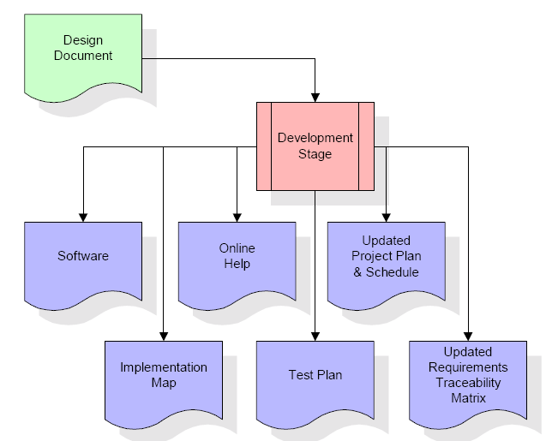

The outputs of the development stage include a fully functional set of software that satisfies the requirements and design elements previously documented, an online help system that describes the operation of the software, an implementation map that identifies the primary code entry points for all major system functions, a test plan that describes the test cases to be used to validate the correctness and completeness of the software, an updated RTM, and an updated project plan.

Integration & Test Stage :

During the integration and test stage, the software artifacts, online help, and test data are migrated from the development environment to a separate test environment. At this point, all test cases are run to verify the correctness and completeness of the software. Successful execution of the test suite confirms a robust and complete migration capability. During this stage, reference data is finalized for production use and production users are identified and linked to their appropriate roles. The final reference data (or links to reference data source files) and production user list are compiled into the Production Initiation Plan

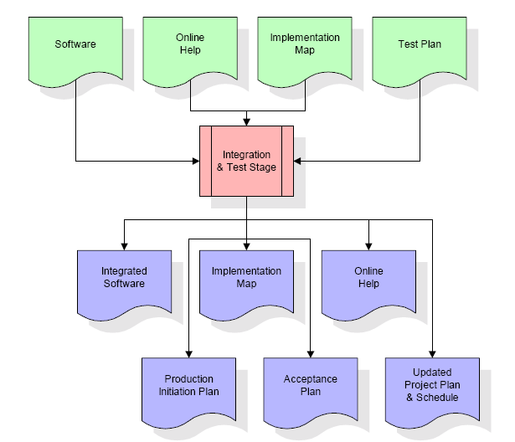

The outputs of the integration and test stage include an integrated set of software, an online help system, an implementation map, a production initiation plan that describes reference data and production users, an acceptance plan which contains the final suite of test cases, and an updated project plan.

Installation & Acceptance Stage :
During the installation and acceptance stage, the software artifacts, online help, and initial production data are loaded onto the production server. At this point, all test cases are run to verify the correctness and completeness of the software.
Successful execution of the test suite is a prerequisite to acceptance of the software by the customer. After customer personnel have verified that the initial production data load is correct and the test suite has been executed with satisfactory results, the customer formally accepts the delivery of the software.

The primary outputs of the installation and acceptance stage include a production application, a completed acceptance test suite, and a memorandum of customer acceptance of the software. Finally, the PDR enters the last of the actual labor data into the project schedule and locks the project as a permanent project record. At this point the PDR "locks" the project by archiving all software items, the implementation map, the source code, and the documentation for future reference.

SYSTEM DEVELOPMENT LIFE CYCLE MODEL

This project is to be developed step by step using RAD model the time division for various stages is as follows.
Prototyping Model :
The Prototyping model is based on a linear sequential software development process that emphasizes on refinement of the S/W requirement process in the form of toy implementation. Once the requirements for the S/W freezes then the final coding phase starts .The Prototyping approach is good for the S/W development using this model we can see how it will function after the completion of the S/W before it completion, Early defects are removed at the time of the First Cycle of this model due to that error correction and detection is minimized. S/W passes through the following phases during the development:
  - Requirement Analysis:
In the first phase of the prototyping model entire details is gathered about the customer requirement and prepare a data dictionary and SRS document he flow of data.
  - Design:
In this phase we design the S/W requirement according to the nature of problem using UML/USE CASE/SEQUENCE diagram to show the relationships among the entities and attributes and also design the database and E-R Diagram.
  - Coding:
In this phase we use a suitable language to implement the design into coding form and establish the connection from front end to back end and make the all details in computerized form

INFORMATION GATHERING:

Information about the puzzle history, rules, structure of functionalities was gathered. Information about the people who run the present system - their job functions and information requirements, the relationships of their job to the existing system, and the interpersonal network that holds the user group together and the expectation of each user was analyzed. Information about the work flow within the specific module.

The information gathering tools applied here were:

1. Study of Magazines, Newspapers :
The manual functioning was observed within the premises of some magazines and newspaper in which sudoku puzzle is published in daily or weekly or monthly.

2. Manuals study :

We also studied the manuals in which we have found these data and the procedure of the result analysis and their storage techniques and searching techniques.

3. Observe problems :
After studying of magazines and newspapers we observe the problem phases in solving sudoku puzzle and gather information about the working of the present system, the problems faced, the drawbacks regarding the solutions for the problems, the enhancements needed and the type.

FEASIBILITY STUDY:

Feasibility study considers the economic, technical, and behavioral factors in system development -

1. Economical Feasibility :
This is a very important aspect to be considered while developing the project. We decided the technology based on minimum possible cost factor.

2. Technical Feasibility :
Technical feasibility center’s on the computer system (hardware, software and etc.) and to what extent it can support the proposed addition.
While developing any system what we should keep in mind is that the technique we are using in our system is easily understandable by the users. We are using GUI technique in developing our system.
GUI technique is very easily under stable and useable by the user making our system technically feasible.

3. Behavioral Feasibility :
People are inherently resistant to change, and computers have been known to facilitate change. An estimate should be made of how strong a reaction the user is likely to have toward the development of computerized system.
While changing or developing a system we have to usually face such users who do not want any change in the current system. But if we make the changes according to them then they generally have no problem to accept it.
We are developing our project in GUI Java Swing taken as front so that the user faces no problem in using the system.

SYSTEM REQUIREMENTS SPECIFICATION

System Requirement :

There are the minimum hardware and software requirement, the system was developed and required for successful running of the system.

Hardware Specification :

1. PROCESSOR- PENTIUM (MINIMUM 166MHZ OR ABOVE)
2. HARD DISK- MINIMUM 40GB & ABOVE
3. PRIMARY STORAGE- 512MB RAM & ABOVE
4. KEY BOARD (STANDARD)
5. MOUSE (STANDARD)
6. COLOR MONITOR
7. INKJET PRINTER (FOR BETTER QUALITY)
8. CD ROM
9. UNINTERUPTED POWER SUPPLY (500V)

Software Specification :

1. OPERATING SYSTEM- WINDOWS 7/8/10
2. SOFTWARE REQUIRMENT-

FRONT END: - Java , Java Swing

BACK END: - Oracle

Software requirement specifications capture system behavior as opposed to non-software requirement specifications define attributes as opposed to behavior. This behavior is often expressed as services, tasks or in product development, it is important to understand the difference between the baseline functionality necessary for any system to compete in that product domain, and features that make the system different from their competitor's products. Features may be functionality, or differ from the basic functionality like some quality property.
Some strategies have important implications for software architecture. Specifically, it is not just the software requirement specifications of the initial release that must be supported in the architecture. The software requirement specifications of early products need to be explicitly taken into consideration. Later releases are done through architectural qualities including extensibility and flexibility. The latter are expressed as non-software requirement specifications. Use cases have become a widespread necessity for capturing software requirement specifications. This is the case in object-oriented projects.

The SRS process will define what the application needs to do now and also will capture what you would like it to do in the future. Knowing with reasonable accuracy what you will want in the future allows developers to keep an "open door" to these features so that it will be simple to add them when you are ready. This is the type of forward thinking that is generally missing in "Scope of Work" documents used by most development or contractor developers.

It can cost up to 8 times as much to go back and fix a poorly designed application as it does to design it correctly in the first place. So every dollar spent building your "application blueprint" is money well spent. Rushing to development is short-sighted and costly. This is further insight as to why 70 to 90% of software projects fail.

E-R DIAGRAM :

The entity-relationship model or entity-relationship diagram (ERD) is a data model or diagram for high-level descriptions of conceptual data model, and it provides a graphical notation for representing such data models in the form of entity-relationship diagrams. Such models are typically used in the first stage of information-system design; they are used, for example, to describe information needs and/or the type of information that is to be stored in the database during the requirement analysis. The datamodelling technique, however, can be used to describe any ontology (i.e. an overview and classifications of used terms and their relationships) for a certain universe of discourse (i.e. area of interest). In the case of the design of an information system that is based on a database, the conceptual data model is, at a later stage (usually called logical design), mapped to a logical data model, such as the relational model; this in turn is mapped to a physical model during physical design. Note that sometimes, both of these phases are referred to as "physical design".
There are a number of conventions for entity-relationship diagrams (ERDs). The classical notation is described in the remainder of this article, and mainly relates to conceptual modeling. There are a range of notations more typically employed in logical and physical database design
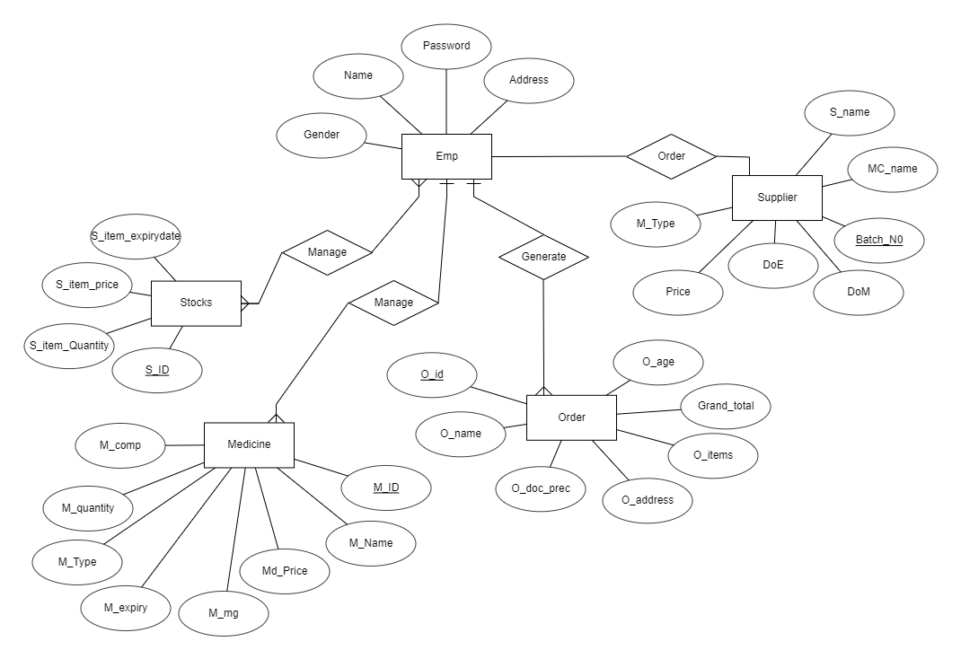

DFD (Data Flow Diagram)

A data-flow diagram (DFD) is a graphical representation of the "flow" of data through an information system. DFDs can also be used for the visualization of data processing (structured design).
On a DFD, data items flow from an external data source or an internal data store to an internal data store or an external data sink, via an internal process.
A DFD provides no information about the timing or ordering of processes, or about whether processes will operate in sequence or in parallel. It is therefore quite different from a flowchart, which shows the flow of control through an algorithm, allowing a reader to determine what operations will be performed, in what order, and under what circumstances, but not what kinds of data will be input to and output from the system, nor where the data will come from and go to, nor where the data will be stored (all of which are shown on a DFD)

It is common practice to draw a context-level data flow diagram first, which shows the interaction between the system and external agents which act as data sources and data sinks. On the context diagram (also known as the Level 0 DFD) the system's interactions with the outside world are modeled purely in terms of data flows across the system boundary. The context diagram shows the entire system as a single process, and gives no clues as to its internal organization This context-level DFD is next "exploded", to produce a Level 1 DFD that shows some of the detail of the system being modeled. The Level 1 DFD shows how the system is divided into sub-systems (processes), each of which deals with one or more of the data flows to or from an external agent, and which together provide all of the functionality of the system as a whole. It also identifies internal data stores that must be present in order for the system to do its job, and shows the flow of data between the various Parts of the system.

DATA FLOW DIAGRAM

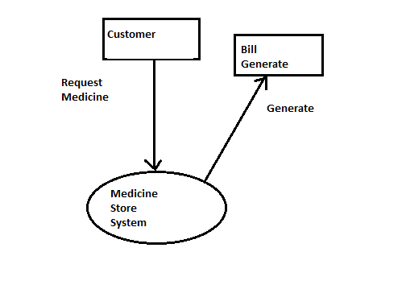
DFD LEVEL 0

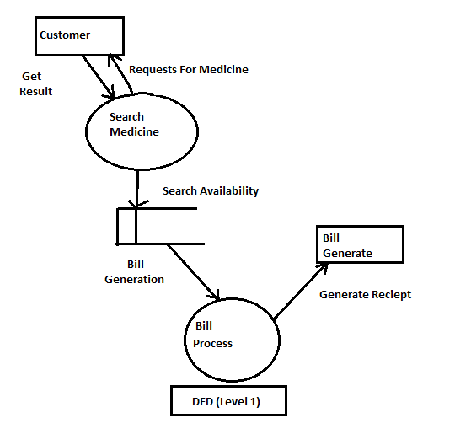

TOOLS AND TECHNOLOGY USED

What is Java: Java programming language was originally developed by Sun Microsystems which was initiated by James Gosling and released in 1995 as core component of Sun Microsystems' Java platform (Java 1.0 [J2SE]).
The latest release of the Java Standard Edition is Java SE 15. With the advancement of Java and its widespread popularity, multiple configurations were built to suit various types of platforms. For example: J2EE for Enterprise Applications, J2ME for Mobile Applications.
The new J2 versions were renamed as Java SE, Java EE, and Java ME respectively. Java is guaranteed to be Write Once, Run Anywhere.
.
Important Features
- Object Oriented − In Java, everything is an Object. Java can be easily extended since it is based on the Object model.
- Platform Independent − Unlike many other programming languages including C and C++, when Java is compiled, it is not compiled into platform specific machine, rather into platform independent byte code. This byte code is distributed over the web and interpreted by the Virtual Machine (JVM) on whichever platform it is being run on.
- Simple − Java is designed to be easy to learn. If you understand the basic concept of OOP Java, it would be easy to master.
- Secure − With Java's secure feature it enables to develop virus-free, tamper-free systems. Authentication techniques are based on public-key encryption.
- Architecture-neutral − Java compiler generates an architecture-neutral object file format, which makes the compiled code executable on many processors, with the presence of Java runtime system.
- Portable − Being architecture-neutral and having no implementation dependent aspects of the specification makes Java portable. Compiler in Java is written in ANSI C with a clean portability boundary, which is a POSIX subset.
- Robust − Java makes an effort to eliminate error prone situations by emphasizing mainly on compile time error checking and runtime checking.
- Multithreaded − With Java's multithreaded feature it is possible to write programs that can perform many tasks simultaneously. This design feature allows the developers to construct interactive applications that can run smoothly.
- Interpreted − Java byte code is translated on the fly to native machine instructions and is not stored anywhere. The development process is more rapid and analytical since the linking is an incremental and light-weight process.
- High Performance − With the use of Just-In-Time compilers, Java enables high performance.
- Distributed − Java is designed for the distributed environment of the internet.
- Dynamic − Java is considered to be more dynamic than C or C++ since it is designed to adapt to an evolving environment. Java programs can carry extensive amount of run-time information that can be used to verify and resolve accesses to objects on run-time.

Oracle SQL: Structured Query Language (SQL) is the set of statements with which all programs and users access data in an Oracle database. Application programs and Oracle tools often allow users access to the database without using SQL directly, but these applications in turn must use SQL when executing the user's request. This chapter provides background information on SQL as used by most database systems.
Dr. E. F. Codd published the paper, "A Relational Model of Data for Large Shared Data Banks", in June 1970 in the Association of Computer Machinery (ACM) journal, Communications of the ACM. Codd's model is now accepted as the definitive model for relational database management systems (RDBMS). The language, Structured English Query Language (SEQUEL) was developed by IBM Corporation, Inc., to use Codd's model. SEQUEL later became SQL (still pronounced "sequel"). In 1979, Relational Software, Inc. (now Oracle) introduced the first commercially available implementation of SQL. Today, SQL is accepted as the standard RDBMS language.

Database Table

- Emp :

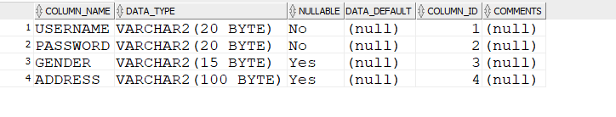
- Medicine
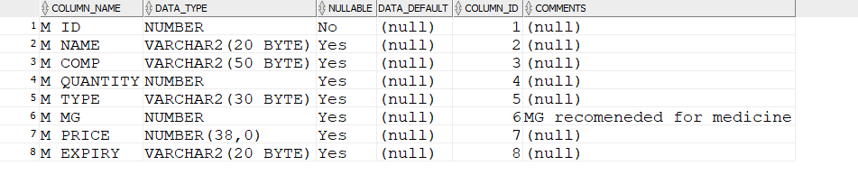

- Supplier
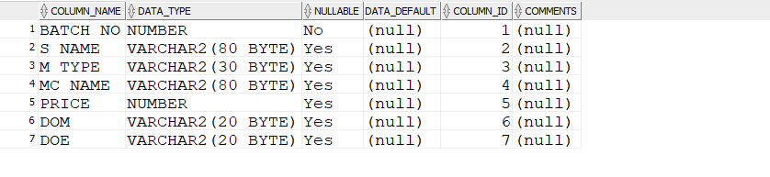
- Stock
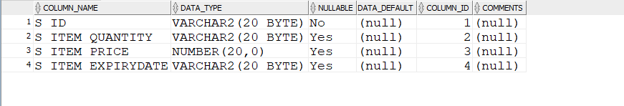

- Orders
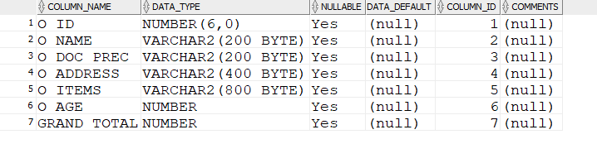

FORM LAYOUT

Login Form

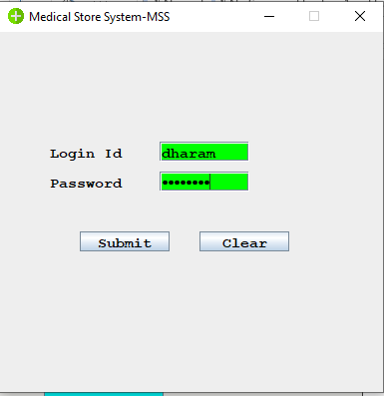

Main Form:
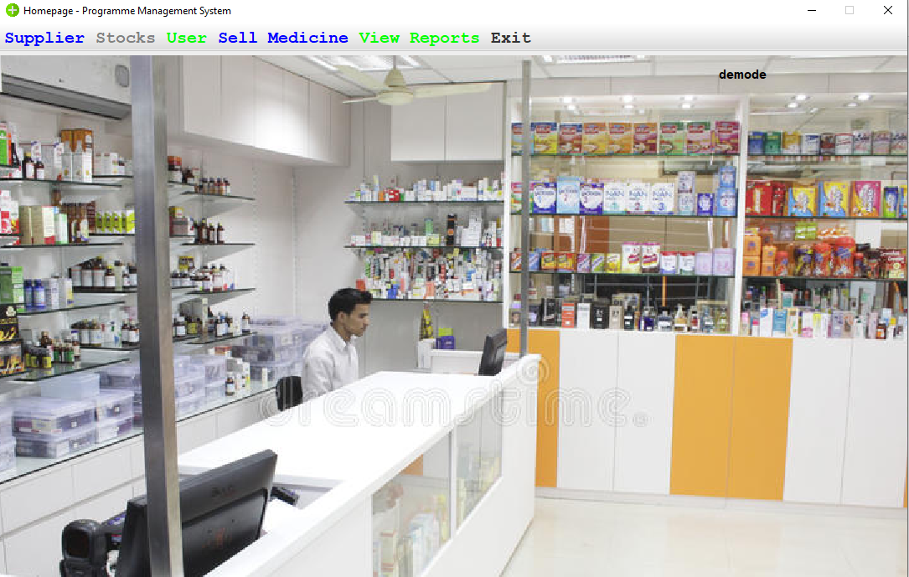

New user creation:

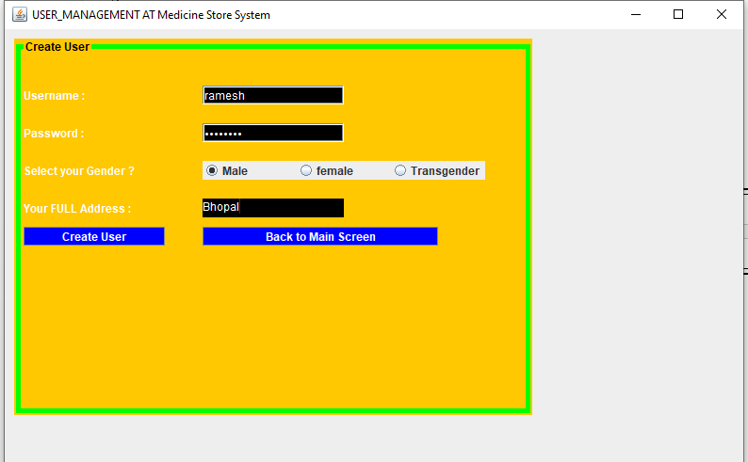

Supplier Form :
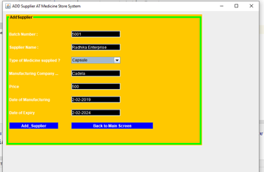

Stock Form:
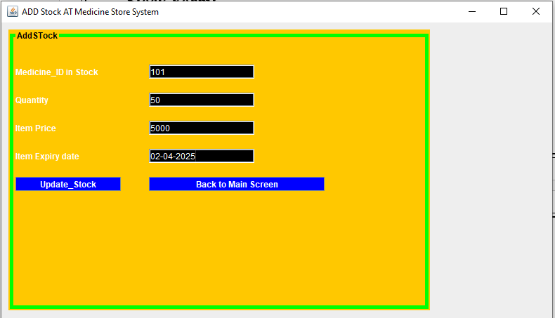

Sell Medicine Form:

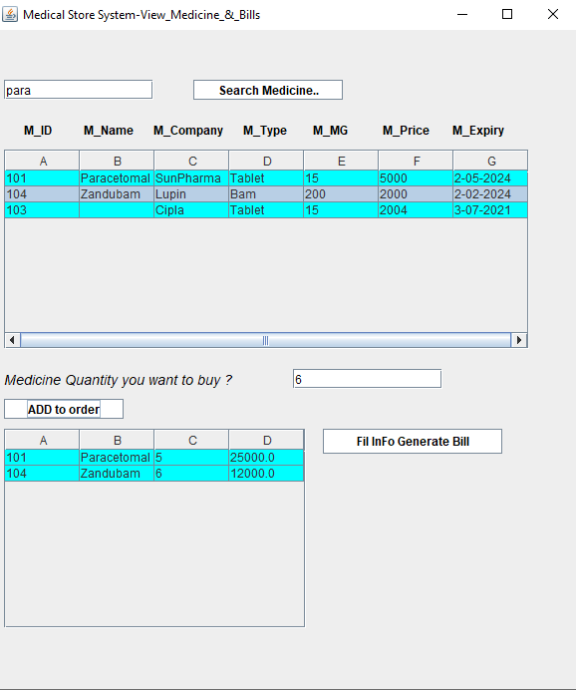

Order Generate From:

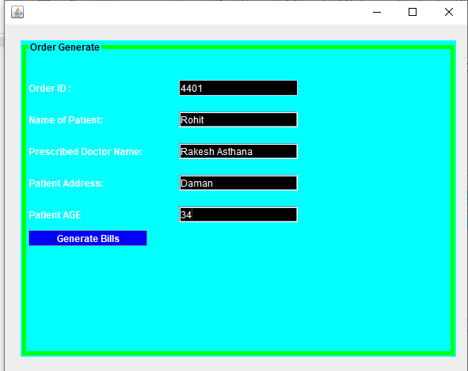

Bill Generate

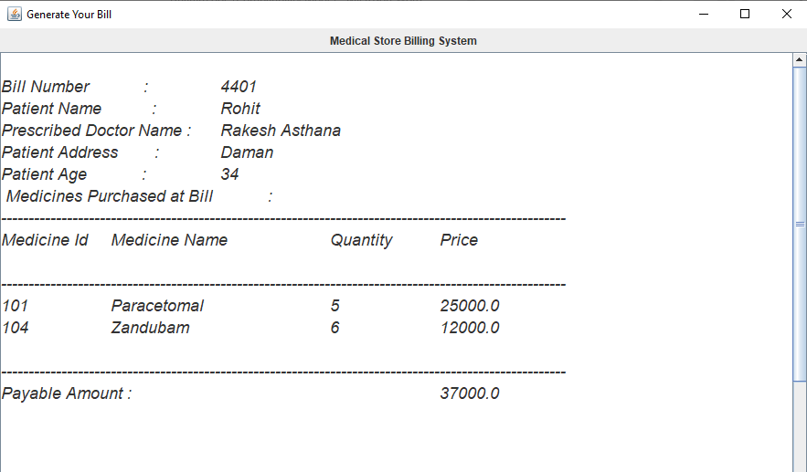

CODING
- Login.java -

package com;

import javax.swing.*;
import java.awt.*;
import java.awt.event.ActionEvent;
import java.awt.event.ActionListener;
import java.sql.ResultSet;
import java.sql.SQLException;

public class Login extends JFrame implements ActionListener {

JButton b1, b2;
JLabel l1, l2, l3;
JTextField t1;
JPasswordField p1;

public Login() {

/*This is used to perform login operations */
super("Medical Store System-MSS");
setLayout(null);
//setContentPane().setBackgroundColor(gray);
ImageIcon icon = new ImageIcon(ClassLoader.getSystemResource("com/img/add.png"));
Image img = icon.getImage();
setIconImage(img);

l1 = new JLabel("Login_Id");
l1.setFont(new Font("monospaced", Font.BOLD, 15));
l1.setForeground(Color.BLACK);
l1.setBounds(50, 110, 90, 20);
add(l1);

l2 = new JLabel("Password");
l2.setFont(new Font("monospaced", Font.BOLD, 15));
l2.setForeground(Color.BLACK);
l2.setBounds(50, 140, 90, 20);
add(l2);
p1 = new JPasswordField();
p1.setFont(new Font("monospaced", Font.BOLD, 15));
p1.setForeground(Color.BLACK);
p1.setBackground(Color.GREEN);
p1.setBounds(160, 140, 90, 20);
add(p1);

t1 = new JTextField();
t1.setFont(new Font("monospaced", Font.BOLD, 15));
t1.setForeground(Color.BLACK);
t1.setBackground(Color.GREEN);
t1.setBounds(160, 110, 90, 20);
add(t1);

/* button used for Submit the information */

b1 = new JButton("Submit");
b1.setFont(new Font("monospaced", Font.BOLD, 15));
b1.setForeground(Color.BLACK);
b1.setBounds(80, 200, 90, 20);
add(b1);
b1.addActionListener(this);

/* button used for clear the information */
b2 = new JButton("Clear");
b2.setFont(new Font("monospaced", Font.BOLD, 15));
b2.setForeground(Color.BLACK);
b2.setBounds(200, 200, 90, 20);
add(b2);
b2.addActionListener(this);

setLocation(500, 100);
setSize(400, 400);
setResizable(false);
setVisible(true);
}

@Override
public void actionPerformed(ActionEvent al) {

dbcon c = new dbcon();
String tn = t1.getText().trim();
String tp = p1.getText().trim();
System.out.println(tn + " " + tp);

if (al.getSource() == b1) {
try {
String r = "select * from emp where USERNAME='" + tn + "'and PASSWORD= '" + tp + "'";
ResultSet rs = c.s.executeQuery(r);
if (rs.next()) {
new Project(tn).setVisible(true);
setVisible(false);

} else {
JOptionPane.showMessageDialog(null, "login with valid username and password");

}
} catch (SQLException throwables) {
throwables.printStackTrace();
}
}
if (al.getSource() == b2) {
t1.setText("");
p1.setText("");

}
}

public static void main(String[] args) {
new Login();

}

}
- Project.java –
package com;

import javax.swing.*;
import java.awt.*;
import java.awt.event.ActionEvent;
import java.awt.event.ActionListener;
import java.awt.event.KeyEvent;
import java.sql.ResultSet;
import java.sql.SQLException;

public class Project extends JFrame implements ActionListener {

JLabel l2,l3;
JButton b1;
String username;
Project(String username){
super("Homepage - Programme Management System");

this.username = username;
ImageIcon icon = new ImageIcon(ClassLoader.getSystemResource("com/img/add.png"));
Image img = icon.getImage();
setIconImage(img);
//
ImageIcon icon1 = new ImageIcon(ClassLoader.getSystemResource("com/img/P1.jpg"));
Image img1 = icon1.getImage().getScaledInstance(1200,800,Image.SCALE_DEFAULT);
ImageIcon icc = new ImageIcon(img1) ;
JLabel l1 = new JLabel(icc);
add(l1);

l3 = new JLabel();
l3.setFont(new Font("Sanserif", Font.BOLD, 20));
l3.setForeground(Color.BLACK);
l3.setSize(500, 20);
l3.setBounds(100,20,700,20);
l1.add(l3);

l2 = new JLabel();
l2.setFont(new Font("Sanserif", Font.BOLD, 15));
l2.setForeground(Color.BLACK);
l2.setSize(500, 20);
l2.setBounds(917,10,500,25);
l1.add(l2);
l2.setText(username);
setDefaultCloseOperation(JFrame.EXIT_ON_CLOSE);

JMenuBar mb = new JMenuBar();
JMenu main = new JMenu("Supplier");
JMenuItem m1 = new JMenuItem("Manage Supplier");
//JMenuItem m2 = new JMenuItem("Update Supplier");
main.setFont(new Font("Monospaced",Font.BOLD,20));
mb.setForeground(Color.white);
main.setForeground(Color.BLUE);

m1.setFont(new Font("Monospaced",Font.BOLD,16));
m1.setMnemonic('A');
m1.setAccelerator(KeyStroke.getKeyStroke(KeyEvent.VK_N, ActionEvent.CTRL_MASK));
m1.setBackground(Color.white);
m1.addActionListener(this);

JMenu Stock = new JMenu("Stocks");
JMenuItem u1 = new JMenuItem("Manage Stock");
//JMenuItem u2 = new JMenuItem("View Stocks");
Stock.setFont(new Font("Monospaced",Font.BOLD,20));
Stock.setForeground(Color.red);

u1.setFont(new Font("Monospaced",Font.BOLD,16));
u1.setMnemonic('D');
u1.setAccelerator(KeyStroke.getKeyStroke(KeyEvent.VK_S, ActionEvent.CTRL_MASK));
u1.setBackground(Color.white);
u1.addActionListener(this);

JMenu User = new JMenu("User");
JMenuItem user1 = new JMenuItem("Manage User");
User.setFont(new Font("Monospaced",Font.BOLD,20));
User.setForeground(Color.green);

user1.setFont(new Font("Monospaced",Font.BOLD,16));
user1.setMnemonic('U');
user1.setAccelerator(KeyStroke.getKeyStroke(KeyEvent.VK_U, ActionEvent.CTRL_MASK));
user1.setBackground(Color.white);
user1.addActionListener(this);

JMenu sellmed = new JMenu("Sell Medicine");
JMenuItem med = new JMenuItem("Manage Medicine");
sellmed.setFont(new Font("Monospaced",Font.BOLD,20));
sellmed.setForeground(Color.BLUE);

med.setFont(new Font("Monospaced",Font.BOLD,16));
med.setMnemonic('M');
med.setAccelerator(KeyStroke.getKeyStroke(KeyEvent.VK_M, ActionEvent.CTRL_MASK));
med.setBackground(Color.white);
med.addActionListener(this);

JMenu ex = new JMenu("Exit");
JMenuItem ex1 = new JMenuItem("Exit");
ex.setFont(new Font("Monospaced",Font.BOLD,20));
ex1.setFont(new Font("Monospaced",Font.BOLD,16));
ex1.setBackground(Color.WHITE);
ex1.addActionListener(this);

JMenu about = new JMenu("About");
JMenuItem about1 = new JMenuItem("About");
about.setForeground(Color.RED);
about.setFont(new Font("Monospaced",Font.BOLD,20));
about1.setFont(new Font("Monospaced",Font.BOLD,16));
about1.setBackground(Color.WHITE);
about1.addActionListener(this);

main.add(m1);
//main.add(m2);

Stock.add(u1);
//Stock.add(u2);

User.add(user1);
ex.add(ex1);
sellmed.add(med);
about.add(about1);

mb.add(main);
mb.add(Stock);
mb.add(User);
mb.add(sellmed);
mb.add(about);
mb.add(ex);

setJMenuBar(mb);
setFont(new Font("sanserif",Font.BOLD,20));
setLayout(new FlowLayout());
setSize(1100,700);
setLocation(150,0);
setResizable(false);
}

public static void main(String[] args) {
new Project("demode").setVisible(true);
}
public void actionPerformed(ActionEvent ae) {
String str = l2.getText();
String action = ae.getActionCommand();
if (action.equals("Manage Supplier")) {
setVisible(false);
new AddSupplier().setVisible(true);
} else if (action.equals("Manage Stock")) {
setVisible(false);
new AddStock().setVisible(true);
} else if (action.equals("Manage User")) {
setVisible(false);
new ManageUser().setVisible(true);
} else if (action.equals("Manage Medicine")) {
setVisible(false);
new ManageMedicine().setVisible(true);
}else if (action.equals("Exit")) {
System.exit(0);
}

}

}

- ManageMedicine:
package com;

import javax.swing.*;
import javax.swing.table.DefaultTableModel;
import java.awt.*;
import java.awt.event.*;
import java.sql.*;
import java.util.Random;

public class ManageMedicine extends JFrame implements ActionListener {
JButton b1, b2,b3;
JTextField t1, t2, t3, t4, t5,t6;
JLabel l1, l2, l3, l4, l5, l6, l7, l8;
JPanel p1, p2;
JTable jt, jt1;
JScrollPane sp, sp1;
int m_id=0;
public ManageMedicine() {
super("Medical Store System-View_Medicine_&_Bills");
setLayout(null);

/*main code for view medicine and bill payments*/

t1 = new JTextField();
t1.setBounds(10, 50, 150, 20);
t1.setBackground(Color.WHITE);
t1.setForeground(Color.BLACK);
add(t1);

b1 = new JButton("Search Medicine..");
b1.setBounds(200, 50, 150, 20);
b1.setBackground(Color.WHITE);
b1.setForeground(Color.BLACK);
add(b1);
b1.addActionListener(this);

l1 = new JLabel("M_ID");
l1.setBounds(30, 90, 50, 20);
l1.setBackground(Color.WHITE);
l1.setForeground(Color.BLACK);
add(l1);

l2 = new JLabel("M_Name");
l2.setBounds(90, 90, 80, 20);
l2.setBackground(Color.WHITE);
l2.setForeground(Color.BLACK);
add(l2);
l3 = new JLabel("M_Company");
l3.setBounds(160, 90, 70, 20);
l3.setBackground(Color.WHITE);
l3.setForeground(Color.BLACK);
add(l3);
l4 = new JLabel("M_Type");
l4.setBounds(250, 90, 80, 20);
l4.setBackground(Color.WHITE);
l4.setForeground(Color.BLACK);
add(l4);
l5 = new JLabel("M_MG");
l5.setBounds(320, 90, 50, 20);
l5.setBackground(Color.WHITE);
l5.setForeground(Color.BLACK);
add(l5);
l6 = new JLabel("M_Price");
l6.setBounds(390, 90, 150, 20);
l6.setBackground(Color.WHITE);
l6.setForeground(Color.BLACK);
add(l6);
l7 = new JLabel("M_Expiry");
l7.setBounds(460, 90, 180, 20);
l7.setBackground(Color.WHITE);
l7.setForeground(Color.BLACK);
add(l7);

l8 = new JLabel("Medicine Quantity you want to buy ?");
l8.setBounds(10, 340, 250, 20);
l8.setFont(new Font("ariel",Font.ITALIC,14));
l8.setBackground(Color.WHITE);
l8.setForeground(Color.BLACK);
add(l8);

t2 = new JTextField();
t2.setBounds(300, 340, 150, 20);
t2.setBackground(Color.WHITE);
t2.setForeground(Color.BLACK);
add(t2);

jt = new JTable(9, 7);
jt.setBackground(Color.cyan);
jt.setAutoResizeMode(JTable.AUTO_RESIZE_OFF);
JViewport vp = new JViewport();
vp.setView(new JLabel("Name"));
sp = new JScrollPane(jt);
sp.setColumnHeader(vp);
jt.addMouseListener(new MouseAdapter() {
@Override
public void mouseClicked(MouseEvent e) {
int row = jt.getSelectedRow();
m_id = Integer.parseInt(jt.getModel().getValueAt(row, 0).toString());
System.out.println(m_id);
}
});

sp.setBounds(10, 120, 527, 200);
add(sp);
b2 = new JButton("ADD to order");
b2.setBounds(10, 370, 120, 20);
b2.setBackground(Color.WHITE);
b2.setForeground(Color.BLACK);
b2.addActionListener(this);
add(b2);

jt1 = new JTable(9, 4);
jt1.setBackground(Color.cyan);
jt1.setAutoResizeMode(JTable.AUTO_RESIZE_OFF);
sp1 = new JScrollPane(jt1);
sp1.setBounds(10, 400, 303, 200);
add(sp1);

b3 = new JButton("Fil InFo Generate Bill");
b3.setBounds(330, 400, 180, 25);
b3.setBackground(Color.WHITE);
b3.setForeground(Color.BLACK);
b3.addActionListener(this);
add(b3);

setVisible(true);
setSize(600, 700);
setLocation(300, 50);

}

public static void main(String[] args) {
new ManageMedicine().setVisible(true);
}
double grand_total = 0;
int i =0;
StringBuffer all_med = new StringBuffer();
Random rand = new Random();
int o_id = rand.nextInt(9999);
@Override
public void actionPerformed(ActionEvent e) {
dbcon c = new dbcon();

if (e.getSource() == b1) {
dbcon con = new dbcon();
ResultSet rs = null;
try {
rs = con.s.executeQuery("select * from medicine ");
DefaultTableModel tm = (DefaultTableModel) jt.getModel();
tm.setRowCount(0);
int i = 1;
while (rs.next()) {
Object o[] = new Object[]{rs.getString("M_ID"), rs.getString("M_NAME"), rs.getString("M_COMP"), rs.getString("M_TYPE"), rs.getString("M_MG"), rs.getString("M_PRICE"),rs.getString("M_EXPIRY")};
tm.addRow(o);

}
} catch (SQLException throwables) {
throwables.printStackTrace();
}
}
String med_id = null;
String m_name = null;
int m_qty = 0;
double total_price = 0;
if (e.getSource() == b2) {
try {

ResultSet rs = c.s.executeQuery("select * from MEDICINE where M_id='" + m_id + "'");
DefaultTableModel tm = (DefaultTableModel) jt1.getModel();

while (rs.next()) {
if (i==0){
tm.setRowCount(0);
}else {
tm.setRowCount(i);
}
med_id = rs.getString("M_ID");
m_name = rs.getString("M_NAME");
m_qty = Integer.parseInt(t2.getText());
total_price = rs.getInt("M_PRICE") * m_qty;
Object o[] = new Object[]{med_id,m_name,m_qty,total_price};
tm.addRow(o);

all_med.append(med_id+'\t'+m_name+'\t'+'\t'+m_qty+'\t'+total_price+'\n');
System.out.println(all_med);
grand_total = grand_total + total_price;
}

} catch (Exception ge) {
System.out.println("invalid input");
}
i++;
}

if (e.getSource() == b3){
dbcon con = new dbcon();
try {
System.out.println("Done");
con.s.executeQuery("insert into orders values('"+o_id+"',null,null,null,'"+all_med+"',null,'"+grand_total+"')");
JOptionPane.showMessageDialog(null, "Order is saved in db");
setVisible(false);
new BillInfo(o_id).setVisible(true);
}catch (Exception ex){

}
}

}
}

- Dbcon.java:

package com;

import java.sql.*;

public class dbcon {

Connection c;
Statement s;

dbcon() {
try {
c = DriverManager.getConnection("jdbc:oracle:thin:@localhost:1521:xe", "jadmin", "India123");
s = c.createStatement();

} catch (SQLException e) {
e.printStackTrace();
}
}

public static void main(String[] args) {
new dbcon();
}
}

- GenerateBill.java:
package com;

import java.awt.*;
import java.sql.ResultSet;
import javax.swing.*;

public class GenerateBill extends JFrame {
JLabel l1;
Choice c1,c2;
JButton b1;
JTextArea t1;
JPanel p1;
int order_id;

public GenerateBill(int order_id) {
super("Generate Your Bill");
this.order_id = order_id;

setSize(500,900);
setLayout(new BorderLayout());

p1 = new JPanel();

l1 = new JLabel("Medical Store Billing System");

t1 = new JTextArea(60,15);
t1.setEditable(false);
JScrollPane jsp = new JScrollPane(t1);
t1.setFont(new Font("senserif", Font.ITALIC, 18));

p1.add(l1);
add(p1, "North");
add(jsp, "Center");
double total = 0;

try {
dbcon con = new dbcon();
ResultSet resultSet = con.s.executeQuery("select * from orders where o_id='"+order_id+"'");
while (resultSet.next()){
t1.append("\nBill Number : "+'\t'+resultSet.getString("o_id"));
t1.append("\nPatient Name : "+'\t'+resultSet.getString("o_name"));
t1.append("\nPrescribed Doctor Name : "+'\t'+resultSet.getString("O_DOC_PREC"));
t1.append("\nPatient Address : "+'\t'+resultSet.getString("O_address"));
t1.append("\nPatient Age : "+'\t'+resultSet.getString("O_age"));
t1.append("\n Medicines Purchased at Bill : ");
t1.append("\n-------------------------------------------------------------------------------------------------------");
t1.append("\nMedicine Id\tMedicine Name\tQuantity\tPrice\n");
t1.append("\n-------------------------------------------------------------------------------------------------------");
t1.append("\n"+resultSet.getString("O_ITEMS"));
total = Double.parseDouble(resultSet.getString("grand_total"));
}
t1.append("\n-------------------------------------------------------------------------------------------------------");
t1.append('\n'+"Payable Amount : "+'\t'+'\t'+'\t'+String.valueOf(total));
}catch (Exception ex){
ex.printStackTrace();
}

setSize(900,800);
setLocation(350,40);

}

public static void main(String[] args) {
new GenerateBill(0).setVisible(true);
}

}

- Billinfo.java:
package com;

import javax.swing.*;
import javax.swing.border.LineBorder;
import javax.swing.border.TitledBorder;
import java.awt.*;
import java.awt.event.ActionEvent;
import java.awt.event.ActionListener;
import java.sql.SQLException;

public class BillInfo extends JFrame implements ActionListener{
JPanel p;
JLabel l1,l2,l3,l4,l5,l6;
JButton b1,b2;
JTextField t1,t2,t3,t4,t5;
int order_id;
public BillInfo(int order_id){
this.order_id = order_id;
setLayout(null);

p = new JPanel();
p.setLayout(null);
p.setBounds(20, 20, 550, 400);
p.setBackground(Color.cyan);
p.setBorder(new TitledBorder(new LineBorder(Color.GREEN, 5), "Order Generate", TitledBorder.LEADING, TitledBorder.TOP, null, Color.BLACK));

add(p);
l1 = new JLabel("Order ID :");
l1.setBackground(Color.BLACK);
l1.setForeground(Color.WHITE);
l1.setBounds(10, 50, 150, 20);
p.add(l1);
t1 = new JTextField();
t1.setBackground(Color.BLACK);
t1.setForeground(Color.WHITE);
t1.setBounds(200, 50, 150, 20);
t1.setEditable(false);
p.add(t1);
t1.setText(String.valueOf(order_id));

l2 = new JLabel("Name of Patient:");
l2.setBackground(Color.BLACK);
l2.setForeground(Color.WHITE);
l2.setBounds(10, 90, 150, 20);
p.add(l2);

t2 = new JTextField();
t2.setBackground(Color.BLACK);
t2.setForeground(Color.WHITE);
t2.setBounds(200, 90, 150, 20);
p.add(t2);

l3 = new JLabel("Prescribed Doctor Name:");
l3.setBackground(Color.BLACK);
l3.setForeground(Color.WHITE);
l3.setBounds(10, 130, 150, 20);
p.add(l3);

t3 = new JTextField();
t3.setBackground(Color.BLACK);
t3.setForeground(Color.WHITE);
t3.setBounds(200, 130, 150, 20);
p.add(t3);

l4 = new JLabel("Patient Address:");
l4.setBackground(Color.BLACK);
l4.setForeground(Color.WHITE);
l4.setBounds(10, 170, 150, 20);
p.add(l4);

t4 = new JTextField();
t4.setBackground(Color.BLACK);
t4.setForeground(Color.WHITE);
t4.setBounds(200, 170, 150, 20);
p.add(t4);

l5= new JLabel("Patient AGE");
l5.setBackground(Color.BLACK);
l5.setForeground(Color.WHITE);
l5.setBounds(10, 210, 150, 20);
p.add(l5);

t5 = new JTextField();
t5.setBackground(Color.BLACK);
t5.setForeground(Color.WHITE);
t5.setBounds(200, 210, 150, 20);
p.add(t5);

b1 = new JButton("Generate Bills");
b1.setBackground(Color.BLUE);
b1.setForeground(Color.WHITE);
b1.setBounds(10, 240, 150, 20);
b1.addActionListener(this);
p.add(b1);

setSize(600,800);
setLocation(300,100);

}

public static void main(String[] args) {
new BillInfo(0);
}

@Override
public void actionPerformed(ActionEvent e) {
if(e.getSource()==b1){
dbcon c = new dbcon();
try {
System.out.println(order_id);
c.s.executeUpdate("update orders set o_name='"+t2.getText()+"' , O_DOC_PREC='"+t3.getText()+"',O_ADDRESS='"+t4.getText()+"',O_AGE='"+Integer.parseInt(t5.getText())+"' where o_id='"+order_id+"'");

} catch (SQLException throwables) {
throwables.printStackTrace();
}
JOptionPane.showMessageDialog(null, "Order Is Saved.");
setVisible(false);
GenerateBill bill = new GenerateBill(order_id);
bill.setVisible(true);
}
}
}

TESTING METHODOLOGY

INTRODUCTION:

In a software modal development project, errors can be injected at any stage during development. For each phase, we use different testing technique for detecting and eliminating errors that originates in that phase. No technique is perfect.

During testing the project (program) to be tested is executed with a set of test case, and the output of the program for the test case is evaluated to determine if the program is performing as expected.

SCOPE OF TESTING:

1. Testing is a processes of executive a program with the intent of finding an error.

2. A good test case is in that has a high probability of finding an as yet undiscovered error.

3. A successful test is one that uncovers an as yet undiscovered error.

TEST PLAN/METHODOLOGY:

Testing is asset of activities that can be planned in advance & systematically. For this reason a template for software testing a set of steps into which we can place specific test case method should be defined for the software engineering process. A number of software testing strategies have been proposed in the literature. All provide the software developer with a template for testing and all have following characteristics

1. Testing begins at the module level & work” Outwards" toward the integration of the entire computer based system.
2. Different testing techniques are appropriate at different point in time.
3. The developer of the software and independent test groups conducts testing.

CONCLUSION

A project is never complete. There is always room for improvement. This project is no exception. There are many things that have still to be provided. Once major thing is that this project is itself is a bigger project. Hence, it has been called a “MODULE”.
In this fast changing world no system can be best solution to fulfill changing demands. Other than this system, many systems can be designed for satisfying similar requirements and amendments can also be done this system to gather more information
Analysis System is developed using Java And Java Swing fully meets the objectives of the system which it has been developed. The system has reached a steady state where all bugs have been eliminated. The system is operated at a high level of efficiency and owner of the store can associated with the system understands its advantage. The system solves the problem. It was intended to solve as requirement specification.

Limitations

PROBLEM OF EXISTING SYSTEM

- Inability of modification of data: The managing of huge data effectively and efficiently for efficient results, storing the details of the consumers etc. in such a way that the database can be modified as not possible in the current system.

- Not user friendly: The existing system is not user friendly because the retrieval and storing of data is slow and data is not maintained efficiently.

- Difficulty in reports generating: Either no reports generating in a current system or they are generated with great difficulty reports take time to generate in the current system.

- Manual operator control: Manual operator control is there and leads to a lot of chaos and errors.

- Lot of paperwork: Existing system requires lot of paper work and even a small transaction require many papers fill. Moreover any unnatural cause (such as fire in the organization) can destroy all data of the organization. Loss of even a single paper led to difficult situation because all the papers are interrelated.

- Inability of sharing the data: Data cannot be shared in the existing system. This means that no two persons can use the same data in existing system. Also the two departments in an organization cannot interact with each other without the actual movement of data.

- No support in decision-making: Existing system does not support managerial decision-making.
Bibliography

During the development of this software we took help of various books which helped us a lot to develop this software.

Following are the books which we referred:-

1. Java: A Beginner’s Guide
2. Practical Oracle SQL

Websites
1. https://docs.oracle.com/cd/B19306_01/server.102/b14200/intro.htm
2. www.w3schools.com
3. www.oracle.com

