A GPU Sonar simulator for automatic target recognition

Jo Inge Buskenesa, Herman Midelfartb, Øivind Midtgårdb

aDept. of Informatics, University of Oslo, P. Box. 1080 Blindern, N-0316-OSLO  
bMÅ FYLLES UT ….

Contact author: Jo Inge Buskenes  
Dept. of Informatics, University of Oslo, P.Box 1080 Blindern, N-0316 OSLO [joibu@ifi.uio.no](mailto:joibu@ifi.uio.no)

***Abstract:*** *Template matching is a common technique used when classifying objects in synthetic aperture sonar (SAS) images. The principle is to isolate an image segment containing an object of interest, correlate it with a set of template images, and assign it to the class of the template yielding the highest correlation coefficient. The challenge is to come up with a suitable set of template images considering that no seabed or object is truly alike.*

*We target this challenge with a sonar simulator that first take as input a seabed model derived from the real sonar image. Then it places an object model on the seabed, renders the scene, and adds the resulting image to the template set. For any object position, alignment, type and material, the procedure is repeated, and a correlation coefficient computed. The faster we are able to perform these simulations, the better we can expect the classification result to be. Therefore the simulator is written in OpenGL and OpenCL and run on graphics processing units (GPUs).*

*The result is a fast performing, mobile and portable on-the-fly template generator which can adapt its behavior to the nature of the current scene. We believe this can prove a powerful tool for mobile sonar imaging platforms such as autonomous underwater vehicles (AUVs).*

**Keywords:** sonar, simulator, ATR, automatic target recognition

1. INTRODUCTION
2. **METHODS**

The sonar svene

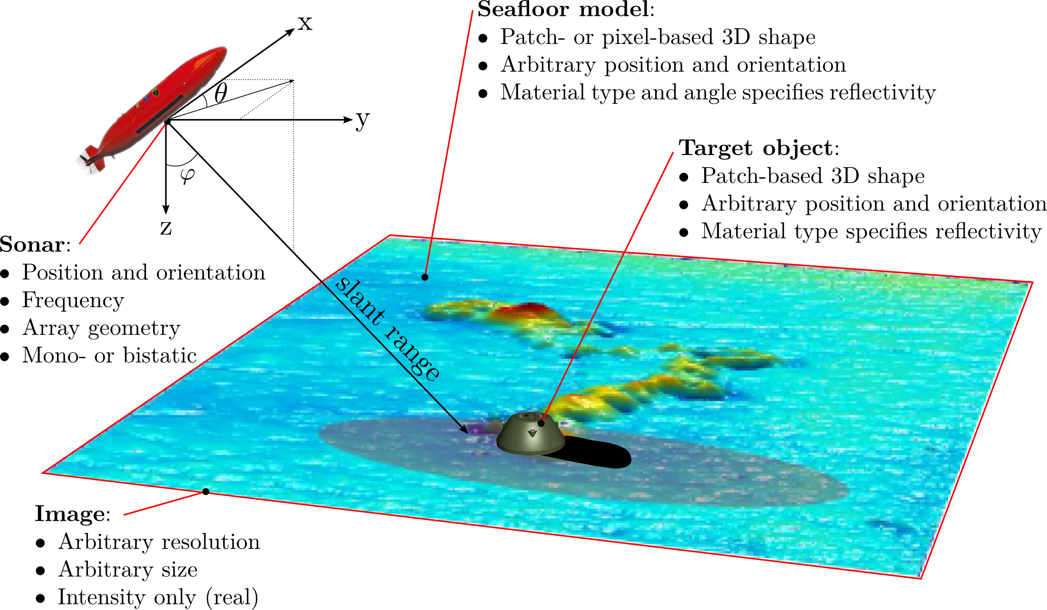

*Fig.1: Sonar simulator features.*

SAS – orthographic rendering

OpenGL scene rendering + depth

OpenCL sonar image construction

1. **RESULTS**



*Fig.2: A synthetic aperture sonar image of a 2 m cylinder buried at 0.1 m depth.*

1. **DISCUSSION**
2. **CONCLUSION**

# GINTRODUCTION

The text of the Paper should be written in English preferably using Microsoft Word. The Paper format should be A4. All margins should be set-up to the value of 2.54 cm. Oral and Poster Papers shall not exceed 6 pages, Invited Papers shall not exceed 8 pages and Plenary Papers shall not exceed 12 pages.

All documents should be written in font Times New Roman. Do not put any headers /footers or type any page numbers on the manuscript. The editor will insert them.

The electronic media version of the proceedings will be in **colour.**

Styles of the following fields are predefined when loading this document from the conference website:

* Paper Title,
* Author,
* Address,
* Contact author’s name
* Abstract,
* Keywords,
* Section heading,
* Subsection heading,
* Body Text,
* Acknowledgement heading,
* Acknowledgement,
* Bibliography heading,
* Bibliography,
* Annexe heading,
* Annexe section heading,
* Annexe subsection heading.

Authors should use these styles that can be easily and automatically selected in the Page set up toolbox. In case of problems, details of font and paragraph parameters are given in the annexe of this document.

Formulas, Figures and tables

Formulas should be clear and legibly written in the same point size as the text, i.e. 12 pt. Indexes’ size can differ but shouldn’t be smaller than 8 pt. Each formula should be placed on a separate line to the left of the page and numbered sequentially. The formula’s number should be enclosed in parentheses and placed to the right of the page. All symbols occurring in the formulae should be explained in the text where they appear for the first time.

|  |  |
| --- | --- |
|  | (1) |

Figures (tables) should be centred and referred to in the text as Fig. N (Table N), where N is a consecutive Arabic number.

The caption of a figure (table) should be preceded with the word ‘Fig. N’ (‘Table N’) and should be positioned centred below the figure and typed in 12 pt Times New Roman, Italics/lowercase. The spacing between the figure (table) and its caption should be 12 pt (1 line). Figures must be legible and understandable in black and white.

**Check lettering carefully for spelling mistakes and consistency with the main text. Wherever feasible, combine analogous graphs into one single figure. Tables shall have a clear structure, with simple column headings giving all units.**

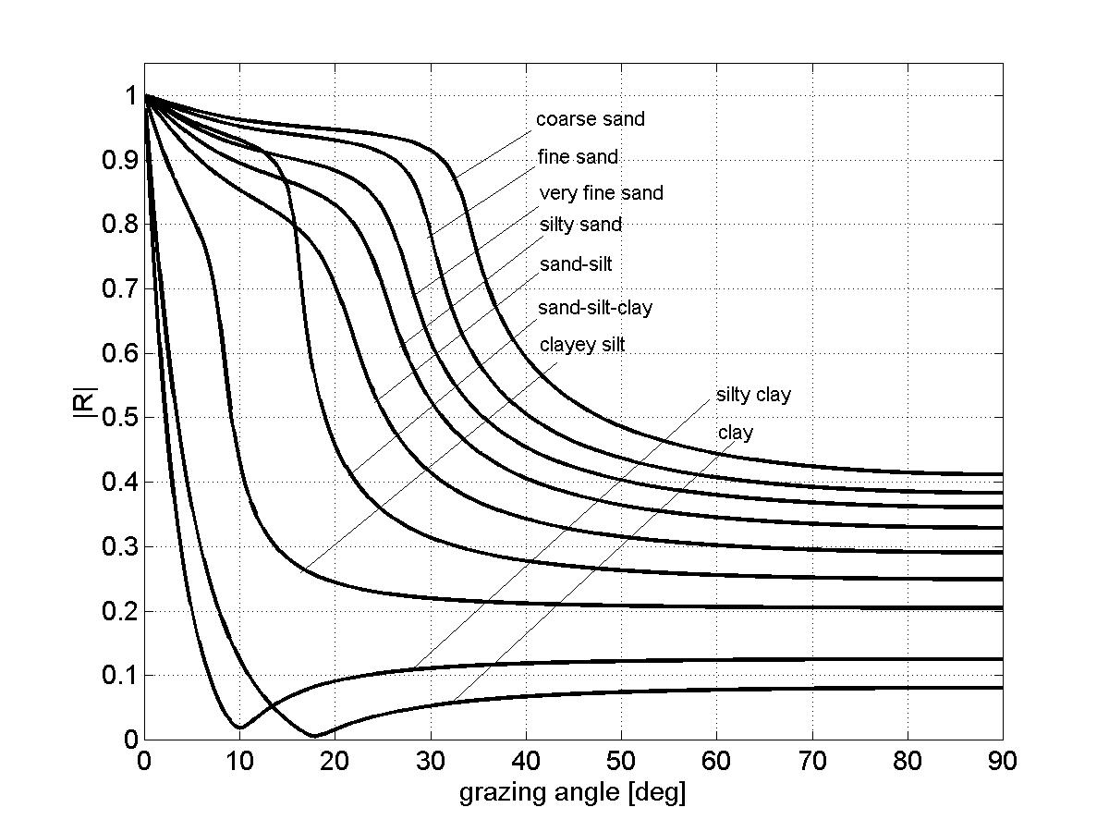

*Fig.1: Reflection coefficient at the water-sediment interface for the sediment types listed in table 1.*

|  |  |  |  |  |  |  |  |
| --- | --- | --- | --- | --- | --- | --- | --- |
| Sediment type | *M*z  (φ) | n | *ρ*2  g/cm3] | *c*2  [m/s] | *α*2 [dB/λ] | *c*s,2  [m/s] | *h*  [cm] |
| Clay | 9 | 0.80 | 1.2 | 1470 | 0.08 | - | 0.5 |
| Silty clay | 8 | 0.75 | 1.3 | 1485 | 0.10 | - | 0.5 |
| Clayey silt | 7 | 0.70 | 1.5 | 1515 | 0.15 | 125 | 0.6 |
| Sand-silt-clay | 6 | 0.65 | 1.6 | 1560 | 0.20 | 290 | 0.6 |
| Sand-silt | 5 | 0.60 | 1.7 | 1605 | 1.00 | 340 | 0.7 |
| Silty sand | 4 | 0.55 | 1.8 | 1650 | 1.10 | 390 | 0.7 |
| Very fine sand | 3 | 0.50 | 1.9 | 1680 | 1.00 | 410 | 1.0 |
| Fine sand | 2 | 0.45 | 1.95 | 1725 | 0.80 | 430 | 1.2 |
| Coarse sand | 1 | 0.40 | 2.0 | 1800 | 0.90 | 470 | 1.8 |

*Table 1: Geo-acoustic parameters of unconsolidated sediments.*

Acknowledgements

Acknowledgement section should be positioned at the end of the manuscript before the bibliography.

referenceS

The references heading should not be numbered and should be named ‘REFERENCES’. Reference to the literature should be done as follows:  [1] numbers in brackets according to the order of appearance in the text.

1. **Authors**, Paper Title, *Name of Journal*, volume (number), pp. pages, year.
2. **Authors**, *Book Title*, Editor, Publisher, pp. pages, year.
3. **Authors**, Paper Title, In *conference name*, address, Proceedings Editor(s), volume, pp. pages, year.

Annexe

1. Fonts
   1. Paper Title

* Times New Roman,
* Caps,
* Bold,
* size – 14 pt,
  1. Abstract, Keywords
* Times New Roman,
* Italics,
* size – 12 pt,
  1. Body Text, Authors, Address, Contact author’s name
* Times New Roman,
* size – 12 pt,
  1. Section, Subsection and subsubsection
* Times New Roman,
* Bold,
* size – 12 pt,

1. Paragraph

* line spacing – single,
* paragraph indentation, first line - 0.5 cm,
* spacing before section, subsection, subsubsection headings - 24 pt (2 lines),
* spacing between section, subsection, subsubsection headings and Body Text - 12 pt (1 line),
* alignment – justified (centred across the full width of the text),
* spacing between top margin and Paper Title – 96 pt (8 lines),
* spacing between Paper Title and Authors – 48 pt (4 lines),
* spacing between Authors and Addresses – 24 pt (2 lines),
* spacing between Addresses and Contact author’s name – 24 pt (2 lines),
* spacing between emails and Abstract – 24 pt (2 lines),
* spacing between Abstract and Keywords – 24 pt (2 lines).