A LOW COMPLEXITY ADAPTIVE BEAMFORMER FOR ACTIVE SONAR IMAGING
J.I.Buskenesª , A.Austengª , C.-I.C.Nilsenª
ªDept. of Informatics, P.Box 1080 Blindern, N-0316 OSLO….
Jo Inge Buskenes
Dept. of Informatics, Univ. of Oslo, P.Box 1080 Blindern, N-0316 OSLO
joibu@ifi.uio.no
Abstract: The angular resolution and contrast in active sonar images depend on the beamformer's ability to receive signals from directions of interest, while suppressing noise and interference emanating from other directions. For sonar arrays, this is achieved by applying weights to the array channels. While classical beamformers use predefined windows, adaptive beamformers estimate the optimal window by analytical evaluation of the data. The minimum variance (MV) beamformer, for instance, calculates the set of weights that minimises the variance of the beamformer's output.
We have implemented a Low Complexity Adaptive (LCA) beamformer, which adaptively selects a window from a predefined set. The set is comprised of windows that are typical solutions found by the Minimum Variance method. The LCA beamformer was tested using simulated and experimental data from the Kongsberg Maritime HISAS 1030 sonar. On a simulated scene with speckle, highlight and shadow, the beamformer offered better lateral edge definition compared to the MV beamformer, and speckle intensity and shape comparable to DAS and MV beamformers. These results were verified by the experimental data.
An attactive trait of the LCA is its low computational complexity; while the MV beamformer is of O(M 3 ), the LCA is of O(M W ). Here M is the number of channels, W the number of windows. Hence the proposed method performs like a MV beamformer or better, but at a fraction of the computational cost..
Keywords: Beamforming, Capon, Minimum variance, Low Complexity, Sonar
- General: page set up
The text of the Paper should be written in English preferably using Microsoft Word. The Paper format should be A4. All margins should be set-up to the value of 2.54 cm. Oral and Poster Papers shall not exceed 6 pages, Invited Papers shall not exceed 8 pages and Plenary Papers shall not exceed 12 pages.
All documents should be written in font Times New Roman. Do not put any headers /footers or type any page numbers on the manuscript. The editor will insert them.

The printed proceedings will be in black and white. The electronic media version of the proceedings will be in colour
Styles of the following fields are predefined when loading this document from the conference website:
- Paper Title,
- Author,
- Address,
- Contact author’s name
- Abstract,
- Keywords,
- Section heading,
- Subsection heading,
- Body Text,
- Acknowledgement heading,
- Acknowledgement,
- Bibliography heading,
- Bibliography,
- Annexe heading,
- Annexe section heading,
- Annexe subsection heading.
Authors should use these styles that can be easily and automatically selected in the Page set up toolbox. In case of problems, details of font and paragraph parameters are given in the annexe of this document.
- Formulas, Figures and tables
Formulas should be clear and legibly written in the same point size as the text, i.e. 12 pt. Indexes’ size can differ but shouldn’t be smaller than 8 pt. Each formula should be placed on a separate line to the left of the page and numbered sequentially. The formula’s number should be enclosed in parentheses and placed to the right of the page. All symbols occurring in the formulae should be explained in the text where they appear for the first time.
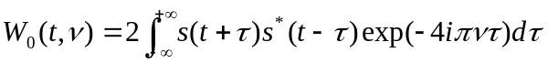 | (1)

Figures (tables) should be centred and referred to in the text as Fig. N (Table N), where N is a consecutive Arabic number.
The caption of a figure (table) should be preceded with the word ‘Fig. N’ (‘Table N’) and should be positioned centred below the figure and typed in 12 pt Times New Roman, Italics/lowercase. The spacing between the figure (table) and its caption should be 12 pt (1 line). Figures must be legible and understandable in black and white.
Check lettering carefully for spelling mistakes and consistency with the main text. Wherever feasible, combine analogous graphs into one single figure. Tables shall have a clear structure, with simple column headings giving all units.

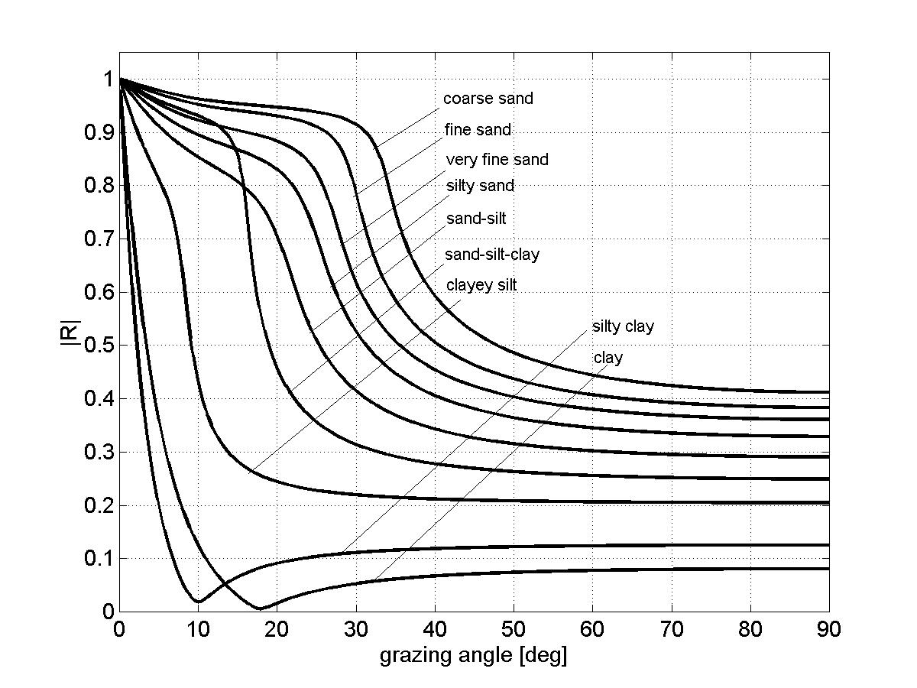
Fig.1: Reflection coefficient at the water-sediment interface for the sediment types listed in table 1.

Sediment type | M_{z}  (φ) | n | ρ₂  g/cm³] | c₂  [m/s] | α₂  [dB/λ] | c_{s,2}  [m/s] | h  [cm]
Clay | 9 | 0.80 | 1.2 | 1470 | 0.08 | - | 0.5
Silty clay | 8 | 0.75 | 1.3 | 1485 | 0.10 | - | 0.5
Clayey silt | 7 | 0.70 | 1.5 | 1515 | 0.15 | 125 | 0.6
Sand-silt-clay | 6 | 0.65 | 1.6 | 1560 | 0.20 | 290 | 0.6
Sand-silt | 5 | 0.60 | 1.7 | 1605 | 1.00 | 340 | 0.7
Silty sand | 4 | 0.55 | 1.8 | 1650 | 1.10 | 390 | 0.7
Very fine sand | 3 | 0.50 | 1.9 | 1680 | 1.00 | 410 | 1.0
Fine sand | 2 | 0.45 | 1.95 | 1725 | 0.80 | 430 | 1.2
Coarse sand | 1 | 0.40 | 2.0 | 1800 | 0.90 | 470 | 1.8

Table 1: Geo-acoustic parameters of unconsolidated sediments.

- Acknowledgements
Acknowledgement section should be positioned at the end of the manuscript before the bibliography.
referenceS
The references heading should not be numbered and should be named ‘REFERENCES’. Reference to the literature should be done as follows: [1] numbers in brackets according to the order of appearance in the text.

- Authors, Paper Title, Name of Journal, volume (number), pp. pages, year.
- Authors, Book Title, Editor, Publisher, pp. pages, year.
- Authors, Paper Title, In conference name, address, Proceedings Editor(s), volume, pp. pages, year.

Annexe
- Fonts
  - Paper Title
- Times New Roman,
- Caps,
- Bold,
- size – 14 pt,
  - Abstract, Keywords
- Times New Roman,
- Italics,
- size – 12 pt,
  - Body Text, Authors, Address, Contact author’s name
- Times New Roman,
- size – 12 pt,
  - Section, Subsection and subsubsection
- Times New Roman,
- Bold,
- size – 12 pt,
- Paragraph
- line spacing – single,
- paragraph indentation, first line - 0.5 cm,
- spacing before section, subsection, subsubsection headings - 24 pt (2 lines),
- spacing between section, subsection, subsubsection headings and Body Text - 12 pt (1 line),
- alignment – justified (centred across the full width of the text),
- spacing between top margin and Paper Title – 96 pt (8 lines),
- spacing between Paper Title and Authors – 48 pt (4 lines),
- spacing between Authors and Addresses – 24 pt (2 lines),
- spacing between Addresses and Contact author’s name – 24 pt (2 lines),
- spacing between emails and Abstract – 24 pt (2 lines),
- spacing between Abstract and Keywords – 24 pt (2 lines).

