Image feature extraction using the LCA beamformer
J. I. Buskenesª, J. P. Åsen^{b}, C.-I. C. Nilsenª, Andreas Austengª
ªDept. of Informatics, University of Oslo, P. Box. 1080 Blindern, N-0316-OSLO
^{b}MI-Lab, Norwegian Institute of Science and Technology, NO-7491 Trondheim
Contact author: Jo Inge Buskenes
Dept. of Informatics, University of Oslo, P.Box 1080 Blindern, N-0316 OSLO joibu@ifi.uio.no FAX???
Abstract: In active sonar imaging systems the choice of sensor weights will greatly influence image quality. The best results are obtained when the weights are allowed to change to accommodate the dynamic nature of the impinging wavefield. The Minimum Variance Distortionless Response (MVDR) beamformer achieves this by computing the set of weights that minimises the effects of noise and interference on the output image.

Another technique, the Low Complexity Adaptive (LCA) beamformer, addresses the task in an ad-hoc manner. Instead of computing the weights based on the current wavefield, it iterates through a list of predefined weight sets, applies each in turn, and finally selects the one yielding the most desirable response in a minimum variance sense. This is done locally for each pixel in the image. With a diverse set of responses to choose from, LCA produces images similar to MVDR, but is much less computationally expensive.

In this work we extend LCA beamformer to not only produce MVDR-like images, but also to enhance other features in the image, such as edges, shadows or highlighted regions. From the statistics found when comparing these images, we are able to make qualified guesses of whether a pixel belongs to a speckle region, the object under study, or something else. This can be achieved with hardly any additional computational cost.
Keywords: Adaptive beamforming, minimum variance, MVDR, LCA, complexity, sonar
- INtroduction

A typical sonar image is reconstructed from an echo recorded by a sensor array. This is achieved though the the use of digital beamforming, a method where delays and weights are applied to each of the sensor channels to focus on a pixel in the image. The full image is formed by repeating this step for each image pixel.
For purposes such as automatic target recognition (ATR), the final image can be processed to emphasize features such as edges, speckle regions, or the object under study. But the final image does not contain all the information present in the raw sensor data, so what if we performed feature extraction at a beamforming level?
In this study we investigate how image features can be extracted using the Low Complexity Adaptive (LCA) beamformer. In its original form the LCA iterates through a predefined set of sensor weight sets, applies each in turn, and computes the beamformer output for each. Usually the weight set leading to the least beamformer output power is selected, which minimizes the influence of interference and noise in the final image. But other weight sets might

- METHODS

Suppose that a backscattered wavefield is recorded by an M element uniform linear array, that a suitable set of delays are applied to the channels for the pixel of interest, and let the delayed output from the m’th channel be given as x_{m} . By definition a beamformer’s output z[n] at time instant n is a weighted sum all the delayed data outputs:
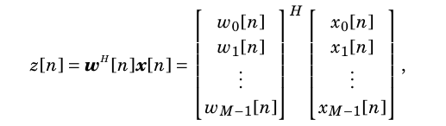
where w_{m} is the weight factor assigned to channel m. With static weights this would be referred to as the conventional delay-and-sum (DAS) beamformer. Various weighting patterns exists here for trading lateral resolution for improved noise suppression (contrast), but one always ends up with a compromise between the two [?]. However, there exists a class of adaptive beamformers that target this limitation by adapting the weights to the impinging wavefield. The MVDR method is one such technique.

The basic idea behind the MVDR method is to compute the set of weights that minimizes the noise and signal power accumulated by the array, but with the constraint of unity gain for signals coming from the pixel of interest. When the data is delayed this can be formulated as follows:
The Low Complexity Adaptive (LCA) beamformer is another take on the optimization
problem in (2). Instead of calculating the weights like in (3), it simply computes the beamformer output for each window in a larger set of windows, and finally applies the one that best fulfils the given optimization criterion. If we let w_{p} be the p’th of a total of P windows, then this can be formulated as [?]:

Note the similarity between (2) and (7). The LCA and MVDR uses essentially the same optimization criterion, but whereas MVDR searches a continuous solution space for the best set of weights to apply, the LCA beamformer only have P solutions to select from. However, we have found that once the LCA has 10-20 well designed windows available the quality of the images it produces quickly approaches that of the MVDR beamformer.
Although LCA promotes good image quality, its two most attractive traits is perhaps its simplicity and low computational complexity. The LCA is essentially a delay-and-sum (DAS) beamformer where the delay step is carried out as usual, but where the weighting and summing is repeated for each of the P windows. In its basic form its computational complexity only of O(M P).

- RESULTS

- DISCUSSION

- CONCLUSION

- Paper Title,
- Author,
- Address,
- Contact author’s name
- Abstract,
- Keywords,
- Section heading,
- Subsection heading,
- Body Text,
- Acknowledgement heading,
- Acknowledgement,
- Bibliography heading,
- Bibliography,
- Annexe heading,
- Annexe section heading,
- Annexe subsection heading.

- Formulas, Figures and tables
Formulas should be clear and legibly written in the same point size as the text, i.e. 12 pt. Indexes’ size can differ but shouldn’t be smaller than 8 pt. Each formula should be placed on a separate line to the left of the page and numbered sequentially. The formula’s number should be enclosed in parentheses and placed to the right of the page. All symbols occurring in the formulae should be explained in the text where they appear for the first time.
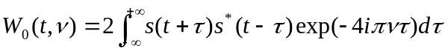 | (1)

Figures (tables) should be centred and referred to in the text as Fig. N (Table N), where N is a consecutive Arabic number.
The caption of a figure (table) should be preceded with the word ‘Fig. N’ (‘Table N’) and should be positioned centred below the figure and typed in 12 pt Times New Roman, Italics/lowercase. The spacing between the figure (table) and its caption should be 12 pt (1 line). Figures must be legible and understandable in black and white.
Check lettering carefully for spelling mistakes and consistency with the main text. Wherever feasible, combine analogous graphs into one single figure. Tables shall have a clear structure, with simple column headings giving all units.

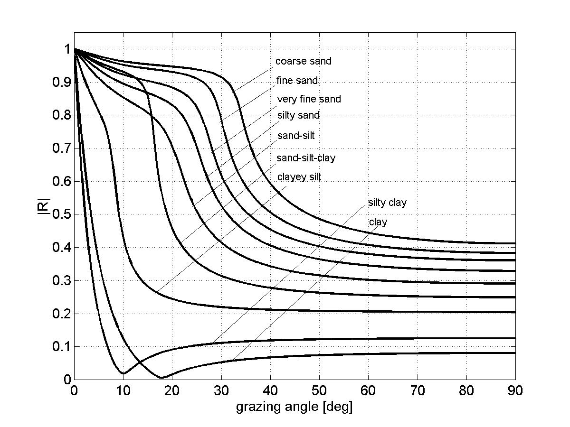
Fig.1: Reflection coefficient at the water-sediment interface for the sediment types listed in table 1.

Sediment type | M_{z}  (φ) | n | ρ₂  g/cm³] | c₂  [m/s] | α₂  [dB/λ] | c_{s,2}  [m/s] | h  [cm]
Clay | 9 | 0.80 | 1.2 | 1470 | 0.08 | - | 0.5
Silty clay | 8 | 0.75 | 1.3 | 1485 | 0.10 | - | 0.5
Clayey silt | 7 | 0.70 | 1.5 | 1515 | 0.15 | 125 | 0.6
Sand-silt-clay | 6 | 0.65 | 1.6 | 1560 | 0.20 | 290 | 0.6
Sand-silt | 5 | 0.60 | 1.7 | 1605 | 1.00 | 340 | 0.7
Silty sand | 4 | 0.55 | 1.8 | 1650 | 1.10 | 390 | 0.7
Very fine sand | 3 | 0.50 | 1.9 | 1680 | 1.00 | 410 | 1.0
Fine sand | 2 | 0.45 | 1.95 | 1725 | 0.80 | 430 | 1.2
Coarse sand | 1 | 0.40 | 2.0 | 1800 | 0.90 | 470 | 1.8

Table 1: Geo-acoustic parameters of unconsolidated sediments.

- Acknowledgements
Acknowledgement section should be positioned at the end of the manuscript before the bibliography.
referenceS
The references heading should not be numbered and should be named ‘REFERENCES’. Reference to the literature should be done as follows: [1] numbers in brackets according to the order of appearance in the text.

- Authors, Paper Title, Name of Journal, volume (number), pp. pages, year.
- Authors, Book Title, Editor, Publisher, pp. pages, year.
- Authors, Paper Title, In conference name, address, Proceedings Editor(s), volume, pp. pages, year.

Annexe
- Fonts
  - Paper Title
- Times New Roman,
- Caps,
- Bold,
- size – 14 pt,
  - Abstract, Keywords
- Times New Roman,
- Italics,
- size – 12 pt,
  - Body Text, Authors, Address, Contact author’s name
- Times New Roman,
- size – 12 pt,
  - Section, Subsection and subsubsection
- Times New Roman,
- Bold,
- size – 12 pt,
- Paragraph
- line spacing – single,
- paragraph indentation, first line - 0.5 cm,
- spacing before section, subsection, subsubsection headings - 24 pt (2 lines),
- spacing between section, subsection, subsubsection headings and Body Text - 12 pt (1 line),
- alignment – justified (centred across the full width of the text),
- spacing between top margin and Paper Title – 96 pt (8 lines),
- spacing between Paper Title and Authors – 48 pt (4 lines),
- spacing between Authors and Addresses – 24 pt (2 lines),
- spacing between Addresses and Contact author’s name – 24 pt (2 lines),
- spacing between emails and Abstract – 24 pt (2 lines),
- spacing between Abstract and Keywords – 24 pt (2 lines).

