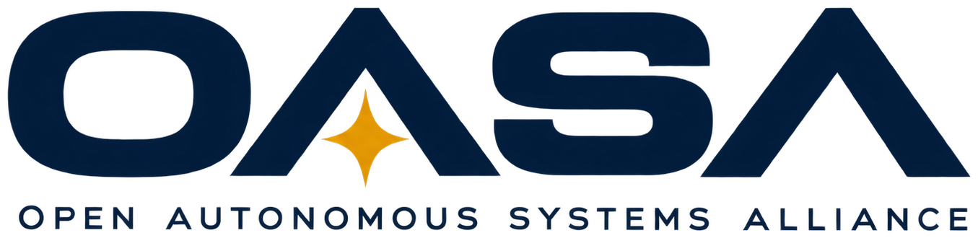 | THE OASA MANIFESTO  Founding edition · 2026

THE OASA MANIFESTO
Welcome to the era of endless frontiers.
Now build it.
A declaration of what the Open Autonomous Systems Alliance believes, who it is for, and what it intends to build.
01
The frontier never closed
In the summer of 1945, as one era ended and another began, a report landed on the President's desk with a title that set the course for a generation: Science, the Endless Frontier. Its argument was simple. The open land was gone, but the frontier wasn't. It had moved into laboratories and workshops, into the questions no one had answered yet. America took that idea seriously, and it changed the world.
We believe that report was right, and that it is right again today.
The next frontier isn't one place. It's the sky above a wildfire and the water below a bridge. It's the floor of a river, the inside of a collapsed tunnel, the far side of a mountain range with no cell signal. It's the top of the atmosphere, and the surfaces of other worlds. These are places people can't easily go, or can't stay, or can't reach in time. Autonomous systems can.
Humanity's greatest achievements are not behind us. They are waiting to be built.
02
An American idea
America was founded on the belief that people can shape their own destiny, that liberty and ingenuity can create opportunities no one has imagined yet, and that each generation owes the next something better than it inherited.
Those ideals are still a work in progress. We believe one of the best ways to carry them forward is through science, engineering, education and discovery.
OASA is proudly American in its foundation and global in its curiosity. We welcome ideas from anywhere, because knowledge has no nationality and a breakthrough can come from anyone willing to chase it. Our job is to turn that knowledge into technology that strengthens our nation, improves human life and widens what tomorrow can hold.
03
The future shouldn't need a permission slip
For too long, building the future has looked like something reserved for a few: astronauts, agencies, large companies, people with the right degree from the right school. Everyone else was invited to watch.
We reject that.
You don't need to be an astronaut. You don't need to work for a space agency, hold a PhD, or have a million-dollar lab. The tools are cheaper than they have ever been. The knowledge is more open than it has ever been.
And artificial intelligence is changing what one determined person can do. Knowledge that once took years to reach can be explored in an afternoon. Software, electronics, mechanical design and research are more approachable than ever. AI doesn't replace judgment, testing or the discipline of engineering. But paired with open tools and a willingness to learn, it puts real invention within reach of far more people.
What's been missing is a place to bring it all together: a place where a good idea finds the people who can build it, and the people who can build it find a mission worth their time. That's what OASA is here to be.
You don't need permission to help build the future.
You just need somewhere to begin.
04
Who belongs here
Picture the people who walk through our door.
A high school student teaching herself electronics at the kitchen table. A veteran who has seen what good technology means in the field, and what bad technology costs. A software developer who wants their code to fly. A mechanical engineer tired of designs that never leave the drawing board. A farmer, a firefighter, a retiree, a tinkerer, someone with nothing but an idea and the stubbornness to learn whatever it takes.
They should all leave with the same feeling: something extraordinary is happening here, and I can be part of it.
We value curiosity, proven ability, dedication and a willingness to learn, not prestige or credentials alone. Some work demands training and experienced supervision, and we'll provide both. If you're still learning, everything we make is published for you to study, build and improve, and our doors will open wider as we grow. If you're ready to build, there's a node on the tech tree waiting for you.
05
What we are
OASA stands where three great traditions meet.
The ambition of NASA  Grand missions. Technical excellence. The belief that the next frontier is worth the effort, and that hard things are worth doing because they are hard. |  | The ingenuity of the maker movement  Open hardware. Shared designs. Garages and makerspaces. The freedom to take someone else's work, make it better, and hand it back. |  | The optimism of science fiction  Intelligent machines helping people explore the oceans, cross distant landscapes, keep communities safe, and carry humanity beyond Earth.

We are not a club that talks about technology. We are not a trade association that writes reports about it. We are an alliance that builds it: real systems, tested in the field, documented so anyone can reproduce them, and connected so they can work together.
06
What we're building
We're not just building drones, robots or autonomous vehicles. We're building the technologies that let humanity explore, understand and work in places it hasn't reached before.
It starts small, on purpose. One drone, one person, one encrypted link, one dot on a shared map. Then two people, then a team, then a fleet. Every rung works on its own and makes the next one possible.
Every project unlocks another, the way a tech tree does. A radio link becomes a mesh. A mesh becomes a regional network. A regional network keeps a town connected when everything else goes down. People grow the same way: learn the fundamentals, build a first system, contribute to a mission, then lead one and mentor the next builder.
Our work points toward two missions. Much of it is still ahead of us, and that's the point.
MISSION ONE · EARTH  Protect and advance life on Earth  We are building toward systems that help communities survive disasters and recover faster. That watch for wildfires before they spread, map flood zones while the water is still rising, and find people who are lost. That inspect the bridges, dams, power lines and water mains Americans depend on every day. That clean our rivers and coastlines, restore reefs and forests, and keep shared places well cared for. That strengthen American engineering and manufacturing, so the systems we rely on are built here, audited openly and trusted by the communities that use them. |  | MISSION TWO · THE STARS  Build our future among the stars  The same autonomy, networks, power systems and robotics that serve a county on Earth are the stepping stones beyond it. High-altitude balloons lead to small satellites. Desert and cave expeditions lead to planetary missions. Robots that can repair each other in a remote field are the first draft of robots that keep an outpost running a world away. We intend to be ready.

Behind both missions stand three pillars.
01  Resilience  Protecting lives, strengthening infrastructure, and preparing for the unexpected. |  | 02  Ingenuity  Advancing American engineering, domestic manufacturing, open standards and the skills to use them. |  | 03  Exploration  Pushing autonomous systems across land, air, sea and space.

07
How we build
Ambition without discipline is just a poster on a wall. So we hold ourselves to a few commitments.
- People come first. Safety comes before speed, before autonomy, before everything. Our systems fail safe, keep the right people in control, and grow more careful as the stakes rise. When a machine isn't sure, it doesn't guess.
- Security is built in. Every link we design is encrypted. Our systems are decentralized, so no single server or company is a point of failure, while the people authorized to run them can always take control or shut them down. We attack our own work before anyone else gets the chance.
- Open by default. Designs, code and documentation are published, with clear exceptions only where privacy, safety, security or the law require them. If someone has already built something great, we join them instead of competing with them. If it doesn't exist yet, we build it, and we write it down so anyone can build it again.
- Built to last. Repairable, documented, affordable, and designed so others can reproduce it and build it at scale.
- One shared picture. Our systems work with the platforms responders already use, so the people who need the information can see it and act on it.
08
The era begins with you
Every great program in history began smaller than it looked in hindsight. A handful of people, a shared conviction, a first test that barely worked. The difference between an idea and an achievement was always the same: someone decided to start.
OASA isn't about waiting for the future to arrive. It's about building it, testing it, sharing it, and exploring what comes next.

We are the dreamers who dare to imagine it,
the engineers who dare to attempt it,
and the builders who will make it real.
We are the explorers of tomorrow, today.
AMERICAN INGENUITY. HUMAN PERSEVERANCE. ENDLESS FRONTIERS.
Welcome to the era of endless frontiers. Now build it.
JOIN THE ALLIANCE → joinoasa.org/join


OPEN AUTONOMOUS SYSTEMS ALLIANCE
joinoasa.org

