Micro Hardness Testing

I. Introduction

+ Objective :
- Using the micro hardness tester machine
- Determining the hardness of material

+ Definition :
Micro Hardness Testing is a measure of how resistance solid matter is to various kinds of permanent shape change when a force is applied.

II. Experiment

+ Apparatus :
- Micro hardness tester (SHIMADZU MICRO HARDNESS TESTERS)
- Specimen: - Stainless steel
- Titanium
- Aluminum
- Carbon steel

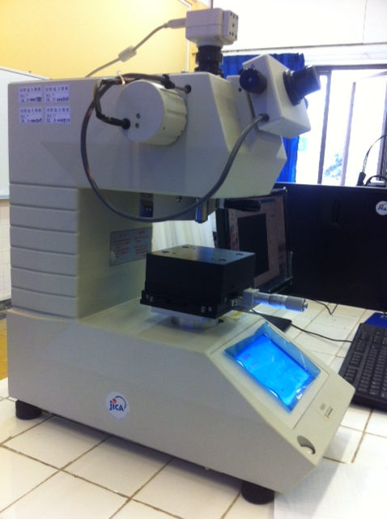
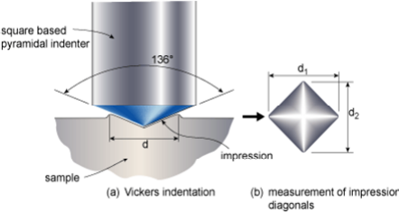

Hardness tester Vickers hadness

+ Procedure :
- It is important that the polished specimens are also etched (lightly) to reveal the microstructural features.
- Measure the hardness at least in six different locations along longitudinal line or transversal line with indented space 1mm.
- There is scope for personal error in measuring the diagonal lengths in the Vickers hardness testing. Take a few measurements on the same indentation to get an accurate value of the length of the diagonal.
- It makes sure that the appropriate phase is chosen under the microscope and that the indentation is made in that area.

III. Result

Material | Diagonal  Length I ($μm)$ | Diagonal  Length II ($μm)$ | Average Diagonal  Length ($μm)$ | Hardness  Number
Stainless steel  Titanium  Aluminum alloy  Carbon steel | 38.22  43.41  51.02  43.79 | 38.38  43.54  49.26  42.07 | 38.30  43.48  50.16  42.93 | 253  196  147  201

IV. Conclusion

After completely experimental we can conclude that the specimens which have more hardness testing is stainless steel. Because , when the force applied we saw the diagonal length smaller than the other materials.

V. Answer

1. What is hardness?
Answer: Hardness is a measure of how resistant solid matter is to various kinds of permanent shape change when a force applied.

2. What are the different ways in which hardness can be measured ?
Answer: There is scratch hardness , indentation hardness , and rebound hardness.

3. Name the different methods in which indentation hardness can be measured?
Answer: There are - Brinell hardness testing
- Rockwell hardness testing
- Vickers hardness testing

4. What is the different between macrohardness and microhardness ?
Answer: - Macrohardness is applied to tests with a larger test load.
- Microhardness is applied to tests with low test load.

5. What is the relationship between hardness and strength of material?
Answer: - Hardness study about measurement of material is to various kinds and shape changed.
- Strength of material study about behavior of solid subject to stress and strain.

6. How is the hardness of a material determined by hardness testing machine?
Answer: The most common way of measuring the hardness of material in a quantitative way is by indentation testing. In these case , an indenter is pressed at right angles into the surface of a material to be tested. The forcing of the indenter is done under controlling condition of load and rate of application.

7.
8. Compare hardness values

- By formula

HV = 0.1981 $× \frac{F}{d^{2}}$

- Stainless steel :
HV = 0.1981 $× \frac{1.961}{{(38.30×{10}^{-3})}^{2}}$

= 265

- Titanium :
HV = 0.1981 $× \frac{1.961}{(43.48×{{10}^{-3})}^{2}}$

= 205

- Aluminum alloys :
HV = 0.1981 $× \frac{1.961}{(50.16×{{10}^{-3})}^{2}}$

= 154

- Carbone steel :
HV = 0.1981 $× \frac{1.916}{(42.93×{{10}^{-3})}^{2}}$

= 206

- By machine

- Stainless steel : HV = 253

- Titanium : HV = 196

- Aluminum alloys : HV = 147

- Carbone steel : HV = 201

Compare : After determine the result we saw that hardness value by using the formula is almost equal to hardness value by using machine.

