Matnao, Joyce Anne B.

BSCpE 3A

**UNIVERSITY COURSE MANAGEMENT SYSTEM**

1. Made folder in the File Manager.
2. Created a repository in Git GUI.
3. Initialized it.
4. Logged in with my name and email.
5. Added my repository in GitHub as my origin.
6. Made branch “main.”
7. Made folders and .gitignore & README files.
8. Pushed it to the main branch.
9. 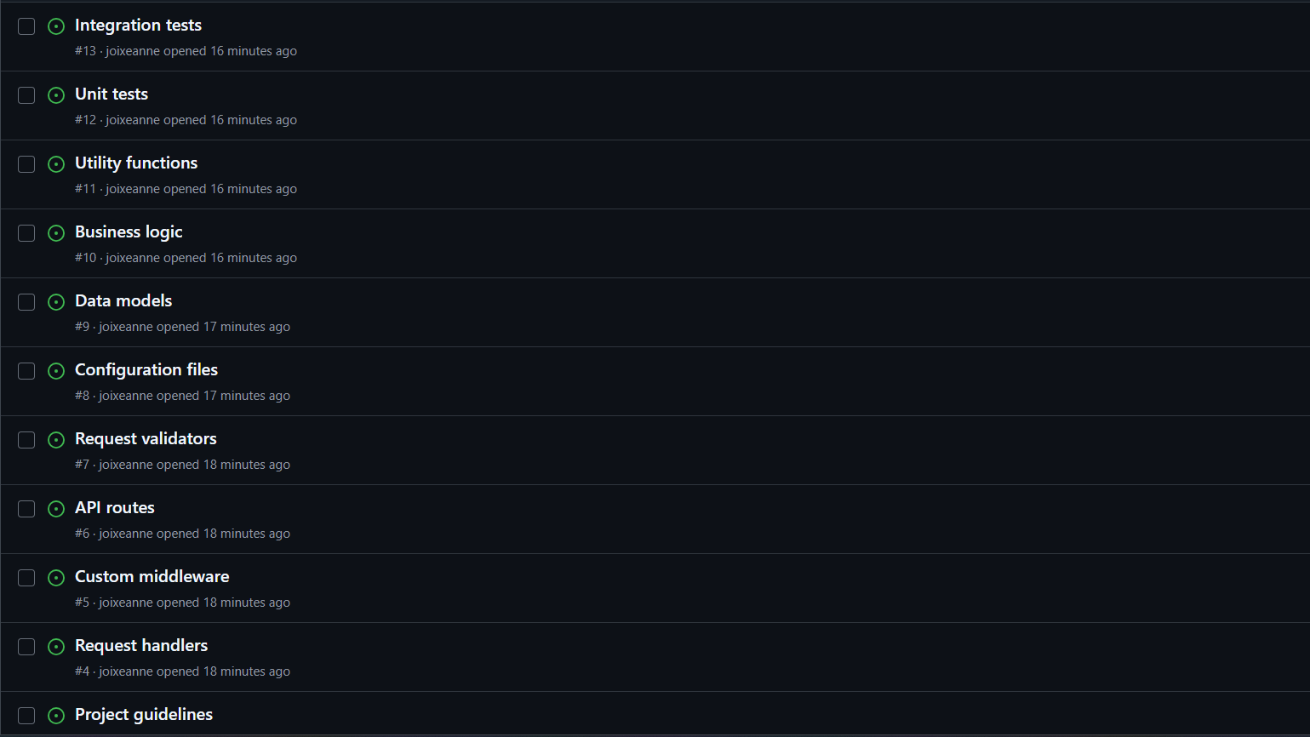Made issues in GitHub.
10. Created new branch “Project Requirements.”
11. Made folders inside the docs and created files in each folders.
12. 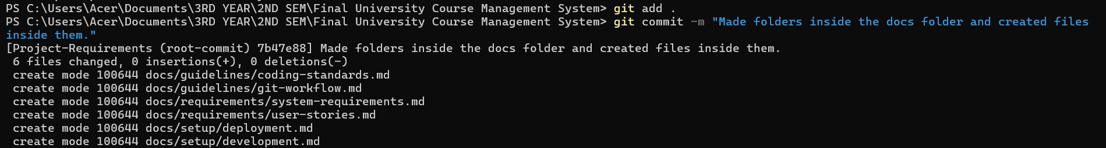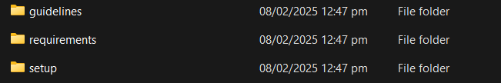Added, pushed.
13. Switched to the main branch and merged the Project-Requirements branch.
14. 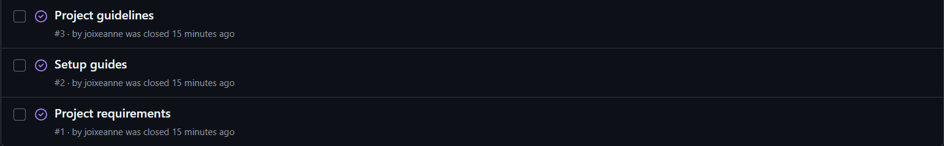Marked issues as completed.
15. Made new branch “api.”
16. Created subfolders in the src folder and files inside the folders.
17. Added, pushed.
18. 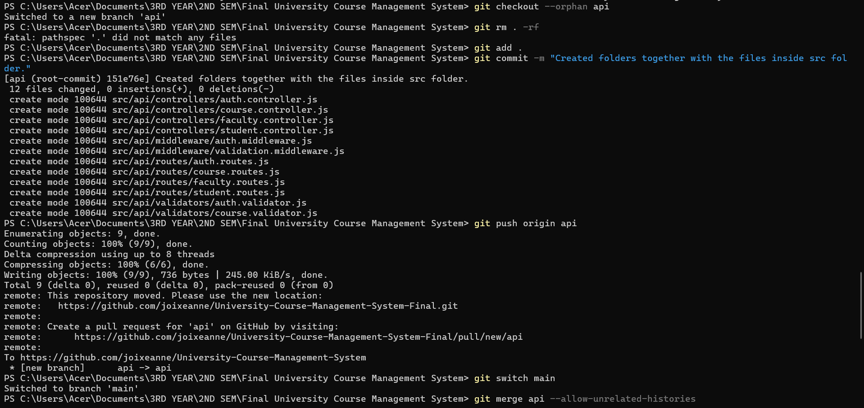Switched to the main branch and merged the api branch.
19. 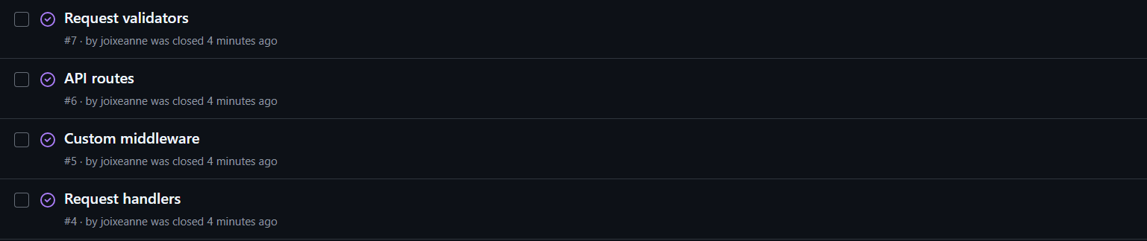Marked issues as completed.
20. Made new branch “config-files.”
21. Created files under config.
22. Added, pushed.
23. 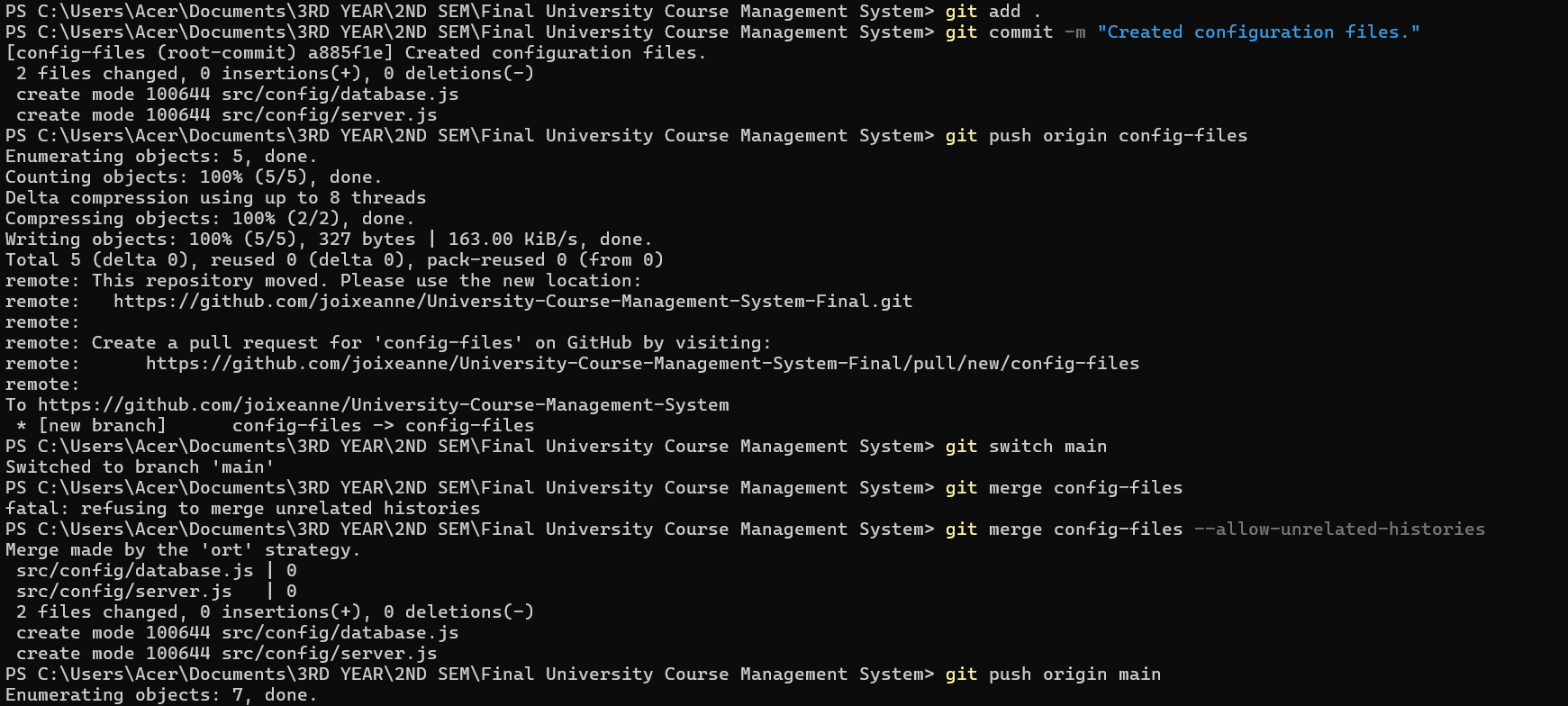Switched to the main branch and merged config-files.
24. Marked issue as completed.
25. Made new branch “data-models.”
26. Created files under models.
27. Added, pushed.
28. Switched to the main branch and merged data-models.
29. 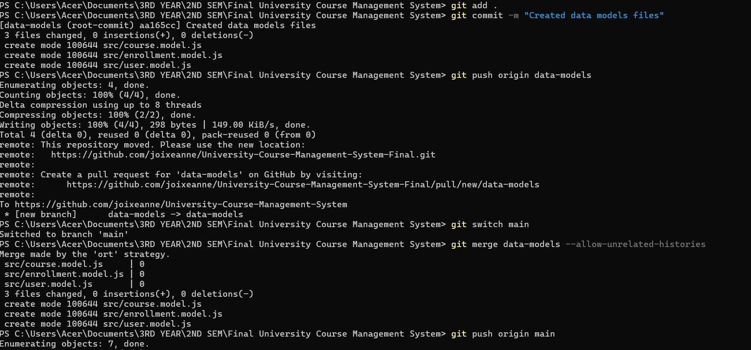Marked issue as completed.
30. Created new branch “business-logic” in GitHub.
31. 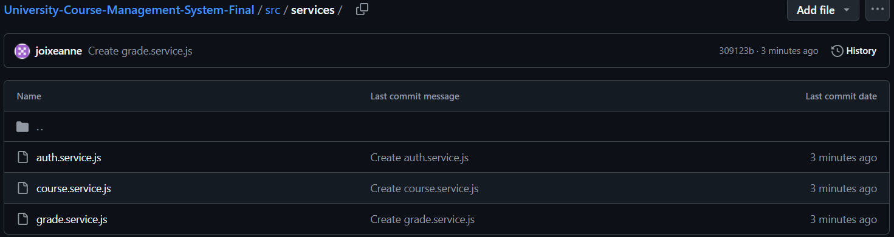Created files.
32. Made pull request.
33. 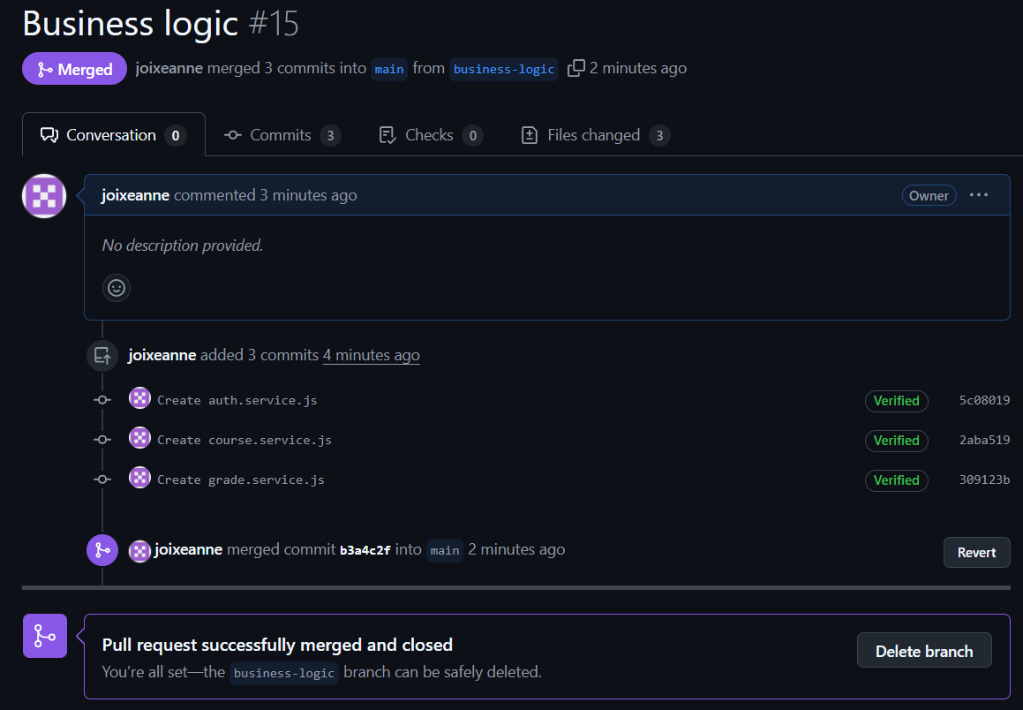Merged the pull request to the main branch.
34. Made new branch “utility-functions.”
35. Created files.
36. Made pull request.
37. 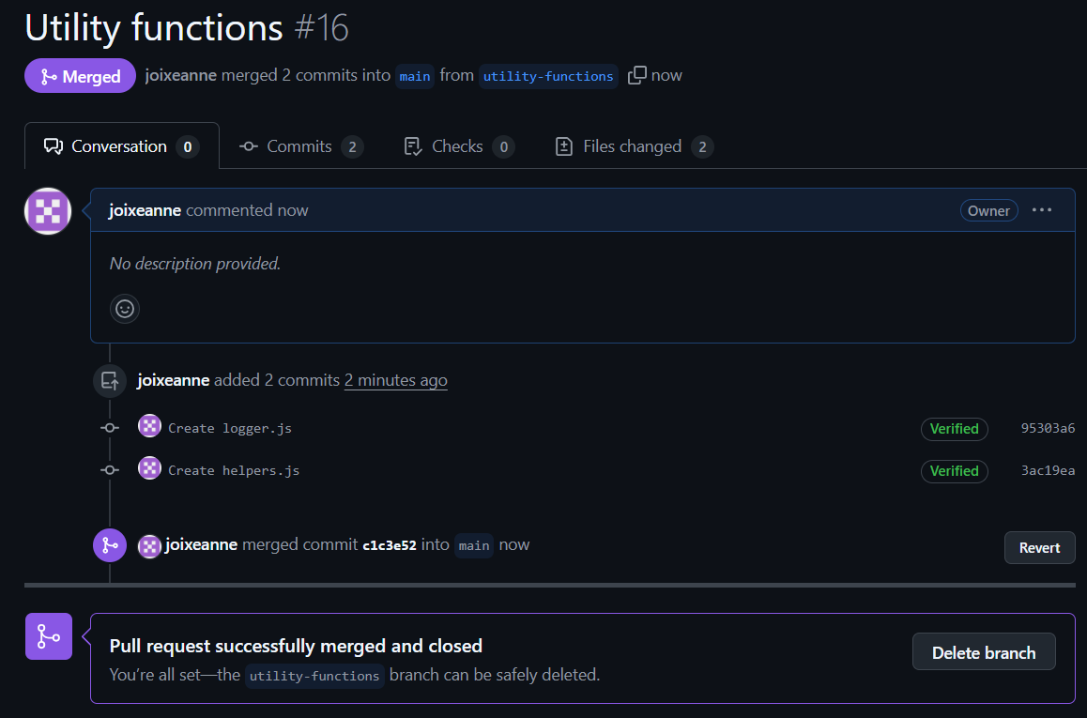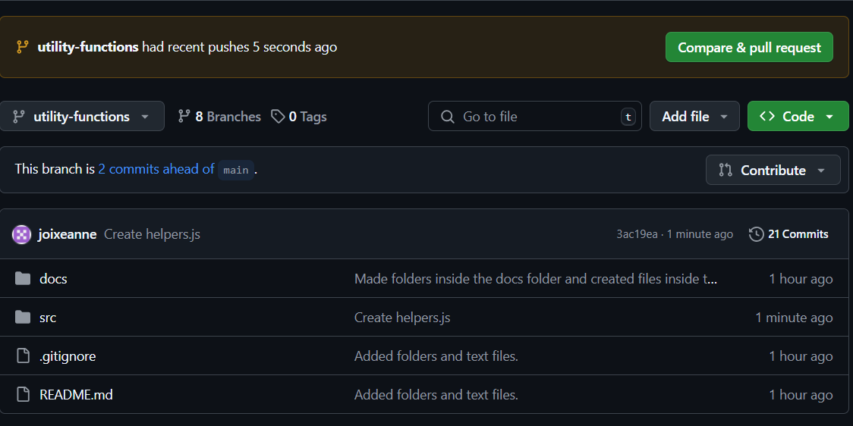Merged the changes into the main branch.
38. Made new branch “test-files.”
39. Uploaded the folder “tests” in GitHub.
40. Created a folder for “units.”
41. Made pull request.
42. Compared and merged the changes.

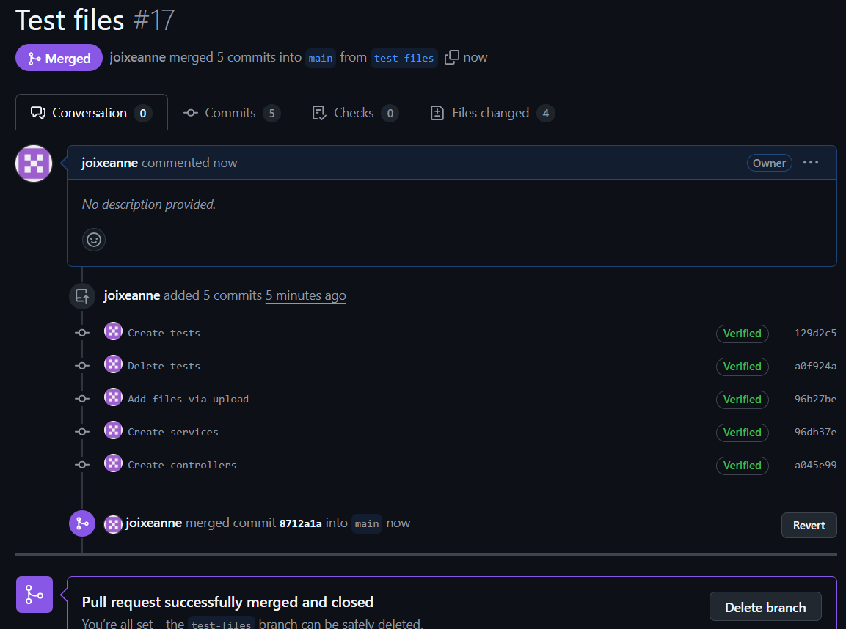

1. Updated README.md
2. **ALL DONEEE!**