Application of Maturity Offset Prediction Equation
Worked Example & Anthropometric Protocols

Predicting age of peak height velocity web calculator (http://taurus.usask.ca/growthutility/phv_ui.cfm?type=1)

Males:

Equation:

Maturity Offset = -9.236 + (0.0002708 * Leg Length *Sitting Height) +
(-0.001663 * Age * Leg Length) + (0.007216 * Age*Sitting Height ) + (0.02292 * Weight by Height Ratio)

Example Male:
Age 12.084 y
Height 157.0 cm
Weight 53.0 kg
Leg Length 77.4 cm
Sitting Height 79.6 cm

Leg Length & Sitting Height interaction 77.4 * 79.6 = 6161.04
Age & Leg Length interaction 12.084 * 77.4 = 935.3016
Age & Sitting Height interaction 12.084 * 79.6 = 961.8864
Weight by Height Ratio (53.0/157.0) * 100 = 33.75796

Maturity Offset = -9.3236 + (0.0002708 * 6161.04) + (-0.001663 * 935.3016) + (0.007216 * 961.8864) + (0.02292 * 33.75796)

Maturity Offset = -9.3236 + 1.6684 – 1.5554 + 6.9410 + 0.7737

= - 1.496 y
By calculating the maturity offset as -1.496 y prior to Peak Height Velocity(PHV), we are estimating the Age of PHV for this individual to be 12.084 + 1.496 or 13.580 y.

Note:
Weight by Height ratio may be calculated as illustrated above or it can be calculated as Weight in kg divided by Height in m (53.0 / 1.57).
In the female specific equation, one additional term is included; Age * Weight interaction (12.084 * 53.0)

Girls Equation:

-9.376+0.0001882* Leg Length *Sitting Height)) + 0.0022* Age * Leg Length + 0.005841*Age*Sitting Height - 0.002658*age*weight + 0.07693*(Weight by Height Ratio)
Anthropometric Measurements Protocol:

Need to record the following: Decimal Age (years), body mass (kg), standing height (cm) and sitting height (cm)

- A. Decimal Age – calculate by subtracting date of birth from date of measurement.
- 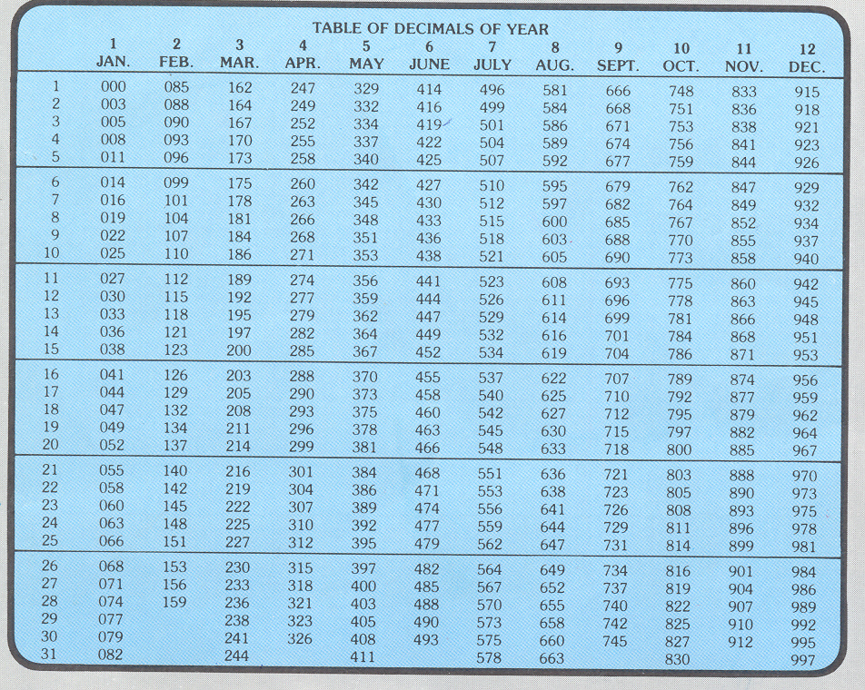
- To calculate a decimal age use the above table
- For example,
- 1. if a child is born on Jan 17th 1995 this would be 1995.044
- 2. If they are measured on Aprit 7th 2005 this would be 2005.263
- 3. There decimal age would be equal to 2005.263-1995.004 = 10.219.

B. Body Mass – Weigh subject with minimal clothing and with shoes removed.

- Check the scale is reading zero
- Ask subject to stand on the centre of scales, without support and with their weight distributed evenly on both feet – record body mass to nearest 0.1 kg.
- Ask subject to step off the scale
- Repeat steps 1 to 3
- If the 2 measurements differ by more than 0.4 kg then repeat steps 1 to 3
- If two measurement record the average value. If three measurements record the median value.

C. Standing Height – Use the stretch stature method. Stature is the maximum distance from the floor to the vertex of the head (Figure 1). The vertex is defined as the highest point on the skull when the head is held in the Frankfort plane (Figure 2). This position is when the imaginary line joining the orbitale to the tragion is perpendicular or at a right angle to the long axis of the body as shown in Figure 2. Subject is measured with shoes removed.

- Ask subject to stand with back, buttocks and heels against a stadiometer. Subject’s feet should be together and flat on the floor.
- Place subject’s head in the Frankfort plane (Figures 1 & 2). Place your hands far enough along the line of the subjects jaw to ensure that upward pressure is transferred through the mastoid processes. 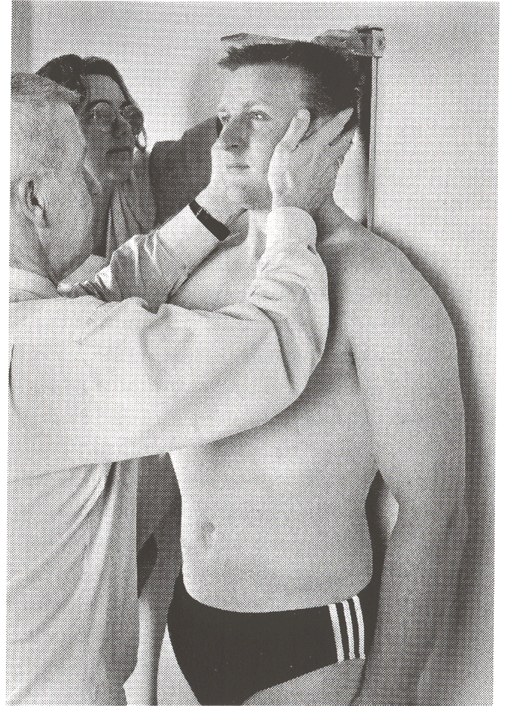 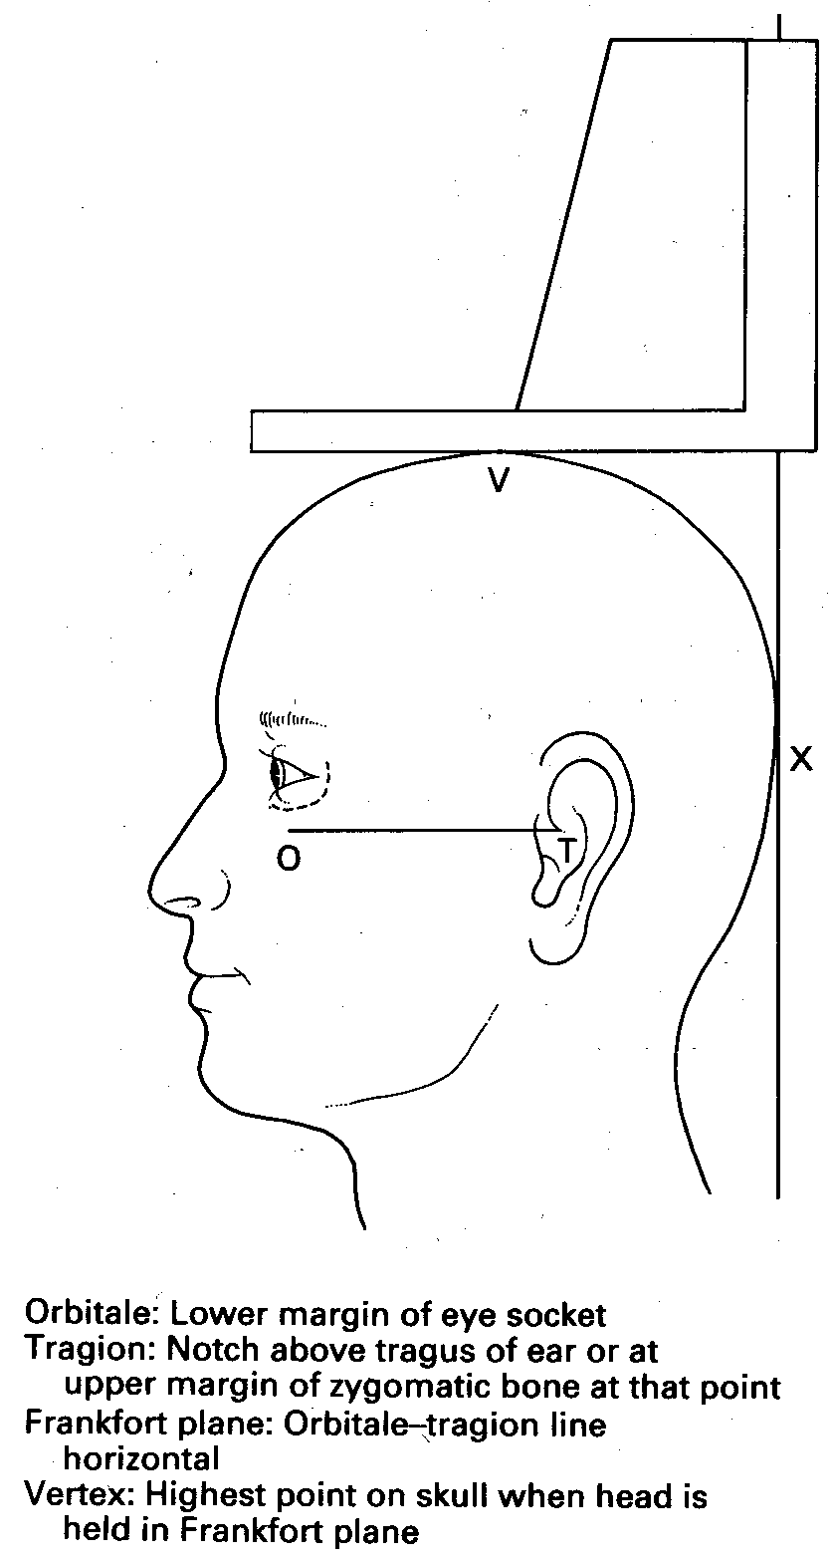
Figure 1: Measuring stretch stature Figure 2: Position of the head in Frankfort plane

- Instruct subject to take and hold a deep breath. While keeping the head in the Frankfort plane apply gentle upward lift through the mastoid processes. At the same time place the headboard firmly down on the vertex, crushing the hair as much as possible. Ensure that the feet do not come off the ground and that the position of the head is maintained in the Frankfort plane.
- Record measurement at the end of the subject’s deep inward breath – record stature to the nearest 0.1 cm.
- Ask subject to step away from the stadiometer
- Repeat steps 1 to 4
- If the 2 measurements differ by more than 0.4 cm then repeat steps 1 to 4
- If two measurement record the average value. If three measurements record the median value.

D. Sitting height – Use the stretch stature method. Sitting height is the maximum distance from the vertex to the base of the sitting surface (Figure 3).
- Seat subject on a measuring box or level platform (of known height) with their hands resting on their thighs
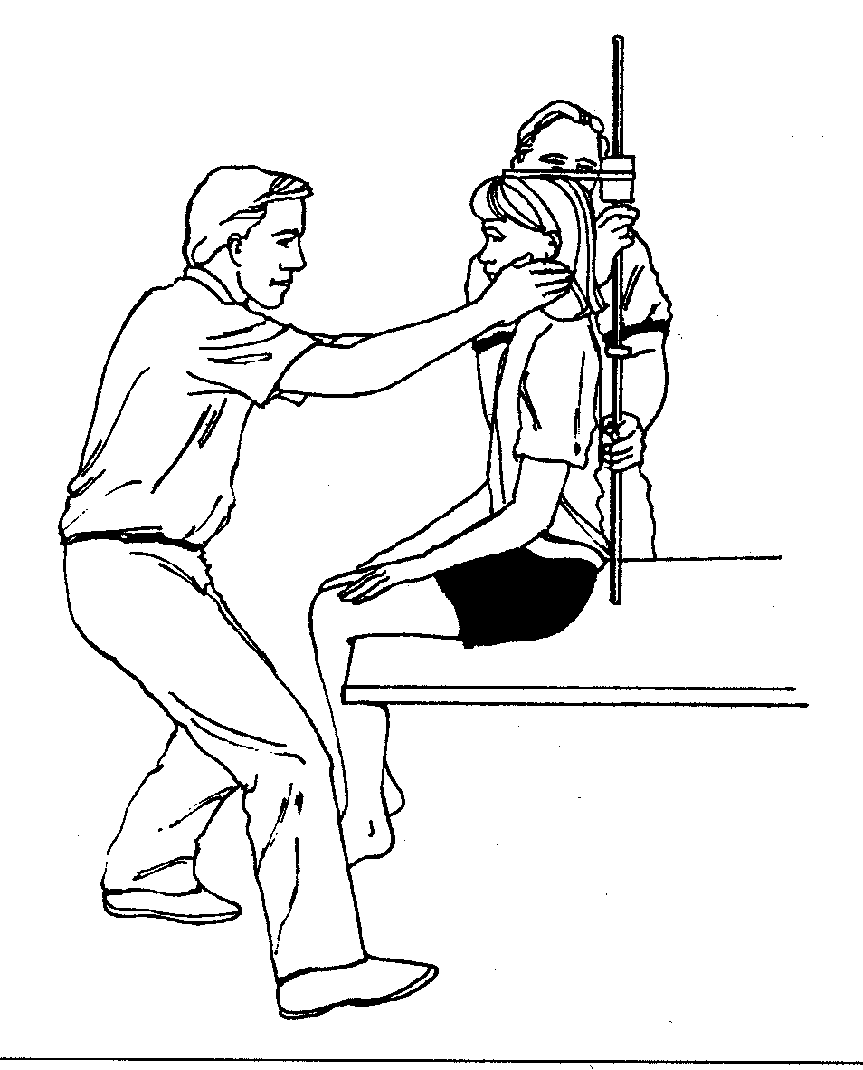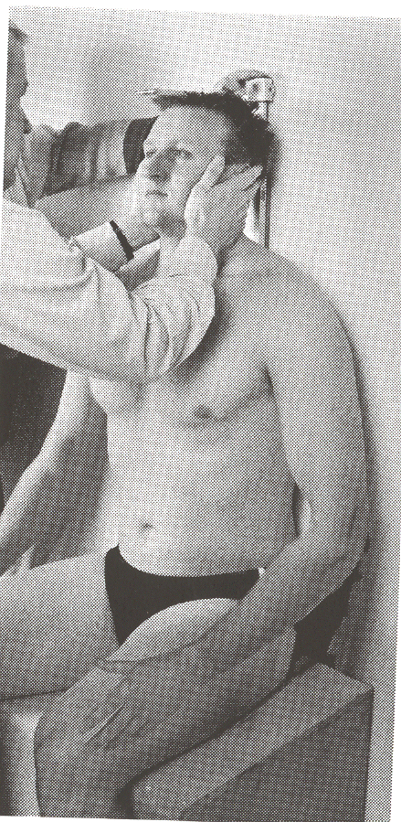
Figure 3: Measurement of sitting height
- Instruct subject to take and hold a deep breath. While keeping the head in the Frankfort plane (Figure 2) apply gentle upward lift through the mastoid processes. At the same time place the headboard firmly down on the vertex, crushing the hair as much as possible. Ensure the subject does not contract the gluteal muscles nor push with the legs.
- Record measurement at the end of the subject’s deep inward breath – record sitting stature to the nearest 0.1 cm.
- Ask subject to step off the box and away from the stadiometer
- Repeat steps 1 to 4
- If the 2 measurements differ by more than 0.4 cm then repeat steps 1 to 4
- If two measurement record the average value. If three measurements record the median value.
- If using a floor stadiometer the observed height minus the box / platform height is the sitting height.

E. Leg Length = Standing Height (cm) - Sitting height (cm)

