WHITESPACE: WEB BASED SQL LEARNING HUB WITH SQL DIAGRAM CONVERTER

CRUZ, AIMEE LOU D.

DE VERA, JAZELENE MAE M.

GEORGE, DONALD PATRICK C.

A Thesis Proposal Presented to the

Faculty of the College of Science

Technological University of the Philippines

Manila

In Partial Fulfillment of the

Requirements for the Degree

Bachelor of Science in Information Technology

September 2017

**TABLE OF CONTENTS**

|  |  |
| --- | --- |
|  | **Page No.** |
| Title Page  Table of Contents  List of Tables  List of Figures  List of Appendixes | 1  2  4  5  6 |
| **Chapter 1 THE PROBLEM AND ITS SETTING**  Introduction  Background of the Study  Objectives of the Study  Scope and Limitations of the Study | 7  8  11  12 |
| **Chapter 2 CONCEPTUAL FRAMEWORK**  Review of Related Literature  Related Studies  Conceptual Model of the Study  Operational Definition of Terms | 14  21  22  24 |
| **Chapter 3 METHODOLOGY**  Project Design  Project Development  Operation and Testing Procedure  Evaluation Procedure | 25  38  39  43 |
| **REFERENCES** | 46 |
| **APPENDIXES** | 51 |
| **CURRICULUM VITAE** | 52 |

**LIST OF TABLES**

|  |  |  |
| --- | --- | --- |
| **Table** |  | **Page** |
| 1  2  3  4  5  6  7  8  9  10  11  12  13  14  15  16 | Use Case Scenario for Create Class  Use Case Scenario for Student’s Progress Monitoring for Professor  Use Case Scenario for Uploading of lesson  Use Case Scenario for SQL Create Quiz  Use Case Scenario for SQL Schedule Quiz for Professor  Use Case Scenario for Join Class for Student  Use Case Scenario for Student’s Progress Monitoring for Student  Use Case Scenario for Interactive SQL Query Lessons  Use Case Scenario for SQL Query Simulator  Use Case Scenario for SQL Diagram Converter  Use Case Scenario for Downloading of lesson  Use Case Scenario for Taking Quizzes for Students  Testing Procedure for Functionality for Professor  Testing Procedure for Functionality for Student  Numerical Rating Scale  Four-Point Likert Scale | 26  26  27  28  28  29  29  30  30  31  31  32  41  42  44  45 |

**LIST OF FIGURES**

|  |  |  |
| --- | --- | --- |
| **Figure** |  | **Page** |
| 1  2  3  4  5  6  7 | Conceptual Model  Use Case Diagram  Flowchart of Login Page  Flowchart of Register Page  Flowchart of Professor Page  Flowchart of Student Page  Entity Relationship Diagram | 23  25  33  34  35  36  37 |

**LIST OF APPENDIXES**

|  |  |  |
| --- | --- | --- |
| **Figure** |  | **Page** |
| 1 | Evaluation Instrument | 51 |

# **Chapter 1**

# **THE PROBLEM AND SETTING**

## Introduction

Data, in the modern world, is one of the most essential things in how everything works nowadays. It is in our government, our jobs, our bank and our accounts in them, and many more. We could even see it in our computers and smartphones without even noticing, as we view websites on desktops or use applications on our phone, raw data that is being collected and stored in a database is being transformed into readable information so that we, the average user or professionals, can use that information in our everyday decisions. Handling these databases and keeping it organized as much as possible can be done in many ways, but the most popular among developers and programmers is SQL.

Structured Query Language, according to JetBrains (2016), is one of the most widely used programming languages in the world specifically to manage or manipulate data in databases. Many tech giants like Google, Facebook, Twitter, and even small companies all over use this. It would be very useful to have the knowledge of the ins and outs of the language, but to be able to use the language, we need an RDBMS.

A Relational Database Management System is like the framework of SQL, there are many RDBMS to choose from, some are freeware, like the most popular among developers according to JetBrains (2016) is MySQL or open-source ones like PostgreSQL, while others are proprietary, like Oracle Database and Microsoft SQL Server, and many more. Just like every framework from other languages, it has its own set of unique features that sets them apart from each other, and sometimes this makes it learning SQL a lot harder because you have to take into account that not every command or syntax in each of them is the same as others. This is where e-learning comes in.

E-learning is the use of multimedia tools in order to help with education. With more and more people using the internet, learning about these topics can be much easier to take up in the user’s spare time. Various exercises can help in getting the user’s attention and not make it seem boring to be self-taught. Ranking in these exercises can also help motivate the user to do better in learning. Using e-learning nowadays can also help with cost and time, without having to spend money on textbooks or any other reading materials and if money is scarce, a student will not need to go to a library or borrow from friends or professors, it can be accessed using the web.

**Background of the Study**

Database is one of the most important aspects in programming which supports the back-end of a system. Structured Query Language or SQL is a vital component of a database. Database and its servers has different specifications which causes difficulty in installation of database servers along with its compatibility in servers and devices. Standard conversion of physical to logical design or vice versa is another dilemma which risks the relationship of entities. Mostly, SQL learners are students who is currently taking database-related course hence unaffordable learning materials is a difficulty as well.

These problems arise due to variation of database servers based on device specifications that results inconvenient assembling database servers and devices. Standard conversion of physical to logical or vice versa is another discernment by cause of entity relationships, data integrity and constraints are in risks. Few open source SQL learning materials with immediate results.

In the past years, database-related subjects in College of Science required installing a server or tool in order to create an activity or exercise, moreover, the correct versions of installers and a compatible device is needed for it to function properly. Database exercises or activities done by the students which will be passed to professors were transferred by means of flash drive for evaluation. Everyone cannot assure that the flash drives, computer lab's PC of files do not contain malicious software so the recipient unit could be in harm. Entity relationship diagrams and/or schema were done manually risking data constraints and integrity.

With the existing situation, our team came up to create a system that lets the user to learn lessons in an effective manner, to practice their skills through exercise along with the lessons and to sum up the knowledge gained by activities. This will also help the professors to evaluate the class standings since the system will be designed to allow them to see the points earned of the student.

The findings of this study will be deflected as for the advancement of learning approach of the students and teaching method by the instructors considering Structured Query Language or SQL depicts a vital role in programming, storing and maintaining data. As the computers and technology continuously rising, academe could adapt this learning method in order to avoid the dilemmas in installing the database servers along with its compatibility. Conversion of physical to logical design or vice versa are a risk in data constraints and integrity so with this feature, diagrams are assured to be accurate. Nurturing one’s knowledge requires more learning materials which are effective but some of these is expensive and not everyone can afford it.

    Implementing this system to the College of Science will help the COSians and SQL learners who is in line with database-related courses for advancing their database knowledge. It will help the students have more interest in learning SQL, by giving them lessons and activities that is visually eye catching. This will also assist professors in giving out activities or exercises to their students and also to keep track of the student’s performance with the use of the ranking system. This can also be easily accessed using the college’s computers.

    With this proposed project, students of College of Science will now have an entertaining and interesting training environment. Installation of database servers in students’ devices concerning in creating activities, will be convenient now without having difficulties in compatibility and specifications. Converting physical to logical design or vice versa will be more accurate and accessible considering its data integrity and constraints. Visual aid using multimedia aims to catch the attention of the student, this can be helpful especially if a student finds it difficult to learn the lessons on their own. Another benefit into having this system is to not have to spend money on reading and learning materials about SQL, sometimes these can be expensive so this will eliminate the cost to both the professors and to the students as well.

**Objectives of the Study**

The general objective of the study is to develop a SQL learning, Whitespace: Web Based MySQL and MSSQL Interactive Learning System that will serve as a learning tool for students to have an interactive approach in SQL learning along with its exercises and quizzes as well as for instructors that aids in advancement SQL teaching technique.

Specifically, the study aims to:

1. Design the system with the following features:
   1. Interactive SQL Query Lessons, which presents SQL lessons that students can interact with.
   2. SQL Query Simulator, where the students can execute SQL queries.
   3. SQL Query History Module, which allows to record and retrieve previous queries created by students.
   4. SQL Diagram Designer, which allows the student to export database schema.
   5. SQL Quiz Generator, which allows the teacher to manage quizzes that can be taken by students.
   6. Student’s Progress Monitoring Module, which the teacher can track all students’ performance on SQL topics wherein students can monitor their own development.
   7. Uploading and Downloading of Lessons, where the teacher can upload lessons which can be downloaded by students.
2. Create the system using Atom text editor using the Laravel framework for the PHP coding, Bootstrap, CSS, Adobe Photoshop, Illustrator and Edge Animate for Multimedia features, MySQL for main system, XAMPP as third-party database server and knowledge in network connections.
3. Test and improve the system in terms of system functionality and reliability. Determine the level of acceptability of the developed system using ISO 25010 evaluation instrument.

**Scope and Limitations of the Study**

    The project study focuses on the design, creation, testing, and improvement, and evaluation of the web-based learning system called WhiteSpace, an interactive MySQL and MSSQL learning system.

    This system is composed of seven modules to wit, interactive SQL classroom, interactive SQL query lessons, SQL Query Simulator, SQL Quiz Generator, student’s progress monitoring module, uploading and downloading of lessons and SQL diagram converter. Each of it plays a crucial part in the development of WhiteSpace, to deliver an exquisite yet informative software.

    To begin with, interactive SQL classroom, this allows the professor to create a class and specify slots to be occupied by the students. In this action, this will result to a class id where the students will join the class by using this id.

The interactive SQL query lessons, this module contains lesson and exercises that comes along with a simulator where they can execute MySQL queries in line with the lesson and exercise they are taking. With this, the student can easily practice what he/she had learnt. Lessons only cover MySQL syntax. For this simulator, there will be two databases ready for them to have their practice. Students are not allowed to make permanent changes to this database.

    The SQL query simulator can detect the error in the syntax inputted and highlights the mistake. The professor is allowed to create a database accessible by the students. The students may view the archived query used. In Data Definition Language (DDL) and Data Manipulation Language (DML) have limitations in simulating query. Data Definition Language (DDL) cannot create and drop index while in Data Manipulation Language (DML) has no SQL injection, triggers, and stored procedure.

    For the SQL quiz generator, this can only generate a multiple choice type of quiz. The professor can create a multiple choice quiz that has a right answer so that right after the student takes the quiz, the result will show instantly. The questions will randomly change for each student, in line with the created quiz of professor.

    As for the student’s progress monitoring module, the professor can view all of his/her students’ progress. Where the students’ id, name and ranks are displayed, it can be sort by course and ranks, it also has a feature of searching a string. As for the students, they can view their ranking in the class on their own dashboard.

    The uploading and downloading of lessons module, professors can upload document (doc), portable document format (pdf), PowerPoint (ppt/pptx), audio (mp3), text (txt), images (jpeg/jpg/png) files. The uploaded lessons can be found on the professor’s profile, for the students to download this.

Lastly, the logical - physical design converter. This allows the student to input queries and the system will be able to generate an Entity Relationship Diagram using Crow’s foot notation.

    The Laravel framework will be used for the PHP coding and Bootstrap for the HTML, CSS, and JS formatting, as well as knowledge in network connection will be applied as an intranet-based e-learning system.

**Chapter 2**

**CONCEPTUAL FRAMEWORK**

    This chapter presents the review of related literature, related studies, conceptual model of the study and the operational definition of terms.

**Review of Related Literature**

***E-learning***

E-learning is a learning system that delivers learning, training or education program by electronic means. This involves the use of electronic device to provide materials that can help in one's learning.

There are five essential components in e-learning namely: User, Course Structure, Graphical User Interface, Content Engagement and Usability. The user or the audience is the most critical factor, this should be the center since the system is for them to use and gain knowledge which is the main purpose of the system. Next, course structure, refers on how the course is designed. This also plays a critical role on how a user learns the material. One great way to build the course structure is by storyboarding. Then, the page design, this can have a huge impact on the learning experience of the users. In designing, the page must have an appealing and interactive interface. Content engagement refers on how users interact with content course. Exercises and activities are incorporated into learning process, this will greatly enhance the user's learning experience. Lastly, an e-learning system should function properly. Usability refers to test the content and applications of an e-learning system.

***Database***

Database is a collection of related data organized to provide efficient retrieval.  The language that operates databases is called SQL or Structured Query Language. This allows to store, manipulate, and retrieve data stored in a relational database.

Relational database, a database model that stores data in tables containing rows and columns also known as tuples and attributes. It is relational since all the records obtain the same fields.

Database Management System, this serves as an interface between the database and the application programs, to assure that all data were consistently organized and still accessible. Data Definition Language also known as Data Description Language is a syntax in database which establishes data framework and schemas. Data Manipulation Language, acronym as DML is a subgroup of commands that modifies the data within their databases.

Relational Database Management System allows to create, update, and administer a relational database. MySQL and Microsoft SQL are examples of RDBMS.

***Crow’s Foot Notation***

Crow’s Foot Notation used in data modelling and it is one of the components of entity relationship diagram and relationship indicator in database. It represents relationship through lines between entities. Using crow’s foot, cardinality and modality can be determine as well such as one to one, one to many and many to many with the correspondence of mandatory or optional.

***Physical Design***

Physical Design is a process where expected schema will be converted into actual database architecture. It regards on physical implementation on the database and its storage. Concerning on its database design made up of tables, foreign keys, columns, primary key and unique keys. On its database structure, it requires to create tablespaces, partitions, indexes and constraints.

***Logical Design***

Logical Design of a database is an abstract and conceptual technique used to represent data composition of an actual database structure. It deals in defining the types of information needed. Entity relationship diagram (ERD) is an example of data modelling. ERD consists of entities, relationships, attributes, primary unique identifier and unique identifiers.

***Simulator***

Simulator is a device that enables to execute a certain command to show the desired result and can be manipulated to observe the outcomes of different assumptions or actions, without exposing the experimenter to any danger or risk.

***Multimedia***

Multimedia is the integration of multiple forms of media, including text, graphics, audio, video, etc.  through computer hardware and software for education, entertainment or training.

This consists of four essential components. First, there must be medium to interact with, particularly a computer. Second, there must be correlations that adheres the information. Third, there must be navigational tools that allows to traverse the web of connected information. Finally, gathering, processing, and communicating to information and idea is a must.

***Networking***

Networking refers to the construction, design and use of a network. Computer networking is the practice of interfacing two or more computing devices to share data. These are built with the combination of hardware and software.

***HTML and CSS***

Hypertext Markup Language or HTML is the basic framework of web. It illustrates the content of a web page. Hypertext refers to interconnected links which connect web pages either within single or between websites.

With the correspondence of HTML, CSS defines as Cascading Style Sheet is another component of web. CSS basically used to emphasize web page’s appearance written in HTML or XML. It expresses how elements should be presented in web pages.

***PHP***

PHP is a recurrent acronym for PHP: Hypertext Processor. It is extensively-used and open source general-purpose scripting language. PHP suits for web development along with HTML. It is simple and comprehensible for new and beginner web developers.

On its origin, PHP was a Common Gateway Interface (CGI) by Rasmus Lerdorf for him to track who visits his online resume. He called the scripts as Personal Home Page Tools commonly known as PHP Tools.

***Frameworks***

Framework is an application utilized by developers in more convenient coding. It allows developers to create web applications and provide structures. Frameworks can save time and avoid the needs of repetitively codes.

Laravel is an open source PHP web framework created by Taylor Otwell which has a purpose of executing web development applications through architectural pattern MVC, particularly known as Model, View and Controller. The other features are customizable packaging system, another method in accessing relational databases, functionalities that assist in application deployment and maintenance.

***Text Editor***

Text Editor which also called a code editor is an application used by developers in writing a code. It is one of the tool needed in creating a code. There are different text editors depending on developer’s preference concerning the features and workflow.

Atom is an open source text editor created by GitHub. It is free wherein all the features are accessible and usable. The code is readable, can be modified and equip enhancements. Atom is also called as hackable text editor because it is absolutely customizable.

***Evaluation System***

Evaluation is the assessment through systematic approach of a system or project in line with its design, quality, implementation and output whether completed or ongoing. ISO 25010 and World Wide Web Consortium (W3C) Standards Compliance are paradigm in evaluating a system based on their standards.

***ISO 25010***

ISO 25010 is an international standard for software evaluation. It examines the quality characteristics and composition needed in order to comply in software’s evaluation.

ISO 25010 has a product quality decomposition concerning on static and dynamic properties of a software that determines software quality model with eight characteristics expressly as functional suitability, performance efficiency, compatibility, usability, reliability, security, maintainability and portability.

***World Wide Web Consortium (W3C) Standards Compliance***

World Wide Web Consortium Standards Compliance is a conformity of a website in line with web standards established by W3C to ensure its interoperability.

A website created using standards compliant coding will make it to load swiftly, beneficial to search engines to read easily, render in any browser, enhanced easily as the web technology advances and inexpensive to maintain.

There is various software in determining if a web page is using valid standards compliant coding but W3C offers markup validation service which is very convenient and up to date. This can validate by URI, file upload and direct input.

***Respondent’s Profile***

This consist of number of respondents and their profile which aids in operation and testing procedure they will be conducted. A respondent must have a knowledge and/or expertise that corresponds to the project’s scope and system’s field in order to have an accurate evaluation.

***Sampling Technique***

Sampling Technique is the classification of a particular process wherein the quantities of element have been selected. It is the sorting out of sample data components which will give the model view of a whole.

***Statistical Treatment***

Statistical analysis is the fundamental of data analytics. It includes gathering and auditing of data which are presented in a set of data values. Frequency is an example of statistical tool which can be used on evaluation along with its data values.

***Frequency***

Frequency is a method used in statistics which refers to the number of times a value of a data occurs. It is usually represented by letter F. Frequency chart is created by classifying data values in ascending order with their corresponding frequencies.

In computing the frequency by count, this is the formula % = (F / N) × 100, where % is the percentage result, then F is the frequency and N is the total number of elements in a data.

**Related Studies**

    There are many aspects into developing an E-learning website, like the many different tools to use in building it, or the functionalities of the website that has to cater to people’s likings, and many other. Reviewing these can help in improving a system and can learn some things that could be helpful. First is the aspect of using multimedia in e-learning system and the psychology of cognitive learning through technology and multimedia.

    According to Mayer and Clark (2011) that it is more likely that people especially with little to no prior knowledge of a subject tends to take the lessons but does not really form it into a deeper understanding with what they already know therefore only taking a shallow dive into the lesson. Word alone cannot help the brain be more active when it comes to learning, research has shown in a study by Park, Moreno, Seufert, and Brünken (2011), they wanted to show the effects of seductive details in learning. With the help of 100 high school students that when presented with and without seductive detailing and a high-load (text on the screen) vs. low-load (audio narration) condition. They came to a conclusion that the students learned more with the use of seductive details and low-load conditions, but this is not always the case.

    Another study done by Magner, Schwonke, Aleven, Popescu and Renkl (2014), tells that decorative illustrations—add nothing helpful to the lesson but creates visual appeal—does not really help much in students with low prior knowledge of a subject, although, it is reversed when students with high prior knowledge. It actually helps and should be implemented, but it truly depends on the cognitive factors of every individual’s background of the subject being learned.

    Second is the people who will be using the E-learning system and how those people interact within the said system. There are many different ways to approach this, but it really depends on the kind of system will be implemented. It can be implemented in a school as an intranet website, or it can be for public use where anyone in the world can access it. Starting with a public website, there will only be two users, one being the clients who use the lessons and activities and the other is the admin who manages the website. The other way is the internal based for example in a school, that there can be up to 4 or 5 users, these can be the admin, student, teacher or professor, principal, or even the parent, this is according to Avila, Moron, and Reyes (2017).

    Lastly are the tools that will be used to develop the system. There are so many frameworks, text editors, and many versions to choose from. The most important in this is the PHP language, according to JetBrains (2017), in their Developer Ecosystem Survey says that Laravel is the most used out of 12 other frameworks getting 44%, this is also accompanied by 96% of the participants of the survey, that they use MySQL as their database of choice when it comes to PHP. It goes to show that more and more people are into MySQL, keeping up with the industry is important, and making an e-learning system based on this is the key for student to learn more in SQL so that they will be ready.

**Conceptual Model of the Study**

    The conceptual model of the study consists of input, process, output which is presented in this figure. It shows the flow and structure of the proposed project.

    Input is composed of knowledge, software and hardware requirements. Knowledge requirements determine the skills that would be apply on the development phase. Then, software requirements define the tool which will be used in developing the system. Lastly, hardware requirements show the specifications needed in order to create the proposed project.

    Process presents the phases required to be accomplished expressly as analysis, planning, designing, testing, implementation, evaluation and maintenance. It discerns on the methodology in creating the system.

    Output is the outcome of the input and process that serves as the product. It is the proposed system that has already done and ready for testing, implementation and evaluation.

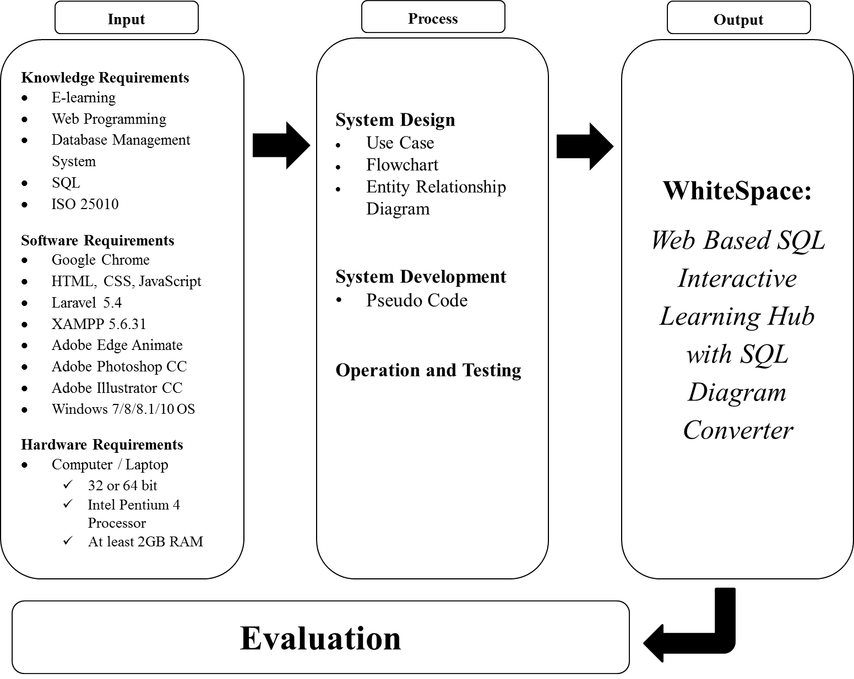

***Figure 1.***The Conceptual Model of the Study

**Operational Definition of Terms**

    For further understanding of the content of this study, the following terms are defined:

**WhiteSpace** refers to a web-based interactive MySQL and Microsoft SQL learning system.

**COSians** refers to the students of College of Science taking DBMS

**DBMS** refers to Database Management System

**Enroll** refers to a process where the professor will register the student to have an account.

**Lesson** refers to presenting knowledge in entertaining way.

**Exercise** refers to lessons which can help in improving one’s skills.

**Simulator** refers to simulation of SQL statements with a corresponding result.

**Quiz** refers to chapter test to assess their capabilities after learning.

**Diagram** refers to SQL queries converted to physical design.

**Rank** refers to student’s achievement based on their skills.

**Chapter 3**

**METHODOLOGY**

This chapter contains the methods and procedures used in conducting the study. It includes the project design, project development, operations and testing procedure and the evaluation procedure of the study.

**Project Design**

    The following diagrams show the many different ways the system will function from the users, the flow of the system, and the relations of the databases.

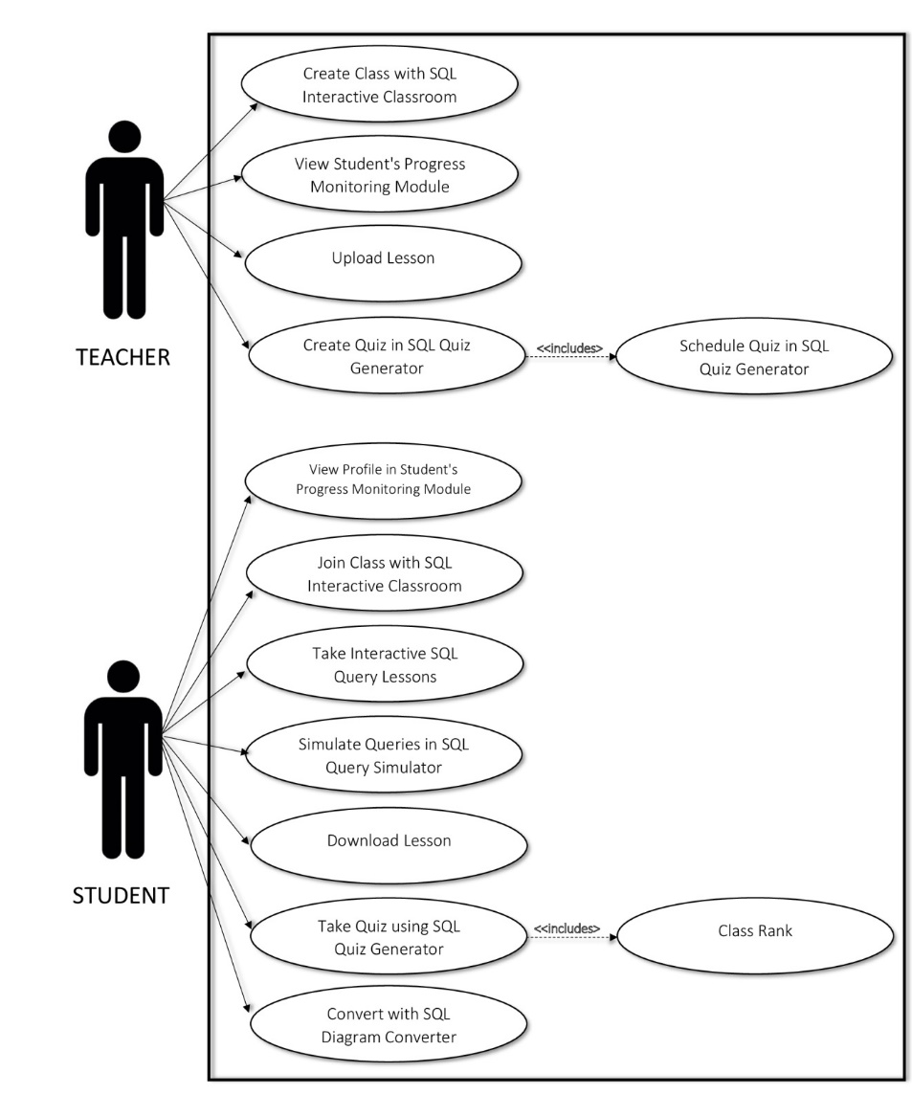

***Figure 2.***Use Case Diagram

Figure 2 shows the role of each user consisting of professor and students. As for the professors, this shows their ability to create class for students, view the student’s progress monitoring module and upload lesson. This also allows creating and scheduling quiz. Lastly, the students are allowed to join class, take lessons in line with exercises, take quizzes, download lesson and convert SQL logical design to physical and vice versa.

**Table 1.**

*Use Case Scenario for Create Class*

|  |  |  |
| --- | --- | --- |
| Use case name: Create Class | | Unique ID: CreateClass |
| Area: SQL Interactive Classroom | | |
| Actor(s): Professor | | |
| Description: Allows the professor to create class for students. | | |
| Triggering Event: The professor uses the system, enters Professor ID and Password and click create new class. | | |
| Trigger Type: | x | External | | Temporal | | |
| Steps Performed (Main Path) | **Information for Steps** | |
| 1. Professor logs in to system. | Professor ID, Password | |
| 2. Click “Create New Class” button. | Whitespace, Teacher’s Dashboard | |
| 3. New class created successfully. | Whitespace, Teacher’s Dashboard | |
| Preconditions: Professor logs on the system. | | |
| Post conditions: Professor can now create class. | | |
| Assumptions: Professor has already created class. | | |
| Requirements Met: Professor has successfully created class. | | |
| Outstanding Issues: None | | |
| Priority: High | | |
| Risk: Medium | | |

**Table 2.**

*Use Case Scenario for Student’s Progress Monitoring for Professor*

|  |  |  |
| --- | --- | --- |
| Use case name: View Student’s Progress Monitoring Module | | Unique ID: ViewStud |
| Area: Student’s Progress Monitoring Module | | |
| Actor(s): Professor | | |
| Description: Allow the professor to view students’ progress. | | |
| Triggering Event: The professor uses the system, enters Professor ID and Password. | | |
| Trigger Type: | x | External | | Temporal | | |
| Steps Performed (Main Path) | **Information for Steps** | |
| 1. Professor logs into the system | Professor ID, Password | |
| 2. Verifies the ID and password | Professor ID, Password | |
| 3. Login successfully | Professor ID, Password | |
| 4. Students’ profile displayed | Student Profile | |
| Preconditions: Professor logs on the system | | |
| Post conditions: Professor could monitor student’s profile and progress | | |
| Assumptions: Professor will view student’s profile and progress | | |
| Requirements Met: Professor can monitor student’s progress | | |
| Outstanding Issues: None | | |
| Priority: High | | |
| Risk: Medium | | |

**Table 3.**

*Use Case Scenario for Uploading of lesson*

|  |  |  |
| --- | --- | --- |
| Use case name: Upload Lesson | Unique ID: Upload | |
| Area: Uploading of lesson | | |
| Actor(s): Professor | | |
| Description: Allows the professor to upload lessons. | | |
| Triggering Event: The professor uses the system, enters valid id and password, click add file | | |
| Trigger Type: | x | External | | Temporal | | |
| Steps Performed (Main Path) | | **Information for Steps** |
| 1. Professor’s profile will be displayed | | Professor’s Profile |
| 2. Click add file | | Whitespace, Files |
| 3. Upload lesson successfully | | Upload Notification |
| Preconditions: Professor upload a same topic lesson. | | |
| Post conditions: Professor has successfully uploaded lesson files. | | |
| Assumptions: Added lesson already existed. | | |
| Requirements Met: Professor can add lesson files. | | |
| Outstanding Issues: How professor should handle SQL lessons? | | |
| Priority: Medium | | |
| Risk: High | | |

**Table 4.**

*Use Case Scenario for SQL Create Quiz*

|  |  |  |
| --- | --- | --- |
| Use case name: Create Quiz in SQL Quiz Generator | Unique ID: CreateQuiz | |
| Area: SQL Quiz Generator | | |
| Actor(s): Professor | | |
| Description: Allows the professor to create quiz in SQL Quiz Generator | | |
| Triggering Event: The professor uses the system, enters valid id and password, click create quiz | | |
| Trigger Type: | x | External | | Temporal | | |
| Steps Performed (Main Path) | | **Information for Steps** |
| 1. Professor’s dashboard will be displayed | | Professor’s Dashboard |
| 2. Click create quiz | | SQL Questions, WhiteSpace |
| 3. Quiz successfully created | | Quiz Created Notification |
| Preconditions: Professor has random questions for quiz. | | |
| Post conditions: Professor has successfully created quiz. | | |
| Assumptions: Professor has a quiz for students. | | |
| Requirements Met: Allow professor to create a quiz. | | |
| Outstanding Issues: How professor should handle random quizzes in SQL Quiz Generator? | | |
| Priority: High | | |
| Risk: High | | |

**Table 5.**

*Use Case Scenario for SQL Schedule Quiz for Professor*

|  |  |  |
| --- | --- | --- |
| Use case name: Schedule Quiz in SQL   Quiz Generator | | Unique ID: SchedQuiz |
| Area: SQL Quiz Generator | | |
| Actor(s): Professor | | |
| Description: Allows the professor to schedule quiz | | |
| Triggering Event: After creating quiz, professor can now schedule quiz. | | |
| Trigger Type: | | External | x | Temporal | | |
| Steps Performed (Main Path) | **Information for Steps** | |
| 1. Quiz successfully created | Quiz Created Notification | |
| 2. Schedule quiz | Scheduled Date, Scheduled Time, Section | |
| 3. Quiz successfully scheduled | Quiz Scheduled Notification | |
| Preconditions: Professor has created quiz. | | |
| Post conditions: Professor has successfully scheduled quiz. | | |
| Assumptions: Professor has a scheduled quiz. | | |
| Requirements Met: Allows the professor to schedule quiz. | | |
| Outstanding Issues: Schedule conflict | | |
| Priority: Medium | | |
| Risk: High | | |

**Table 6.***Use Case Scenario for Join Class for Student*

|  |  |  |
| --- | --- | --- |
| Use case name: Join Class | | Unique ID: JoinClass |
| Area: SQL Interactive Classroom | | |
| Actor(s): Student | | |
| Description: Allows the students to join in a class. | | |
| Triggering Event: The student uses the system, enters Professor ID and Password and click join class. | | |
| Trigger Type: | x | External | | Temporal | | |
| Steps Performed (Main Path) | **Information for Steps** | |
| 1. Student logs in to system. | Student ID, Password | |
| 2. Click “Create Join Class” button. | Whitespace, Student’s Dashboard | |
| 3. Successfully joined class. | Whitespace, Student’s Dashboard | |
| Preconditions: Student logs on the system. | | |
| Post conditions: Student can now join class. | | |
| Assumptions: Student has already joined class. | | |
| Requirements Met: Student has successfully joined class. | | |
| Outstanding Issues: None | | |
| Priority: High | | |
| Risk: Medium | | |

**Table 7.**

*Use Case Scenario for Student’s Progress Monitoring for Student*

|  |  |  |
| --- | --- | --- |
| Use case name: View Profile in Student's Progress Monitoring Module | | Unique ID: StudProfile |
| Area: Student's Progress Monitoring Module | | |
| Actor(s): Student | | |
| Description: Allows the students to view their own profile and progress | | |
| Triggering Event: The student uses the system, enters valid id and password | | |
| Trigger Type: | x | External | | Temporal | | |
| Steps Performed (Main Path) | **Information for Steps** | |
| 1. Student logs into the system | Student ID, Password | |
| 2. Verifies the id and password | Student ID, Password | |
| 3. Login successfully | Student ID, Password | |
| 4. View Dashboard | Student’s Profile | |
| Preconditions: Student logs on the system. | | |
| Post conditions: Students viewed their profile and progress | | |
| Assumptions: Student has already viewed their profile. | | |
| Requirements Met: Allows the student to view their profile and progress. | | |
| Outstanding Issues: None | | |
| Priority: High | | |
| Risk: Medium | | |

**Table 8.**

*Use Case Scenario for Interactive SQL Query Lessons*

|  |  |  |
| --- | --- | --- |
| Use case name: Take Interactive SQL Query Lessons | Unique ID: StudLesson | |
| Area: Interactive SQL Query Lessons | | |
| Actor(s): Student | | |
| Description: Allows the student to take interactive SQL query lessons | | |
| Triggering Event: The student logs into the system. | | |
| Trigger Type: | x | External | | Temporal | | |
| Steps Performed (Main Path) | | **Information for Steps** |
| 1. Student’s dashboard will be displayed | | Student’s Dashboard |
| 2. Click take lesson | | Whitespace |
| 3. Start lesson | | Whitespace, SQL Lessons |
| Preconditions: Student logs on the system. | | |
| Post conditions: Student has started an interactive SQL lesson. | | |
| Assumptions: Student has already take a lesson. | | |
| Requirements Met: Allows the user to take SQL interactive lesson. | | |
| Outstanding Issues: None | | |
| Priority: High | | |
| Risk: High | | |

**Table 9.**

*Use Case Scenario for SQL Query Simulator*

|  |  |  |
| --- | --- | --- |
| Use case name: Practice Exercises in SQL Query Simulator | | Unique ID: StudSimulator |
| Area: SQL Query Simulator | | |
| Actor(s): Student | | |
| Description: Allows the student to enter SQL statements to practice lessons learned | | |
| Triggering Event: The student uses the system, takes lesson and practice exercise of lessons learned | | |
| Trigger Type: | x | External | | Temporal | | |
| Steps Performed (Main Path) | **Information for Steps** | |
| 1. Student successfully logs into the system | Student’s ID, password | |
| 2. Takes lesson | Lesson | |
| 3. Answer exercise | Exercise, Query | |
| 4. Simulate query | Query | |
| 5. Returns result |  | |
| Preconditions: Error will appear to inform student’s mistake | | |
| Post conditions: Student has successfully simulated SQL statements. | | |
| Assumptions: Student enter an invalid query. | | |
| Requirements Met: Allows the student to simulate SQL statements. | | |
| Outstanding Issues: Limited SQL statements can be simulated. | | |
| Priority: High | | |
| Risk: Medium | | |

**Table 10.**

*Use Case Scenario for SQL Diagram Converter*

|  |  |  |
| --- | --- | --- |
| Use case name: SQL Diagram Converter | | Unique ID: DiagramConverter |
| Area: SQL Query Simulator | | |
| Actor(s): Student | | |
| Description: Allows the student to convert SQL queries to diagram | | |
| Triggering Event: The student will enter SQL query. | | |
| Trigger Type: | x | External | | Temporal | | |
| Steps Performed (Main Path) | **Information for Steps** | |
| 1. Student clicks SQL Simulator on side bar. | Whitespace, Student’s Dashboard | |
| 2. Enter SQL query. | Whitespace, Student’s Dashboard | |
| 3. Click “Generate” button. | Whitespace, Student’s Dashboard | |
| Preconditions: Enters SQL query. | | |
| Post conditions: Generates SQL diagram. | | |
| Assumptions: Student has already SQL diagram. | | |
| Requirements Met: Allows the student to generate SQL diagram based on queries. | | |
| Outstanding Issues: Many-to-many relationship will be breakdown as one-to-many. | | |
| Priority: High | | |
| Risk: Medium | | |

**Table 11.**

*Use Case Scenario for Downloading of lesson*

|  |  |  |
| --- | --- | --- |
| Use case name: Download Lesson | | Unique ID: Download |
| Area: Downloading of lesson | | |
| Actor(s): Student | | |
| Description: Allows the student to download lesson uploaded by professors | | |
| Triggering Event: The student will download a lesson file | | |
| Trigger Type: | | External | x | Temporal | | |
| Steps Performed (Main Path) | **Information for Steps** | |
| 1. Student successfully logged into the system | Student ID, Password | |
| 2. Search for the professor’s profile | Professor’s Name | |
| 3. Professor’s profile will be displayed | Professor’s Profile | |
| 4. Download the lesson needed | Download Button | |
| 5. Lesson file successfully downloaded. | Download Notification | |
| Preconditions: No uploaded lesson file at the moment. | | |
| Post conditions: Student allows to download lesson file. | | |
| Assumptions: Download lessons rather on saving it | | |
| Requirements Met: Allows the student to download lesson file. | | |
| Outstanding Issues: Handling in download files. | | |
| Priority: High | | |
| Risk: Medium | | |

**Table 12.**

*Use Case Scenario for Taking Quizzes for Students*

|  |  |  |
| --- | --- | --- |
| Use case name: Take Quiz in SQL Quiz Generator | Unique ID: TakeQuiz | |
| Area: SQL Quiz Generator | | |
| Actor(s): Student | | |
| Description: Allows the student to take quiz in SQL Quiz Generator | | |
| Triggering Event: The student finishes a chapter lesson and will take quiz | | |
| Trigger Type: | x | External | | Temporal | | |
| Steps Performed (Main Path) | | **Information for Steps** |
| 1. Quiz was scheduled by professor | | Scheduled date, Section |
| 2. Quiz will notify | | Quiz Notification |
| 3. Take Quiz | | Take Quiz Button |
| 4. Finished Quiz | | Submit Button |
| Preconditions: Student finishes a chapter lesson. | | |
| Post conditions: Student could take quiz in SQL Query Generator | | |
| Assumptions: Student takes a multiple-choice quiz. | | |
| Requirements Met: Allow the students to take quiz in SQL Quiz Generator | | |
| Outstanding Issues: Limited type of quiz. | | |
| Priority: High | | |
| Risk: Medium | | |

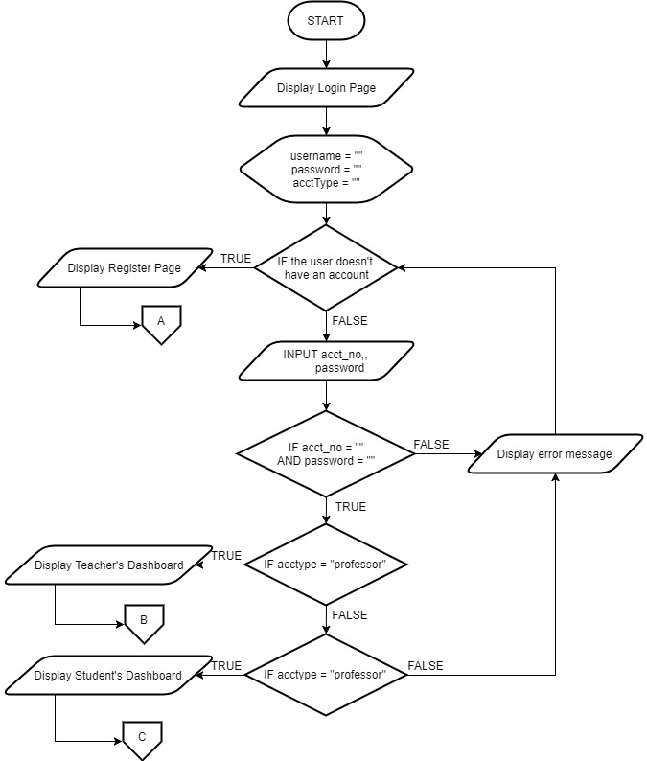

***Figure 3.*** Flowchart of Login Page

Figure 3 shows the flow of the login page being used by the users of the system. If a user does not have an account yet, they can register. Before proceeding to their respective main pages, it will check for the user type—whether it is a student or teacher—of the inputted username and password.

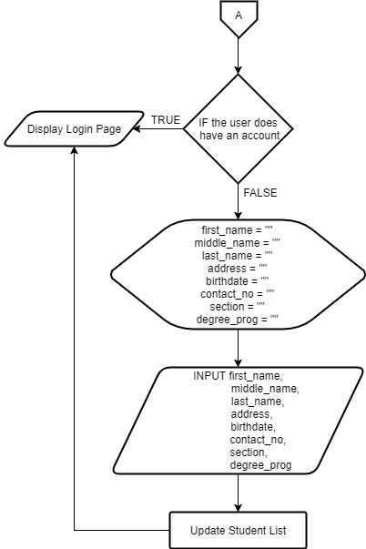

***Figure 4.***Flowchart of Register Page

Figure 4 shows if a user does not have an existing account in the system, he/she can register by inputting some basic information about the user. After that the student database is updated and then proceeds to the login page.

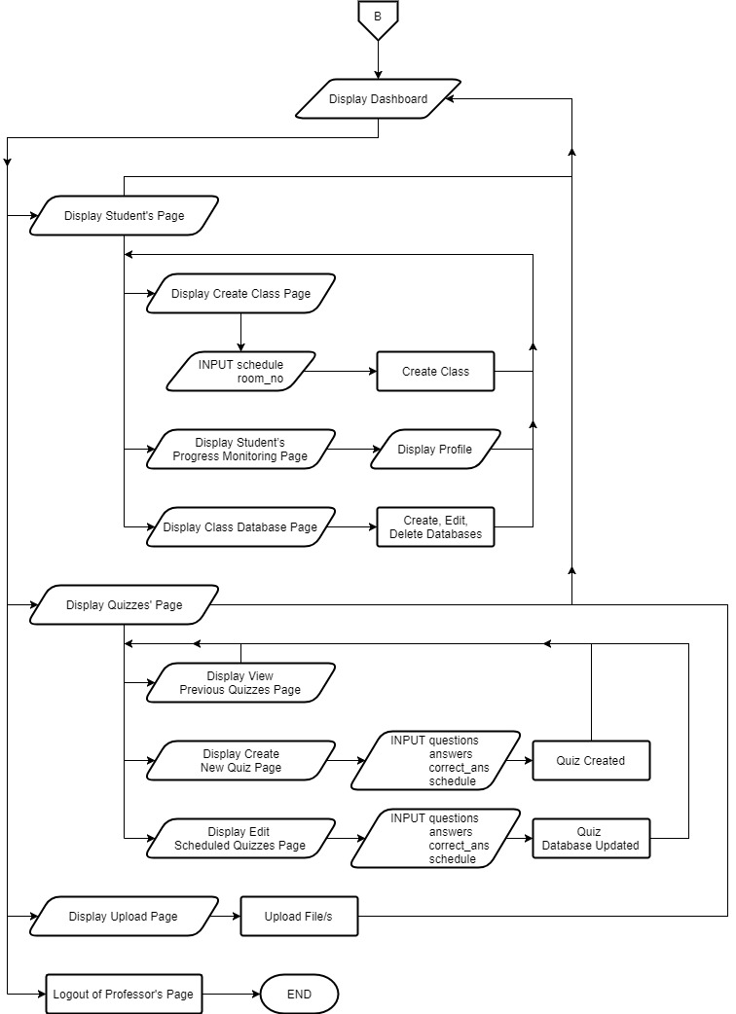

***Figure 5.***Flowchart of Professor Page

Figure 5 shows what the professor can do in the system. In the student page, the professor can create a class for the students, view their progress, and create, edit or delete the class database.

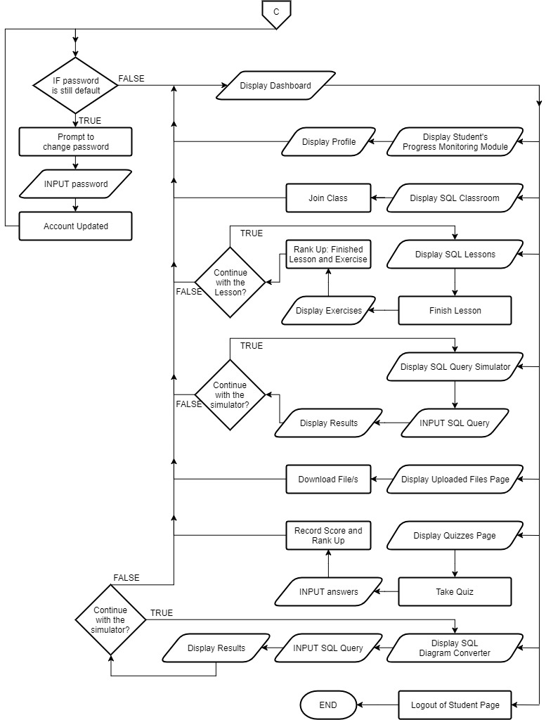

***Figure 6.***Flowchart of Student Page

Figure 6 shows what the student can do in the system. Firstly, if the student user is new and have not changed their password they will be prompted to change it, to make their account secure. The student can, view their dashboard, join classes, view their progress, use the SQL simulator and Diagram Converter. view and study their lessons, practice with their exercises, and take quizzes, they can also rank up and earn badges.

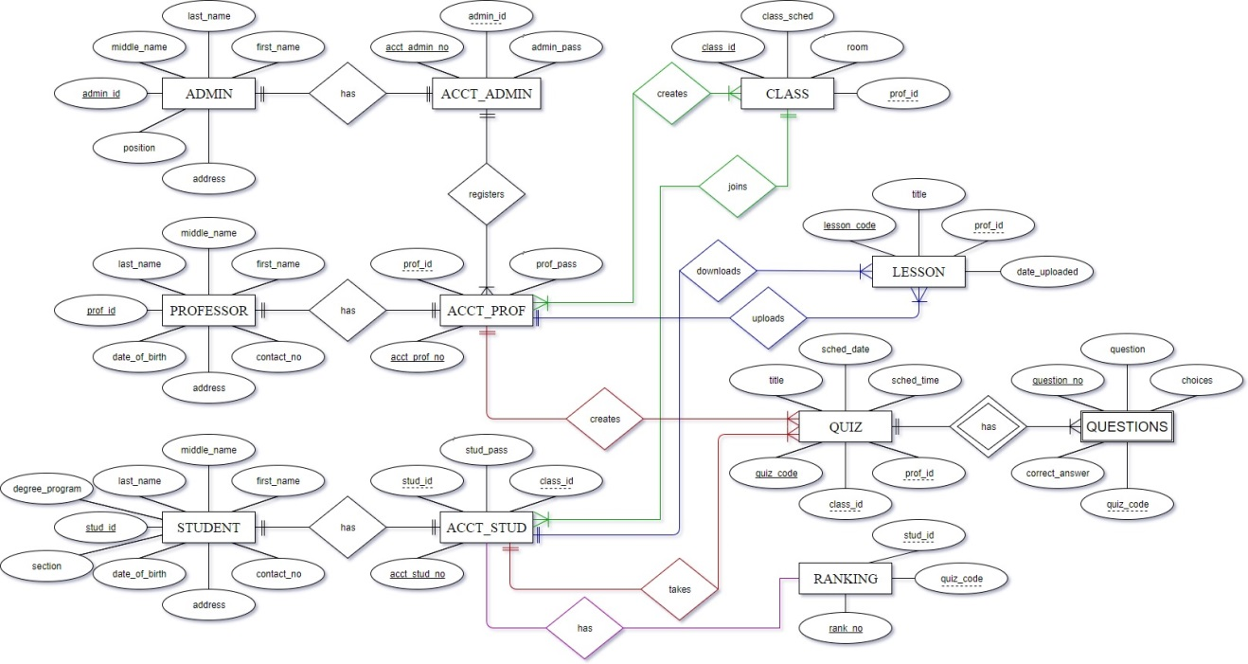

***Figure 7.***Entity Relationship Diagram

Figure 7 shows the relationship of each table. The admin, professor and student have an account to interact with the system. The admin’s account will serve as a tool to register a professor. The enrollment of the students can be done with the professor’s account.

**Project Development**

1. Create the website in XAMPP and install Laravel as the PHP framework
2. Create the design using bootstrap as a framework
3. Modules
   1. Interactive SQL Classroom
      1. Create the function to create a class for professor and join class for students in order to take lessons.
   2. Interactive SQL Query Lessons
      1. Create the page using multimedia tools for user interaction.
   3. SQL Query Simulator
      1. Create the function to execute an SQL query inputted by a user.
   4. SQL Quiz Generator
      1. Create the function that randomizes the questions of the quiz for each student.
   5. SQL Diagram Converter
      1. Create the function that converts SQL queries into diagram for the students.
   6. Student’s Progress Monitoring Module
      1. Create the function for searching for the students and viewing their progress.
   7. Uploading and Downloading of Lessons
      1. Create a function of uploading of files for the students to download.

**Operation and Testing Procedure**

The proposed system WhiteSpace will be operated by the students and professors of College in Science.

The operation procedure for professor presented as follows:

1. The system’s uniform resource location (URL) address will verify on the browser by encoding on the address bar. It will run as well on other browsers.
2. Professor will sign up to create an account. The system will generate a temporary password.
3. When the login form shows on the screen, the user must enter professor’s username and password. Temporary password can be changed.
4. A main page will appear after a successful login. This page contains dashboard of the professor.
5. The professor will create a class with schedule.
6. The professor can view list of students in order to sort and look at the list to monitor a student’s information.
7. The professor can create a database for each section.
8. Dashboard will display, a professor can Create Quiz by clicking its button then supply questions and will be scheduled.
9. A page for scheduling quiz will appear. The professor can schedule quizzes.

The operation procedure for students presented as follows:

1. The system’s uniform resource location (URL) address will verify on the browser by encoding on the address bar. It will run as well as on other browsers.
2. Student will sign up to create an account. The system will generate as temporary password.
3. When the login form shows on the screen, the user must enter student’s username and password. Temporary password can be changed.
4. Home page will appear after a successful login. This page contains the dashboard.
5. The student must join a class in order to start on SQL lessons.
6. The student can choose a schedule in line with teacher.
7. Exercise comes with lessons, the student can practice learned lessons in simulator to query SQL statements.
8. Students can apply their knowledge learned in SQL Query Simulator with the corresponding database made by the professor.
9. Students can convert SQL queries to diagram with the use of SQL Diagram Converter.
10. To sum up the lessons learned, students will have quizzes to apply their gained knowledge.

.

Tables 13 and 14 present the testing procedure for functionality both for the professor’s and student’s module.

Reliability testing has two types expressly as test-pretest and parallel form. These will be done to test the reliability of professor’s and student’s module. Test-pretest is a measure of reliability acquired by testing the system twice over a period of time then comparing the results. In line with Whitespace, it could be analyzed twice over a period of time then compare the outcome. Parallel form is reliability testing through different assessment tool with same components. Concerning in Whitespace, it could be administer with two different browsers then compare the end result.

**Table 13.**

*Testing Procedure for Functionality for Professor*

|  |  |
| --- | --- |
| **MODULE** | **TEST SCENARIO** |
| A. SQL Quiz Generator  · *Create Quiz*  · *Schedule Quiz* | * Enter question * Enter choices * Enter right answer * Save * Click quiz needed to be scheduled * Enter scheduled date and time * Enter section |
|  |  |
| B. Student’s Progress Monitoring Module | * Sort by course, section or rank order * Search strings |
|  |  |
| C. Upload Lessons | * Upload document, powerpoint and/or portable document file on professor’s profile |

**Table 14.**

*Testing Procedure for Functionality for Student*

|  |  |
| --- | --- |
| **MODULE** | **TEST SCENARIO** |
| A. Interactive SQL Query Lessons | * Take lesson |
|  |  |
| B. SQL Query Simulator | * Enter valid SQL statement * Click database * Click tables |
|  |  |
| C. SQL Quiz Generator | * Access quiz based on scheduled date and time * Answer quiz, randomly changes for each user |
|  |  |
| D. Download Lessons | * Download file on professor’s profile |

**Evaluation Procedure**

To determine the acceptability of the system, the WhiteSpace: Web Based MySQL and MSSQL Interactive System will be evaluated by the students and professors of College of Science consisting of 30 respondents, composing of 20 students and 10 IT Experts.

This study uses ISO 25010 evaluation instrument software composing of eight criteria namely; Functional Suitability, Performance Efficiency, Compatibility, Usability, Reliability, Security, Maintainability and Portability with Likert scale as an evaluation instrument.

The evaluation procedure is presented as follows:

1. Each respondent will be given a questionnaire.

2. The researchers will discuss the system flow and structure. Every respondent will have the opportunity to test and evaluate system’s performance.

3. The system will be rated using the Likert scale shown in Table 7.

4. The evaluation of the respondents will be calculated using the frequency method by count with the formula of:With the given formula, % = (F / N) × 100, the frequency was computed by summing up all the products of the frequency and its corresponding score and dividing it to the total number of respondents.

5. The results will be presented in a tabular manner, and then the frequency of responses will be determined based on the range interpretation shown in table 8.

**Table 15.**

*Rating Scale for Frequency and its Percentage*

|  |  |  |  |
| --- | --- | --- | --- |
| NUMERICAL RATING | FREQUENCY | PERCENTAGE | DESCRIPTIVE RATING |
| 4 | F | % | Highly Acceptable |
| 3 | F | % | Very Acceptable |
| 2 | F | % | Fairly Acceptable |
| 1 | F | % | Not Acceptable |

**Table 16.**

*Four-Point Likert Scale*

|  |  |
| --- | --- |
| INTERPRETATION | WEIGHT |
| Highly Acceptable | 3.26 - 4.00 |
| Very Acceptable | 2.51 - 3.25 |
| Fairly Acceptable | 1.76 - 2.50 |
| Not Acceptable | 1.00 - 1.75 |

**REFERENCES**

**Book**

Ramez Elmasri, Shamkant B. Navathe. (2016). Fundamentals of Database Systems 7th Edition.

E-Learning and the Science of Instruction Proven Guidelines for Consumers and Designers of Multimedia Learning 3rd Edition.

**Published Theses**

Magner, Schwonke, Aleven, Popescu & Renkl. (2014). Triggering situational interest by decorative illustrations both fosters and hinders learning in computer-based learning environments, Learning and Instruction. (p. 141-152)

Park, Moreno, Seufert & Brünken. (2011). Does cognitive load moderate the seductive details effect? A multimedia study, Computers in Human Behavior. (p. 5-10).

**Unpublished Theses**

Avila, Moron & Reyes. (2017). Online Learning Management System for Kaunlaran Elementary School Grade 1 Students. Undergraduate Thesis. Technological University of the Philippines.

Maco & Papa. (2013). TUP Intranet: Email and To-Do List. Undergraduate Thesis. Technological University of the Philippines.

Francisco, Sabido & Valdez. (2016). Development of Learning Management System for Technological University of the Philippines. Undergraduate Thesis. Technological University of the Philippines.

**Electronic Sources**

JetBrains. (2017). The State of Developer Ecosystem 2017 – Infographic. Retrieved August 14, 2017, from https://www.jetbrains.com/research/devecosystem-2017/

Christensson, P. (2016, July 16). Relational Database Definition. Retrieved September 5, 2017, from https://techterms.com/definition/relational_database

TechTarget. (n.d.). What is database management system (DBMS)? - Definition from WhatIs.com. Retrieved September 5, 2017, http://searchsqlserver.techtarget.com/ definition/database-management-system

Christensson, P. (2006). Multimedia Definition. Retrieved September 5, 2017, from https://techterms.com

University of Delaware. (n.d.). What is Multimedia? – Definition from http://www1.udel.edu. Retrieved September 5, 2017, from http://www1.udel.edu/edtech/multimedia/index.html

Instructional Design Expert. (n.d.). The Five eLearning Components. Retrieved September 5, 2017, from http://www.instructionaldesignexpert.com/ eLearning_Components.html

Derek Stockley. (n.d.). E-learning Definition and Explanation (E-learning, Online Training, Online Learning). Retrieved September 5, 2017, from http://www.derekstockley.com.au/elearning-definition.html

TechTarget. (n.d.). What is networking? Retrieved September 5, 2017, from http://searchnetworking.techtarget.com/definition/networking

Bradley Mitchell. (2017). What is Computer Networking? Retrieved September 5, 2017, from https://www.lifewire.com/what-is-computer-networking-816249

Mozilla Foundation. (n.d.). HTML. Retrieved September 5, 2017, from https://developer.mozilla.org/en-US/docs/Web/HTML

Mozilla Foundation. (n.d.). CSS. Retrieved September 5, 2017, from https://developer.mozilla.org/en-US/docs/Web/CSS

The PHP Development Team. (n.d.). PHP: What is PHP? – Manual. Retrieved September 5, 2017, from http://php.net/manual/en/intro-whatis.php

The PHP Development Team. (n.d.). PHP: History of PHP? – Manual. Retrieved September 5, 2017, from http://php.net/manual/en/history.php.php

OneExtraPixel. (2010). An Overview of PHP Framework Guides for Developers. Retrieved September 5, 2017, from https://onextrapixel.com/an-overview-of-php-framework-guides-for-developers/

Codecademy. (n.d.). Text Editors: Atom and Sublime | Codecademy. Retrieved September 5, 2017, from https://www.codecademy.com/es/articles/text-editors-sublime-atom

ISTQB Exam Certification. (n.d.). What is functionality testing in software? Retrieved October 7, 2017, from http://istqbexamcertification.com/what-is-functionality-testing-in-software/

ISTQB Exam Certification. (n.d.). What is Usability testing in software and it’s benefits to end user? Retrieved October 7, 2017, from http://istqbexamcertification.com/ what-is-usability-testing-in-software-and-its-benifits-to-end-user/

Software Testing Fundamentals. (n.d.). Usability Testing - Software Testing Fundamentals. Retrieved October 7, 2017, from http://softwaretestingfundamentals.com/usability-testing/

Statistics How To. (2017, September 11). Make a frequency chart and determine frequency Retrieved October 7, 2017, from http://www.statisticshowto.com/how-to-make-a-frequency-chart-and-determine-frequency/

Statistics How To. (2017, September 11). Make a frequency chart and determine frequency. Retrieved October 7, 2017, from http://www.statisticshowto.com/how-to-make-a-frequency-chart-and-determine-frequency/

Tech Target. (2014). What is statistical analysis? - Definition from WhatIs.com. Retrieved October 7, 2017, from http://whatis.techtarget.com/definition /statistical-analysis

Wikipedia. (2017). Standards compliant - Wikipedia. Retrieved October 7, 2017, from https://en.wikipedia.org/wiki/Standards-compliant

Wikipedia. (2017). Proprietary software - Wikipedia. Retrieved October 7, 2017, from https://en.wikipedia.org/wiki/Proprietary_software

World Wide Web Consortium. (n.d.). About W3C Standards. Retrieved October 7, 2017, from https://www.w3.org/standards/about.html

UNODC. (n.d.). What is evaluation? Retrieved October 7, 2017, from https://www.unodc.org/unodc/en/evaluation/ what-is-evaluation1.html

OECD. (2004). OECD Glossary of Statistical Terms - Sampling Technique Definition. Retrieved October 7, 2017, from https://stats.oecd.org/glossary/ detail.asp?ID=2380

Web Page Mistakes. (2011). Standards Compliant Coding. Retrieved October 7, 2017, from http://www.webpagemistakes.ca/standards-compliant/

World Wide Web Consortium. (n.d.). Developer Tools - W3C Developers. Retrieved October 7, 2017, from https://w3c.github.io/developers/tools/

Dummies. (n.d.). Make Your Web Site W3C–Compliant for Better Search Engine Results - dummies. Retrieved October 7, 2017, http://www.dummies.com/web-design-development/search-engine-optimization/make-your-web-site-w3ccompliant-for-better-search-engine-results/

Concept Draw. (n.d.). Design elements - ERD (crow's foot notation). Retrieved October 7, 2017, from https://conceptdraw.com/a672c3/preview

University of Regina. (n.d.). Crow’s Foot Notation. Retrieved October 7, 2017, from http://www2.cs.uregina.ca/~bernatja/crowsfoot.html

Oracle. (n.d.). Overview of Physical Design. Retrieved October 7, 2017, from https://docs.oracle.com/cd/A84870_01/doc/server.816/a76994/physical.htm

Oracle. (n.d.). Overview of Logical Design. Retrieved October 7, 2017, from https://docs.oracle.com/cd/A87860_01/doc/server.817/a76994/logical.htm