SOC Task 2 – Incident Investigation Report
Prepared by: Jojin John
Tool Used: Elastic Stack (ELK)
Index: soc_task2_logs_fixed
Date: 19/11/2025

📌 Executive Summary
This report documents the incident investigation performed using the Elastic Stack.
Security logs were analyzed to identify signs of suspicious or malicious activity, including:
- Malware detections
- Failed login attempts
- Connection attempts (possible network probing)
- File access events
- Activity from suspicious public IP ranges
The findings indicate multiple potential security incidents involving ransomware behavior, worm infection attempts, and unauthorized login attempts.

🔍 Detailed Findings

1️⃣ Malware Detection Events
Search Query:
Action=malware detected
Observations
- Multiple malware alerts were found in the logs.
- Detected threats include:
  - Ransomware Behavior
  - Rootkit Signature
  - Trojan Detected
  - Worm Infection Attempt
- Affected users: bob, alice, eve, david
- Source IPs: 10.0.0.5, 198.51.100.42, 172.16.0.3
Conclusion
⚠️ Multiple malware infections indicate possible compromise of several systems. Immediate containment is required.
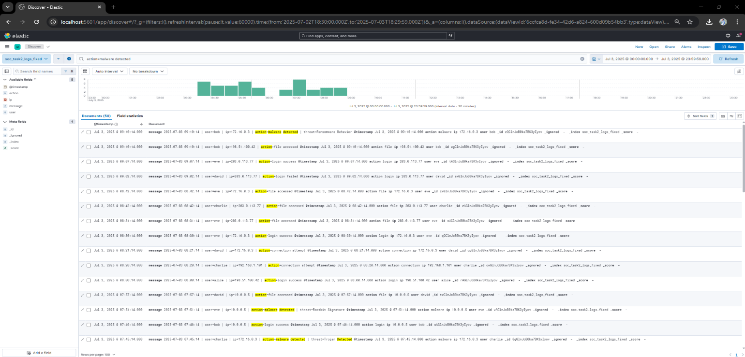
2️⃣ Failed Login Attempts
Search Query:
message:”login failed”
Observations
- Repeated failed login attempts for:
  - david
  - bob
  - charile
- Indicates possible brute-force attack or credential misuse.
Conclusion
⚠️ Unauthorized access attempts are likely underway.
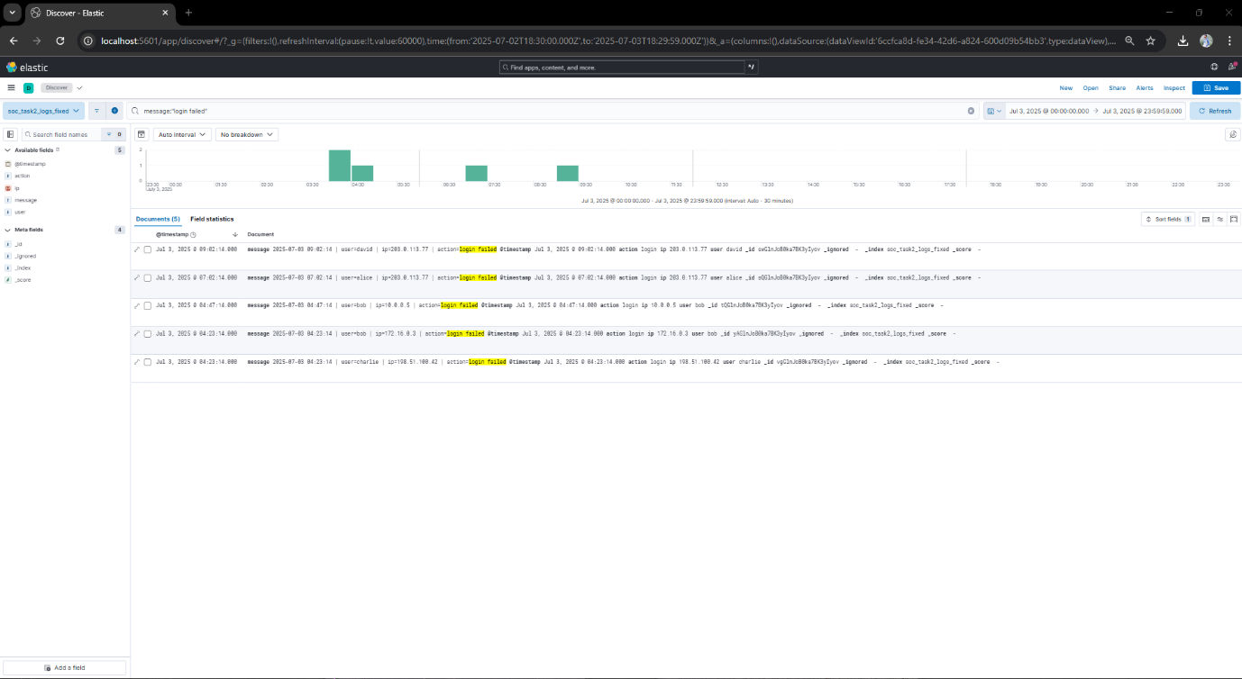

3️⃣ Connection Attempt Events
Search Query:
message:"connection attempt"
Observations
- Many connection attempts from internal + suspicious external IPs:
  - 198.51.x.x
  - 203.x.x.x
- Behavior resembles scanning or probing.
Conclusion
⚠️ High-volume connection attempts may indicate reconnaissance before an attack.
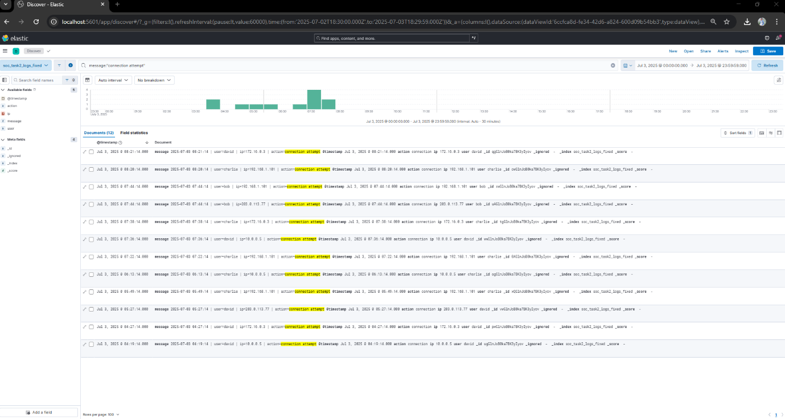
4️⃣ File Access Events
Search Query:
message:"file accessed"
Observations
- Users accessing files include:
  - bob, eve, charlie, david
- Some file access timestamps correlate with malware activity.
Conclusion
⚠️ Possible unauthorized data access or malware executing payloads.
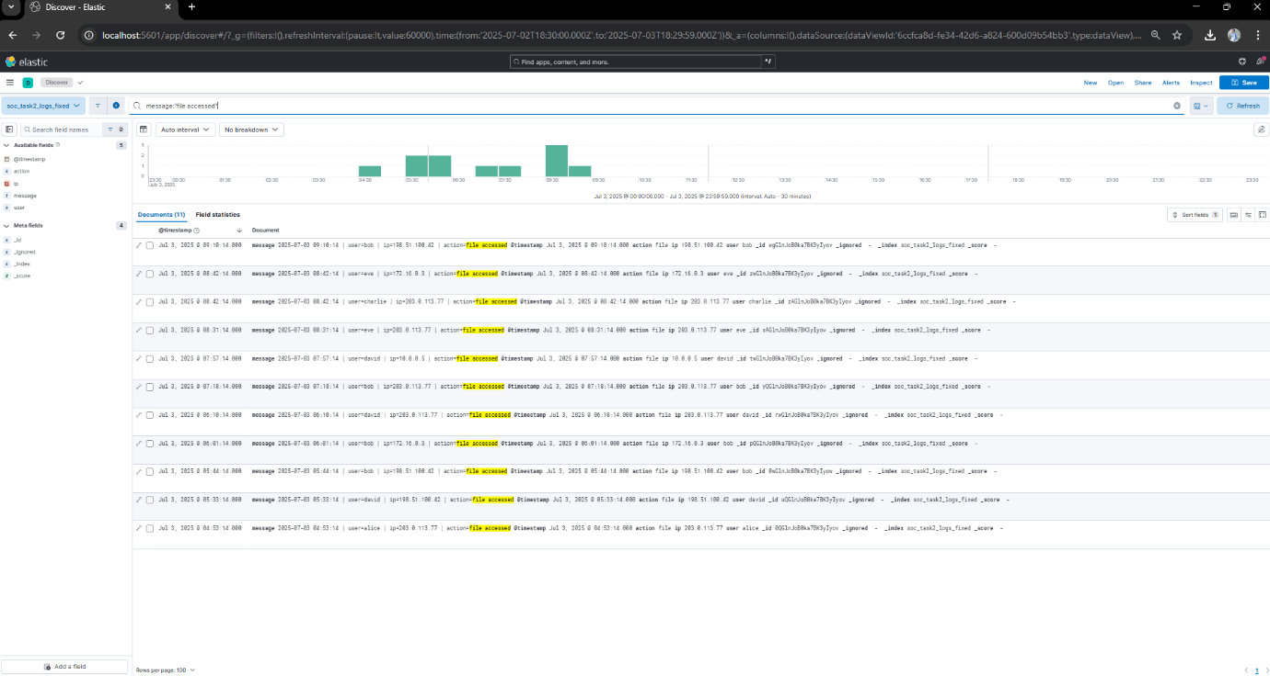

🔥 Overall Attack Summary
The combined activity suggests a multi-stage attack:
- Reconnaissance: connection attempts
- Credential attacks: failed logins
- Compromise: malware detected
- Post-exploitation activity: suspicious file access
This behavior resembles a real-world intrusion sequence (MITRE ATT&CK style).

🛡 Recommended Actions
Priority | Action
🔴 High | Isolate infected systems immediately
🔴 High | Reset credentials of affected users
🔴 High | Block malicious IP ranges
🟠 Medium | Enable account lockout & MFA
🟠 Medium | Patch all vulnerable hosts
🟢 Normal | Perform a full network threat hunt
🟢 Normal | Deploy updated anti-malware solutions

