Smart Interior Designer

Graduation Project 1 prepared to obtain the degree of B.Sc. in the Department of Artificial Intelligence Engineering and Data Science

Authors:

Joudi Almasre
Aya Sahlol
Aya Al tawiel

Supervised by:

Dr.Majeda Albakor
Wessam Alsohle

$\frac{هـ1447-1448}{م 2025-2026}$: Damascus

Abstract :
This research addresses the development of an intelligent system for realistic and guided editing of indoor space images. The system enables users to preview different interior design modifications, such as wall recoloring, floor material replacement, room redesign, and unwanted object removal, before applying these changes in reality. This problem is important for interior design, real estate visualization, and furniture, paint, and flooring businesses, as it reduces the time and effort required to visualize final design alternatives. However, indoor image editing is challenging due to the complexity of interior scenes, the overlap between architectural elements and furniture, and the need to preserve perspective, lighting, shadows, and visual realism.
The proposed system integrates several computer vision and generative AI models within a structured pipeline instead of relying on a single image-generation model. The pipeline begins with room-type classification using Swin Transformer Tiny to understand the scene context. Then, SegFormer is used to extract key structural regions such as walls, floors, ceilings, and background at the pixel level. The generated masks are refined using Segment Anything Model (SAM) and mask-processing operations to improve boundary accuracy. After identifying the target region, editing is applied in a guided manner using Stable Diffusion Inpainting, while ControlNet-Depth helps preserve geometric structure and perspective. LoRA is used to adapt the generative model to specific floor materials such as wood, ceramic, and stone. The system also supports object removal using SAM and LaMa, which increases its flexibility.
The evaluation results show that the proposed system can perform guided visual modifications on indoor room images with a good level of control and realism. The room classification model achieved an accuracy of 95.24%, while the semantic segmentation model achieved mIoU = 82.69% for extracting the main structural regions. The integration of SegFormer and SAM improved mask quality, ControlNet-Depth helped maintain perspective during generation, and LaMa produced better object-removal results for small objects and simple backgrounds. Overall, the results indicate that combining room classification, semantic segmentation, mask refinement, and guided generative models provides a practical solution for intelligent interior design applications. However, further improvement is still needed for complex scenes with dense furniture, unclear boundaries, or difficult lighting conditions.
Keywords: Smart Interior Design, Computer Vision, Semantic Segmentation, Stable Diffusion Inpainting, ControlNet, LoRA, SAM.

Contents
Chapter One: Introduction 7
1.1 Introduction : 7
1.2 Scientific Problem of the Research : 8
1.3 Research Objectives: 8
1.4 Research Contribution : 9
1.5 Beneficiaries of the Research: 10
1.6 Thesis Organization: 11
Chapter Two: Theoretical Study 12
2.1 Introduction : 12
2.2 Room Classification : 12
2.3 Semantic Segmentation: 13
2.4 SegFormer Model : 13
2.5 Segment Anything Model — SAM : 14
2.6 Depth Estimation : 15
2.7 Stable Diffusion Inpainting : 15
2.8 ControlNet : 16
2.9 LoRA Technique : 16
2.10 Prompt Engineering : 17
2.11 LaMa Model for Object Removal : 17
Chapter Three- Literature Review: 19
3.1 Introduction: 19
3.2 Previous Studies in Related Fields: 19
3.2.1Analysis of Previous Studies: 21
3.3 Modern Technologies and Frameworks in the Field: 22
3.3.1Transformers in Computer Vision: 22
3.3.2Semantic Segmentation: 22
3.3.3Segment Anything Model – SAM: 22
3.3.4Integration Between SegFormer and SAM: 23
3.3.5Intrinsic Image Decomposition and Wall Color Change: 23
3.3.6Image Inpainting and LaMa for Object Removal: 24
3.3.8LLM and Graph Neural Networks as Modern Directions: 24
3.4 Comparative Analysis of Systems: 25
3.5 Research Gap and Proposed Innovation: 26
Chapter Four: Research Methodology: 28
4.1 Introduction: 28
9.1 Traditional Methods for Solving the Proposed Problem: 28
9.1.1Numerical Methods: 29
9.1.2Machine Learning Methods: 29
9.2 Explanation of the Proposed Model, Detailed Architecture, Loss Function, and Training Algorithms: 30
9.2.1General Architecture of the Proposed System: 30
9.2.2Room-Type Classification Using Swin Transformer: 31
9.2.3Semantic Segmentation Using SegFormer: 32
9.2.4Mask Refinement Using SAM: 33
9.2.5Object Removal Using LaMa: 34
9.2.6Wall Color Changing While Preserving Shadows: 35
9.2.7Floor Replacement Using LoRA, Stable Diffusion, and ControlNet-Depth: 35
9.2.8Room Redesign and Style Selection: 37
9.2.9Loss Function and Training Algorithms: 38
9.2.10Detailed Explanation of the Pipeline: 39
9.2.11Datasets Used: 43
4.4 Chapter Conclusion and Research Contribution: 47
Chapter Five: Research Results: 48
5.1 Introduction: 48
5.2 Tools Used and Evaluation Methods Adopted: 49
10.2.1Evaluation Metrics for Room-Type Classification: 50
10.2.2Evaluation Metrics for Semantic Segmentation Using SegFormer: 52
10.2.3Evaluation Metrics for SAM and Mask Refinement: 53
10.2.4Evaluation Criteria for Wall Recoloring: 54
10.2.5Evaluation Metrics for Object Removal: 55
10.2.6Evaluation Metrics for LoRA-Based Floor Replacement: 56
5.3 Results of the Proposed Model: 57
10.3.1Results of the Room-Type Classification Model: 57
10.3.2Results of SegFormer Semantic Segmentation: 61
10.3.3Results of Integrating SegFormer with SAM: 62
10.3.4Results of Wall Recoloring: 63
10.3.5Results of Object Removal: 64
10.3.6Results of LoRA Training for Floor Materials 66
10.3.7Results of Floor Replacement: 68
10.3.8Results of Room Redesign: 70
10.3.9Did the Proposed System Achieve Its Objective? 71
5.4 Results Comparison: 71
10.4.1Comparison of the Proposed Models’ Results: 71
10.4.2Comparison with Previous Works: 73
5.5 Chapter Summary 74
Chapter Six: Conclusion 76
6.1 Introduction: 76
6.2 Conclusions: 76
6.3 Challenges and Future Work — revised version : 77

List of Tables
Table 1: 3.2 Previous Studies 21
Table 2:3.4most commercial systems 25
Table 3: 5.2 the tools and metrics actually used 50
Table 4:5.3.1 Data for Room_type Classification model 57
Table 5:5.3.1 Results of the Room-Type Classification Model 58
Table 6:5.3.1 Final Classification Report 58
Table 7:5.3.1 Overall Performance Metrics of the Room-Type Classification Model 58
Table 8:5.3.2 Dataset foe segformer 61
Table 9:5.3.2 class for training segformaer 61
Table 10:5.3.2 final Results of SegFormer 61
Table 11:5.3.3 Effect on the System 62
Table 12:5.3.3Wall Recoloring 63
Table 135.3.3 resuls analyzed 64
Table 14:5.3.5 numerical results remove 65
Table 15:5.3.5 The removal path 66
Table 16:5.3.6 ceramic loss values 67
Table 17:5.3.6 wood LoRA Data 67
Table 18:5.3.6 wood loss values 67
Table 19:5.3.6 stone LoRA Data 67
Table 20::5.3.6 stone loss values 68
Table 21:5.3.7 evaluated visually according 68
Table 22:5.4.1 Proposed Models’ Results 71
Table 23:5.4.1Classification and Segmentation Results 72
Table 24:5.4.1 LoRA Floor Dataset Comparison 72
Table 25:5.4.1 Wall Recoloring Method Comparison 72
Table 26:5.4.1 Floor Replacement Method Comparison 73

List of Figures
Figure 1: 4.3.7Floor Replacement Using LoRA, Stable Diffusion, and ControlNet-Depth 37
Figure 2: 4.3.10.1 General System Pipeline 40
Figure 3: 4.3.10.2Wall Color Changing Pipeline 41
Figure 4: 4.3.10.3Floor Replacement Pipeline 42
Figure 5: 4.3.10.4Object Removal Pipeline 42
Figure 6: 4.3.10.5Room Redesign Pipeline 43
Figure 7: 4.3.11.5Tools Used 47
Figure 8: 5.3.1 Training and Validation Loss Curves for the Room-Type Classification Model 59
Figure 9:5.3.1Training and Validation F1-score Curves for the Room-Type Classification Model 60
Figure 10:5.3.1 Confusion Matrix for Room-Type Classification 60
Figure 11:5.3.3 SAM mask or final mask after integration 63
Figure 12:5.3.3 SegFormer mask before SAM 63
Figure 13:5.3.2 Result after wall recoloring 64
Figure 14:5.3.4 Original image before wall recoloring 64
Figure 15:5.3.5 remove object 66
Figure 16:5.3.6 ceramic LoRA Data 66
Figure 17:5.3.7 result ceramic 69
Figure 18::5.3.7 result wood 69
Figure 19:5.3.7 result stone 69
Figure 20:5.3.8 Results of Room Redesign 70
Figure 21:5.3.8 boho and modern 70
Figure 22:5.3.8 orginal image 70
Figure 23:5.3.8 classic 70
Figure 24:5.3.8 scandinavian and industrial 70
List of Equations:
Equation 1:5.2.1 Acuuracy 50
Equation 2:5.2.1Precision 51
Equation 3:5.2.1 Recall 51
Equation 4:5.2.1 F1-score 51
Equation 5: 5.2.2 Mean Intersection over Union 52
Equation 6: 5.2.2 Mean IoU 52
Equation 7:5.2.2 Mean Accuracy 53
Equation 8:5.2.3 Internal IoU for Selecting the Best Mask 53
Equation 9: 5.2.3 Core Recall 54
Equation 10: 5.2.5 Evaluation Metrics for Object Removal 55
Equation 11 :5.2.5 Texture Variance 55
Equation 12:5.2.5 Mask Area Ratio 56
Equation 13:5.2.5 SSIM Halo 56
Equation 14: 5.2.6 minimizing the noise prediction error 56

List of Terms and Abbreviations:
Abbreviation / Symbol | English Term | Meaning
AI | Artificial Intelligence | The field that enables machines to perform tasks requiring human-like intelligence.
CV | Computer Vision | A field concerned with analyzing and understanding visual data such as images.
CNN | Convolutional Neural Network | A deep learning model commonly used for image processing and visual feature extraction.
ViT | Vision Transformer | A transformer-based model designed for computer vision tasks.
Swin Transformer | Swin Transformer | A hierarchical vision transformer used in this project for room-type classification.
SegFormer | SegFormer | A semantic segmentation model used to extract wall, floor, ceiling, and background masks.
SAM | Segment Anything Model | A promptable segmentation model used for mask refinement and object selection.
LaMa | Large Mask Inpainting | An inpainting model used to remove unwanted objects and reconstruct the background.
SD | Stable Diffusion | A generative diffusion model used for image editing and visual generation.
ControlNet | ControlNet | A model used to guide Stable Diffusion using structural conditions such as depth maps.
LoRA | Low-Rank Adaptation | A lightweight fine-tuning technique used to adapt generative models to specific materials.
Depth Anything V2 | Depth Anything V2 | A depth estimation model used to extract depth maps from indoor images.
API | Application Programming Interface | A backend interface that connects the user interface with the AI processing services.
UI | User Interface | The visual interface through which the user uploads images and selects editing options.
Mask | Segmentation Mask | A binary or semantic region used to define the area that should be edited.
mIoU | Mean Intersection over Union | A segmentation metric that measures the overlap between predicted and true masks.
F1-score | F1-score | A classification metric that balances Precision and Recall.
SSIM | Structural Similarity Index Measure | A metric used to measure structural similarity between image regions.
LAB | LAB Color Space | A color space that separates luminance from color information, used for wall recoloring.
RGB | Red Green Blue | A standard color model used to represent images digitally.
Ground Truth | Ground Truth | The correct reference label, mask, or output used for evaluation.

Chapter One: Introduction

Introduction :
In recent years, artificial intelligence applications have witnessed significant development in visual and creative fields, particularly in interior design. Computer vision techniques and generative models have become capable of analyzing images, understanding their components, and applying visual modifications that help users preview how a room may look after changes are applied in reality.
Indoor spaces, such as bedrooms, living rooms, kitchens, offices, and entrances, are considered visually complex environments because they contain many interconnected elements, including walls, floors, ceilings, furniture, windows, lighting, shadows, and perspective. Therefore, editing an indoor room image is not limited to changing a color or adding a material texture; rather, it requires an accurate understanding of the scene structure and a clear identification of the regions that should be modified and the regions that should be preserved.
Traditionally, users or designers need professional software and technical experience to test modifications such as changing wall colors, replacing floor materials, modifying furniture style, or removing an unwanted object from an image. In this project, artificial intelligence techniques are used to build a system that helps users perform these operations in a simpler and more controlled way.
This research focuses on building an intelligent system for improving indoor spaces by analyzing a room image, classifying its type, extracting the main elements such as walls and floors, refining the generated masks, and then applying guided visual editing while preserving the realism of the original image as much as possible. The system also supports the use of generative and guidance-based models such as Stable Diffusion Inpainting, ControlNet, and LoRA, in addition to LaMa for removing small unwanted objects.

Scientific Problem of the Research :
The scientific problem of this research lies in the difficulty of building a system capable of understanding an indoor room image and applying realistic visual modifications without distorting the structure of the scene or affecting non-targeted elements. For example, when modifying the floor, the walls and furniture should not be changed. When changing the wall color, the ceiling, windows, lighting, shadows, and boundaries of other objects should be preserved. Similarly, removing an object from the image requires reconstructing the removed region in a natural way that is consistent with the surrounding background.
This problem becomes more complex due to the nature of indoor scenes, where architectural elements overlap with furniture, and colors or materials may be visually similar between walls, floors, furniture, and background regions. In addition, lighting, shadows, camera angle, and perspective affect the clarity of object boundaries, making accurate separation of the target regions a challenging task.
Moreover, using generative models directly without a prior analysis and separation stage may lead to inaccurate results, such as modifying unintended parts of the image, distorting furniture, losing the correct perspective, or generating materials that are inconsistent with the lighting and spatial structure of the room.
Accordingly, the problem is not only related to generating a visually appealing image, but also to controlling the editing process. This requires integrating several stages within one processing pipeline, starting with understanding the room type, identifying the target regions, refining the masks, and finally applying guided visual editing that preserves the realism of the scene as much as possible.

Research Objectives:
The main objective of this research is to build an intelligent system for improving and editing indoor space images using artificial intelligence techniques. The system aims to analyze a room image and apply guided design modifications, such as changing wall colors, replacing floor materials, modifying furniture appearance, or removing small unwanted objects, while preserving the original scene structure and realism as much as possible.
The sub-objectives of the research are as follows:
- Build or integrate a component capable of classifying the room type, such as bedroom, living room, kitchen, bathroom, office, or entrance, in order to provide an initial contextual understanding of the scene.
- Use semantic segmentation techniques to extract the main elements inside the room image, especially walls, floors, ceilings, and furniture.
- Refine the masks generated from the segmentation stage in order to improve boundary accuracy and reduce overlap between the target region and surrounding elements.
- Use the Segment Anything Model to support mask refinement or to identify objects selected by the user for removal.
- Use depth estimation to preserve the perspective and spatial structure of the scene, especially when modifying floors or materials that extend within the image.
- Employ Stable Diffusion Inpainting to apply editing inside the selected region only, instead of regenerating the entire image.
- Use ControlNet to guide the generation process and preserve the geometric structure, depth, and perspective during editing.
- Use LoRA to adapt the generative model to specific materials or design styles, such as wood, ceramic, stone, or modern and oriental styles.
- Use LaMa Inpainting in the object removal path to remove small objects and reconstruct the removed background in a visually consistent way.
- Build a simple user interface that allows the user to upload a room image, choose the required type of modification, and preview the final result.
- Evaluate the system in terms of mask quality, result realism, accuracy of restricting the modification to the target region,and preservation of non-targeted elements.

Research Contribution :
The contribution of this research lies in proposing an integrated system for editing indoor space images by combining several computer vision and generative model techniques within one processing pipeline. The contribution is not the development of a new deep learning model from scratch, but rather the organization and integration of several existing models so that they work together to achieve more controlled guided visual editing.
The first contribution is the integration of room type classification within the system. This stage helps provide an initial understanding of the indoor scene before applying any modification. Understanding the room type is important because the structure and distribution of elements differ between bedrooms, kitchens, living rooms, bathrooms, and offices.
The second contribution is the use of semantic segmentation to extract the main regions such as walls and floors, followed by mask refinement to obtain more accurate boundaries that are more suitable for visual editing. This helps restrict the modification to the required region only and reduces the effect on non-targeted elements.
The third contribution is the use of guided generative models. Stable Diffusion Inpainting is used to edit the selected region inside the mask, while ControlNet helps preserve the perspective and spatial structure of the image. LoRA is also used to customize materials and design styles in a more realistic and consistent way.
The project also adds a special path for removing small objects using SAM and LaMa. In this path, the user can select an unwanted object, and the system generates a mask for it, removes it, and reconstructs the background in a way that is visually consistent with the scene.
Thus, the project provides a practical application that combines scene understanding, mask extraction, boundary refinement, generative editing, and object removal within one system directed toward intelligent interior design applications.

Beneficiaries of the Research:
Several parties can benefit from this research due to its practical nature and its relation to interior design, visual previewing, and applied artificial intelligence.
- Interior designers can use the system to generate quick initial previews of design modifications before applying them in reality. This helps them present several options to clients within a short time.
- Furniture and decoration companies can use the system to show how certain materials, colors, or styles may appear inside real rooms, which supports the customer experience before making a purchase decision.
- Ordinary users can benefit from the system by testing different design ideas inside their own room images without needing experience in design software or image editing tools.
- Real estate platforms can use such systems to improve the presentation of apartments and houses by showing different design possibilities for indoor spaces.
- Paint and flooring stores can use the system to allow customers to preview wall colors or floor materials inside their own room images before purchasing.
- Students and researchers in artificial intelligence can benefit from the project as an applied example that combines computer vision, semantic segmentation, generative models, and user interface design within one system.

Thesis Organization:

This thesis is organized into six main chapters, each addressing a specific aspect of the research.
Chapter One presents a general introduction to the research topic. It includes the introduction, the scientific problem, the research objectives, the research contribution, the beneficiaries of the research, and the organization of the thesis.
Chapter Two presents the theoretical study of the concepts and models used in the project, such as room type classification, semantic segmentation, SegFormer, Segment Anything Model, depth estimation, Stable Diffusion Inpainting, ControlNet, LoRA, prompt engineering, and LaMa Inpainting.
Chapter Three discusses the related works and reference studies associated with AI-based interior design, room image editing, semantic segmentation, image inpainting, and guided visual generation. It also explains the research gap that the proposed project aims to address.
Chapter Four explains the proposed research methodology. It includes the system architecture, the processing pipeline, the role of each model used, the interaction between the user interface and the AI components, and the steps followed to obtain the final edited image.
Chapter Five presents the experimental results and system evaluation. It includes the results of room type classification, semantic segmentation, mask refinement, object removal, and visual editing, in addition to evaluating the quality of the results in terms of realism, accuracy of the modified region, and preservation of the original scene elements.
Chapter Six presents the conclusion and future work. It summarizes the main findings of the research, discusses the limitations of the current system, and proposes future improvements such as supporting video input, improving temporal consistency, expanding the supported design styles, and enhancing real-time user interaction.

Chapter Two: Theoretical Study

Introduction :
This chapter represents the theoretical foundation on which the project is built. It aims to explain the computational concepts and models adopted in developing an intelligent tool for improving interior spaces, particularly the modification of walls, floors, and furniture within room images. The project is not limited to generating a new image of a room; rather, it first relies on understanding the indoor scene, accurately isolating the target elements, and then applying guided visual editing while preserving the realism of the original image as much as possible.
The proposed system relies on an interconnected set of computer vision and deep learning techniques. The processing pipeline begins with room type classification, followed by semantic segmentation of architectural elements such as walls and floors. The resulting masks are then refined, and finally, generative and guidance-based models are used to perform visual editing. The system integrates Swin Transformer Tiny for room classification, SegFormer for semantic segmentation, and SAM for improving mask accuracy, which together form the practical basis of the proposed methodology.
The importance of this chapter lies in explaining the theoretical foundations that justify the selection of each technique within the processing pipeline. Room classification provides a general understanding of the scene context, semantic segmentation identifies the target regions at the pixel level, and mask refinement improves the geometric accuracy of the boundaries. Meanwhile, generative models such as Stable Diffusion Inpainting, ControlNet, and LoRa enable more realistic and controlled visual modifications.

Room Classification :

Room classification is the stage that aims to identify the general category of the input image, such as bedroom, living room, kitchen, bathroom, office, or entrance. This stage is not merely an additional component; rather, it plays an important contextual role in the processing pipeline, because the spatial distribution of elements inside a room varies according to its type.
For example, the presence of cabinets and a work surface may strongly indicate a kitchen, while the presence of a bed usually indicates a bedroom. Similarly, the nature of walls and floors may differ from one room type to another. This contextual information can later support the selection of the appropriate visual modification or help interpret the results of semantic segmentation more accurately.
In this project, Swin Transformer Tiny is adopted for room classification, specifically the swin_tiny_patch4_window7_224 architecture. The input image is resized to 224×224 pixels, divided into small patches, and then processed using self-attention within local and shifted windows. This architecture allows the model to extract both local and contextual features at the same time, making it suitable for understanding indoor scenes.
The value of this stage appears in providing the system with an initial understanding of the scene identity before moving into detailed analysis. This helps reduce ambiguity between visually similar elements and supports the following stages, such as semantic segmentation, mask refinement, and visual editing

Semantic Segmentation:

Semantic segmentation is one of the most important tasks used in this project, because it shifts image understanding from a general image-level interpretation to a pixel-level interpretation. In ordinary image classification, the model assigns one label to the entire image. In semantic segmentation, however, each pixel in the image is classified into a specific category, such as wall, floor, ceiling, furniture, window, or another object.
The importance of this type of analysis lies in its ability to provide a precise map of element locations within the image. Even if the system recognizes that the image represents a living room, it still needs to know where the wall begins, where the floor ends, which part should be edited, and which part should be protected from modification.
In the interior space improvement project, semantic segmentation is used to generate masks representing the target regions, such as walls or floors. These masks later become essential inputs for coloring, material replacement, or generative editing. Therefore, the quality of the mask directly affects the quality of the final result.
SegFormer can identify the general spatial extent of walls and floors. However, it may show some overlap near boundaries close to furniture or decorative objects, especially in regions with weak visual contrast. This justifies the need for a mask refinement stage after the initial segmentation.

SegFormer Model :
SegFormer is a modern semantic segmentation model that combines a Transformer encoder with a lightweight MLP decoder. The model is characterized by its ability to extract multi-scale features from the image, allowing it to understand both local details and the general contextual relationships within the scene. It also does not rely on traditional positional encoding, which makes it more flexible when dealing with images of different resolutions.
The mechanism of SegFormer begins by passing the image through a hierarchical encoder that extracts different levels of features. The early levels capture fine details such as edges and textures, while deeper levels capture broader contextual relationships within the scene. After that, a lightweight decoder combines these features to produce the final segmentation map.
SegFormer was selected in this project because it is suitable for indoor scene analysis. Such scenes require a dual understanding: accurate interpretation of fine boundary details and contextual understanding to determine whether a region belongs to a wall, a floor, or furniture. Since the project requires masks for walls and floors, SegFormer represents a key stage in extracting the target regions.
However, like most semantic segmentation models, SegFormer may face difficulty in perfectly controlling boundaries, especially when objects overlap, shadows appear, reflections exist, or colors are visually similar. Therefore, it is not used alone in the final system. Instead, its outputs are passed to a later stage for boundary refinement using SAM and mask processing.

Segment Anything Model — SAM :

Segment Anything Model, commonly known as SAM, is a general-purpose visual segmentation model developed by Meta AI to generate accurate masks for different objects within images based on guiding inputs such as points, bounding boxes, or initial masks. SAM is not restricted to a fixed set of semantic classes; rather, it can handle diverse objects even when it is not specifically trained for the exact context of the project.
In this project, SAM is not used as a replacement for SegFormer. Instead, it is used as a complementary stage. SegFormer provides semantic understanding by identifying whether a region belongs to a wall or a floor. SAM, on the other hand, helps improve the geometric boundaries of the mask, making the edges closer to the actual object boundaries in the image.
In this project, SAM is not used as a replacement for SegFormer. Instead, it is used as a complementary stage. SegFormer provides semantic understanding by identifying whether a region belongs to a wall or a floor. SAM, on the other hand, helps improve the geometric boundaries of the mask, making the edges closer to the actual object boundaries in the image.
The importance of SAM becomes especially clear when dealing with real indoor images, where wall boundaries may be unclear due to paintings, cabinets, curtains, shadows, or furniture. In such cases, SegFormer outputs can be used as an initial signal, while SAM helps produce a more coherent and accurate mask.

Depth Estimation :

Depth estimation is the process of estimating the relative distance of image elements from the camera. Since a normal image is two-dimensional, depth estimation helps the model understand the spatial structure of the scene, such as identifying which regions are closer or farther and how the wall or floor extends within the perspective.
In the interior space improvement project, depth becomes particularly important when using ControlNet or when attempting to preserve the room perspective during editing. For example, when changing floor material, the lines and patterns must follow the perspective direction. The material should not appear as if it were pasted flatly over the image.
Modern depth estimation models such as Depth Anything V2 can be used to generate more accurate and flexible depth maps from a single image. Depth Anything V2 has been introduced as a strong monocular depth estimation model with improvements in accuracy, speed, and generalization ability compared with previous approaches.
When depth maps are integrated with generative models, visual editing becomes more geometrically controlled. This is especially important for floor modification, because floors often contain tile, wood, or stone patterns that must align with the direction and depth of the scene.

Stable Diffusion Inpainting :

Stable Diffusion Inpainting is a specialized application of Stable Diffusion that allows specific parts of an image to be modified based on a mask and a textual prompt. The mask defines the region to be edited, while the prompt defines the type of modification required, such as changing the wall color, transforming the floor into wood, or making a surface appear ceramic.
In this project, this technique represents the stage responsible for performing visual editing after the mask has been prepared. If the goal is to change the wall color, the wall mask is passed to the model along with the required color, material, and lighting description. If the goal is to change the floor, the floor mask is passed with a description of the new material, such as wood, ceramic, stone, or marble.
The strength of Stable Diffusion Inpainting lies in the fact that it does not simply fill the selected region with a solid color. Instead, it attempts to generate visually consistent content that matches the original image. This is essential in interior design, because the modification must preserve lighting, shadows, perspective, and realism. However, the quality of the result depends heavily on the quality of the mask and the accuracy of the prompt. Therefore, this stage cannot be separated from the previous segmentation and mask refinement stages.

ControlNet :
ControlNet is a neural architecture used to add spatial control to text-to-image diffusion models such as Stable Diffusion. Instead of relying only on the textual prompt, ControlNet allows the model to use additional visual conditions such as depth maps, edge maps, segmentation maps, or pose maps. This makes image generation more consistent with the geometric structure of the input image.
In the interior space improvement project, ControlNet can be used with depth maps to preserve room perspective during editing. This is very important when modifying floors or walls, because a generative model alone may produce a visually attractive texture that does not match the direction or depth of the original scene.
For example, when changing the floor to wood, the wooden planks should extend toward the depth of the room rather than appearing in a random direction. When modifying a wall, the system should preserve straight corners and the boundaries of furniture and windows. In this case, ControlNet helps guide the generation process so that it respects the spatial structure of the original image.
ControlNet acts as an additional control layer above Stable Diffusion Inpainting. It does not replace inpainting; rather, it makes it more committed to the original geometry of the scene. As a result, the modification becomes less random and more suitable for interior design applications.

LoRA Technique :

LoRA, or Low-Rank Adaptation, is a lightweight fine-tuning technique that aims to customize large models without retraining all of their weights. The main idea is to freeze the original model and add trainable low-rank matrices, which reduces the number of trainable parameters and lowers memory consumption compared with full fine-tuning.
In this project, LoRA is important because it allows the model to be customized for specific materials or design styles, such as ceramic, wood, stone, or Arabic majlis style. Instead of relying only on the general knowledge of Stable Diffusion, LoRA can be trained on images of a specific material so that the model becomes more capable of generating it realistically and consistently.
The usefulness of LoRA becomes clear in floor and wall modification. For example, when using a prompt such as “ceramic floor,” the model may generate a general and imprecise texture. However, when using a LoRA trained on ceramic textures, it becomes possible to generate clearer tiles, more consistent grout lines, appropriate gloss, and better directional alignment. The same applies to wood, stone, and decorative styles.
Therefore, LoRA can be considered a material and style adaptation stage within the system. SegFormer and SAM define the target region, ControlNet preserves the geometry, Stable Diffusion Inpainting performs the generation, and LoRA improves the specificity and consistency of the generated material or style.
.

Prompt Engineering :
Generative models such as Stable Diffusion rely on textual prompts to define the desired output. Therefore, prompt engineering is an important element in this project, because it controls color, material, style, realism, lighting, and the constraints imposed on the modification.
In interior space editing, the prompt should not be overly general. For example, the phrase “change the wall color” may not be sufficient, because it does not specify the color, paint type, gloss level, or the need to preserve furniture. Therefore, the prompt should include clear instructions such as modifying only the wall, preserving the furniture, maintaining the original lighting, preserving the perspective, and avoiding changes to the floor or ceiling.
A negative prompt can also be used to prevent undesired results, such as distorted furniture, changes in room structure, the addition of new objects, loss of realism, or the appearance of unwanted materials. This is highly important in this project because the goal is not to generate an entirely new room, but to modify a specific region inside the original room image.
The role of prompt engineering in the project can be summarized as the link between the user’s decision and the generative model. The user selects a color, material, or style, and these choices are converted into a controlled prompt that guides the model toward producing a modification consistent with the design objective.

LaMa Model for Object Removal :

LaMa, which stands for Large Mask Inpainting, is a model specialized in image inpainting. Its purpose is to fill missing or removed regions inside an image in a way that is visually consistent with the surrounding background. This task differs from color modification or material replacement, because the objective is to remove an object from the image and reconstruct the area that was occupied by that object as naturally as possible.

In this project, LaMa is used in the object removal component for small objects within indoor scenes. The process begins when the user selects the object to be removed, usually by clicking a point on the object through the user interface. After that, Segment Anything Model is used to generate a mask representing the selected object. The mask is then processed using operations such as dilation or smoothing to ensure that the object boundaries are fully covered. Finally, the mask and the original image are passed to LaMa, which removes the selected region and regenerates a suitable background in its place.

The importance of LaMa lies in the fact that it does not simply blur the object or replace it with a solid color. Instead, it attempts to infer the surrounding visual structure, such as the continuation of a wall, floor, shadows, or background texture. This makes it suitable for cases where the user wants to remove a small unwanted object from the room before applying further modifications to walls or floors.
However, the performance of LaMa depends on the size of the removed object and the complexity of the background behind it. The smaller the object and the simpler or more repetitive the surrounding background, the more realistic the result is likely to be. In contrast, if the object is large or covers complex details such as furniture, architectural corners, or a wide area of the room, reconstructing the background becomes more difficult and visual artifacts may appear.

Thus, LaMa plays a complementary role in the proposed system. It is used specifically in the object removal path, while Stable Diffusion Inpainting, ControlNet, and LoRA are used in the visual editing and redesign path for walls and floors.

Chapter Three- Literature Review:

Introduction:
The literature review is an essential step in building any research or applied project, because it clarifies the position of the current project within previous works and shows what has already been achieved in the field and what still requires further development. Since our project aims to build an intelligent system for analyzing images of interior spaces and visually modifying them, the focus was placed on studies that intersect with the main technical axes of the system: room-type classification, semantic segmentation of scene elements, mask refinement, object removal, wall color change while preserving shadows, depth estimation, and controlling generative models using depth maps.
The proposed project relies on integrating several techniques within one pipeline, starting from understanding the room type using Swin Transformer, then extracting architectural elements using semantic segmentation models such as SegFormer, then refining masks or selecting objects using SAM, and finally applying guided visual modifications such as changing wall colors, removing objects, or redesigning the room while preserving the geometric structure and general perspective. Therefore, the literature review is not limited to one type of research, but includes several complementary research directions.
Most of the selected studies are recent and were published during the last few years. However, some older foundational references such as Swin Transformer, SegFormer, and LaMa were included because they are actually used in the implementation of the project. Therefore, they cannot be removed from the literature review even if they are older than three years. These papers are not mentioned only as theoretical background, but as direct technologies included in the architecture of the proposed system.

Previous Studies in Related Fields:
Previous studies have addressed several problems related to understanding and modifying interior images. Some studies focused on indoor scene classification, others on semantic segmentation, others on mask refinement, while other studies addressed generative editing, object removal, or depth estimation. The following table presents the main studies that were relied on to build the general idea of the project.

No. | Paper Title | Research Group | Year | Contribution | Model | Metrics | Results | Strengths | Weaknesses
1 | Swin Transformer | Microsoft Research Asia | 2021 | Hierarchical vision transformer using shifted windows. | Swin Transformer | Top-1 Acc, mIoU, AP | Strong results in classification, detection, and segmentation. | Efficient hierarchical design. | Not specific to indoor rooms.
2 | SegFormer | HKU, NVIDIA, Caltech | 2021 | Efficient semantic segmentation framework. | Transformer encoder + MLP decoder | mIoU | High performance on ADE20K and Cityscapes. | Simple and efficient. | Boundaries may need refinement.
3 | Segment Anything | Meta AI / FAIR | 2023 | General promptable segmentation model. | SAM | IoU, zero-shot eval. | Strong zero-shot mask generation. | Accurate masks. | No semantic labels.
4 | Semantic Segment Anything | Fudan University | 2023 | Combines SAM masks with semantic labels. | SAM + Semantic branch | mIoU, visual eval. | Improves semantic use of SAM masks. | Links masks with labels. | More computational complexity.
5 | Intrinsic Image Decomposition via Ordinal Shading | Simon Fraser University | 2023 | Separates reflectance and shading. | Dense ordinal shading | WHDR, D3R, SAW AP | Supports recoloring and relighting. | Preserves shadows during recoloring. | Under-constrained problem.
6 | Depth Anything V2 | HKU, TikTok | 2024 | Robust monocular depth estimation. | Depth Anything V2 | AbsRel, δ1, Accuracy | Strong depth accuracy and fine details. | Useful for perspective preservation. | Depth may fail in difficult scenes.
7 | ControlNet | Zhang, Rao, Agrawala | 2023 | Adds spatial control to diffusion models. | ControlNet + Stable Diffusion | FID, user study, visual eval. | Controls generation using depth, edges, segmentation. | Preserves structure during generation. | Depends on input condition quality.
8 | LaMa | Suvorov et al. | 2022 | Large-mask image inpainting. | LaMa + Fourier Convolutions | PSNR, SSIM, LPIPS, FID | Good high-resolution inpainting. | Strong for object removal. | Needs accurate mask.
9 | DreamBooth | Google Research, Boston University | 2023 | Personalizes text-to-image diffusion. | DreamBooth | DINO, CLIP, user study | Good subject and prompt fidelity. | Useful for model personalization. | Needs fine-tuning.
10 | LoRA | Microsoft | 2021 | Parameter-efficient model adaptation. | Low-Rank Adaptation | Accuracy, ROUGE, GLUE | Similar quality with fewer parameters. | Low training cost. | Originally for NLP.
Table 1: 3.2 Previous Studies

Analysis of Previous Studies:
Through the previous table, it can be observed that each study addressed a specific part of the problem, but none of them alone presented a complete system for modifying interior spaces. Studies such as Swin Transformer and Vision Transformers addressed the problem of understanding and classifying images, but they do not move to the stage of scene editing. SegFormer, on the other hand, presented an effective solution for semantic segmentation at the pixel level, but it does not always guarantee accurate geometric boundaries, especially in indoor scenes that contain overlap between furniture, walls, and floors.
On the other hand, SAM presented an important advancement in producing high-accuracy masks interactively, but it does not provide semantic meaning for the mask. This point is very important in our project, because the required task is not only to identify a specific region, but also to know whether this region is a wall, floor, or piece of furniture. Therefore, the integration between SegFormer and SAM becomes necessary: SegFormer identifies the semantic class, while SAM refines the geometric boundaries.
As for visual editing, changing the wall color cannot be only a direct replacement of RGB values, because this may lead to the loss of natural shadows and lighting. Therefore, the importance of Intrinsic Image Decomposition appears, because it separates surface properties from light. On the other hand, when redesigning the room or changing the floor using generative models, relying only on text may change the room perspective or remove important elements. Here comes the role of Depth Anything V2 and ControlNet-Depth, where the depth map is used as a visual constraint that preserves the general structure of the scene.
Regarding object removal, LaMa represents a suitable practical option because it does not only delete the object, but also attempts to fill the removed area based on the surrounding context. However, it requires a good mask beforehand, which is why it is linked in our project with SAM.

Modern Technologies and Frameworks in the Field:
The project relies on a set of modern technologies that appeared in recent years in the field of computer vision and generative models. These technologies do not work separately, but integrate within one pipeline that starts from understanding the image and ends with producing a realistic visual modification.

Transformers in Computer Vision:
Transformer models have created an important shift in computer vision because they rely on the Self-Attention mechanism, which allows the model to understand relationships between different parts of the image. In indoor images, it is not enough for the model to recognize only one object; it must understand the relationships between furniture, walls, floor, windows, and lighting.
In our project, Swin Transformer was used to classify the room type. The importance of this model comes from the fact that it does not apply self-attention to the entire image at once as in traditional ViT, but instead uses shifted local windows. This design reduces computational cost while preserving the ability to exchange information between different regions of the image. Therefore, it is suitable for room classification, because the type of room is often understood from the distribution of elements, not from one object only.

Semantic Segmentation:
Semantic segmentation is the stage that allows the system to understand the image at the pixel level. Instead of saying only that the image contains a room, the model identifies each region inside the image: wall, floor, ceiling, furniture, window, door, and others. This stage is essential in our project because any guided visual modification requires an accurate mask of the target region.
The project relies on SegFormer or a similar logic for extracting semantic masks. SegFormer is distinguished by combining a hierarchical Transformer encoder with a simple MLP decoder, making it suitable for extracting multilevel features from the image. However, semantic segmentation results may contain boundary errors, which is common in real images, especially when there are shadows or overlaps between furniture pieces and walls. Therefore, the masks are later refined using SAM.

Segment Anything Model – SAM:
SAM represents a general model for visual segmentation, where it can be guided using a point, box, or initial mask. This makes it suitable for user interaction, especially in the object removal feature; the user can click on the object, then SAM identifies it.
However, SAM alone is not enough in our project because it does not provide semantic meaning for the selected region. If SAM provides an accurate mask, that does not mean it knows whether the mask represents a wall, floor, or chair. Therefore, it is used as a tool for refining boundaries or selecting the object, while the semantic knowledge comes from a segmentation model such as SegFormer.

Integration Between SegFormer and SAM:
The main idea of integrating SegFormer and SAM is to benefit from the strengths of each model. SegFormer provides semantic classification, but it may make boundary errors. SAM provides accurate boundaries, but it does not provide labels. Therefore, the system uses SegFormer to identify the required class, then uses SAM to refine the mask or select the object with higher accuracy.
For example, in the case of changing the wall color, SegFormer identifies the wall region, then SAM can be used to refine the wall boundaries so that the modification does not extend to furniture, ceiling, or windows. In the case of object removal, SAM is used to identify the object based on the user’s click, then the mask is sent to the inpainting model.
This integration is one of the important elements in the project because it makes the visual modification guided rather than random. That is, the system does not change the whole image, but changes only the required region.

Intrinsic Image Decomposition and Wall Color Change:
Changing wall color realistically requires preserving the original shadows and lighting. If the wall color is directly replaced with a new color, the result may become flat and unnatural. Therefore, Intrinsic Image Decomposition is based on decomposing the image into two components: the first represents the color or reflectance of the surface, Albedo / Reflectance, and the second represents the effect of lighting and shadows, Shading.
In our project, this idea is very important because the goal is not only to color the wall, but to color it while preserving natural shadows, so that the modification appears as part of the original image. The paper Intrinsic Image Decomposition via Ordinal Shading showed that decomposition results can be used in applications such as recoloring and relighting, which makes it directly related to the wall color change feature.

Image Inpainting and LaMa for Object Removal:
Removing an object from an indoor image requires two steps: first, identifying the object to be removed, and second, filling the removed region with content suitable for the background. Therefore, the project uses SAM to identify the object, then uses LaMa to complete the region produced after deletion.
The strength of LaMa comes from its use of Fast Fourier Convolutions, which help the model benefit from a wide context inside the image, not only from pixels near the removed region. This is important in rooms because the background may contain a floor with a repeated pattern, a wall, a shadow, or a texture that must be completed consistently. However, LaMa cannot by itself know which object the user wants to delete, so it needs an accurate mask from SAM.
    - Depth Anything V2 and ControlNet-Depth:
When using generative models to change the style, floor, or furniture, the model may change the room structure or perspective if it is not constrained by spatial information. Therefore, depth estimation is used as a way to preserve the geometric structure of the scene.
Depth Anything V2 extracts a depth map from a single image, and then this map is passed to ControlNet-Depth. The depth map works as a visual condition that guides the generation process, so that the model preserves the positions of walls, floor extension, element distribution, and general perspective. The Depth Anything V2 paper showed that the model provides more detailed and robust depth maps, and offers models of different sizes suitable for multiple scenarios.
ControlNet adds a spatial control layer to Stable Diffusion or other text-to-image diffusion models. Thus, generation does not depend only on a textual prompt, but becomes constrained by a depth map, edges, or a segmentation map. This idea is very important in our project because the goal is to change the appearance while preserving the original room structure.

LLM and Graph Neural Networks as Modern Directions:
Large Language Models LLMs can be used in the future in interior design systems to understand user preferences and convert them into precise commands or prompts. For example, the user can write: “I want a calm room in a modern style with warm colors,” and the LLM can convert this preference into a suitable prompt for the generative model, or suggest consistent colors and materials.
As for Graph Neural Networks – GNNs, they can be used in the future to represent the relationships between room elements as a scene graph, such as the relationship between the sofa and the wall, the bed and the window, or the table and chairs. This type of representation is useful if we want the system to understand spatial and logical relationships between elements, not only their visual appearance. However, the current project does not directly rely on GNN, but focuses on computer vision, masks, depth, and generative models.

Comparative Analysis of Systems:
In addition to research studies, there are many commercial applications and systems in the field of AI-based interior design. These systems help users visualize modifications before implementation, but they often do not show the technical mechanism they rely on, and do not clarify how walls or floors are isolated or how masks are refined before applying the modification. The old report included several of these applications, including AI Home, RoomGPT, Roomify, DECOZY, Fotor, REimagineHome, DecorMatters, and IKEA Kreativ.
System | Features | Technologies | Strengths | Weaknesses
RoomGPT | Room redesign from one image. | Generative AI | Fast and simple. | Changes whole scene.
REimagineHome.ai | Wall, floor, and style editing. | AI interior editing | Close to project idea. | Closed system.
Fotor AI Interior Design | General AI image editing. | Generative AI | Easy interface. | Not specialized for precise masks.
IKEA Kreativ | Interactive furniture visualization. | AR / scene scanning | Strong user experience. | Focuses more on furniture.
Table 2:3.4most commercial systems
The comparison shows that commercial systems usually aim to provide a fast visual result for the user, but they do not focus on explaining a clear pipeline. The user sees the final result, but does not know how the wall was identified, how shadows were preserved, or how the model was prevented from changing non-targeted elements. Here appears the difference between our project and these systems, as the project attempts to build a clear workflow that starts from scene understanding, then mask extraction, then mask refinement, and finally applying the required modification.
Also, most commercial systems focus either on complete redesign or on user experience, while our project focuses on guided localized editing. This means that the system does not change the entire image, but tries to change only the wall, only the floor, or remove only a specific object, while preserving the rest of the scene components.

Research Gap and Proposed Innovation:
Through analyzing previous studies and commercial systems, it can be said that the main problem is not the absence of models, but the fact that each model handles only one part of the task. There are strong models for image classification, strong models for semantic segmentation, strong models for mask refinement, and strong models for generation or object removal. However, the final user needs one integrated system that starts from a room image and ends with a usable visual result.
The first gap is that room classification studies alone are not enough to perform visual editing. They can identify the room type, but they cannot identify the wall, floor, or object to be removed. Therefore, the project needs to move from understanding the image as a whole to understanding each region inside the image.
The second gap is that semantic segmentation models may provide good pixel classification, but they do not always guarantee accurate boundaries. In real room images, the boundaries of the wall may mix with curtains, the floor with furniture, or the ceiling with lighting. Any small error in the mask may lead to an unrealistic result when changing the color or floor. Therefore, semantic segmentation alone is not enough; the mask must be geometrically refined.
The third gap appears in SAM. It is strong in extracting masks, but it does not provide semantic meaning for them. Therefore, it cannot be relied on alone in a system that needs to know the type of element. From here came the idea of integrating SegFormer and SAM, so that the first provides semantic meaning, while the second provides geometric accuracy.
The fourth gap is related to generative editing. Generative models such as Stable Diffusion can produce realistic images, but they may change the room structure or element positions if they are not constrained by depth maps or accurate masks. Therefore, the project needs ControlNet-Depth to preserve perspective and geometric structure.
The fifth gap is related to changing wall color. Many systems may change the color directly, but the result may appear flat if shadows are not preserved. Therefore, the project benefits from the concept of intrinsic decomposition, so that the surface appearance is changed while attempting to preserve the original lighting and shadows.
Based on these gaps, the project proposes an integrated system for improving and redesigning interior spaces. The system begins by classifying the room type using Swin Transformer, then uses SegFormer to extract semantic masks of architectural elements, then uses SAM to refine the masks or select the object to be deleted. After that, the processing differs according to the type of modification: in the case of changing wall color, a color modification is applied while preserving shadows as much as possible; in the case of removing an object, the mask is passed to LaMa; and in the case of redesigning or changing the floor, Depth Anything V2 is used to extract the depth map, then ControlNet-Depth is used to guide the generative model and preserve perspective.
The proposed innovation in this project lies in integrating these stages within one pipeline directed toward interior spaces. The project does not rely on regenerating the entire image, nor does it stop at classifying or segmenting the image only. Instead, it combines semantic understanding, geometric accuracy, shadow preservation, depth preservation, and localized visual editing.

Chapter Four: Research Methodology:

Introduction:
This chapter presents the research methodology adopted for developing the proposed intelligent system for interior space enhancement and redesign. The system processes a single indoor image and performs several tasks, including wall recoloring, floor replacement, object removal, room redesign, room-type classification, and style-based transformation. Rather than relying on a single model, the proposed approach is designed as an integrated pipeline that combines computer vision and generative AI components.
The main objective of the methodology is to enable localized and controlled image editing. Therefore, the system first analyzes the input image, extracts the relevant structural regions, refines the required masks, and then applies the selected operation only to the target area. This helps preserve non-targeted elements such as furniture, windows, ceilings, lighting, and the overall room perspective.
The proposed system consists of several modules. Swin Transformer is used for room-type classification, SegFormer is used to extract structural regions such as walls, floors, ceilings, and background, SAM is used for mask refinement and interactive object selection, and LaMa is used for object removal through image inpainting. For generative editing, Stable Diffusion is combined with LoRA and ControlNet-Depth, while Depth Anything V2 provides the depth map required to preserve spatial structure.
The methodology follows a task-decomposition strategy. Instead of treating interior redesign as a single image-to-image generation problem, the process is divided into smaller stages: classification, segmentation, mask refinement, depth estimation, and controlled generation. This makes the system more interpretable, easier to evaluate, and more suitable for realistic interior editing.
This chapter discusses the traditional methods that could address the problem, explains their limitations, and then presents the proposed architecture, pipeline, training strategy, datasets, preprocessing steps, and implementation tools.

Traditional Methods for Solving the Proposed Problem:
Before relying on deep learning and generative models, the problem of editing indoor images could be approached using traditional numerical image-processing methods or classical machine learning techniques. These methods have been widely used in earlier image editing and computer vision systems. However, they become limited when the input images are complex, realistic, and highly variable, as is the case with interior scenes.
Indoor images usually contain multiple challenges. The same wall may contain shadows, reflections, decorations, windows, and furniture occlusions. The floor may include perspective distortion, tiles, grout lines, object boundaries, and lighting gradients. Furniture may overlap with walls or floors, and different surfaces may have similar colors. Therefore, simple rules based on pixel values or handcrafted features are usually not sufficient to perform accurate and realistic editing.
Traditional methods were examined not because they are sufficient for the final solution, but because they provide an important baseline for understanding the complexity of the problem. Interior image editing includes both low-level and high-level visual tasks. Low-level tasks include color transformation, smoothing, mask cleaning, and blending. High-level tasks include understanding the semantic meaning of room regions, identifying objects, preserving perspective, and generating realistic textures. Traditional methods can support the low-level part, but they cannot solve the high-level part alone. This explains why the proposed system combines classical image-processing operations with deep learning models rather than replacing one approach entirely with the other.

Numerical Methods:
Numerical methods rely on direct mathematical operations on pixel values, such as thresholding, edge detection, morphological processing, color replacement, blending, histogram manipulation, and color-space conversion. Although these methods are fast, interpretable, and useful for simple image-processing tasks, they do not understand the semantic meaning of image regions. Therefore, they cannot independently distinguish between walls, floors, ceilings, furniture, or background regions.
In this project, numerical methods were used mainly as supporting operations rather than as the primary solution. For wall recoloring, direct RGB replacement was not sufficient because it could remove shadows and lighting variations. Therefore, the LAB color space was used, where the luminance channel is preserved while the color channels are modified inside the wall mask. This helped maintain shadows and produce more realistic recoloring results. Morphological operations such as Opening, Closing, and Dilation were also applied to clean and refine masks before editing.
However, numerical methods remain limited for complex tasks such as floor replacement and object removal. Floor replacement requires material generation while preserving perspective, depth, and furniture boundaries, which cannot be achieved by simply pasting a texture. Similarly, traditional inpainting methods may fail when the removed object is large or the background is complex. For this reason, the proposed system uses numerical methods only for refinement and post-processing, while relying on deep learning and generative models for semantic understanding, realistic generation, and perspective preservation.

Machine Learning Methods:
Classical machine learning methods depend on handcrafted image features, such as color histograms, edges, texture descriptors, and shape features, which are then used by classifiers such as SVM, Random Forest, or KNN. Although these methods can perform well in controlled environments, they are limited in real indoor scenes because room appearance varies significantly in terms of lighting, layout, furniture, occlusion, and perspective.
For this reason, the proposed system relies on deep learning models instead of classical machine learning. Swin Transformer is used for room-type classification because it can learn hierarchical visual features and capture relationships between different image regions. SegFormer is used for semantic segmentation because it can classify pixels into structural classes such as wall, floor, ceiling, and background. Since segmentation masks may still contain boundary errors, SAM is integrated with SegFormer to improve mask precision and support more accurate localized editing.
Classical machine learning is also insufficient for generative tasks, such as realistic floor replacement, furniture-style modification, or room redesign. These tasks require semantic understanding, texture generation, and perspective preservation. Therefore, the proposed system combines multiple modern models in one pipeline, including SegFormer, SAM, Stable Diffusion, LoRA, and ControlNet-Depth, where each model contributes to a specific stage of the overall editing process.

Explanation of the Proposed Model, Detailed Architecture, Loss Function, and Training Algorithms:
The proposed system is based on a multi-model architecture rather than a single unified model. This design was chosen because the project includes several different tasks, and each task requires a specific type of model. Room classification requires an image classification model, semantic region extraction requires a segmentation model, mask refinement requires an interactive segmentation model, object removal requires an inpainting model, and floor replacement requires a generative model customized for specific materials.
Therefore, the proposed architecture combines pre-trained models, fine-tuned models, and classical image-processing operations. Some models are used directly after loading their checkpoints, such as SAM and LaMa. Other models are trained or fine-tuned for project-specific purposes, such as Swin Transformer for room classification, SegFormer for structural segmentation, and LoRA modules for floor materials. The system also uses post-processing operations such as morphological filtering and color-space conversion to improve the final output.

General Architecture of the Proposed System:
The system starts when the user uploads an indoor image through the user interface. The image is then sent to the backend API, which selects the appropriate processing path according to the requested operation: wall recoloring, floor replacement, object removal, or room redesign.
The first stage applies Swin Transformer to classify the room type and provide contextual understanding of the scene. Then, SegFormer performs semantic segmentation to extract the main architectural regions: wall, floor, ceiling, and background. These classes were selected because they are directly required for the editing tasks. During development, additional indoor classes were tested, but they did not provide significant practical benefit for the final redesign path. Therefore, the adopted strategy focuses on extracting wall, floor, and ceiling masks as protected structural regions, while the remaining regions are treated as editable furniture and interior elements.
After semantic segmentation, SAM is used when more accurate mask boundaries are needed. In wall recoloring, SAM helps refine the wall mask and reduce color leakage into furniture, windows, or the ceiling. In object removal, SAM is used interactively: the user selects a point on the target object, and SAM generates the corresponding object mask.
The architecture is modular and conditionally executed. Each module has a specific function, which allows the system to be maintained and improved independently. For example, improving wall segmentation would directly improve wall recoloring without changing the full pipeline. Similarly, replacing LaMa with a stronger inpainting model would only affect the object-removal path. Moreover, not all models are activated for every task: wall recoloring uses segmentation, mask refinement, and LAB-based color editing; object removal activates SAM and LaMa; while floor replacement uses floor segmentation, depth estimation, Stable Diffusion, ControlNet-Depth, and the selected LoRA file.
The wall-painting service demonstrates this integration. SegFormer is loaded locally and executed using ONNX Runtime, while SAM ViT-H is loaded from a local checkpoint. The service uses OpenCV, NumPy, PIL, Transformers, ONNX Runtime, and Segment Anything to process the image, extract and refine the wall mask, and apply the final color transformation.

Room-Type Classification Using Swin Transformer:
Swin Transformer is used for room-type classification. This model was selected because it is suitable for computer vision tasks that require both local and global understanding. Unlike traditional Vision Transformer, which applies self-attention globally, Swin Transformer divides the image into local windows and applies attention within these windows. It then shifts the windows across layers, allowing information to move between neighboring regions.
This design is suitable for indoor scene classification because the type of room is not determined by one object only. A living room may contain a sofa, table, carpet, and wall decorations. A bedroom may contain a bed, wardrobe, and bedside table. A kitchen may contain cabinets, countertops, and appliances. Therefore, the model must understand the relationships between visual elements rather than simply detecting isolated objects.
In the proposed system, room classification is used as a contextual stage. The output of the classifier helps the system understand the type of space being processed. This can support later decisions, such as selecting appropriate design styles or presenting relevant options to the user. The model processes the input image after resizing and normalization and produces probabilities for the available room classes. The class with the highest probability is selected as the predicted room type.
The use of room-type classification also improves the user experience. Once the system predicts the room type, the interface can provide more relevant design options. For example, styles and materials suitable for a bedroom may differ from those suitable for a kitchen or bathroom. Although the classification result is not directly responsible for editing the pixels, it provides contextual information that supports the design logic of the system.
This chapter does not present classification metrics because its focus is the methodology and architectural design of the system rather than experimental evaluation.

Semantic Segmentation Using SegFormer:
SegFormer is used as the main semantic segmentation model in the system. Its role is to produce pixel-level masks for the structural regions of the room. The model was trained on the essential classes required by the project: wall, floor, ceiling, and background.
These classes were chosen because they are directly connected to the editing operations. The wall class is used in wall color modification. The floor class is used in floor material replacement. The wall, floor, and ceiling classes are used in redesign to protect the architectural structure of the room. The background class helps separate non-targeted regions and improves the overall segmentation map.
The decision to focus on structural classes was based on the practical requirements of the system. In interior editing, walls, floors, and ceilings are more stable and easier to define than furniture categories. Furniture can vary greatly in shape, size, style, and position. A chair, sofa, bed, or table may appear in different forms and may overlap with other objects. Training reliable masks for all these categories would require a much larger and more diverse dataset. Therefore, the system uses structural segmentation as a more stable foundation.
This strategy also supports better control during generation. When the system knows which regions are structural, it can protect them during redesign or use them as target regions during wall and floor editing. In other words, SegFormer provides the semantic map that defines the editing logic. Without this stage, the system would not be able to determine which pixels should be modified and which pixels should remain unchanged.
In the wall color changing path, only the wall mask is used. In the floor replacement path, only the floor mask is used. In the room redesign path, the wall, floor, and ceiling masks are combined and subtracted from the image. The remaining regions are considered candidate areas for decor and furniture transformation.
This design decision was based on practical experimentation. Although additional furniture-related classes were tested, they were not adopted in the final pipeline. Training many fine-grained classes may increase complexity and may introduce errors, especially when furniture overlaps with walls or floors. Instead, the system focuses on identifying the structural regions that must be preserved and deriving the editable regions indirectly.
In the wall-painting service, the input image is processed using the SegFormer image processor, and the model is executed in ONNX format. The output logits are resized to match the original image resolution. Then, argmax is applied to obtain the predicted class for every pixel. The wall mask is created by selecting pixels whose predicted class corresponds to WALL_ID = 1. After that, morphological opening and closing are applied to clean the mask and improve its usability for editing.
The importance of SegFormer in the proposed system is that it provides semantic awareness. Without semantic segmentation, the system would not know which region corresponds to the wall, floor, or ceiling. This semantic understanding is necessary for localized and controlled editing.

Mask Refinement Using SAM:
SAM is used to improve mask boundaries and support user-guided object selection. While SegFormer provides the semantic class of each pixel, SAM provides more accurate object and region boundaries. The integration between the two models is essential because visual editing requires both semantic correctness and geometric precision.
In the wall color changing service, SamAutomaticMaskGenerator is used to generate a set of candidate masks from the image. These masks are combined into a union mask. The wall mask produced by SegFormer is then used as a protected semantic reference. Regions outside the wall are suppressed, and the final wall mask is obtained after additional morphological processing. The implementation uses SAM quality parameters such as pred_iou_thresh=0.86, stability_score_thresh=0.88, and min_mask_region_area=700, which help filter low-quality or very small masks.
In the object-removal path, SAM is used differently. The user selects a point on the object to be removed. SAM uses this point as a prompt and generates a mask for the selected object. The mask can then be expanded slightly using dilation to ensure that the whole object is covered. This is important because if a small part of the object remains outside the mask, it may still appear after inpainting.
The integration between SegFormer and SAM solves a practical limitation in both models. SegFormer is strong in assigning semantic labels, but its masks may be coarse at object boundaries. SAM is strong in generating accurate masks, but it does not assign semantic labels by itself. By combining both models, the system obtains masks that are both meaningful and geometrically useful. This is particularly important for interior editing, where small boundary errors can be visually obvious. For instance, if a wall mask includes part of a sofa, the sofa may be recolored unintentionally. If a floor mask misses areas near furniture legs, the replacement floor may appear incomplete.
Therefore, SAM is not used as a replacement for SegFormer, but as a refinement and interaction layer. It improves mask quality and supports user control, especially in object removal. This layered design makes the system more robust than using either model alone.

Object Removal Using LaMa:
Object removal is implemented as a two-stage process. The first stage identifies the object to be removed, and the second stage fills the missing region after removal. The user selects a point on the object, SAM generates the object mask, the mask is refined, and then LaMa performs inpainting.
The main challenge in object removal is not only deleting the selected object, but reconstructing the hidden background in a visually consistent way. If the object covers part of a wall, the wall texture and lighting must continue naturally. If it covers part of a floor, the floor material and perspective should remain coherent. This is why LaMa was adopted, as it is suitable for large-mask inpainting and can use broader contextual information when reconstructing missing regions in structured indoor scenes.
Before passing the mask to LaMa, the mask may be processed using dilation and smoothing. Dilation ensures that the entire object is included in the mask, including its borders. Smoothing helps reduce hard transitions between the inpainted region and the original image. The quality of the inpainting result depends strongly on the quality of the mask. If the mask is too small, parts of the object may remain visible. If it is too large, LaMa may remove useful surrounding details. Therefore, mask preparation is an essential stage in the object-removal path.
This path is important because it allows the system to support interactive editing. The user does not need to manually draw a complex mask; selecting a point is enough to initiate the segmentation and removal pipeline.

Wall Color Changing While Preserving Shadows:
Wall color changing is one of the main features of the system. The main requirement in this task is to recolor the wall without destroying the original lighting and shadows. A realistic wall-color editing method should preserve the illumination pattern of the original image.
The pipeline begins by extracting the wall mask using SegFormer. The mask is then refined using SAM and cleaned using morphological operations. Once the final wall mask is obtained, the color transformation is applied.
The system uses the LAB color space instead of directly modifying RGB values because LAB separates luminance from chromatic information. The L channel stores lightness information, while the a and b channels represent color components. In the implemented service, the target RGB color is converted to LAB, and only the a and b channels are modified inside the final wall mask, while the L channel is preserved. This allows the new wall color to be applied without destroying the original shadows and illumination gradients.
After converting the result back to RGB, Gaussian Blur is applied to the mask before blending, which reduces hard boundaries and produces a smoother transition between the edited wall and the surrounding regions. This blending step is important because even if the wall mask is accurate, a hard transition at the mask boundary can make the result look artificial.
This method is computationally simpler than full intrinsic image decomposition, but it follows a similar principle: separating color modification from illumination preservation. Therefore, it is suitable for an applied system where speed, simplicity, and visual realism must be balanced.
However, the final result still depends strongly on the quality of the wall mask. If the mask is inaccurate, the color may affect undesired regions or fail to cover the entire wall.

Floor Replacement Using LoRA, Stable Diffusion, and ControlNet-Depth:
Floor replacement is more complex than wall recoloring because the floor contains material, texture, direction, perspective, lighting, and interaction with furniture. A simple color or texture overlay is not sufficient. Therefore, the proposed system uses a generative approach based on Stable Diffusion, LoRA fine-tuning, and ControlNet-Depth guidance.
The floor replacement methodology consists of two main stages: the training stage and the application stage. In the training stage, a LoRA model is trained for each floor material category. The project focuses on three main material categories: ceramic, wood, and stone. For each category, images were collected manually because suitable ready-made datasets were not available. Approximately 400 images were collected for each class.
The collected floor images were paired with structured captions generated from JSON metadata. These captions describe material-related attributes such as color, pattern, finish, tile shape, layout, and grout information, allowing LoRA to learn more specific floor-material characteristics.
The floor dataset construction was one of the most challenging stages of the project. Unlike common classification or segmentation tasks, floor replacement requires data that describes both the appearance and the material properties of the floor. Most available datasets do not provide this type of detailed annotation. They may contain indoor images, but they do not usually contain structured descriptions such as tile layout, grout width, finish type, or stone category. Therefore, manual data collection and annotation were necessary.
The three selected categories—ceramic, wood, and stone—were chosen because they represent common floor materials in interior design and because each category has distinct visual characteristics. Ceramic often contains tile grids, clean surfaces, and visible grout. Wood contains grain direction, warm tones, and plank structures. Stone contains irregular patterns, veins, matte or honed finishes, and natural color variation. Training separate LoRA modules allows the system to specialize in each material type instead of forcing one model to learn all material distributions at once.
The fine-tuning process is performed using LoRA. LoRA does not retrain the entire Stable Diffusion model. Instead, it freezes the base model and trains small additional low-rank parameters. This reduces computational cost and allows the creation of separate LoRA files for ceramic, wood, and stone.
In the application stage, the trained LoRA file is loaded together with Stable Diffusion and ControlNet-Depth. The floor mask is extracted using SegFormer, and the depth map is extracted using Depth Anything V2. The depth map is then used as a spatial condition for ControlNet-Depth. This helps preserve the perspective and geometric structure of the room while generating the new floor.
The final floor replacement path can be summarized as follows:
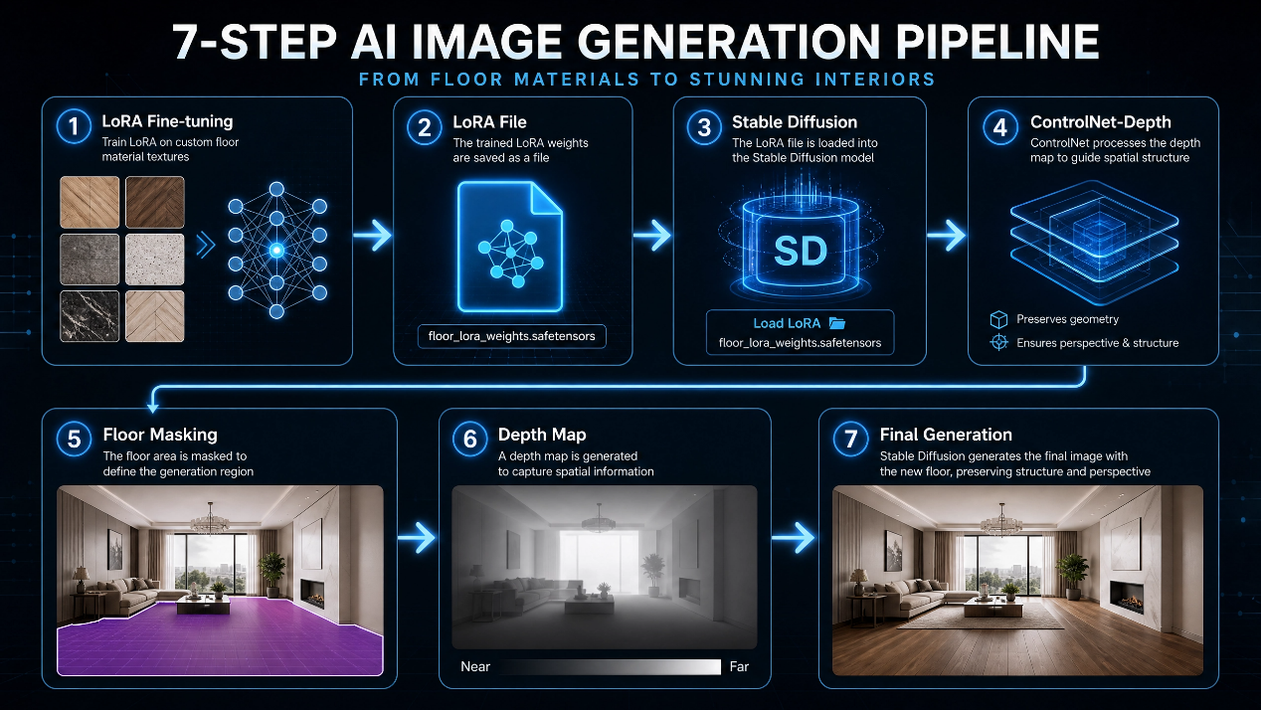
Figure 1: 4.3.7Floor Replacement Using LoRA, Stable Diffusion, and ControlNet-Depth
The benefit of this design is that LoRA provides material-specific visual knowledge, Stable Diffusion performs image generation, and ControlNet-Depth preserves the spatial structure of the original scene.
The use of LoRA and ControlNet-Depth together provides two complementary forms of control. LoRA controls the learned visual style or material appearance. It teaches the model what a specific material should look like. ControlNet-Depth controls the spatial structure. It guides the generation process so that the new floor follows the perspective and depth of the original room. Without LoRA, the generated floor may not match the desired material accurately. Without ControlNet-Depth, the generated floor may ignore the room geometry or appear inconsistent with the scene perspective.
This combination was therefore necessary for the project. The goal was not only to generate an attractive floor texture, but to place that texture inside the original room in a way that respects the spatial layout. This makes the floor replacement path more advanced than a simple image-to-image generation process.

Room Redesign and Style Selection:
The redesign feature allows the user to transform the visual style of the room according to a selected design style, such as Modern, Boho, or Scandinavian. This task differs from wall recoloring and floor replacement because it targets broader interior elements such as furniture, decor, and style-related visual features.
The methodology used in this path is based on protecting the architectural structure of the room. The walls, floor, and ceiling are extracted using SegFormer and treated as protected regions. These masks are subtracted from the image, and the remaining regions are considered editable areas. This approach avoids the need to segment every furniture item separately. It also helps preserve the basic geometry of the room while allowing the model to modify interior elements.
After identifying the editable regions, a prompt is constructed according to the selected style. The generative model then uses Stable Diffusion with ControlNet-Depth to produce a redesigned version of the room. ControlNet-Depth is important because it prevents the generative model from changing the perspective or geometry too aggressively. The depth map acts as a structural guide, while the text prompt controls the visual style.
The redesign path is designed to balance creativity and preservation. A generative model can easily create a new room, but the challenge is to redesign the existing room without losing its structure. This is why the system protects walls, floors, and ceilings before applying generative editing. By protecting these regions, the output remains connected to the original image, while the editable regions can be modified according to the selected style.
The style prompt plays a major role in this stage. It translates the user’s design preference into visual guidance for the generative model. However, the prompt alone is not sufficient, because text does not provide exact spatial constraints. Depth guidance and masks are needed to maintain structure. Therefore, the redesign path combines semantic masks, depth maps, and text prompts. This allows the system to produce style-based redesigns while reducing uncontrolled changes.
This path reflects the general philosophy of the project: the system does not regenerate the entire image randomly, but performs controlled editing based on semantic masks, protected regions, style prompts, and depth guidance.

Loss Function and Training Algorithms:
The loss functions and training algorithms differ depending on the model and task. Since the system is composed of multiple models, each model is trained or fine-tuned according to the nature of its task.
For room-type classification, the task is formulated as a multi-class classification problem. The model receives an image and predicts the probability of each room class. A common loss function for this type of task is Cross-Entropy Loss, which compares the predicted class distribution with the true class label. Optimizers such as Adam or AdamW are commonly used because they are suitable for training deep neural networks and Transformer-based architectures.
For semantic segmentation, the task is performed at the pixel level. Each pixel is classified into one of the semantic classes: wall, floor, ceiling, or background. Therefore, the training loss is also classification-based, but it is applied across all pixels in the segmentation map. The goal is to train the model to produce a semantic map that can later be converted into usable masks for editing.
For diffusion-based generation, the training objective is different. Stable Diffusion does not learn a direct class label. Instead, it learns how to remove noise from a noisy latent representation. The model is trained to predict the noise or denoised representation at different diffusion steps. In conditional diffusion, the denoising process is guided by a conditioning signal such as text, depth, or another visual condition.
For LoRA training, the base Stable Diffusion model is frozen, and only the low-rank adaptation parameters are trained. This makes training more efficient and allows multiple material-specific adapters to be created. In this project, LoRA is used to learn visual characteristics of different floor materials, such as ceramic, wood, and stone. During inference, the required LoRA file is loaded with Stable Diffusion and ControlNet-Depth to generate the selected floor type.
From a methodological perspective, the training objectives reflect the role of each model. Classification loss teaches the model to assign an image to the correct room type. Segmentation loss teaches the model to assign each pixel to the correct class. Diffusion loss teaches the model to reconstruct clean visual content from noisy representations. LoRA fine-tuning adapts a large generative model to a narrower visual domain without retraining all parameters.
This separation of objectives is important because it prevents the system from forcing one learning objective to solve all tasks. Instead, each component is trained or fine-tuned according to the type of information it must learn. The final system then integrates these specialized components during inference.

Detailed Explanation of the Pipeline:
The system relies on several processing pipelines. Each pipeline corresponds to one of the main system functions. Although the details differ from one function to another, all pipelines follow the same general principle: the system first analyzes the image, extracts the required mask or structure, applies the selected model, and returns the final edited image.

General System Pipeline:
The general system pipeline begins when the user uploads an image through the interface. The image is passed to the backend, where the room type is classified using Swin Transformer. After that, SegFormer extracts the basic semantic masks. If the selected operation requires a more precise mask, SAM is used for refinement or interactive selection. Finally, the system calls the appropriate editing module based on the user’s selected operation.
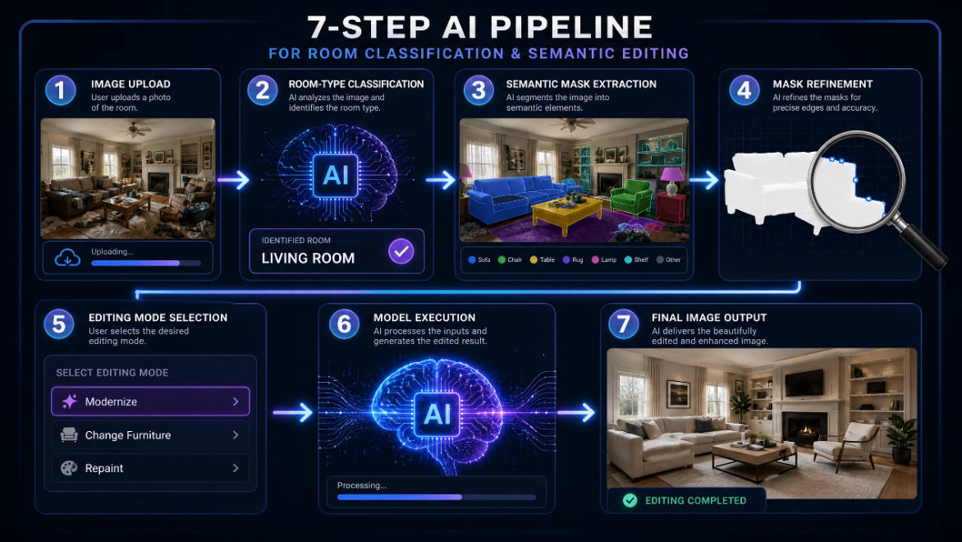
The general pipeline can be represented as follows:
Figure 2: 4.3.10.1 General System Pipeline

This general pipeline provides flexibility because each editing mode can use the same initial analysis while applying a different final processing path.

Wall Color Changing Pipeline:
The wall color changing pipeline is designed to recolor the wall while preserving the original shadows and lighting. The steps are as follows:
- The user uploads the image and selects the target wall color.
- The image is resized while preserving the aspect ratio.
- SegFormer extracts the initial wall mask.
- Morphological operations remove noise and fill gaps in the mask.
- SAM refines the wall boundaries.
- A final wall mask is constructed.
- The image is converted to LAB color space.
- The a and b channels are modified inside the wall mask.
- The L channel is preserved to maintain illumination.
- Gaussian Blur is applied to the mask.
- The recolored wall is blended with the original image.
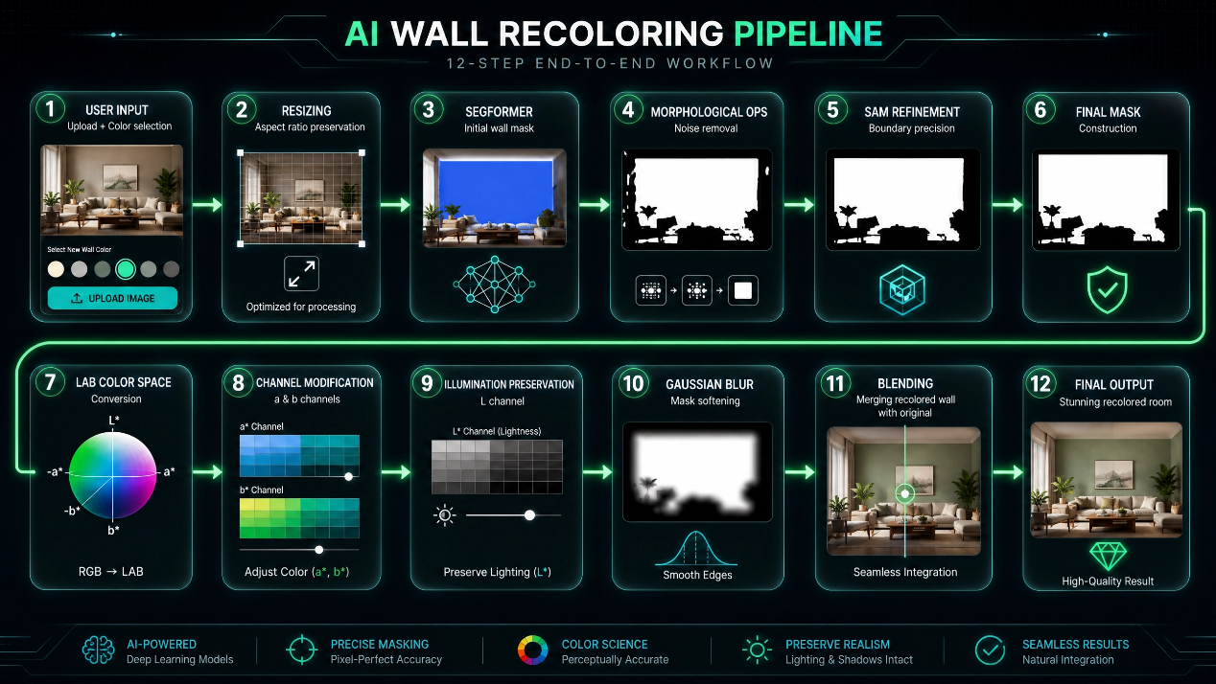
- The final recolored image and mask are returned.
Figure 3: 4.3.10.2 Wall Color Changing Pipeline

This pipeline ensures that the color modification is localized and visually smooth.

Floor Replacement Pipeline:
The floor replacement pipeline is divided into training and inference.
During training, floor images are collected and organized according to material type. Each image is described using a JSON file, and the JSON entries are converted into captions. These image-caption pairs are used to fine-tune Stable Diffusion using LoRA. At the end of the training stage, a LoRA file is produced for each floor material.
During inference, the user selects the desired floor type. The system extracts the floor mask using SegFormer and extracts the depth map using Depth Anything V2. Stable Diffusion, ControlNet-Depth, and the appropriate LoRA file are loaded together. The model then generates a new floor material inside the floor region while preserving the room perspective.
The pipeline can be summarized as follows:
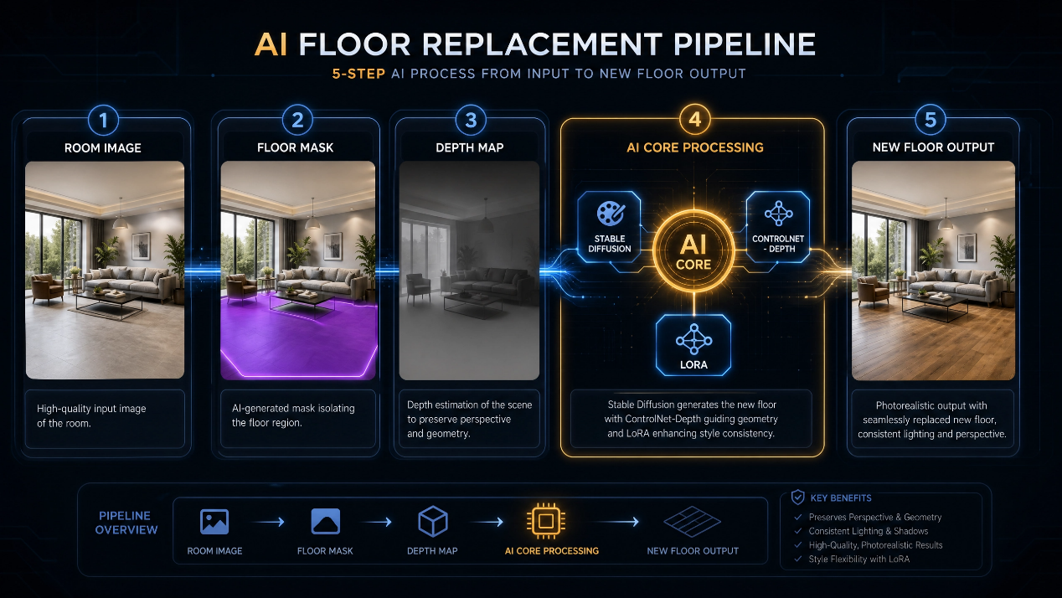
Figure 4: 4.3.10.3 Floor Replacement Pipeline

Object Removal Pipeline:
The object removal pipeline is interactive. The user selects a point on the object to remove. SAM uses this point to generate the object mask. The mask is refined and passed to LaMa, which fills the removed region.


The pipeline is as follows:
Figure 5: 4.3.10.4 Object Removal Pipeline
This path allows the user to remove objects without manually drawing a mask.

Room Redesign Pipeline:
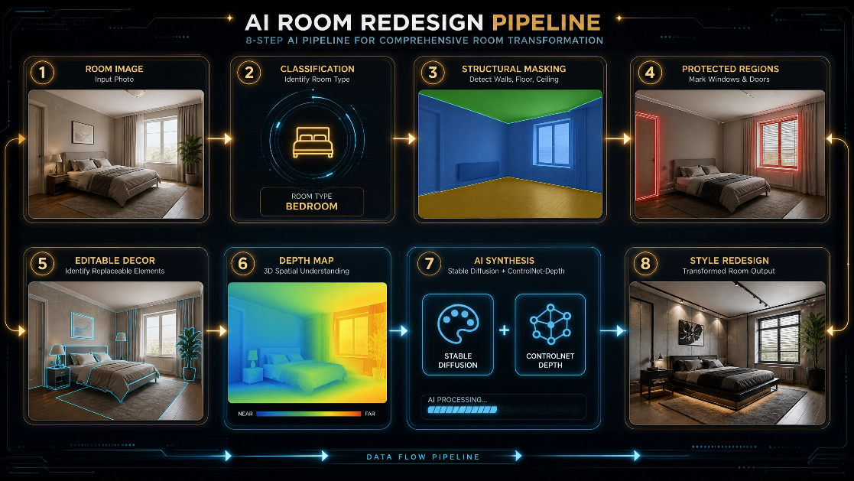
The room redesign pipeline modifies interior elements according to a selected style. The system first extracts the wall, floor, and ceiling masks using SegFormer. These regions are protected because they represent the main architectural structure. The remaining regions are considered editable interior elements. Depth Anything V2 extracts the depth map, and Stable Diffusion with ControlNet-Depth generates the redesigned image based on the selected style prompt.
Figure 6: 4.3.10.5 Room Redesign Pipeline

This path is designed to modify the visual style while preserving the main room structure.

Datasets Used:
Data plays a central role in the proposed system. The quality of the trained and fine-tuned models depends strongly on the quality, organization, and diversity of the data. Since the system performs multiple tasks, different datasets were required for different components: room-type classification data, semantic segmentation data, and floor-material data.
The datasets used in this project were not treated as a single homogeneous data source. Each task required a different type of data and a different annotation strategy. Room classification required image-level labels. Semantic segmentation required pixel-level masks. Floor replacement required image-caption pairs and structured material descriptions. This diversity of data types reflects the multi-task nature of the proposed system.
The most difficult dataset to prepare was the floor replacement dataset. This difficulty was not only related to the number of images, but also to the lack of structured and realistic annotations. A useful floor dataset for generative editing must describe properties that are visually important, such as pattern, finish, tile shape, layout, grout, and material type. These properties are not usually available in public datasets, which is why manual annotation was necessary.

Room-Type Classification Data:
The room-type classification dataset contains indoor room images labeled according to room class. This dataset is used to train the Swin Transformer classifier. Each image is associated with a room category, allowing the model to learn the visual patterns that distinguish different room types.
Before training, the images are preprocessed. They are resized to the required input size, converted to RGB format, and normalized according to the model requirements. This preprocessing ensures that the input images have consistent dimensions and value ranges.
The classification dataset is used only in the first stage of the system. It does not directly modify the image, but it provides contextual understanding. This context can later support editing decisions, style selection, or interface behavior.

Semantic Segmentation Data:
The semantic segmentation dataset is used to train SegFormer. The target classes are wall, floor, ceiling, and background. These classes were selected because they are the most relevant to the editing operations supported by the system.
The wall class is required for wall recoloring. The floor class is required for floor replacement. The wall, floor, and ceiling classes are required in redesign to protect the architectural structure of the room. The background class supports separation between relevant and non-relevant regions.
Additional classes were tested during development, but they were not adopted in the final methodology because they did not improve the practical redesign process. Instead, the system uses the basic structural masks and derives editable regions by subtracting protected areas from the image.

Floor Replacement Data:
Floor replacement required a custom dataset because ready-made realistic datasets for this task were not available. The goal was not only to collect floor images, but to collect images with enough descriptive information to support LoRA fine-tuning.
The dataset was divided into three main categories:
- Ceramic floors
- Wood floors
- Stone floors
Approximately 400 images were collected for each category. Since this amount is not sufficient to train a complete generative model from scratch, LoRA was used as a lightweight fine-tuning method. To improve the training quality, each image was accompanied by a structured JSON description.
The JSON files include detailed material information. For example, the stone dataset contains fields such as material, surface, base color, secondary color, vein color, stone type, pattern, finish, tile shape, layout, grout existence, grout color, and grout width. These fields allow the system to generate detailed captions for training.
This manual data construction was one of the most important parts of the project. Since floor replacement depends heavily on material appearance, the model needs captions that describe visual properties precisely. A caption such as “stone floor” is too general, while a caption that describes slate, matte finish, irregular tiles, gray base color, and wide grout provides richer supervision for the model.

Data Preprocessing:
The preprocessing steps differed according to the dataset type.
For classification data, images were resized, converted to RGB, and normalized. This allowed the classifier to receive consistent input.
For semantic segmentation data, image-mask consistency was checked. The image and its corresponding mask had to have compatible dimensions. The class labels were also unified to match the required categories: wall, floor, ceiling, and background.
For floor data, preprocessing was more detailed. The images were organized by material category. Missing or incorrect files were checked. JSON files were used to generate captions automatically or semi-automatically. Each image was paired with a text file containing its caption. The data was then copied to the Google Colab training environment to speed up reading during training. Outputs, checkpoints, and logs were saved in Google Drive.
Preprocessing was necessary to reduce inconsistencies between images and captions. In generative fine-tuning, inconsistent captions may confuse the model. For example, if a stone floor is described only as “floor,” the model may not learn the specific visual characteristics of stone. If the caption includes material type, finish, color, tile shape, and layout, the model receives a stronger learning signal. Therefore, the preprocessing stage was not limited to resizing images; it also included organizing visual and textual information in a consistent training format.
Data organization was also important for reproducibility. By storing image names and material properties in JSON files, the dataset became easier to inspect, update, and extend. New floor images can be added later by following the same structure. This makes the dataset design scalable for future development.
These preprocessing steps were necessary because generative fine-tuning is sensitive to data quality. Poor captions or inconsistent images may lead to weak LoRA results.

Tools Used:
The implementation of the system relied on several tools and libraries:
- Python was used as the main programming language.
- PyTorch was used for deep learning model execution and training.
- Transformers was used for SegFormer and its image processor.
- ONNX Runtime was used to execute SegFormer efficiently in the wall-painting service.
- OpenCV was used for image processing, morphological operations, mask cleaning, Gaussian Blur, and color-space conversion.
- PIL was used for image loading and saving.
- Segment Anything was used for SAM-based mask generation and refinement.
- LaMa was used for image inpainting in object removal.
- Stable Diffusion was used for generative editing.
- ControlNet-Depth was used to preserve geometric structure during generation.
- Depth Anything V2 was used to extract depth maps from single RGB images.
- Kohya sd-scripts was used for LoRA training.
- Google Colab and Google Drive were used for dataset preparation, LoRA training, storage, and output management.
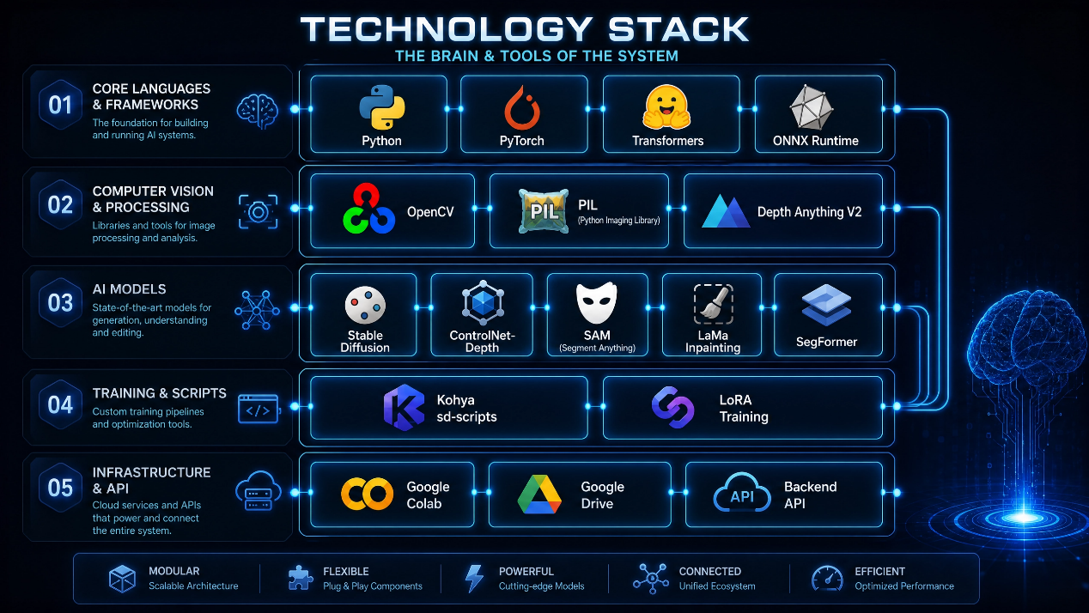
- A Backend API was used to connect the user interface with the processing services.
Figure 7: 4.3.11.5Tools Used

4.4 Chapter Conclusion and Research Contribution:
This chapter presented the methodology adopted in building the proposed system for interior space enhancement and redesign. The system was designed as an integrated multi-stage pipeline rather than a single model. This design was necessary because the problem includes several subtasks: understanding the room type, extracting semantic regions, refining masks, removing objects, changing wall color, replacing the floor, and redesigning the room.
The main research contribution lies in combining semantic understanding with controlled generative editing. Swin Transformer is used to classify the room type. SegFormer is used to extract the main structural masks. SAM is used to refine masks and support user-guided object selection. LaMa is used to remove objects and fill missing regions. LAB color-space processing is used to recolor walls while preserving shadows. LoRA is used to customize Stable Diffusion for specific floor materials. ControlNet-Depth is used to preserve perspective during generation.
Another important contribution is the construction of a custom dataset for floor replacement. Because suitable ready-made datasets were not available, images were collected manually for ceramic, wood, and stone flooring. Detailed JSON descriptions and captions were created to support LoRA fine-tuning. This step was essential because floor materials contain visual details that cannot be learned effectively from weak or general captions.
The proposed methodology also provides interpretability. Each stage has a clear function and can be analyzed separately. If the wall recoloring result is inaccurate, the issue can be traced to the wall mask, the SAM refinement step, or the color blending step. If floor replacement fails, the issue may be related to the floor mask, the depth map, the LoRA quality, or the generation prompt. This interpretability is important in applied AI systems because it allows debugging and improvement at the component level.
The system also demonstrates the importance of combining data-driven models with rule-based processing. Deep models provide high-level understanding and generation ability, while classical processing operations provide control and refinement. This hybrid methodology is more suitable for interior editing than relying only on either traditional methods or generative models.
The proposed methodology provides a practical and interpretable approach for intelligent interior design. It does not aim to regenerate the whole image randomly. Instead, it performs localized and guided modifications while preserving the original room structure, shadows, perspective, and non-targeted elements as much as possible. The system is also modular, meaning each component can be improved independently in future work. For example, the segmentation model can be improved, the LoRA dataset can be expanded, the inpainting model can be replaced, or the redesign prompts can be made more adaptive.
In conclusion, this chapter showed how the proposed system connects several modern AI techniques into one coherent pipeline that serves a practical interior design task. The methodology bridges traditional image processing, semantic segmentation, interactive mask generation, image inpainting, diffusion-based generation, and depth-guided control in a single applied framework.

Chapter Five: Research Results:

Introduction:
This chapter presents the results obtained after implementing and testing the proposed system for interior space enhancement and redesign. It evaluates the practical performance of the system and examines the extent to which the proposed models achieved the research objectives.
The system consists of several interconnected components, including Swin Transformer for room-type classification, SegFormer for semantic segmentation, SAM for mask refinement and object selection, LaMa for object removal, and Stable Diffusion combined with LoRA and ControlNet-Depth for floor replacement and room redesign. Since each component produces a different type of output, a single evaluation metric is not sufficient to assess the whole system.
Therefore, a multi-level evaluation methodology was adopted. Quantitative metrics were used for tasks with labeled reference data, such as room classification and semantic segmentation. These metrics include Accuracy, Precision, Recall, F1-score, Mean IoU, and Mean Accuracy. For generative and editing tasks, such as wall recoloring, floor replacement, object removal, and redesign, the evaluation relied mainly on visual and analytical assessment, supported by available numerical indicators such as Mask Coverage, Texture Variance, and SSIM Halo. This approach is suitable because some visual editing tasks do not have one fixed Ground Truth output, but may produce multiple acceptable results.

Tools Used and Evaluation Methods Adopted:
The proposed system was implemented using a set of programming tools and libraries suitable for computer vision, deep learning, and visual generation tasks. The main tools used include Python, PyTorch, Transformers, OpenCV, PIL, ONNX Runtime, Segment Anything, LaMa, Stable Diffusion, ControlNet, and Kohya sd-scripts for LoRA training. Google Colab and Google Drive were also used for training the LoRA models related to floor materials, organizing files, and storing outputs.
The evaluation process relied on two main types of evaluation methods.
The first type is Quantitative Evaluation, which is used when the outputs can be compared against correct values or labeled test data. This includes room-type classification and semantic segmentation. In this case, precise numerical metrics can be calculated to reflect model performance.
The second type is Qualitative Evaluation, which is used for tasks that produce edited or generated images and do not have one fixed Ground Truth output. This includes wall recoloring, floor replacement, object removal, and room redesign. In these tasks, the result is evaluated by inspecting image realism, boundary quality, shadow preservation, perspective preservation, and whether non-targeted regions remained unchanged.
The reason for adopting this dual evaluation strategy is that the system is multi-task. If only Accuracy were used, it would not be possible to evaluate floor replacement quality or object-removal realism. Similarly, if only visual evaluation were used, it would not be possible to measure the strength of the room classification model or the semantic segmentation model. Therefore, the evaluation metrics were selected according to the nature of each stage.
The following table shows the tools and metrics actually used to evaluate each part of the system:
System Component | Task Type | Implementation Tools | Evaluation Method
Room Classification | Image classification | PyTorch / Swin Transformer | Accuracy, Precision, Recall, F1-score, Confusion Matrix
SegFormer | Semantic segmentation | Transformers / SegFormer | Mean IoU, Mean Accuracy, eval_loss
SAM | Mask refinement / object selection | Segment Anything | Internal IoU, Core Recall, visual boundary evaluation
Wall Recoloring | Wall color modification | OpenCV / LAB / SegFormer / SAM | Visual evaluation, debug masks, number of pixels in the mask
Object Removal | Object removal | SAM / LaMa | Mask Coverage, Texture Variance, Mask Area Ratio, SSIM Halo
LoRA Floors | Material fine-tuning | Kohya sd-scripts / TensorBoard | Training Loss, Dataset Integrity Check, visual evaluation
Redesign | Room redesign | Stable Diffusion / ControlNet-Depth | Visual evaluation of style, structure, and perspective
Table 3: 5.2 the tools and metrics actually used

Evaluation Metrics for Room-Type Classification:
Room-type classification is a multi-class classification task. In this task, the model receives an image of an indoor room and predicts the class to which the image belongs, such as Bathroom, Bedroom, or Kitchen. The model was evaluated using standard classification metrics because these metrics are suitable for this type of output.

Accuracy:
Accuracy measures the ratio of correct predictions to the total number of samples:
$$Accuracy=\frac{TP+TN}{TP+TN+FP+FN}$$

Equation 1:5.2.1 Acuuracy
This metric represents the general performance of the model, meaning how many images were correctly classified among all test images. It is useful for providing an overall view of the model’s performance, but it does not reveal the model’s performance on each class separately, especially if the classes are not balanced.

Precision:
Precision measures how correct the predictions of a specific class are:
$$Precision=\frac{TP}{TP+FP}$$
Equation 2:5.2.1Precision
In other words, it answers the following question: among the images that the model predicted as belonging to a specific class, how many were actually correct?
This metric is important when we want to know whether the model incorrectly assigns too many images to a certain class.

Recall:
Recall measures the model’s ability to detect all images that actually belong to a specific class:
$$Recall=\frac{TP}{TP+FN}$$
Equation 3:5.2.1 Recall
In other words, it answers the question: among all images that actually belong to a specific class, how many did the model successfully detect?
This metric is important because a model may be precise when predicting a certain class, but it may still fail to detect many real samples of that class.

F1-score:
The F1-score is the harmonic mean of Precision and Recall:
$$F1=2×\frac{Precision×Recall}{Precision+Recall}$$
Equation 4:5.2.1 F1-score
This metric is highly suitable for this project because it provides a balance between the correctness of the model’s predictions and its ability to avoid missing true samples of each class. These metrics were presented in the final classification report, in addition to Macro Average and Weighted Average.

Confusion Matrix:
The Confusion Matrix is used to show the number of correct and incorrect predictions for each class. It is useful for deeper error analysis because it shows which classes are confused with each other. For example, if the model confuses Living Room with Dining Room, this will appear directly in the matrix.

Evaluation Metrics for Semantic Segmentation Using SegFormer:
In semantic segmentation, the goal is not to classify the entire image, but to classify every pixel in the image. Therefore, the evaluation metrics differ from ordinary classification metrics. In this project, SegFormer was trained on four main classes: background, wall, floor, and ceiling. These are the classes that support wall recoloring, floor replacement, and protection of architectural elements during redesign. Chapter Four explained that these classes are the essential classes on which the system depends for localized editing operations.

Mean Intersection over Union – Mean IoU:
IoU measures the amount of overlap between the predicted mask and the ground truth mask:
$$IoU=\frac{Area of Intersection}{Area of Union}$$

Equation 5: 5.2.2 Mean Intersection over Union
It can also be written as:
$$IoU=\frac{TP}{TP+FP+FN}$$
Equation 6: 5.2.2 Mean IoU
Mean IoU is the average IoU value across all classes. It is one of the most important metrics for semantic segmentation because it does not only count correctly classified pixels; it also measures how well the predicted mask overlaps with the correct mask in terms of area.
This metric is highly suitable for the project because the quality of wall or floor editing directly depends on mask accuracy. If the IoU value is low, this means that the mask does not overlap well with the real region, and therefore the modification may spread to non-targeted regions or fail to cover the required region completely.

Mean Accuracy:
Mean Accuracy measures the average pixel classification accuracy across classes:
$$Mean Accuracy=\frac{1}{N}\sum_{i=1}^{N}{Accuracy}i$$
Equation 7:5.2.2 Mean Accuracy
where N represents the number of classes.
This metric shows the model’s ability to correctly classify pixels for each class. However, it may be less informative than Mean IoU in identifying mask-overlap problems. Therefore, Mean IoU was considered the main metric for mask quality.

eval_loss:
eval_loss represents the error value on the validation set. A decrease in this value indicates that the model became better at predicting correct masks during training. However, eval_loss alone is not sufficient to evaluate mask quality visually, so it was interpreted together with Mean IoU and Mean Accuracy.

Evaluation Metrics for SAM and Mask Refinement:
SAM was used in the project to refine masks produced by SegFormer or to identify the object that the user wants to remove. It is important to clarify that SAM in this project was not always used as a final evaluation metric against Ground Truth. Instead, in some cases, it was used as a tool for mask refinement and for selecting the most suitable mask.

Internal IoU for Selecting the Best Mask:
In the integration stage between SegFormer and SAM, SAM may generate several candidate masks. Since SAM does not provide semantic meaning for the mask, SegFormer is used as a semantic reference. Therefore, the overlap between the SAM mask and the SegFormer mask is calculated to select the mask that is closest to the required region:
$$IoUinternal​=\frac{MaskSAM​∩MaskSegFormer​}{MaskSAM​∪MaskSegFormer​}$$
Equation 8:5.2.3 Internal IoU for Selecting the Best Mask
This metric is not a final evaluation against Ground Truth. Rather, it is an internal criterion for selecting the best mask. Its importance lies in preventing the selection of a geometrically accurate mask that does not represent the required region semantically.

Core Recall:
In some mask-selection steps, Core Recall can be used to ensure that the SAM mask covers the central part of the region identified by SegFormer:
$$Core Recall=\frac{∣CoreSegFormer∩MaskSAM​ |​}{​∣CoreSegFormer​∣}$$
Equation 9: 5.2.3 Core Recall
This metric is suitable when we need to ensure that the mask does not only cover the edges of the region, but also covers its main core. This is particularly important for floor and wall masks, because losing an essential part of the mask may lead to an incomplete editing result.

Evaluation Criteria for Wall Recoloring:
Wall recoloring cannot always be evaluated directly using a numerical metric because the new color is selected by the user, and there is no single Ground Truth image representing the correct result. Therefore, this task was evaluated using visual assessment and intermediate outputs saved by the system.
In the wall recoloring service, several debug images are saved to help analyze the result, such as the original image, the wall mask produced by SegFormer, the final refined mask, and the recolored output image. The number of white pixels in the mask is also used to observe the size of the targeted region. Chapter Four explained that the wall recoloring path uses the wall mask, converts the image to LAB, preserves the luminance channel L, and modifies only the color channels.
Wall recoloring was evaluated according to the following criteria:
Evaluation Criterion | Evaluation Method
Wall targeting accuracy | Checking whether recoloring remained only inside the wall
Shadow preservation | Checking whether lighting gradients remained after recoloring
Boundary smoothness | Checking that no sharp edges appeared around the wall
Preservation of other elements | Ensuring furniture, floor, and ceiling were not recolored
Realism of the output | Checking whether the wall looked natural after editing
The LAB color space is suitable for this task because RGB mixes color with illumination, while LAB allows illumination to be separated from color. Therefore, when the L channel is preserved, shadows remain visible and the wall does not appear flat or unnatural.

Evaluation Metrics for Object Removal:
In the object-removal path, SAM was used to identify the mask, and LaMa was used to complete the removed region. Several numerical indicators appeared in the code and helped evaluate the process, namely Mask Coverage, Texture Variance, Mask Area Ratio, and SSIM Halo.

Mask Coverage:
This metric measures the ratio of the mask area to the total image area:
$$Mask Coverage=\frac{Number of Mask Pixels}{Total Image Pixels}×100$$

Equation 10: 5.2.5 Evaluation Metrics for Object Removal
This metric is important because it shows the size of the object to be removed. The larger the mask, the harder the inpainting task becomes because the model needs to reconstruct a larger missing region.

Texture Variance:
Texture Variance measures the amount of variation inside the region defined by the mask:
$$Variance= \frac{1}{N}\sum_{i=1}^{N}{{(x_{i}​-μ)}^{2}}$$
Equation 11 :5.2.5 Texture Variance
If the variance value is high, this means that the region contains noticeable details or complex texture, such as a patterned floor or a rich background. If the value is low, the region is more uniform and easier to complete.

Mask Area Ratio:
This metric measures the ratio of the mask area to the image area:
$$Mask Area Ratio=\frac{Mask Area}{Image Area}$$
Equation 12:5.2.5 Mask Area Ratio

It is close to Mask Coverage, but it is often used as a relative value to help determine whether the mask is too large.

SSIM Halo:
SSIM measures the similarity between two image regions in terms of structure, illumination, and contrast:
$$SSIM=\frac{(2μ_{x}μ_{y}+C_{1})(2σ_{xy}+C_{2})}{(μ_{x}^{2}+μ_{y}^{2}+C_{1})(σ_{x}^{2}+σ_{y}^{2}+C_{2})}$$
Equation 13:5.2.5 SSIM Halo
In this project, SSIM Halo was used to examine the region surrounding the mask, not necessarily the inside of the removed region itself. Therefore, this metric must be interpreted carefully: if the SSIM Halo value is high, this means that the region around the mask was not clearly distorted after processing.

Evaluation Metrics for LoRA-Based Floor Replacement:
In LoRA training for floor materials, the main numerical metric was Training Loss extracted from TensorBoard. Training Loss is used to monitor the fine-tuning process and to ensure that the model is learning from image-caption pairs.
In diffusion models, training is usually based on minimizing the noise prediction error:
$$L=E\left[{\left\|ϵ-ϵ_{θ}(x_{t}.t.c)\right\|}^{2}\right]$$
Equation 14: 5.2.6 minimizing the noise prediction error

where ϵ represents the real noise, ϵθ\epsilon_\thetaϵθ​ represents the noise predicted by the model, and ccc represents the textual condition or caption.
However, Training Loss alone is not enough to evaluate the quality of the generated floor. The loss may be low, while the visual result may still not be ideal in terms of perspective or material realism. Therefore, Training Loss was combined with visual evaluation of the generated images after integrating LoRA with Stable Diffusion and ControlNet-Depth.
Dataset Integrity Check was also used to ensure that each image has a corresponding caption and that there are no images without descriptions or descriptions without images. This step is very important because LoRA training depends on image-caption pairs, and any inconsistency in these pairs may weaken the learning process.

Results of the Proposed Model:
- This section presents the results achieved by the proposed system in each of its processing paths. The results were divided according to the system components, because each component performs a different function and contributes to the final output in a different way.

Results of the Room-Type Classification Model:
The room-type classification model was trained using Swin Transformer on a dataset containing 14189 images distributed across seven classes. The dataset was divided into training and validation sets, where the training set contained 11351 images and the validation set contained 2838 images. The purpose of this model was to provide the system with an initial understanding of the room type before performing subsequent editing operations.
 |  | Class | Number of Images
 |  | Bathroom | 1488
 |  | Bedroom | 3257
 |  | Livingroom | 1830
 |  | dining_room | 1786
 |  | entrance | 1108
 |  | home_office | 1873
 |  | kitchen | 2847
 |  | Total | 14189
Table 4:5.3.1 Data for Room_type Classification model
The model was trained for 20 epochs, and Train Loss, Validation Loss, Train F1, and Validation F1 were tracked. The results show that the model improved gradually during training, as the F1 values increased on both training and validation data, while loss values generally decreased.
Epoch | Train Loss | Train F1 | Val Loss | Val F1
1 | 0.8846 | 0.8159 | 0.7497 | 0.8752
5 | 0.7402 | 0.8815 | 0.7588 | 0.8937
10 | 0.6307 | 0.9377 | 0.6685 | 0.9216
15 | 0.5659 | 0.9672 | 0.6031 | 0.9494
17 | 0.5403 | 0.9781 | 0.6057 | 0.9527
20 | 0.5203 | 0.9879 | 0.6066 | 0.9496
Table 5:5.3.1 Results of the Room-Type Classification Model
These results show that the model was able to learn strong representations for room classes. The Train F1 increased from 0.8159 in the first epoch to 0.9879 in the twentieth epoch. The Validation F1 reached its highest approximate value at epoch 17 with a value of 0.9527. This indicates that the model did not only learn the training data, but also generalized well to the validation data.
Class | Precision | Recall | F1-score | Support
Bathroom | 0.9829 | 0.9631 | 0.9729 | 298
Bedroom | 0.9567 | 0.9493 | 0.9530 | 651
Livingroom | 0.8981 | 0.9153 | 0.9066 | 366
dining_room | 0.9566 | 0.9888 | 0.9725 | 357
entrance | 0.9812 | 0.9414 | 0.9609 | 222
home_office | 0.9219 | 0.9440 | 0.9328 | 375
kitchen | 0.9750 | 0.9613 | 0.9681 | 569
Metric | Value
Accuracy | 0.9524
Macro Precision | 0.9532
Macro Recall | 0.9519
Macro F1-score | 0.9524
Weighted Precision | 0.9529
Weighted Recall | 0.9524
Weighted F1-score | 0.9525
Validation Samples | 2838

Table 7:5.3.1 Overall Performance Metrics of the Room-Type Classification Model

The final evaluation results show that the model achieved an overall accuracy of 95.24%, which is a strong result for a multi-class indoor room classification task. The Macro F1 and Weighted F1 values are also very close, indicating that the model did not perform well only because of larger classes, but maintained relatively balanced performance across classes. The previous report showed that the classification model achieved Accuracy = 0.9524 with Macro F1 = 0.9524 and Weighted F1 = 0.9525.
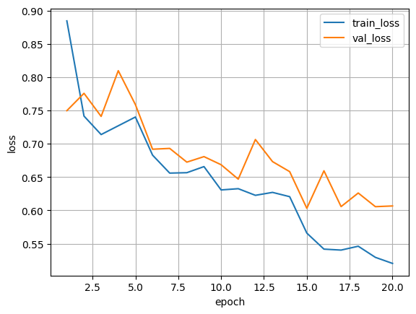
It can be observed that the Bathroom, dining_room, and Kitchen classes achieved high F1-score values, indicating that the model was able to distinguish them well. The Livingroom class was relatively lower, with F1 = 0.9066. This can be explained by the visual similarity between living rooms and other categories such as dining rooms or home offices, due to shared furniture types, open layouts, or similar decor elements.
Figure 8: 5.3.1 Training and Validation Loss Curves for the Room-Type Classification Model
Figure 8 shows the training and validation loss curves during the training of the room-type classification model. The training loss decreases gradually from the first epoch to the last epoch, which indicates that the model was learning from the training data. The validation loss also generally decreases, although it contains some fluctuations across epochs. These fluctuations are expected in validation performance and may be caused by differences between training and validation samples. Overall, the curve shows that the model improved during training and did not suffer from severe instability.

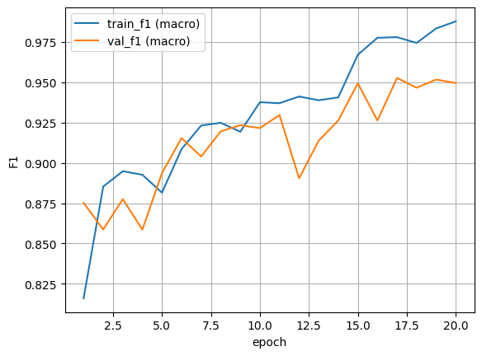

Figure 9:5.3.1Training and Validation F1-score Curves for the Room-Type Classification Model
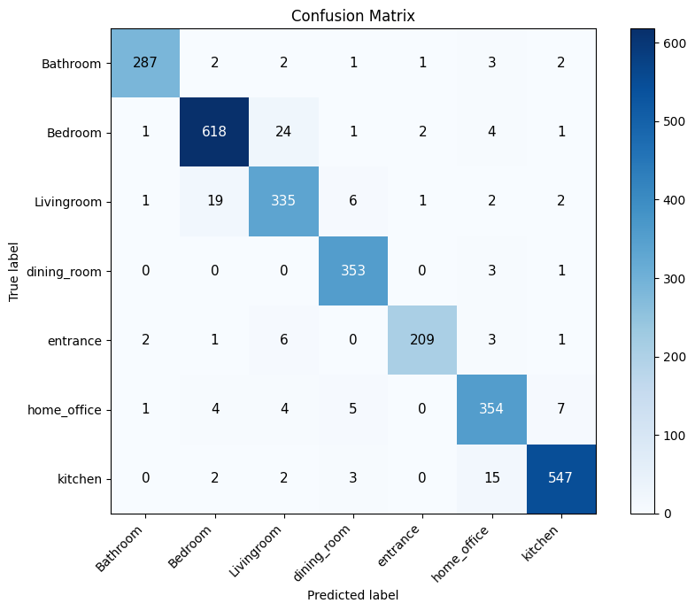
Figure 9 shows the training and validation F1-score curves. The training F1-score increased steadily across epochs, reaching a high value near the end of training. The validation F1-score also improved

Figure 10:5.3.1 Confusion Matrix for Room-Type Classification
significantly and reached its best value around epoch 17. This indicates that the model achieved good generalization on the validation set. The gap between training and validation F1-score is relatively small, which suggests that the model did not show severe overfitting.
Figure 10 presents the confusion matrix of the room-type classification model. The matrix helps identify the classes that were correctly classified and the classes that were confused with each other. Most predictions are concentrated on the diagonal, which indicates strong classification performance. Any off-diagonal values represent misclassified samples and can be used to understand which room categories are visually similar, such as Livingroom, dining_room, and home_office.

Results of SegFormer Semantic Segmentation:
Item | Number
Images | 1449
Masks | 1449
Matched Pairs | 1449
Training Pairs | 1231
Validation Pairs | 218
SegFormer was trained on a dataset consisting of images and masks. The objective was to extract the main architectural classes inside the room. The number of matched image-mask pairs was 1449, divided into 1231 training pairs and 218 validation pairs.

Table 8:5.3.2 Dataset foe segformer

Class ID | Class Name
0 | background
1 | wall
2 | floor
3 | ceiling
The classes used in training were:

Table 9:5.3.2 class for training segformaer

The model was trained for 25 epochs, and the final validation results were as follows:
Metric |  | Value
eval_loss |  | 0.2506
eval_mean_iou |  | 0.8269
eval_mean_accuracy |  | 0.9082
epoch |  | 25
Table 10:5.3.2 final Results of SegFormer
The value of Mean IoU = 0.8269 indicates that the model was able to produce good masks for the main architectural elements. This result is very important because later editing quality depends on these masks. If the wall or floor mask is inaccurate, the result of color or material replacement will be directly affected.
The value of Mean Accuracy = 0.9082 indicates that the model was able to correctly classify a high percentage of pixels. However, Mean IoU is more expressive for this task because it measures the actual overlap between the predicted mask and the correct mask, while Accuracy may be affected by the large size of some classes such as wall or background.
The importance of these results in the project lies in the fact that the objective was not to segment every piece of furniture inside the image, but to extract the main architectural elements on which the system depends: wall, floor, and ceiling. Therefore, these values are suitable for the nature of the system because they support the localized editing operations performed by the project.

Results of Integrating SegFormer with SAM:
The experiments showed that SegFormer alone can provide a good semantic mask, but it may not always provide precise boundaries, especially when there is furniture close to the wall, overlap between the floor and objects, or color similarity between surfaces. Therefore, it was integrated with SAM to improve the geometric boundaries of the mask.
In this integration, SegFormer provides the semantic meaning, meaning it identifies whether the region is a wall, floor, or ceiling, while SAM helps improve the mask shape and boundaries. This integration is very important because SAM alone does not know the semantic class of the mask, and SegFormer alone may produce less accurate boundaries. Chapter Four explained that SegFormer provides the semantic map that defines the editing logic, while SAM is used to refine the mask or select objects.
Method | Advantage | Limitation | Effect on the System
SegFormer only | Provides a clear semantic label | Boundaries may be rough | Suitable as an initial region extractor
SAM only | Provides accurate boundaries | Does not provide semantic meaning | Needs a semantic reference
SegFormer + SAM | Combines meaning and accuracy | Requires selection and processing | Best for localized editing
Table 11:5.3.3 Effect on the System
This integration was not only a technical addition; it was necessary for achieving localized editing. In wall recoloring, it helps prevent the color from spreading to furniture or windows. In floor replacement, it helps improve floor boundaries near furniture. In object removal, SAM allows user interaction and selection of the object to be removed.
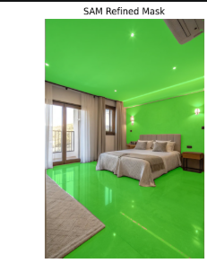
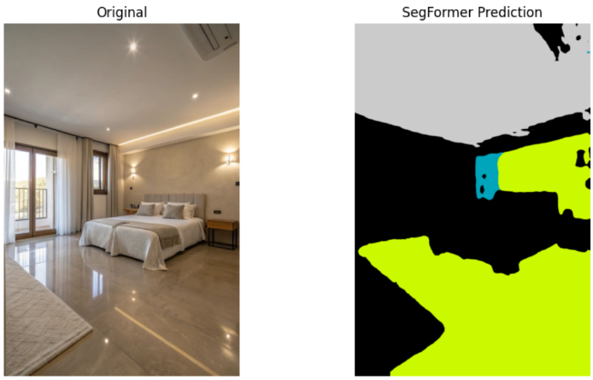

Figure 11:5.3.3 SAM mask or final mask after integration
Figure 12:5.3.3 SegFormer mask before SAM

Results of Wall Recoloring:
The wall recoloring results showed that the system is able to apply a new color to the wall while relatively preserving shadows and illumination. This is due to the fact that the system does not perform direct color replacement in RGB. Instead, it relies on the LAB color space, where the luminance channel L is preserved, and only the color channels a and b are modified.
This method is highly suitable for the wall recoloring problem because the wall in a real image is not a uniform flat surface. It contains shadows, lighting, and slight reflections. Therefore, if the color is changed directly, the sense of depth and realism may disappear. However, when the L channel is preserved, the illumination gradients remain visible, and the new color appears more integrated with the original image.
The system also saves a set of intermediate outputs that help evaluate the result:
Output | Purpose
01_input.png | Original image
02_segformer_wall_mask.png | Wall mask produced by SegFormer
03_final_sam_wall_mask.png | Final mask after refinement
04_recolored_result.png | Final result after recoloring
Table 12:5.3.3Wall Recoloring
The results can be analyzed according to the following cases:
Case | Result | Analysis
Clear and exposed wall | Very good | The mask is clear and shadows are preserved
Wall behind furniture | Partially good | Errors may appear near furniture boundaries
Wall with strong lighting | Medium to good | The color is affected by lighting but shadows are preserved
Wall color close to furniture color | Medium | It may be difficult to separate the wall accurately
Table 135.3.3 resuls analyzed
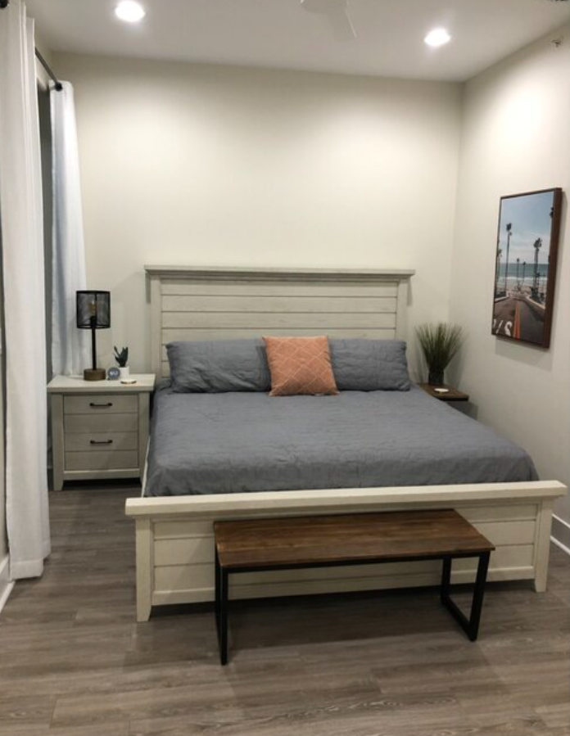
These results indicate that the success of wall recoloring depends directly on mask quality. If the mask is accurate, the LAB method produces a realistic result. If the mask is inaccurate, the problem is not in the recoloring method itself, but in identifying the targeted region.
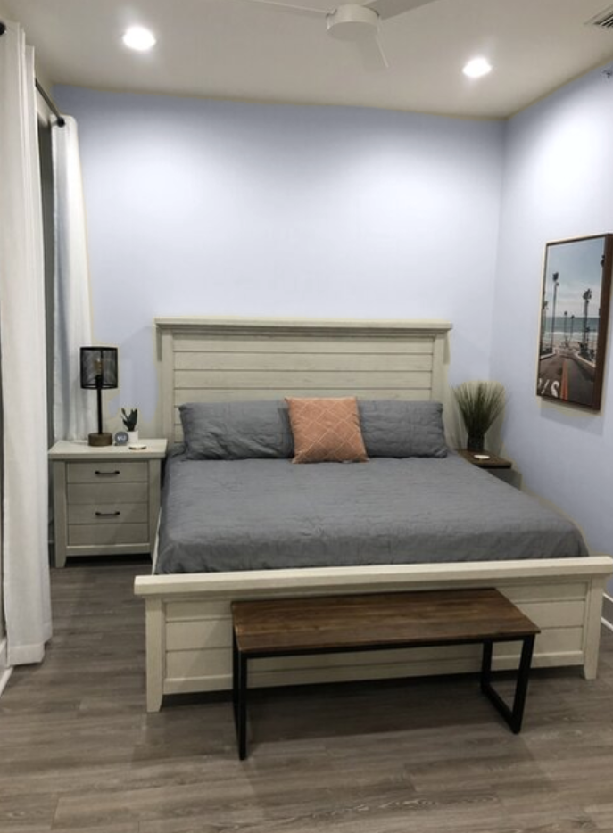
Figure 13:5.3.2 Result after wall recoloring
Figure 14:5.3.4 Original image before wall recoloring

Results of Object Removal:
The object-removal path was implemented using SAM to identify the object and LaMa to complete the removed region. This path depends on user interaction, where the user selects a point on the object to be removed. Then, the object mask is extracted and processed before being passed to the inpainting model.

In one experiment, the image size was:
1103×7361103
The selected point was:
x=370, y=330
The following numerical results were obtained:
Metric | Value
Mask Coverage | 4.66%
Texture Variance | 1219.0
Texture Variance Threshold | 800.0
Mask Area Ratio | 0.047
Area Threshold | 0.08
SSIM Halo | 1.0
Table 14:5.3.5 numerical results remove
The value Mask Coverage = 4.66% indicates that the object to be removed occupied a relatively small portion of the image. This is generally favorable because small regions are easier to reconstruct than large missing areas.
The value Texture Variance = 1219.0 is higher than the threshold 800.0. This means that the region contains noticeable details or texture and is not a completely flat area. Therefore, the inpainting process was not completely simple, because the model had to reconstruct a visually detailed region.
The value Mask Area Ratio = 0.047 is lower than the threshold 0.08. This indicates that the mask was not too large compared with the image size. This helps LaMa produce a better result because an excessively large mask may remove important visual information from the surrounding region.
Finally, the value SSIM Halo = 1.0 indicates that the region surrounding the mask remained highly similar before and after processing. However, this value must be interpreted carefully because it measures the halo region around the mask and does not necessarily measure the quality of the generated content inside the removed area. Therefore, this metric was supported by visual evaluation of the final output.

The removal path usually produces four images:
Output | Purpose
Original + Click | Shows the point selected by the user
SAM Binary Mask | Mask used for removal
Soft Mask | Smooth mask used for blending
Final Result | Final image after object removal
Table 15:5.3.5 The removal path
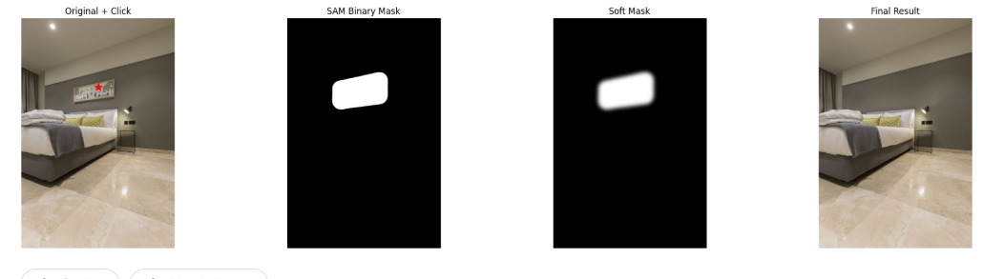
Figure 15:5.3.5 remove object

Results of LoRA Training for Floor Materials
LoRA was trained separately for each type of floor material because each material has different visual characteristics. Ceramic is usually characterized by tiles and grout lines, wood is characterized by grain direction and elongated patterns, while stone is characterized by veins and natural patterns.
Training Loss was used to monitor LoRA training, in addition to Dataset Integrity Check to ensure that each image has a corresponding caption. This step is important because LoRA depends on image-caption pairs, and any missing or mismatched image-caption pair may weaken the learning quality.

Ceramic LoRA:
Item | Value
Images | 326
Captions | 326
Images without captions | 0
Captions without images | 0
Dataset Integrity | Passed
Loss Tag | loss/current
Figure 16:5.3.6 ceramic LoRA Data

First loss values during training:
Step | Loss
1 | 0.180996
2 | 0.009776
3 | 0.003103
4 | 0.013656
5 | 0.238732
Table 16:5.3.6 ceramic loss values

Wood LoRA:
Item | Value
Valid Pairs | 194
Images | 194
Captions | 194
Images without captions | 0
Captions without images | 0
Dataset Integrity | Passed
Loss Tag | loss/current
Table 17:5.3.6 wood LoRA Data
First loss values:
Step | Loss
1 | 0.053811
2 | 0.053221
3 | 0.005875
4 | 0.003000
5 | 0.059118
Table 18:5.3.6 wood loss values

Stone LoRA:
Item | Value
Saved Pairs | 199
Valid Pairs | 197
Images | 197
Captions | 197
Images without captions | 0
Captions without images | 0
Dataset Integrity | Passed
Loss Tag | loss/current
Table 19:5.3.6 stone LoRA Data

First loss values:
Step | Loss
1 | 0.039664
2 | 0.054519
3 | 0.282644
4 | 0.005236
5 | 0.271511
Table 20::5.3.6 stone loss values
These results show that the LoRA datasets were correctly organized, as no images without captions or captions without images appeared. Ceramic also had the largest number of image-caption pairs, which may help it learn a more stable material representation than Wood and Stone because a larger number of images and captions provides more diversity during learning.
However, Training Loss alone cannot be used to judge LoRA quality completely. The loss shows that training was performed and that the model was learning, but it does not necessarily guarantee that the generated floor will be realistic or consistent with the room perspective. Therefore, these results must be supported by loss curves and generated images after applying LoRA with Stable Diffusion and ControlNet-Depth.

Results of Floor Replacement:
ControlNet-Depth to replace floors inside images. The goal of this path is to generate a new floor with a specific material while preserving the room perspective, furniture boundaries, and other elements.
The success of this task depends on three main factors:
- The quality of the floor mask produced by SegFormer.
- The quality of the LoRA trained on the required material.
- The quality of the depth map used in ControlNet-Depth.
The results were evaluated visually according to the following criteria:
Evaluation Criterion | What It Examines
Material quality | Whether the result matches the selected material
Perspective | Whether the floor follows the room depth
Mask boundaries | Whether editing remains inside the floor region
Realism | Whether the floor looks natural in the scene
Table 21:5.3.7 evaluated visually according

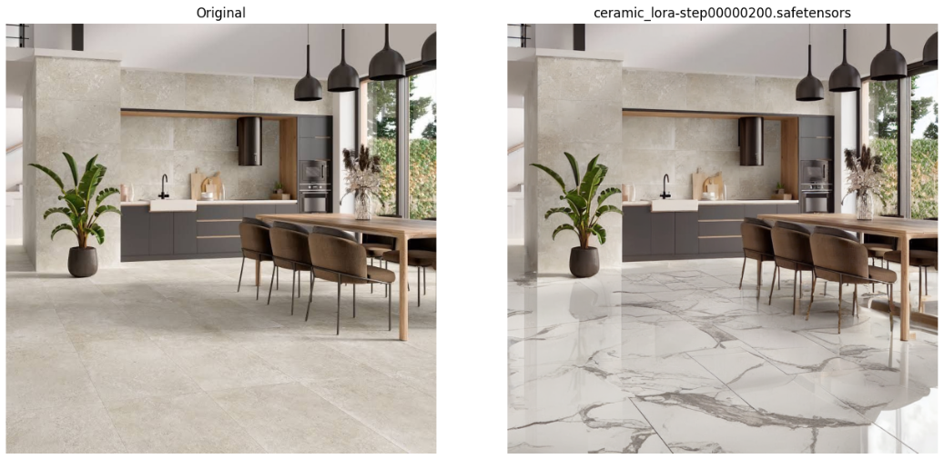
The results show that using LoRA alone is not sufficient if perspective is not preserved. Similarly, ControlNet-Depth alone does not guarantee a specific material. Therefore, combining LoRA with ControlNet-Depth was important: LoRA defines the appearance and material, while ControlNet-Depth helps control the spatial structure.
Figure 17:5.3.7 result ceramic

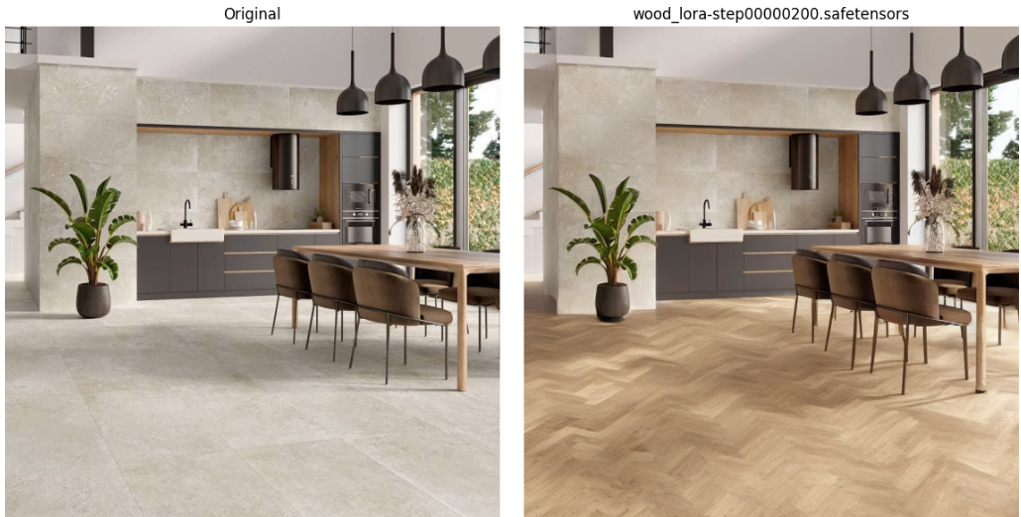
Figure 18::5.3.7 result wood

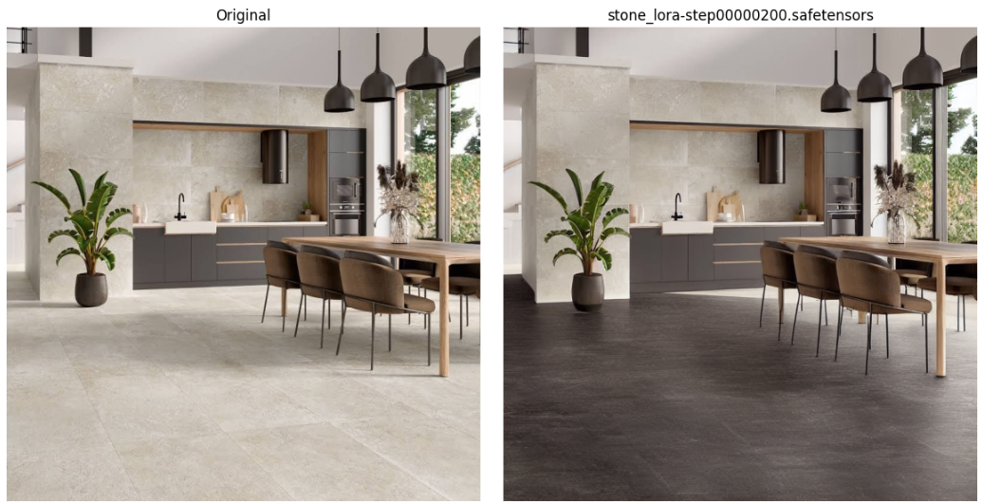
Figure 19:5.3.7 result stone

Results of Room Redesign:
In the room redesign path, the system does not modify only one surface. Instead, it changes the general appearance of interior elements according to a style selected by the user, such as Modern, Boho, or Scandinavian. To prevent the model from randomly changing the entire scene, the main architectural elements such as walls, floor, and ceiling are protected, and the remaining regions are modified according to the style prompt.
Room redesign results were visually evaluated according to the following criteria:
Evaluation Criterion | What It Examines
Material Quality | Checks whether the generated floor matches the selected material.
Perspective | Checks whether the new floor follows the room depth.
Mask Boundaries | Checks whether the editing remains inside the floor region.
Realism | Checks whether the floor looks natural within the scene.
Figure 20:5.3.8 Results of Room Redesign
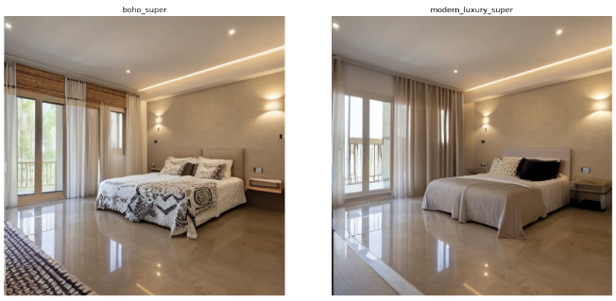
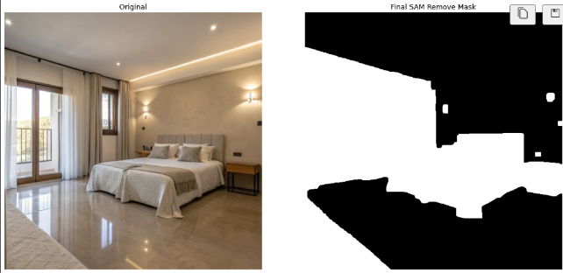
The results show that redesign worked better when the original image was clear, well lit, and did not contain highly overlapping elements. In complex images, undesired changes or inconsistencies may appear in some details. This is expected in generative models because the prompt alone is not enough to control all details. Therefore, using masks and depth maps was necessary.
Figure 21:5.3.8 boho and modern
Figure 22:5.3.8 orginal image
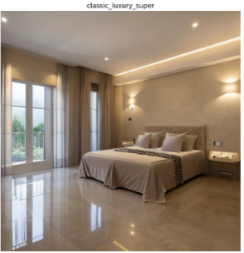
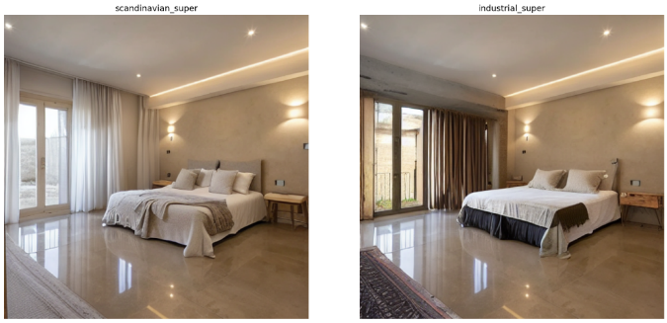
Figure 23:5.3.8 classic
Figure 24:5.3.8 scandinavian and industrial

Did the Proposed System Achieve Its Objective?
Based on the obtained results, the proposed system achieved the main objective of the project to a good extent. It successfully integrated several tasks within one platform, including room-type classification, mask extraction, wall recoloring, floor replacement, object removal, and room redesign.
The achieved results support this conclusion. The room classification model reached an accuracy of 0.9524, while SegFormer achieved Mean IoU = 0.8269 and Mean Accuracy = 0.9082. In addition, the integration of SegFormer with SAM improved mask refinement, LAB color space helped preserve shadows during wall recoloring, and SAM with LaMa enabled interactive object removal. LoRA models were also trained for Ceramic, Wood, and Stone floor materials, while ControlNet-Depth was used to guide floor replacement and redesign.
However, the system still has some limitations. The final output quality depends on mask accuracy, image quality, depth-map quality, prompt formulation, and the size of the LoRA datasets, especially for Wood and Stone.

Results Comparison:
This section compares the results of the proposed system internally, then compares it with similar existing systems. The purpose is to identify the strengths, limitations, and research value of the proposed approach.

Comparison of the Proposed Models’ Results:
Model / Path | Task | Main Metric / Evaluation | Result
Swin Transformer | Room classification | Accuracy, F1-score | Accuracy = 0.9524
SegFormer | Semantic segmentation | Mean IoU, Mean Accuracy | mIoU = 0.8269
SAM + SegFormer | Mask refinement | Internal IoU, Core Recall | Better semantic mask selection
Wall Recoloring | Wall color editing | Visual evaluation, debug outputs | Preserves shadows relatively well
SAM + LaMa | Object removal | Mask Coverage, Texture Variance, SSIM Halo | SSIM Halo = 1.0 in one experiment
LoRA Floors | Floor material generation | Training Loss, Dataset Check | Ceramic, Wood, and Stone LoRAs trained
ControlNet-Depth | Perspective preservation | Visual evaluation | Improves depth consistency
Table 22:5.4.1 Proposed Models’ Results

The comparison shows that each component contributes to a different part of the system. Swin Transformer provides room context, SegFormer extracts structural masks, SAM improves mask boundaries, LaMa supports object removal, LoRA learns floor materials, and ControlNet-Depth helps preserve perspective.
Classification and Segmentation Results:
Model | Task | Metric | Value
Swin Transformer | Classification | Accuracy | 0.9524
Swin Transformer | Classification | Macro F1 | 0.9524
Swin Transformer | Classification | Weighted F1 | 0.9525
SegFormer | Segmentation | Mean IoU | 0.8269
SegFormer | Segmentation | Mean Accuracy | 0.9082
Table 23:5.4.1Classification and Segmentation Results
The classification model achieved higher numerical performance, which is expected because image classification is less sensitive than pixel-level segmentation. The achieved SegFormer result remains suitable for the project because it provides practical masks for walls, floors, and ceilings.
LoRA Floor Dataset Comparison:
LoRA Type | Images | Captions | Dataset Integrity
Ceramic | 326 | 326 | Passed
Wood | 194 | 194 | Passed
Stone | 197 | 197 | Passed
Table 24:5.4.1 LoRA Floor Dataset Comparison
Ceramic had the largest dataset, which may support more stable generation. Wood and Stone require more samples and more diverse captions to improve future results.
Wall Recoloring Method Comparison:
Method | Used? | Main Observation
RGB Replacement | No | Weak shadow preservation
LAB Editing | Yes | Preserves luminance using the L channel
LAB + Mask Blur | Yes | Produces smoother blending
Table 25:5.4.1 Wall Recoloring Method Comparison

LAB-based editing was more suitable because it changes color while preserving lighting and shadows.
Floor Replacement Method Comparison:
Method | Used? | Main Observation
Texture Overlay | Not final | Weak perspective preservation
Stable Diffusion only | Partially tested | May change scene structure
Stable Diffusion + LoRA | Yes | Better material control
Stable Diffusion + LoRA + ControlNet-Depth | Yes | Best balance between material and perspective
Table 26:5.4.1 Floor Replacement Method Comparison
The final path combining LoRA with ControlNet-Depth was the most suitable because LoRA controls material appearance, while ControlNet-Depth helps preserve room structure.

Comparison with Previous Works:
Several similar systems exist in intelligent interior design, such as RoomGPT, REimagineHome.ai, Fotor AI Interior Design, and IKEA Kreativ. These systems often provide visually appealing outputs, but they usually operate as closed systems and do not explain how masks are extracted, how perspective is preserved, or how non-targeted regions are protected.
The proposed system is more interpretable because it follows a clear pipeline:
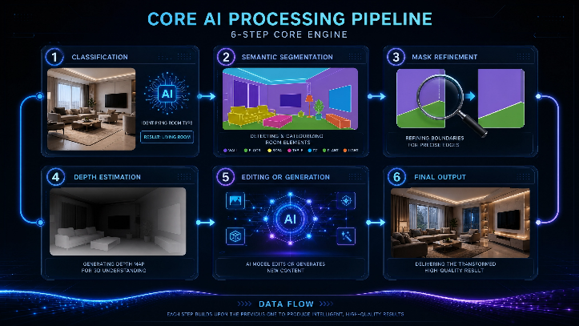

Figure 25:5.4.2 The proposed system

The proposed system is valuable from a research perspective because its stages can be analyzed and improved independently. Commercial systems may have stronger interfaces and larger datasets, but their internal methodology is usually not transparent.
Strengths
- High room-classification accuracy: 0.9524.
- Reliable segmentation: Mean IoU = 0.8269.
- Improved mask quality through SegFormer and SAM.
- Shadow-preserving wall recoloring using LAB.
- Interactive object removal using SAM and LaMa.
- Material-specific floor generation using LoRA.
- Perspective preservation using ControlNet-Depth.
- Clear multi-stage pipeline supporting several functions.
Weaknesses
- Results depend strongly on mask accuracy.
- LoRA datasets are limited, especially for Wood and Stone.
- Some generative results require visual evaluation because Ground Truth is unavailable.
- Large object removal may produce distortions.
- Floor replacement depends on depth-map quality.
- Room redesign requires precise prompts.
- More testing is needed on diverse real-world images.
Future Improvements
Future work can focus on expanding the LoRA datasets, improving captions, using SAM2, increasing SegFormer training data, improving depth estimation, refining redesign prompts, adding post-generation verification, and supporting video-based editing through mask tracking.

Chapter Summary
This chapter presented the results of the proposed system and the evaluation methods adopted. The results showed that the system achieved strong performance in room-type classification, reaching an accuracy of 95.24%. SegFormer also achieved a good semantic segmentation result with Mean IoU = 0.8269 and Mean Accuracy = 0.9082.
The results also showed that integrating SegFormer with SAM helped improve masks, and that using LAB for wall recoloring helped preserve shadows. The object-removal experiment showed that the system can identify and remove an object using SAM and LaMa, while using indicators such as Mask Coverage, Texture Variance, and SSIM Halo to analyze the quality of the process. For floor replacement, LoRA models were trained for Ceramic, Wood, and Stone materials, and the evaluation relied on Training Loss curves in addition to visual evaluation of the results.
Based on this, it can be concluded that the proposed system achieved the main objective of the project, which is to build an intelligent system capable of analyzing an indoor image and performing guided visual modifications on it. However, there is still a need to expand the datasets, improve masks, increase testing on diverse real-world images, and develop quantitative evaluation methods for generative results when suitable reference data becomes available.

Chapter Six: Conclusion

Introduction:

This chapter presents the final summary of the research by reviewing the main findings and conclusions reached during the development of the proposed system for improving indoor spaces using artificial intelligence techniques. It also discusses the extent to which the achieved results are related to the objectives defined at the beginning of the research, especially those concerned with indoor scene understanding, target region extraction, mask refinement, and guided visual editing.

This chapter also highlights the main challenges encountered during the development of the system, including the complexity of indoor room images, the difficulty of generating accurate masks, and the need to preserve realism and perspective during the editing process. In addition, it presents several future directions that can contribute to improving the system, such as enhancing segmentation accuracy, expanding the supported styles and materials, improving the user interface, and extending the system to support video-based editing instead of single-image editing
Thus, this chapter represents the final stage of the research, linking the theoretical and practical aspects of the project, clarifying the limitations of the current system, and suggesting possible directions for future development.

Conclusions:

This research concluded that building an intelligent system for editing indoor space images requires a multi-stage methodology and cannot rely on a single generative model alone. Indoor scenes contain several interconnected elements, such as walls, floors, furniture, lighting, and perspective. Therefore, visual editing requires an initial understanding of the image before applying any modification. For this reason, integrating scene analysis models with generative visual editing models represented an essential foundation of the proposed system.
The system showed that scene understanding and target region extraction are critical steps before editing. Room classification helped provide a general contextual understanding of the scene, while semantic segmentation allowed the system to identify important elements such as walls and floors. The Segment Anything Model also supported region selection and improved the practical usability of masks, both for surface editing and object removal.

Mask accuracy can be considered one of the main strengths of the system, since the generated masks provided a clear separation between target regions and areas that should remain unchanged. This helped make the editing process more controlled, as the modification was not applied to the whole image but restricted to predefined regions. This is consistent with the requirements of interior design applications, where users usually need to edit a specific part of the room, such as a wall or a floor, while preserving the remaining elements.

The research also showed that the generative editing stage needs clear guidance in order to produce suitable results. Stable Diffusion Inpainting enabled the system to edit only the selected region, while ControlNet helped preserve geometric structure and perspective, especially when dealing with floors and extended surfaces. LoRA also added the ability to adapt materials and design styles, making the results more aligned with the user’s intention instead of relying on general and uncontrolled generation.

In the object removal path, the integration of SAM and LaMa showed the possibility of removing small unwanted objects from the image and reconstructing the surrounding background in a visually acceptable way. This function adds practical value to the system, as it makes the tool not limited to changing colors or materials, but also capable of supporting additional visual editing operations needed before applying the final design.

Based on the above, the project presented a practical model for an intelligent interior design system based on guided editing rather than random generation. The value of the system lies in organizing several models within one processing pipeline, where each component performs a specific role: room classification for contextual understanding, semantic segmentation for region extraction, SAM for mask support, Stable Diffusion Inpainting for editing, ControlNet for perspective control, LoRA for material adaptation, and LaMa for object removal.

Although the system achieved good results in identifying target regions and producing masks suitable for editing, the quality of the final output remains strongly related to the visual generation stage. The results may vary depending on image complexity, required material, lighting distribution, furniture density, and scene perspective. Therefore, mask accuracy can be considered a strong foundation of the system, while generation quality, material consistency, and output controllability remain important aspects for future improvement.

Challenges and Future Work — revised version :

The proposed system faced several challenges related to visual editing of indoor spaces. The main difficulty was not the identification of target regions, since the segmentation and mask refinement stages provided suitable and usable masks. Instead, the challenges appeared more clearly in the generation stage and in the ability of the model to produce outputs that are realistic and consistent with the original image.

One of the main challenges was preserving visual consistency between the edited region and the rest of the image. When changing a floor material or wall color, the new modification must be compatible with the lighting, shadows, brightness, and general perspective of the image. In some cases, the generated material may appear less consistent with the scene if the model guidance is not sufficiently precise.

Preserving geometric perspective is another important challenge, especially when editing floors. Floors usually extend toward the depth of the image, and any new material such as wood, ceramic, or stone must follow this direction. Therefore, improving the use of depth information and ControlNet remains an important aspect for producing more realistic and stable results.

Another challenge is the diversity of materials and design styles that users may request. The system may need to support many styles, such as modern, classic, Scandinavian, industrial, or Arabic majlis, in addition to various materials such as wood, marble, stone, ceramic, and paint. As the variety of options increases, the need for specialized models or LoRA models trained on specific materials and styles becomes more important.

In the object removal path, the system performs better when the object is small and the surrounding background is simple. However, when the removed object covers a complex area, such as a large part of furniture or a region with many details, reconstructing the background becomes more difficult. Therefore, this stage can be improved in the future by using stronger inpainting models or by adding a verification stage after object removal to enhance the final result.

Future work can first focus on improving visual generation quality by using newer diffusion models or improving the settings of ControlNet and Stable Diffusion Inpainting. This would help generate more realistic materials, especially in cases that require preserving lighting, perspective, and fine details.

The system can also be expanded by building a wider library of supported materials and styles. Instead of offering a limited number of options, future versions can include more wall colors, floor materials, furniture styles, and local or international design themes. LoRA models can also be trained for specific styles such as Arabic majlis, luxury design, modern minimalist interiors, or classic interiors.

Another important future direction is improving the user interface to provide more control. For example, the user may be able to adjust the editing strength, select an exact color, compare before-and-after results, generate multiple alternatives for the same design, or manually refine the mask in special cases. Although the generated masks are good, providing additional user control increases system flexibility and makes it more suitable for practical use.

The system can also be extended to support video instead of still images only. This direction requires additional processing, because video editing needs temporal consistency between frames, so that the modified color, material, or object remains stable during motion. This can be achieved in future work through keyframe selection, object tracking, and consistent generation across multiple frames.
Finally, a more comprehensive evaluation strategy can be developed. In addition to visual evaluation, user studies can be conducted to measure user satisfaction, interface usability, and perceived realism of the results. Evaluation criteria can also include material consistency, preservation of non-target regions, and editing quality inside the selected region.

Overall, these future directions show that the proposed system provides a foundation that can be further developed. The current stage demonstrated the possibility of building a structured pipeline for editing indoor space images, while future stages can focus on improving generation quality, expanding design options, increasing user interaction, and supporting more complex scenarios such as video and multi-output design.

