[Synth 8-327] inferring latch for variable 'height_reg' ["C:/Users/jojo/Desktop/Elevator/StatusTransition.v":43]

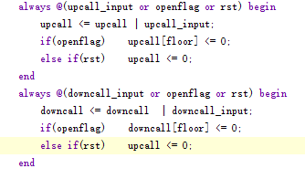

这种if… if else 分支判断 若掉了一个分支即掉了一种情况会出现这种warinning

有关referenced signal should be on a sensitivity list

[When must a signal be inserted into the sensitivity list of a process](https://stackoverflow.com/questions/8991223/when-must-a-signal-be-inserted-into-the-sensitivity-list-of-a-process)

https://stackoverflow.com/questions/8991223/when-must-a-signal-be-inserted-into-the-sensitivity-list-of-a-process