DEPARTMENT:ICT
OPTION:BTECH IN IT
NAME:NIYOMUSHUMBA JOSIANE
REG NO:25RP20948
MODULE NAME: DATA WAREHOUSE AND DATA MINING

TOPIC:Hospital / Mental Health Data Warehouse for Decision Support
1. Introduction
Hospitals and mental health centers generate large volumes of data related to patient visits, mental health diagnoses, severity levels, geographic locations, and time. Despite the importance of this data, most healthcare institutions rely on operational databases that are designed mainly for daily transactions and routine operations rather than long-term analysis and strategic decision-making. This limitation makes it difficult for healthcare managers and policymakers to analyze historical trends, identify critical mental health challenges, and plan future services effectively.To address this challenge, this project focuses on the development of a Hospital / Mental Health Data Warehouse for Decision Support, which consolidates historical mental health data into a centralized and structured repository optimized for analytical processing. The data warehouse enables decision-makers to analyze mental health visit trends over time, identify high-risk mental health conditions based on severity levels, and assess service demand across different districts. In addition, the system incorporates AI-based forecasting techniques to predict future mental health service needs, thereby supporting proactive planning, efficient resource allocation, and informed decision-making in the healthcare sector.
2. Problem Statement
Traditional hospital information systems are primarily designed to support daily operational activities such as patient registration, diagnosis, and treatment. While these systems are effective for transaction processing, they store data in isolated tables and lack integrated, historical, and aggregated views of mental health information. As a result, they do not support complex analytical queries required for strategic analysis and decision-making. Furthermore, these systems do not provide predictive insights that could help anticipate future mental health service demands. Due to these limitations, hospital management and healthcare policymakers face significant challenges in planning resources efficiently, identifying high-risk mental health patterns, and making proactive, data-driven decisions to improve mental health care delivery.
3. Objectives of the Study
3.1 General Objective
To design and implement a Hospital / Mental Health Data Warehouse that supports analytical reporting and decision-making through data visualization and AI-based prediction.
3.2 Specific Objectives
- To design a dimensional data warehouse schema for mental health data
- To integrate hospital mental health data into a centralized data warehouse
- To perform OLAP analysis for trends and risk identification
- To apply AI forecasting techniques for predicting future mental health visits
- To generate decision-support reports with graphs and summaries

4. Methodology
4.1 Data Warehouse Design
The data warehouse was designed using a star schema, which is widely adopted for analytical systems due to its simplicity and query efficiency. The schema consists of a central fact table that records mental health visits and several dimension tables that describe time, district, mental health condition, and treatment type.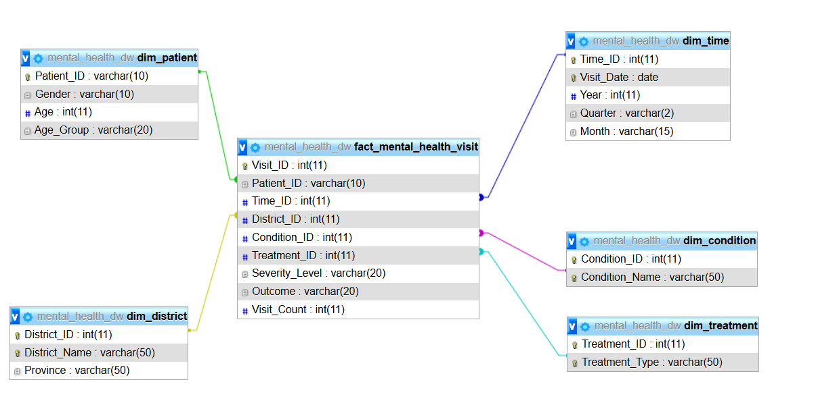

4.2 ETL Process (Extract, Transform, Load)
Extract: Mental health visit data was extracted from hospital operational data sources.
Transform: Data cleaning was performed to handle missing values, standardize severity levels, and format time attributes.
Load: The cleaned and transformed data was loaded into the MySQL-based data warehouse.
5. Tools and Technologies Used
Category | Tools / Technologies | Purpose
Database | MySQL | Data warehouse storage
Programming | Python | Data analysis and automation
Data Analysis | Pandas | Data manipulation
Visualization | Matplotlib, Seaborn | Graphs and charts
Forecasting (AI) | ARIMA (Statsmodels) | Trend prediction
Reporting | FPDF | PDF report generation
Automation | SMTP (Gmail) | Emailing reports

6. Data Analysis and Results
6.1 Trend Analysis (OLAP)
OLAP queries were used to analyze monthly mental health visits over time. This analysis revealed periods of increased service demand and provided insights into long-term trends. Such information is critical for planning staffing levels and healthcare resources.
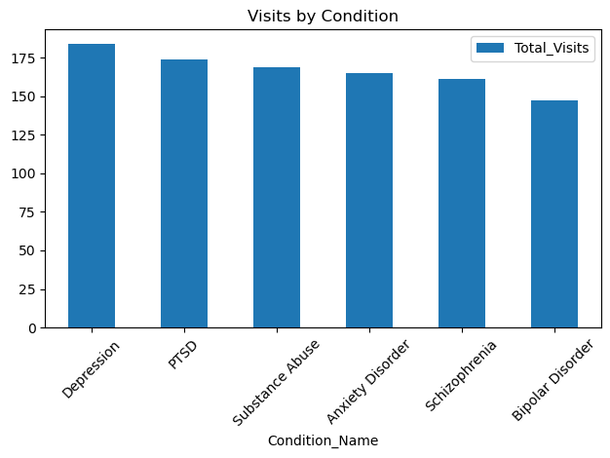
6.2 AI-Based Prediction (Forecasting)
An ARIMA (AutoRegressive Integrated Moving Average) model was applied to historical monthly visit data to forecast mental health service demand for the next 12 months. The forecasting results help hospitals anticipate future workloads and plan resources proactively.
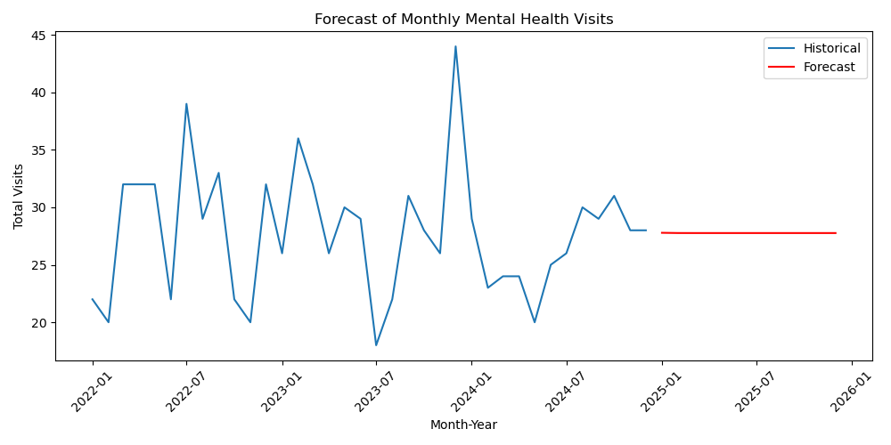
6.3 High-Risk Mental Health Conditions
A heatmap analysis was conducted to identify mental health conditions associated with higher severity levels and visit frequencies. The analysis highlighted conditions that require priority attention, specialized care, and targeted interventions. 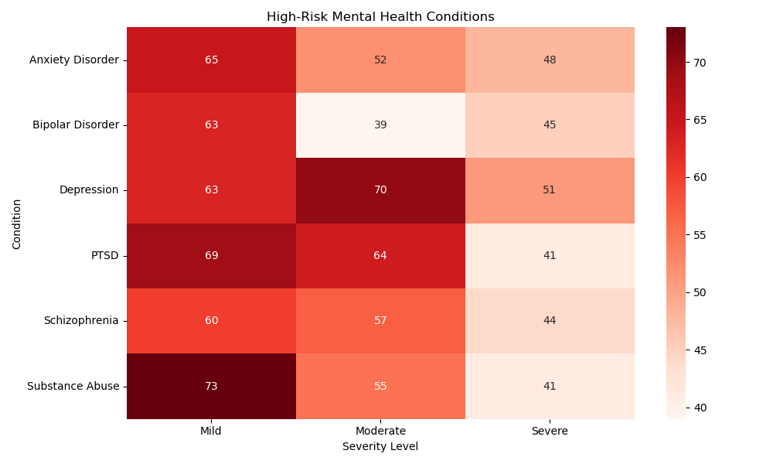
6.4 District-Wise Analysis
Mental health visits were analyzed by district to understand geographical patterns of service utilization. The results showed that some districts experience higher demand for mental health services, providing valuable guidance for equitable resource allocation.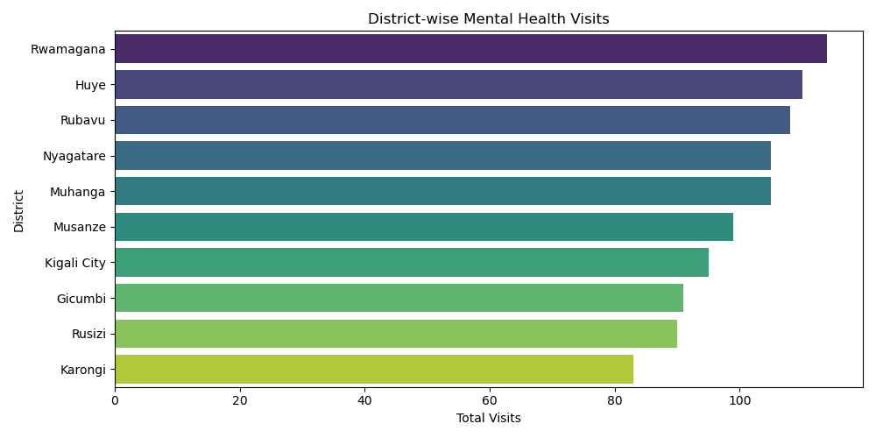
7. Decision Support Value
The developed Hospital / Mental Health Data Warehouse provides significant decision-support benefits by:
- Offering a centralized and reliable source of mental health data
- Enabling fast and flexible analytical queries using OLAP
- Visualizing trends and high-risk patterns through charts and dashboards
- Predicting future service demand using AI-based forecasting models
By transforming raw hospital data into meaningful insights, the system supports data-driven and proactive decision-making.
8. Conclusion
This project successfully demonstrates the application of data warehousing and artificial intelligence techniques in the healthcare sector. The Hospital / Mental Health Data Warehouse integrates historical data, supports analytical reporting, and applies predictive models to enhance mental health service planning. The system provides healthcare managers and policymakers with actionable insights, contributing to improved mental health care delivery and informed strategic decision-making.

