**Lab 1 linux_services.md**

1. Sudo installed all the required

2. Started services

-Edit page to display “Bridging Module Page”

**Nmap**  
nmap 192.168.188.139 -nmap shows my Apache server port 80 open

after removing the nmap scan shows no service up

**UFW**

sudo apt install ufw -y -had to install ufw on my kali linux

When ufw is enabled the nmap scan shows no open ports

Ufw is active

Now we allow port 80 tcp

Now its back, we see port 80 open

**SSH**

****will not be able to access as there is no ssh service on the port 22

**Create a new user  
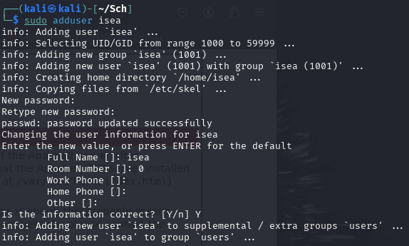**Created new user isea

****What changed is new account found

**SSH revisited**

  
same issue, no port 22 open so wont be able to connect

**Dealing with compressed archives**

Pretty good compression ratio, saves a lot of space and easier from transfer

**Extension Tasks**

**ssh in using isea

Can create file

**Challenge 2**

Standard ssh wouldn’t be interactive so a gedit would probably not work

**Challenge 3  
**Can copy files, just that I copied kali files that’s why no permision

**Challenge 4**

SCP file transfer

before

after

**Lab 2 linux_permissions.md**

sudo adduser alice  
sudo adduser bob  
sudo adduser Mallory

sudo groupadd sharedgroup

sudo usermod -aG sharedgroup alice  
sudo usermod -aG sharedgroup bob

sudo mkdir /home/shared  
sudo chown root:sharedgroup /home/shared  
sudo chmod 750 /home/shared

sudo touch /home/shared/file{1..10}.txt  
sudo chgrp sharedgroup /home/shared/file*.txt  
sudo chmod 750 /home/shared/file*.txt

sudo usermod -aG sudo Mallory

Mallory was added to the sudo group using sudo usermod -aG sudo mallory. This allowed her to execute commands as root using sudo. Although Mallory still lacked direct access to /home/shared, she could now use sudo to bypass these restrictions and read, write, or modify any files. This demonstrates that being in the sudoers group overrides standard file permission limitations.

**Lab 3 searching_file_systems.md**

Cant find the Zip so I made my own with text files inside

1. How many times does the string "verdigris" appear, enter a number only**A black background with white text

   AI-generated content may be incorrect.**  
   For mine the string "verdigris" appeared 0 times
2. What is the surname of the author of the filename “1107.txt”, the answer is case sensitive

William Shakespeare  
less gutenberg/pg1107.txt -command ran

1. What is the surname of the book author, of the file that is exactly 255258 bytes. The answer is case sensitive

None of my books were 255258 bytes

1. What is the filename of the file with the 3rd oldest creation dateA screen shot of a computer

   AI-generated content may be incorrect.  
   Show the 3 oldest and take the 3rd so pg84.txt
2. Find the word that follows the follows the text “Next day there was a surprise for Jack”: (Case sensitive-no spaces)  
   A black background with yellow text

   AI-generated content may be incorrect.  
   Man I couldn’t find in my top 10 books

Tip: I couldn’t find the proper gutenberg.tar.bz2 so my answers will be wrong, but I hope you can see I am familiar with linux