**Installing Yarn for React JS**

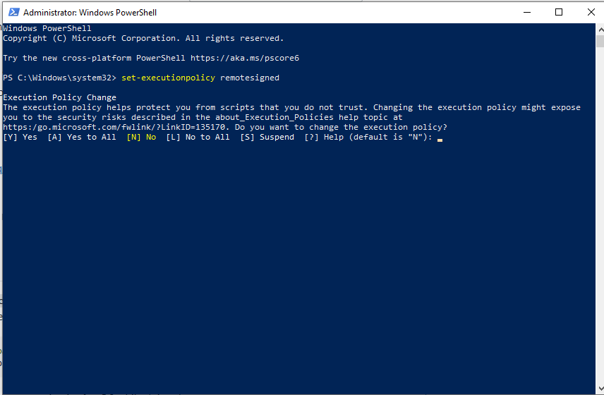

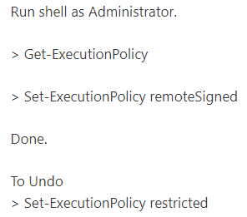

If you encounter an error like this

*“yarn : The term 'yarn' is not recognized as the name of a cmdlet, function, script file, or operable program. Check the spelling o"f the name, or if a path was included, verify that the path is correct and try again.”*

**Input this in the terminal**

npm install -g yarn

**GitHub**

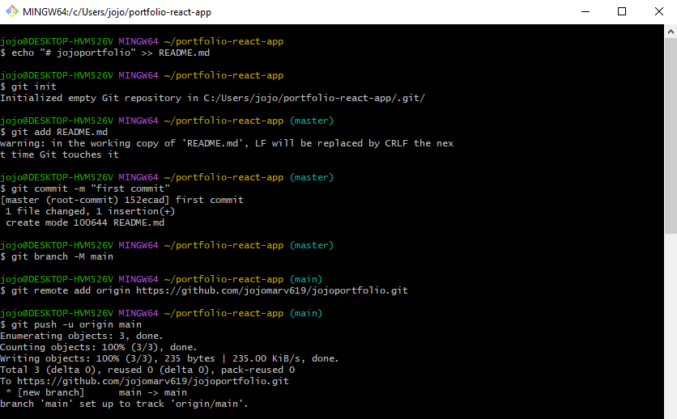

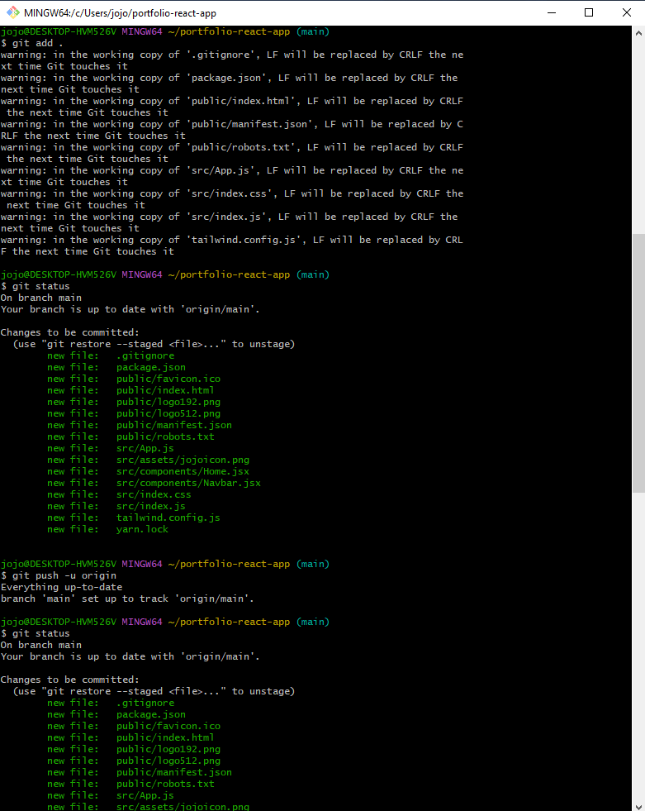

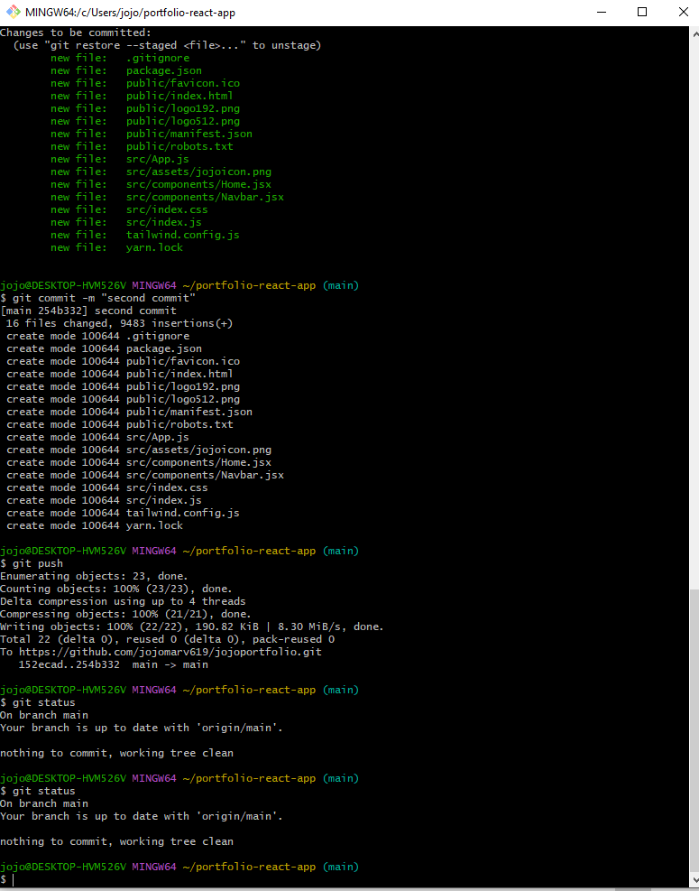

$ echo "# jojoportfolio" >> README.md

$ git init

$ git add README.md

$ git commit -m "first commit"

$ git branch -M main

$ git remote add origin <https://github.com/jojomarv619/jojoportfolio.git>

$ git status

$ git add .

$ git push -u origin