Internet Technologies and Application

Homework2

四電子三乙 B10702113 林修維

1. **Implementation**

Because I don’t have two computers, so I use Virtual box to simulate multiple devices. By the way, I choose ubuntu20.04. After this implementation, I consider that socket is such as an object, and it is also unit of client.

1. **TCP Client**

Client code

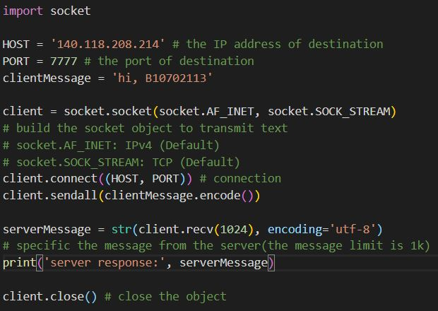

Client output



And if I want to create multi-clients, I just declare multi-objects.

1. **TCP Server**

Server code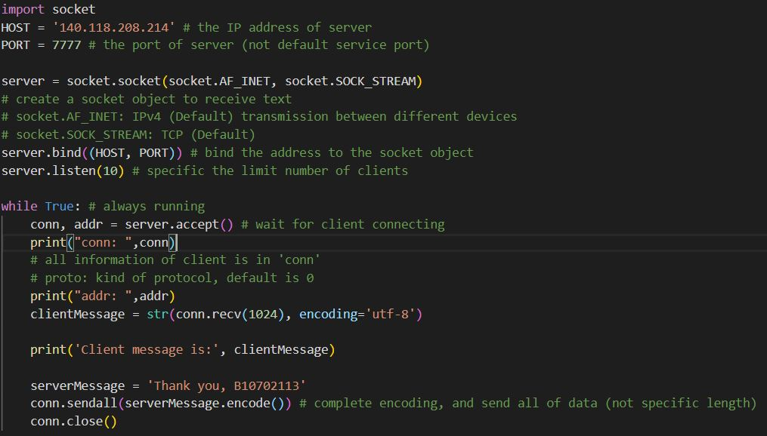

Server output

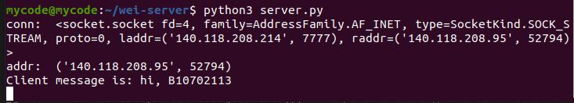

Server waits for clients connecting all the time.

1. **UDP Client**

Client code

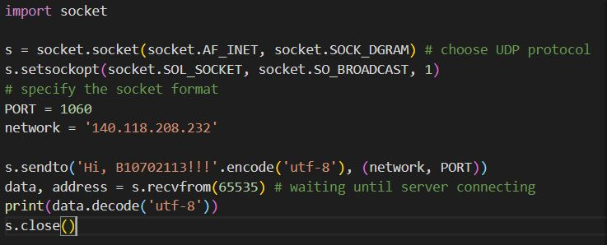

Client output



1. **UDP Server**

Server code

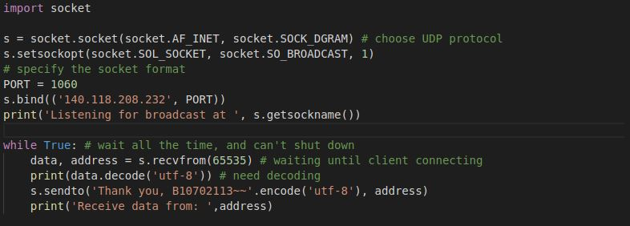

Server output

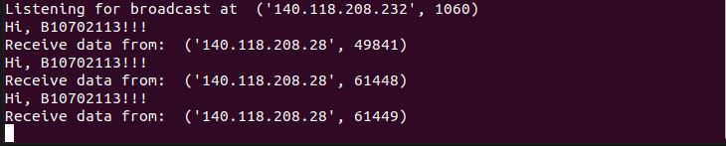

We can find that UDP architecture is easier than TCP.

1. **Test**

Change “listen(10)” into “listen(1)”

Establish multiple socket objects from the same address

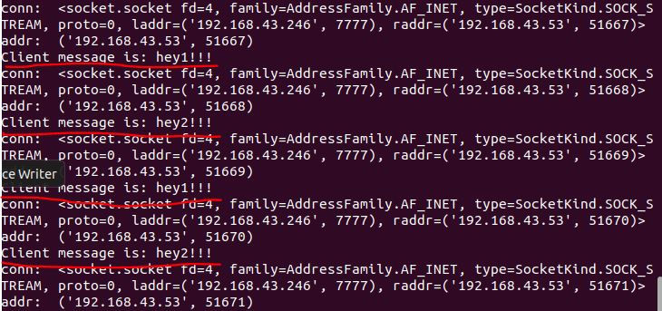

Establish multiple socket objects from the different address

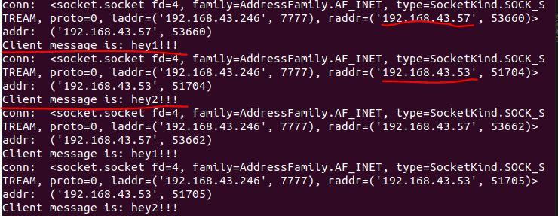

So I find that the queue only happens at “client.connect()”, but there is very low probability of two socket objects connecting at the same time.

1. **Compare TCP and UDP**

* UDP is simpler than TCP.
* UDP loses packet more easily.
* TCP is more accurate.
* UDP server doesn’t need “listen()” and “accept()”, only need “sendto()” and “recvfrom()”
* UDP uses “sendto()” and “recvfrom()” to exchange address.
* TCP uses “connect()” and “accept()” to exchange address.
* There is no “shut down” in UDP protocol.

1. **Summary**

* I think I can see socket as an object.
* I can also use “socket.AF_INET” to do local transmission.
* There is low probability of two sockets conflicting.
* UDP format and TCP format are different.
* Different sockets will have its own port.
* UDP is easier than TCP.

1. **Reference**

Socket of Python: <https://clay-atlas.com/blog/2019/10/15/python-chinese-tutorial-socket-tcp-ip/>

Interpret of socket: <https://codertw.com/%E7%A8%8B%E5%BC%8F%E8%AA%9E%E8%A8%80/374721/>

UDP Tutorial: <http://cheng-min-i-taiwan.blogspot.com/2018/11/pythonudp.html>