**1.2.1** Audio-only and Video-only (Prerecorded)

**A** **1.2.2** Captions (Prerecorded)

* + 1. Audio Description or Media

Alternative (Prerecorded)

* + 1. Captions (Live)

**AA** **1.2.5** Audio Description (Prerecorded)

* + 1. Sign Language (Prerecorded)
    2. Extended Audio Description
    3. Timing Adjustable
    4. Pause, Stop, Hide
    5. No Timing
    6. Interruptions
    7. Re-authenticating
    8. Timeouts

## **A**

**AAA**

* + 1. Bypass Blocks
    2. Page Titled

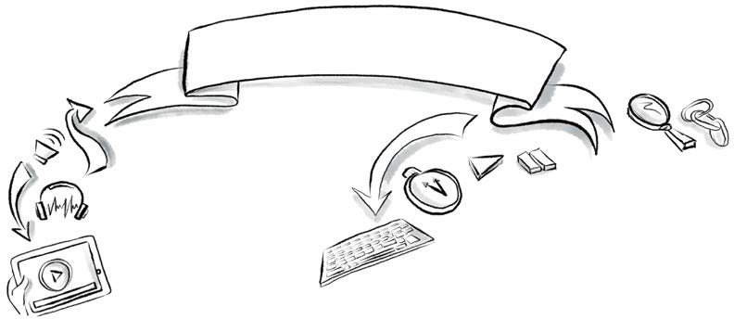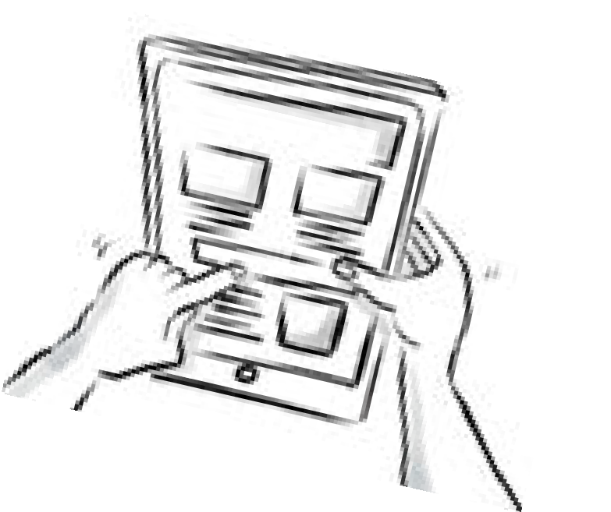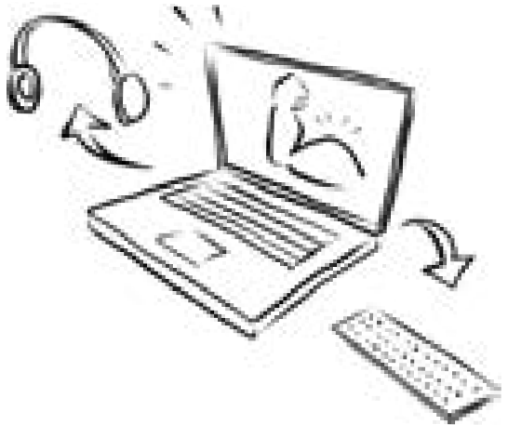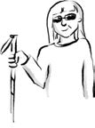

* + 1. Focus Order **A**
    2. Link Purpose

(In Context)

* + 1. Multiple Ways
    2. Headings and Labels
    3. Focus Visible **AA**

**2.4.11** Focus Not Obscured (Minimum)

**1.3.1** Info and Relationships

**A** **1.3.2** Meaningful Sequence

* + 1. Sensory Characteristics
    2. Orientation

**AAA**

(Prerecorded)

* + 1. Media Alternative (Prerecorded)
    2. Audio-only (Live)

**A** **1.1.1** Non-text Content

* + 1. Keyboard
    2. No Keyboard Trap

**2.1.4** Character Key Shortcuts

**2.1.3** Keyboard

(No Exception)

## **A**

**AAA**

* + 1. Location
    2. Link Purpose (Link Only)
    3. Section Headings
    4. Focus Not Obscured (Enhanced)
    5. Focus Appearance

## **AAA**

**AA** **1.3.5** Identify Input Purpose

## **AAA**

**1.3.6** Identify Purpose

### 1.3 Adaptable

**1.2 Time-based Media**

**1.1 Text Alternatives**

#### Information and user interface components must be presentable to users in ways they can

perceive.

* 1. **Keyboard Accessible**

User interface components and navigation must be operable.

* 1. **Enough Time**
     1. Three Flashes or Below Threshold
     2. Three Flashes
     3. Animation from Interactions

### Seizures and Physical Reactions

**A**

**AAA**

* 1. **Navigable**

**1.4 Distinguishable**

**A** **1.4.1** Use of Color

* + 1. Audio Control
    2. Contrast (Minimum)
    3. Resize Text

# Perceivable

Robust

#### Content must be robust enough that it

WCAG 2.2

# Operable Understandable

### 2.5 Input Modalities

* + 1. Pointer Gestures
    2. Pointer Cancellation **A**
    3. Label in Name

**1.4.5** Images of Text

**AA** **1.4.10** Reflow

* + 1. Non-text Contrast
    2. Text Spacing
    3. Content on Hover or Focus

#### can be interpreted reliably by a wide variety of user agents, including

assistive technologies.

Information

and the operation of user interface

must be understandable.

* + 1. Motion Actuation
    2. Dragging Movements
    3. Target Size (Minimum)
    4. Target Size (Enhanced)
    5. Concurrent Input

**AA**

**AAA**

**AAA**

* + 1. Contrast (Enhanced)
    2. Low or No Background Audio
    3. Visual Presentation
    4. Images of Text (No Exception)

### 4.1 Compatible

* 1. **Predictable**

Mechanisms

### Input Assistance



**3.1 Readable**

* + 1. On Focus
    2. On Input

**3.2.6** Consistent Help

**A**

**3.1.2** Language of Parts **AA**

* + 1. Consistent Navigation
    2. Consistent

Identification

* + 1. Change on Request

**AA**

* + 1. Unusual Words
    2. Abbreviations
    3. Reading Level
    4. Pronunciation

**AAA**

**AAA**

* + 1. Error Identification
    2. Labels or Instructions

**3.3.7** Redundant Entry

**A**

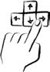**A** **4.1.1** Parsing (Removed in 2.2)

**3.1.1** Language of Page

**A**

**4.1.2** Name, Role, Value

**AA** **4.1.3** Status Messages





**Key:** New in WCAG 2.2

**AA**Success Criteria Level

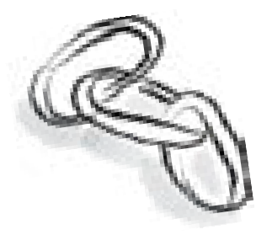

* + 1. Error Suggestion
    2. Error Prevention (Legal, Financial, Data)

**3.3.8** Accessible Authentication (Minimum)

**AA**

[intopia.digital](http://intopia.digital/)

**Visual map of Web Content Accessibility Guidelines 2.2 Based on World Wide Web Consortium documentation available at https://**[**www.w3.org/TR/WCAG22**](http://www.w3.org/TR/WCAG22)

**Licenced under Creative Commons Attribution-ShareAlike 4.0 International**



* + 1. Help
    2. Error Prevention (All) **AAA**

**3.3.9** Accessible Authentication (Enhanced)