BIT 4107 – Mobile Application Development
ENHANCED PROFESSIONAL STUDENT LOGBOOK

DUKASTOCK
B2B Mobile Marketplace — Connecting Wholesalers & Retailers in Kenya

Student Name | Eugene Goodness Ndungu

Admission Number | BIT/2025/69183

School / Faculty | School of Computing and Informatics

Programme | Bachelor of Science in Information Technology

Academic Year | 2026

Semester | Semester 2

Lecturer | ___________________________________

Phone Number | ___________________________________

GitHub Repository | https://github.com/jokacoded124/-dukastock

Test Device | Redmi Note 14 (Android)

Instructions

This logbook is used to document weekly learning activities, practical exercises, skills acquired, challenges encountered, solutions applied, and reflections. Students should complete all sections every week.

Each week contains the following sections:
- Practical Activities Undertaken — screenshots of actual work done
- Screenshots / Evidence Attached — insert real screenshots from your computer
- Tools / Software Used — list all tools used that week
- Personal Reflection — not more than 50 words

Note: Generic AI-generated reports without practical screenshots will not be accepted. All screenshots must show your own running system.

Table of Contents
Instructions 3
Table of Contents 4
Week 1: Introduction to Mobile Application Development 5
Practical Activities Undertaken 5
Screenshots / Evidence Attached 5
Tools / Software Used 9
Personal Reflection 10
Week 2: Mobile Development Environment — Firebase & Authentication 11
Practical Activities Undertaken 11
Screenshots / Evidence Attached 11
Tools / Software Used 13
Personal Reflection 13
Week 3: User Interface Design 14
Practical Activities Undertaken 14
Screenshots / Evidence Attached 14
Tools / Software Used 15
Personal Reflection 15
Week 4: Data Management — Firestore CRUD & Local Storage 16
Practical Activities Undertaken 16
Screenshots / Evidence Attached 16
Tools / Software Used 17
Personal Reflection 17
Week 5: Networking — Connectivity & Error Handling 18
Practical Activities Undertaken 18
Code Implemented 18
Screenshots / Evidence Attached 19
Tools / Software Used 20
Personal Reflection 20
Week 8: User Input and Event Handling 22
Practical Activities Undertaken 22
Screenshots / Evidence Attached 23
Tools / Software Used 26
Personal Reflection 27

Week 1: Introduction to Mobile Application Development

Practical Activities Undertaken

- Installed Android Studio Panda 4 (2025.3.4 Patch 1) on Windows 11 including Android SDK, Build Tools 37, and Android Emulator
- Installed Git for Windows and configured global user name and email for GitHub integration
- Created a GitHub account and set up the DukaStock repository with Flutter .gitignore and README
- Cloned the DukaStock GitHub repository to G:\Projects\-dukastock on the local machine
- Downloaded Flutter SDK 3.44.0-stable (Windows x64) from the official Flutter archive and extracted to G:\flutter
- Created the DukaStock Flutter project using the flutter create command with Android-only platform flag
- Opened the project in Android Studio and configured the Flutter SDK path
- Created and configured a Pixel 6 Android Virtual Device with API 37 (Android 17.0 CinnamonBun)
- Customized main.dart — changed app title to DukaStock, theme color to green, added Welcome to DukaStock! text
- Ran DukaStock app successfully on the Pixel 6 emulator
- Committed and pushed all Week 1 code to GitHub (53 objects pushed)

Screenshots / Evidence Attached

Screenshots Attached: Yes

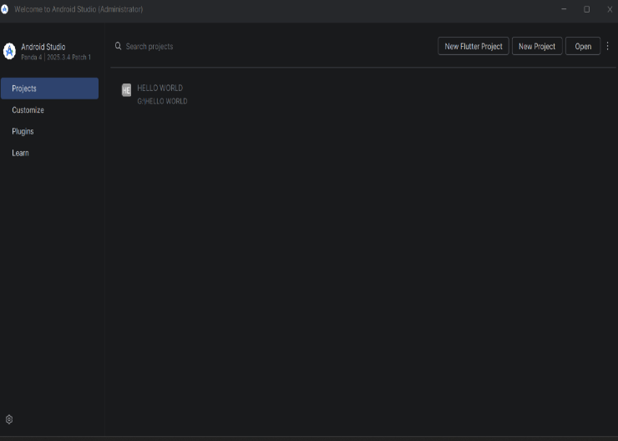
Screenshot 1: Android Studio welcome screen after installation

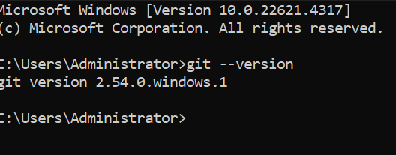

Screenshot 2: git --version output in Command Prompt

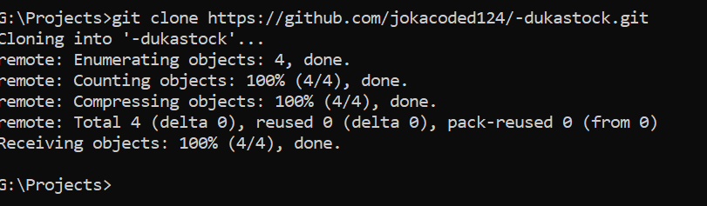
Screenshot 4: git clone and git status output in Command Prompt

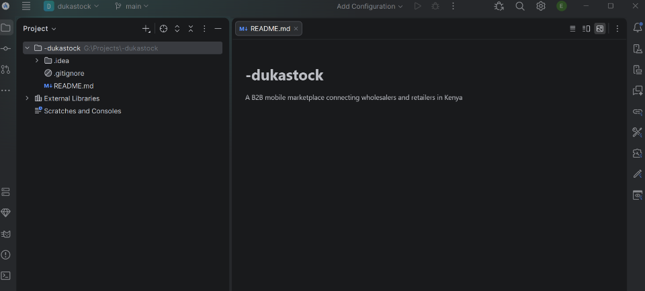

Screenshot 7: Android Studio showing DukaStock project structure and main.dart

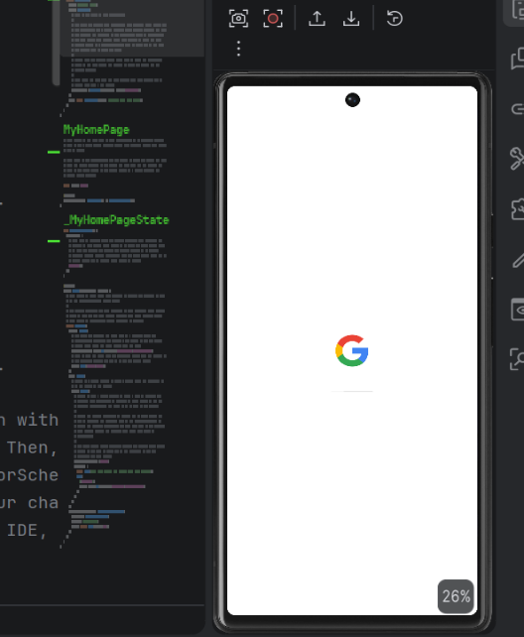

Screenshot 8: Pixel 6 Virtual Device configured in Device Manager

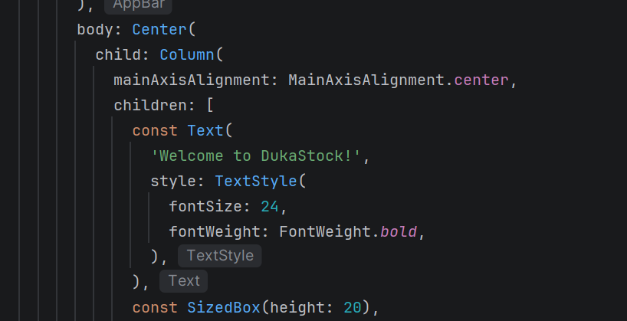

Screenshot 9: Customized main.dart code in Android Studio

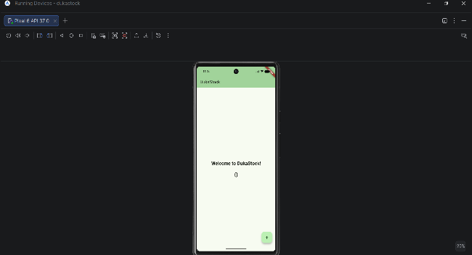

Screenshot 10: DukaStock running on Pixel 6 emulator — green theme visible

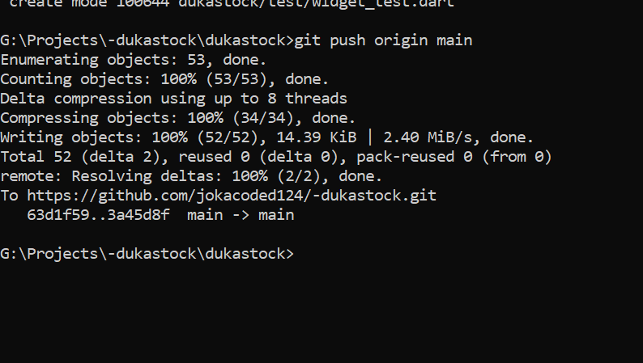

Screenshot 11: git push output showing 53 objects pushed to GitHub

Tools / Software Used

- Android Studio Panda 4 (2025.3.4 Patch 1)
- Git 2.47.0 for Windows
- GitHub
- Flutter SDK 3.44.0
- Dart programming language
- Command Prompt (Windows)
- Android SDK + Emulator
- VS Code

Personal Reflection

This week I set up the full Flutter development environment from scratch. The biggest challenge was configuring the Flutter SDK path and resolving Gradle build errors caused by syntax mistakes in main.dart. I learned that CLI tools are more reliable than GUI wizards for precise project setup

Week 2: Mobile Development Environment — Firebase & Authentication

Practical Activities Undertaken

- Created Firebase project 'dukastock' on the free Spark plan at console.firebase.google.com
- Enabled Email/Password Authentication provider in Firebase Authentication console
- Created Cloud Firestore database in Standard edition with test mode security rules, location: europe-west1
- Registered DukaStock Android app in Firebase with package name com.jokacoded.dukastock.dukastock
- Downloaded google-services.json and placed it in android/app/ folder of the Flutter project
- Added Firebase packages: firebase_core, firebase_auth, cloud_firestore using flutter pub add
- Configured project-level and app-level build.gradle.kts files with Google Services plugin
- Built professional Login screen with email/password fields, show/hide password toggle, and Firebase Auth integration
- Built Registration screen with Full Name, Email, Password fields and visual Retailer/Wholesaler role selector
- Built role-based Dashboard showing different menus for Retailers and Wholesalers based on Firestore role field
- Resolved disk space issue on C: drive (2.78GB free) using MiniTool Partition Wizard to transfer 30GB from G: drive
- Tested full authentication flow on real Redmi Note 14 Android device via USB debugging
- Verified user data saved correctly in Firestore users collection with name, email, role, and timestamp
- Pushed all Week 2 code to GitHub (19 objects pushed)

Screenshots / Evidence Attached

Screenshots Attached: Yes

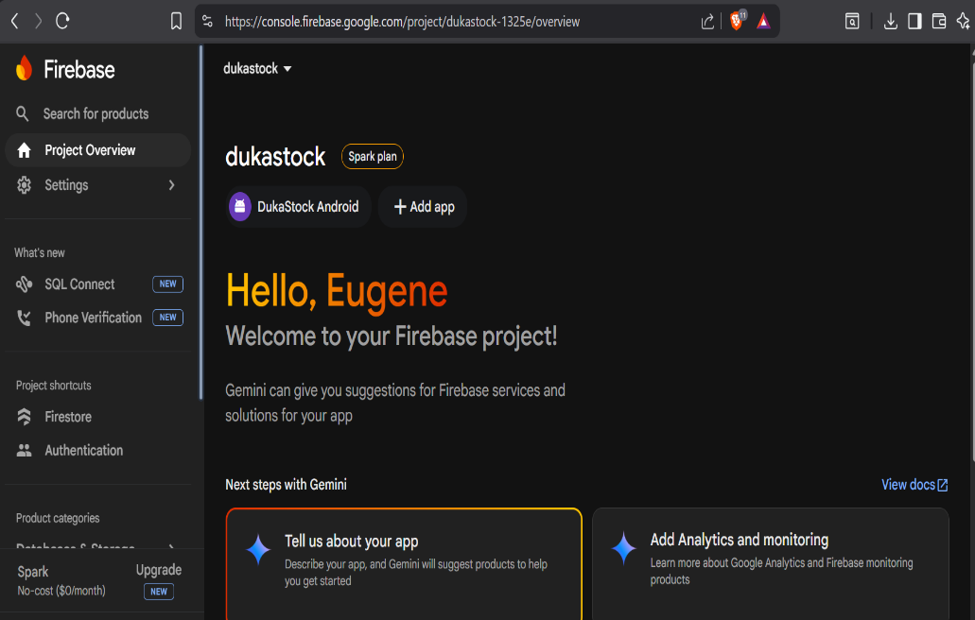

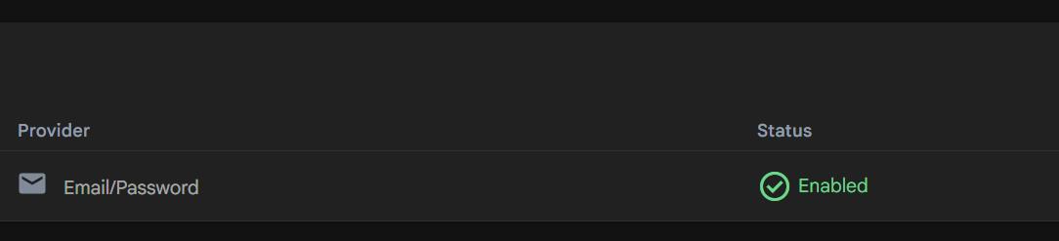

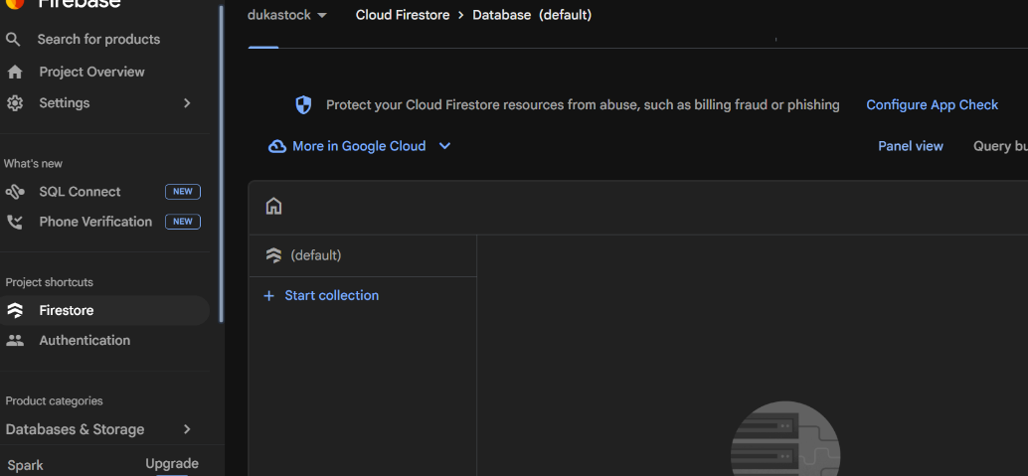

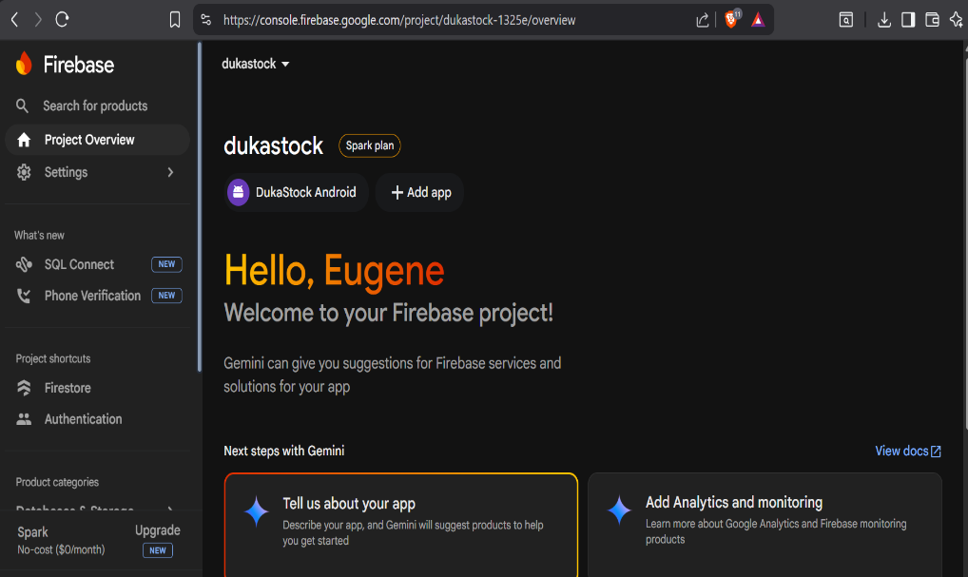

Screenshot 15: Firebase Project Settings showing DukaStock Android app registered

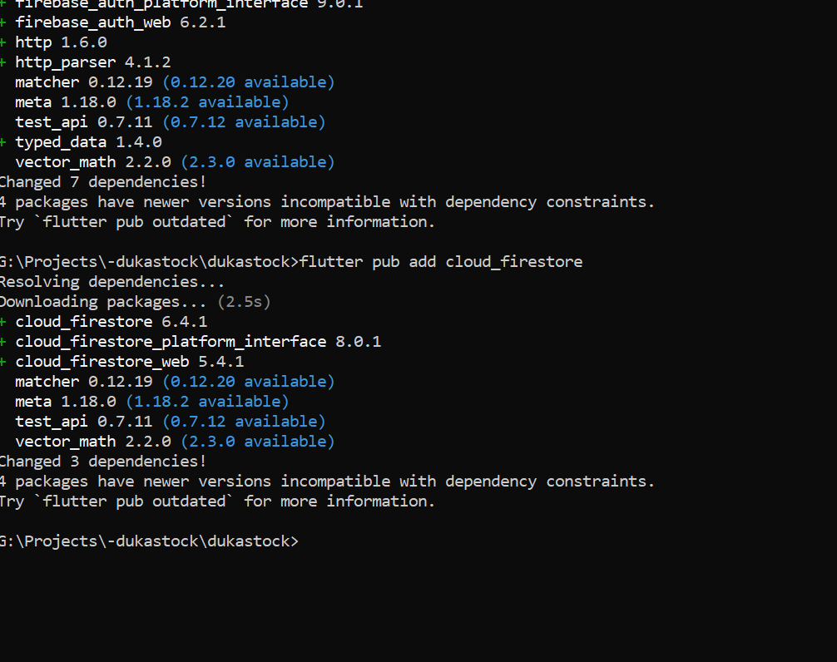

Screenshot 16: Command Prompt confirming google-services.json in android/app/

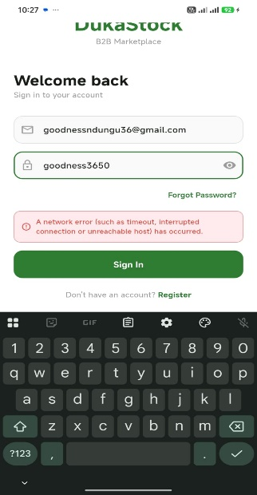
Screenshot 19: DukaStock Login screen running on Redmi Note 14

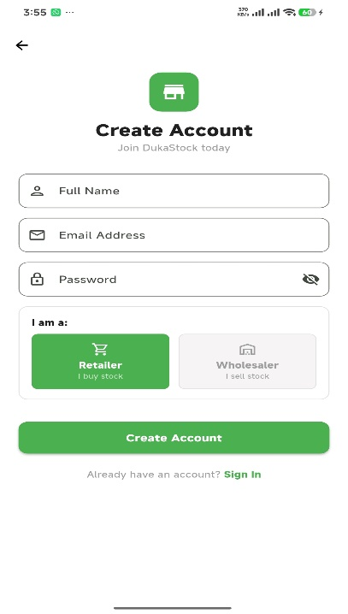
Screenshot 20: DukaStock Registration screen showing Retailer/Wholesaler role selector

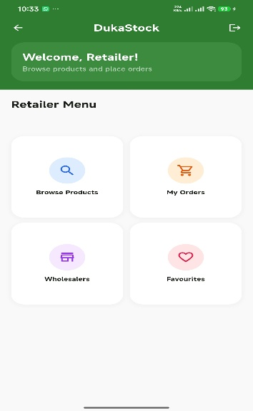
Screenshot 21: Retailer Dashboard — Welcome, Retailer! with 4 menu cards

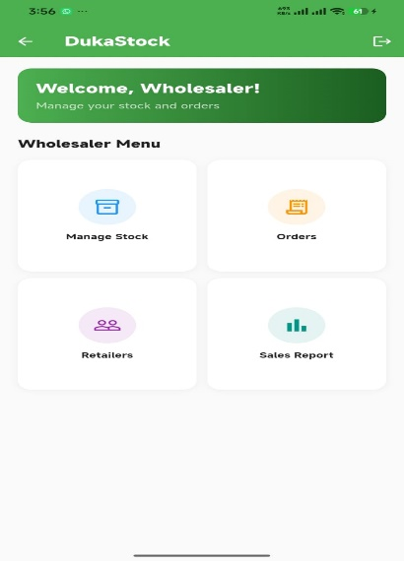
Screenshot 22: Wholesaler Dashboard — Welcome, Wholesaler! with 4 menu cards

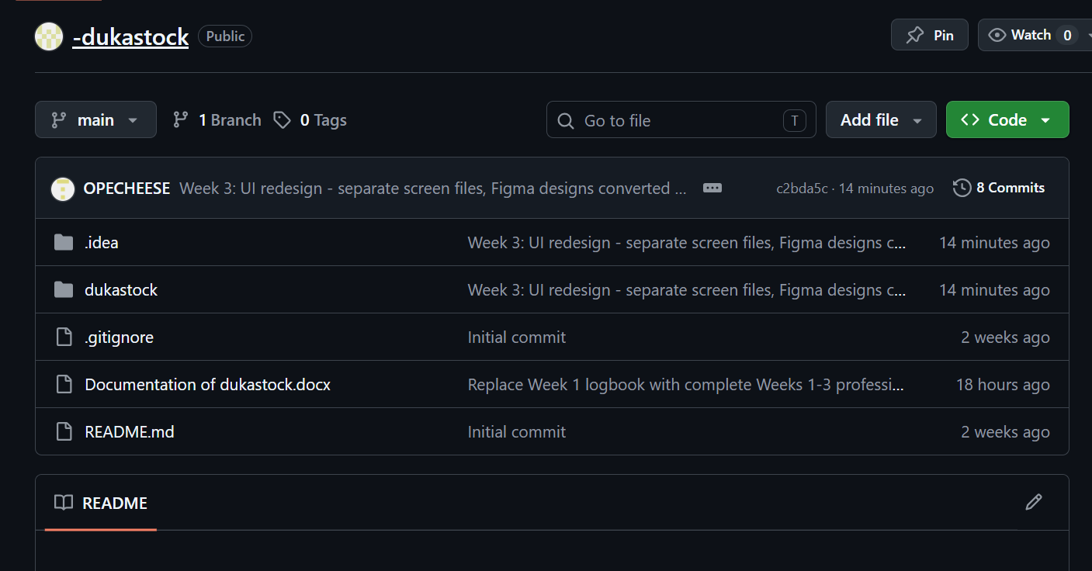
Screenshot 25: git push output showing Week 2 code pushed to GitHub

Tools / Software Used

- Firebase Console (console.firebase.google.com)
- Firebase Authentication
- Cloud Firestore
- Flutter SDK 3.44.0
- firebase_core, firebase_auth, cloud_firestore packages
- Android Studio — Gradle configuration
- Redmi Note 14 — USB debugging
- MiniTool Partition Wizard Free 13.6
- Git + GitHub

Personal Reflection

This week I integrated Firebase into DukaStock and built working authentication. The key challenge was a package name mismatch between Firebase and Flutter which caused a Gradle build failure. I resolved it by registering a new Android app in Firebase with the exact package name from build.gradle.kts

Week 3: User Interface Design

Practical Activities Undertaken

- Created DukaStock UI project in Figma for professional wireframe design
- Designed Login screen wireframe in Figma with DukaStock branding, email/password fields, Log In / Register tabs, and green button
- Designed Register screen wireframe with Full Name, Email, Password fields and Retailer/Wholesaler role selector tabs
- Designed Reset Password screen with new password and confirm password fields
- Designed Retailer Dashboard wireframe with green app bar, welcome banner, and 4 menu cards grid
- Designed Wholesaler Dashboard wireframe with different role-specific menu cards
- Designed Product Catalog screen with search bar and product listing cards
- Converted Figma Login design to Flutter code with improved UI components
- Converted Figma Register design to Flutter code with visual role selector cards
- Added form validation for all input fields — empty field checks and email format validation
- Implemented page transition animations between screens
- Tested all screens on Redmi Note 14 and verified navigation flow works correctly
- Pushed all Week 3 UI improvements to GitHub

Screenshots / Evidence Attached

Screenshots Attached: Yes

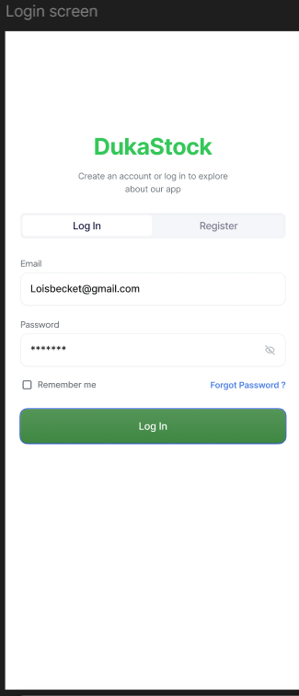
Screenshot 26: Figma workspace showing DukaStock Login screen wireframe

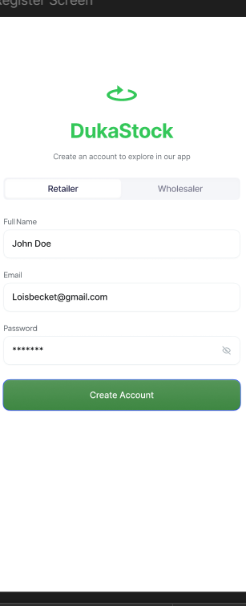
Screenshot 27: Figma workspace showing Register screen with Retailer/Wholesaler selector

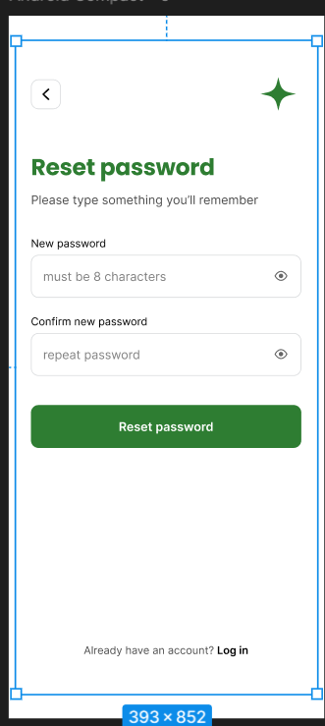
Screenshot 28: Figma workspace showing Reset Password screen

Tools / Software Used

- Figma (UI/UX design and wireframing)
- Flutter SDK 3.44.0
- Dart
- Android Studio
- Redmi Note 14 — real device testing
- Git + GitHub

Personal Reflection

This week I designed all DukaStock screens in Figma before writing code — a professional workflow. Translating Figma designs to Flutter required careful attention to spacing, colors, and component structure. I learned that designing first saves significant coding time by eliminating guesswork

Week 4: Data Management — Firestore CRUD & Local Storage

Practical Activities Undertaken

- Implemented Firestore CRUD operations for the Product Catalog screen using StreamBuilder for real-time, automatically updating product lists
- Built Add Product screen allowing wholesalers to add new products with name, price, unit, and category, writing directly to the Firestore products collection
- Implemented a live search/filter feature on the Product Catalog screen to filter products by name as the user types
- Added the shared_preferences package and created a StorageService class to persist the logged-in user's name, role, and email on the device after login or registration
- Updated the Dashboard screen to load the stored user name from SharedPreferences and display a personalised greeting (e.g. "Welcome, admin!") instead of a generic role-based greeting
- Tested the product catalog and search filter on the real Redmi Note 14 device with sample products: Unga Ndovu 2kg, Blueband 250g, Mafuta Rina 500ml, Sukari 10kg, and Omo 1kg
- Debugged a greeting display issue where the dashboard showed a generic "Welcome, Wholesaler!" instead of the stored name — resolved by performing a fresh app restart and login to correctly populate SharedPreferences
- Verified the Firestore users collection contains correct name, email, role, and createdAt fields for test accounts
- Created a new week4-data-management branch and pushed all Week 4 code to GitHub

Screenshots / Evidence Attached

Screenshots Attached: Yes

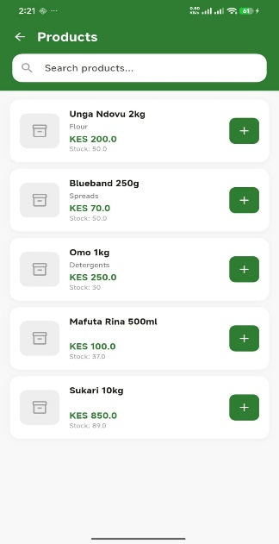
Screenshot 29: Product Catalog screen showing real-time product list (Unga Ndovu, Blueband, Mafuta Rina, Sukari, Omo)

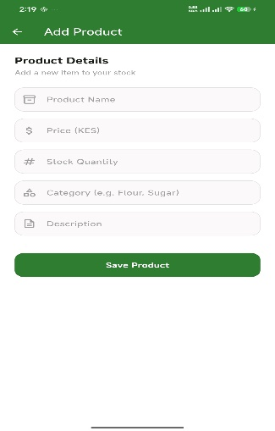
Screenshot 30: Add Product screen — wholesaler product entry form

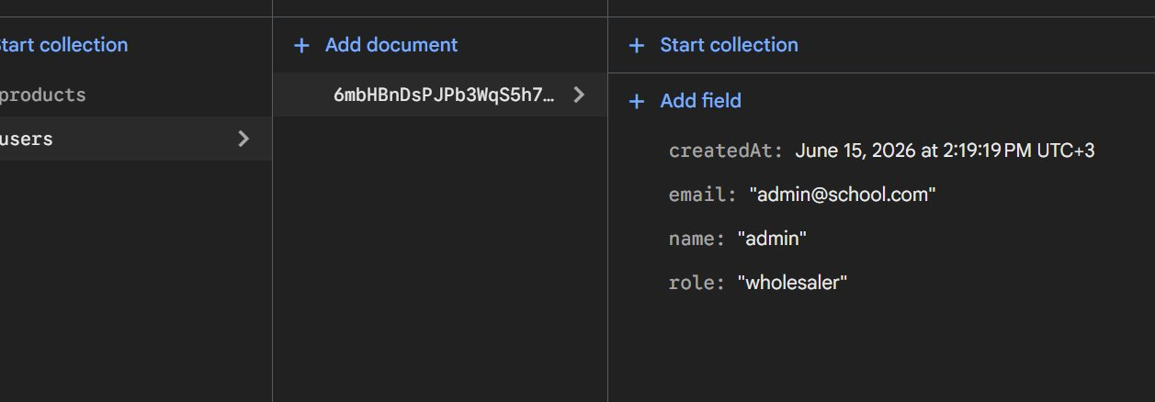
Screenshot 31: Firestore users collection showing the user document with name, email, role, and createdAt fields

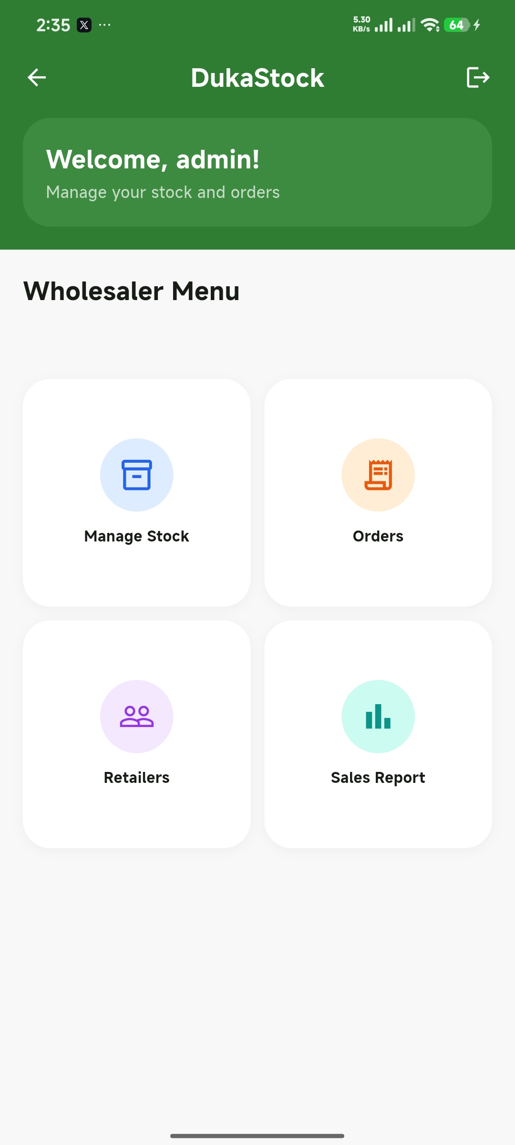
Screenshot 32: Wholesaler Dashboard on Redmi Note 14 — "Welcome, admin!" personalised greeting from SharedPreferences

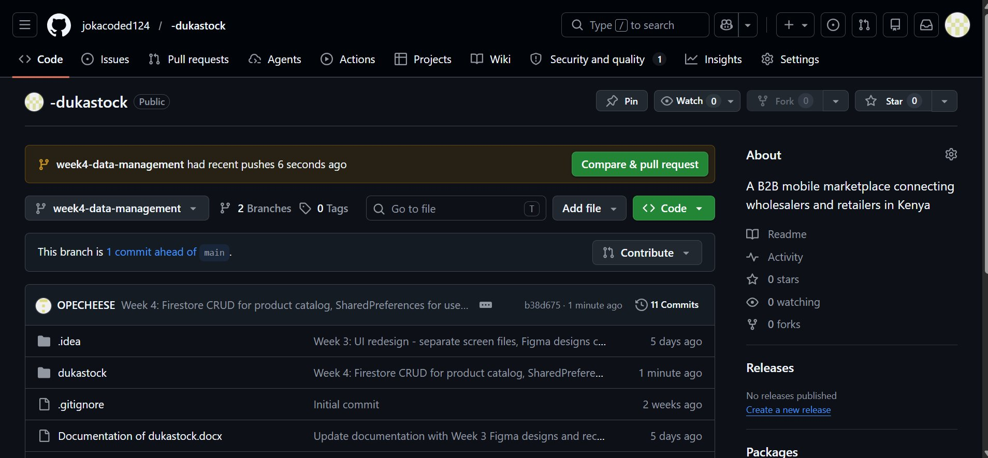
Screenshot 33: GitHub repository showing the week4-data-management branch pushed with Week 4 commit

Tools / Software Used

- Flutter SDK 3.44.0
- Dart
- Cloud Firestore (StreamBuilder for real-time CRUD)
- shared_preferences package (local device storage)
- Android Studio
- VS Code
- Redmi Note 14 — real device testing via USB debugging
- Git + GitHub

Personal Reflection

This week I connected the UI to real data by implementing Firestore CRUD with StreamBuilder and adding SharedPreferences for session persistence. The main challenge was a stale session causing the dashboard to show a generic greeting instead of the stored name; a fresh restart and login resolved it. I learned the importance of testing storage-dependent features with a clean app state

Week 5: Networking — Connectivity & Error Handling

Practical Activities Undertaken

- Added the connectivity_plus package to detect real-time network status (Wi-Fi, mobile data, or none)
- Created a ConnectivityService class wrapping connectivity_plus, exposing a simple stream (onStatusChange) and a one-off check (isOnline) used throughout the app
- Built a reusable OfflineBanner widget that automatically shows a red "No internet connection" bar at the top of any screen when the device loses connectivity, and hides itself when connection is restored
- Integrated the OfflineBanner into the Dashboard screen so connectivity status is visible immediately after login
- Updated the Add Product screen to check connectivity before attempting a Firestore write, avoiding a doomed request and giving immediate feedback if offline
- Replaced the generic catch (e) block in Add Product with separate on FirebaseException and catch (e) handlers, so Firebase-specific errors (permission-denied, unavailable, etc.) show a clear message instead of a raw exception
- Tested connectivity handling on the real Redmi Note 14 device by toggling Airplane Mode: confirmed the offline banner appears on the Dashboard and that attempting to save a product while offline shows a clear error message instead of crashing or hanging
- Created a new week5-networking branch and pushed all Week 5 code to GitHub

Code Implemented

lib/services/connectivity_service.dart
import 'dart:async';
import 'package:connectivity_plus/connectivity_plus.dart';
class ConnectivityService {
static final Connectivity _connectivity = Connectivity();
// Stream of booleans: true = online, false = offline.
static Stream<bool> get onStatusChange {
return _connectivity.onConnectivityChanged.map((results) {
return !results.contains(ConnectivityResult.none);
});
}
// One-off check, used before firing a Firestore write.
static Future<bool> isOnline() async {
final results = await _connectivity.checkConnectivity();
return !results.contains(ConnectivityResult.none);
}
}

Add Product — connectivity check and Firebase-specific error handling
// Check connectivity before attempting the network call.
final online = await ConnectivityService.isOnline();
if (!online) {
setState(() {
_isLoading = false;
_errorMessage = 'No internet connection. Please reconnect and try again.';
});
return;
}
try {
await FirebaseFirestore.instance.collection('products').add({...});
} on FirebaseException catch (e) {
setState(() {
_errorMessage = 'Failed to save product: ${e.message ?? "Unknown Firebase error"}';
});
} catch (e) {
setState(() {
_errorMessage = 'Something went wrong. Please try again.';
});
}

Screenshots / Evidence Attached

Screenshots Attached: Yes

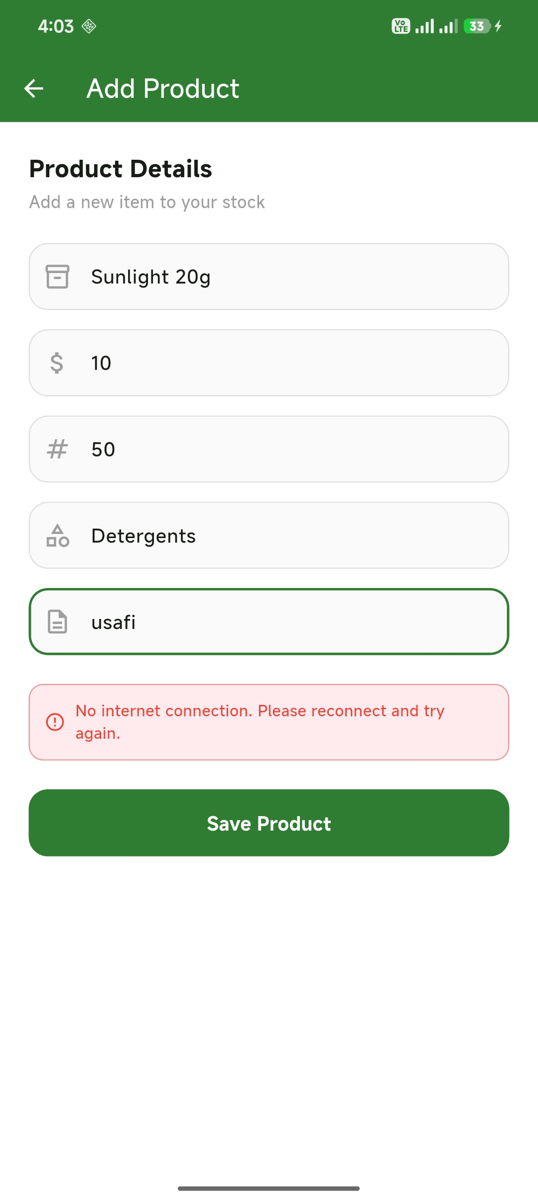
Screenshot 34: Add Product screen on Redmi Note 14 with Airplane Mode on — connectivity check correctly blocks the save and shows "No internet connection. Please reconnect and try again."

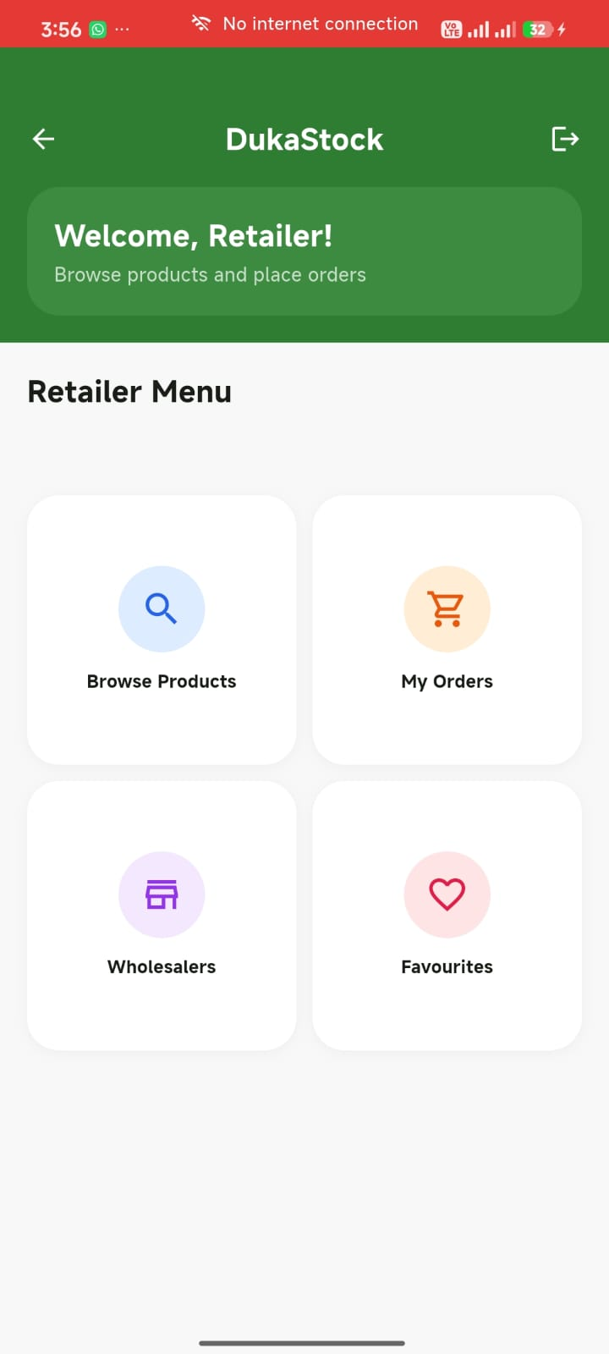
Screenshot 35: Retailer Dashboard on Redmi Note 14 with Airplane Mode on — OfflineBanner displays "No internet connection" (status bar confirms Airplane Mode is active)

Tools / Software Used

- Flutter SDK 3.44.0
- connectivity_plus package (network status detection)
- Cloud Firestore (FirebaseException error handling)
- Android Studio
- VS Code
- Redmi Note 14 — real device testing via USB debugging, Airplane Mode toggling for connectivity tests
- Git + GitHub

Personal Reflection

This week I learned that good error handling means anticipating failure before it happens, not just catching exceptions after the fact. Checking connectivity before firing a Firestore request avoids a doomed network call entirely, while separating FirebaseException from generic exceptions gives users far more useful feedback than a single catch-all. Testing on the real device with Airplane Mode was essential — the offline banner and error message both behaved exactly as designed, confirming the app degrades gracefully rather than crashing when the network drops

Week 8: User Input and Event Handling

Practical Activities Undertaken

- Implemented long press gesture on Product Catalog cards using GestureDetector with onLongPress, triggering a modal bottom sheet showing full product details (name, category, price, stock, description) with Add to Cart and Close actions
- Implemented pull-to-refresh on the Product Catalog screen using RefreshIndicator wrapping the ListView, giving users explicit manual control alongside automatic StreamBuilder updates
- Added undo snackbar to the add-to-cart tap event — tapping the + button shows a SnackBar with an Undo action button, demonstrating event-driven state management
- Built a separate ManageStockScreen for wholesalers showing only their own products (filtered by wholesalerId), with a search bar, stock level colour badges (green/orange/red), and a FAB navigating to Add Product
- Implemented long press delete on Manage Stock — holding a product opens a bottom sheet with a Delete option, followed by a confirmation dialog before executing the Firestore delete, completing the full CRUD cycle
- Built a ProfileScreen loading the logged-in user's name, email, and role from SharedPreferences, displaying them in a card with an avatar showing the first letter of the user's name and a Log Out button
- Wired all previously dead-end dashboard menu items to dedicated screens: Orders, Wholesalers, Retailers, Favourites, and Sales Report each now navigate to purpose-built placeholder screens
- Implemented class-based event handling throughout: each screen separates gesture handling (_onProductLongPress, _onAddToCart, _onMenuTap) from data loading and UI rendering, following the OOP single responsibility principle
- Pushed all Week 8 code to GitHub on a new week8-input-gestures branch with a weeks/week8 documentation folder

Screenshots / Evidence Attached

Screenshots Attached: Yes

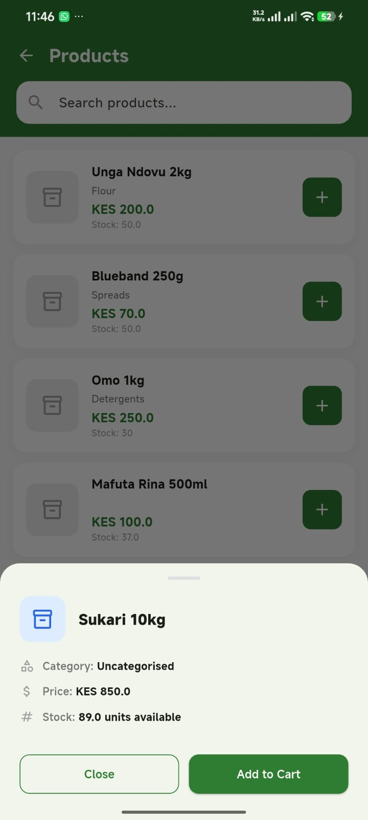
Screenshot 36: Long press on Sukari 10kg in Product Catalog — bottom sheet shows category, price, stock, and Add to Cart / Close buttons

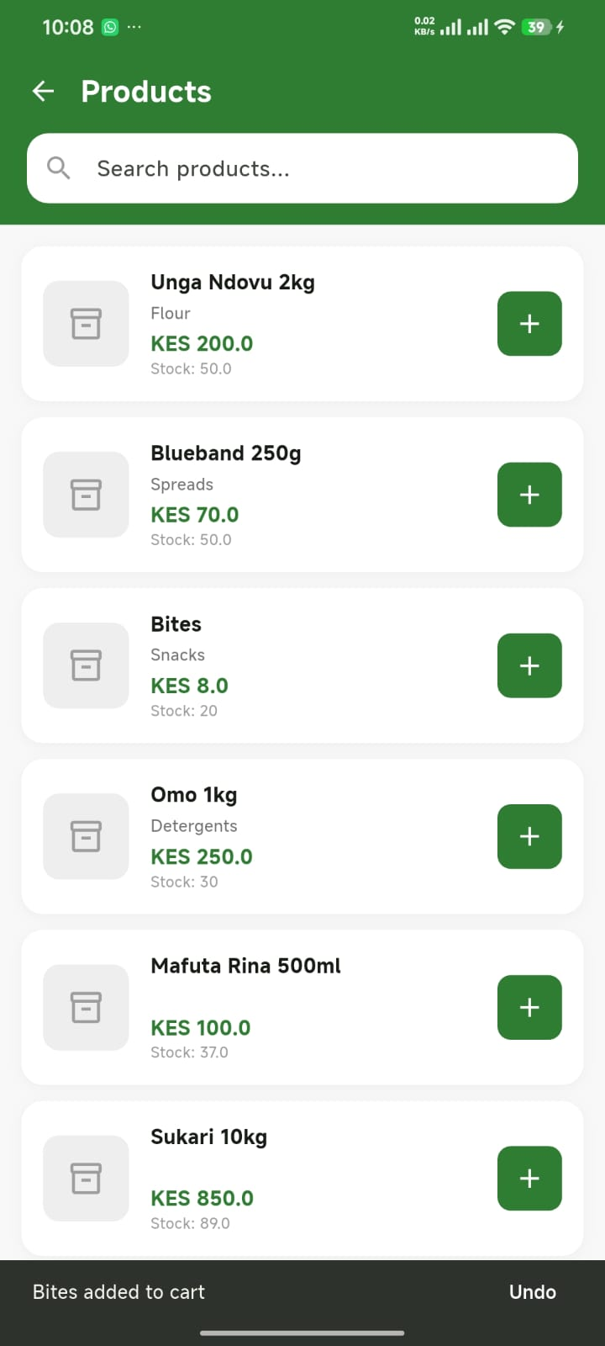
Screenshot 37: Product Catalog — tapping + on Bites shows 'Bites added to cart' snackbar with Undo action button

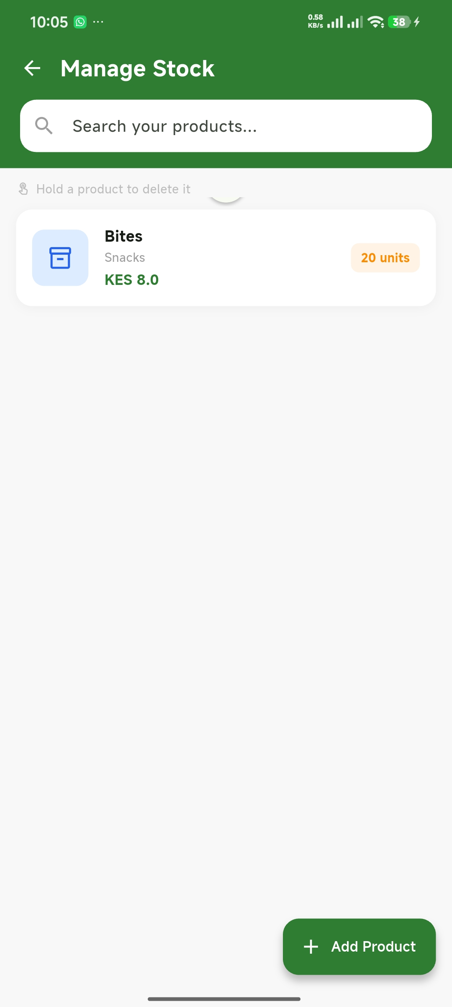
Screenshot 38: Manage Stock screen showing Bites product with orange stock badge (20 units) and Add Product FAB

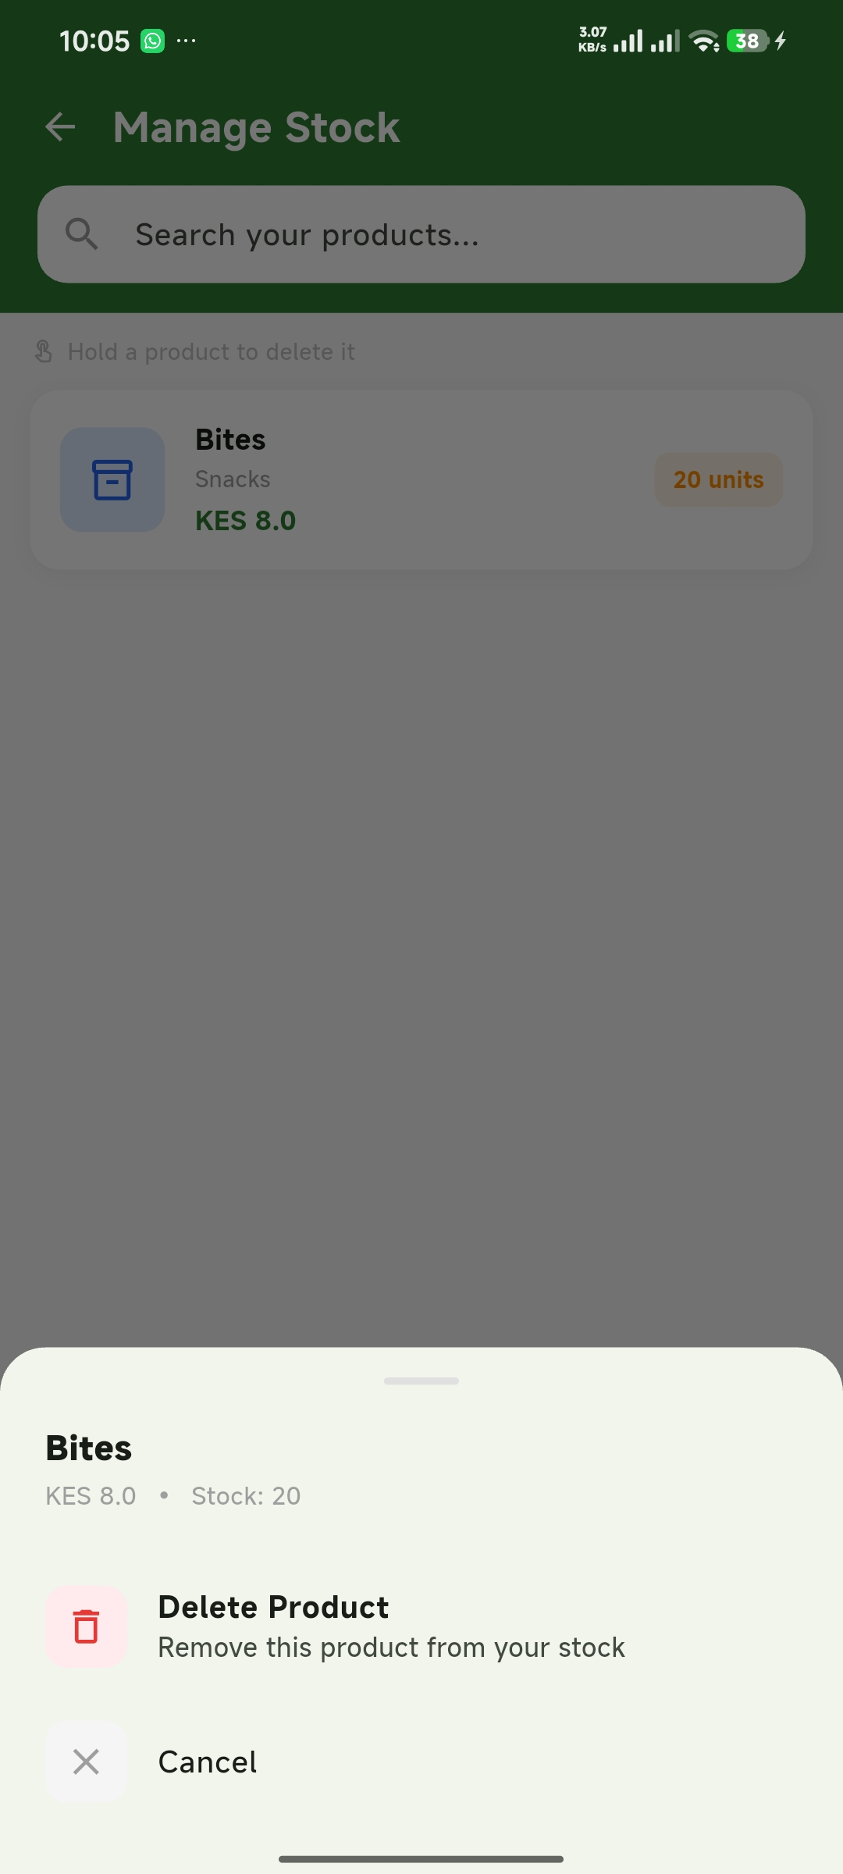
Screenshot 39: Long press on Bites in Manage Stock — bottom sheet with Delete Product option and Cancel

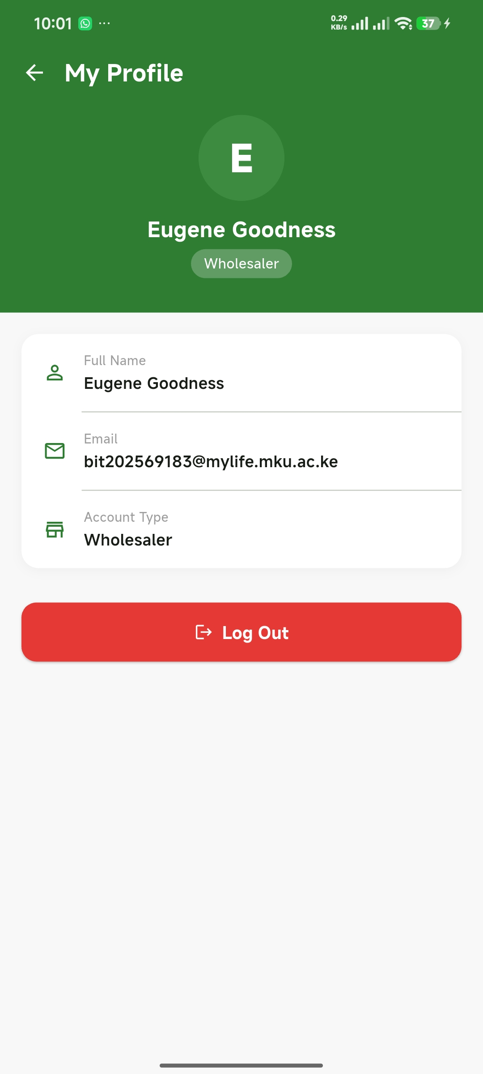
Screenshot 40: Profile screen — Eugene Goodness, university email, Wholesaler role, Log Out button

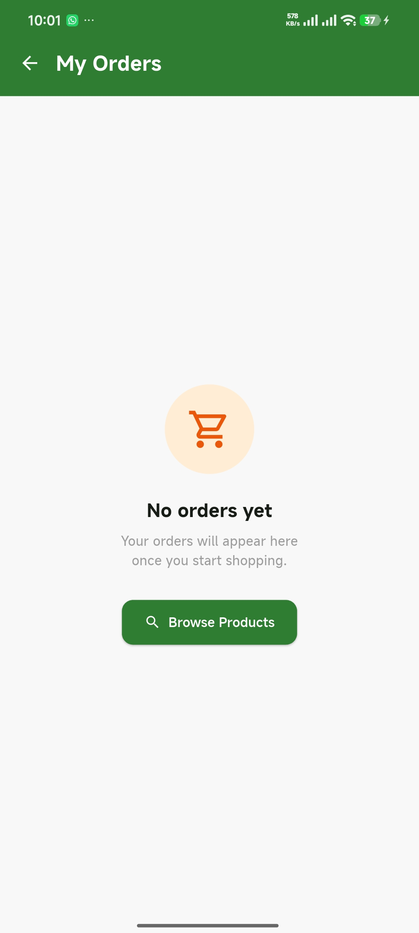
Screenshot 41: My Orders screen — empty state with cart icon and Browse Products button

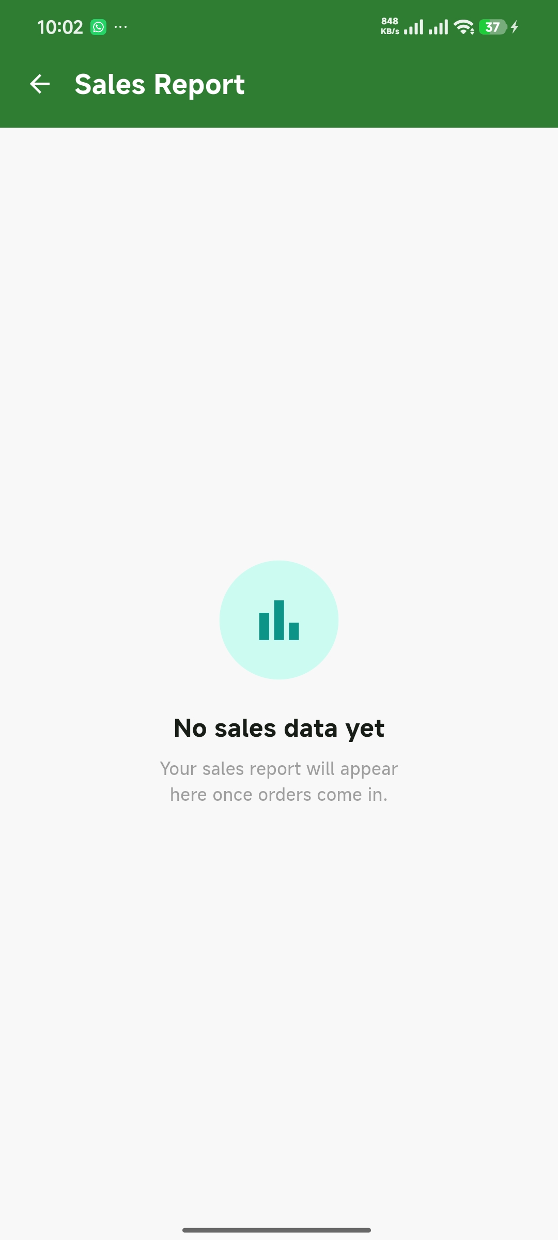
Screenshot 42: Sales Report screen — empty state with teal bar chart icon

Tools / Software Used

- Flutter SDK 3.44.0
- Dart
- GestureDetector (long press, tap)
- RefreshIndicator (pull-to-refresh gesture)
- showModalBottomSheet (bottom sheet UI)
- Cloud Firestore (CRUD — Create, Read, Delete)
- shared_preferences package (ProfileScreen data)
- Android Studio
- VS Code
- Redmi Note 14 — real device testing via USB debugging
- Git + GitHub

Personal Reflection

This week I implemented multiple gesture types in a single app, which demonstrated how different events serve different user intentions — a tap is a quick action, a long press reveals additional options, and a swipe down is a deliberate request to refresh. Separating gesture handlers into dedicated named methods made the code significantly easier to read, test, and explain. The delete feature completed the CRUD cycle, and building the Profile screen showed how SharedPreferences integrates naturally with navigation to give users a personalised experience without an extra network call.

