BIT4107: Mobile Application Development
Week 8: User Input and Event Handling
Student: Eugene Goodness Ndungu
Registration: BIT/2025/69183
Project: DukaStock — B2B Mobile Marketplace

Task 1: Class-Based Event Handling in DukaStock
In Flutter, a StatefulWidget class encapsulates both the UI and its associated event handlers. DukaStock follows this pattern throughout: each screen is a class that separates data loading, gesture handling, and UI rendering into distinct methods, directly implementing the OOP principle of single responsibility.
The table below maps each event handler in DukaStock to the lecturer's class-based model:
Event Type | Handler Method | What it does in DukaStock
Keyboard input | onChanged(value) | Search bar in Product Catalog and Manage Stock — filters the product list in real time as the user types
Tap (button) | _onAddToCart(name) | Tap the + button on a product card — shows a snackbar with an Undo action
Tap (navigation) | _onMenuTap(index) | Tap a dashboard menu card — navigates to the appropriate screen using a switch statement
Long Press | _onProductLongPress(data) | Hold a product card — opens a modal bottom sheet with full product details or delete options
Pull to Refresh | onRefresh callback | Swipe down on the Product Catalog — triggers a manual refresh of the product list via RefreshIndicator
Form submission | _saveProduct() | Tap Save Product button — validates all fields, checks connectivity, then writes to Firestore

Key Event Handler Code — Product Catalog Screen
The _ProductCatalogScreenState class demonstrates class-based event handling with clearly separated handler methods:
class _ProductCatalogScreenState extends State<ProductCatalogScreen> {
String _searchQuery = '';

// Long press gesture handler
void _onProductLongPress(Map<String, dynamic> data) {
showModalBottomSheet(context: context, ...);
}

// Tap gesture handler with undo snackbar
void _onAddToCart(String name) {
ScaffoldMessenger.of(context).showSnackBar(
SnackBar(
content: Text('$name added to cart'),
action: SnackBarAction(label: 'Undo', onPressed: () { ... }),
),
);
}
}

Task 2: Input Validation in DukaStock
Input validation ensures only correct, complete data is submitted before any network action is taken. DukaStock implements validation at multiple levels across different screens:

Add Product Screen — Validation Logic
Future<void> _saveProduct() async {
// 1. Presence validation — required fields must not be empty
if (_nameController.text.trim().isEmpty ||
_priceController.text.trim().isEmpty ||
_stockController.text.trim().isEmpty) {
setState(() => _errorMessage = 'Please fill in name, price and stock.');
return;
}

// 2. Type validation — price and stock must be valid numbers
final price = double.tryParse(_priceController.text.trim());
final stock = int.tryParse(_stockController.text.trim());
if (price == null || stock == null) {
setState(() => _errorMessage = 'Price and stock must be numbers.');
return;
}

// 3. Connectivity validation — check network before write
final online = await ConnectivityService.isOnline();
if (!online) {
setState(() => _errorMessage =
'No internet connection. Please reconnect and try again.');
return;
}

// Only reaches Firestore if ALL validation passes
await FirebaseFirestore.instance.collection('products').add({...});
}

Validation Type | Screen | What is checked
Presence check | Login | Email and password must not be empty before sign-in is attempted
Presence check | Register | Name, email, password, and role must all be filled in
Presence + type check | Add Product | Name, price, and stock required; price must parse as double, stock as integer
Connectivity check | Add Product | Internet connection verified before Firestore write is attempted
Firebase error handling | Add Product / Login | FirebaseException caught separately from generic exceptions, showing specific error messages

Task 3: Gesture Implementation — Screenshots and Evidence
The following screenshots demonstrate all gesture and event handling features implemented in DukaStock during Week 8, tested on a real Redmi Note 14 device.

3.1 Long Press Gesture — Product Catalog (Bottom Sheet)
Holding a product card for ~500ms triggers a modal bottom sheet showing full product details (name, category, price, stock, description) with Add to Cart and Close actions. Implemented using GestureDetector with onLongPress and showModalBottomSheet.
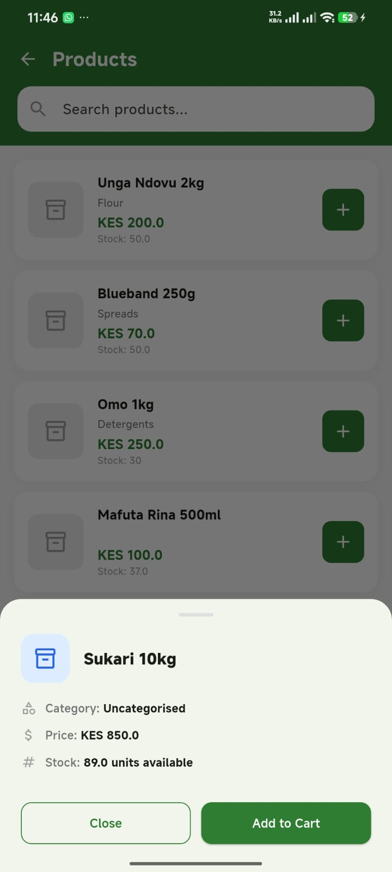
Screenshot 1: Long press on Sukari 10kg in Product Catalog — bottom sheet shows product details, Close and Add to Cart buttons

3.2 Long Press Gesture — Manage Stock (Delete)
Wholesalers can long press any product in their Manage Stock screen to access a delete option. A confirmation dialog appears before the Firestore delete is executed, preventing accidental data loss. This completes the full CRUD cycle: Create (Add Product), Read (catalog), Delete (long press).
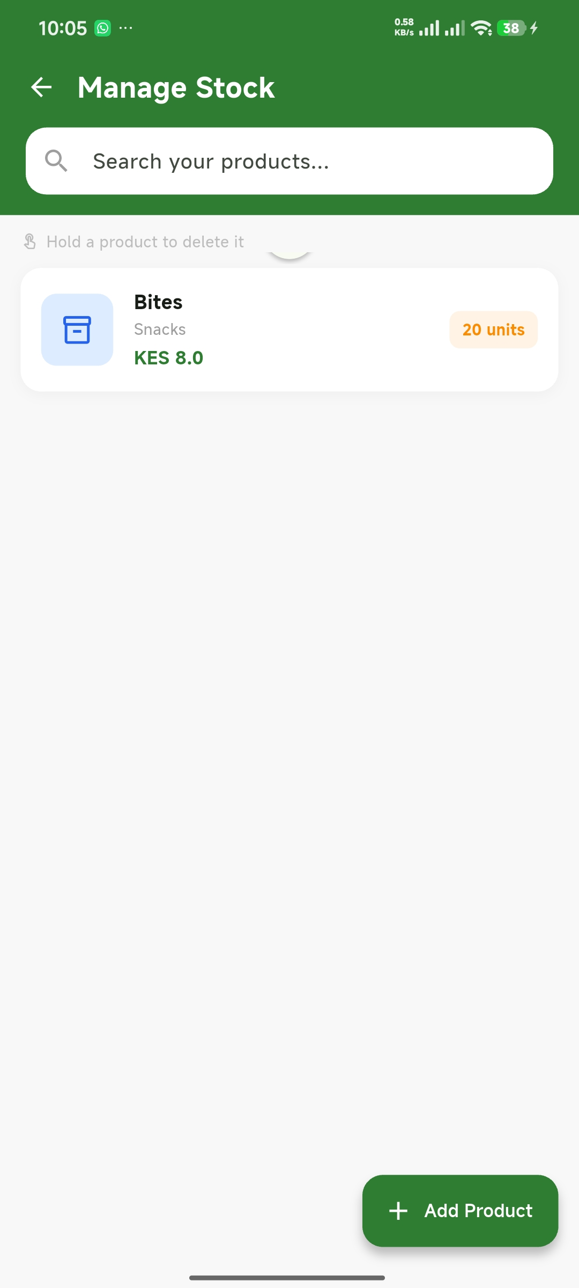
Screenshot 2: Manage Stock screen showing 'Bites' product with stock level badge and 'Hold a product to delete it' hint

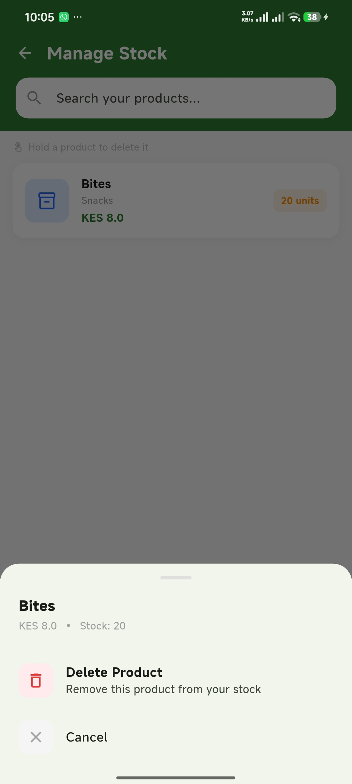
Screenshot 3: Long press on 'Bites' in Manage Stock — bottom sheet with Delete Product option (red icon) and Cancel

3.3 Profile Screen — Local Storage Retrieval
Tapping the person icon on the dashboard navigates to the Profile screen, which loads the logged-in user's name, email, and role from SharedPreferences (local storage). The avatar displays the first letter of the user's name. A Log Out button clears storage and returns to the login screen.
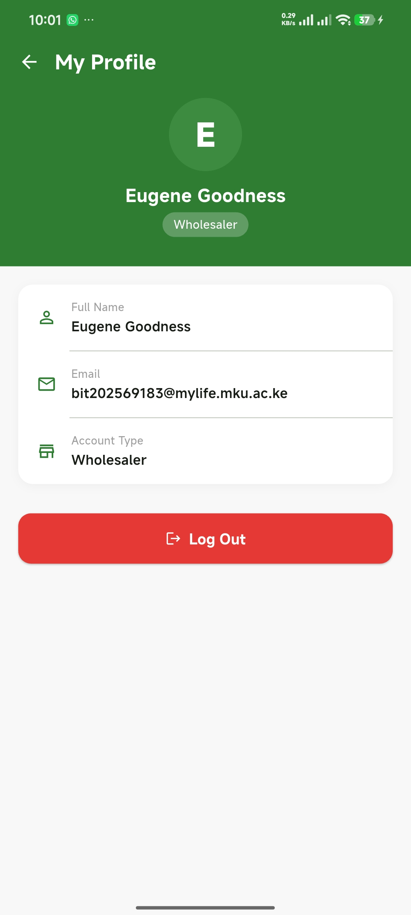
Screenshot 4: Profile screen showing Eugene Goodness's name, university email, Wholesaler role, and Log Out button

3.4 Navigation — All Menu Items Active
All dashboard menu items now navigate to dedicated screens. Previously dead-end taps now route to fully implemented placeholder or functional screens, demonstrating complete navigation coverage.
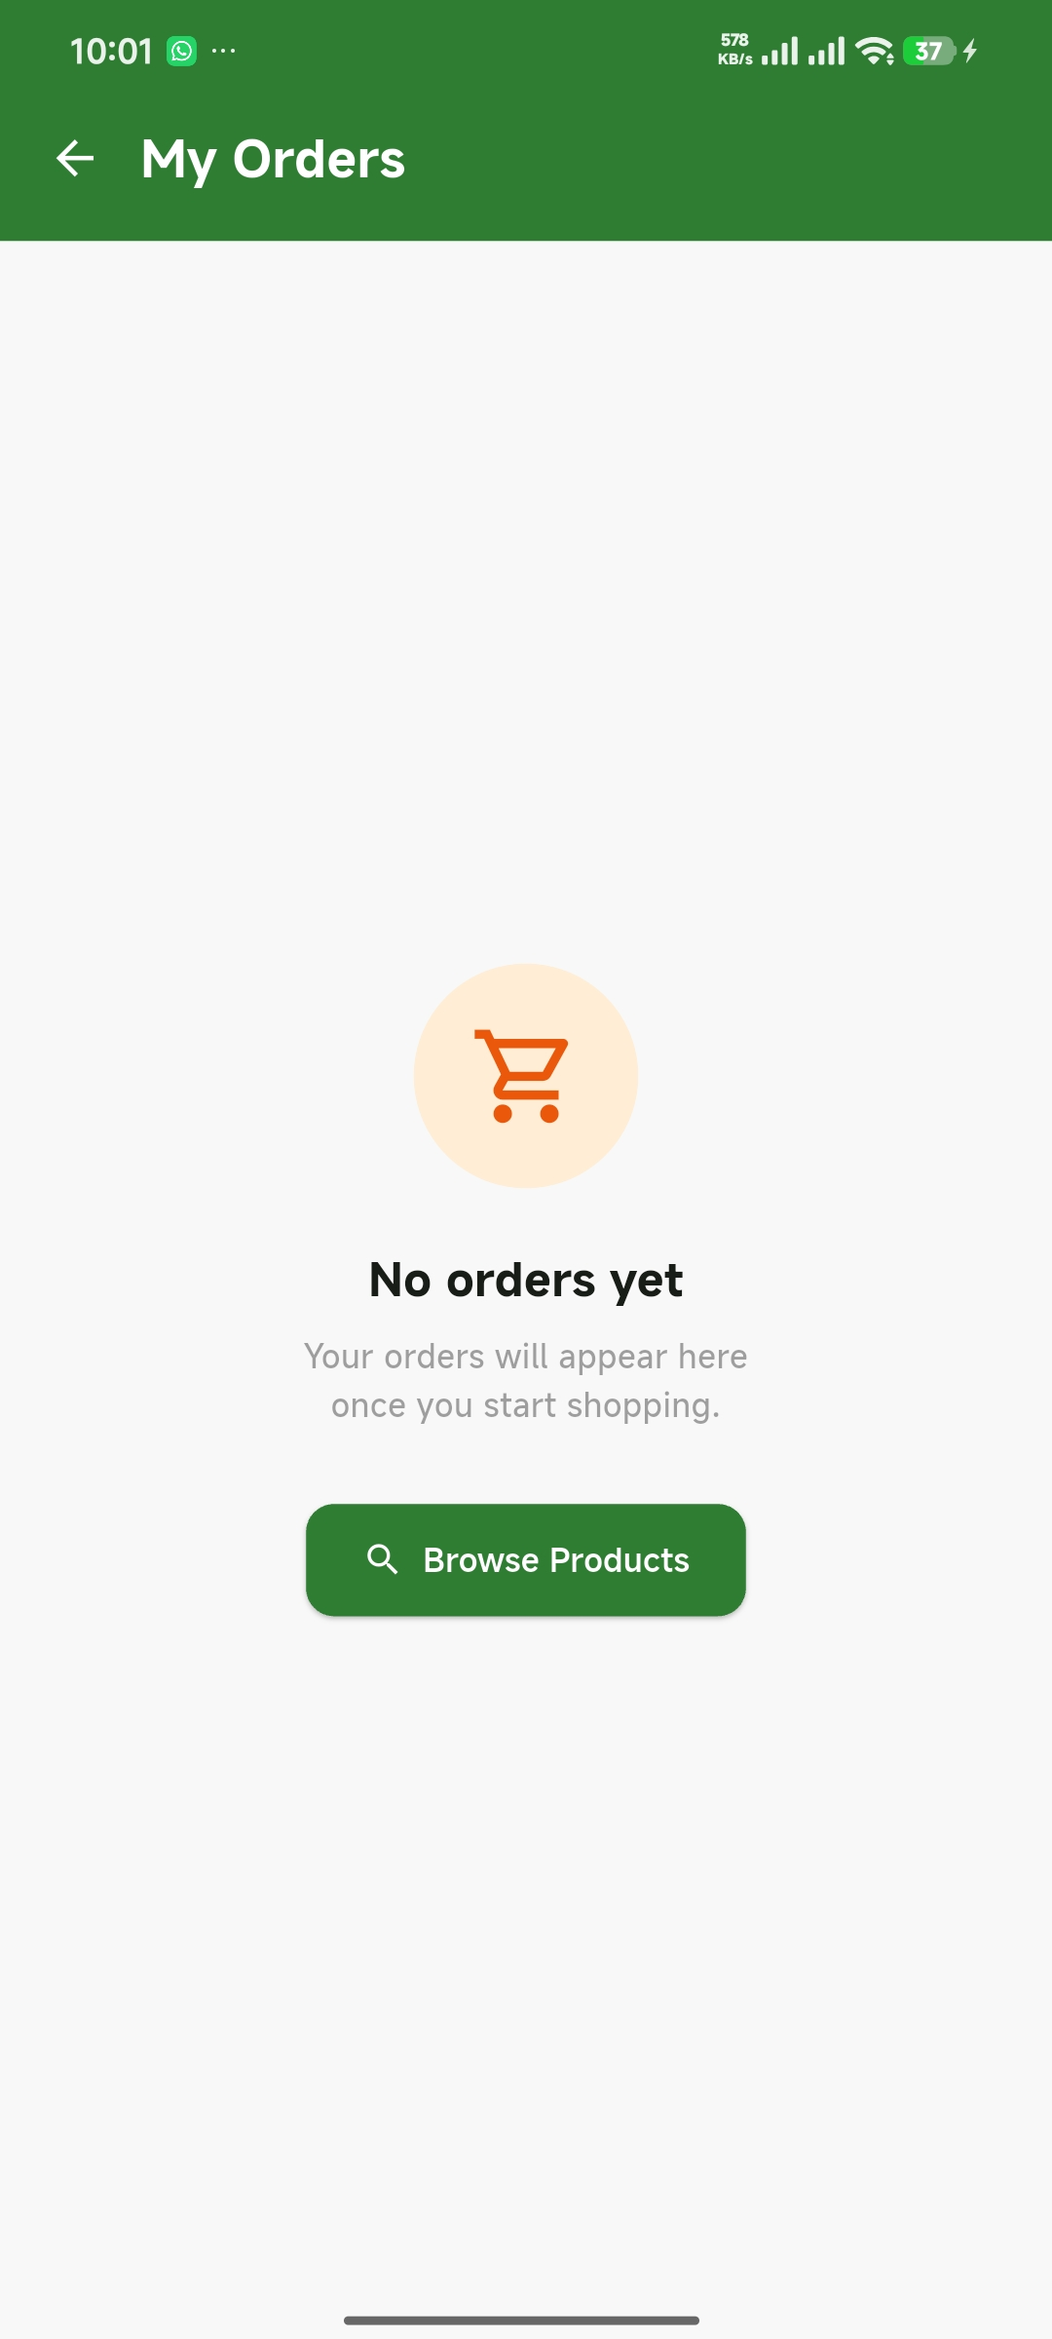
Screenshot 5: My Orders screen — clean empty state with Browse Products call-to-action

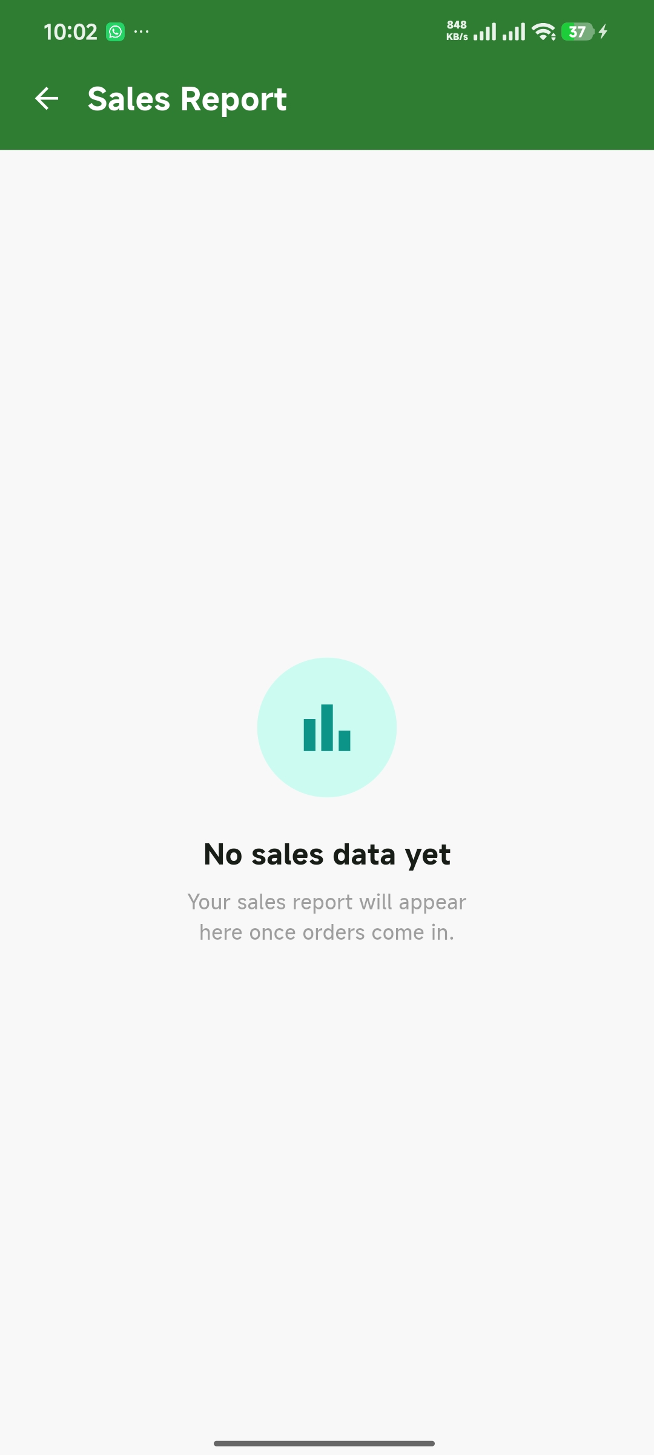
Screenshot 6: Sales Report screen — empty state with teal bar chart icon

Task 4: Summary of Features Implemented
Feature | Gesture / Event | Screen
Product details viewer | Long press | Product Catalog
Add to cart with Undo | Tap + SnackBar action | Product Catalog
Pull to refresh | Swipe down gesture | Product Catalog
Delete product (CRUD) | Long press + confirm dialog | Manage Stock
Profile / account screen | Tap navigation | Dashboard → Profile
Orders screen | Tap navigation | Dashboard → Orders
Retailers / Wholesalers screen | Tap navigation | Dashboard → Retailers/Wholesalers
Favourites screen | Tap navigation | Dashboard → Favourites
Sales Report screen | Tap navigation | Dashboard → Sales Report
Live search filter | Keyboard input (onChanged) | Product Catalog, Manage Stock
Multi-level input validation | Form submission | Add Product, Login, Register

