DUKASTOCK
B2B Mobile Marketplace — Wholesalers & Retailers

PROJECT LOGBOOK
Week 1: Introduction to Mobile Development

Student Name | Eugene Goodness Ndungu
Registration No. | BIT/2025/69183
Unit Name | Mobile Application Development
Unit Code | BIT4107
Year | 2026
Project Name | DukaStock — B2B Mobile Marketplace
Week | Week 1 of 3 (Foundation & Setup)
Date Submitted | 31 May 2026

1. Project Overview

1.1 Introduction
DukaStock is a B2B mobile marketplace application designed to connect wholesalers and retailers in Kenya. The application digitizes the ordering and stock management process that currently relies on phone calls, WhatsApp messages, and handwritten records.

1.2 Problem Statement
Many wholesalers and retailers in Kenya still rely on informal communication channels for business operations. This leads to:
- Delays in order processing and fulfilment
- Poor record keeping and stock confusion
- Inefficient communication between trading partners
- Loss of sales due to stock unavailability information
- Lack of digital transaction history and reporting

1.3 Proposed Solution
DukaStock provides a mobile platform where:
- Retailers can browse product catalogs, place orders, and track delivery status
- Wholesalers can manage inventory, receive orders, and communicate with retailers
- Both parties can initiate and manage business transactions digitally

1.4 Project Objectives
- To develop a cross-platform Android mobile application using Flutter
- To allow retailers to browse and order products from wholesalers online
- To help wholesalers manage inventory and track orders efficiently
- To improve communication between wholesalers and retailers
- To digitize stock management and generate sales insights

1.5 Technology Stack
Area | Tool | Reason
Framework | Flutter 3.44.0 | Cross-platform Android app from one codebase
Language | Dart | Official Flutter language, easy to learn
Backend | Firebase | Free tier, real-time, no server setup needed
Database | Firestore | NoSQL, perfect for product catalogs
Auth | Firebase Auth | Handles wholesaler/retailer roles
UI Design | Figma | Industry standard wireframing tool
IDE | Android Studio + VS Code | Official Android IDE + lightweight editor
Version Control | GitHub | Portfolio evidence and collaboration

2. Week 1 Logbook — Introduction to Mobile Development

2.1 Weekly Objectives
By the end of Week 1, the following objectives were set:
- Install and configure all required development tools on Windows 11
- Set up a professional GitHub repository for the DukaStock project
- Download and configure Flutter SDK 3.44.0
- Create the first DukaStock Flutter project
- Run the app successfully on an Android emulator (Pixel 6 API 37)
- Customize the app with DukaStock branding — title, color, and text
- Push all source code to GitHub as Week 1 evidence

2.2 Activities Completed
Activity 1: Android Studio Installation
Downloaded and installed Android Studio Panda 4 (2025.3.4 Patch 1) on Windows 11. During the setup wizard, selected Standard installation which automatically downloaded the Android SDK, Build Tools 37, Platform Tools 37, and the Android Emulator.
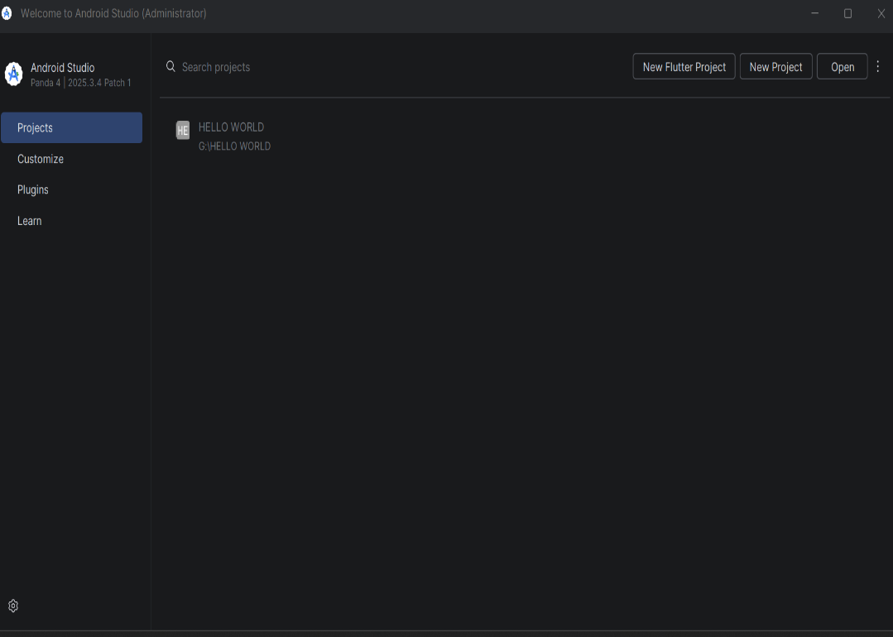

Activity 2: Git Installation and Configuration
Downloaded Git for Windows from git-scm.com. During installation, set Visual Studio Code as the default editor and selected the recommended PATH option. After installation, configured Git with student name and email using the following commands:
git config --global user.name "Eugene Goodness Ndungu"
git config --global user.email "your.email@example.com"
git --version
📸 INSERT SCREENSHOT HERE
Screenshot 2: Command Prompt showing git --version output

Activity 3: GitHub Repository Creation
Created a new GitHub account and set up the DukaStock repository at github.com/jokacoded124/-dukastock. The repository was initialized with a README file and a Flutter .gitignore template. The description was set to: 'A B2B mobile marketplace connecting wholesalers and retailers in Kenya'.
📸 INSERT SCREENSHOT HERE
Screenshot 3: GitHub repository page showing DukaStock repo

Activity 4: Cloning Repository to Local Machine
Switched to the G: drive and created a Projects folder. Cloned the GitHub repository to G:\Projects\-dukastock using the git clone command. Verified the connection using git status which confirmed the branch was up to date with origin/main.
G:
cd G:\Projects
git clone https://github.com/jokacoded124/-dukastock.git
cd -dukastock
git status
📸 INSERT SCREENSHOT HERE
Screenshot 4: Command Prompt showing successful git clone and git status

Activity 5: Flutter SDK Download and Setup
Downloaded Flutter SDK version 3.44.0-stable (Windows x64) from the official Flutter archive page at docs.flutter.dev/release/archive. Extracted the ZIP file to G:\flutter\flutter_windows_3.44.0-stable\flutter. This folder contains the bin directory which is the Flutter SDK root.
📸 INSERT SCREENSHOT HERE
Screenshot 5: File Explorer showing Flutter SDK extracted at G:\flutter

Activity 6: DukaStock Flutter Project Creation
Created the Flutter project using the command line inside the cloned GitHub repository folder. This approach was chosen because Android Studio's project wizard did not correctly place files inside the existing Git repository folder. The flutter create command generated all necessary project files including the android folder, lib/main.dart, and pubspec.yaml.
set PATH=%PATH%;G:\flutter\flutter_windows_3.44.0-stable\flutter\bin
G:
cd G:\Projects\-dukastock
flutter create --org com.jokacoded.dukastock --platforms android dukastock
📸 INSERT SCREENSHOT HERE
Screenshot 6: Command Prompt showing 'All done!' after flutter create

Activity 7: Opening Project in Android Studio
Opened the newly created project in Android Studio using File > Open and navigating to G:\Projects\-dukastock\dukastock. The project loaded successfully with all Flutter files visible in the project tree including android/, lib/, test/, pubspec.yaml, and the main entry point lib/main.dart.
📸 INSERT SCREENSHOT HERE
Screenshot 7: Android Studio showing DukaStock project files and main.dart open

Activity 8: Android Virtual Device Setup
Created a Pixel 6 virtual device in Android Studio using the Device Manager. Downloaded the Android API 37.0 (CinnamonBun, Android 17.0) system image — Google APIs Intel x86_64. The virtual device was configured with 1080x2400 resolution at 420 dpi, matching a real Pixel 6 device.
📸 INSERT SCREENSHOT HERE
Screenshot 8: Device Manager showing Pixel 6 API 37 configured

Activity 9: App Customization — DukaStock Branding
Modified the default Flutter counter app in lib/main.dart to reflect DukaStock branding. The following changes were made as required by the Week 1 assignment:
- App title changed from 'Flutter Demo' to 'DukaStock'
- Seed color changed from Colors.deepPurple to Colors.green
- AppBar title changed to 'DukaStock - B2B Marketplace'
- Body text changed from default counter message to 'Welcome to DukaStock!'
- Font size increased using TextStyle with fontSize: 24 and fontWeight: FontWeight.bold

Final main.dart code:
import 'package:flutter/material.dart';

void main() {
runApp(const MyApp());
}

class MyApp extends StatelessWidget {
const MyApp({super.key});

@override
Widget build(BuildContext context) {
return MaterialApp(
title: 'DukaStock',
theme: ThemeData(
colorScheme: ColorScheme.fromSeed(seedColor: Colors.green),
useMaterial3: true,
),
home: const MyHomePage(title: 'DukaStock'),
);
}
}

class _MyHomePageState extends State<MyHomePage> {
@override
Widget build(BuildContext context) {
return Scaffold(
appBar: AppBar(
backgroundColor: Theme.of(context).colorScheme.inversePrimary,
title: Text(widget.title),
),
body: Center(
child: Column(
mainAxisAlignment: MainAxisAlignment.center,
children: [
const Text(
'Welcome to DukaStock!',
style: TextStyle(fontSize: 24, fontWeight: FontWeight.bold),
),
],
),
),
);
}
}

📸 INSERT SCREENSHOT HERE
Screenshot 9: Android Studio showing the customized main.dart code

Activity 10: Running DukaStock on Emulator
Launched the Pixel 6 emulator from Android Studio Device Manager. After the emulator booted successfully (showing the Android 17.0 home screen), ran the DukaStock app using the Play button. The app compiled and deployed successfully onto the virtual device, displaying the green-themed DukaStock interface.
📸 INSERT SCREENSHOT HERE
Screenshot 10: DukaStock running on Pixel 6 emulator showing green theme and 'Welcome to DukaStock!' text

Activity 11: Pushing Code to GitHub
Added all project files to Git staging, committed with a descriptive message, and pushed to the main branch on GitHub. All 53 objects were written successfully at 2.40 MiB/s, confirming a successful push to the remote repository.
git add .
git commit -m "Week 1: DukaStock first Flutter app with green theme"
git push origin main
📸 INSERT SCREENSHOT HERE
Screenshot 11: Command Prompt showing successful git push to GitHub

3. Challenges Faced and Solutions

# | Challenge | Solution | Lesson Learned
1 | Flutter SDK download link on docs.flutter.dev was not working | Used the official Flutter archive page at docs.flutter.dev/release/archive to find and download Flutter 3.44.0 stable directly | Always have a backup download source for large SDK files
2 | Flutter SDK URL typed directly in Command Prompt caused 'not recognized' error | Learned that git clone command must prefix the URL — the URL alone cannot be run as a command | Commands and URLs serve different purposes in the terminal
3 | Android Studio project wizard did not create Flutter files in the existing Git repository folder | Used flutter create command in Command Prompt instead, which correctly placed files inside the repository folder | Command-line tools are sometimes more reliable than GUI wizards for precise folder control
4 | Android system image download (2GB) failed mid-way with 'Connection reset' error | Retried the download — it resumed and completed successfully on the second attempt | Large file downloads on unstable internet connections may need multiple attempts
5 | Syntax errors in main.dart (extra quotes and colon) caused Gradle build failure | Replaced entire main.dart content with a clean version using Ctrl+A then paste, eliminating all syntax errors | Always verify code syntax before running — small typos cause full build failures
6 | Emulator showed 'System UI isn't responding' dialog on first boot | Clicked 'Wait' instead of 'Close app' — the emulator settled and loaded normally after a short wait | First-time emulator boot always takes longer; patience is required

4. Week 1 Deliverables Checklist

Task / Deliverable | Status | Evidence
Android Studio installed and configured | ✅ Done | Screenshot 1
Git installed and version verified | ✅ Done | Screenshot 2
GitHub account created | ✅ Done | Screenshot 3
DukaStock GitHub repository created | ✅ Done | Screenshot 3
Repository cloned to G: drive | ✅ Done | Screenshot 4
Flutter SDK 3.44.0 downloaded and extracted | ✅ Done | Screenshot 5
DukaStock Flutter project created | ✅ Done | Screenshot 6
Project opened in Android Studio | ✅ Done | Screenshot 7
Pixel 6 Android Emulator configured (API 37) | ✅ Done | Screenshot 8
App title changed to DukaStock | ✅ Done | Screenshot 9
Background/theme color changed to green | ✅ Done | Screenshot 9
Welcome text customized | ✅ Done | Screenshot 9
Font size increased (24px, bold) | ✅ Done | Screenshot 9
App running successfully on emulator | ✅ Done | Screenshot 10
Code pushed to GitHub (53 objects) | ✅ Done | Screenshot 11

5. Reflections and Lessons Learned

5.1 Technical Lessons
- Setting up a Flutter development environment on Windows requires careful attention to file paths — Flutter must not be placed in Program Files due to permission issues
- The command line (flutter create) is often more reliable than GUI project wizards when working with existing Git repositories
- Git must be configured with a name and email before making commits — this links commits to your GitHub profile
- Large SDK downloads (2GB+) on unstable internet may fail and need to be retried
- Dart syntax is strict — a single extra quote or colon prevents the entire app from building

5.2 Development Process Lessons
- Screenshots must be taken at every step during development — it is difficult to reconstruct evidence after the fact
- Committing to GitHub after every significant milestone protects work and creates a development history
- Reading error messages carefully reveals exactly what went wrong — most errors have a clear solution
- The emulator requires patience on first boot; forcing it to close causes more problems

5.3 Project-Specific Insights
- DukaStock addresses a real problem faced by Kenyan traders who rely on informal communication for business
- The green color theme was chosen to represent growth, money, and the trading nature of the app
- Having both wholesaler and retailer roles from the start will require careful UI design in Week 3 to ensure each user sees only what is relevant to them

5.4 Next Steps — Week 2 Plan
- Set up Firebase project and connect it to the DukaStock Flutter app
- Build the Login screen with email/password fields and role selector (Wholesaler / Retailer)
- Build the Registration screen with form validation
- Save user data to Firestore with role field
- Implement navigation from Login to a basic Dashboard screen
- Begin designing DukaStock screens in Figma for Week 3 UI development

6. System Analysis

6.1 Users of the System

User Role | Permissions / Can Do | Cannot Do
Retailer | Browse product catalog, place orders, track order status, view order history, receive notifications | Manage inventory, approve orders, view sales reports
Wholesaler | Manage stock/inventory, receive and approve orders, push stock offers, view sales reports, manage retailer accounts | Place orders (they receive orders)

6.2 Functional Requirements
- User registration and login with role selection (Wholesaler / Retailer)
- Product catalog browsing with search and filter functionality
- Order placement by retailers with quantity selection
- Order management by wholesalers — view, approve, reject orders
- Inventory management — add, update, delete stock items
- Real-time notifications for new orders and status updates
- Order history and basic sales reporting

6.3 Non-Functional Requirements
- Security: All data transmitted over HTTPS; Firebase Authentication for user management
- Performance: App should load within 3 seconds on a standard Android device
- Usability: Interface must be intuitive for users with basic smartphone literacy
- Reliability: App should function with intermittent internet connectivity
- Scalability: Firebase backend can scale to handle growing user base

7. Declaration

I, Eugene Goodness Ndungu (BIT/2025/69183), hereby declare that this project logbook represents my own practical work undertaken during Week 1 of the Mobile Application Development unit. All screenshots, code, and documentation reflect genuine development activities performed by myself.

Student Signature: ________________________________

Date: 31 May 2026

Lecturer Signature: ________________________________

Date: ________________________________

