M3I625656-19-A
Coursework
Games Programming 2

Ben Hammond S1709378
(bhammo201@gcu.ac.uk)

Session 2019 - 2020
Plagiarism
I confirm that the code contained in this file (other than that provided or authorised) is all my own work and has not been submitted elsewhere in fulfilment of this or any other award.

Contents
Introduction 3
Main.cpp 3
Display.h/cpp 3
Camera.h 4
Mesh.h/cpp 6
Shader.h/cpp 6
MainGame.h/cpp 7
InitSystems() 7
GameLoop() 8
ProccessInput() 8
DrawGame() 8
Collisions 9
Game objective 9
Conclusion 10

Introduction

Opengl is a free to use cross platform programming interface that allows the rendering of 2D and 3D vector graphics. Using opengl with other compatible libraries such as Opengl Mathematics (glm) , Simple DirectMedia Layer (SDL) and OpenAL allows a developer to create a game. These libraries cover almost every part of what is required to make a game: Audio, graphics, user input and a whole lot of maths.

Main.cpp

This is the entry point for the application, not much happens in this file. An instance of the main game is created, then the function maingame.run() is called.

Display.h/cpp

To allow for the game to be seen and interacted with, a window must be created. The function initDisplay() is called to setup the window.
Firstly, SDL is initialised to make sure that everything is properly installed and ready to be used, next some application attributes are set to specify how many bits should be used to display each colour. A window is then created using the screenWidth and screenHeight variables that were created in the display constructor. 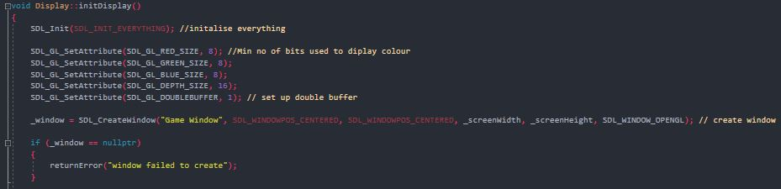
If the window is created successfully then a context is created, this allows the systems to know where it should be drawing and processing to.
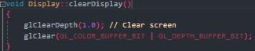
After a frame has been drawn, the window must be cleared to allow for the next frame to be displayed, clearDisplay() is used to clear the screen and remove the previous draw. 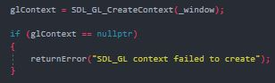

Camera.h

The camera is created and used to display the game in a more interactive and intuitive way, without the camera being created, the user would not be able to “move around” within the world. When the camera moves, it is not actually moving, everything else within the view is moving.

Firstly the camera is initalized using initCamera this defines what the position, forward vector, up vector and projection of the camera is. When calling this function, we must define the position, fov, aspect and the near and far clipping plane.
Field of view can be whatever we want but the most popular values are between 60 and 120. Aspect ratio is calculated by dividing the windows width by the windows height. The near clip and far clipping plane is distance from the camera that will actually be rendered. If the camera were to get close to a model at a certain point the model will stop being rendered. 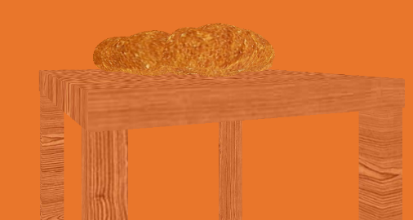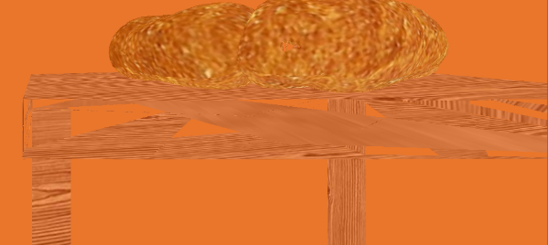
There is no need to define what the forward and up vector as it is already set. 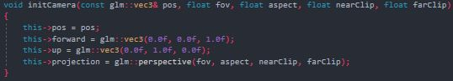

Moving the camera within the space is easy once the position is defined. To move forward or backwards, the current position vector is added to the forward vector multiplied by the forward amount, the higher the forward amount, the further the camera moves each update. 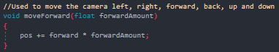
Moving up and down is similar to above but the up vector is used.
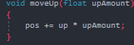
Moving left and right is a little different, since there are no left or right vectors defined. A left vector could be defined and used but it is easier to just cross the up and forward vector. Doing this creates the left vector, this can then be used to move the camera.
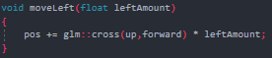

To be able to rotate the camera is a little more difficult to calculate. The up vector is taken and then used in a glm::rotate calculation, the angle is passed through as an argument. This rotation value is then used to calculate the new forward and up vectors. Since there are no left or right vectors to calculate the move left and right function still work.
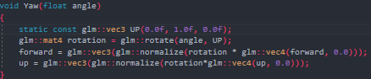

Mesh.h/cpp

The mesh class takes .obj files and reads them. It then takes the vertex data from the obj file and creates a model from the vertex data. That model can then be drawn to the screen.

loadModel() is used to take the location of the file and pass it through the obj_loader.cpp file. This file does most of the hard work of reading and making sense of the obj file.
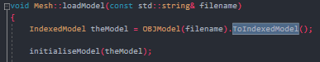
The newly read and understood obj file is then passed to initaliseModel(), this is where the vertex array object and buffer is bound and told to read certain parts of the data as: Position data (vec3), texture coordinates (vec2) and normal (vec3). Since the file was passed through the obj_loader.cpp file, the data needed has been put into arrays already, so we just pass them through.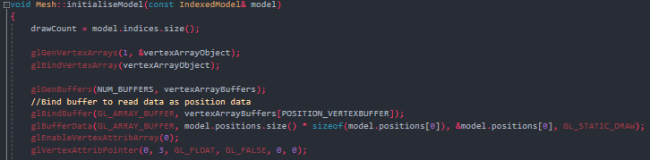

To draw the model onto the screen, firstly the VAO is bound and then glDrawElements() and glDrawArrays() is called, this draws the triangles needed to make up the model. The VAO is then unbound to allow for another model to be drawn.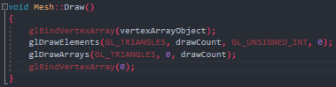

Shader.h/cpp

The shader class is takes in a vertex and fragment shader file, reads the files and then creates a shader from data provided.
There are 2 shader files being used, .vert and .frag, these two files are passed in when the shader is created. The constructor takes these two files and sends them through the createShader() function.
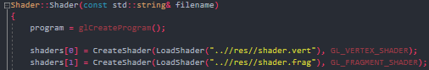
This function takes a loaded file, compiles it and then checks for errors.
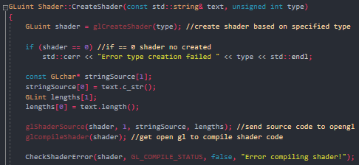
But before it can be compiled, the shader files must first be read and loaded. The shader is loaded through the loadShader() function which opens and reads the file provided, the data that is read is ouputed to the createShader() function.
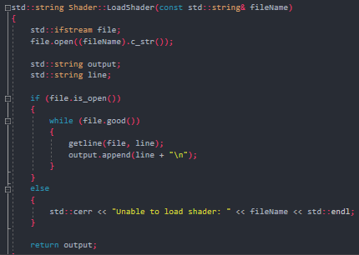
When the shaders have been successfully compiled, they are then attached to the program for use.

MainGame.h/cpp

InitSystems()
When main game is ran, it first initSystems() which is where the games display/window is initialised. The audio files used within the game are loaded, these audio files must be in .wav otherwise they will not load. I had a problem with the .wav files being read but not played. The problem ended up being the application that I was creating them in. Firstly it was creating stereo wav files instead of mono, but it was also putting metadata into the wav files which caused them not to work. The issue was resolved by exporting them from a different application.
The .obj files are loaded, loading them at the start up of the program increases the time it takes for the application to start but loading them at the start prevents any critical errors from occurring during runtime, since the errors would be seen before the application even starts.
The camera is initialised with values and position information. A counter variable is set so that the passing of time can be recorded and used for things such as animation or timing.
The background music sound is played, and the first audio clip is also played at the beginning of the game.
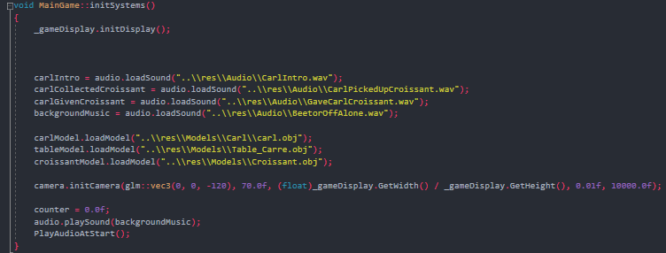

GameLoop()

The game loop is the update function of our game, every time this function is ran, 3 things happen. The input from the user is taken in, this is the users keyboard presses, certain keys do different thing such as move the camera forward or look left and right. The game is drawn, this is where the 3D models and their textures are drawn to the window for the user to see. Lastly the game checks for collisions, if a specific collision is detected, an event will be triggered.

ProccessInput()

The users keyboard inputs are detected using an SDL_Event, this is used to check if a key has been pressed down. The key inputs are mainly used to move the camera around the scene, I chose to use the WASD keys and the arrow keys to control the camera. Using case statements, when the key is pushed the program detects it and calls upon the appropriate camera.move function.

DrawGame()

At the start of each loop of the draw game function, the display is cleared. The textures that are to be used on each of the models are loaded and stored, these are used later. A transform is created, this is used to set the position of each model.
Drawing each model is done by firstly setting the transforms position, rotation and scale. Then the shader is bound, next the camera’s view is updated with the new transform information. Next the texture to be applied to the models is bound, once that is done the model is finally drawn. This process is repeated for each model.
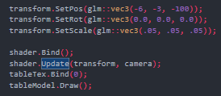
Using the counter variable mentioned earlier, we can set any value to change over time. The way that I used it is to change the rotation of one of the models over time. Each time the draw method is called the counter variable is incremented, this means that every time the draw method is called, the counter value will be incremented. This allows us to make the models move.

Collisions

Collisions between objects within a game are needed if you want the users to be able to interact with anything within the game. A collision is a calculation that checks to see if two objects are touching. If they are touching, we can program something to happen.
With the collision code two things have to be specified, the distance between the objects and the each objects collider. To make it easier to program I used a radius for the collider, this radius acts as a sphere around the object.
To detect collisions, we first have to calculate the distance between two objects. The distance can be found by finding the square root of the difference between the xyz of each object. √(x2-x1)^2+(y2-y1) ^2+(z2-z1)^2.
Then we check to see if the distance between the two objects is less than their two radii, if that is the case then a collision has occurred.
This is checked every update.
In my project there are two collisions being checked for, a collision between the player and the object they have to collect and the collision between the player and the person they have to give that object to.

Game objective

The objective of the game is to go and retrieve a croissant for Carl, when the player collects the croissant (collision 1) a Boolean named collectedCroissant is set to true, when this Boolean is true an audio clip plays letting the player know that they have to bring it to Carl. The player then takes the croissant to Carl (collision 2) when this occurs a Boolean named givenCroissant is set to true, when this Boolean is true another audio clip plays telling the player that they have succeeded in their task. Without the Boolean variables, the game objectives would not work. Since the player could collide with Carl before the collecting the croissant.
To make sure that the audio clip does not play again even if the player triggers the collision again, a Boolean is set to check if the audio clip has been played or not.
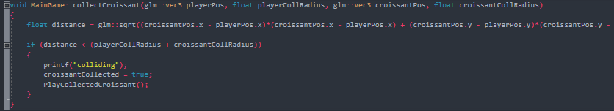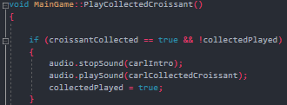

Conclusion

This has been quite the learning experience, most of my experience with programming has been with unity and game maker. These game engines do most of the hard work for you. Opengl forces you to think ahead with what you are doing; you can’t just create a class and not think of the other ones. Using opengl has given me the confidence and the drive to investigate other sections and topics of programming. Hopefully soon I’ll be able to look back on all the work I’ve done and know that I have learned and gained useful information on topics that I will use.

