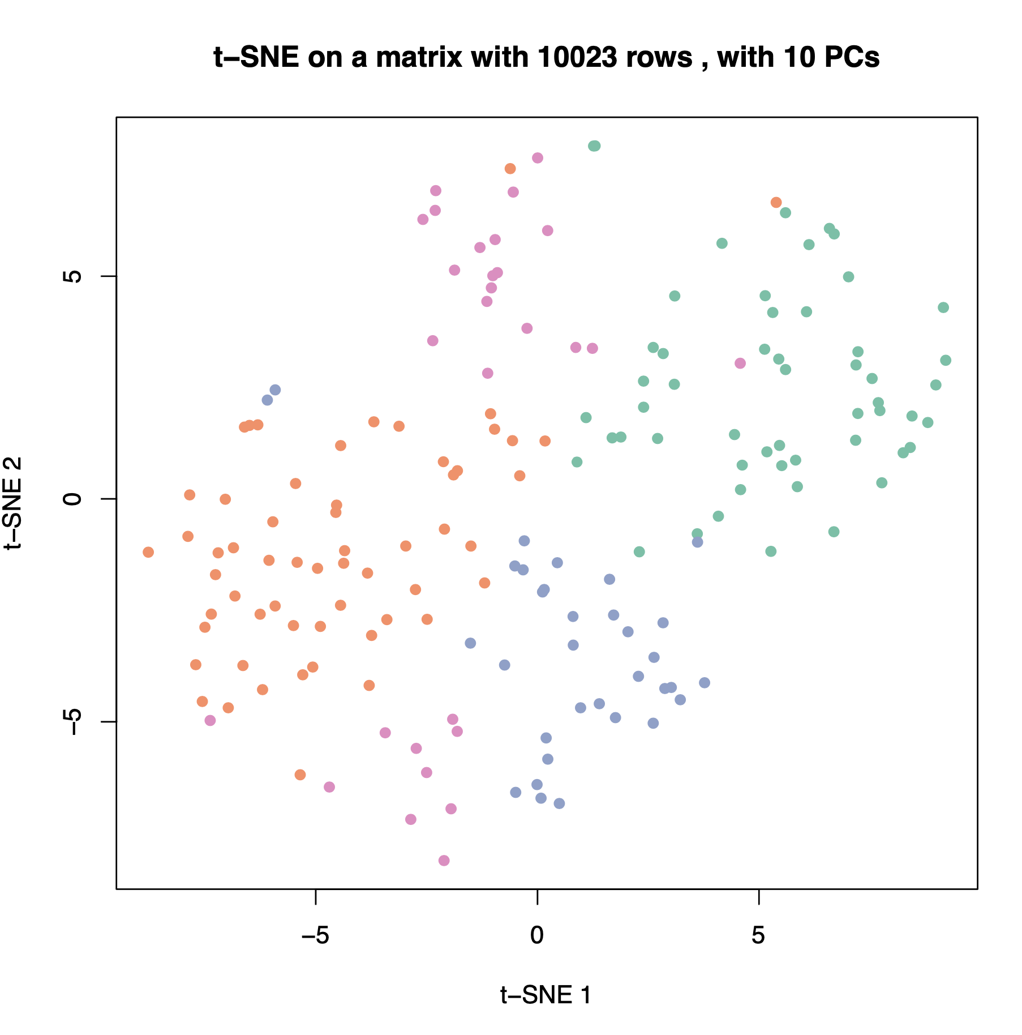

**Supplementary Figure 1.** The *t*-SNE visualization on the matrix used in Figure 2C-D. Colors correspond to the classifications from the consensus clustering.