**Names:** Trovald (p1703218), Lim Yong Kang, Bryan (p1707139)

**Class:** DISM/FT/2B/21

**SPMovy:**

Our project is to create a movie website and a database that stores all the data and information of movies. The website that we had created should allow users to be able to browse and view movies with ease. Furthermore, we have a Admin page to allow administrators to edit and manage the site by either updating new movies or edit the movie pages.

**Steps on how to deploy and use our SPMovy website and database:**

1) Import the war file to eclipse.

2) In eclipse locate over to Project Explorer tab > Right Click > import war file

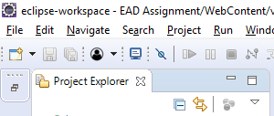

3) In Mysql Database locate to Server tab > Left Click > Data Import.

4) Once you are in data import tab check the radio button which says Import from Self-contained File browse to the file provided in the zip. Import both the sql file called: EAD_Assignment_2B21_Trovald_Bryan_P1703218_P1707139_Movies.sql

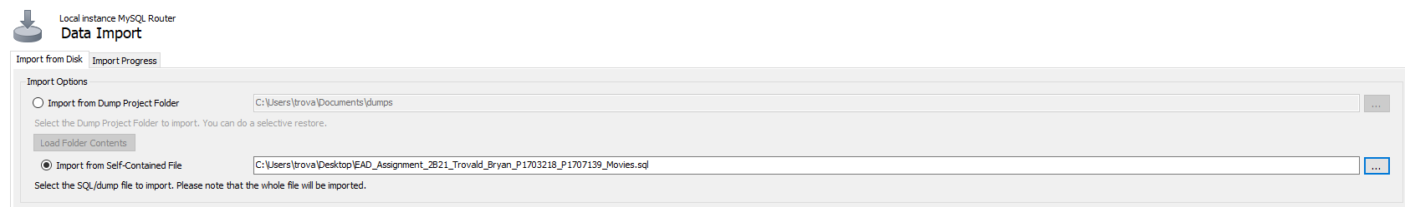

5) Next the New button on the Default schema to be imported tab and create a new Schema called Movies for the sql data imported.



6) Repeat step 4 again but with the file called: EAD_Assignment_2B21_Trovald_Bryan_P1703218_P1707139_Login.sql

7) Go back to eclipse and now edit some JSP pages. The list of JSP pages that needs to be edited are as follows: 1.jsp, 2.jsp, 3.jsp, 4.jsp, 5.jsp, 6.jsp, validatereviews.jsp, validation.jsp, deletemovie.jsp, editpagevalid.jsp

Change this part of the code:



Change the values, **“root”** and **“1234”** to your sql database username and password.

8) You should be able to run the program with ease now.

**Acknowledgments:**

* We like to thank our lecturer Mr Ji, for his guidance throughout our progress in our assignment. And not to mention our peers that has helped us with this assignment.
* Usage of bootstrap for designing the website’s user interface: <https://getbootstrap.com/docs/4.1/getting-started/introduction/>
* Usage of “fontawesome” for specific fonts and images:

<https://fontawesome.com/>

* We also use “StackOverflow” for referencing purposes:

<https://stackoverflow.com/>