|  |  |  |
| --- | --- | --- |
| **CHLORINE TYPE** | **UNIT OF MEASUREMENT (SACK/DRUM/ETC.)** | **REPLENISHMENT UOM (KG., LITER/ETC.)** |
| Calcium hypochlorite | Drum | Kg |
| Chlorine dioxide, powder | Pack | Kg |
| Sodium hypochlorite | Carbouy | Liters |
| Chlorine dioxide, liquid | Bottle | Liters |

**Chlorine Data**

**Chlorinator Stroke**

|  |  |
| --- | --- |
| Minimum SPM: | Varies per actual water quality |
| Maximum SPM: | Varies per actual water quality |

**Chlorinator form layout on System**

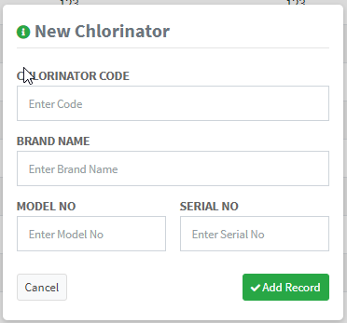

Any suggested data for ~~Chlorinator~~ Chlorine Dosing System Record?

Pls add repairs and maintenance/ troubleshooting history

* Parts replace, date replaced, brand new parts/ refurbished parts
* Replaced by.

For the pump if new/ or repaired.