**Lab 3: Vaccination during a pandemic**

# SIR Model plus Vaccination

To explore the consequences of a vaccine being rolled out and administered during a pandemic, we are modifying the simple SIR model to include vaccination.

**Figure 1**: Our modified SIR model breaks the population into four segments. Note that we will use **b***,* **g***,* and **vr** to represent the rate constants for infection, recovery, and vaccination. Also note that the rate of infection is proportional to both the number of susceptible people and the number of infected people.

As we saw in class, our differential equations will be:

$$\frac{dS}{dt}=-bIS-v_{r}S$$

$$\frac{dI}{dt}=bIS-gI$$

$$\frac{dR}{dt}=gI$$

$$\frac{dV}{dt}=v_{r}S$$

Here, the variables S, I, R, and V represent the fraction of the population (values between 0 and 1) that are in each of the four categories.

# Designing the Model

Looking at the above equations, what will happen to the rate at which people are vaccinated (dV/dt) as S decreases to half its original value (for example if S decreases from 0.9 to 0.45)?

dV/dt will decrease proportionally to S.

Does that seem reasonable? How would you change the above differential equations if you believe that the rate of vaccination will stay constant, even as S declines?

If dV/dt is to stay constant, vr would have to increase at a rate inversely proportional to the decrease in S.

Frequently in generating mathematical models, we must make choices about the mathematical form we expect a process to have. The choices we make can have a significant impact on the results of our model, so it is important to think about these choices, try to make the most appropriate choice, and to be aware that we are making a choice. In some cases, if two choices both seem reasonable, it may be worth evaluating and comparing two versions of the model.

In this case, we need to make a choice for how we think the rate of vaccination will change over time as more and more people are vaccinated. What is an argument why the first model (dV/dt proportional to S) might be a good model?

dV/dt will change as the number of unvaccinated (susceptible) people changes – more of a long-term perspective.

What is an argument why the second model (dV/dt constant) might be a good model?

This would be relevant in the early stages of the rollout, when the number of vaccine doses is limited and there’s more demand than can be accommodated.

Pick the model that you think is more reasonable and indicate your choice below. In the following sections, you will edit the differential equations in MATLAB according to your choice.

I’m sticking to the long-term perspective.

# Simulating the past

To have a good frame of reference for the future, we will use a version of the model without vaccination first to simulate the course of the pandemic up to approximately January, 2021.

Open the provided m-file “SIRV_Model_Vaccine_Rollout.m”. Notice that Block 1 will load the same data set that you used last week. If you do not have this .mat file in your working directory or in a directory contained in the MATLAB path, put it in such a folder now. Then run Block 1 to load the data. Or drag the file into the workspace window.

Run Block 2 to set up our transmission and recovery rate constants.

Block 3 sets up our differential equations, similarly to how we have done it in the past. Notice that dyBefore has four equations on four lines. What do these four equations correspond to?

They correspond to the equations for dS/dt, dI/dt, dR/dt, and dV/dt.

Execute Blocks 4 and 5 to simulate the model and plot the results. In Block 5, we set the axis limits in lines 44 and 45.

# Modeling the vaccine rollout

Now we want to model the vaccine rollout during the pandemic. What is the impact of the speed at which vaccines are administered? What about the impact of changes in behavior once vaccination rates are rising?

Block 6 defines rate constants for modeling the rollout. Here, we are keeping the recovery rate the same, but we need to make decisions for how to model vaccination and virus transmission. For an initial attempt, we will define a vector of possible vaccination rates ranging from 0 (no vaccination) to 0.003 (vaccinating about 2% of the population in one week). For reference, according to <https://ourworldindata.org/covid-vaccinations>, the United States administered about 2 vaccine doses per 100 people during mid-January of 2021, equivalent to fully vaccinating 1% of the population.

How are we defining b in this block? What assumption does that make about behavior and virus-related restrictions going forward?

Looks like b is defined as a function in which the b/g ratio at a particular timepoint is multiplied by g (which is constant).

Block 7 defines the differential equations for our model. Edit the definition of dy according to the choice you made for the mathematical form of the vaccination rate. Remember that we defined vr as an array, but we need a single number for our differential equation. Enter the completed lines for defining dy here:

vr(i)*y(1)

You may also notice that our definition of tspan is different from what we have typically done in the past. Why do you think we did this?

This model starts where the first one ended, with day 322.

Execute Block 7. In Block 8, we define the initial conditions. We want our simulations to pick up where our model of the past left off. That means our “initial” values for S, I, R, and V should be the values for these populations from the end of our previous simulation. How can you edit the line defining y0 to do this automatically (rather than looking up the numerical values and typing them in)? Fill in this line in the code and paste your code below.

yBefore =(323,:)

We now have a for loop for solving our differential equations. In each iteration of the loop, we store the output for one version of the model, with one value for the vaccination rate. Execute Block 8. What is the size of yAfter{1}? (You can use the “size” function to find out)

279 4

What is the size of yAfter{2}? Do these sizes make sense?

279 4 Same 279 timepoints of same 4 variables

We stored the model output values in a cell array, but we just stored the output time values in a vector tAfter. Why didn’t we need a cell array for the time values?

Time values have only one dimension.

# Interpreting the model output

In Block 9, we are plotting the output of our model. First, we want to visualize how new infections change over time by plotting our simulated data for infections (I) for the past. Edit the line after the figure command to plot this data. Paste your code below:

plot (tAfter, yAfter{i}(:,2));

To get more insight into the effect of vaccinations, we will also generate a second plot underneath the first to track the fraction of the population that is vaccinated over time. Fill in the plot command for the second subplot to plot the fraction vaccinated over time. Paste your code below:

plot (tAfter, yAfter{i}(:,4));

Then we use a for loop to plot the data for each of our simulations of the future. Run Block 9. Paste a screenshot of your figure below:

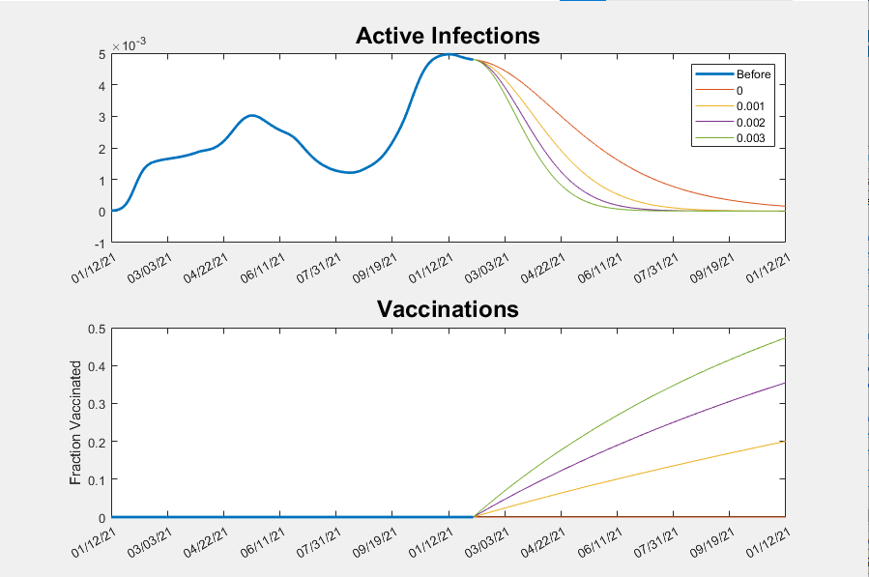

Describe what you see in the results of the plot? Do they look like you expected?

Pretty much, yes

At about what date do the vaccinations start to make a big impact on the course of the pandemic?

I’d say the effects start right away, with a maximum around 22 April 2021.

What fraction of the population has been vaccinated (in our model) at that point? Is that fraction smaller than what you expected?

The maximum vaccination rate at that date would’ve been around 19%, much less than I would have thought.

# Exploring the model

A key assumption that we made in the above model is that the virus transmission rate would stay the same over time. In reality, virus-related restrictions and personal behavior change. Additionally, new variants of the virus with greater infectivity have emerged and become the dominant strains.

A simplest alternate assumption would be that the virus transmission rate will be constant, but it will not be equal to the current rate. Try increasing the transmission rate by 20% How would you adjust the code in the above blocks to do this?

in Block 6, b = @(t) [1.2*b_to_g_ratio(322)*g];

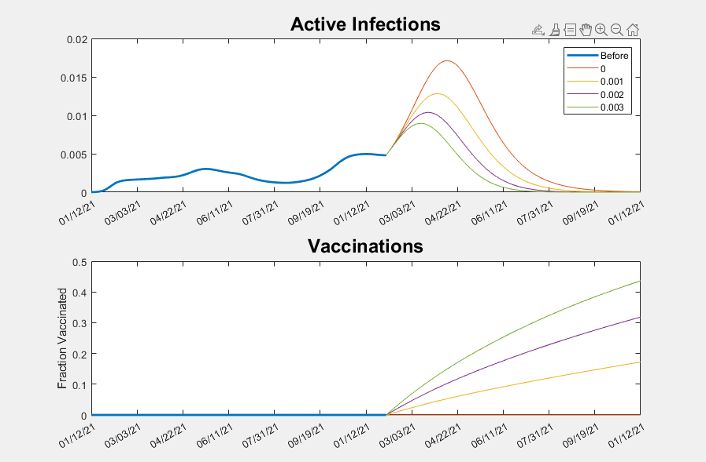

How did your results change. Does the impact of differences in the vaccination look the same as before?

Vaccination effects are more pronounced with increased transmission rate.

# If you have time

In Block 5, what does the code max(yBefore(:,2) + yBefore(:,3)) do and why does line 44 give us a reasonable set of bounds for the y-axis?

Col 2 is I and Col 3 is R, so these commands call up those columns from the yBefore variable. We want to keep the numbers on the same order of magnitude for better visibility.

With the rest of your time, explore the model using different definitions for the transmission rate b. Try making b a function that depends on t (time). You could try making the transmission rate increase linearly over time. You could do this by adding a term to your definition of b that is some small value multiplied by (t-322). (The reason to subtract 322 is so that the rate will still start at the same value that our “Before” simulation ended with.) How does that change your results? How does that change the impact of vaccination?

Replace this text with your answer