Important links:
https://www.agriculture.gov.bz/document-center/ data on production, economic valuation and exports imports

Small-Scale Fishery in Caye Caulker and Placencia
The information presented here was obtained through the realization of two workshops, one in Placencia and one in Caye Caulker, where community members representing different sectors of society share their knowledge, experiences and expectations related to the fishery activity.

A fisher’s perspective
We obtained responses from 15 fishers in Caye Caulker, 58% male and 41.7% female, demonstrating significant and equal participation by both genders in Caye Caulker's fishing activity and, 5 fishers in Placencia, only one of them female. The most represented ethnic groups during workshops were Creole and Mestizos, but also Garifuna and Maya were active during the activities.
Caye Caulker has a more even distribution of fishers across age groups, with the highest proportion (26.67%) in the age groups >55 and 25 – 34 years old. In contrast, Placencia has a smaller sample size, with the largest proportion (40%) in the age group 45 - 54. The absence during the workshops of young people under 25 years of age is highlighted.
Table 1: Age group of participants during the workshops
Site | Age Group | Fisher by age group | Percentage
Caye Caulker | >55 | 4 | 26.66%
Caye Caulker | 25 - 34 | 4 | 26.66%
Caye Caulker | 35 - 44 | 3 | 20.00%
Caye Caulker | 45 - 54 | 2 | 13.33%
Placencia | 25 - 34 | 1 | 20.00%
Placencia | 35 - 44 | 1 | 20.00%
Placencia | 45 - 54 | 2 | 40.00%

As expected in small-scale Caribbean fisheries, most fishers engage in multispecies fisheries, with 65% of them being active in the three fisheries studied here (lobster, queen conch, and fish), while 30% reported engaging in only one of them.
Table 2: Engagement in multispecific fisheries by participants
category | Fisher count | Percentage
All fisheries | 13 | 65%
One fishery | 6 | 30%
Two fisheries | 1 | 5%

The lobster fishery is mainly performed using shades and combined it with lobster traps and hook sticks. For the finfish fishery, the most frequent fishing gear is the hand line and its combinations with spearfishing and traps. While the queen conch is mostly fished by free diving (Tables x x x ). Other fishing gears like the snare and the jamo are present but less frequently used. Most of fishers reported to be licensed to finish lobster in zones 1 and 3, which are already well know zones for lobster fishery in Belize (Signa, 2023). However, other zones were reported to be used by participants like zone 4, 5, 6, 8 and 9.
Table 3: Fishing Gear used in Lobster Fishery
Fishing Gear | Count
Hook stick | 2
Jamo | 1
Other | 1
Shade | 4
Shade and Hook stick | 1
Shade and Lobster trap | 4
Snare | 1
Unknown | 1

Table 4: Fishing Gear used in Finsish Fishery
Fishing Gear | Count
Hand line | 6
Hand line and Other | 3
Hand line and Spearfishing | 3
Hand line and Spearfishing and Other | 1
Hand line and Trap | 1
Other | 1
Spearfishing and Other | 1
Spin Rode | 1

Table 5: Fishing Gear used in Queen Conch Fishery
Fishing Gear | Count
Free diving | 14
Other | 1

Fishing effort can vary significantly between fishers, with some of them reporting as low as one fishing trip per month, and others can fish almost the complete month during the lobster season (30 fishing trips per month). In Caye Caulker, the lobster fishery and finfish fishery exhibit similar efforts, probably because fishers tend to target both species on the same fishing trip (TABLE). In Placencia there is a significant interest in the lobster fishery, exhibiting the highest monthly effort and variability (13.2 trips as mean and 12.1 SD), and very low interest in the conch fishery, only 3.8 fishing trips per month on average during the conch season.
Table 6: Montlhy Fishing Effort in number of trips
Site | Specie | Average Monthly Effort | SD
Caye Caulker | Conch | 8.25 | 9.01
Caye Caulker | Finfish | 10.72 | 9.71
Caye Caulker | Lobster | 10.65 | 7.52
Placencia | Conch | 3.87 | 2.78
Placencia | Finfish | 8.25 | 8.53
Placencia | Lobster | 13.25 | 12.14
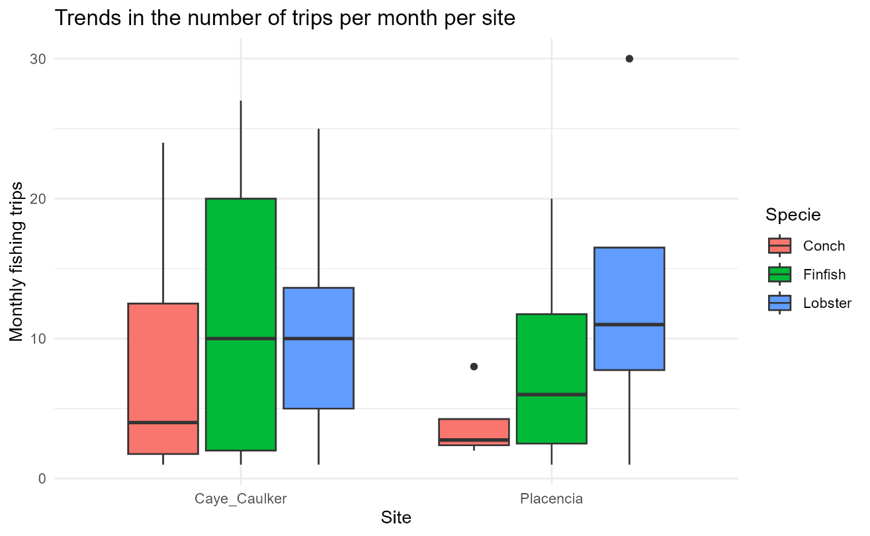
There is a significant difference in the estimated average catch per fishing trip performed by the participants from both sites, with higher catches for all species in Placencia compared to Caye Caulker (table). The queen conch exhibits the higher average catch per fishing trip (and higher variability sd) in Placencia in agreement with the lowest fishing pressure on that site. In Caye Caulker, the finfish fishery exhibits the higher average CPUE and lobsters the lowest average catch.
Table 7: Average catch (pounds) in the three fisheries.
Site | Specie | Average Catch per Trip | SD
Caye Caulker | Conch | 57.25 | 65.12
Caye Caulker | Finfish | 69.00 | 21.33
Caye Caulker | Lobster | 47.90 | 38.62
Placencia | Conch | 301.25 | 406.18
Placencia | Finfish | 180.62 | 48.83
Placencia | Lobster | 106.25 | 60.60

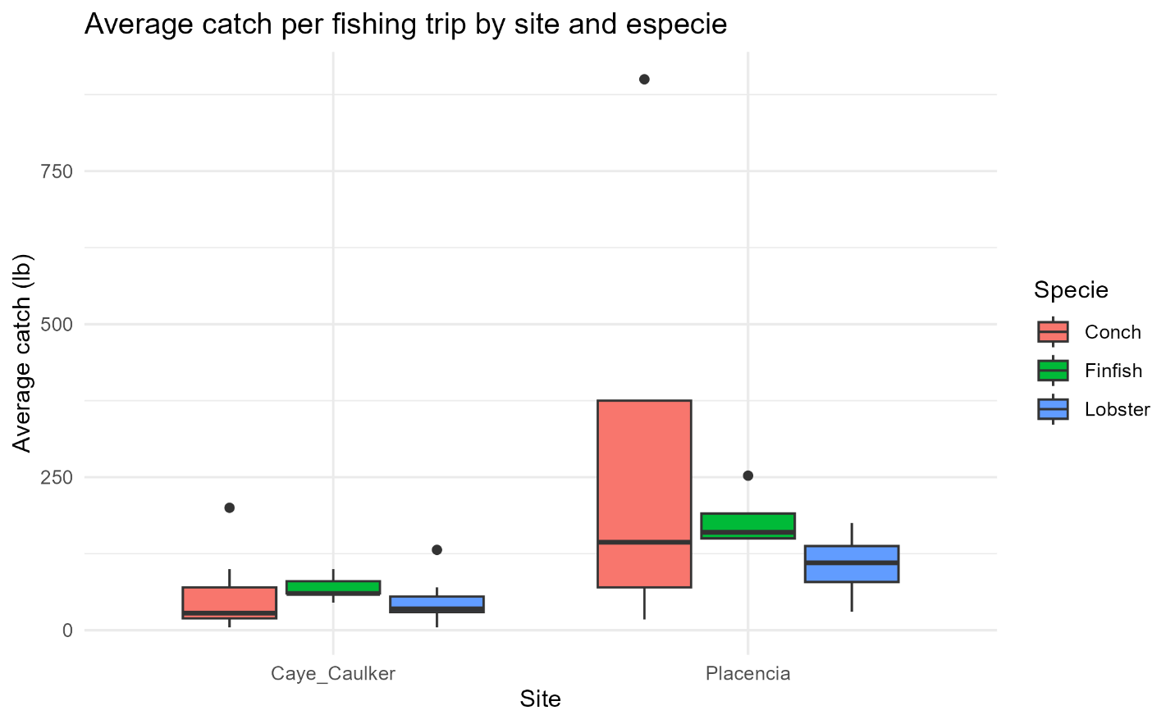

However, as explained by several fishers during the activity, part of the monthly variability of the catch, at least in the lobster and conch fishery, occurs between the first months and the last months of the season. During the first two months of the lobster season in Caye Caulker as explained by one fisher, each fishing trip can yield around 400 lbs. Then, the catch decreases to around 200 lbs. between the 3rd and 4th months, and in the last months, it drops to less than 100 lbs. per trip. This gives a weighted average estimation of 131.25 lbs. per fishing trip considering the different catch between months during the season for that fisher.
Lobster is the species with the highest selling price, with a higher value in Placencia compared to Caye Caulker. While the value of finfish tends to have a better selling price in Caye Caulker than in Placencia. Price fluctuations are observed across species, with groupers in both places being the fish species with the best-selling prices. Conch prices demonstrate similar values between the two sites, although Caye Caulker exhibits greater price variability. Fisher's selling prices are influenced by both the degree of product processing (e.g., fillets, whole fish, tails) and the buyer, with restaurants typically offering higher prices than cooperatives.
Table 8: Average primary landing selling price in Belizean dollars
Site | Specie | Average Selling Price | SD
Caye Caulker | Conch | 9.37 | 3.24
Caye Caulker | Finfish | 10.98 | 3.12
Caye Caulker | Lobster | 23.25 | 6.9
Placencia | Conch | 9.12 | 0.85
Placencia | Finfish | 6.77 | 2.34
Placencia | Lobster | 29.00 | 1.15

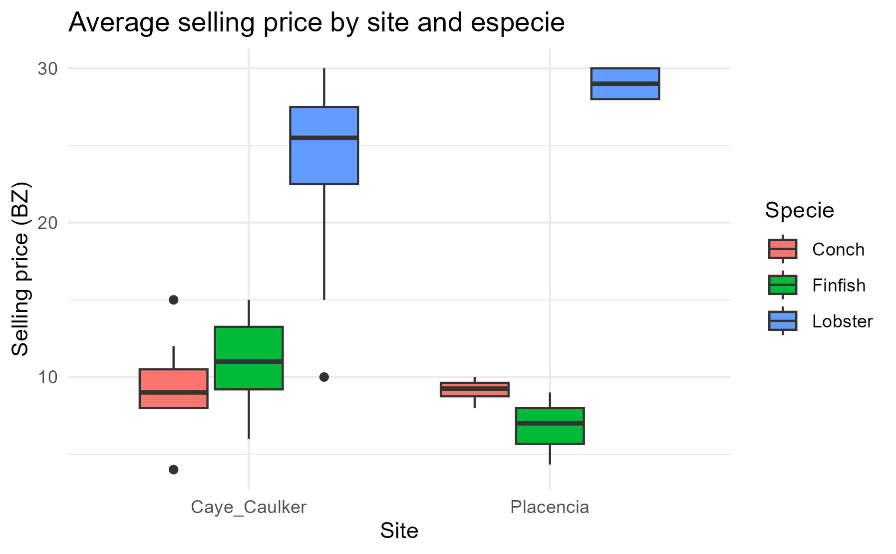
The main primary buyers, those that buy directly from the fishers, are restaurants and cooperatives. As participants commented during the activities, fisher prefer to sell to restaurants because they pay a better price for catches, this is more noticeable in both places where most people responded that they sell to restaurants. However, restaurants only buy in large quantities when it is the high tourist season, and in the other months of the year, fisher depend on cooperatives to sell their production.
Despite the differences in selling prices between species, no significant differences are observed in the profit obtained from fishing trips when compared between the target fisheries. Although differences are observed between the two locations, with fishing in Placencia being potentially more profitable than in Caye Caulker (table). Lobster and conch fishing tend to have similar average profits in Caye Caulker, even though lobster fishery present higher variability. Fishing for fish in Caye Caulker appears to be the fishery that yields the lowest average profit.
Table 9: Average profit from fishing trips in Belizean dollars
Site | Specie | Average Profit | SD
Caye Caulker | Conch | 505.00 | 621.59
Caye Caulker | Finfish | 352.00 | 196.26
Caye Caulker | Lobster | 589.84 | 498.14
Placencia | Conch | 877.50 | 751.23
Placencia | Finfish | 806.25 | 726.39
Placencia | Lobster | 858.25 | 972.91

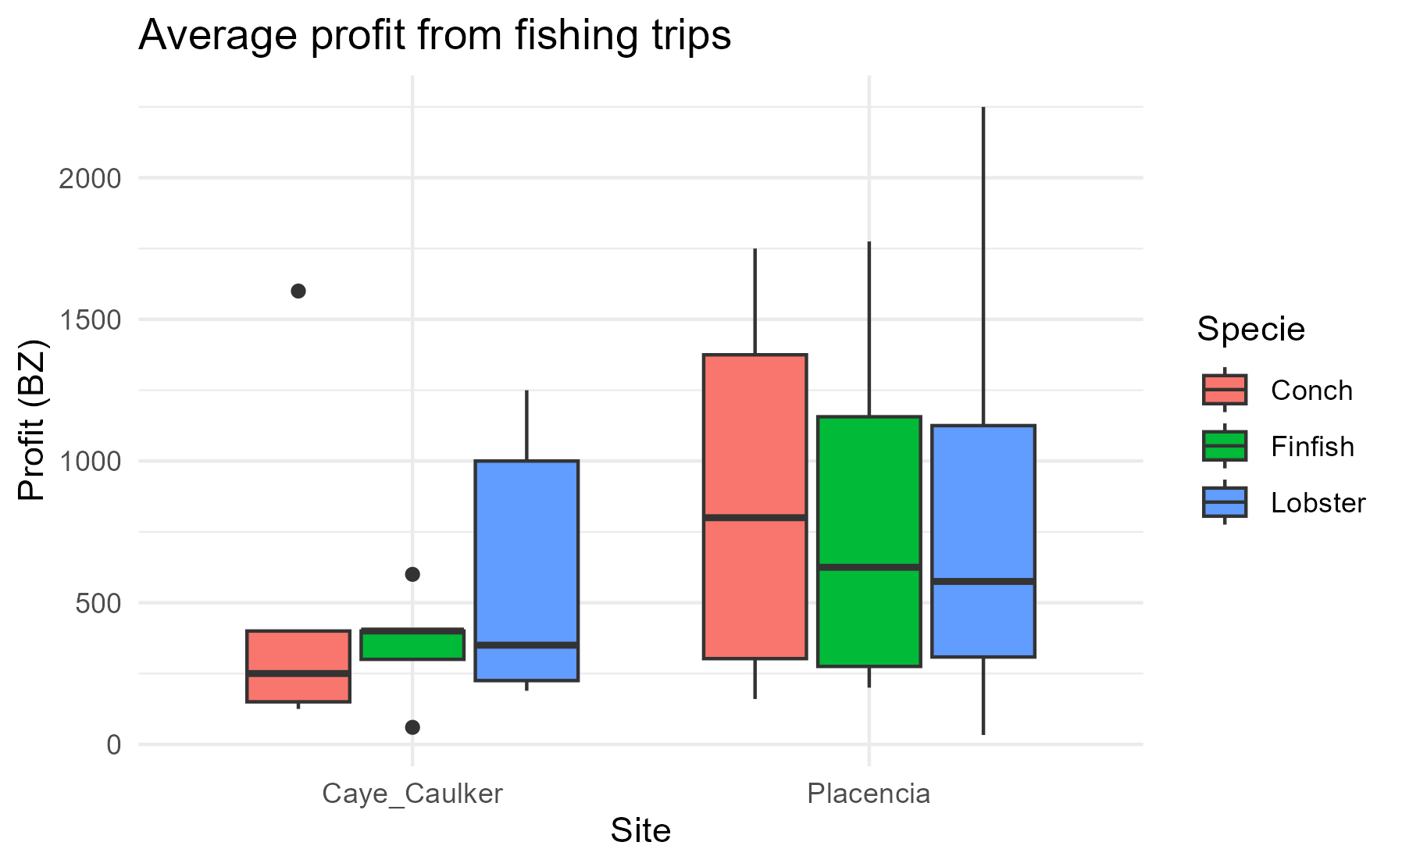

Eight respondents in Caye Caulker and four in Placencia reported secondary employment in tourism, emphasizing the strong interconnection between small-scale fisheries and tourism. Additionally, only three fisher indicated membership in a cooperative, all of whom belong to the Northern Cooperative, while two fishers reported being affiliated with the Placencia Cooperative.

Retailers
Retail Seafood Trade in Caye Caulker and Placencia
The seafood retail industry in Caye Caulker and Placencia, showcases both similarities and distinctions in the way local retailers source, purchase, and sell marine products. Both locations depend on close relationships with fishers to secure a steady supply of fresh seafood, with key species such as spiny lobster, queen conch, and snapper playing a central role in the trade.
Retailers and Business Structures
In both communities, three individuals identified themselves as retailers, all over the age of 35. However, their backgrounds and business models varied. In Caye Caulker, the retailers were all women—two of Creole descent and one Garifuna—operating restaurants and a fishing shop. Their businesses relied on direct arrangements with fishers, often providing ice or other benefits in exchange for priority access to fresh catch.
In contrast, the Placencia retailers included two Creole men and one woman of mixed Creole and East Indian heritage. Their businesses were more diverse, spanning a dive shop, a fish market, and an independent family-run seafood sales operation. Only those running dive shops reported exclusive agreements with fishers, offering ice and credit in return for preferential purchasing rights.
Seafood Pricing and Trade
Pricing structures in both locations reflected similar trends but varied in specific values. Spiny lobster remained the highest-priced species, with reported purchase prices ranging from $18 BZD per pound in Caye Caulker to $28 BZD per pound in Placencia. Selling prices varied accordingly, with restaurant plates of lobster reaching $40 BZD in both locations.
- Queen conch was purchased at an average of $9.50 BZD per pound in Placencia, slightly lower than in Caye Caulker, where prices ranged between $10–$15 BZD, depending on size and processing.
- Snapper maintained its prominence, with purchase prices around $10 BZD per pound in Placencia and selling prices varying between $3–$10 BZD in Caye Caulker, depending on size and probably on specie.
- Finfish species such as barracuda, snook, and grouper exhibited variability in pricing, with barracuda being notably cheaper at $7 BZD per pound in Placencia, compared to higher prices for grouper and snapper.
Despite these differences, in both communities, pricing fluctuated based on availability, processing, and consumer demand.
Supplier Relationships
Retailers in both locations primarily sourced their seafood from local fishers, reinforcing the deep economic and cultural ties between the fishing industry and retail businesses. In Caye Caulker, restaurants and shops often secured their supply through direct partnerships with fishers. Additionally, while lobster and finfish were often sourced directly from fishers, retailers in both areas relied on fish markets or wholesalers for more consistent access to lobster and queen conch.
Priorities in Seafood Selection
Retailers in Caye Caulker emphasized availability (100%) and quality (66.7%) as the most critical factors in their purchasing decisions, while price, demand, and sustainability were less influential. In Placencia, however, retailers placed greater emphasis on price, quality, and sustainability, with availability and demand playing a secondary role.
This contrast suggests a key difference in market dynamics—Caye Caulker's businesses prioritize consistent access to fresh seafood, while Placencia retailers balance economic considerations with sustainability concerns.

Consumers
Seafood Consumption Trends in Placencia and Caye Caulker
In Placencia, twelve participants identified as seafood consumers, with 58% male and 33% female. The majority (75%) were Creole, followed by Mestizo, White, and Garifuna (each 8.3%). The consumer base skewed older, with 58% over 55 years old, and no participants under 25, suggesting limited youth involvement in the workshops.
In contrast, Caye Caulker had seven identified consumers, of whom 66% were male and 33% female. The ethnic distribution was more diverse: 50% Mestizo, 33.3% Maya and Creole, and one individual of East Indian and White descent. The age distribution was more balanced, with 50% between 35 and 44 years old, and the remaining age groups (18-24, 45-54, and over 55) each representing 16.7% of participants. However, there was no representation from the 25-34 or under-18 groups.
Seafood Consumption Patterns
Snapper and barracuda were the most widely consumed species in Placencia, with 11 and 9 consumers, respectively. Interestingly, barracuda had the highest per capita consumption at 14.3 pounds per month, followed by jack at 11.5 pounds per month. In contrast, snapper was the most frequently purchased species but had a slightly lower per capita consumption (10 lb/month).
In Caye Caulker, snapper, lobster, and conch dominated seafood consumption. Snappers had the highest total consumption (17.5 lb/month), followed by lobster (15 lb/month) and conch (13.5 lb/month). Grouper consumption was moderate (8 lb/month), while barracuda, jacks, and snook were consumed in smaller amounts. Wrasses (hogfish) were not reported as consumed in either community.
Species | Consumers  Placencia | Avg Consumption  Placencia | Consumers  Caye Caulker | Avg Consumption  Caye Caulker
Lobster | 7 | 6 | 4 | 3.8
Conch | 8 | 4 | 6 | 2.3
Snook | 3 | 10 | 1 | 1.0
Barracuda | 9 | 14 | 2 | 2.0
Snapper | 11 | 10 | 6 | 2.9
Grouper | 6 | 14 | 1 | 8.0
Wrasses | 0 | 0 | 0 | 0.0
Jacks | 6 | 12 | 2 | 2.0

While snapper and conch had the highest number of consumers in both communities, grouper, lobster, and snapper had the highest per capita consumption. Consumers in Caye Caulker expressed interest in eating parrotfish, goliath grouper, tuna, and hogfish, but these species were difficult to find, suggesting potential overfishing or declining stocks.
Seafood Pricing and Market Trends
Pricing varies across species and locations. In Placencia, spiny lobster was the most expensive species, purchased at BZ$27 per pound and sold for BZ$29.3 per pound. Snappers and grouper had similar pricing at BZ$8 per pound, while barracuda was the most affordable species, costing BZ$6 per pound.
In Caye Caulker, pricing information was more varied due to individual-based reporting, but snapper, conch, and lobster were the most commonly purchased species.
In both communities, most consumers preferred purchasing directly from fishers, as it provided higher quality, better traceability, and stronger social ties with local fishing families.
- In Placencia, direct purchases from fishers were the most popular, followed by fishboards and local markets. Restaurants played a minor role in local seafood consumption, catering mainly to tourists rather than residents.
- In Caye Caulker, 71.4% of respondents bought seafood from fishers, while local markets and restaurants were secondary sources. Supermarkets had a minimal role (14.3%), and fishboards were not mentioned at all.
Economic Impact and Household Seafood Intake
In Placencia, seafood constituted an average of 37.5% of a family's monthly food intake, with some households consuming up to 50% seafood-based meals. Monthly household seafood expenditures varied widely, averaging BZ$127, but ranging from BZ$5 to BZ$200, depending on whether families purchased seafood or sourced it through fishing and community sharing.
In contrast, in Caye Caulker, seafood intake per family was significantly lower. Three out of four respondents reported that seafood represented less than 1% of their food intake, with one participant being vegetarian. Only one person estimated seafood to make up 10-20% of their family's diet, with spending at approximately BZ$100 per month.
When asked whether they would pay a higher price for sustainably sourced seafood that supports small-scale fishers, all participants in Placencia (100%) responded "Yes". In Caye Caulker, 75% of respondents were also willing to pay more for sustainable seafood.
This suggests widespread consumer awareness of sustainability and ethical fishing practices, although Caye Caulker had slightly lower enthusiasm, possibly due to its lower per capita seafood consumption compared to Placencia.
Awareness of Sustainable Fishing Practices
Both communities demonstrated an understanding of sustainable fishing initiatives, though Placencia residents were more familiar with conservation efforts.
- Placencia residents cited organizations such as SEA, the Placencia Tour Guide Association, Fragments of Hope, BTIA, and the Belize Tourism Board, highlighting efforts like coral restoration, size limits, and alternative livelihoods for fishers.
- Caye Caulker residents mentioned value-added marketing, minimum-size lobster tail restrictions, zoning, licensing, marine protected areas, and seasonal closures as key strategies for sustainability.
A shared cultural norm in both communities was the respect for "aggers” -larger fish that are believed to be essential for maintaining fish populations-. Additionally, avoiding habitat destruction, particularly of coral reefs and mangroves, was widely acknowledged as crucial for sustainable fishing.

NGOs and Academic Institutions
Non-governmental organizations (NGOs) and academic institutions play an important role in supporting small-scale fisheries in Belize. Their involvement spans training, education, governance, and economic development initiatives aimed at improving the sustainability of fisheries and enhancing fishers’ livelihoods.
Data collected from workshops in Caye Caulker and Placencia provide insights into how these institutions interact with fishers, wholesalers, and retailers, highlighting shared priorities and distinct regional approaches.
Demographics of NGO Participants
In Caye Caulker, four NGO members participated in the survey, representing WWF, Fragments of Hope, Caye Caulker BTIAC, and Belioness. Participants were evenly split between men and women and came from Creole and Mestizo backgrounds. Their roles ranged from community engagement to leadership positions, emphasizing their direct involvement with fishers and other stakeholders in the fisheries value chain.
In contrast, Placencia had a higher level of participation, with nine NGO representatives. Creole was the most common ethnic background, particularly among women, while Mestizo was equally common among men. The range of roles was more diverse, including Site Coordinators, Executive Directors, Educators, Project Managers, and Board Chairpersons. These different roles indicate varying priorities:
- Educators and Outreach Coordinators focused on training and capacity building.
- Chairpersons and Site Coordinators were more involved in governance and decision-making.
- Conservation Planners and Project Managers prioritized sustainable fishing practices and economic development.
Institutional Interactions with Fishers
Both Caye Caulker and Placencia prioritized education and training for fishers, with training programs and outreach initiatives being the most common activities.
- In Caye Caulker, 100% of respondents indicated their institutions focused on training and education, with moderate involvement in governance (50%). Other activities such as licensing, quota allocation, and monitoring catch were less emphasized.
- In Placencia, institutions displayed a more diverse range of interactions. While education remained a core focus, roles such as Site Coordinators and Chairpersons had a greater involvement in governance and decision-making compared to Caye Caulker.
Overall, these findings suggest that while training and education are general priorities, Placencia NGOs have stronger governance and policy engagement, whereas Caye Caulker institutions focus more on direct training and best practices.
Institutional Interactions with Wholesalers and Retailers
Beyond fishers, NGOs and academic institutions also interact with wholesalers and retailers to support sustainable seafood supply chains.
- In Caye Caulker, 66.7% of responses indicated that training and education were the primary ways institutions engaged with retailers. Governance and decision-making received a lower score (33.3%), showing limited institutional influence on policies affecting retailers.
- In Placencia, similar patterns emerged, but with a wider range of strategic roles influencing policy and governance. Respondents noted that regulatory frameworks, licensing, and monitoring catch volumes were areas where institutions could strengthen engagement.
Despite these variations, education and outreach remain the dominant strategies for institutional engagement with seafood retailers in both locations.
Focus Areas in the Fisheries Value Chain
NGOs and academic institutions in both Caye Caulker and Placencia primarily focus on the catch/production stage of the seafood value chain.
- Caye Caulker NGOs target fishers and retailers, aiming to improve capture techniques and promote sustainable practices.
- Placencia institutions place a stronger emphasis on research and management efforts, with seven occurrences of engagement across spiny lobster, queen conch, and finfish fisheries.
While catch/production remains the most studied stage, respondents from both sites acknowledged the need for increased research into consumption and distribution patterns to ensure long-term sustainability.
Strategies to Improve Fishers’ Livelihoods
Institutions in both communities employ a variety of strategies to support small-scale fishers by focusing on:
- Income Diversification – Providing training in alternative livelihoods, such as small business development, tourism, and conservation work.
- Skill Development – Enhancing fishers' ability to monitor stock levels, improve fishing techniques, and engage in sustainable practices.
- Sustainable Fishing Practices – Educating communities on regulations, best practices, and ecosystem conservation.
- Community Education – Raising awareness on the importance of fisheries management and the economic benefits of conservation efforts.
Key Institutional Contributions
Strategies of Institutions to Improve Fishers' Livelihoods
Institution | Primary Role of participant | Impact on Fishers Income | Measurement of Success
WWF (Caye Caulker & Placencia) | Community Engagement & Conservation Planning | Training in alternative livelihoods, income diversification | Surveys, economic impact tracking
Fragments of Hope | Site Coordinator | Training fishers in monitoring & conservation | Not quantified
Caye Caulker BTIAC | Chairperson | Training, quality control, best practices | Number of fishers participating in programs
Belioness | Vice Chair | Lionfish population monitoring | Changes in lionfish abundance
Humana People to People | Grant Proposal Writing & Project Management | Sustainable development training, funding for alternative livelihoods | Improved community economic conditions
Southern Environmental Association | Executive Director & Board Chairman | Capacity building & best practices training | Tracking fisher compliance with regulations
Toledo Institute for Development and Environment | Protected Area Manager | Managed access programs for traditional fishers | Expansion into tourism-related activities

The data suggests a collaborative effort between institutions, local fishers, and retailers to create sustainable and economically viable fishing communities.

Network analysis
To assess the interaction patterns among the actors participating in the workshop, the value chain was defined as a socio-ecological system, where individuals, or the sectors with which they identify, interact with each other through various activities associated with the three fisheries - lobster fishing, queen conch fishing, and finfish fishing.

Caye Caulker
While there is a direct, relatively strong link between local consumers and fishers, the low monthly seafood consumption per household limits fishers' ability to depend solely on this market.
Cooperatives, despite their dominance in the export market, play a secondary role in the domestic market, purchasing only a limited number of species at lower prices. To enhance fisher livelihoods, increasing domestic seafood consumption is essential.
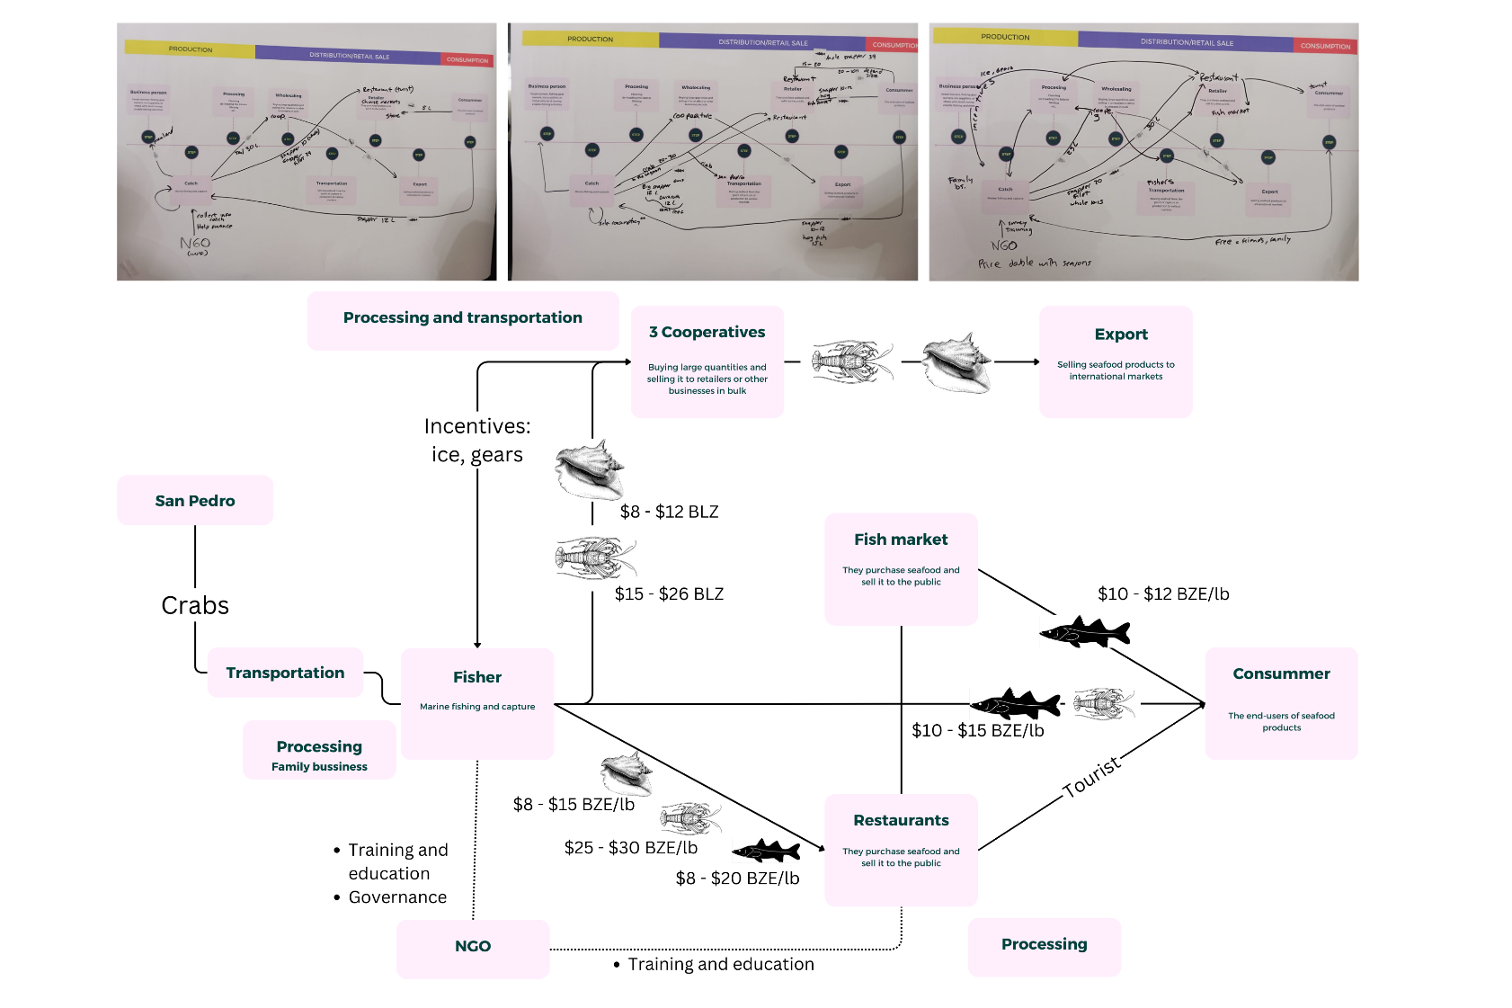
NGOs and academia can facilitate connections between various sectors, promoting responsible consumption and expanding sales opportunities for fishers.
Restaurants, though with lower centrality, play a pivotal role due to their direct interactions with fishers and consumers. By offering competitive prices and a diverse range of seafood, restaurants are preferred buyers, reducing intermediaries and improving fisher profitability. However, their capacity to buy majority of fish production is linked to the tourism season.
The lobster fishery follows the same interactions patterns described before with the aggregate network.
Increased fish abundance, resulting from nature-based solutions, has the potential to enhance fisher catches. This could manifest as larger catches, larger individuals commanding higher market prices, or a greater diversity of species to exploit, thereby distributing fishing effort and reducing the risk of overexploitation of highly demanded species. However, to translate these increased catches into improved livelihoods, a fair and equitable market for multi-species catches must be ensured year-round. Currently, fishers heavily rely on sales to restaurants during peak tourist seasons, receiving high prices for all captured species. When restaurants are not purchasing, fishers turn to cooperatives, selling only lobster and queen conch at lower prices, impacting their earnings.
Other factors to consider include the misalignment between the lobster fishing season and the tourist season. This mismatch often results in selling larger initial catches to cooperatives at lower prices, as storage is prohibited.
To enhance fisher resilience and incomes, leveraging the strong relationship between local consumers and fishers is promising. Yet, low local seafood consumption hinders this potential. A coordinated effort to increase seafood consumption can not only boost fisher incomes but also improve household nutritional security and reduce the environmental impact of other protein sources like beef, pork, and chicken, particularly in island communities like Caye Caulker.
Placencia
Most fishermen divide their activities between lobster fishing and finfish and conch fishing. Their catches serve various purposes. Some of them sell 100% of their catches to cooperatives that act as wholesalers, although these only buy lobster and conch, which they then export to international markets. Some fishermen set aside part of their production for their own consumption and subsistence or sell in the community.
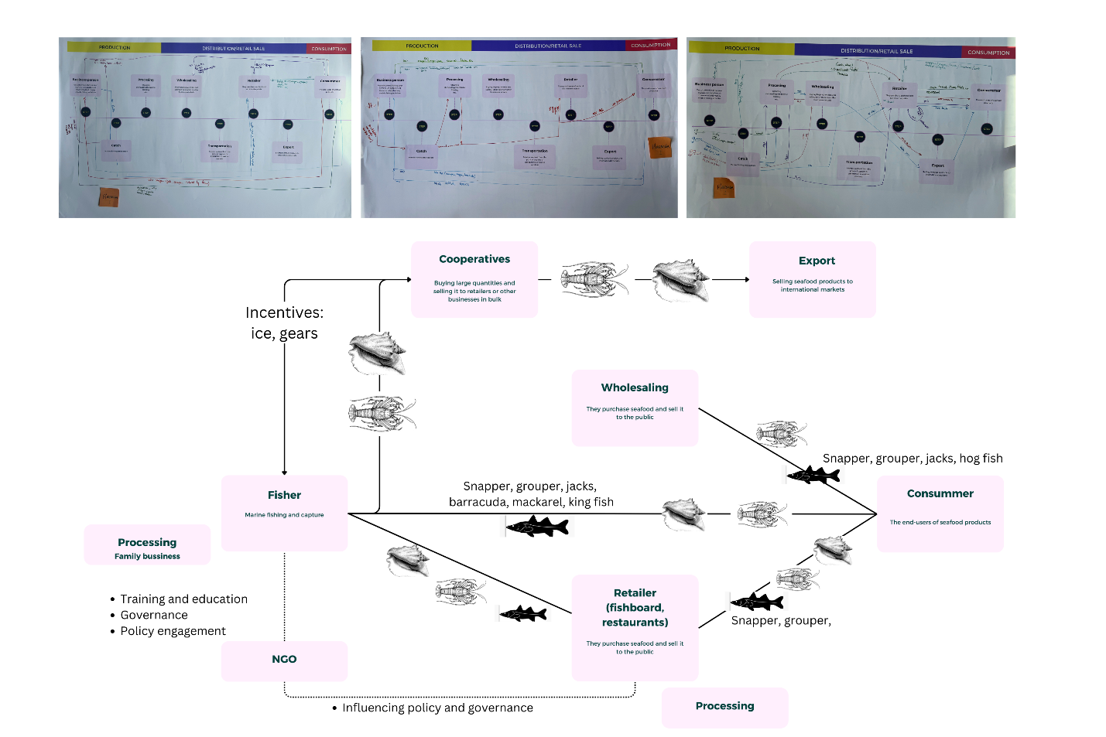
Some of the fishermen reported having pre-agreements with restaurants and hotels that place orders with them for the species they want.
Final consumers in Placencia have the option of buying seafood from different actors. Some buy directly from fishermen, while tourists access these foods, mainly snapper, grouper, and lobster, through restaurants. NGOs play an important role in generating education and training spaces, but they also encourage processes of fisheries governance and regulation.

