Caye Caulker

Fishers

We obtained responses from 15 fishers, 58% male and 41.7% female, demonstrating significant and equal participation by both genders in Caye Caulker's fishing activity. Most fishers (58%) identified as Mestizo or Creole, with a few Mayan and only one Garifuna participant. The age range of respondents was 25 to over 55 years old, with no participants under the age of 24

Lobster fishery
The shade is the most reported fishing gear in the lobster fishery of the participants in Caye Caulker, followed by lobster traps and hook sticks (Figure 1). Most fishers (90%) own their vessels and gear, granting them a degree of autonomy.
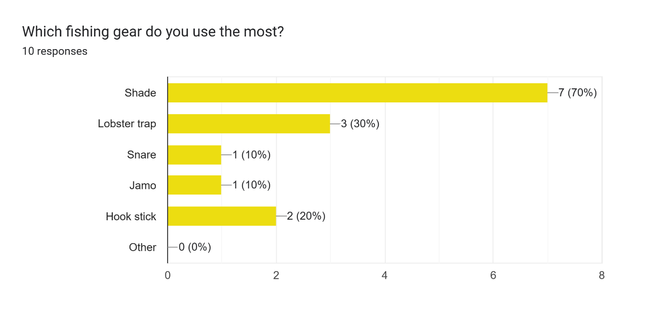
Figure 1 Fishing gear used in the spiny lobster fishery
Most fishers (70%) are licensed to fish in Zone 1, where Caye Caulker is located, followed by Zones 6, 3, and 4 (28%, 14%, and 14%, respectively). On average, fishers make 21.4 fishing trips per month during the lobster season, ranging from 1 to 100 trips. However, most fishers make between 4 and 25 trips during the season (Figure 2).
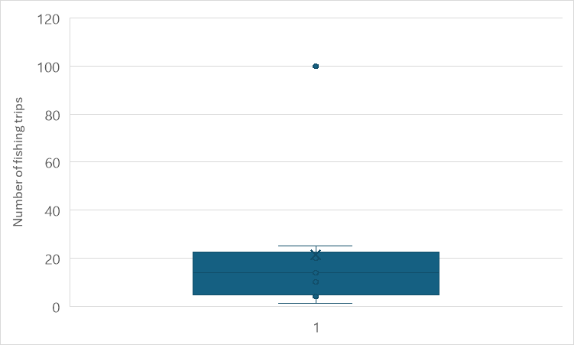
Figure 2 Individual number of fishing trips per month for lobsters

On average, fishing trips last 7 hours per day, ranging from 2 to 24 hours. The average cost of a fishing trip is $277 Belize dollars. While the cost per trip varies across gear types, the average catch and profit per trip seem to be relatively similar, suggesting that different gear types might have different cost-benefit profiles (Table 1). Fishers using the shade tend to make more trips per season compared to those using other gear types. Costs range from $100 to $500 Belize dollars, with a tendency for fishers who report fewer trips per season to also report higher trip costs (Figure 3).

Table 1 Summary of responses in the lobster fishery. All data were reported by fishers. Catch values are in pounds. Cost and sell prices in Belize dollars.
Gear | Number of answers | Average Number of trips season | Average hours per trip | Average cost per trip | Average catch per trip | Average of price | Average profit per trip
Hook stick | 1 | 5.0 |  |  |  | 10.0
Jamo | 1 | 10.0 | 24.0 | 300.0 | 50.0 | 30.0 | 1200.0
Shade | 3 | 71.7 | 4.3 | 316.7 | 17.5 | 25.5 | 200.0
Shade, Hook stick | 1 | 4.0 | 8.0 | 100.0 | 27.5 | 27.5 | 393.3
Shade, Lobster trap | 3 | 44.7 | 7.0 | 333.3 | 27.5 | 22.5 | 350.0
Snare | 1 | 1.0 | 3.0 | 150.0 | 5.0
Average |  | 36.9 | 7.7 | 277.8 | 25.0 | 23.3 | 498.7

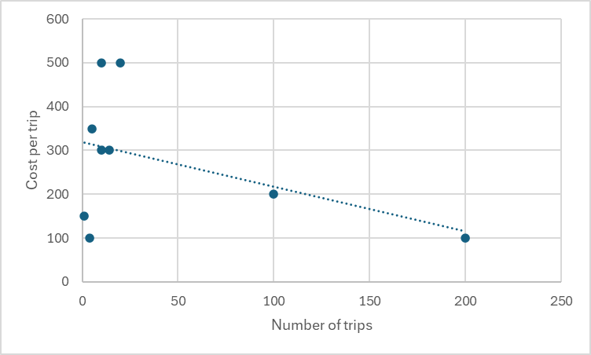
Figure 3 Relation between the number of fishing trips during lobster season and the cost per trip reported by participants
As explained by several fishermen during the activity, the best catches are made in the first two months of the season, where each fishing trip can yield around 400 lbs. of lobster. The catch decreases to around 200 lbs. between the 3rd and 4th months, and in the last months, it drops to less than 100 lbs. per trip. It is important to monitor the changes in fishing effort and catch throughout the season to make accurate CPUE estimates.
Most lobster catches are sold to local restaurants and cooperatives. Nevertheless, fishers generally prefer selling to restaurants as they offer a better price per pound. Cooperatives become the secondary option when restaurant demand is low, typically during the off-tourist season. The fisher who reported only one fishing trip per season indicated that he does not sell and kept the catch for self-consumption.

Queen conch fishery
A significant majority of 10 out of 11 respondents (90.9%) uses free diving as their primary fishing method. Only one respondent (9.1%) uses other fishing gear, indicating a strong preference for free diving to catch the queen conch.
On average, fishers make 9.2 fishing trips per season, ranging from 1 to 24. Each fishing trip can last between 3 and 10 hours per day for several days, yielding an average catch of 57 pounds of conch per trip (Table 2). However, the catch can vary significantly, ranging from 5 to 200 pounds. This variability may be attributed to differences in free-diving skills among fishers or the timing of the fishing season.
The average selling price is $9.17 Belize dollars. However, prices reported by fishers varied, where higher prices ($10 to $15 Belize dollars) were typically paid by restaurants, while cooperatives offered lower prices ($4 to $12 Belize dollars) per pound.
Table 2 Summary of responses in the queen conch fishery. All data were reported by fishers
Gear | Number of fishers | Average Number of fishing trips | Average of Hours | Average of Cost | Average of Catch | Average of selling Price | Average of Profit
Free diving | 9 | 9.17 | 18.14 | 278.57 | 63.00 | 9.17 | 455.00
Other | 1 | 10.00 | 6.00 | 300.00 | 20.00 | 12.00 | 300.00
Average |  | 9.29 | 16.63 | 281.25 | 57.63 | 9.57 | 429.17

Fin fish fishery
Hand line is the most common gear type, with 8 fishers using it. They make an average of 11 trips per month, spending an average of $258.3 Belize dollars per trip. Each trip lasts about 6.1 hours. Two fishers use the combination hand line and spearfishing. They are more active, making 15.5 trips per month and spending on average $300 Belize dollars per trip. Their trips are longer, lasting 10 hours. Only one fisher reported fish only with spearfishing. They make 3 trips per month, spending $200 Belize dollars per trip, and also spend 10 hours per trip. One fisher uses Spin rod, making a single trip per month at a cost of $300 Belize dollars and lasting 7 hours (Table 3).
Table 3 Summary of responses in the fin fish fishery. All data were reported by fishers. Catch is in pounds; cost and selling prices in Belize dollars.
Gear | Number fishers | Average Number of trips/month | Average Cost per trip | Average of Hours per trip | Average Catch |  |  |  | Average sell price |  |  |  | Average profit per trip
 |  |  |  |  | barracuda | snapper | grouper | jacks | barracuda | snapper | grouper | jacks
Hand line | 8 | 11.0 | 258.3 | 6.1 | 15.0 | 33.3 | 10.0 | 5.0 | 9.0 | 13.2 | 17.5 | 10.0 | 500
Hand line, Spearfishing | 2 | 15.5 | 300.0 | 10.0 | 60.0 | 20.0 |  |  | 8.0 | 10.0 | 10.0 | 8.0 | 300
Spearfishing | 1 | 3.0 | 200.0 | 10.0 | 50.0 | 50.0 |  |  | 12.0 | 15.0 |  |  | 400
Spin Rode | 1 |  | 300.0 | 7.0
Average |  | 11.1 | 265.0 | 7.3 | 31.0 | 34.0 | 10.0 | 5.0 | 9.3 | 13.0 | 15.0 | 9.3 | 425

The average catch varies by gear type. Hand line users catch fewer fish of each species compared to those using spearfishing or the combination of hand line and spearfishing. The selling prices for different fish species also vary. Generally, grouper and snapper seem to fetch higher prices compared to barracudas and jacks. All fin fish production is sold to restaurants or kept for self-consumption.
Eight respondents reported secondary employment in tourism, highlighting the strong interconnection between small-scale fishery and tourism in Caye Caulker. Furthermore, only 3 fishermen reported being members of a cooperative, all of whom belong to the Norther cooperative.

Retailers
Three people identified themselves as retailers, all of them females over 35 years old. Two were of Creole origin and the other was Garifuna.
Two of the respondents owned restaurants, while the third was a vendor in a fishing shop. All of them had arrangements with fishers, providing ice or other benefits in exchange for the fishers "securing" the sale of their catch to them.
The only species purchased by all respondents was snapper. However, spiny lobster was the species purchased in the highest quantity, despite being the most expensive at $18 Belize dollars. Barracuda was the other finfish species purchased by two of the respondents.
Selling prices varied between respondents and within species, depending on size or processing. Lobster was sold between $20 and $30 Belize dollars, and restaurant plates could cost around $40 Belize dollars. Queen conch prices varied from $10 to $15 Belize dollars, depending on size, and plates could cost around $30 Belize dollars in restaurants. Snapper prices ranged from $3 to $10 Belize dollars, depending on size, and could be sold at $40 Belize dollars in restaurants. Species like snook, grouper, wrasses, and jacks are more difficult to find in restaurants.
The primary suppliers of fish and queen conch to retailers are fishermen. While fishermen also supply lobster, restaurants and stores often source these items from fish markets or other wholesale distributors (Figure 2).
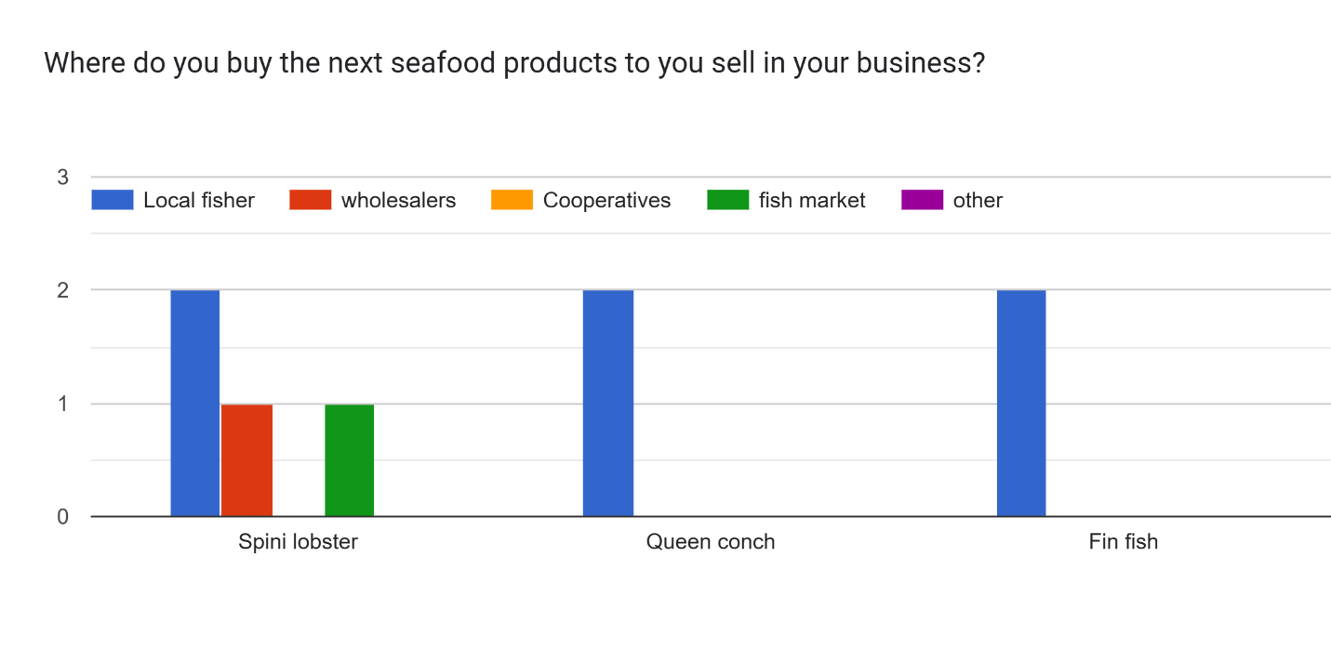
Figure 4 Purchase of seafood products from retailers in Caye Caulker

When purchasing seafood, respondents prioritize products that are readily available and of good quality. Price, demand, and sustainability considerations seem to be less influential in their decision-making process
- Availability was the most important factor for all respondents, with a score of 3 (100%).
- Quality was the second most important factor, mentioned by 2 out of 3 respondents (66.7%).
- Price, Demand, and Sustainability were considered by only 1 respondent each (33.3%).
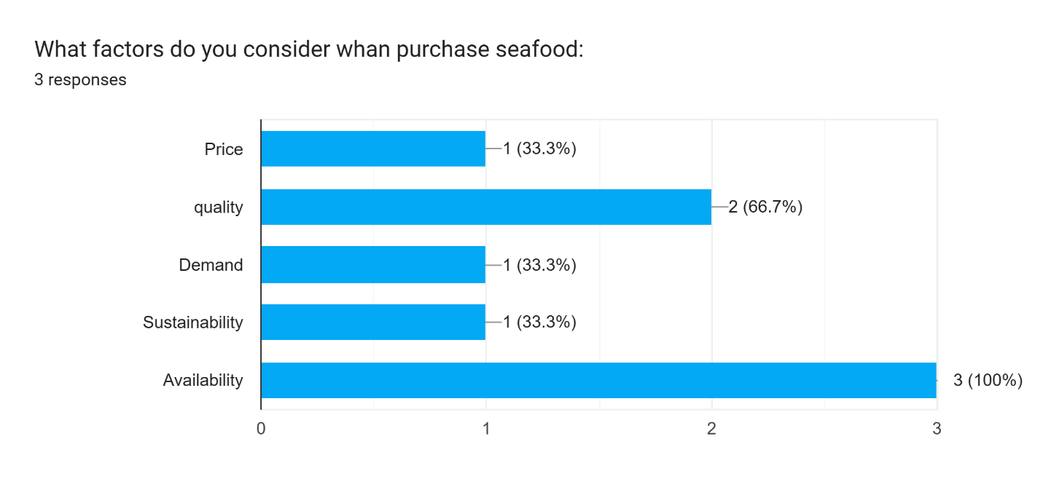

Consumers
Seven participants identified themselves as consumers within the fishing value chain. Of these participants, 66% were male and 33% were female. The majority (50%) self-identified as Mestizo, followed by Maya and Creole (each 33.3%). One participant identified as East Indian and another as White.
Regarding age, half of the participants (50%) were between 35 and 44 years old. The remaining age groups, 18-24, 45-54, and over 55, were each represented by 16.7% of the participants. Notably, there was no representation from the 25-34 or under-18 age groups (Figure 5).
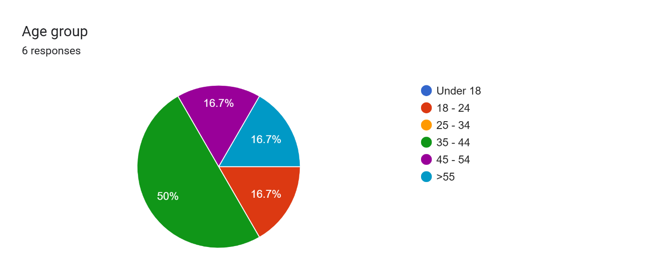
Figure 5 Age Distribution of Consumers respondents in Caye Caulker
Snapper, lobster, and conch have the highest total consumption, indicating a strong overall demand for these species. Groupers follow with moderate levels of total consumption. Jacks, barracuda, and snook have significantly lower total consumption, and no one reported consuming wrasses (Figure 6).
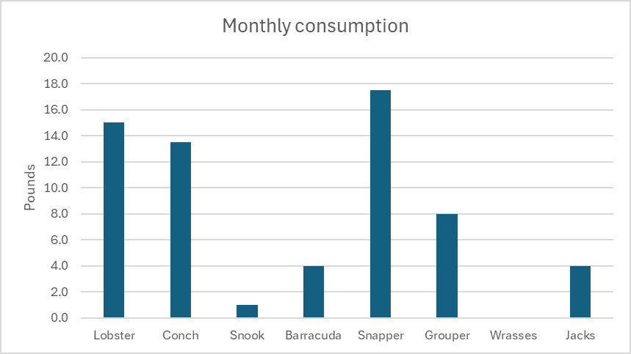
Figure 6 Monthly total consumption per species.
The number of people consuming snapper and conch is highest, followed by lobster, the remaining seafood types have significantly fewer consumers (Table 4). However, in terms of per capita consumption, grouper, lobster, and snapper have the highest average values (8, 3.8, and 2.9 pounds per month, respectively), suggesting that those who consume these seafood types tend to consume larger quantities. Conch, barracuda, and jacks have moderate per capita consumption levels (around 2 pounds per month) (Table 4).
Table 4 Consumption of sea food species in Caye Caulker. NA= do not report their participant ID. Values are in pounds consumed by month.
Participant | Lobster | Conch | Snook | Barracuda | Snapper | Grouper | Wrasses | Jacks
NA | 10 | 8 |  |  | 5
SC 20 | 2 | 2 |  | 3 | 3 |  |  | 3
NA |  | 1 |  |  | 5 | 8
SC 23 | 1 | 1 | 1 | 1 |  |  |  | 1
SC 15 | 2 | 1 |  |  | 3
SC 52 |  |  |  |  | 1
NA |  | 0.5 |  |  | 0.5
Total consumption | 15.0 | 13.5 | 1.0 | 4.0 | 17.5 | 8.0 | 0.0 | 4.0
Average Individual consumption | 3.8 | 2.3 | 1.0 | 2.0 | 2.9 | 8.0 | 0.0 | 2.0
Number of people consuming the species | 4 | 6 | 1 | 2 | 6 | 1 | 0 | 2

Overall, the data suggests a strong preference for snapper, conch and lobster among consumers, both in terms of total consumption and consumption per capita.
Respondents indicated an interest in consuming parrotfish, goliath grouper, tuna, and hogfish (Lachnolaimus maximus) but they are difficult to find in Caye Caulker. As seen in Table 4 and Figure 5, only one participant reported eating grouper, and none had consumed hogfish. Considering the low reported consumption and the scarcity of these species in local markets, it is likely that factors such as overfishing and limited availability are contributing to their low supply.
Fisher was the most common source of seafood, with 5 out of 7 respondents (71.4%) purchasing from them (Figure 7). Local markets and restaurants were the second most common sources, each mentioned by 3 respondents (42.9%). Supermarkets were mentioned by 1 respondent (14.3%). Fishboard and Other were not mentioned by any respondents. This suggests that the survey participants primarily rely on fishers as their main source of seafood, with local markets and restaurants being secondary options.
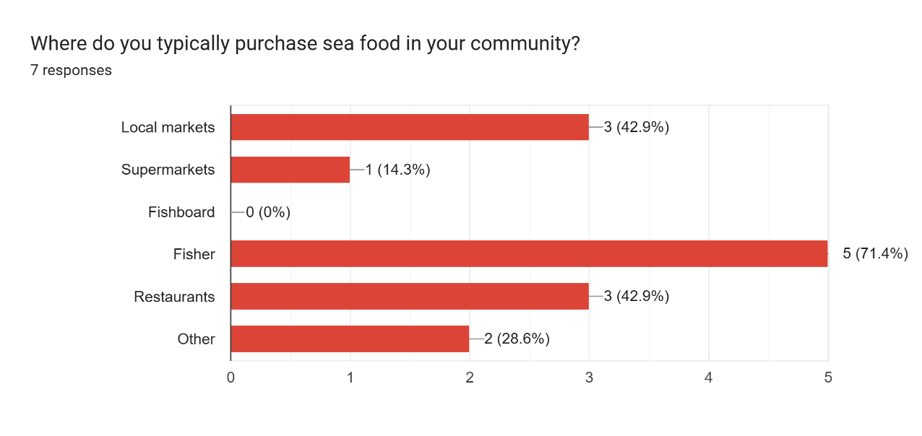
Figure 7 Main seafood purchase locations by consumers in Caye Caulker
However, despite the previous information, the proportion of seafood intake per family is considerably low. Three out of four respondents reported that seafood represents less than 1% of their family's food intake (one is fully vegetarian), and only one person indicated that it's about 10-20%, representing approximately $100 BZ per month.
When asked, "Would you be willing to pay a higher price for seafood if you knew it's more sustainable and supported the livelihood of small-scale fishers?", a significant majority of 75% of the four respondents answered "Yes," indicating a willingness to pay a premium for sustainable seafood that benefits small-scale fishers.
When asked about initiatives to promote sustainable fishing practices, respondents highlighted a variety of strategies. Some mentioned value-added marketing initiatives, which focus on increasing the economic value of fish products. Others pointed to specific regulations, such as minimum-size lobster tail restrictions. Additionally, another respondent emphasized the importance of traditional conservation measures like no-take zones, managed access, size limits, zoning, licensing, enforcement, marine protected areas, and seasonal closures. These responses indicate a knowledge and a desire among community members to participate in sustainable fishing initiatives.

Academic and NGO
We obtained 4 responses from members of NGOs out of the eight participating in the workshop. Women and men were equally represented, and participants came from various ethnic backgrounds, including Creole and Mestizo. The age range of the participants was broad, spanning from the 25-34 age group to the 45-54 age group. The participants were affiliated with various organizations, such as WWF, Fragments of Hope, Caye Caulker BTIAC, and Belioness, and held roles ranging from community engagement to leadership positions. Any member of the academic institutions responded to the survey.
When asked how their institution interacts with fishers, strong emphasis on training and education was found. The highest number of responses were for "Training programs" and "Education and outreach," both receiving a score of 4 (100%) (Figure 8). This suggests that the institutions prioritize knowledge sharing with fishers. Moderate Involvement in governance and decision-making, receiving a score of 2 (50%). This indicates that while institutions are involved in governance processes to some extent, it may not be a primary focus. And limited engagement in other areas such as "Licensing," "Quota allocation," "Monitoring catch," "Research," and "Other," received either 0 or 1 response, suggesting that these areas are not as prominent in the interactions between Academic institutions and NGOs and fishers (Figure 8).
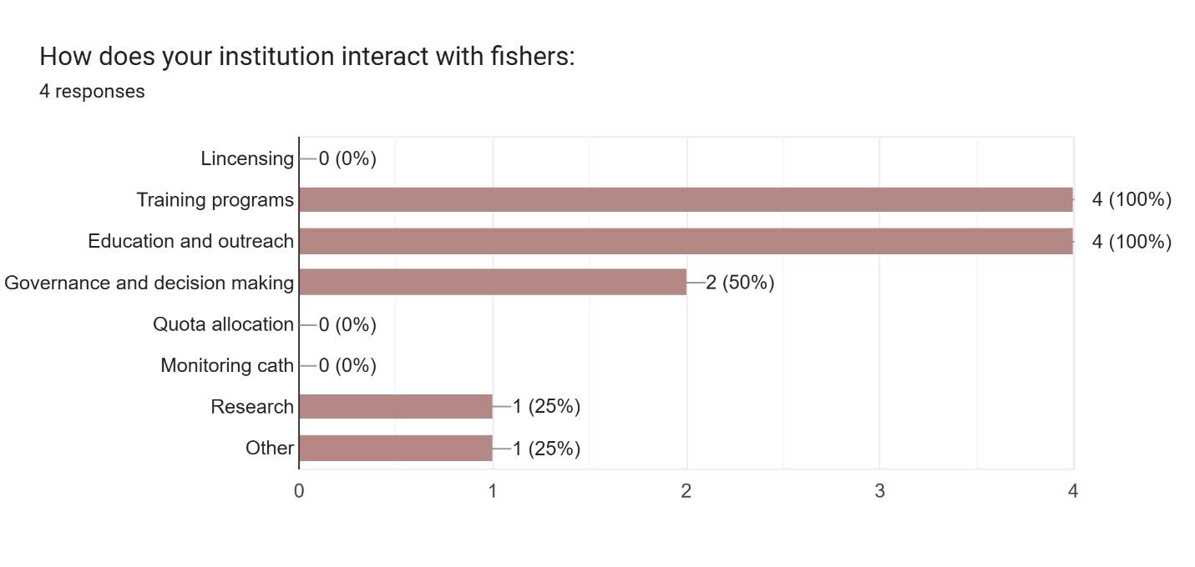
Figure 8 How institutions interact with fishers
Overall, the previous graph highlights the importance of training, education, and outreach in the interactions between institutions and fishers. It also suggests potential areas for improvement, such as increasing involvement in governance and decision-making processes and strengthening capacity building, monitoring and research efforts.
When asked, “How does your institution interact with wholesalers and retailers" we obtained three respondents (Figure 9). Similar to the previous graph (Figure 8), "Training programs" and "Education and outreach" received the highest scores, both at 2 (66.7%). This suggests that institutions prioritize knowledge sharing with wholesalers and retailers. Governance and decision making received a score of 1 (33.3%), indicating a moderate level of involvement in shaping policies and regulations. The remaining categories, such as "Licensing," "Quota allocation," "Monitoring catch," "Research," "Other," and "Governance and decision making," received either 0 or 1 response, suggesting that these areas are not as prominent in the interactions between institutions and wholesalers/retailers (Figure 9).
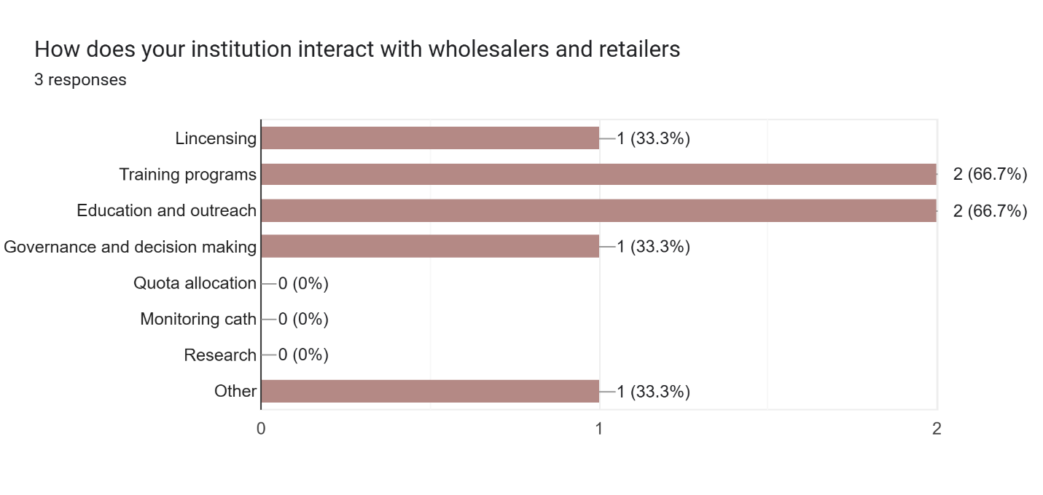
Figure 9 How institutions interact with wholesalers and retailers
Academic institutions and NGOs in Caye Caulker are directing their attention to the fishing activity, specifically targeting the capture/production, and less extent the consumption processes of the three primary fisheries (Figure 10). This focus involves a strong emphasis on education and training initiatives aimed at both fishers and retailers (Figure 8 and Figure 9).
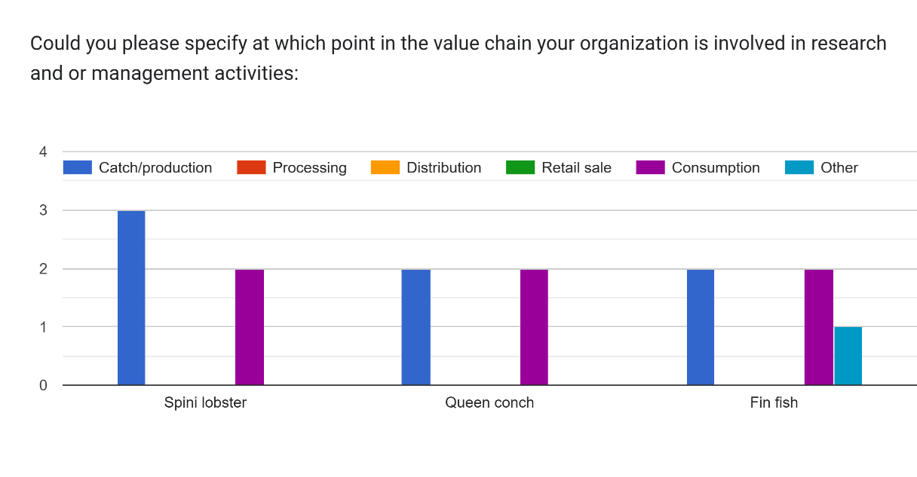
Figure 10 Point in the value chain where organizations are involved in research and management activities

The Table 5 provides insights into the strategies employed by respondent institutions to increase the income of small-scale fishers and improve their livelihoods. WWF, for example, focuses on diversifying income sources through small business development and skill training. They also train fishers in monitoring and alternative livelihoods to enhance their resilience. Fragments of Hope, while not explicitly quantifying economic impacts, emphasize training and knowledge sharing to improve fishing practices and potentially increase fishers' catches. The Caye Caulker BTIAC prioritizes training and knowledge sharing, aiming to identify problems and best practices. They would measure their impact on fishers' livelihoods by tracking the number of fishers actively participating in their training activities. Belioness, on the other hand, is focused on monitoring changes in lionfish populations to assess the effectiveness of management strategies.
Table 5 Strategies employed by respondent institutions to increase the income of small-scale fishers and improve their livelihoods
ID | Gender | Name of your institution | What is your primary role in the institution | How have your programs directly increased the income of small-scale fishers and their families? | How would you measure changes in fishers' ability to meet their basic needs and invest in the future? Can you explain?
SC 11 | Female | WWF | Community/stakeholder, outreach engagement, education | project intervention for income diversification, small business, development and skill training | project upi, household surveys (baseline vs end and project intervention results)
SC 19 | Male | Fragments of Hope | Site coordinator | train fishers to engage in monitoring and alternative livelihood | Not quantified in the economic status of fisher and fishing grounds
SC 40 | Male | Caye Caulker BTIA | Chairperson, Caye caulker captor | Training and knowledge sharing, identification of problems, quality control, best practices | Number of fishers who can fish, new fishers; Number of fishers involved in training, participating in training; number of sustainable practices in fishing
SC 46 | Female | Belioness | Vice Chair | Educating the people about lionfish, maybe can help to have more fish | changes in lionfish abundance

Overall, the table highlights a diverse range of strategies aimed at improving the livelihoods of small-scale fishers, including income diversification, skill development, sustainable fishing practices, and community education.

Network analysis
To assess the interaction patterns among the sectors participating in the study, the value chain was defined as a socio-ecological system, where individuals, or the sectors with which they identify, interact with each other through various activities associated with the country's three main fisheries - lobster fishing, queen conch fishing, and finfish fishing. Nodes in the network represent the participating sectors (see table), while edges depict interactions derived from group activity discussions and survey responses. For instance, if a consumer survey respondent indicates purchasing seafood from fishers, an edge labeled "buy lobster" connects the Consumer and Fisher nodes.
Based on group activity, key interactions between sectors were identified and summarized in the (Figure 11).

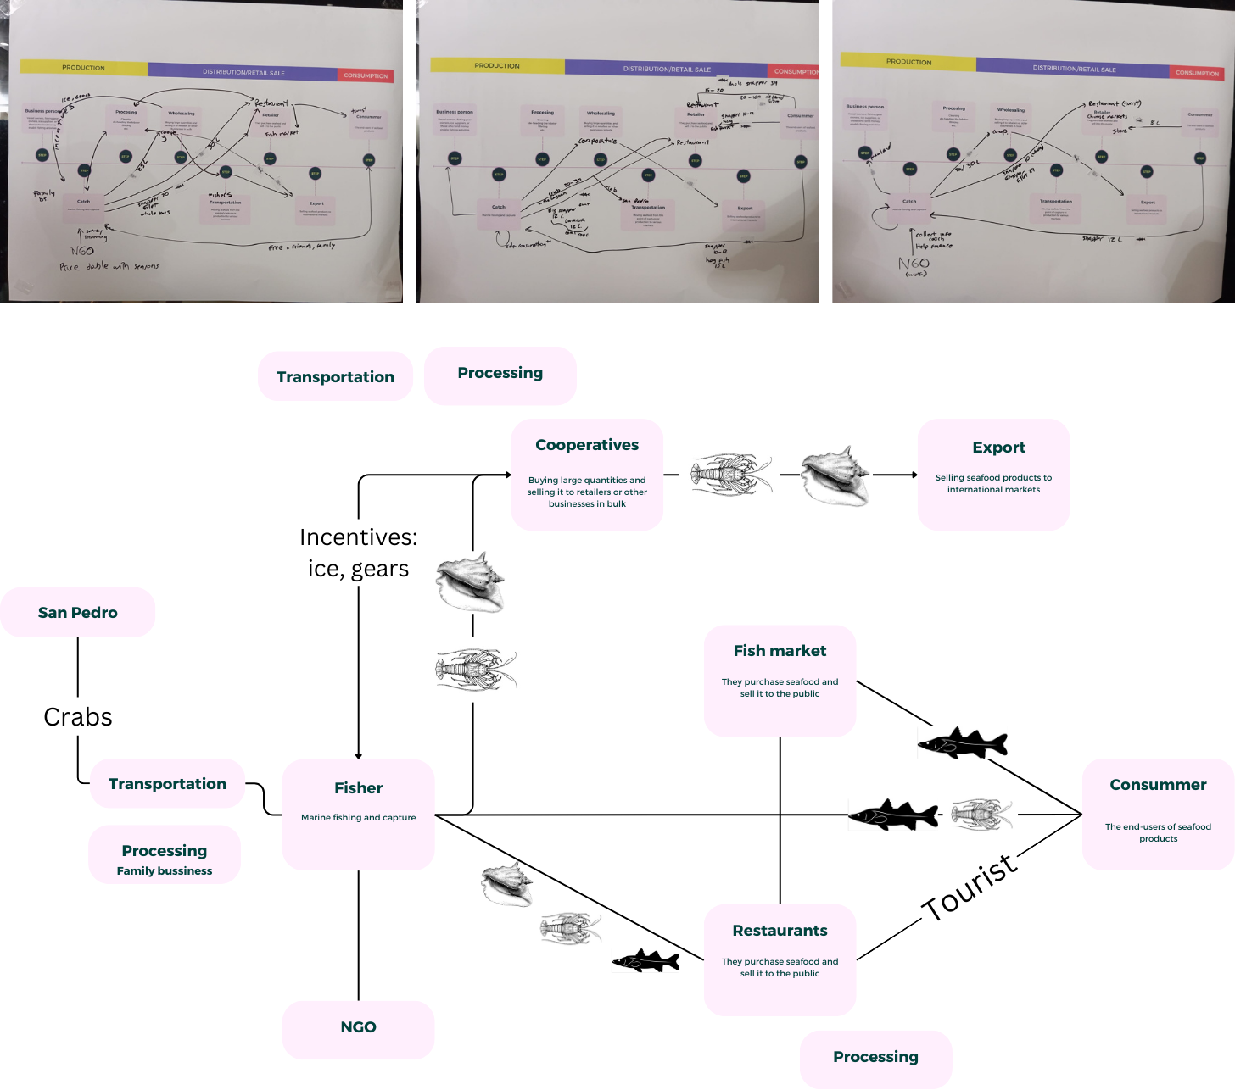
Figure 11 Schematic representation of intersectoral relationships in the Caye Caulker fisheries value chain. The upper panels present the raw data from the three workshop groups, illustrating the initial perceptions of sectoral interactions. The lower panel offers a synthesized schematic, consolidating these findings into a comprehensive overview.
To gain a comprehensive understanding of the network, we constructed a network visualization using the Igraph package in R. To create a simplified overview of the value chain, all interactions, irrespective of their specific type (e.g., purchase, training, sale) or associated species (lobster, queen conch, finfish), were consolidated into a general interaction for the initial visualization. This visualization highlights the central actors and connections that maintain the current flow of resources and information within the Caye Caulker fisheries value chain.
The size of each node represents its degree centrality, indicating the number of connections it has to other nodes (Table 6). Larger nodes, such as "Customer" and "Fisher," have more connections, suggesting their central role in the network (Table 6). The width of the edges represents the betweenness centrality, highlighting the importance of specific connections in facilitating information flow and resource transfer. For instance, the edge between "Fisher" and "Customer" is relatively thick, suggesting that this connection plays a crucial role in the overall network.

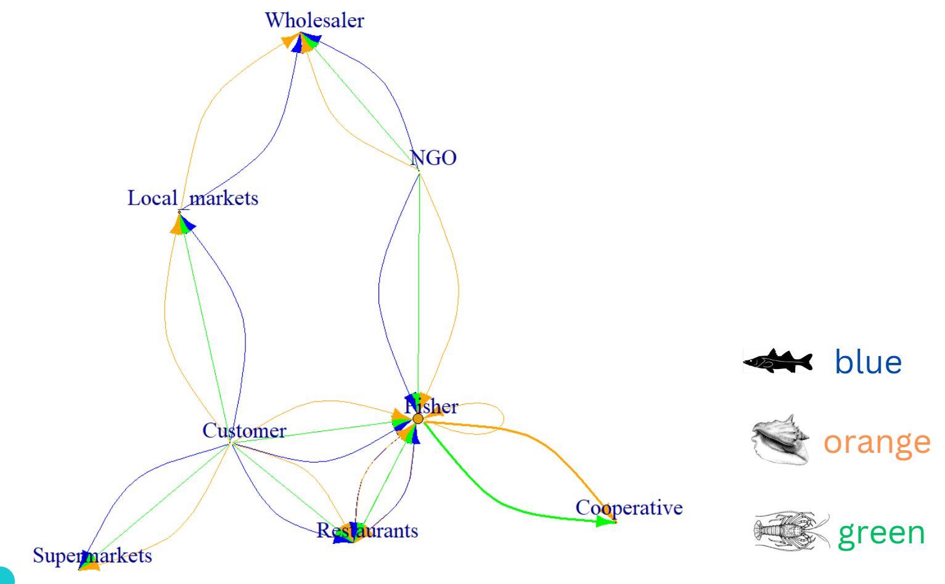
Figure 12 Aggregate network representing the fishery value chain in Caye Caulker
Table 6 Node centrality for the sectors answered the survey
Node | Degree | Betweenness | Closeness | Eigenvector
Fisher | 6 | 9.5 | 0.100 | 1.000
Customer | 4 | 9.5 | 0.100 | 0.495
Local markets | 2 | 2.5 | 0.077 | 0.181
NGO | 2 | 2.5 | 0.077 | 0.324
Restaurants | 2 | 0 | 0.077 | 0.424
Wholesaler | 2 | 1 | 0.067 | 0.143
Cooperative | 1 | 0 | 0.063 | 0.284
Supermarkets | 1 | 0 | 0.063 | 0.140

While there is a direct, relatively strong link between local consumers and fishers (Figure 12), the low monthly seafood consumption per household limits fishers' ability to depend solely on this market.
Cooperatives, despite their dominance in the export market, play a secondary role in the domestic market, purchasing only a limited number of species at lower prices. To enhance fisher livelihoods, increasing domestic seafood consumption is essential.
NGOs and academia can facilitate connections between various sectors, promoting responsible consumption and expanding sales opportunities for fishers.
Restaurants, though with lower centrality, play a pivotal role due to their direct interactions with fishers and consumers. By offering competitive prices and a diverse range of seafood, restaurants are preferred buyers, reducing intermediaries and improving fisher profitability. However, their capacity to buy majority of fish production is linked to the tourism season.
The lobster fishery follows the same interactions patterns described before with the aggregate network.
Increased fish abundance, resulting from nature-based solutions, has the potential to enhance fisher catches. This could manifest as larger catches, larger individuals commanding higher market prices, or a greater diversity of species to exploit, thereby distributing fishing effort and reducing the risk of overexploitation of highly demanded species. However, to translate these increased catches into improved livelihoods, a fair and equitable market for multi-species catches must be ensured year-round. Currently, fishers heavily rely on sales to restaurants during peak tourist seasons, receiving high prices for all captured species. When restaurants are not purchasing, fishers turn to cooperatives, selling only lobster and queen conch at lower prices, impacting their earnings.
Other factors to consider include the misalignment between the lobster fishing season and the tourist season. This mismatch often results in selling larger initial catches to cooperatives at lower prices, as storage is prohibited.
To enhance fisher resilience and incomes, leveraging the strong relationship between local consumers and fishers is promising. Yet, low local seafood consumption hinders this potential. A coordinated effort to increase seafood consumption can not only boost fisher incomes but also improve household nutritional security and reduce the environmental impact of other protein sources like beef, pork, and chicken, particularly in island communities like Caye Caulker.

