Placencia

Fishers

We obtained responses from 5 fishers, 4 males fishing lobster, conch and fin fish, and one female who fish only fin fish. Four fishers identified themselves as Creole and one Garifuna. The age range of males was 35 to 54 years old, and the female fisher was 25 to 34.

Lobster fishery
The shade is the most reported fishing gear by the participants (two fishers) in the lobster fishery in Placencia, followed by lobster traps, hook sticks and other (one fisher each). All fishers own their vessels and gear, granting them a degree of autonomy.
Most fishers fish in Zones 3 and 4, one reported to fish additionally in zone 5 (reporting fishing in zones 3, 4 and 5) and one fisher reported to fish on zones 3, 8 and 9. On average, fishers make 15.5 fishing trips per month during the lobster season, ranging from 8 to 32 trips per month. On average, fishing trips last 6 hours per day, ranging from 4.5 to 8 hours. The average cost of a fishing trip is $400 Belize dollars, ranging from $250 to $800 Belize dollars. While the cost per trip is relatively constant across gear types, the average catch and profit per trip varies across fishers, suggesting that the experience or fishing ground might have different cost-benefit profiles (Table 1).
Table 1 Summary of responses in the lobster fishery. All data were reported by fishers. Catch values are in pounds. Cost and sell prices in Belize dollars.
Gear | Number of answers | Monthly trips per season | Hours per trip | Cost per trip | Catch per trip | Selling price | Profit per trip
Hook stick | 1 | 12 | 6 | 300 | 30 | 28 | 400
Other | 1 | 10 | 30 | 800 | 125 | 30 | 2250
Shade | 1 | 8 | 8 | 250 | 95 | 28 | 750
Shade, Lobster trap | 1 | 32 | 4.5 | 250 | 175 |  | 250
Average | 4 | 16 | 12 | 400 | 106 | 29 | 913

Lobster catches are sold either to restaurants or to cooperatives (with two answers each). In Placencia, sales were reported to 3 different cooperatives, including the Placencia Cooperative, Rainforest and Green Forest Seafood.

Queen conch fishery
The same four fishers that reported fishing lobster fish queen conch as well, and all of them use free diving as their primary fishing method. On average, fishers make 3.8 fishing trips per month during the season, ranging from 2 to 8. Each fishing trip can last between 3 and 7 hours per day for several days. Fishermen reported a wide range of catches, from as low as 17 pounds to as high as 900 pounds per trip. This variability is likely to be due to fluctuations in catch rates throughout the fishing season -with earlier trips typically yielding higher catches-, or to differences in free-diving skills among fishers.
The average selling price is $9.1 Belize dollars. However, prices reported by fishers varied, where higher prices ($10 Belize dollars) were typically paid by restaurants, while cooperatives offered lower prices ($8 to $9 Belize dollars) per pound. Reported earnings per fishing trip also varied among fishers, with values as low as $160 and as high as $1750. These variations may be associated with the way fishermen reported their earnings, as some indicated that the total earnings are divided among the crew, which is typically composed of 3 fishermen. Therefore, some may have reported the total earnings, while others reported their individual share.
Table 2 Summary of responses in the queen conch fishery. All data were reported by fishers
Gender | Ethnic background | Age group | Monthly trips per season | hours per trip | cost per trip | catch per trip | Selling price | profit per trip
Male | Creole | 45 - 54 | 2 | 30 | 700 | 87 | 10 | 1250
Male | Creole | 45 - 54 | 8 | 7 | 120 | 17.5 | 9.5 | 160
Male | Creole | 35 - 44 | 2.5 | 3.5 | 450 | 900 | 9 | 1750
Male | Garifuna | 45 - 54 | 3 | 5 | 300 | 200 | 8 | 350
Average |  |  | 4 | 11 | 393 | 301 | 9 | 878

Fin fish fishery
Hand line is the most common gear type, with 4 fishers using it, two of them combined it with spearfishing, and one with fish trap. They make an average of 8 trips per month, spending an average of $366.8 Belize dollars per trip. However, the reported costs varied among fishermen, with those who reported fewer trips having more expensive trips (between $680 to $580 dollars per trip), and the fisherman who made the most trips reporting a lower cost per trip ($87.5 dollars). Each trip lasts about 6.1 hours. Like conch fishing, fishermen who make more trips per month also report that these trips are cheaper compared to trips made by fishermen who go out less frequently.
Snappers are the most frequently caught species, with an average of 131 pounds per trip, followed by barracudas and jacks. Fishermen who report using handlines with spearfishing are the only ones who catch all species (snappers, groupers, barracudas, and jacks), and they also report the highest earnings ($1362 on average). Groupers are the fish that sell for the highest price ($12 per pound), but their low catch rates indicate a scarcity of these species (Table 3).
Table 3 Summary of responses in the fin fish fishery. All data were reported by fishers. Catch is in pounds; cost and selling prices in Belize dollars.
Fishing Gear | Number fishers | Average Number of trips/month | Average Cost per trip | Average of Hours per trip | Average Catch |  |  |  | Average Selling Price |  |  |  | Average profit per trip
 |  |  |  |  | barracuda | snapper | grouper | jacks | barracuda | snapper | grouper | jacks
Hand line | 1 | 3 | 680 | 9 | 50 | 175 |  | 27.5 |  |  |  |  | 300
Hand line, Spearfishing | 2 | 5 | 350 | 7 | 50 | 100 | 20 | 50 |  | 6.5 | 12 |  | 1362.5
Hand line, Trap | 1 | 20 | 87.5 | 3.5 |  | 150 |  |  | 5 | 5 |  | 3 | 200
Other | 1 |  |  | 5
Total Average | 5 | 8.2 | 366.8 | 6.1 | 50 | 131.2 | 20 | 38.7 | 5 | 6 | 12 | 3 | 806.2

Fish are primarily sold to local restaurants, vendors, or even resorts. The female fisher reported that she does not sell her catch. Two of the fishermen reported belonging to the Placencia Cooperative. Four respondents reported secondary employment in tourism, highlighting the strong interconnection between small-scale fishery and tourism in Placencia.

Retailers
Three people identified themselves as retailers, two of them Creole origin males over 35 years old. The other, was a female Garifuna. The type of retailer business was one dive shop and two fish sellers, one working in the fish market, and the other selling the catch of a home member.
Only the respondent that run the dive shop have an arrangement with fishers, providing ice and credits in exchange for the fishers "securing" the sale of their catch to them.
One respondent reported buy conch, snapper, and jacks at $10, $12 and $10 Belizean dollars respectively. However, spiny lobster was the species purchased in the highest quantity, despite being the most expensive at $18 Belize dollars. Barracuda was the other finfish species purchased by two of the respondents.
Selling prices varied between respondents and within species, depending on size or processing. Lobster was sold between $20 and $30 Belize dollars, and restaurant plates could cost around $40 Belize dollars. Queen conch prices varied from $10 to $15 Belize dollars, depending on size, and plates could cost around $30 Belize dollars in restaurants. Snapper prices ranged from $3 to $10 Belize dollars, depending on size, and could be sold at $40 Belize dollars in restaurants. Species like snook, grouper, wrasses, and jacks are more difficult to find in restaurants.
The primary suppliers of fish and queen conch to retailers are fishermen. While fishermen also supply lobster, restaurants and stores often source these items from fish markets or other wholesale distributors (Figure 2).
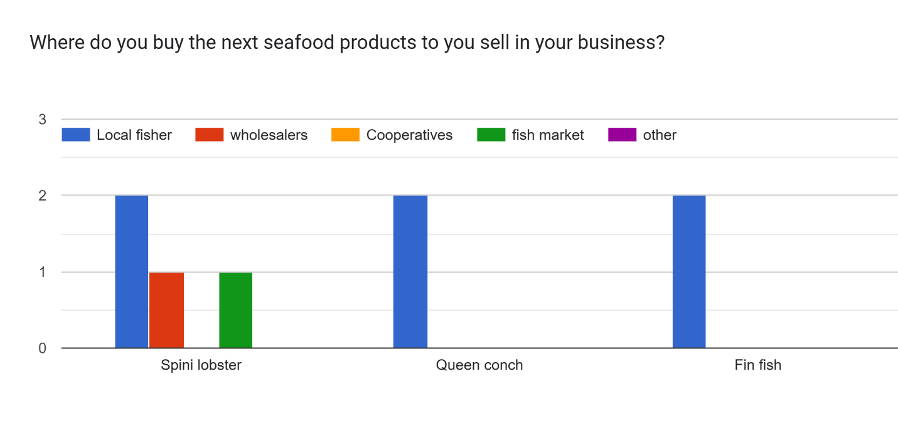
Figure 4 Purchase of seafood products from retailers in Caye Caulker

When purchasing seafood, respondents prioritize products that are readily available and of good quality. Price, demand, and sustainability considerations seem to be less influential in their decision-making process
- Availability was the most important factor for all respondents, with a score of 3 (100%).
- Quality was the second most important factor, mentioned by 2 out of 3 respondents (66.7%).
- Price, Demand, and Sustainability were considered by only 1 respondent each (33.3%).
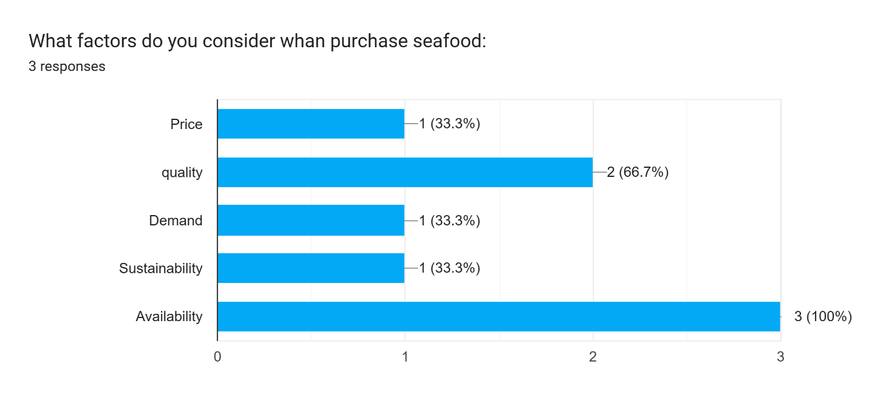

Consumers
Seven participants identified themselves as consumers within the fishing value chain. Of these participants, 66% were male and 33% were female. The majority (50%) self-identified as Mestizo, followed by Maya and Creole (each 33.3%). One participant identified as East Indian and another as White.
Regarding age, half of the participants (50%) were between 35 and 44 years old. The remaining age groups, 18-24, 45-54, and over 55, were each represented by 16.7% of the participants. Notably, there was no representation from the 25-34 or under-18 age groups (Figure 5).
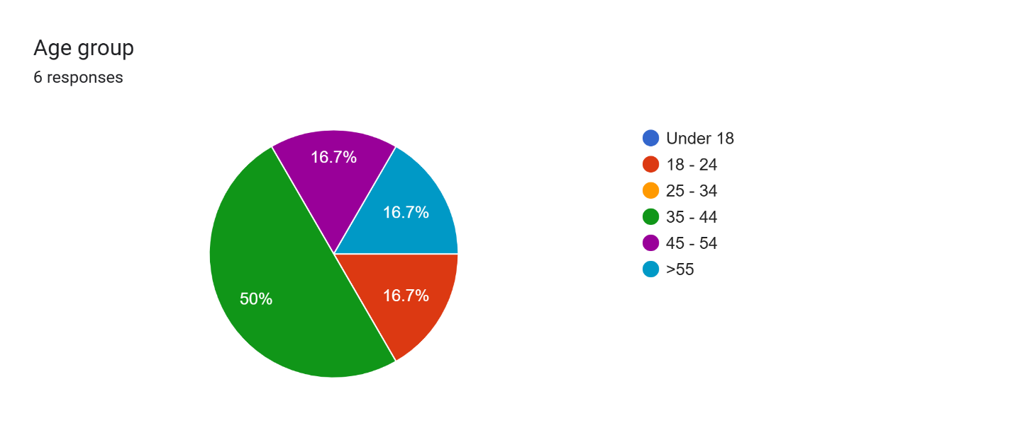
Figure 5 Age Distribution of Consumers respondents in Caye Caulker
Snapper, lobster, and conch have the highest total consumption, indicating a strong overall demand for these species. Groupers follow with moderate levels of total consumption. Jacks, barracuda, and snook have significantly lower total consumption, and no one reported consuming wrasses (Figure 6).
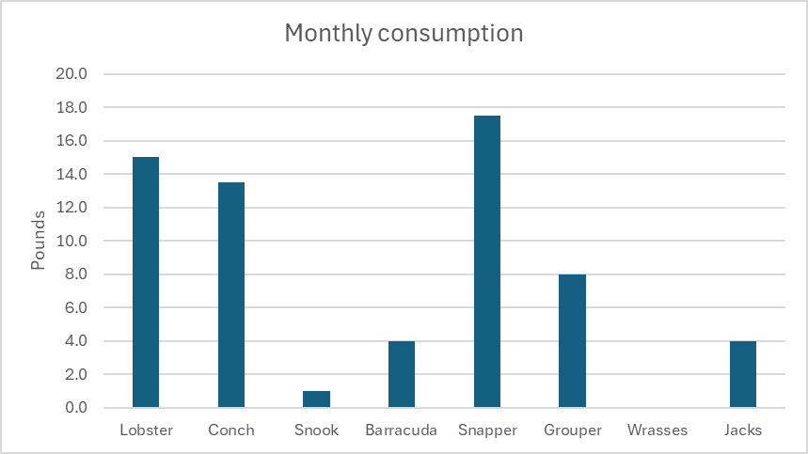
Figure 6 Monthly total consumption per species.
The number of people consuming snapper and conch is highest, followed by lobster, the remaining seafood types have significantly fewer consumers (Table 4). However, in terms of per capita consumption, grouper, lobster, and snapper have the highest average values (8, 3.8, and 2.9 pounds per month, respectively), suggesting that those who consume these seafood types tend to consume larger quantities. Conch, barracuda, and jacks have moderate per capita consumption levels (around 2 pounds per month) (Table 4).
Table 4 Consumption of sea food species in Caye Caulker. NA= do not report their participant ID. Values are in pounds consumed by month.
Participant | Lobster | Conch | Snook | Barracuda | Snapper | Grouper | Wrasses | Jacks
NA | 10 | 8 |  |  | 5
SC 20 | 2 | 2 |  | 3 | 3 |  |  | 3
NA |  | 1 |  |  | 5 | 8
SC 23 | 1 | 1 | 1 | 1 |  |  |  | 1
SC 15 | 2 | 1 |  |  | 3
SC 52 |  |  |  |  | 1
NA |  | 0.5 |  |  | 0.5
Total consumption | 15.0 | 13.5 | 1.0 | 4.0 | 17.5 | 8.0 | 0.0 | 4.0
Average Individual consumption | 3.8 | 2.3 | 1.0 | 2.0 | 2.9 | 8.0 | 0.0 | 2.0
Number of people consuming the species | 4 | 6 | 1 | 2 | 6 | 1 | 0 | 2

Overall, the data suggests a strong preference for snapper, conch and lobster among consumers, both in terms of total consumption and consumption per capita.
Respondents indicated an interest in consuming parrotfish, goliath grouper, tuna, and hogfish (Lachnolaimus maximus) but they are difficult to find in Caye Caulker. As seen in Table 4 and Figure 5, only one participant reported eating grouper, and none had consumed hogfish. Considering the low reported consumption and the scarcity of these species in local markets, it is likely that factors such as overfishing and limited availability are contributing to their low supply.
Fisher was the most common source of seafood, with 5 out of 7 respondents (71.4%) purchasing from them (Figure 7). Local markets and restaurants were the second most common sources, each mentioned by 3 respondents (42.9%). Supermarkets were mentioned by 1 respondent (14.3%). Fishboard and Other were not mentioned by any respondents. This suggests that the survey participants primarily rely on fishers as their main source of seafood, with local markets and restaurants being secondary options.
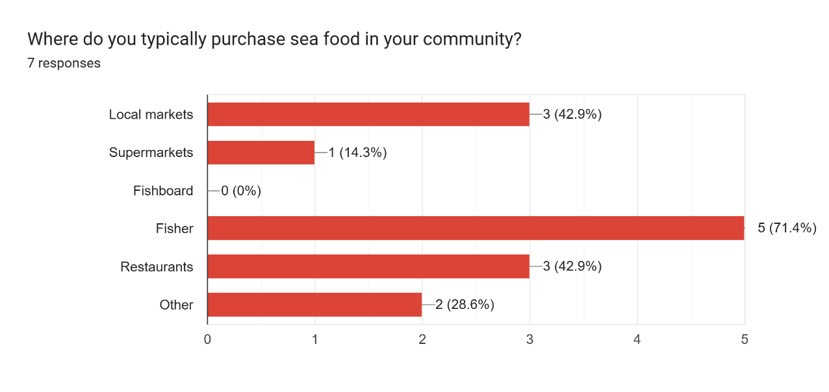
Figure 7 Main seafood purchase locations by consumers in Caye Caulker
However, despite the previous information, the proportion of seafood intake per family is considerably low. Three out of four respondents reported that seafood represents less than 1% of their family's food intake (one is fully vegetarian), and only one person indicated that it's about 10-20%, representing approximately $100 BZ per month.
When asked, "Would you be willing to pay a higher price for seafood if you knew it's more sustainable and supported the livelihood of small-scale fishers?", a significant majority of 75% of the four respondents answered "Yes," indicating a willingness to pay a premium for sustainable seafood that benefits small-scale fishers.
When asked about initiatives to promote sustainable fishing practices, respondents highlighted a variety of strategies. Some mentioned value-added marketing initiatives, which focus on increasing the economic value of fish products. Others pointed to specific regulations, such as minimum-size lobster tail restrictions. Additionally, another respondent emphasized the importance of traditional conservation measures like no-take zones, managed access, size limits, zoning, licensing, enforcement, marine protected areas, and seasonal closures. These responses indicate a knowledge and a desire among community members to participate in sustainable fishing initiatives.

Academic and NGO
We obtained 4 responses from members of NGOs out of the eight participating in the workshop. Women and men were equally represented, and participants came from various ethnic backgrounds, including Creole and Mestizo. The age range of the participants was broad, spanning from the 25-34 age group to the 45-54 age group. The participants were affiliated with various organizations, such as WWF, Fragments of Hope, Caye Caulker BTIAC, and Belioness, and held roles ranging from community engagement to leadership positions. Any member of the academic institutions responded to the survey.
When asked how their institution interacts with fishers, strong emphasis on training and education was found. The highest number of responses were for "Training programs" and "Education and outreach," both receiving a score of 4 (100%) (Figure 8). This suggests that the institutions prioritize knowledge sharing with fishers. Moderate Involvement in governance and decision-making, receiving a score of 2 (50%). This indicates that while institutions are involved in governance processes to some extent, it may not be a primary focus. And limited engagement in other areas such as "Licensing," "Quota allocation," "Monitoring catch," "Research," and "Other," received either 0 or 1 response, suggesting that these areas are not as prominent in the interactions between Academic institutions and NGOs and fishers (Figure 8).
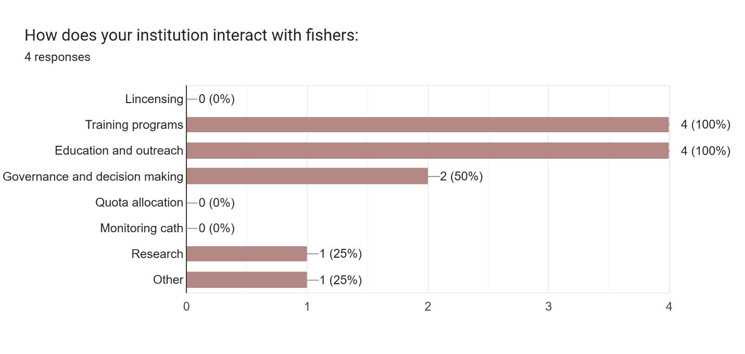
Figure 8 How institutions interact with fishers
Overall, the previous graph highlights the importance of training, education, and outreach in the interactions between institutions and fishers. It also suggests potential areas for improvement, such as increasing involvement in governance and decision-making processes and strengthening capacity building, monitoring and research efforts.
When asked, “How does your institution interact with wholesalers and retailers" we obtained three respondents (Figure 9). Similar to the previous graph (Figure 8), "Training programs" and "Education and outreach" received the highest scores, both at 2 (66.7%). This suggests that institutions prioritize knowledge sharing with wholesalers and retailers. Governance and decision making received a score of 1 (33.3%), indicating a moderate level of involvement in shaping policies and regulations. The remaining categories, such as "Licensing," "Quota allocation," "Monitoring catch," "Research," "Other," and "Governance and decision making," received either 0 or 1 response, suggesting that these areas are not as prominent in the interactions between institutions and wholesalers/retailers (Figure 9).
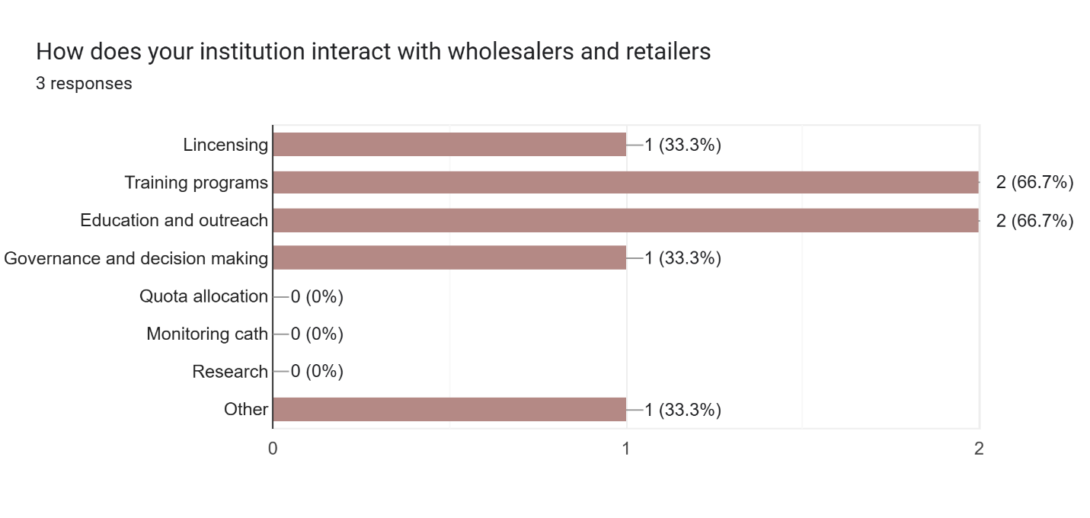
Figure 9 How institutions interact with wholesalers and retailers
Academic institutions and NGOs in Caye Caulker are directing their attention to the fishing activity, specifically targeting the capture/production, and less extent the consumption processes of the three primary fisheries (Figure 10). This focus involves a strong emphasis on education and training initiatives aimed at both fishers and retailers (Figure 8 and Figure 9).
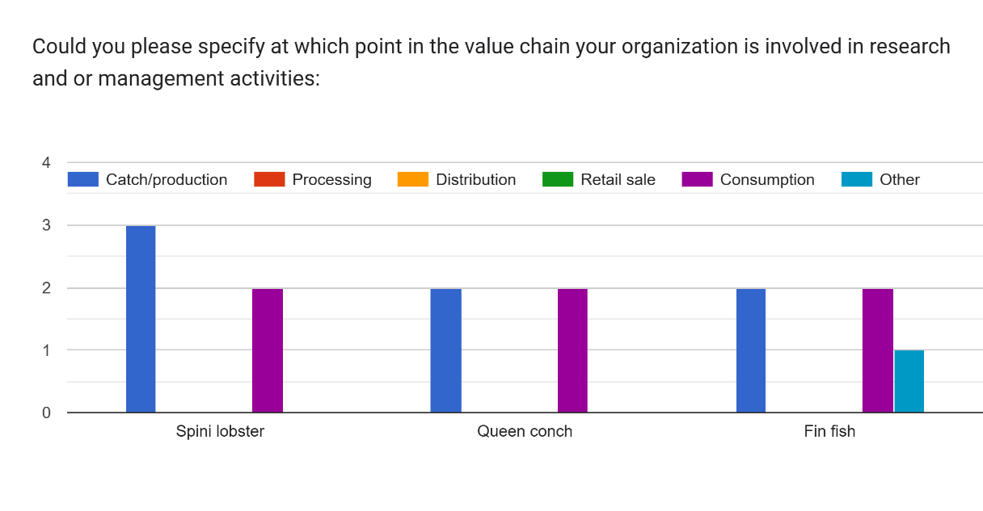
Figure 10 Point in the value chain where organizations are involved in research and management activities

The Table 5 provides insights into the strategies employed by respondent institutions to increase the income of small-scale fishers and improve their livelihoods. WWF, for example, focuses on diversifying income sources through small business development and skill training. They also train fishers in monitoring and alternative livelihoods to enhance their resilience. Fragments of Hope, while not explicitly quantifying economic impacts, emphasize training and knowledge sharing to improve fishing practices and potentially increase fishers' catches. The Caye Caulker BTIAC prioritizes training and knowledge sharing, aiming to identify problems and best practices. They would measure their impact on fishers' livelihoods by tracking the number of fishers actively participating in their training activities. Belioness, on the other hand, is focused on monitoring changes in lionfish populations to assess the effectiveness of management strategies.
Table 5 Strategies employed by respondent institutions to increase the income of small-scale fishers and improve their livelihoods
ID | Gender | Name of your institution | What is your primary role in the institution | How have your programs directly increased the income of small-scale fishers and their families? | How would you measure changes in fishers' ability to meet their basic needs and invest in the future? Can you explain?
SC 11 | Female | WWF | Community/stakeholder, outreach engagement, education | project intervention for income diversification, small business, development and skill training | project upi, household surveys (baseline vs end and project intervention results)
SC 19 | Male | Fragments of Hope | Site coordinator | train fishers to engage in monitoring and alternative livelihood | Not quantified in the economic status of fisher and fishing grounds
SC 40 | Male | Caye Caulker BTIA | Chairperson, Caye caulker captor | Training and knowledge sharing, identification of problems, quality control, best practices | Number of fishers who can fish, new fishers; Number of fishers involved in training, participating in training; number of sustainable practices in fishing
SC 46 | Female | Belioness | Vice Chair | Educating the people about lionfish, maybe can help to have more fish | changes in lionfish abundance

Overall, the table highlights a diverse range of strategies aimed at improving the livelihoods of small-scale fishers, including income diversification, skill development, sustainable fishing practices, and community education.

Network analysis
To assess the interaction patterns among the sectors participating in the study, the value chain was defined as a socio-ecological system, where individuals, or the sectors with which they identify, interact with each other through various activities associated with the country's three main fisheries - lobster fishing, queen conch fishing, and finfish fishing. Nodes in the network represent the participating sectors (see table), while edges depict interactions derived from group activity discussions and survey responses. For instance, if a consumer survey respondent indicates purchasing seafood from fishers, an edge labeled "buy lobster" connects the Consumer and Fisher nodes.
Based on group activity, key interactions between sectors were identified and summarized in the (Figure 11).

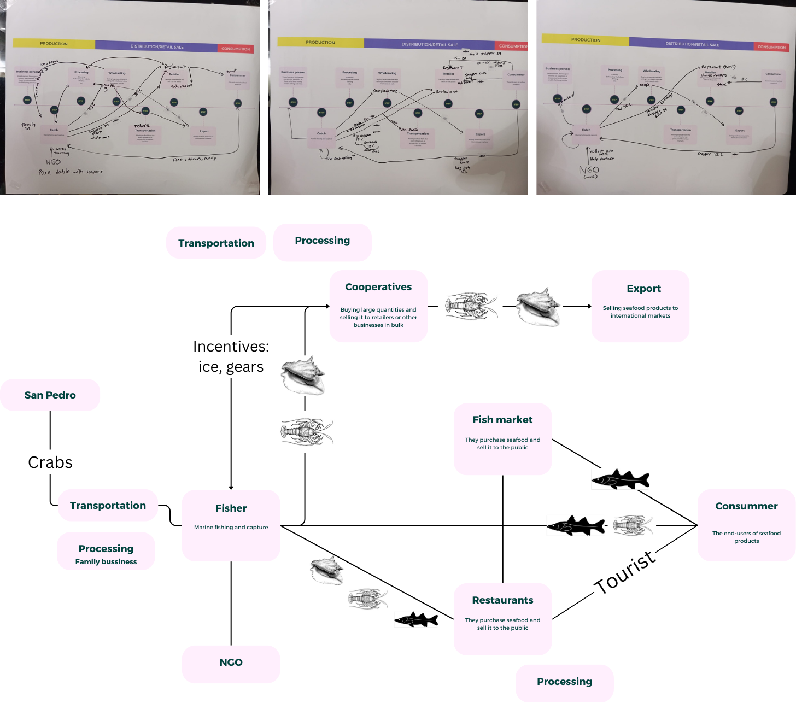
Figure 11 Schematic representation of intersectoral relationships in the Caye Caulker fisheries value chain. The upper panels present the raw data from the three workshop groups, illustrating the initial perceptions of sectoral interactions. The lower panel offers a synthesized schematic, consolidating these findings into a comprehensive overview.
To gain a comprehensive understanding of the network, we constructed a network visualization using the Igraph package in R. To create a simplified overview of the value chain, all interactions, irrespective of their specific type (e.g., purchase, training, sale) or associated species (lobster, queen conch, finfish), were consolidated into a general interaction for the initial visualization. This visualization highlights the central actors and connections that maintain the current flow of resources and information within the Caye Caulker fisheries value chain.
The size of each node represents its degree centrality, indicating the number of connections it has to other nodes (Table 6). Larger nodes, such as "Customer" and "Fisher," have more connections, suggesting their central role in the network (Table 6). The width of the edges represents the betweenness centrality, highlighting the importance of specific connections in facilitating information flow and resource transfer. For instance, the edge between "Fisher" and "Customer" is relatively thick, suggesting that this connection plays a crucial role in the overall network.

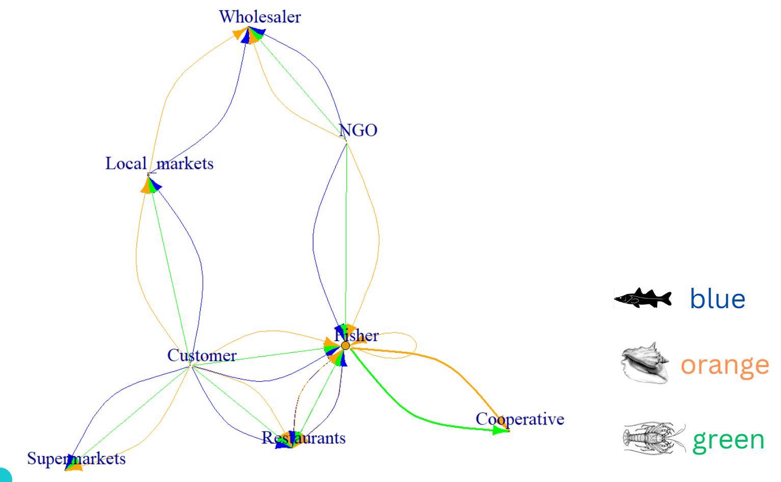
Figure 12 Aggregate network representing the fishery value chain in Caye Caulker
Table 6 Node centrality for the sectors answered the survey
Node | Degree | Betweenness | Closeness | Eigenvector
Fisher | 6 | 9.5 | 0.100 | 1.000
Customer | 4 | 9.5 | 0.100 | 0.495
Local markets | 2 | 2.5 | 0.077 | 0.181
NGO | 2 | 2.5 | 0.077 | 0.324
Restaurants | 2 | 0 | 0.077 | 0.424
Wholesaler | 2 | 1 | 0.067 | 0.143
Cooperative | 1 | 0 | 0.063 | 0.284
Supermarkets | 1 | 0 | 0.063 | 0.140

While there is a direct, relatively strong link between local consumers and fishers (Figure 12), the low monthly seafood consumption per household limits fishers' ability to depend solely on this market.
Cooperatives, despite their dominance in the export market, play a secondary role in the domestic market, purchasing only a limited number of species at lower prices. To enhance fisher livelihoods, increasing domestic seafood consumption is essential.
NGOs and academia can facilitate connections between various sectors, promoting responsible consumption and expanding sales opportunities for fishers.
Restaurants, though with lower centrality, play a pivotal role due to their direct interactions with fishers and consumers. By offering competitive prices and a diverse range of seafood, restaurants are preferred buyers, reducing intermediaries and improving fisher profitability. However, their capacity to buy majority of fish production is linked to the tourism season.
The lobster fishery follows the same interactions patterns described before with the aggregate network.
Increased fish abundance, resulting from nature-based solutions, has the potential to enhance fisher catches. This could manifest as larger catches, larger individuals commanding higher market prices, or a greater diversity of species to exploit, thereby distributing fishing effort and reducing the risk of overexploitation of highly demanded species. However, to translate these increased catches into improved livelihoods, a fair and equitable market for multi-species catches must be ensured year-round. Currently, fishers heavily rely on sales to restaurants during peak tourist seasons, receiving high prices for all captured species. When restaurants are not purchasing, fishers turn to cooperatives, selling only lobster and queen conch at lower prices, impacting their earnings.
Other factors to consider include the misalignment between the lobster fishing season and the tourist season. This mismatch often results in selling larger initial catches to cooperatives at lower prices, as storage is prohibited.
To enhance fisher resilience and incomes, leveraging the strong relationship between local consumers and fishers is promising. Yet, low local seafood consumption hinders this potential. A coordinated effort to increase seafood consumption can not only boost fisher incomes but also improve household nutritional security and reduce the environmental impact of other protein sources like beef, pork, and chicken, particularly in island communities like Caye Caulker.

