Introduction
This report provides an analysis of two workshops conducted in Belize, specifically in the regions of Placencia and Caye Caulker. The workshops aimed to assess the roles and steps associated with the value chain in the small-scale fishery in these places, as well as the engagement strategies between various institutions and local fishers. This report synthesizes key findings from the workshops, highlighting ethnic diversity, institutional roles, interaction patterns, and strategies to enhance the livelihoods of small-scale fishers.

Methodology
Data was collected through surveys administered to participants involved in fisheries management and community engagement. Respondents included representatives from various roles within organizations, allowing for a comprehensive analysis of institutional interactions related to fisheries.

General Summary of Caye Caulker and Placencia Fisheries Activity:
The hands-on activity of fisheries in Caye Caulker and Placencia workshops provided insights into the local dynamics of lobster, queen conch, and fin fish fisheries. Both regions showcase a strong interconnection between small-scale fishery and the local economy, emphasizing the importance of sustainable practices, equal gender participation, and community engagement. Key stakeholders include fishers, retailers, consumers, NGOs, and academic institutions, all playing vital roles in the fisheries value chain and emphasizing the importance of education and training for sustainable practices.

Key Points on Values, Numbers, Similarities, and Differences:
- Participation and Demographics:
  - Both Caye Caulker and Placencia exhibit diverse participation among fishers, with a strong presence of Creole ethnicity. Caye Caulker has a greater gender balance, whereas Placencia reported a predominantly male participation.
  - Age demographics in both regions emphasize a middle-aged participant base, though Caye Caulker includes participants over 55 years old.
- Lobster Fishery:
  - Similarities: Both regions use Shades as a primary fishing gear, showcasing autonomy as fishers own their vessels and gear. Lobster traps are also used in both areas.
  - Differences: In Caye Caulker, fishers average about 21.4 trips during fishing season, with costs averaging $277 Belize dollars per trip. In Placencia, the average is 15.5 trips, with a higher cost of $400 per trip, implying possible economic or logistical differences.
  - Profit and catch margins vary significantly, particularly in Placencia, likely due to geographic and economic factors.
- Queen Conch Fishery:
  - Similarities: Free diving is the primary method in both regions and catch variability may depend on skill and season timing.
  - Differences: Caye Caulker has a higher average of about 9 trips per season compared to 3.8 in Placencia. Differences in reported profits are notable, with variations in how earnings are calculated or shared.
- Fin Fish Fishery:
  - Similarities: The hand line is the predominant gear in both locales, with fishermen integrating fishing with tourism for supplemental income in both places.
  - Differences: In Placencia, a combination of hand line, spearfishing, and traps is noted with diverse tactics, contributing to variable costs and catches. Caye Caulker does not mention such combinations extensively.
- Retail and Consumer Dynamics:
  - Similarities: Retailers in both regions focus on product quality and have strong ties with local fishers. Purchases are often affected by price and availability.
  - Differences: In Caye Caulker, snappers and lobster are most consumed, while in Placencia, snappers and barracudas dominate consumer preferences.
- Economic and Sustainability Initiatives:
  - Similarities: Both regions have a high willingness among consumers to pay more for sustainably sourced seafood. NGOs and academic institutions engage strongly in education, training, and alternative livelihood strategies.
  - Differences: Institutions in Placencia emphasize alternative livelihoods and conservation more broadly in the community, whereas in Caye Caulker focuses intensively on training and knowledge sharing.
- Overall Analysis:
  - Caye Caulker highlights a balanced gender participation, with a notable focus on sustainability in retail and consumption preferences. The island-centric geography might influence its concentrated economic model.
  - Placencia features a greater diversity in fishing tactics and shows significant connections between fisheries and tourism. This influences more varied economic activities and possibly more refined conservation strategies in the community.
Together, these studies offer a comprehensive view of the fisheries' economic, demographic, and ecological aspects in Caye Caulker and Placencia, pinpointing areas of potential collaboration and growth in sustainable practices.

Caye Caulker

Fishers

We obtained responses from 15 fishers, 58% male and 41.7% female, demonstrating significant and equal participation by both genders in Caye Caulker's fishing activity. Most fishers (58%) identified as Mestizo or Creole, with a few Mayan and only one Garifuna participant. The age range of respondents was 25 to over 55 years old, with no participants under the age of 24.

Lobster fishery
The combination of shade and lobster trap are the most reported fishing gears in the lobster fishery of the participants in Caye Caulker, followed by only the use of shade (Figure 1). The use of Snare, Jamo, hook and stick, and the combination of shade and hook stick were mentioned only once. Most fishers (93%) own their vessels and gear, granting them a degree of autonomy.
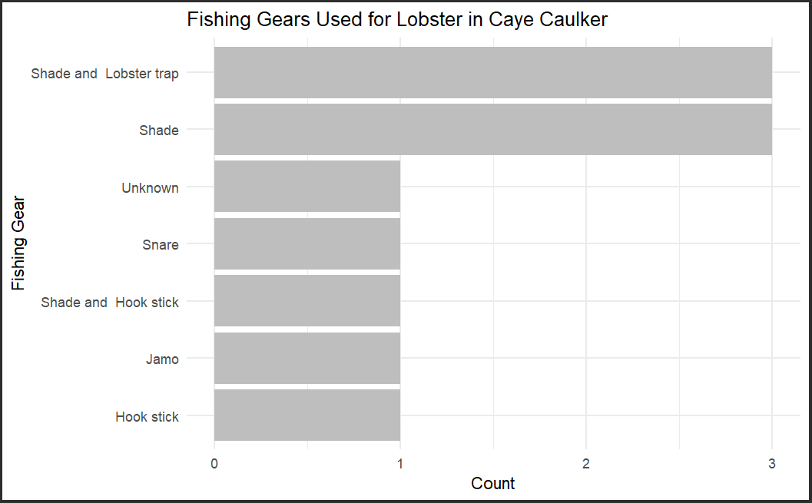
Figure 1 Fishing gear used in the spiny lobster fishery
Most fishers (70%) are licensed to fish in Zone 1, where Caye Caulker is located, followed by Zones 6, 3, and 4 (28%, 14%, and 14%, respectively). On average, fishers make 21.4 fishing trips per month during the lobster season, ranging from 1 to 100 trips. However, most fishers make between 4 and 25 trips during the season (Figure 2).
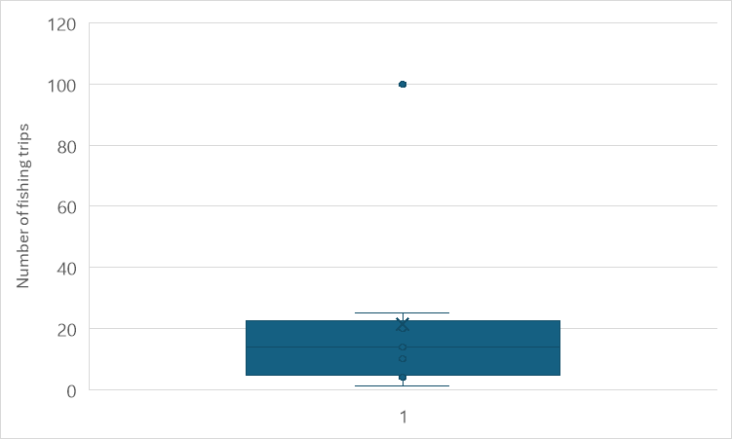
Figure 2 Individual number of fishing trips per month for lobsters

On average, fishing trips last 7 hours per day, ranging from 2 to 24 hours. The average cost of a fishing trip is $277 Belize dollars. While the cost per trip varies across gear types, the average catch and profit per trip seem to be relatively similar, suggesting that different gear types might have different cost-benefit profiles (Table 1). Fishers using the shade tend to make more trips per season compared to those using other gear types. Costs range from $100 to $500 Belize dollars, with a tendency for fishers who report fewer trips per season to also report higher trip costs (Figure 3).

Table 1 Summary of responses in the lobster fishery. All data were reported by fishers. Catch values are in pounds. Cost and sell prices in Belize dollars.
Gear | Number of answers | Average Number of trips season | Average hours per trip | Average cost per trip | Average catch per trip | Average of price | Average profit per trip
Hook stick | 1 | 5.0 |  |  |  | 10.0
Jamo | 1 | 10.0 | 24.0 | 300.0 | 50.0 | 30.0 | 1200.0
Shade | 3 | 71.7 | 4.3 | 316.7 | 17.5 | 25.5 | 200.0
Shade, Hook stick | 1 | 4.0 | 8.0 | 100.0 | 27.5 | 27.5 | 393.3
Shade, Lobster trap | 3 | 44.7 | 7.0 | 333.3 | 27.5 | 22.5 | 350.0
Snare | 1 | 1.0 | 3.0 | 150.0 | 5.0
Average |  | 36.9 | 7.7 | 277.8 | 25.0 | 23.3 | 498.7

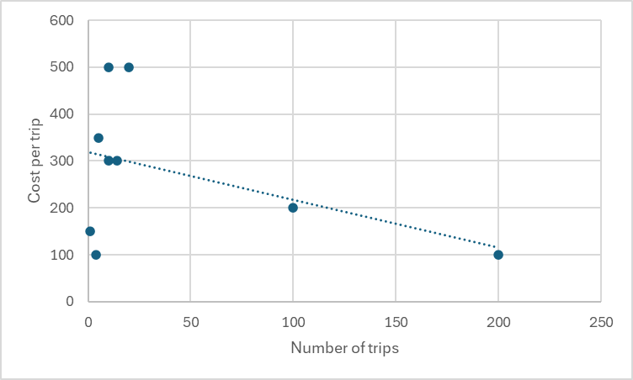
Figure 3 Relation between the number of fishing trips during lobster season and the cost per trip reported by participants
As explained by several fishermen during the activity, the best catches are made in the first two months of the season, where each fishing trip can yield around 400 lbs. of lobster. The catch decreases to around 200 lbs. between the 3rd and 4th months, and in the last months, it drops to less than 100 lbs. per trip. It is important to monitor the changes in fishing effort and catch throughout the season to make accurate CPUE estimates. This gives an weighted average estimation of 131.25 lbs per fishing trip considering the different catch between months during the season.
Most lobster catches are sold to local restaurants and cooperatives. Nevertheless, fishers generally prefer selling to restaurants as they offer a better price per pound. Cooperatives become the secondary option when restaurant demand is low, typically during the off-tourist season. The fisher who reported only one fishing trip per season indicated that he does not sell and kept the catch for self-consumption.

Queen conch fishery
A significant majority of 10 out of 11 respondents (90.9%) uses free diving as their primary fishing method. Only one respondent (9.1%) uses other fishing gear, indicating a strong preference for free diving to catch the queen conch.
On average, fishers make 9.2 fishing trips per season, ranging from 1 to 24. Each fishing trip can last between 3 and 10 hours per day for several days, yielding an average catch of 57 pounds of conch per trip (Table 2). However, the catch can vary significantly, ranging from 5 to 200 pounds. This variability may be attributed to differences in free-diving skills among fishers or the timing of the fishing season.
The average selling price is $9.17 Belize dollars. However, prices reported by fishers varied, where higher prices ($10 to $15 Belize dollars) were typically paid by restaurants, while cooperatives offered lower prices ($4 to $12 Belize dollars) per pound.
Table 2 Summary of responses in the queen conch fishery. All data were reported by fishers
Gear | Number of fishers | Average Number of fishing trips | Average of Hours | Average of Cost | Average of Catch | Average of selling Price | Average of Profit
Free diving | 9 | 9.17 | 18.14 | 278.57 | 63.00 | 9.17 | 455.00
Other | 1 | 10.00 | 6.00 | 300.00 | 20.00 | 12.00 | 300.00
Average |  | 9.29 | 16.63 | 281.25 | 57.63 | 9.57 | 429.17

Fin fish fishery
Hand line is the most common gear type, with 8 fishers using it. They make an average of 11 trips per month, spending an average of $258.3 Belize dollars per trip. Each trip lasts about 6.1 hours. Two fishers use the combination hand line and spearfishing. They are more active, making 15.5 trips per month and spending on average $300 Belize dollars per trip. Their trips are longer, lasting 10 hours. Only one fisher reported fish only with spearfishing. They make 3 trips per month, spending $200 Belize dollars per trip, and also spend 10 hours per trip. One fisher uses Spin rod, making a single trip per month at a cost of $300 Belize dollars and lasting 7 hours (Table 3).
Table 3 Summary of responses in the fin fish fishery. All data were reported by fishers. Catch is in pounds; cost and selling prices in Belize dollars.
Gear | Number fishers | Average Number of trips/month | Average Cost per trip | Average of Hours per trip | Average Catch |  |  |  | Average sell price |  |  |  | Average profit per trip
 |  |  |  |  | barracuda | snapper | grouper | jacks | barracuda | snapper | grouper | jacks
Hand line | 8 | 11.0 | 258.3 | 6.1 | 15.0 | 33.3 | 10.0 | 5.0 | 9.0 | 13.2 | 17.5 | 10.0 | 500
Hand line, Spearfishing | 2 | 15.5 | 300.0 | 10.0 | 60.0 | 20.0 |  |  | 8.0 | 10.0 | 10.0 | 8.0 | 300
Spearfishing | 1 | 3.0 | 200.0 | 10.0 | 50.0 | 50.0 |  |  | 12.0 | 15.0 |  |  | 400
Spin Rode | 1 |  | 300.0 | 7.0
Average |  | 11.1 | 265.0 | 7.3 | 31.0 | 34.0 | 10.0 | 5.0 | 9.3 | 13.0 | 15.0 | 9.3 | 425

The average catch varies by gear type. Hand line users catch fewer fish of each species compared to those using spearfishing or the combination of hand line and spearfishing. The selling prices for different fish species also vary. Generally, grouper and snapper seem to fetch higher prices compared to barracudas and jacks. All fin fish production is sold to restaurants or kept for self-consumption.
Eight respondents reported secondary employment in tourism, highlighting the strong interconnection between small-scale fishery and tourism in Caye Caulker. Furthermore, only 3 fishermen reported being members of a cooperative, all of whom belong to the Norther cooperative.

Retailers
Three people identified themselves as retailers, all of them females over 35 years old. Two were of Creole origin and the other was Garifuna.
Two of the respondents owned restaurants, while the third was a vendor in a fishing shop. All of them had arrangements with fishers, providing ice or other benefits in exchange for the fishers "securing" the sale of their catch to them.
The only species purchased by all respondents was snapper. However, spiny lobster was the species purchased in the highest quantity, despite being the most expensive at $18 Belize dollars. Barracuda was the other finfish species purchased by two of the respondents.
Selling prices varied between respondents and within species, depending on size or processing. Lobster was sold between $20 and $30 Belize dollars, and restaurant plates could cost around $40 Belize dollars. Queen conch prices varied from $10 to $15 Belize dollars, depending on size, and plates could cost around $30 Belize dollars in restaurants. Snapper prices ranged from $3 to $10 Belize dollars, depending on size, and could be sold at $40 Belize dollars in restaurants. Species like snook, grouper, wrasses, and jacks are more difficult to find in restaurants.
The primary suppliers of fish and queen conch to retailers are fishermen. While fishermen also supply lobster, restaurants and stores often source these items from fish markets or other wholesale distributors (Figure 4).
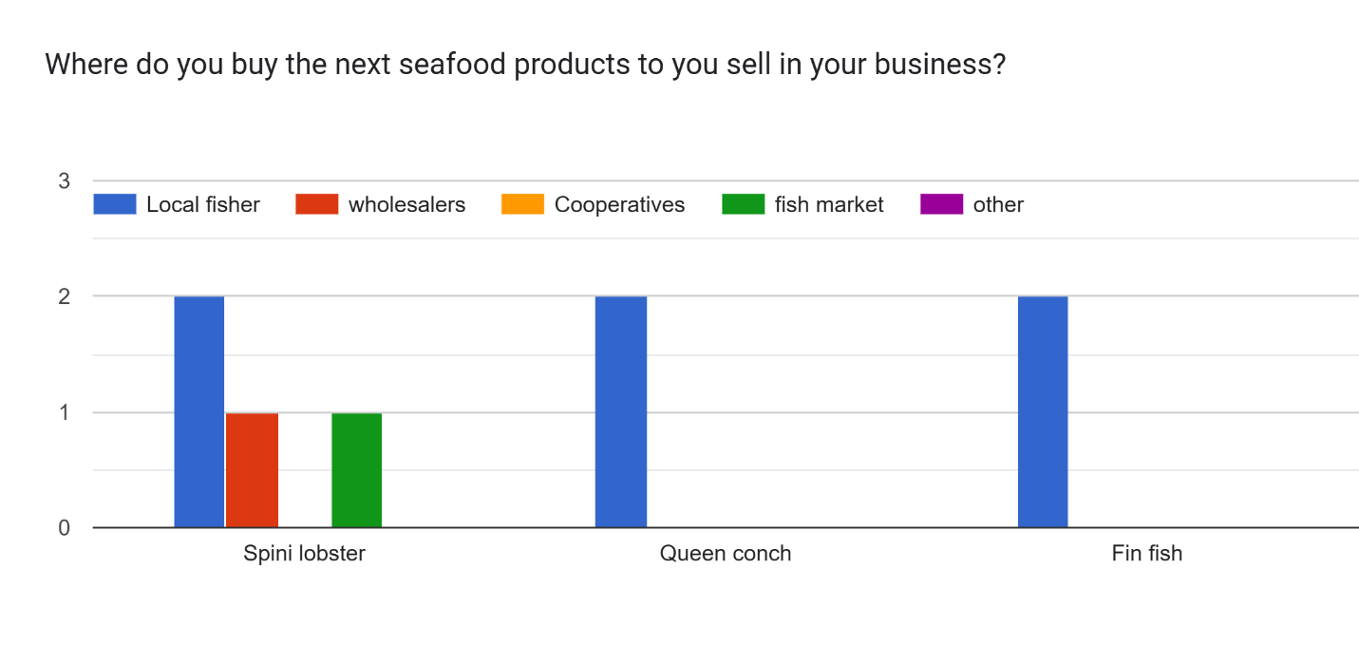
Figure 4 Purchase of seafood products from retailers in Caye Caulker

When purchasing seafood, respondents prioritize products that are readily available and of good quality. Price, demand, and sustainability considerations seem to be less influential in their decision-making process
- Availability was the most important factor for all respondents, with a score of 3 (100%).
- Quality was the second most important factor, mentioned by 2 out of 3 respondents (66.7%).
- Price, Demand, and Sustainability were considered by only 1 respondent each (33.3%).

Consumers
Seven participants identified themselves as consumers within the fishing value chain. Of these participants, 66% were male and 33% were female. The majority (50%) self-identified as Mestizo, followed by Maya and Creole (each 33.3%). One participant identified as East Indian and another as White.
Regarding age, half of the participants (50%) were between 35 and 44 years old. The remaining age groups, 18-24, 45-54, and over 55, were each represented by 16.7% of the participants. Notably, there was no representation from the 25-34 or under-18 age groups (Figure 5).
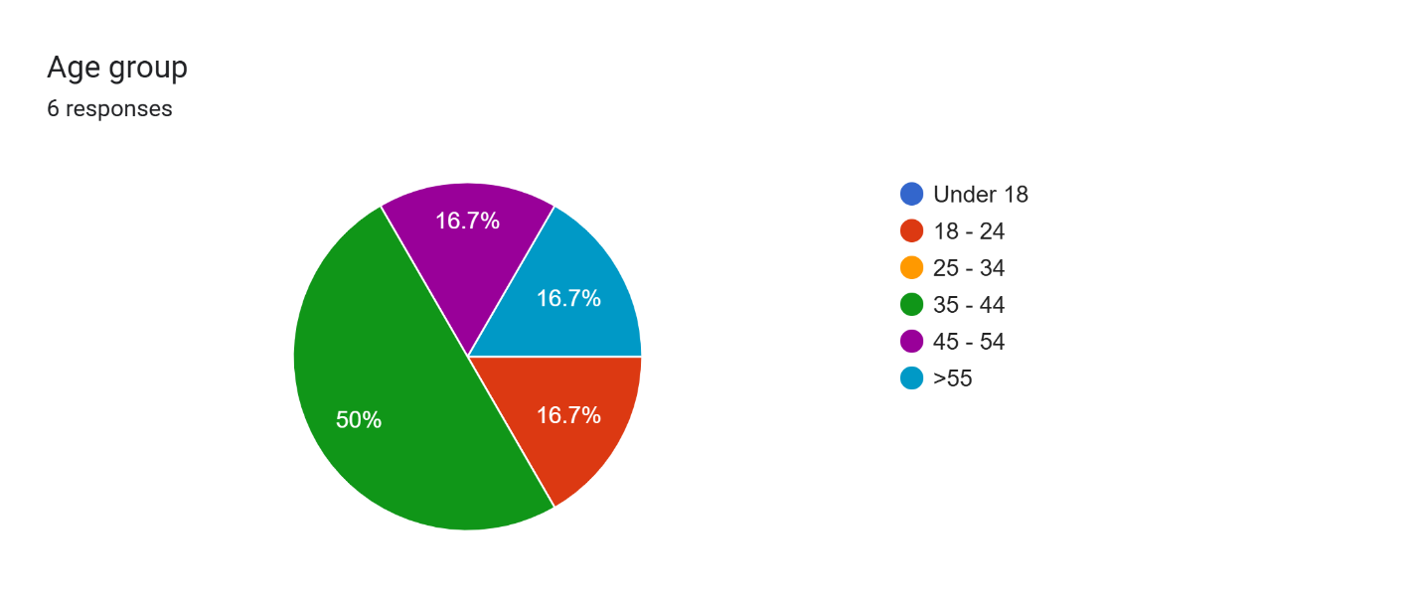
Figure 5 Age Distribution of Consumers respondents in Caye Caulker
Snapper, lobster, and conch have the highest total consumption, indicating a strong overall demand for these species. Groupers follow with moderate levels of total consumption. Jacks, barracuda, and snook have significantly lower total consumption, and no one reported consuming wrasses (Figure 2).
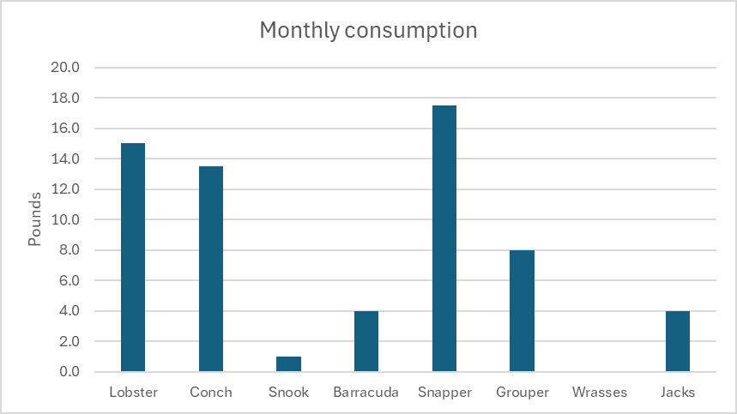
Figure 6 Monthly total consumption per species.
The number of people consuming snapper and conch is highest, followed by lobster, the remaining seafood types have significantly fewer consumers (Table 4). However, in terms of per capita consumption, grouper, lobster, and snapper have the highest average values (8, 3.8, and 2.9 pounds per month, respectively), suggesting that those who consume these seafood types tend to consume larger quantities. Conch, barracuda, and jacks have moderate per capita consumption levels (around 2 pounds per month) (Table 4).
Table 4 Consumption of sea food species in Caye Caulker. NA= do not report their participant ID. Values are in pounds consumed by month.
Participant | Lobster | Conch | Snook | Barracuda | Snapper | Grouper | Wrasses | Jacks
NA | 10 | 8 |  |  | 5
SC 20 | 2 | 2 |  | 3 | 3 |  |  | 3
NA |  | 1 |  |  | 5 | 8
SC 23 | 1 | 1 | 1 | 1 |  |  |  | 1
SC 15 | 2 | 1 |  |  | 3
SC 52 |  |  |  |  | 1
NA |  | 0.5 |  |  | 0.5
Total consumption | 15.0 | 13.5 | 1.0 | 4.0 | 17.5 | 8.0 | 0.0 | 4.0
Average Individual consumption | 3.8 | 2.3 | 1.0 | 2.0 | 2.9 | 8.0 | 0.0 | 2.0
Number of people consuming the species | 4 | 6 | 1 | 2 | 6 | 1 | 0 | 2

Overall, the data suggests a strong preference for snapper, conch and lobster among consumers, both in terms of total consumption and consumption per capita.
Respondents indicated an interest in consuming parrotfish, goliath grouper, tuna, and hogfish (Lachnolaimus maximus) but they are difficult to find in Caye Caulker. As seen in Table 4 and Figure 5, only one participant reported eating grouper, and none had consumed hogfish. Considering the low reported consumption and the scarcity of these species in local markets, it is likely that factors such as overfishing and limited availability are contributing to their low supply.
Fisher was the most common source of seafood, with 5 out of 7 respondents (71.4%) purchasing from them (Figure 7). Local markets and restaurants were the second most common sources, each mentioned by 3 respondents (42.9%). Supermarkets were mentioned by 1 respondent (14.3%). Fishboard and Other were not mentioned by any respondents. This suggests that the survey participants primarily rely on fishers as their main source of seafood, with local markets and restaurants being secondary options.
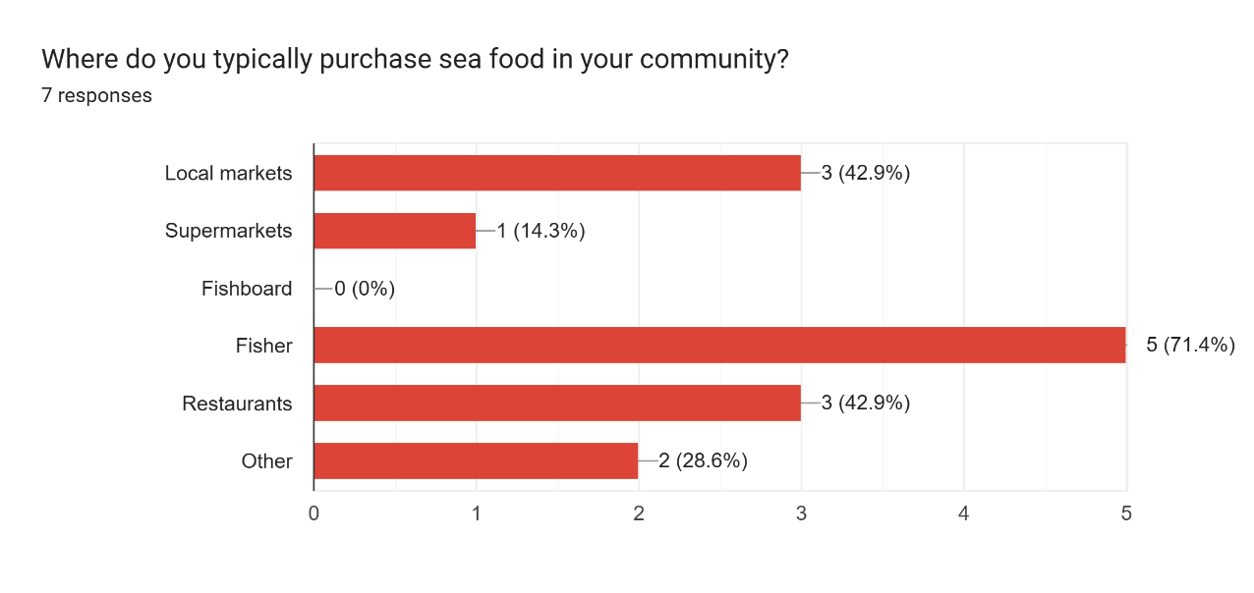
Figure 7 Main seafood purchase locations by consumers in Caye Caulker
However, despite the previous information, the proportion of seafood intake per family is considerably low. Three out of four respondents reported that seafood represents less than 1% of their family's food intake (one is fully vegetarian), and only one person indicated that it's about 10-20%, representing approximately $100 BZ per month.
When asked, "Would you be willing to pay a higher price for seafood if you knew it's more sustainable and supported the livelihood of small-scale fishers?", a significant majority of 75% of the four respondents answered "Yes," indicating a willingness to pay a premium for sustainable seafood that benefits small-scale fishers.
When asked about initiatives to promote sustainable fishing practices, respondents highlighted a variety of strategies. Some mentioned value-added marketing initiatives, which focus on increasing the economic value of fish products. Others pointed to specific regulations, such as minimum-size lobster tail restrictions. Additionally, another respondent emphasized the importance of traditional conservation measures like no-take zones, managed access, size limits, zoning, licensing, enforcement, marine protected areas, and seasonal closures. These responses indicate a desire among community members to participate in sustainable fishing initiatives.

Academic and NGO
We obtained 4 responses from members of NGOs out of the eight participating in the workshop. Women and men were equally represented, and participants came from various ethnic backgrounds, including Creole and Mestizo. The age range of the participants was broad, spanning from the 25-34 age group to the 45-54 age group. The participants were affiliated with various organizations, such as WWF, Fragments of Hope, Caye Caulker BTIAC, and Belioness, and held roles ranging from community engagement to leadership positions. Any member of the academic institutions responded to the survey.
When asked how their institution interacts with fishers, strong emphasis on training and education was found. The highest number of responses were for "Training programs" and "Education and outreach," both receiving a score of 4 (100%) (Figure 8). This suggests that the institutions prioritize knowledge sharing with fishers. Moderate Involvement in governance and decision-making, receiving a score of 2 (50%). This indicates that while institutions are involved in governance processes to some extent, it may not be a primary focus. And limited engagement in other areas such as "Licensing," "Quota allocation," "Monitoring catch," "Research," and "Other," received either 0 or 1 response, suggesting that these areas are not as prominent in the interactions between Academic institutions and NGOs and fishers (Figure 8).
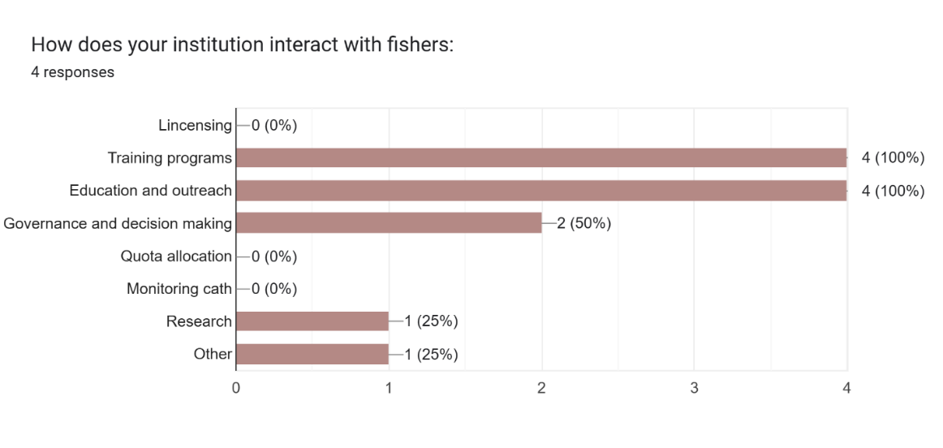
Figure 8 How institutions interact with fishers
Overall, the previous graph highlights the importance of training, education, and outreach in the interactions between institutions and fishers. It also suggests potential areas for improvement, such as increasing involvement in governance and decision-making processes and strengthening capacity building, monitoring and research efforts.
When asked, “How does your institution interact with wholesalers and retailers" we obtained three respondents (Figure 9). Similar to the previous graph (Figure 8), "Training programs" and "Education and outreach" received the highest scores, both at 2 (66.7%). This suggests that institutions prioritize knowledge sharing with wholesalers and retailers. Governance and decision making received a score of 1 (33.3%), indicating a moderate level of involvement in shaping policies and regulations. The remaining categories, such as "Licensing," "Quota allocation," "Monitoring catch," "Research," "Other," and "Governance and decision making," received either 0 or 1 response, suggesting that these areas are not as prominent in the interactions between institutions and wholesalers/retailers (Figure 9).
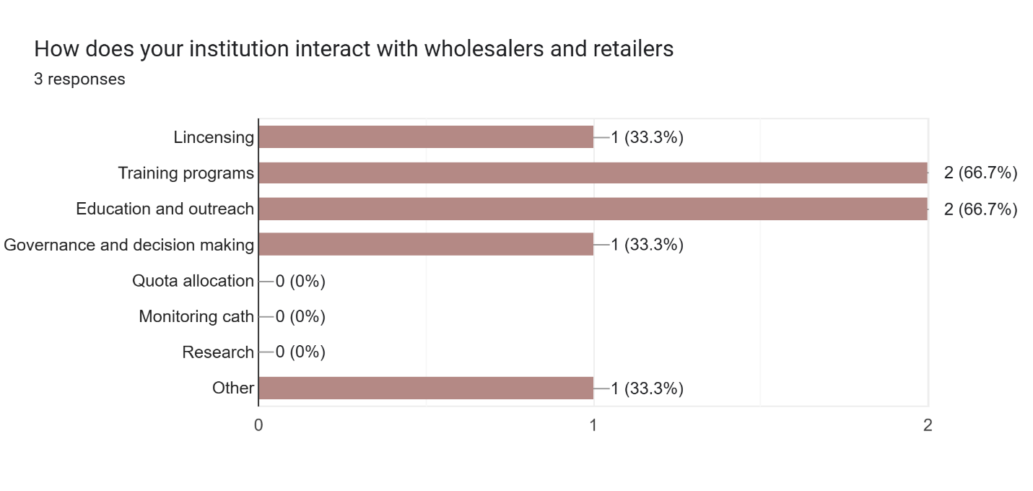
Figure 9 How institutions interact with wholesalers and retailers
Academic institutions and NGOs in Caye Caulker are directing their attention to the fishing activity, specifically targeting the capture/production, and less extent the consumption processes of the three primary fisheries (Figure 10). This focus involves a strong emphasis on education and training initiatives aimed at both fishers and retailers (Figure 8 and Figure 9).
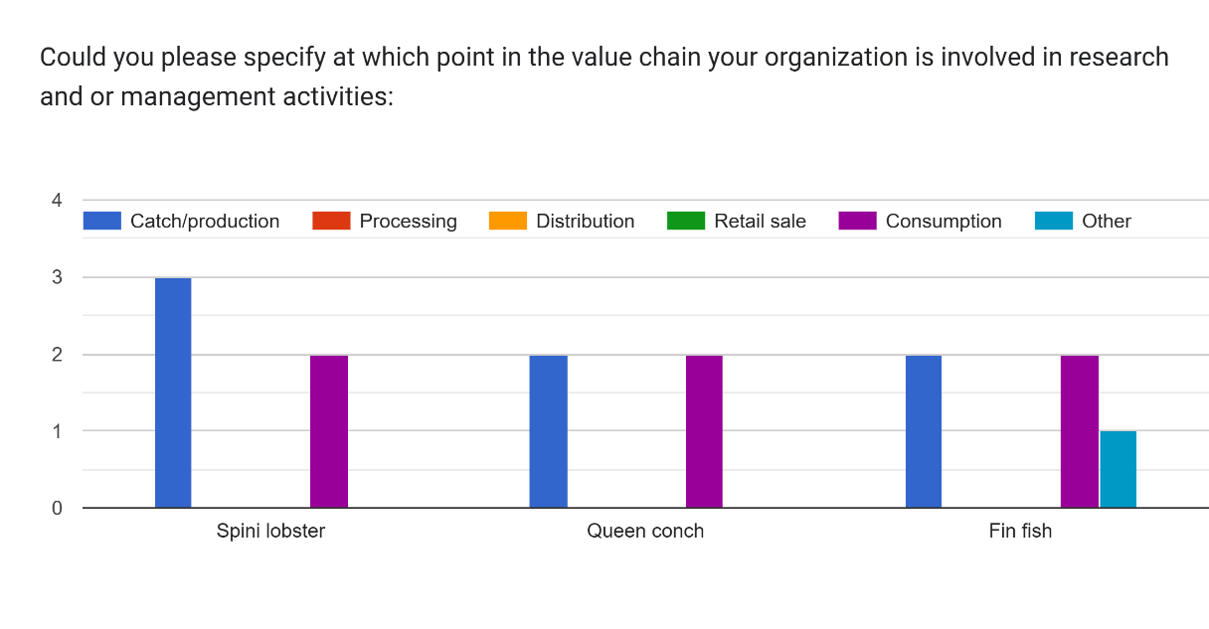
Figure 10 Point in the value chain where organizations are involved in research and management activities

The Table 5 provides insights into the strategies employed by respondent institutions to increase the income of small-scale fishers and improve their livelihoods. WWF, for example, focuses on diversifying income sources through small business development and skill training. They also train fishers in monitoring and alternative livelihoods to enhance their resilience. Fragments of Hope, while not explicitly quantifying economic impacts, emphasize training and knowledge sharing to improve fishing practices and potentially increase fishers' catches. The Caye Caulker BTIAC prioritizes training and knowledge sharing, aiming to identify problems and best practices. They would measure their impact on fishers' livelihoods by tracking the number of fishers actively participating in their training activities. Belioness, on the other hand, is focused on monitoring changes in lionfish populations to assess the effectiveness of management strategies.
Table 5 Strategies employed by respondent institutions to increase the income of small-scale fishers and improve their livelihoods
ID | Gender | Name of your institution | What is your primary role in the institution | How have your programs directly increased the income of small-scale fishers and their families? | How would you measure changes in fishers' ability to meet their basic needs and invest in the future? Can you explain?
SC 11 | Female | WWF | Community/stakeholder, outreach engagement, education | project intervention for income diversification, small business, development and skill training | project upi, household surveys (baseline vs end and project intervention results)
SC 19 | Male | Fragments of Hope | Site coordinator | train fishers to engage in monitoring and alternative livelihood | Not quantified in the economic status of fisher and fishing grounds
SC 40 | Male | Caye Caulker BTIA | Chairperson, Caye caulker captor | Training and knowledge sharing, identification of problems, quality control, best practices | Number of fishers who can fish, new fishers; Number of fishers involved in training, participating in training; number of sustainable practices in fishing
SC 46 | Female | Belioness | Vice Chair | Educating the people about lionfish, maybe can help to have more fish | changes in lionfish abundance

Overall, the table highlights a diverse range of strategies aimed at improving the livelihoods of small-scale fishers, including income diversification, skill development, sustainable fishing practices, and community education.

Placencia

Fishers

We obtained responses from 5 fishers, 4 males fishing lobster, conch and fin fish, and one female who fish only fin fish. Four fishers identified themselves as Creole and one Garifuna. The age range of males was 35 to 54 years old, and the female fisher was 25 to 34.

Lobster fishery
Despite having obtained very few responses about the fishing gear used in the lobster fishery in Placencia (n=4), those mentioned, all with equal frequency, were the combination of shade and lobster trap, the use of shade alone, hook and stick, and another undefined one. All fishers own their vessels and gear, granting them a degree of autonomy.
Most fishers fish in Zones 3 and 4, one reported to fish additionally in zone 5 (reporting fishing in zones 3, 4 and 5) and one fisher reported to fish on zones 3, 8 and 9. On average, fishers make 15.5 fishing trips per month during the lobster season, ranging from 8 to 32 trips per month. On average, fishing trips last 6 hours per day, ranging from 4.5 to 8 hours. The average cost of a fishing trip is $400 Belize dollars, ranging from $250 to $800 Belize dollars. While the cost per trip is relatively constant across gear types, the average catch and profit per trip varies across fishers, suggesting that the experience or fishing ground might have different cost-benefit profiles (Table 6).
Table 6 Summary of responses in the lobster fishery. All data were reported by fishers. Catch values are in pounds. Cost and sell prices in Belize dollars.
Gear | Number of answers | Monthly trips per season | Hours per trip | Cost per trip | Catch per trip | Selling price | Profit per trip
Hook stick | 1 | 12 | 6 | 300 | 30 | 28 | 400
Other | 1 | 10 | 30 | 800 | 125 | 30 | 2250
Shade | 1 | 8 | 8 | 250 | 95 | 28 | 750
Shade, Lobster trap | 1 | 32 | 4.5 | 250 | 175 |  | 250
Average | 4 | 16 | 12 | 400 | 106 | 29 | 913

Lobster catches are sold either to restaurants or to cooperatives (with two answers each). In Placencia, sales were reported to 3 different cooperatives, including the Placencia Cooperative, Rainforest and Green Forest Seafood.

Queen conch fishery
The same four fishers that reported fishing lobster fish queen conch as well, and all of them use free diving as their primary fishing method. On average, fishers make 3.8 fishing trips per month during the season, ranging from 2 to 8. Each fishing trip can last between 3 and 7 hours per day for several days (Table 7). Fishermen reported a wide range of catches, from as low as 17 pounds to as high as 900 pounds per trip. This variability is likely to be due to fluctuations in catch rates throughout the fishing season -with earlier trips typically yielding higher catches-, or to differences in free-diving skills among fishers.
The average selling price is $9.1 Belize dollars. However, prices reported by fishers varied, where higher prices ($10 Belize dollars) were typically paid by restaurants, while cooperatives offered lower prices ($8 to $9 Belize dollars) per pound. Reported earnings per fishing trip also varied among fishers, with values as low as $160 and as high as $1750. These variations may be associated with the way fishermen reported their earnings, as some indicated that the total earnings are divided among the crew, which is typically composed of 3 fishermen. Therefore, some may have reported the total earnings, while others reported their individual share.
Table 7 Summary of responses in the queen conch fishery. All data were reported by fishers
Gender | Ethnic background | Age group | Monthly trips per season | hours per trip | cost per trip | catch per trip | Selling price | profit per trip
Male | Creole | 45 - 54 | 2 | 30 | 700 | 87 | 10 | 1250
Male | Creole | 45 - 54 | 8 | 7 | 120 | 17.5 | 9.5 | 160
Male | Creole | 35 - 44 | 2.5 | 3.5 | 450 | 900 | 9 | 1750
Male | Garifuna | 45 - 54 | 3 | 5 | 300 | 200 | 8 | 350
Average |  |  | 4 | 11 | 393 | 301 | 9 | 878

Fin fish fishery
Hand line is the most common gear type, with 4 fishers using it, two of them combined it with spearfishing, and one with fish trap. They make an average of 8 trips per month, spending an average of $366.8 Belize dollars per trip. However, the reported costs varied among fishermen, with those who reported fewer trips having more expensive trips (between $680 to $580 dollars per trip), and the fisherman who made the most trips reporting a lower cost per trip ($87.5 dollars). Each trip lasts about 6.1 hours. Like conch fishing, fishermen who make more trips per month also report that these trips are cheaper compared to trips made by fishermen who go out less frequently.
Snappers are the most frequently caught species, with an average of 131 pounds per trip, followed by barracudas and jacks. Fishermen who report using handlines with spearfishing are the only ones who catch all species (snappers, groupers, barracudas, and jacks), and they also report the highest earnings ($1362 on average). Groupers are the fish that sell for the highest price ($12 per pound), but their low catch rates indicate a scarcity of these species (Table 8).
Fish are primarily sold to local restaurants, vendors, or even resorts. The female fisher reported that she does not sell her catch. Two of the fishermen reported belonging to the Placencia Cooperative. Four respondents reported secondary employment in tourism, highlighting the strong interconnection between small-scale fishery and tourism in Placencia.

Table 8 Summary of responses in the fin fish fishery. All data were reported by fishers. Catch is in pounds; cost and selling prices in Belize dollars.
Fishing Gear | Number fishers | Average Number of trips/month | Average Cost per trip | Average of Hours per trip | Average Catch |  |  |  | Average Selling Price |  |  |  | Average profit per trip
 |  |  |  |  | barracuda | snapper | grouper | jacks | barracuda | snapper | grouper | jacks
Hand line | 1 | 3 | 680 | 9 | 50 | 175 |  | 27.5 |  |  |  |  | 300
Hand line, Spearfishing | 2 | 5 | 350 | 7 | 50 | 100 | 20 | 50 |  | 6.5 | 12 |  | 1362.5
Hand line, Trap | 1 | 20 | 87.5 | 3.5 |  | 150 |  |  | 5 | 5 |  | 3 | 200
Other | 1 |  |  | 5
Total Average | 5 | 8.2 | 366.8 | 6.1 | 50 | 131.2 | 20 | 38.7 | 5 | 6 | 12 | 3 | 806.2

Retailers
Three people identified themselves as retailers. Two were Creole males over 35 years old. The other was a female with Creole and East Indian ethnic background, also over 35 years old. The types of retail businesses they are engaged in are diverse: one operates a dive shop, another works in the fish market, and the other sells the catch of a family member.
Only respondents operating dive shops reported arrangements with fishers, offering ice and credit in exchange for exclusive rights to purchase their catch. One respondent provided specific purchase quantities for the previous month: 10 pounds of conch, 20 pounds of snapper, 30 pounds of grouper, and 10 pounds of jack. Regarding purchase prices, spiny lobster commanded the highest price at 28 Belize dollars per pound. Queen conch was purchased by retailers at an average of 9.50 Belize dollars per pound, while finfish typically sold for 10 Belize dollars per pound, with barracuda being an exception at a lower price of 7 Belize dollars per pound. The primary source of marine species for retailers is fishermen, although the workshop highlighted that some retailers may also procure these products from unidentified intermediaries.
As discussed during the workshop, selling prices for seafood varied significantly based on the size and processing of the product. Lobster, for example, ranged from $28 to $30 Belize dollars per pound, while restaurant plates of lobster could cost around $40 Belize dollars (Table 9). In Placencia, queen conch was sold for $10 Belize dollars per pound. Among finfish, snook commanded the highest selling price at $10.70 Belize dollars per pound on average, followed by snapper and grouper at $8.70 Belize dollars per pound on average. Jack and barracuda had the lowest average selling prices, around $6 Belize dollars.

Table 9 Quantities and values associated with the fishery species in Placencia. Quantities are in pounds and values in dollars per pound.
Species | Purchase quantity | Purchase price | Selling price
Lobster |  | 28 | 29.3
conch | 10 | 9.5 | 10.0
snook |  | 10 | 10.7
barracuda |  | 7 | 6.0
snapper | 20 | 10 | 8.7
grouper | 30 | 10 | 8.7
wrasses |  | 10
jacks | 10 |  | 6.7

When purchasing seafood, respondents prioritized products based on price, quality, and the sustainability of their catch. Two respondents also emphasized demand and product availability as significant factors in their purchasing decisions.

Consumers
In Placencia, twelve participants identified themselves as consumers within the fishing value chain. Of these, 58% were male and 33% were female. The majority (75%) self-identified as Creole, followed by Mestizo, White, and Garifuna (each 8.3%). Regarding age, most participants (58%) were over 55 years old. The 35-44 and 45-54 age groups each accounted for 16% of participants, while only one person fell within the 25-34 age group. Notably, no participants were under 25 years old (Figure 11). This suggests limited youth involvement in the workshops and potentially in activities related to fishing and the commercialization of seafood products.
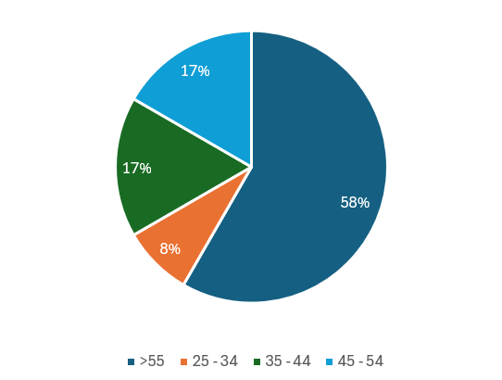
Figure 11 Age Distribution of Consumers respondents in Placencia
Snapper and barracuda were the most frequently consumed species, mentioned by 11 and 9 respondents, respectively. However, per capita consumption was higher for barracuda at 14.3 pounds per month, followed by jack at 11.5 pounds per month (Figure 12 and Table 10).
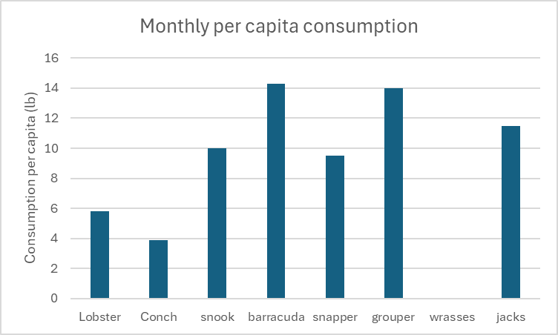
Figure 12 Monthly average per capita consumption in Placencia.
When analyzing finfish consumption, diverse patterns emerge regarding the number of consumers, individual consumption levels, and market prices (Table 5). Snappers emerge as the most popular choice, followed closely by barracudas. Interestingly, while snappers have a broader consumer base, barracudas exhibit higher per capita consumption (14 lb/month), which could be attributed to the relatively lower cost of barracudas compared to snappers. Groupers, though consumed by a smaller segment of the population (50%), demonstrate a high average consumption per individual (14 lb/month). This could be explained by their premium price, suggesting that those who can afford groupers tend to purchase larger quantities when available. Wrasses were not reported as being consumed by any of the respondents.
Table 10 Seafood Consumption Trends and Prices for Consumers in Placencia.
Specie | Number of consumers | Average consumed per month (lb) | Average purchase price ($)
Lobster | 7 | 6 | 27
Conch | 8 | 4 | 11
snook | 3 | 10 | 8
barracuda | 9 | 14 | 6
snapper | 11 | 10 | 8
grouper | 6 | 14 | 11
wrasses | 0 | 0 | 0
jacks | 6 | 12 | 7

When asked about species they would like to consume more often but are becoming scarce or difficult to find, snappers were mentioned most frequently (3 answers). Other species reported as scarce included mackerel jack, wahoo, and tuna. This scarcity in the market may indicate a decline in wild populations.
The Figure 13 illustrates the preferred sources for purchasing seafood among respondents. Direct purchases from fishers emerged as the most popular choice, followed by fishboards. Local markets also have significant preference, while restaurants and other sources were less frequently selected. This data suggests that consumers prioritize direct access to fresh seafood. Purchasing directly from fishers likely appeals to consumers due to the potential for higher quality, better traceability, and potentially stronger social connections with the fisher, facilitating access to their catch. Moreover, although restaurants play an important role in the value chain, they seem to be supplying the tourist market more than contributing to the consumption of local people.
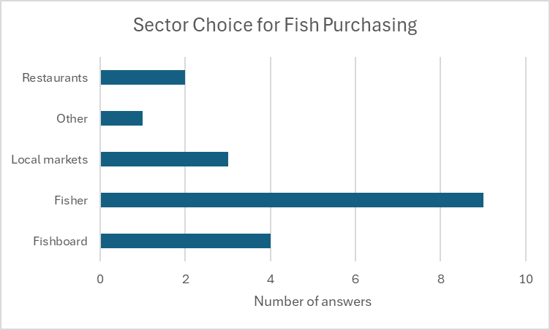
Figure 13 Consumer Preferences for Seafood Purchase Locations in Placencia
In Placencia, seafood constitutes an average of 37.5% of the monthly family food intake, with a median of 50%. However, this varies significantly, with some families consuming as little as 5% of seafood. On average, households spend BZ$127 (standard deviation: BZ$116) per month on seafood. This exhibits high variability, with some families spending as much as BZ$200 per month, while others report no seafood purchases due to either fishing for their own consumption or receiving seafood from relatives and friends.
When asked, "Would you be willing to pay a higher price for seafood if you knew it's more sustainable and supported the livelihood of small-scale fishers?", everybody answered "Yes," indicating a willingness to pay a premium for sustainable seafood that benefits small-scale fishers.
Most residents in Placencia were aware of the initiative to promote sustainable fishing practices. These included capacity building in alternative livelihoods, diversification efforts, and training programs conducted by organizations such as SEA, the Placencia Town Guide Association, Fragments of Hope, the Belize Tourism Industry Association (BTIA), and the Belize Tourism Board (BTB). Additionally, many were aware of coral restoration initiatives undertaken by local NGOs, notably Fragments of Hope. Furthermore, residents recognized that local fishers are mindful of the size of fish they bring ashore. Undersized and oversized fish are typically released back into the sea. There is a strong tradition of respecting larger fish, known locally as "aggers," which are believed to be crucial for maintaining healthy fish populations. Finally, avoiding the destruction of habitats like coral reefs and mangroves is widely acknowledged as a crucial aspect of sustainable fishing practices.

Academic and NGO
We obtained 9 responses from members of NGOs during the workshop in Placencia. Creole was the most common ethnic background among survey participants, with five individuals identifying as Creole (three females and two males). Mestizo was the second most common, with three individuals (one female and two males). While Creole was the most frequent background among females, it was equally common among males as Mestizo. Overall, Creole is the predominant ethnic background in the survey, particularly among females, while Mestizo is also a significant representation, especially among males.
A diverse range of roles represented among the respondents, including Site Coordinator, Executive Director, Educator, Project Manager, Board Chairman, and others. This diversity suggests a wide range of responsibilities and perspectives within the institutions. The specific role of a respondent is likely to significantly influence their responses to questions about interactions with fishers and wholesalers. For instance, Educators and Community/Stakeholder Engagement officers are likely to emphasize education and outreach programs, while Site Coordinators and Chairpersons may prioritize governance and decision-making processes. Conservation Planners and Vice Chairs might focus more on sustainable practices and conservation efforts. Roles like Executive Director and Board Chairman may have a broader strategic perspective, emphasizing compliance and overall institutional goals. Understanding these role-specific perspectives is crucial for a comprehensive understanding of the multifaceted interactions between institutions, fishers, and wholesalers.
The interaction of institutions with fishers varies significantly based on the primary role of the respondent within the institution. While training and education are common themes across all roles, highlighting a strong emphasis on capacity building and community engagement, the specific focus and depth of interaction differ. Roles like Site Coordinator and Chairperson demonstrate a greater involvement in governance and decision-making processes, suggesting a higher level of influence and responsibility. Conversely, roles such as Educator and Coordinator primarily focus on education and outreach, promoting sustainable fishing practices and engaging the community through various programs. This diverse range of interactions highlights the nuanced and multifaceted nature of institutional engagement with fishers, with each role contributing to the overall goal of sustainable fisheries management in unique and valuable ways.
The catch/production stage is the most frequent point in the value chain where organizations engage in research and management activities for all three species: Spiny lobster, Queen conch, and Fin fish. This is evident across all species, with seven occurrences observed for each. This finding indicates a strong emphasis on research and management efforts related to fishing practices, stock assessments, and sustainable harvest strategies. While the catch/production stage is crucial, further research and management efforts could also be beneficial in other stages of the value chain, such as consumption and distribution, to ensure the long-term sustainability of these fisheries.
Institutions employ diverse strategies to directly increase the income of small-scale fishers. WWF, Humana People to People, and the Toledo Institute for Development and Environment all focus on providing alternative livelihood options through initiatives like income diversification training, small business development support, and funding opportunities. Common strategies across these institutions include: 1) enhancing skills and knowledge through training and education programs; 2) promoting alternative livelihood options to diversify income sources; and 3) encouraging sustainable fishing practices to ensure the long-term viability and profitability of the fishery. These multifaceted approaches demonstrate a concerted effort to improve the economic well-being of small-scale fishers while promoting the sustainability of the marine ecosystem.
Table 11 Strategies employed by respondent institutions to increase the income of small-scale fishers and improve their livelihoods
ID | Gender | Name of your institution | What is your primary role in the institution | How have your programs directly increased the income of small-scale fishers and their families? | How would you measure changes in fishers' ability to meet their basic needs and invest in the future? Can you explain?
PLA 67 | Female | WWF | Conservation Planner | Through training and capacity building programs, consultation as part of outreach | No
PLA 69 | Male | Humana People to People | grant proposal writer | Seed to interact capacitation into communities in Toledo and Stann Creek district. Sustainable development, income livelihood sustainable activities | Based on their capacity initiatives to empower communities especially women, youth are vulnerable. Reducing poverty through community-led projects
PLA 13 | Female | Southern Environmental Association | Executive director
PLA 15 | Female | Ecumenical Junior College | Educator | Promote the sale of local foods using catch species in nov and culture Day activities (promoting Garifuna cuisine)
PLA 66 | Male | Humana People to People | Project manager | Provide funding for alternative livelihood. Training and businesses | Improvement in their ability to meet their basic needs after the alternative livelihood training and funding of new business
PLA 65 | Male | Toledo Institute for Development and Environment | protected area manager for terrestrial PAs | Through managed access program where only traditional fishers can fish the protected/fishing zones in the area | The diversification into tourism-related activities is a more sustainable way of using the fishery
Nadia | Female | WWF | Senior Program Manager | Early stage of alternative livelihood exploration | Early stage of analysis with plans to support in 2025
PLA 8 | Female | Youth arm / oceana wavemakers | Coordinator |  | More sustainable fishing practices
PLA 18 | Male | Southern Environmental Association (SEA) | Board Chairman | Our capacity building has encouraged best practices in our fishers

Overall, the table highlights a diverse range of strategies aimed at improving the livelihoods of small-scale fishers, including income diversification, skill development, sustainable fishing practices, and community education.

Value chain analysis
1. Percentage Contribution to GDP
This measures how much a specific sector contributes to the total Gross Domestic Product (GDP) of a country. It is calculated as:
Sector Contribution to GDP (%)=(Sector GDPNational GDP)×100\text{Sector Contribution to GDP (\%)} = \left( \frac{\text{Sector GDP}}{\text{National GDP}} \right) \times 100Sector Contribution to GDP (%)=(National GDPSector GDP​)×100
For example, if the fishery sector contributes 1% of Belize’s national GDP, it means the total economic output of the fishery sector accounts for 1% of the country’s overall GDP.

2. Value-Added Ratio
The value-added ratio focuses on how much value is created within the sector itself. It is the proportion of the sector's value-added (output minus intermediate inputs) to its total output (or gross revenue). The formula is:
Value-Added Ratio=Value Added in the SectorTotal Output of the Sector\text{Value-Added Ratio} = \frac{\text{Value Added in the Sector}}{\text{Total Output of the Sector}}Value-Added Ratio=Total Output of the SectorValue Added in the Sector​
- Value added represents the net contribution of the sector after subtracting costs of intermediate goods and services (inputs).
- A higher value-added ratio indicates that the sector relies less on external inputs and creates more value internally (e.g., through labor, capital, or innovation).

Relationship Between the Two
The percentage contribution to GDP is related to the sector's value-added, but they are not directly interchangeable:
- National GDP is based on value-added across all sectors.
  - Each sector’s contribution to GDP reflects its total value-added compared to other sectors in the economy.
  - For instance, a sector with high value-added but low total output may still contribute a small percentage to the GDP if other sectors are significantly larger.
- Value-Added Ratio is an efficiency metric within the sector.
  - It measures how efficiently a sector generates value from its total output.
  - Even if the fishery sector in Belize contributes 1% to the national GDP, its value-added ratio depends on how much value it creates relative to its inputs and total production.

Example
- Fishery Sector Contribution to GDP: 1%
- Fishery Sector Total Output: $100 million
- Fishery Sector Value-Added: $40 million
Here, the Value-Added Ratio would be:
Value-Added Ratio=Value AddedTotal Output=40100=0.4 (or 40%)\text{Value-Added Ratio} = \frac{\text{Value Added}}{\text{Total Output}} = \frac{40}{100} = 0.4 \text{ (or 40\%)}Value-Added Ratio=Total OutputValue Added​=10040​=0.4 (or 40%)
The sector's contribution to GDP (1%) reflects the relative size of its value-added compared to the overall economy, while the value-added ratio (40%) is a measure of how efficiently the sector adds value to its production.

Key Takeaway
- The percentage contribution to GDP tells you how much the sector contributes to the country's economy.
- The value-added ratio tells you how much of the sector's output is retained as value after accounting for intermediate inputs.
4o
Você disse:
can you obtain the most updated fishery statistics available from Belize to estimate the Value-added ratio? and give me the references
O ChatGPT disse:
ChatGPT
The value-added ratio of a sector represents the proportion of its output that contributes to the Gross Domestic Product (GDP) after accounting for intermediate inputs. In the context of Belize's fisheries sector, this ratio indicates the sector's direct contribution to the national economy.
According to the Inter-American Development Bank, the fisheries sector contributed nearly 2% to Belize's GDP in 2022.
Publicações do BID
Additionally, the Food and Agriculture Organization reported that the fisheries sector accounted for 3% of Belize's GDP in 2015.
FAO
These figures suggest that the value-added ratio of Belize's fisheries sector has ranged between 2% and 3% of the national GDP in recent years.
For more detailed and updated statistics, you may refer to the following sources:
- State of Belize Fisheries Report 2020: This report provides insights into the fisheries sector's contribution to the national economy.
Oceana Belize
- Belize - Fishery and Aquaculture Country Profiles: Offered by the Food and Agriculture Organization, this profile includes data on the fisheries sector's economic impact.
FAO
- Analysis of Agricultural and Fisheries Policies in Belize: Published by the Inter-American Development Bank, this document quantifies support and its relationship to greenhouse gas emissions in the fisheries sector.
Publicações do BID
These references should provide comprehensive information to estimate the value-added ratio of Belize's fisheries sector accurately.
Fontes
4o
Você disse:
1004
what means the Fishery Sector Total Output and the Fishery Sector Value-Added? how can I find those values?
O ChatGPT disse:
ChatGPT
Definitions:
- Fishery Sector Total Output:
  - This represents the total value of goods and services produced by the fisheries sector in a given period, typically within one year.
  - It includes intermediate outputs (goods and services used in production) and final outputs (goods and services sold to consumers or other sectors).
  - Example: Revenue generated by fish harvests, aquaculture, and seafood processing before subtracting costs.
- Fishery Sector Value-Added:
  - This represents the sector's contribution to the GDP, calculated as the total output minus the value of intermediate inputs (e.g., cost of fishing gear, fuel, and bait).
  - It reflects the net economic contribution of the fisheries sector, including wages, profits, and taxes.

How to Find These Values:
- Fishery Sector Total Output:
  - Look for gross revenue or gross output figures from government or industry reports.
  - Check national accounts, sector-specific surveys, or production statistics. For Belize, organizations like the Ministry of Agriculture, Fisheries, Forestry, and the Environment might publish such data.
- Fishery Sector Value-Added:
  - Look for GDP contributions reported by the national statistical office or international organizations like the FAO or the World Bank.
  - Use economic reports or input-output tables for the fisheries sector.
  - If the value-added isn't reported directly, you can estimate it using the formula: Value-Added=Total Output−Intermediate Inputs\text{Value-Added} = \text{Total Output} - \text{Intermediate Inputs}Value-Added=Total Output−Intermediate Inputs You will need data on the costs of inputs (e.g., labor, equipment, fuel).

Possible Sources for Belize:
- National Statistical Institute of Belize (SIB):
  - Publishes GDP reports, sectoral breakdowns, and economic statistics.
  - Website: SIB Belize
- Belize Fisheries Department:
  - Publishes annual reports on production, exports, and revenue.
  - Website: Fisheries Department Belize
- FAO Fishery and Aquaculture Statistics:
  - Offers country profiles, production statistics, and value-added data.
  - Website: FAO Fisheries Country Profile - Belize
- Inter-American Development Bank (IDB):
  - Sometimes provides in-depth analyses of Belize's fisheries and agriculture.
  - Example: Reports on value-added and policy impacts.
- Central Bank of Belize:
  - Produces economic and sector-specific reports that may include value-added contributions to GDP.

Example Estimation:
- If the Fishery Sector Total Output in Belize is $100 million and the Intermediate Inputs are $60 million: Value-Added=100−60=40 million USD.\text{Value-Added} = 100 - 60 = 40 \, \text{million USD.}Value-Added=100−60=40million USD. This $40 million would represent the fisheries sector's net contribution to the GDP.
By reviewing reports or databases from the sources mentioned, you can extract the necessary data to compute or verify these figures.

