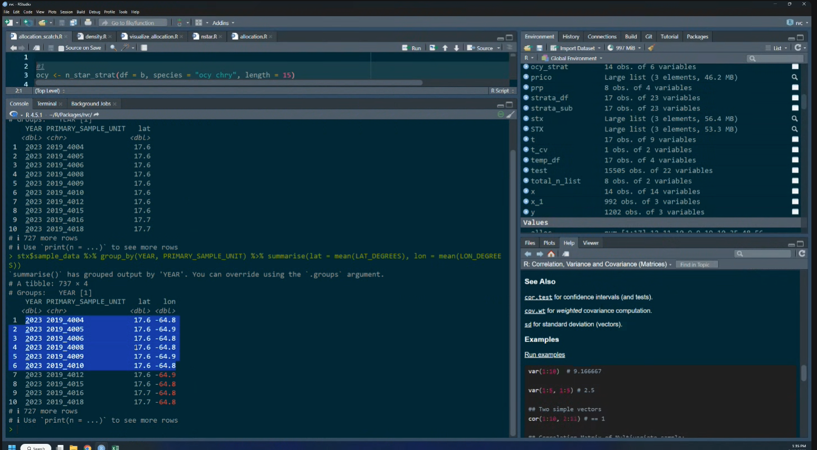

https://jeremiaheb.github.io/NCRMP_R_Fish_Package/downloading.html

