Documentation over the flipping book

Technologies
Javascript (Mainly), HTML5, CSS3

Idea
The flipping book is made in pure HTML5 using the canvas element. The canvas element basically provides everything that a 2D rendering environment can provide, such as rotations, scaling and matrix stack.

After observing the patterns of some real flipping magazines, we noticed that the image from the next page is flipped, rotated and cropped in the right way. Therefore after putting it on the paper, the goal became quite clear: Given an (x,y), find the rotation angle, the width and height to crop the image.

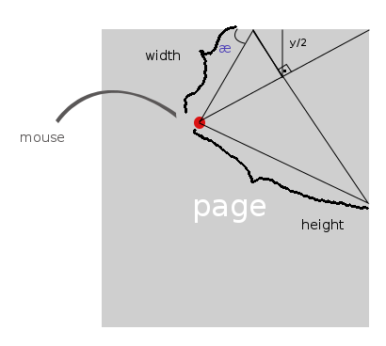
Implementation

As you can see in the image above, the æ (alpha) should be found. That can be done using straightforward math that we will explain only briefly.

Given a (x,y) pair, you can draw a straight line from the point until the edge of the paper. Doing so, you can calculate a middle point (x/2, y/2). With this middle point, a line perpedicular to the diagonal should be then set, reaching the upper part of your paper. But to find this line width, we first need to draw a line from this point reaching the above upper part. Doing so we get something that looks like the drawing now. Well, to calculate the other angles you should calculate the first upper triangle and so forth, until you get your æ. This will be your rotating angle.
After getting the angle you should as well calculate the total width and height of the cropped next image, and also the mirrored triangle that you get, that represents the page after the next one.

Using three main functions “draw”, “drawClipLeft” and “drawClipRight” we draw the two main images – the pages to read – and if the mouse has clicked I then call “drawClipLeft” or “drawClipRight” to flip them respectively. For listening for the clicks in the corner we set two hidden buttons on the right places that as clicked they switch a variable on. On the mouse move I check if this variable is on and call the functions.
For the animations on the arrow click, we used Lagrange polynomials to find the right intersecting polynomial. The final version of the polynomial is:

which depending on the direction should go from 0 until the witdth.

Conclusion
The project still has several bugs due to the lack of time and the tight deadline, but it should be definitely further developed. We could not find any other implementations in Javascript (only one made in flash). You can find this project under https://github.com/jolealdoneto/flipping-page available for the open-source comunity by the member José Leal Domingues Neto, that will try to continue it's development.

