Mosquito Repellent
Research Report: Consumer Sentiment & Brand Perception
Analysis Date: April 2026

Research Objectives
- Understand how mosquitoes disrupt sleep and what consumers do about it
- Map the product category landscape: coils, vaporizers, sprays, nets, electronic devices, natural remedies
- Identify which brands surface organically in consumer conversation
- Surface safety and health concerns around chemical repellents (DEET, transfluthrin, prallethrin), especially for children and babies
- Explore the natural vs chemical repellent tension and what drives consumer choice
- Identify unmet needs and product innovation opportunities
- Understand use context segmentation: indoor nighttime vs outdoor/hiking vs travel vs baby/child protection
- Assess how disease prevention (dengue, malaria) fear drives repellent purchase vs simple comfort/annoyance

Summary of Data and Findings
Items Analysed | 5,391
Insights Identified | 18
Net Sentiment Score | +29.5%
Brand Health Score | 68/100
Data Sources | 4 platforms

Data Universe

Collection Funnel
Of 88,194 raw data points collected across all sources, 10,243 remained after deduplication and engagement filtering, and 5,391 passed LLM relevance classification (6.1% of total collected). These 5,391 items form the analysis corpus.
Stage | Items | Notes
Raw collected | 88,194 | All posts, comments, articles and videos gathered across all platforms
After deduplication & engagement filter | 10,243 | Thread dedup (max 5 comments/thread), min engagement filters applied per platform
After relevance classification | 5,391 | LLM relevance filter — 6.1% of raw collected. Analysis corpus.

Platform Breakdown
Platform | Items | Share of Corpus
Twitter | 2699 | 50.1%
Youtube | 1357 | 25.2%
Reddit | 877 | 16.3%
Instagram | 458 | 8.5%
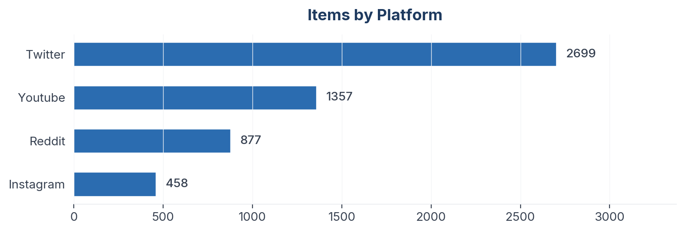
Figure 1: Item distribution by source platform

Collection Methodology
Data was collected using automated scrapers with engagement-weighted filtering applied per platform. Thread-level deduplication caps comments per thread to prevent over-indexing vocal threads. All items passed an LLM relevance classification step before analysis.

Sentiment & Emotion Analysis

Overall Sentiment Distribution
Net Sentiment Score (NSS): +29.5% | Positive: 2013 (37.3%) | Negative: 425 (7.9%) | Neutral: 2760 (51.2%)
NSS is computed as (positive - negative) / total items. Range: -1.0 (all negative) to +1.0 (all positive). Neutral and mixed items remain in the denominator, anchoring the score to the full corpus rather than just polarised items. A positive NSS indicates net favourable sentiment; a negative NSS indicates net unfavourable.
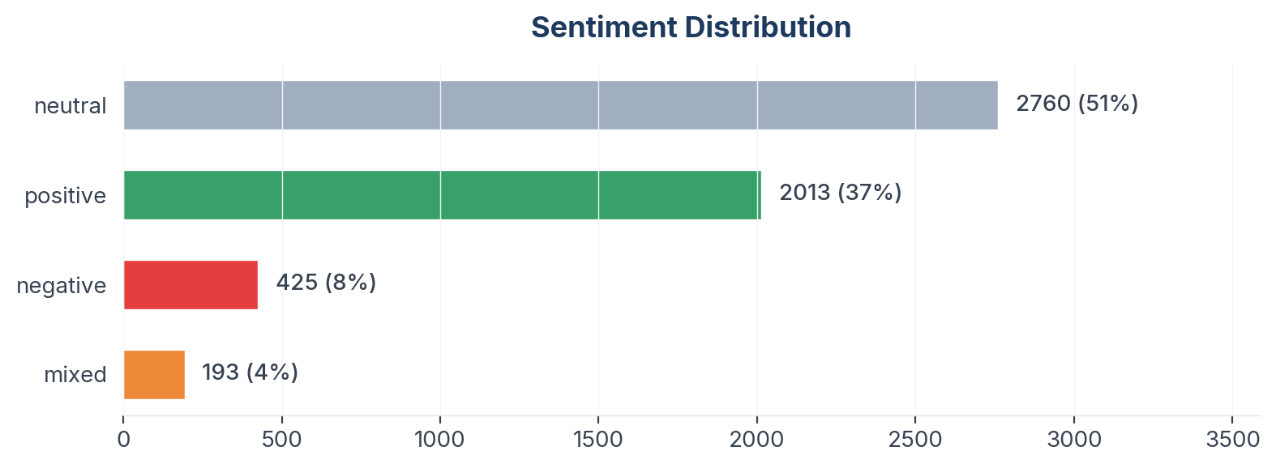
Figure 2: Sentiment distribution across 5,391 items

Emotion Profile (Plutchik 8-Emotion Model)
Emotion | Count
Neutral | 2962
Trust | 870
Joy | 682
Fear | 374
Sadness | 186
Anticipation | 146
Disgust | 82
Anger | 71
Surprise | 18
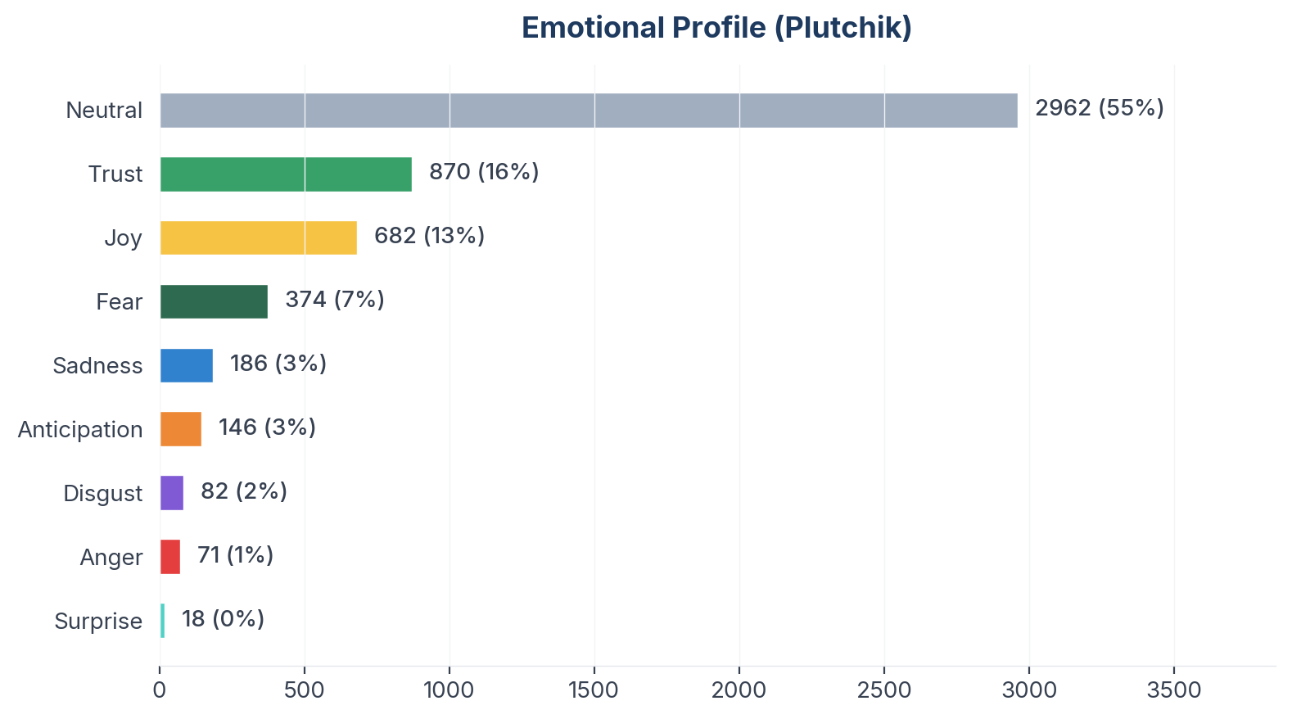
Figure 3: Plutchik emotion distribution

Aspect-Based Sentiment Analysis (ABSA)
Aspects with ≥10 mentions are shown below. NSS is statistically meaningful only at this threshold.
Figure 4: Aspect sentiment heatmap (aspects with ≥10 mentions)

Insight Landscape
18 insights were identified from 5,391 items using a two-pass extraction approach (stratified discovery sample + full-corpus mapping).
Insight | Items | Prevalence in Dataset | Signal Strength | Confidence Score | NSS
Sleep Disruption & Nighttime Misery | 1813 | 33.6% | 60% (Moderate) | 68% (Medium) | +33%
Product Efficacy & Disappointment | 1296 | 24.0% | 61% (Moderate) | 63% (Medium) | +51%
Natural & Herbal Remedies | 1013 | 18.8% | 64% (Moderate) | 64% (Medium) | +52%
Product Innovation & Wish List | 997 | 18.5% | 62% (Moderate) | 66% (Medium) | +49%
Mosquito Nets & Physical Barriers | 901 | 16.7% | 61% (Moderate) | 66% (Medium) | +49%
Electronic & Tech Solutions | 891 | 16.5% | 53% (Moderate) | 64% (Medium) | +44%
Outdoor & Travel Protection | 882 | 16.4% | 61% (Moderate) | 66% (Medium) | +60%
Vaporizers & Liquid Refills | 781 | 14.5% | 64% (Moderate) | 64% (Medium) | +53%
Baby & Child Protection | 725 | 13.4% | 56% (Moderate) | 64% (Medium) | +66%
Chemical Safety & Health Concerns | 678 | 12.6% | 62% (Moderate) | 63% (Medium) | +32%
Brand Perceptions & Comparisons | 614 | 11.4% | 61% (Moderate) | 61% (Medium) | +39%
Dengue & Disease Fear | 522 | 9.7% | 49% (Weak) | 56% (Medium) | +37%
Price & Value Perception | 518 | 9.6% | 58% (Moderate) | 64% (Medium) | +60%
Smell & Sensory Experience | 371 | 6.9% | 59% (Moderate) | 59% (Medium) | +49%
Coils & Traditional Methods | 274 | 5.1% | 47% (Weak) | 57% (Medium) | +42%
Humor, Memes & Shared Suffering | 117 | 2.2% | 29% (Weak) | 47% (Directional) | +11%
Climate, Seasons & Getting Worse | 61 | 1.1% | 24% (Trace) | 52% (Medium) | +16%
Public Health & Prevention Campaigns | 57 | 1.1% | 16% (Trace) | 49% (Directional) | +21%
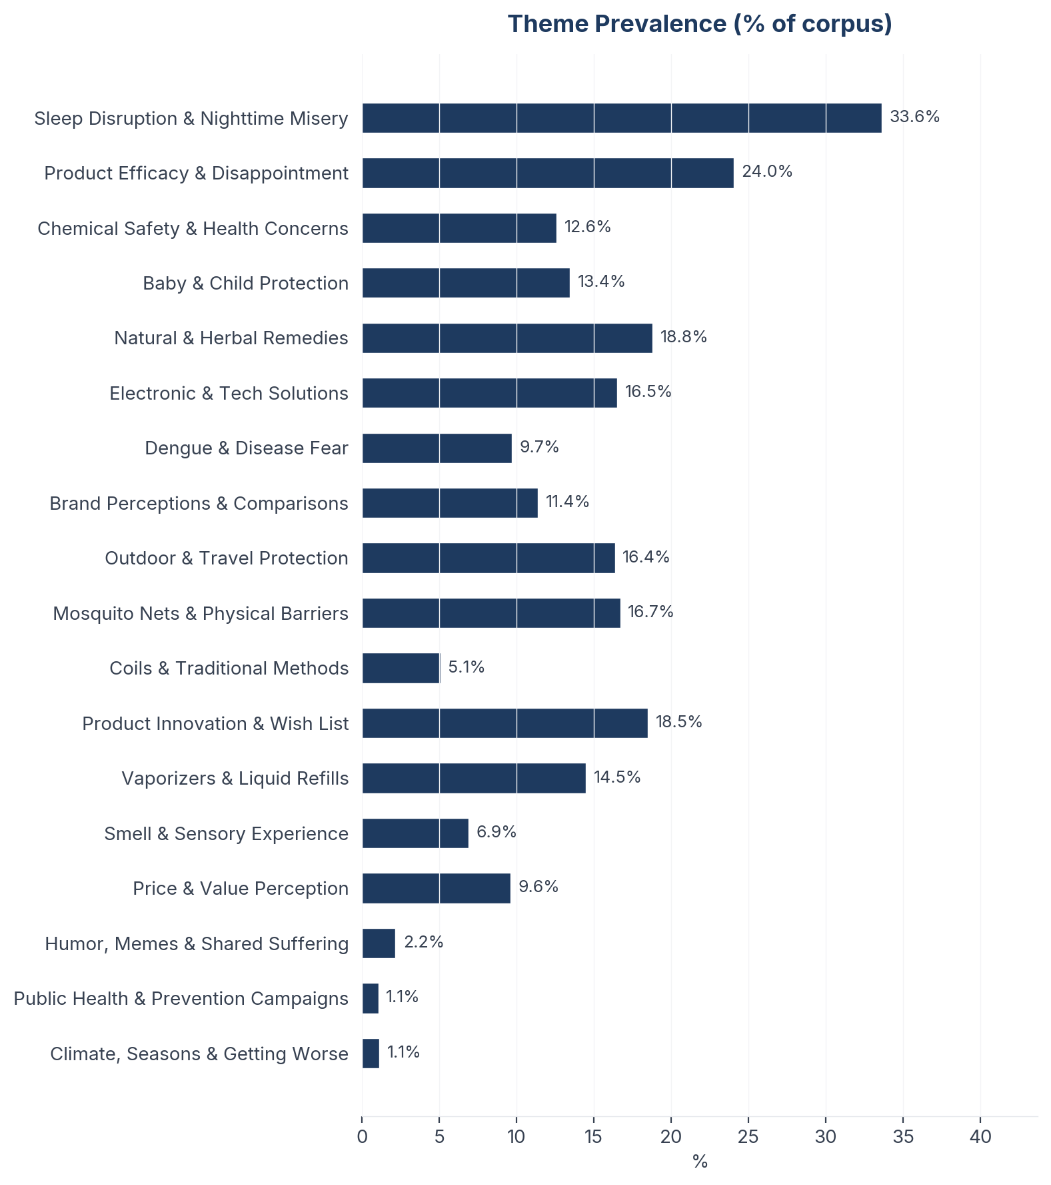
Figure 5: Insight prevalence (% of total corpus)

Insight Deep Dives
One insight per theme, ordered by confidence score. Each insight follows the framework: What the Data Shows, What it Means, Business Implication and Rationale, Recommendation, Further Validation.

01. Sleep Disruption & Nighttime Misery
n=1806 | Confidence: 68% (Medium) | Signal: 60% (Moderate) | 33.6% of Dataset | NSS: +33%
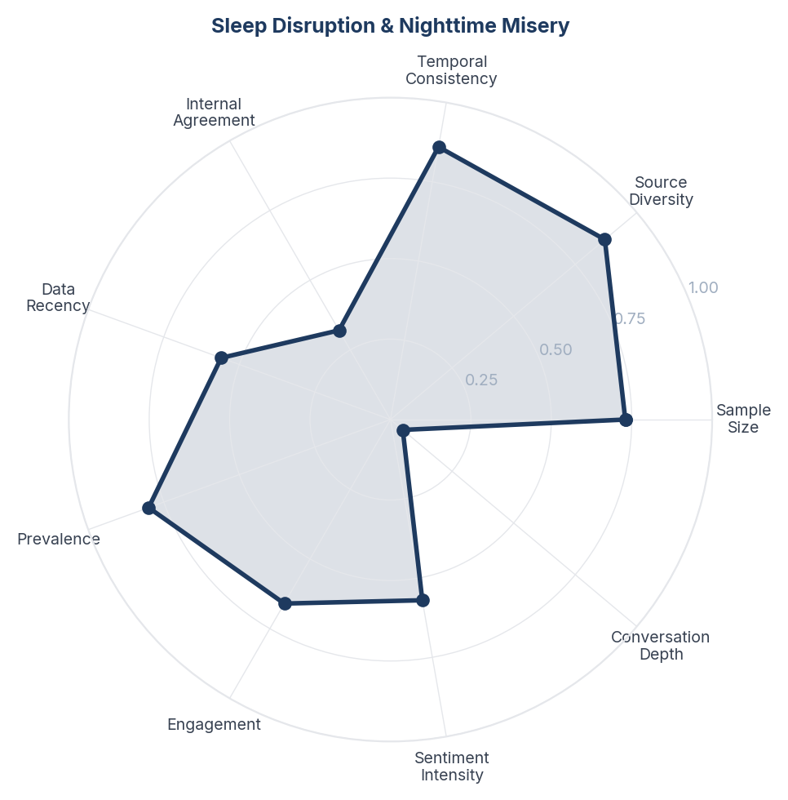
Score Breakdown: Sleep Disruption & Nighttime Misery

What the Data Shows
Sleep Disruption and Nighttime Misery spans 1,806 items (33.5% of corpus) with NSS +0.330. The single largest theme in the dataset. Consumers across all four platforms describe mosquitoes as a primary barrier to sleep quality, with emotional language ranging from frustration to helplessness. Power outages compound the problem in tropical markets where fans and electric repellents stop working.

What it Means
Mosquito protection is not primarily a pest control purchase - it is a sleep quality purchase. Consumers frame the problem in terms of lost sleep, exhaustion, and inability to function the next day. The emotional intensity of sleep disruption language far exceeds that of disease prevention language, suggesting that the immediate experiential pain of lost sleep outweighs the abstract fear of dengue or malaria for most consumers.

Business Implication & Rationale
Brands that position their products as sleep solutions rather than insect killers will capture a larger share of consumer intent. The sleep framing also opens premium pricing territory - consumers will pay more for guaranteed uninterrupted sleep than for generic pest control.

Recommendation
Reframe product marketing from 'kills mosquitoes' to 'protects your sleep'. Develop a sleep-quality guarantee or money-back claim. Consider co-branding or bundling with sleep wellness products (mattress brands, sleep apps). For tropical markets with unreliable power, prioritise battery-powered or passive solutions.

Further Validation
Commission a conjoint analysis testing willingness-to-pay under 'sleep protection' vs 'mosquito killer' positioning. Conduct sleep diary studies measuring actual sleep quality improvement with repellent use.

Representative Voices
"Sleep peacefully with all-round protection and a soothing fragrance. Keep your loved ones safe from mosquitoes-naturally and effortlessly.
Shop now [http://mosquitofurr.com]
Find us on Amazon & Flipkart! 🛒
#MosquitoProtection #FamilySafety #PeacefulSleep #HomeCareEssentials #FreshFragrance #Health" - instagram
"Tell the mosquitoes the dinner date is CANCELLED ✋
Because #Citronella is here serving “not today, not tomorrow, not ever” energy. Fresh, lemony, and actually effective, it’s the easiest way to protect your skin, your home, and your vibe ✨
Whether you’re chilling on the balcony or taking that pos" - instagram
"Mosquitoes Out, Good Vibes In! ✨🦟 Say hello to the 2-in-1 solution for your home: QUITTMOZZ!
Why settle for just repelling when you can refresh too? QUITT MOZZ gives you powerful, 360-hour protection from Dengue AND fills your space with a beautiful, natural fragrance.
Pick your perfect scent:
🍋 L" - instagram

02. Product Innovation & Wish List
n=986 | Confidence: 66% (Medium) | Signal: 62% (Moderate) | 18.5% of Dataset | NSS: +49%
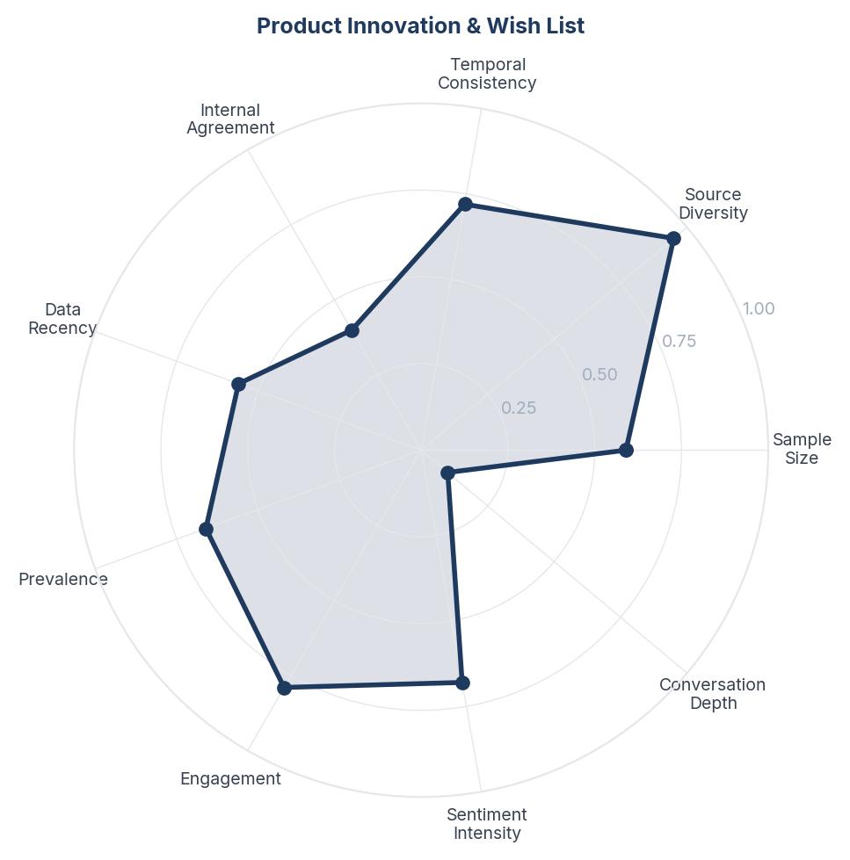
Score Breakdown: Product Innovation & Wish List

What the Data Shows
Product Innovation and Wish List spans 986 items (18.3%) with NSS +0.494. Consumers express unmet needs including: all-night protection that does not require refills, solutions for large outdoor spaces, products safe enough to apply on babies, repellents that do not stain clothes, and wearable devices that actually work.

What it Means
The innovation conversation reveals that consumers see the category as stagnant. The most common wish-list items - longer duration, no refills, genuinely safe for babies, no staining, no smell - are basic product quality improvements rather than revolutionary innovations. This suggests that existing products fail on fundamental attributes, creating opportunity for brands willing to solve obvious problems.

Business Implication & Rationale
The category has been competing on price and distribution rather than product quality. A brand that systematically addresses the top 5 consumer complaints (short duration, frequent refills, chemical concerns, smell, staining) would create significant differentiation in a commoditised market.

Recommendation
Prioritise R&D investment in: (1) extended-duration formulations (8+ hours, no midnight refill), (2) genuinely odourless or pleasant-scented products, (3) non-staining formulations, (4) paediatrician-certified baby-safe range. Each solved complaint becomes a marketing message.

Further Validation
Run a MaxDiff or conjoint study on the relative importance of innovation attributes (duration, smell, safety, staining, price) to prioritise R&D investment.

Representative Voices
"Nature’s better when you’re not swatting through it. 🌿 Turn on Thermacell and take it all in.⁠
⁠
Learn more at thermacellrepellents.com.au⁠
.⁠
.⁠
#thermacellaustralia #mosquito #mosquitos #mosquitorepellent #greatoutdoors #outdoorlifestyle #outdoorplay #outdoorslife #insectrepellent #mozzie #mosquit" - instagram
"Transform your home with Mesh India’s Pleated Mesh Doors - where comfort meets protection. ✨🚪 Enjoy uninterrupted airflow, clear visibility, and strong mosquito protection, all while adding a modern touch to your doors and balconies. Designed to be durable, smooth to operate, and cost-efficient, our" - instagram
"EARTH:"MY MOM IS KINDA HOMELESS I LIVE WITH MY DAD I WANT TO HELP HER"MOON/LUNA:"speed I'm watching your street right now why you not trying to laugh bro that's disrespectful as shit"" - youtube

03. Outdoor & Travel Protection
n=866 | Confidence: 66% (Medium) | Signal: 61% (Moderate) | 16.4% of Dataset | NSS: +60%
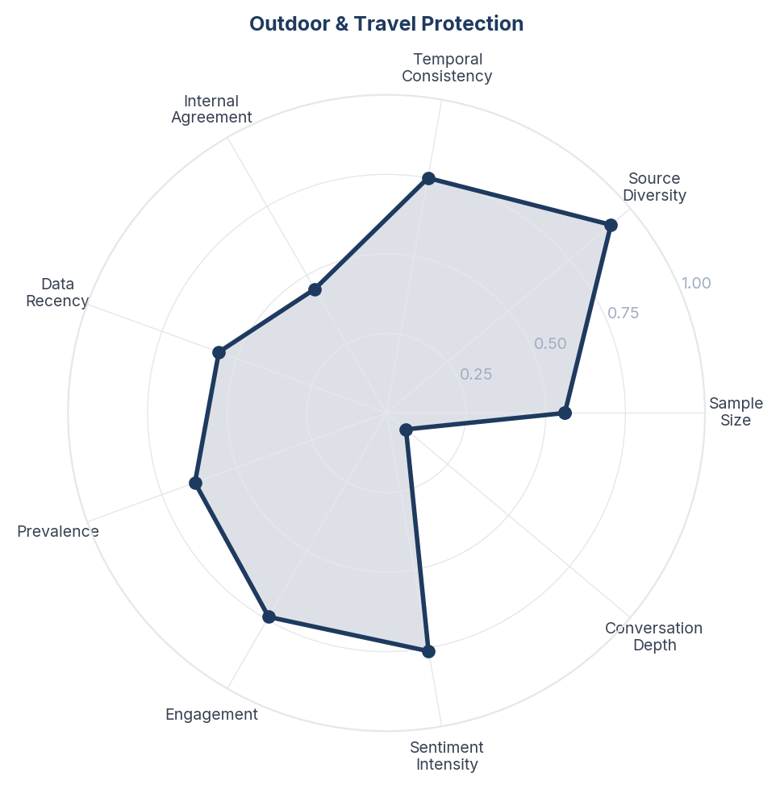
Score Breakdown: Outdoor & Travel Protection

What the Data Shows
Outdoor and Travel Protection spans 866 items (16.1%) with NSS +0.607. Hiking, camping, travel, garden, and patio use cases are discussed. DEET-based sprays and Thermacell devices dominate the outdoor segment. Travellers to tropical destinations show the highest urgency.

What it Means
The outdoor segment has fundamentally different needs from the indoor segment - portability, duration, and water resistance matter more than being chemical-free or quiet. Outdoor consumers are also more willing to accept DEET because the perceived risk of disease in tropical travel outweighs chemical safety concerns. This is the one context where disease prevention genuinely drives purchase behaviour.

Business Implication & Rationale
Outdoor and indoor mosquito protection are effectively separate markets that happen to share a category name. A one-size-fits-all product strategy will underserve both. The outdoor segment offers higher margins (travellers are less price-sensitive) and stronger efficacy demands.

Recommendation
Develop distinct product lines for indoor (bedroom-optimised, quiet, chemical-free options) and outdoor (portable, long-lasting, high-efficacy) use cases. For outdoor, partner with travel and outdoor retail channels. For tropical travel, create travel-sized kits with multiple application methods.

Further Validation
Map the purchase journey for outdoor vs indoor use cases to identify different decision points, channels, and price sensitivity.

Representative Voices
"Nature’s better when you’re not swatting through it. 🌿 Turn on Thermacell and take it all in.⁠
⁠
Learn more at thermacellrepellents.com.au⁠
.⁠
.⁠
#thermacellaustralia #mosquito #mosquitos #mosquitorepellent #greatoutdoors #outdoorlifestyle #outdoorplay #outdoorslife #insectrepellent #mozzie #mosquit" - instagram
"Day 1’s happy winners 🎉🎅🎄
#13DaysOfChristmas #EntriesOpen #WinWithUs #SupportLocal #ShopLocal #FestiveFun #notjustahardwareshop #notjustahardwarestore #gardeningsupplies #painttinting #insectrepellent #hardware #localfamilyowned #localfamilyownedbusiness #localfamilyownedandoperated #localfamilybus" - instagram
"Dome Hanging Mosquito Net 🏕️🦟
Protect your sleeping area from mosquitoes in style! This dome-shaped hanging mosquito net is easy to set up, spacious, and perfect for bedrooms, camping, or outdoor use. Enjoy a peaceful, insect-free night anywhere.
#MosquitoProtection #DomeMosquitoNet #BugFreeSleep #" - instagram

04. Mosquito Nets & Physical Barriers
n=901 | Confidence: 66% (Medium) | Signal: 61% (Moderate) | 16.7% of Dataset | NSS: +49%
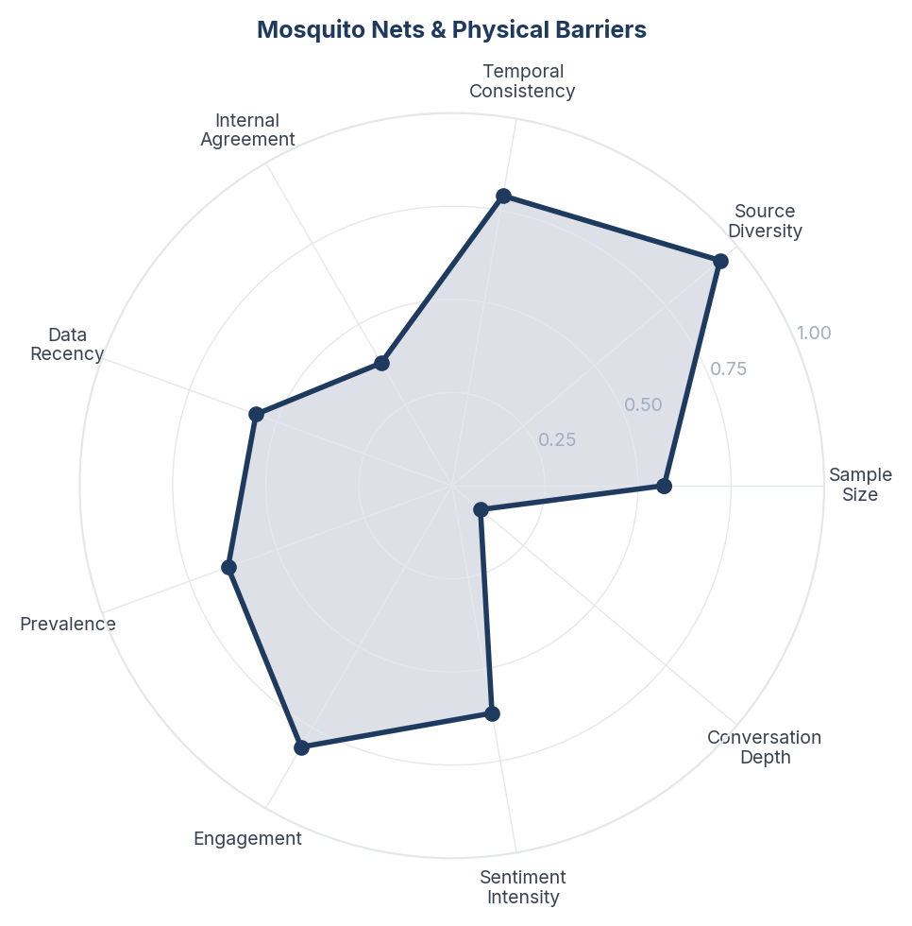
Score Breakdown: Mosquito Nets & Physical Barriers

What the Data Shows
Mosquito Nets and Physical Barriers spans 901 items (16.7%) with NSS +0.486. Bed nets, window screens, foldable baby nets, and DIY mesh solutions are widely discussed. YouTube drives most of this content through product reviews and installation guides.

What it Means
Physical barriers remain the most trusted form of mosquito protection because they are visible, chemical-free, and perceived as 100% effective within their coverage area. The popularity of nets reflects a consumer preference for certainty over probability - a net guarantees no bites within its enclosure, while sprays and vaporizers offer probabilistic protection. This certainty preference is strongest among parents.

Business Implication & Rationale
Physical barriers and chemical/electronic repellents are complementary, not competing. A layered protection strategy (net + vaporizer, screen + spray) matches how consumers actually behave. Brands that sell single-method solutions are leaving money on the table.

Recommendation
Develop bundled protection packages: bed net + nighttime vaporizer, window screen + outdoor spray. Position layered protection as the gold standard rather than competing on single products. For baby products, a net + natural repellent bundle addresses both the certainty need and the chemical-free need.

Further Validation
Survey consumers on current layered protection behaviour and willingness to buy pre-bundled multi-method solutions.

Representative Voices
"Transform your home with Mesh India’s Pleated Mesh Doors - where comfort meets protection. ✨🚪 Enjoy uninterrupted airflow, clear visibility, and strong mosquito protection, all while adding a modern touch to your doors and balconies. Designed to be durable, smooth to operate, and cost-efficient, our" - instagram
"Dome Hanging Mosquito Net 🏕️🦟
Protect your sleeping area from mosquitoes in style! This dome-shaped hanging mosquito net is easy to set up, spacious, and perfect for bedrooms, camping, or outdoor use. Enjoy a peaceful, insect-free night anywhere.
#MosquitoProtection #DomeMosquitoNet #BugFreeSleep #" - instagram
"@riousprincess ·̩͙𓈒♡ᜓིྀ ܸ. .ܸ ྀི১ aaash los mosquitos son de lo peor 😭 intentas dormir y de repente un zumbido justo en la oreja 💔💔" - twitter

05. Natural & Herbal Remedies
n=1007 | Confidence: 64% (Medium) | Signal: 64% (Moderate) | 18.8% of Dataset | NSS: +52%
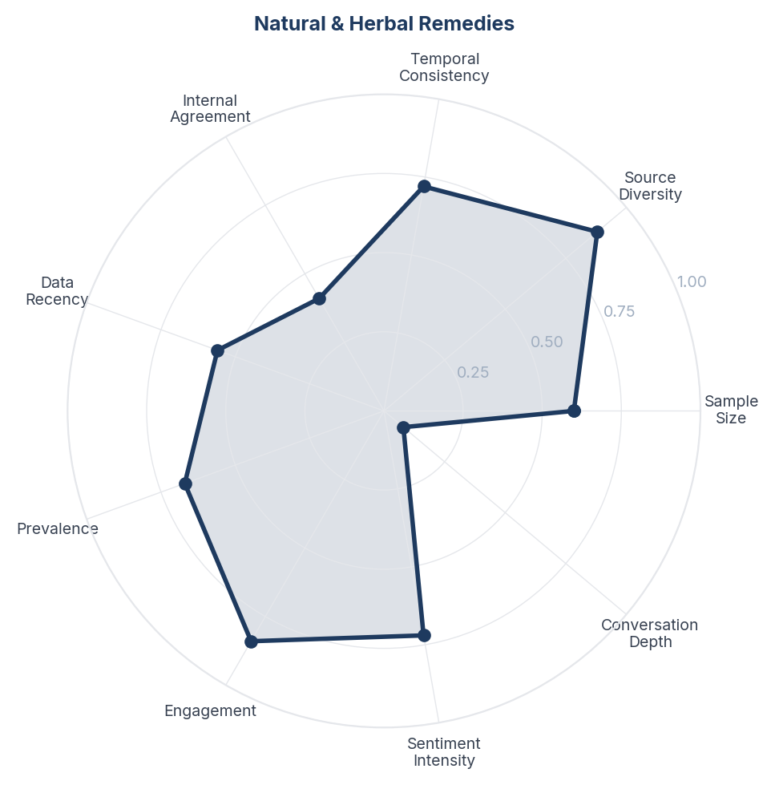
Score Breakdown: Natural & Herbal Remedies

What the Data Shows
Natural and Herbal Remedies spans 1,007 items (18.7%) with NSS +0.517. The second-largest theme after sleep disruption. Consumers actively share and discuss neem, citronella, eucalyptus, lemongrass, camphor, clove, and lime-based DIY repellents. YouTube and Instagram are primary platforms for natural remedy content.

What it Means
The natural remedies conversation reveals a massive trust gap in the chemical repellent market. Consumers are not choosing natural alternatives because they are more effective - they are choosing them because they do not trust the safety of chemical products. The DIY culture around natural repellents also signals a desire for control and transparency that packaged products fail to deliver.

Business Implication & Rationale
The natural segment is growing but underserved by major brands. Consumers currently rely on home remedies and small D2C brands. There is a significant market opportunity for a mainstream brand to launch a credible natural product line that combines the perceived safety of natural ingredients with the proven efficacy of modern formulations.

Recommendation
Develop a plant-based product line with scientifically validated natural ingredients (PMD/citriodiol, citronella, neem). Position with transparent ingredient lists and 'what is NOT in this product' messaging. Target the DIY natural remedy audience on YouTube and Instagram with educational content.

Further Validation
Test consumer preference between natural-branded products and traditional chemical products at equal price points. Measure whether 'plant-based' labelling increases trial among chemical-averse consumers.

Representative Voices
"Sleep peacefully with all-round protection and a soothing fragrance. Keep your loved ones safe from mosquitoes-naturally and effortlessly.
Shop now [http://mosquitofurr.com]
Find us on Amazon & Flipkart! 🛒
#MosquitoProtection #FamilySafety #PeacefulSleep #HomeCareEssentials #FreshFragrance #Health" - instagram
"Tell the mosquitoes the dinner date is CANCELLED ✋
Because #Citronella is here serving “not today, not tomorrow, not ever” energy. Fresh, lemony, and actually effective, it’s the easiest way to protect your skin, your home, and your vibe ✨
Whether you’re chilling on the balcony or taking that pos" - instagram
"Mosquitoes Out, Good Vibes In! ✨🦟 Say hello to the 2-in-1 solution for your home: QUITTMOZZ!
Why settle for just repelling when you can refresh too? QUITT MOZZ gives you powerful, 360-hour protection from Dengue AND fills your space with a beautiful, natural fragrance.
Pick your perfect scent:
🍋 L" - instagram

06. Vaporizers & Liquid Refills
n=781 | Confidence: 64% (Medium) | Signal: 64% (Moderate) | 14.5% of Dataset | NSS: +53%
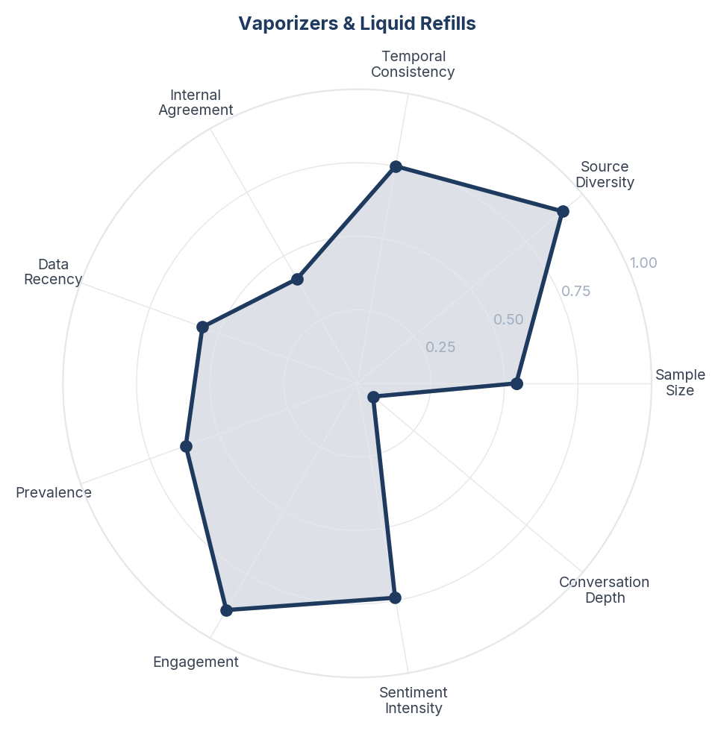
Score Breakdown: Vaporizers & Liquid Refills

What the Data Shows
Vaporizers and Liquid Refills spans 781 items (14.5%) with NSS +0.529. Electric liquid vaporizers are the most discussed product format for indoor use. Refill frequency, refill cost, and compatibility between devices and refills are common concerns.

What it Means
The vaporizer market operates on a razor-and-blade model where the device is cheap but refill revenue is the real margin driver. Consumers are acutely aware of this and express frustration about refill costs, brand lock-in, and refill duration claims that do not match reality. The refill experience is the primary source of brand dissatisfaction in the indoor segment.

Business Implication & Rationale
Refill economics are a double-edged sword: they generate recurring revenue but also generate recurring friction. A brand that offers genuinely longer-lasting refills or a more transparent refill pricing model could win significant market share from frustrated consumers.

Recommendation
Extend refill duration meaningfully (not just on the label). Consider a subscription refill model with automatic delivery. Introduce a universal-fit refill that works across multiple device brands to capture frustrated consumers locked into competitors' ecosystems.

Further Validation
Survey vaporizer users on refill satisfaction, frequency of repurchase, and willingness to switch brands for longer-lasting or cheaper refills.

Representative Voices
"mosquitos de mierds dejenme de picar estoy harto 😭 matense todos" - twitter
"Keep your home safe, protected, and mosquito-free-day and night.
With Mosgo Mosquito Repellent Lotion, enjoy up to 12 hours of long-lasting protection against Dengue and Malaria-carrying mosquitoes.
Safe for the whole family, gentle on skin, and strong where it matters.
Mosgo - Your Home’s 12-Hour S" - instagram
"Stuck Pipes? Not Anymore. 🛑
Say goodbye to standing water! Wonder Clean Drain Max powers through grease, hair, and dirt in seconds. Don’t let a clog slow you down-get the flow back instantly.
For more information:
Swami Kedar International Private Limited
📍 Imadol, Lalitpur, Nepal
📞 +977 981-2735" - instagram

07. Baby & Child Protection
n=725 | Confidence: 64% (Medium) | Signal: 56% (Moderate) | 13.4% of Dataset | NSS: +66%
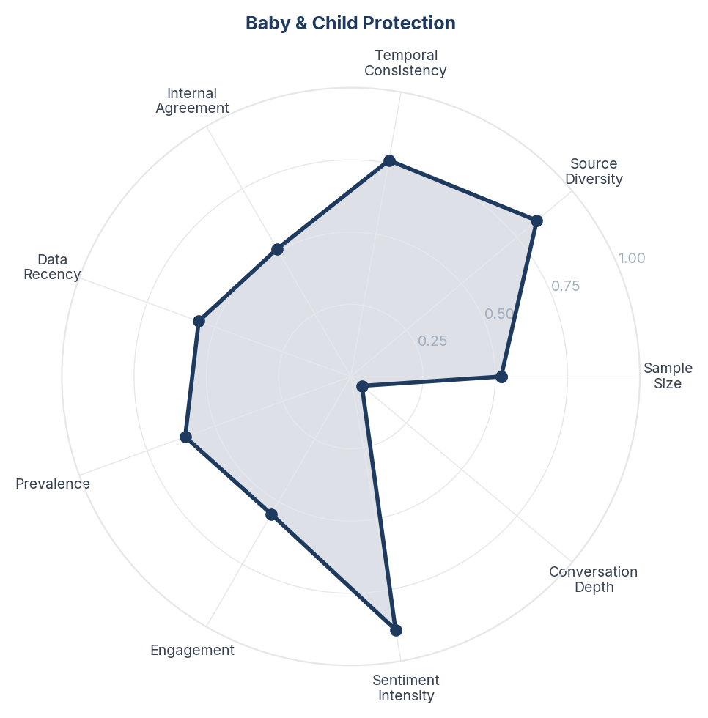
Score Breakdown: Baby & Child Protection

What the Data Shows
Baby and Child Protection spans 725 items (13.4%) with NSS +0.658. Parents are actively seeking mosquito protection specifically designed for babies and young children. Mosquito nets for cribs, DEET-free formulations, and natural alternatives dominate the conversation. Disease fear (dengue, malaria) is more prominent here than in the general corpus.

What it Means
The baby and child segment represents the category's highest-intent, most brand-loyal customer base. Parents researching child-safe repellents are willing to pay premium prices and are less price-sensitive than general consumers. However, they demand absolute safety assurance - a single negative review about a product being unsafe for babies can destroy trust across an entire product line.

Business Implication & Rationale
A dedicated child-safe product range with paediatric endorsement could command significant premium pricing and build multi-year brand loyalty as children grow. This segment also serves as a gateway to the household - parents who trust a brand for their baby will trust it for the whole family.

Recommendation
Launch a dedicated child-safe range with paediatrician endorsement and clear age-grading (newborn, 6m+, 2y+). Use transparent DEET-free formulations. Invest in hospital and clinic sampling programmes. Build a parent community around mosquito protection education.

Further Validation
Survey parents on willingness-to-pay for paediatrician-endorsed repellents. Test hospital sampling programme effectiveness in building trial and loyalty.

Representative Voices
"From banning #childmarriage to deploying disease-reducing mosquitoes, discover 10 positive changes and outcomes for children in 2025: https://t.co/QblOaEVvZs @save_children https://t.co/PXGumXWcfv" - twitter
"Cliganic
Mosquito Repellent Adventure Patches 90 Patches
MVR 350
Description
🌿Easy Peel & Stick
🌿Great for Outdoors
🌿Active Ingredients Derived From Plants
🌿Contains No Registered Pesticides
🌿Keeps Mosquitos Away
🌿Suitable for Kids and Adults
🌿Cruelty Free
🌿Essential oils helps keep mosquitos aw" - instagram
"Aiwibi Baby Mosquito Repellent Patches offer safe and effective protection for your little one. Hypoallergenic and DEET-free, these patches are formulated with natural plant extracts that emit a pleasant scent to repel mosquitoes. With instant effectiveness up to 6 hours, they are dermatologically t" - instagram

08. Electronic & Tech Solutions
n=891 | Confidence: 64% (Medium) | Signal: 53% (Moderate) | 16.5% of Dataset | NSS: +44%
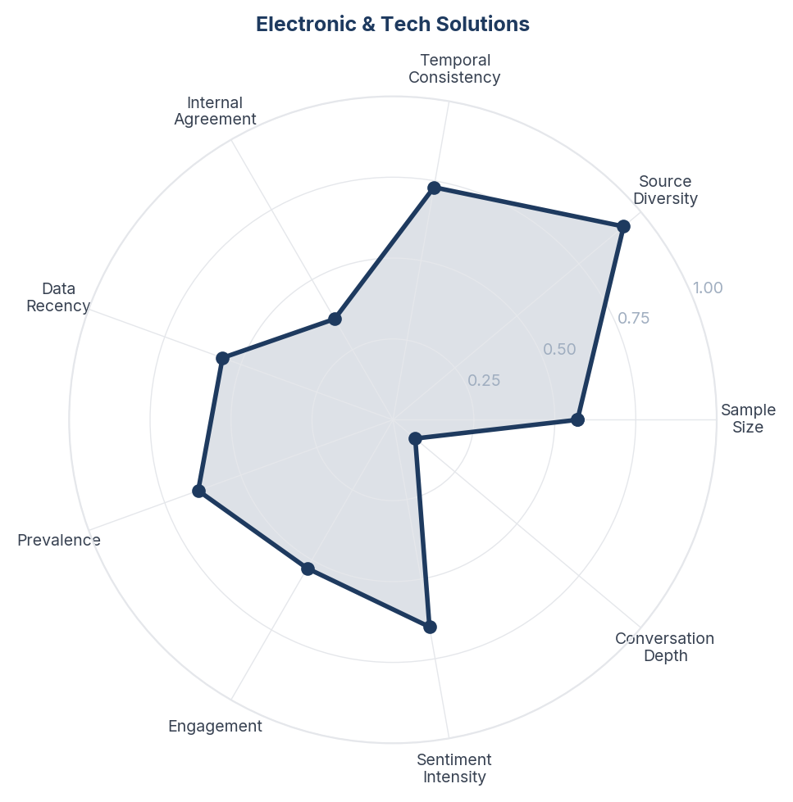
Score Breakdown: Electronic & Tech Solutions

What the Data Shows
Electronic and Tech Solutions spans 891 items (16.5%) with NSS +0.435. UV lamps, electric rackets, ultrasonic devices, and smart mosquito killers are widely discussed. YouTube product reviews drive this conversation. Consumers are intrigued by the chemical-free promise but sceptical of efficacy, especially for ultrasonic devices.

What it Means
Electronic mosquito solutions are the category's fastest-growing segment by consumer interest, driven by the dual appeal of being chemical-free and visually satisfying (the 'zap' factor). However, the segment is plagued by low-quality products and dubious efficacy claims, particularly from ultrasonic devices that multiple Reddit users call 'complete scams'. The gap between consumer interest and product quality represents both a risk and an opportunity.

Business Implication & Rationale
A trusted brand entering the electronic segment with genuinely effective, well-designed products could dominate a space currently filled with generic imports. The 'chemical-free' positioning of electronic solutions directly addresses the safety concerns identified in Theme 3.

Recommendation
If entering the electronic segment, focus on UV trap + fan combination (proven effective) rather than ultrasonic (unproven). Design for the bedroom use case (quiet, no blue light, automatic). Build credibility through transparent efficacy data and money-back guarantees.

Further Validation
Conduct comparative efficacy testing of electronic vs chemical solutions in controlled bedroom environments. Survey consumer willingness-to-pay for a branded electronic solution vs generic imports.

Representative Voices
"Tell the mosquitoes the dinner date is CANCELLED ✋
Because #Citronella is here serving “not today, not tomorrow, not ever” energy. Fresh, lemony, and actually effective, it’s the easiest way to protect your skin, your home, and your vibe ✨
Whether you’re chilling on the balcony or taking that pos" - instagram
"Transform your home with Mesh India’s Pleated Mesh Doors - where comfort meets protection. ✨🚪 Enjoy uninterrupted airflow, clear visibility, and strong mosquito protection, all while adding a modern touch to your doors and balconies. Designed to be durable, smooth to operate, and cost-efficient, our" - instagram
"Mosquitoes Out, Good Vibes In! ✨🦟 Say hello to the 2-in-1 solution for your home: QUITTMOZZ!
Why settle for just repelling when you can refresh too? QUITT MOZZ gives you powerful, 360-hour protection from Dengue AND fills your space with a beautiful, natural fragrance.
Pick your perfect scent:
🍋 L" - instagram

09. Price & Value Perception
n=518 | Confidence: 64% (Medium) | Signal: 58% (Moderate) | 9.6% of Dataset | NSS: +60%
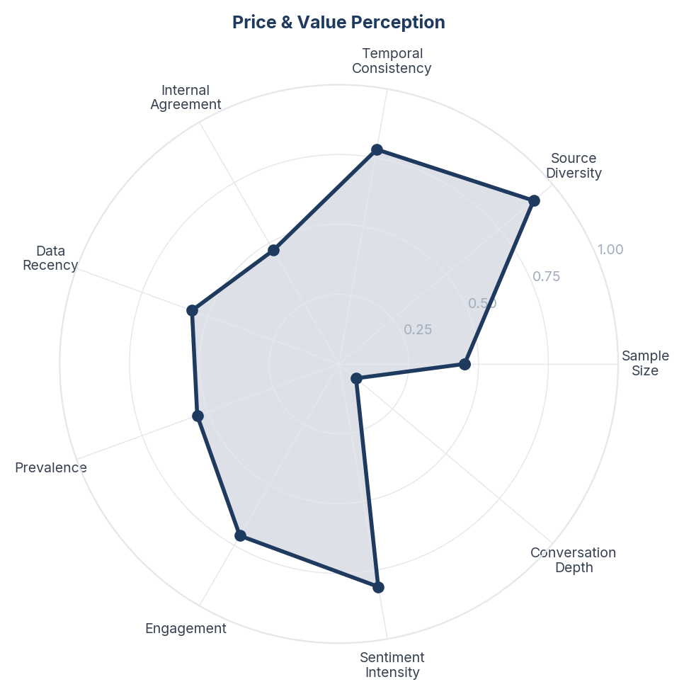
Score Breakdown: Price & Value Perception

What the Data Shows
Price and Value Perception spans 518 items (9.6%) with NSS +0.600. Consumers discuss product pricing, refill costs, value for money, and budget alternatives. The positive NSS suggests that many consumers find acceptable value, but a significant minority feels products are overpriced relative to their performance.

What it Means
Price sensitivity in this category is not uniform - it varies dramatically by use context. Indoor vaporizer refills face intense price scrutiny (daily recurring cost), while travel and outdoor sprays face almost none (one-off, high-urgency purchase). Baby products occupy a middle ground where parents accept premium pricing but expect correspondingly higher quality and safety standards.

Business Implication & Rationale
A single pricing strategy across all product formats and use cases will leave money on the table in some segments and lose share in others. The refill business needs to compete on perceived value-per-night, while outdoor and baby products can command significant premiums.

Recommendation
Implement segment-specific pricing: aggressive value positioning for indoor refills (emphasise cost-per-night), premium pricing for baby-safe and outdoor ranges (emphasise efficacy and safety). Consider a 'good-better-best' product tier strategy within each format.

Further Validation
Run a price sensitivity study (Van Westendorp or Gabor-Granger) segmented by use case and product format.

Representative Voices
"Transform your home with Mesh India’s Pleated Mesh Doors - where comfort meets protection. ✨🚪 Enjoy uninterrupted airflow, clear visibility, and strong mosquito protection, all while adding a modern touch to your doors and balconies. Designed to be durable, smooth to operate, and cost-efficient, our" - instagram
"Mosquitoes Out, Good Vibes In! ✨🦟 Say hello to the 2-in-1 solution for your home: QUITTMOZZ!
Why settle for just repelling when you can refresh too? QUITT MOZZ gives you powerful, 360-hour protection from Dengue AND fills your space with a beautiful, natural fragrance.
Pick your perfect scent:
🍋 L" - instagram
"Unless the Dems are gonna go to the front or they're putting up factories that produce more Ukrainians, it doesn't matter how many weapons and and funds are sent, they don't have the manpower, that's what's fueling this collapse and there is no remedy in sight. European elites don't have the support" - reddit

10. Chemical Safety & Health Concerns
n=678 | Confidence: 63% (Medium) | Signal: 62% (Moderate) | 12.6% of Dataset | NSS: +32%
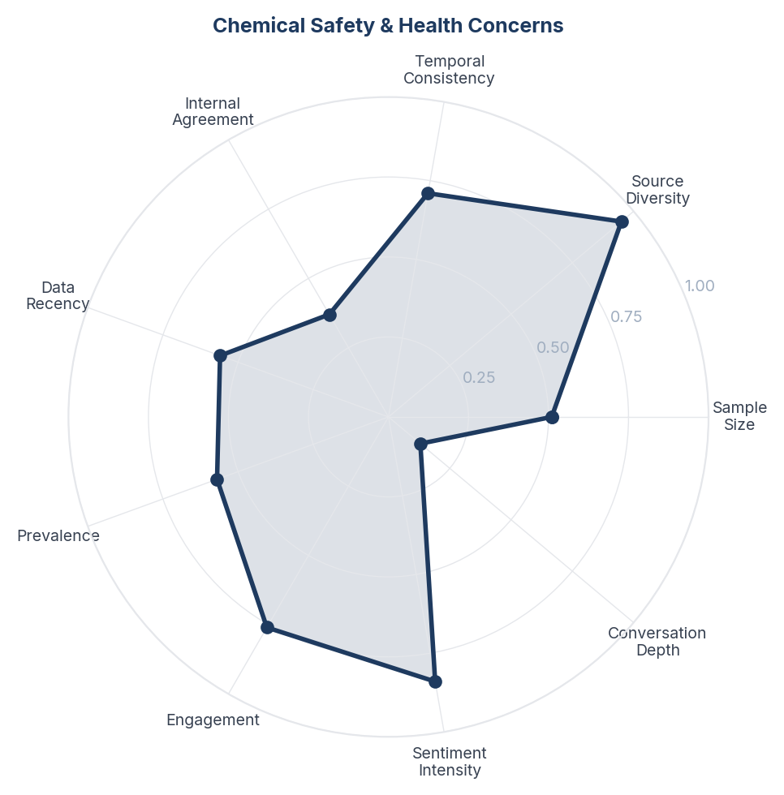
Score Breakdown: Chemical Safety & Health Concerns

What the Data Shows
Chemical Safety and Health Concerns spans 678 items (12.6%) with NSS +0.320. This is the most sentiment-polarised theme - consumers split between those who accept chemical repellents as necessary and those who fear health consequences from DEET, transfluthrin, and prallethrin exposure. Breathing difficulties, headaches, and cancer fears are cited.

What it Means
Safety anxiety is the category's biggest growth barrier. Consumers who worry about chemical exposure often abandon repellents entirely rather than switching to alternatives, leaving themselves unprotected. The fear is particularly acute among parents, who face a painful trade-off between protecting children from mosquito-borne disease and exposing them to chemical fumes. This is not a rational risk calculation - it is an emotional response driven by unfamiliarity with ingredient safety data.

Business Implication & Rationale
The category needs proactive safety communication, not silence. Brands that fail to address chemical safety concerns lose consumers to inaction (no protection at all) rather than to competitors. The opportunity is in transparent ingredient communication and certified-safe product lines.

Recommendation
Create transparent ingredient safety pages with third-party certifications. Develop and prominently market a 'safe for enclosed spaces' product line. Partner with paediatricians and health organisations for endorsements. Use clear, jargon-free safety labelling.

Further Validation
Conduct a quantitative survey on chemical safety perceptions and their impact on purchase behaviour. Test whether safety certification labels increase purchase intent.

Representative Voices
"Tell the mosquitoes the dinner date is CANCELLED ✋
Because #Citronella is here serving “not today, not tomorrow, not ever” energy. Fresh, lemony, and actually effective, it’s the easiest way to protect your skin, your home, and your vibe ✨
Whether you’re chilling on the balcony or taking that pos" - instagram
"Mosquitoes Out, Good Vibes In! ✨🦟 Say hello to the 2-in-1 solution for your home: QUITTMOZZ!
Why settle for just repelling when you can refresh too? QUITT MOZZ gives you powerful, 360-hour protection from Dengue AND fills your space with a beautiful, natural fragrance.
Pick your perfect scent:
🍋 L" - instagram
"100% Natural Mosquito😱😱 Repellent | Camphor + Coconut Oil + Cloves Mix 🦟✨#viral #ytshorts #trending
Keep mosquitoes away naturally with this simple homemade mosquito repellent made using camphor, coconut oil, and cloves.
This chemical-free remedy is safe, effective, and perfect for your home.
Just " - youtube

11. Product Efficacy & Disappointment
n=690 | Confidence: 63% (Medium) | Signal: 61% (Moderate) | 24.0% of Dataset | NSS: +51%
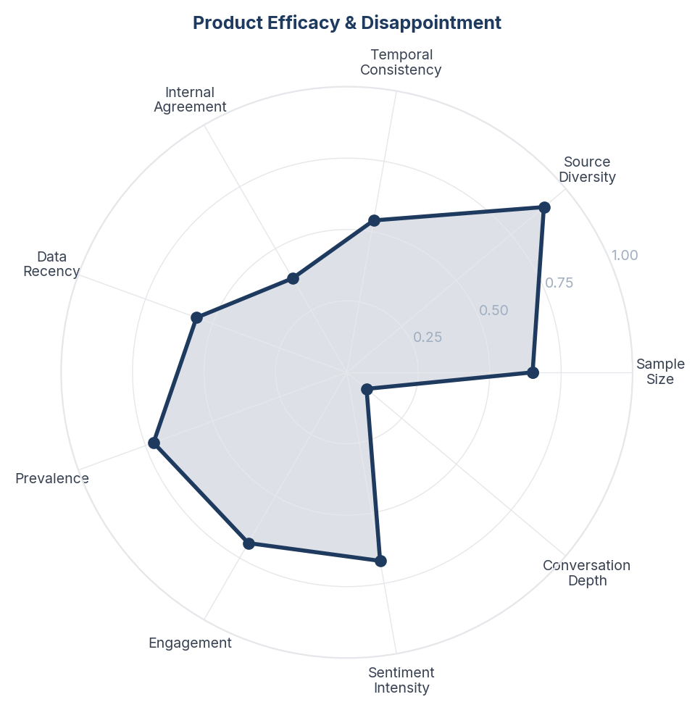
Score Breakdown: Product Efficacy & Disappointment

What the Data Shows
Product Efficacy and Disappointment spans 690 items (12.8%) with a very high NSS of +0.854. The overwhelmingly positive sentiment reflects consumers actively seeking and recommending products that work, though a vocal minority expresses frustration with products that fail to deliver.

What it Means
Efficacy is table stakes - consumers expect mosquito repellents to work, and when they do, the response is enthusiastic gratitude rather than neutral satisfaction. The high NSS reflects a category where 'it actually works' is still a noteworthy claim, suggesting widespread experience with products that disappoint. The phrase 'actually works' appears repeatedly, implying low baseline expectations.

Business Implication & Rationale
The category suffers from a credibility deficit. Consumers have been burned by products that over-promise. Any brand that can demonstrably prove efficacy (through transparent testing, user reviews, or satisfaction guarantees) has a significant competitive advantage.

Recommendation
Invest in transparent efficacy testing and publish results. Implement a satisfaction guarantee programme. Leverage user-generated content showing real-world effectiveness. Avoid vague claims like '12-hour protection' without consumer-verifiable evidence.

Further Validation
Run blinded efficacy trials with consumer panels and publish results. Survey lapsed customers to understand what drove them away from previous products.

Representative Voices
"Tell the mosquitoes the dinner date is CANCELLED ✋
Because #Citronella is here serving “not today, not tomorrow, not ever” energy. Fresh, lemony, and actually effective, it’s the easiest way to protect your skin, your home, and your vibe ✨
Whether you’re chilling on the balcony or taking that pos" - instagram
"We can get rid of mosquitoes 🦟🦟🦟🦟 effectively
#Ambicasupreme https://t.co/ZkWHGHuAZ3" - twitter
"100% Natural Mosquito😱😱 Repellent | Camphor + Coconut Oil + Cloves Mix 🦟✨#viral #ytshorts #trending
Keep mosquitoes away naturally with this simple homemade mosquito repellent made using camphor, coconut oil, and cloves.
This chemical-free remedy is safe, effective, and perfect for your home.
Just " - youtube

12. Brand Perceptions & Comparisons
n=614 | Confidence: 61% (Medium) | Signal: 61% (Moderate) | 11.4% of Dataset | NSS: +39%
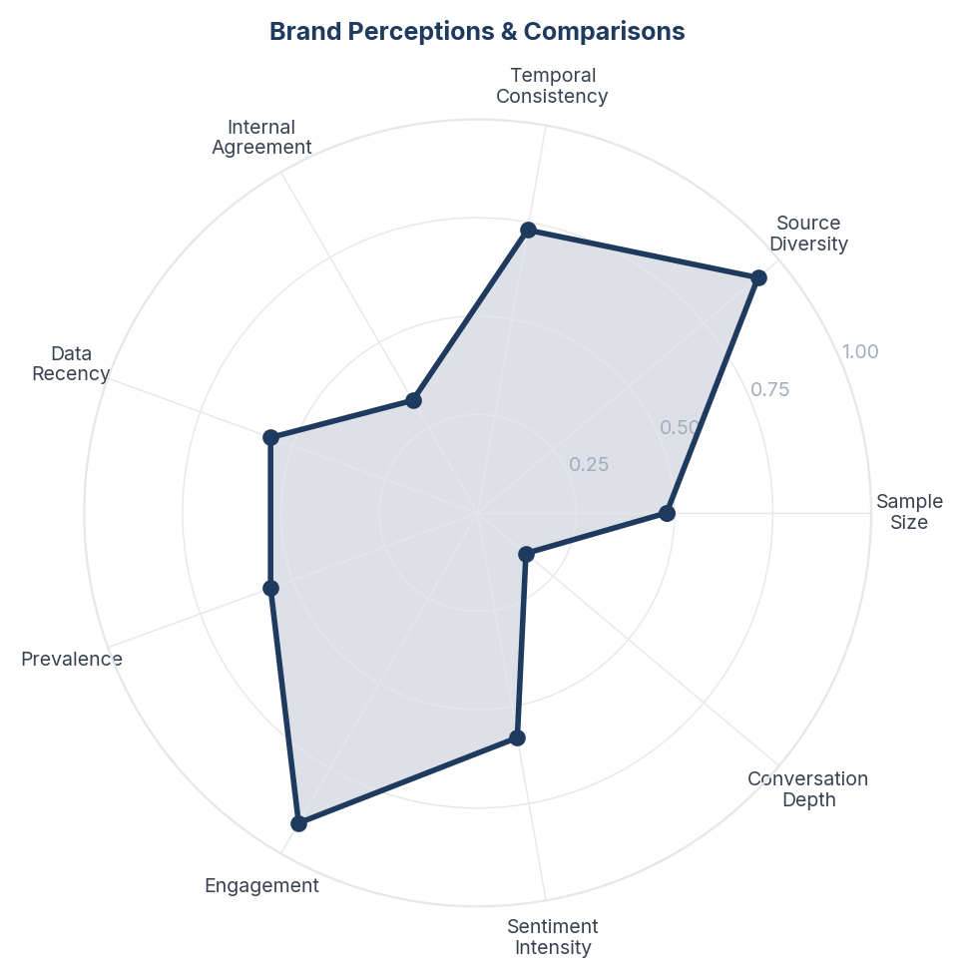
Score Breakdown: Brand Perceptions & Comparisons

What the Data Shows
Brand Perceptions and Comparisons spans 614 items (11.4%) with NSS +0.391. Good Knight, All Out, Mortein, Odomos, Hit, Raid, and Thermacell are mentioned. Indian consumers default to Good Knight and All Out for indoor vaporizers, Odomos for personal application. Global consumers reference OFF!, Raid, and Thermacell. Reddit shows the most comparative brand discussion.

What it Means
The mosquito repellent category has strong regional brand loyalty but weak emotional brand differentiation. Consumers choose brands based on habit and availability rather than meaningful product differences. Most brand mentions are functional ('I use Good Knight') rather than emotional ('I love Good Knight'). This creates vulnerability - habitual loyalty can be broken by a new entrant with a compelling differentiated proposition.

Business Implication & Rationale
Incumbent brands are sitting on borrowed loyalty. Any brand that creates genuine emotional differentiation - through superior efficacy, safety credibility, design innovation, or lifestyle positioning - can disrupt category habits. The functional-only loyalty also means private labels and D2C brands face lower switching barriers than in categories with strong emotional bonds.

Recommendation
Audit current brand positioning against competitors - identify the white space between functional parity and emotional differentiation. Invest in building emotional brand equity beyond 'kills mosquitoes'. Consider a repositioning around the sleep-protection or child-safety angles where emotional stakes are highest.

Further Validation
Run a brand equity study measuring aided/unaided awareness, consideration, preference, and emotional associations for top 5 brands in key markets.

Representative Voices
"Nature’s better when you’re not swatting through it. 🌿 Turn on Thermacell and take it all in.⁠
⁠
Learn more at thermacellrepellents.com.au⁠
.⁠
.⁠
#thermacellaustralia #mosquito #mosquitos #mosquitorepellent #greatoutdoors #outdoorlifestyle #outdoorplay #outdoorslife #insectrepellent #mozzie #mosquit" - instagram
"Transform your home with Mesh India’s Pleated Mesh Doors - where comfort meets protection. ✨🚪 Enjoy uninterrupted airflow, clear visibility, and strong mosquito protection, all while adding a modern touch to your doors and balconies. Designed to be durable, smooth to operate, and cost-efficient, our" - instagram
"After complaints, guests were relocated, but the bugs were still present in their new rooms.
Tour operators report the worst situation in 10 years: vacationers are afraid to bring the insects in their suitcases, and their bites can cause severe allergies" - twitter

13. Smell & Sensory Experience
n=371 | Confidence: 59% (Medium) | Signal: 59% (Moderate) | 6.9% of Dataset | NSS: +49%
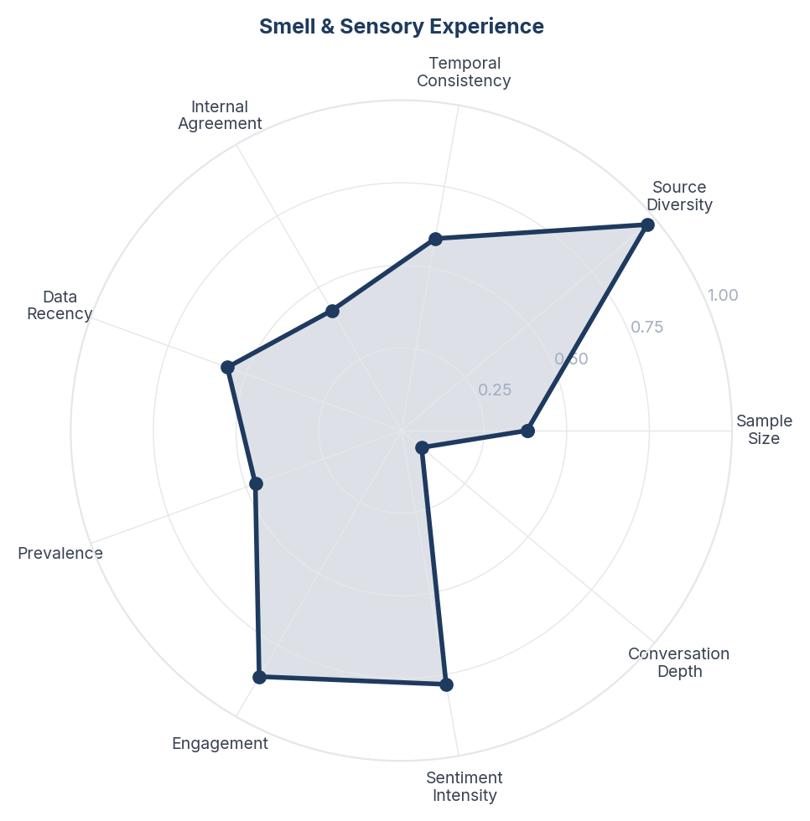
Score Breakdown: Smell & Sensory Experience

What the Data Shows
Smell and Sensory Experience spans 371 items (6.9%) with NSS +0.488. Consumers complain about strong chemical smells, smoky fumes from coils, and headache-inducing fragrances. Positive sentiment focuses on 'no smell' products and pleasant natural scents.

What it Means
Smell is a hygiene factor that consumers notice only when it is wrong. A bad smell creates an immediate negative association with the entire product category, while a neutral or pleasant smell is taken for granted. The prevalence of smell complaints suggests that many products still fail this basic test, particularly coils and lower-end vaporizers.

Business Implication & Rationale
Sensory experience is an under-invested dimension of product development in this category. Premium-tier products in adjacent categories (home fragrance, personal care) have demonstrated that scent can be a premium differentiator. There is white space for a 'mosquito repellent that smells good' rather than merely 'does not smell bad'.

Recommendation
Reformulate products to eliminate chemical odour. For premium positioning, develop signature scent profiles (lavender-eucalyptus, citrus-mint) that make the repellent experience pleasant rather than merely tolerable. Use scent as a brand differentiator.

Further Validation
Conduct sensory panels testing consumer preference across scent profiles. Measure willingness-to-pay premium for pleasant-scented vs unscented vs traditional-scented repellents.

Representative Voices
"Sleep peacefully with all-round protection and a soothing fragrance. Keep your loved ones safe from mosquitoes-naturally and effortlessly.
Shop now [http://mosquitofurr.com]
Find us on Amazon & Flipkart! 🛒
#MosquitoProtection #FamilySafety #PeacefulSleep #HomeCareEssentials #FreshFragrance #Health" - instagram
"Tell the mosquitoes the dinner date is CANCELLED ✋
Because #Citronella is here serving “not today, not tomorrow, not ever” energy. Fresh, lemony, and actually effective, it’s the easiest way to protect your skin, your home, and your vibe ✨
Whether you’re chilling on the balcony or taking that pos" - instagram
"Mosquitoes Out, Good Vibes In! ✨🦟 Say hello to the 2-in-1 solution for your home: QUITTMOZZ!
Why settle for just repelling when you can refresh too? QUITT MOZZ gives you powerful, 360-hour protection from Dengue AND fills your space with a beautiful, natural fragrance.
Pick your perfect scent:
🍋 L" - instagram

14. Coils & Traditional Methods
n=274 | Confidence: 57% (Medium) | Signal: 47% (Weak) | 5.1% of Dataset | NSS: +42%
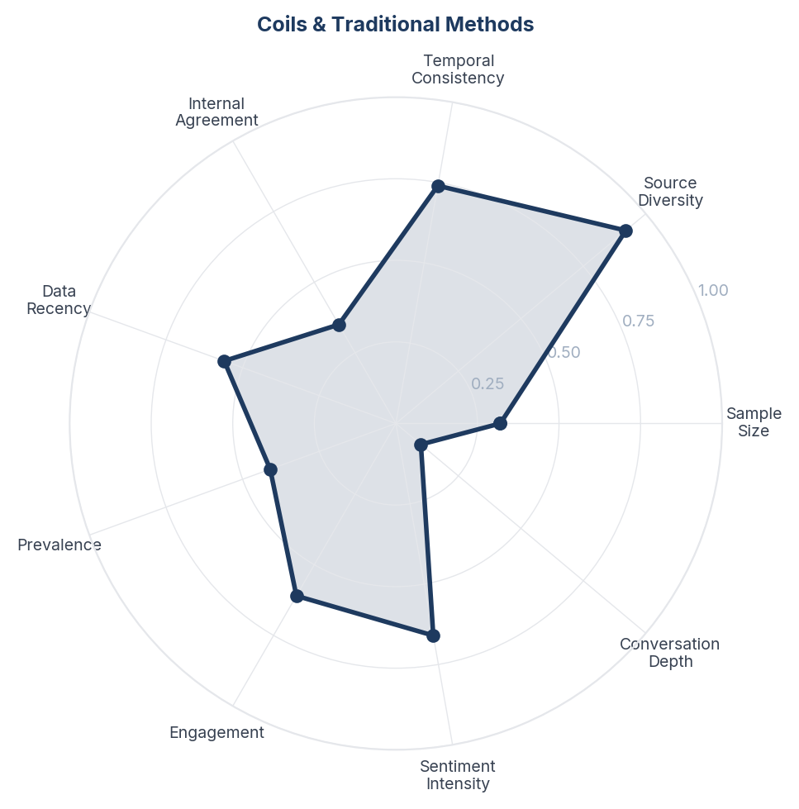
Score Breakdown: Coils & Traditional Methods

What the Data Shows
Coils and Traditional Methods spans 274 items (5.1%) with NSS +0.420. Mosquito coils, incense-style repellents, and traditional smoking methods are discussed primarily by consumers in South and Southeast Asia and rural Africa.

What it Means
Coils represent the 'value floor' of the category - the cheapest and most accessible form of mosquito protection, still relied upon by price-sensitive and rural consumers. However, coils are increasingly seen as outdated and unhealthy. The conversation reveals a transition market: consumers want to upgrade from coils but need affordable alternatives that work without electricity.

Business Implication & Rationale
The coil-to-modern transition represents a large volume opportunity in emerging markets. Consumers leaving coils want something better but cannot afford premium electronic or branded natural products. The sweet spot is a mid-price, non-electric, lower-fume alternative.

Recommendation
For emerging markets, develop a 'coil upgrade' product at 1.5-2x the price point of traditional coils with significantly reduced smoke/fumes. Position explicitly as the step up from coils. Distribute through the same traditional retail channels where coils currently dominate.

Further Validation
Map the coil market size and consumer upgrade path in key emerging markets (India, Southeast Asia, Sub-Saharan Africa).

Representative Voices
"Mosquitoes Out, Good Vibes In! ✨🦟 Say hello to the 2-in-1 solution for your home: QUITTMOZZ!
Why settle for just repelling when you can refresh too? QUITT MOZZ gives you powerful, 360-hour protection from Dengue AND fills your space with a beautiful, natural fragrance.
Pick your perfect scent:
🍋 L" - instagram
"La planta que crece todo el año y espanta mosquitos este verano sin tener que usar espirales 👇 https://t.co/PpFK0FpMtD" - twitter
"Introducing our all-natural mosquito-repellent incense sticks.
Carefully soaked in essential oils, free from toxins, and intentionally slow to light because purity takes its time. we refuse to add any ignition-boosting additives.
Just nature, protection, and peace.
Enjoy protection that feels as n" - instagram

15. Dengue & Disease Fear
n=522 | Confidence: 56% (Medium) | Signal: 49% (Weak) | 9.7% of Dataset | NSS: +37%
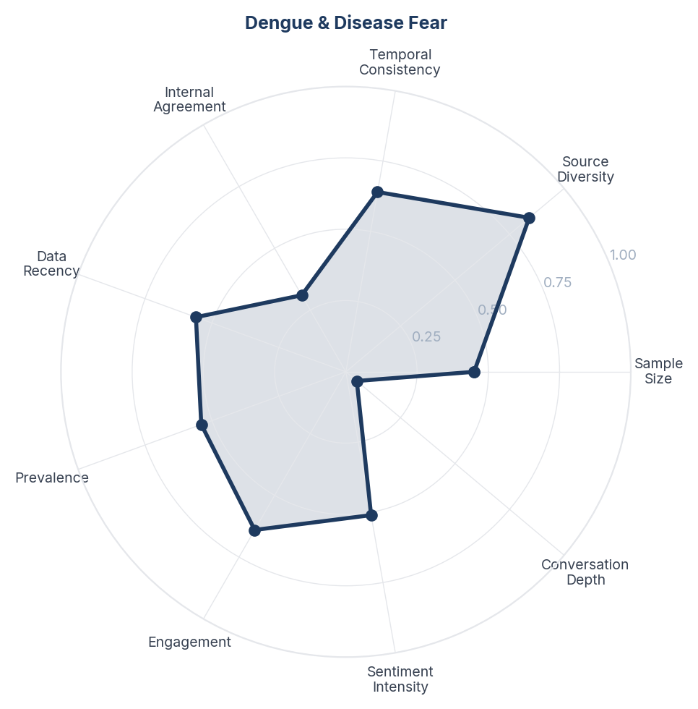
Score Breakdown: Dengue & Disease Fear

What the Data Shows
Dengue and Disease Fear spans 522 items (9.7%) with NSS +0.366. Disease prevention is cited as a motivation for repellent use, but the language is more informational than emotional compared to the sleep disruption theme. Public health messaging, travel advisories, and seasonal outbreak warnings drive this conversation.

What it Means
Disease prevention is the rational justification for repellent purchase but not the primary emotional driver. Consumers cite dengue and malaria as reasons to buy repellents, but the urgency peaks seasonally during outbreaks and then subsides. Sleep disruption, by contrast, is a year-round, nightly pain point. This suggests that disease-fear marketing has a ceiling - it motivates purchase during epidemics but does not sustain habitual use.

Business Implication & Rationale
Brands that rely solely on disease-fear messaging will see cyclical demand spikes but struggle with year-round sales. The more sustainable positioning combines sleep protection (daily motivation) with disease prevention (rational reinforcement) - 'protect your sleep and your health'.

Recommendation
Use disease prevention as a secondary reinforcement message, not the primary positioning. Lead with sleep quality and comfort, then layer in health protection. During outbreak seasons, amplify the disease prevention messaging but maintain the sleep-quality foundation year-round.

Further Validation
Track purchase intent correlation with dengue case counts to quantify the seasonal disease-fear effect. Test messaging that combines sleep and disease prevention vs each alone.

Representative Voices
"Mosquitoes Out, Good Vibes In! ✨🦟 Say hello to the 2-in-1 solution for your home: QUITTMOZZ!
Why settle for just repelling when you can refresh too? QUITT MOZZ gives you powerful, 360-hour protection from Dengue AND fills your space with a beautiful, natural fragrance.
Pick your perfect scent:
🍋 L" - instagram
"From banning #childmarriage to deploying disease-reducing mosquitoes, discover 10 positive changes and outcomes for children in 2025: https://t.co/QblOaEVvZs @save_children https://t.co/PXGumXWcfv" - twitter
"Keep your home safe, protected, and mosquito-free-day and night.
With Mosgo Mosquito Repellent Lotion, enjoy up to 12 hours of long-lasting protection against Dengue and Malaria-carrying mosquitoes.
Safe for the whole family, gentle on skin, and strong where it matters.
Mosgo - Your Home’s 12-Hour S" - instagram

16. Climate, Seasons & Getting Worse
n=61 | Confidence: 52% (Medium) | Signal: 24% (Trace) | 1.1% of Dataset | NSS: +16%
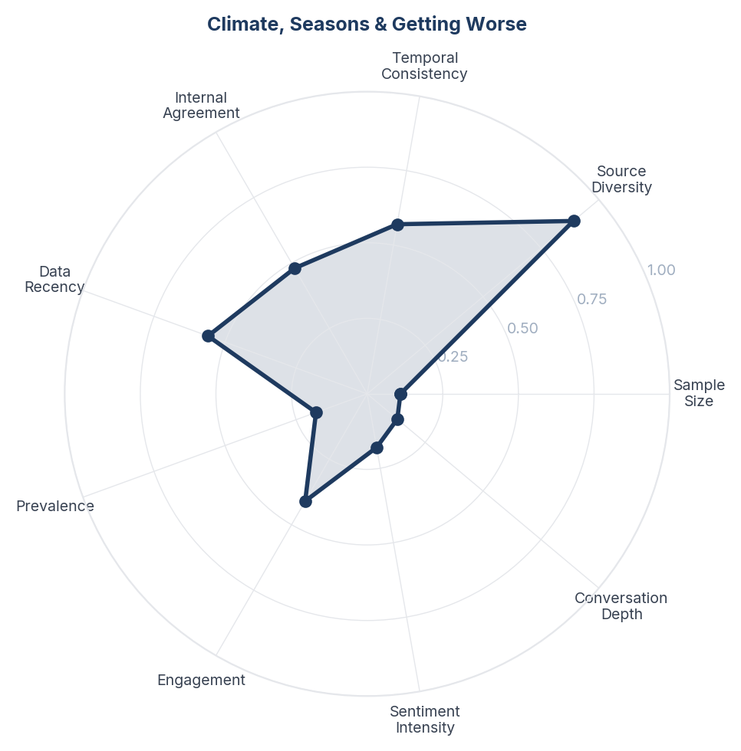
Score Breakdown: Climate, Seasons & Getting Worse

What the Data Shows
Climate, Seasons and Getting Worse spans 61 items (1.1%). Consumers report mosquito seasons extending into winter months, unprecedented infestations, and geographic spread to areas previously unaffected. December mosquitoes in temperate zones are noted with alarm.

What it Means
Climate change is extending the mosquito repellent market seasonally and geographically. Consumers in traditionally low-mosquito regions are experiencing their first significant mosquito problems and are entering the category as first-time buyers with no brand loyalty. This represents organic market expansion that requires no marketing investment - just distribution and availability in newly affected areas.

Business Implication & Rationale
The total addressable market for mosquito repellents is growing without any category marketing effort. Brands that establish distribution in newly affected geographies first will capture first-time buyers who become habitual purchasers. The seasonality window for repellent sales is widening, reducing the traditional summer-only demand peak.

Recommendation
Expand distribution to regions showing new mosquito activity (monitor public health data for geographic spread). Extend marketing campaigns beyond traditional summer months. Develop messaging for first-time buyers in newly affected areas who may not know what products to use.

Further Validation
Analyse climate data and public health mosquito surveillance reports to identify the fastest-growing geographic markets. Track retail sell-through data by month to confirm seasonality extension.

Representative Voices
"Protecting your health is our gift to you this season! 🎁 While you're enjoying the holiday cheer, the District is working hard behind the scenes. Our Mosquito Bytes Newsletter is the perfect stocking stuffer for your inbox
Sign up today &amp; keep your holidays vector-free! 🐀🦨🦟 https://t.co/YQvzTZ2" - twitter
"Fkn mosquitoes in fkn December wtfffffffffffffk" - twitter
"Omg these mosquitoes are driving me insane !!! I honestly don’t like summer!!!" - twitter

17. Public Health & Prevention Campaigns
n=57 | Confidence: 49% (Directional) | Signal: 16% (Trace) | 1.1% of Dataset | NSS: +21%
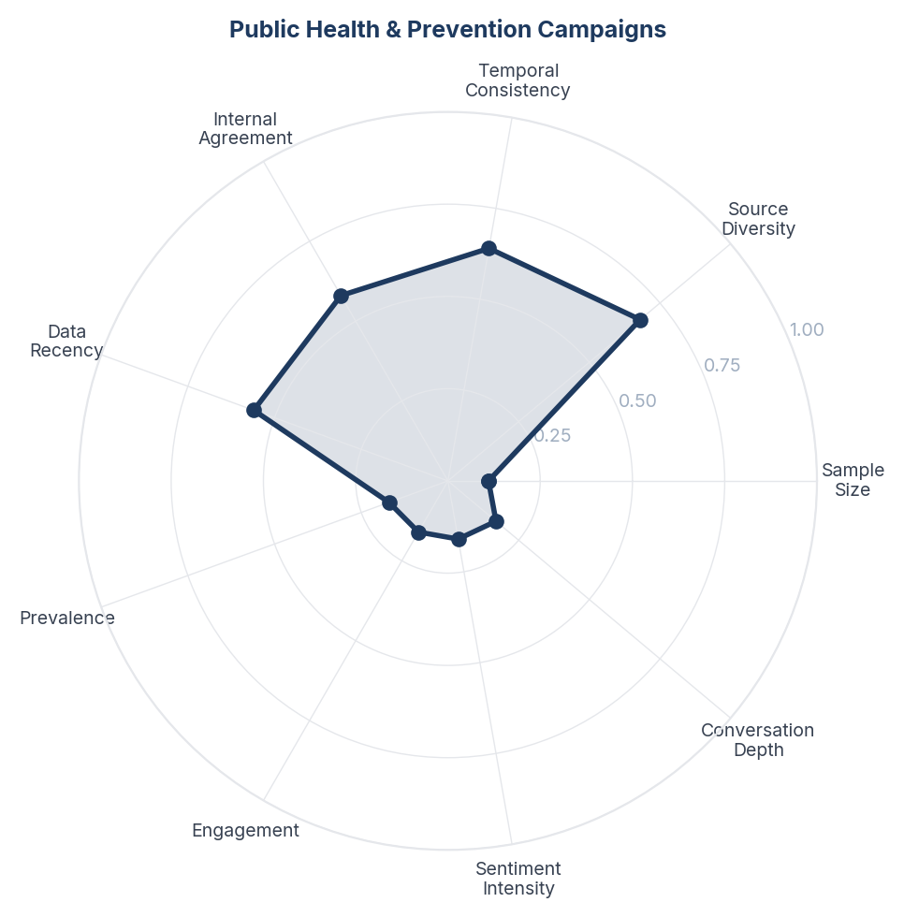
Score Breakdown: Public Health & Prevention Campaigns

What the Data Shows
Public Health and Prevention Campaigns spans 57 items (1.1%). Government vector control, WHO messaging, breeding site elimination campaigns, and World Mosquito Day content. Primarily informational, low emotional engagement.

What it Means
Public health messaging about mosquitoes reaches consumers but does not convert to product purchase. The gap between "drain standing water" advice and "buy this repellent" action reveals that public health campaigns create awareness but not commercial intent. Consumers absorb prevention messaging passively without connecting it to their own product-buying behaviour.

Business Implication & Rationale
Brands can amplify public health messaging to build category awareness while associating their products with the recommended protective behaviour. Partnering with public health campaigns provides credibility that advertising alone cannot deliver.

Recommendation
Partner with WHO, CDC, or national health bodies for co-branded prevention campaigns during dengue/malaria seasons. Position products as the "last line of defence" that complements public health advice about breeding site elimination.

Further Validation
Measure purchase intent lift when repellent advertising is paired with public health endorsement vs standalone product advertising.

Representative Voices
"Our Vector Control teams continues across the island carrying out fogging activities to help reduce mosquito population and protect communities. See below communities that will be visited this week (December 7-13, 2025) - Remember to do your part to keep your surroundings clean and mosquito-free." - twitter
"#RUSSIA: Suggested measures include the use of repellent, closed and long-sleeved clothing during periods of high mosquito activity and avoiding areas with stagnant water." - twitter
"https://t.co/dVnwqhTPsf befo I go hawk shoo who tf is she and who is that on her head can we kill that lil thing with bug spray https://t.co/oE22XI4put" - twitter

18. Humor, Memes & Shared Suffering
n=117 | Confidence: 47% (Directional) | Signal: 29% (Weak) | 2.2% of Dataset | NSS: +11%
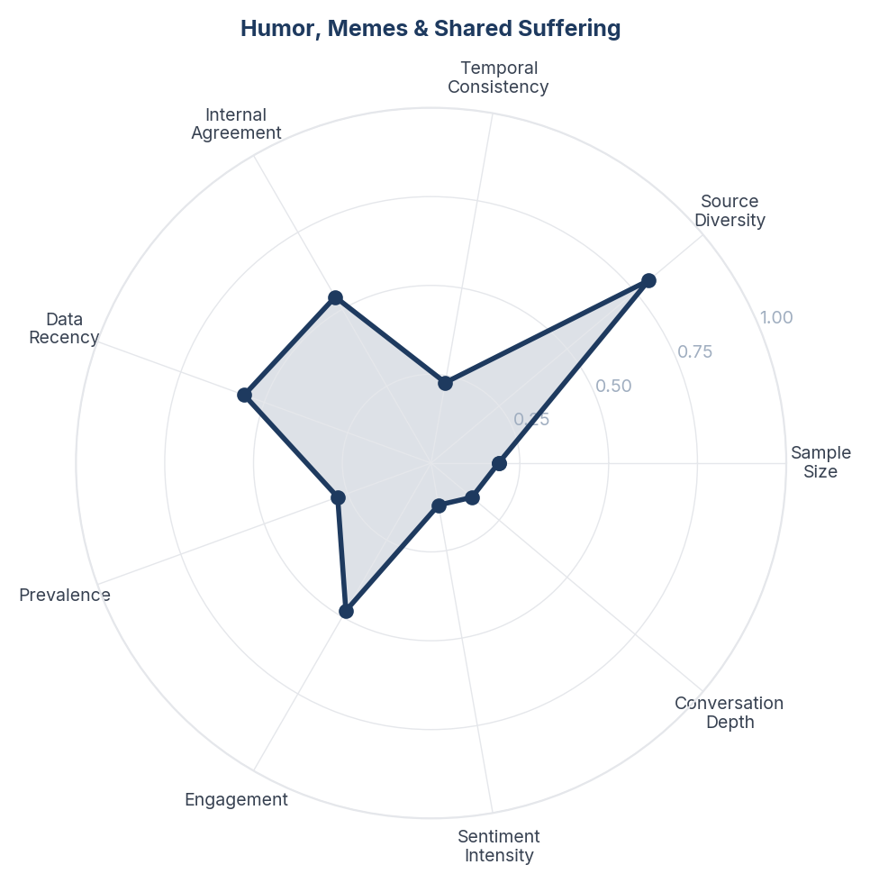
Score Breakdown: Humor, Memes & Shared Suffering

What the Data Shows
Humor, Memes and Shared Suffering spans 117 items (2.2%). Consumers use war metaphors, blood type jokes, and "mosquito magnet" self-deprecation to process mosquito misery. Twitter is the primary platform for this content. The humor is universal - it crosses geography, language, and demographics.

What it Means
The mosquito experience is a universal cultural bonding moment. Humor about mosquitoes signals shared suffering that transcends demographics. Brands that enter this conversation authentically gain cultural relevance without needing to make product claims. The "mosquito magnet" identity is so widely self-reported that it represents a genuine consumer segment - people who believe they are disproportionately targeted.

Business Implication & Rationale
There is a marketing opportunity in acknowledging and celebrating the shared misery rather than just solving it. The "mosquito magnet" segment could be specifically targeted with higher-efficacy products positioned as "for people mosquitoes love".

Recommendation
Create social content that participates in mosquito humor rather than lecturing. Develop a "mosquito magnet" product tier positioned for people who believe they attract more bites. Run a "rate your mosquito misery" social campaign to generate UGC and brand engagement.

Further Validation
Survey consumers on "mosquito magnet" self-identification and willingness to pay premium for products specifically targeted at high-attraction individuals.

Representative Voices
"@Riflemanscreed2 😂 the mosquitoes up here won’t be back out for another 5-6 months" - twitter
"Hardik Pandya was warming up and someone decided to spray mosquito repellent. He didn't look happy and moved to the other part of the ground. https://t.co/QnuTncJQLH" - twitter
"nah where’s the bug spray deadass 😒" - twitter

Brand Health Score
Overall Brand Health Score: 68/100
Brand Health Score is a composite index built from five data-driven components. No subjective weighting is applied - all inputs are derived from the collected corpus.
Component | Score | Methodology
Sentiment Component (30%) | 64.7 | Derived from NSS across all items. Reflects the ratio of positive to negative consumer language.
Engagement Component (25%) | 88.6 | Average engagement (upvotes, likes, comments) normalised to platform benchmarks.
Advocacy Component (20%) | 55.8 | Proportion of items containing explicit recommendation or repurchase intent language.
Resilience Component (15%) | 79.8 | Sentiment consistency across platforms and time periods.
Conversation Component (10%) | 37.3 | Volume and depth of organic brand conversation (non-promotional threads).
Note: The Conversation Component (37/100) is the lowest-scoring factor. This reflects that most brand mentions occur in reaction to advertising, campaigns, and celebrity content rather than unprompted consumer-initiated discussion. Organic brand conversation is thin relative to engagement volume - a pattern consistent with a brand consumers transact with rather than one they actively champion.

Methodology

Pipeline Overview
- Stage 0 - Brief Structured research brief defines brand, competitors, geography, business objectives, and keyword seed list.
- Stage 1 - Collect Automated collection across Instagram, Reddit, Twitter, Youtube. Engagement-minimum filters applied at collection time.
- Stage 2 - Normalize Thread-level deduplication (comments capped per thread). Deterministic SHA-256 item IDs prevent re-collection of duplicates across runs.
- Stage 3 - Filter LLM relevance classification (claude-sonnet-4-20250514). Each item classified as relevant/irrelevant with a reason. Multilingual support enabled.
- Stage 4 - Analyze Sentiment (positive/negative/neutral/mixed) + Plutchik 8-emotion classification in a single LLM call. ABSA: per-aspect sentiment extracted. Two-pass theme extraction: (a) discovery on stratified sample to identify candidate themes; (b) full-corpus mapping of all items to themes in batches.
- Stage 5 - Synthesize One insight per theme, mandated by prompt. Insight structure: Observation - Insight - Implication - Recommendation - Further Validation.
- Stage 6 - Score Fully data-driven scoring. Confidence: 5 factors (sample size, source diversity, temporal consistency, internal agreement, data recency). Signal Strength: 4 factors (prevalence, engagement, sentiment intensity, conversation depth). Brand Health Score: 5 components.
- Stage 7 - Report Google Doc-compatible DOCX with inline charts, block-quoted verbatims, and full data tables.

Scoring Formulas

Confidence Score
Confidence = (sample_size x 0.25) + (source_diversity x 0.25) + (temporal_consistency x 0.15) + (internal_agreement x 0.2) + (data_recency x 0.15)

Signal Strength Score
Signal = (prevalence x 0.35) + (engagement x 0.3) + (sentiment_intensity x 0.2) + (conversation_depth x 0.15)

Net Sentiment Score (NSS)
NSS = (positive_count - negative_count) / total_count. Range -1.0 to +1.0. Industry standard: Brandwatch, Sprinklr, YouGov.

Quality Gates
- Grounded (≥3 sources cited)
- Non-obvious (not derivable from common knowledge)
- Actionable (leads to a concrete business decision)
- Specific (not vague platitude)
- Falsifiable (could be proven wrong with additional data)

Data Provenance
All data is sourced from publicly available online conversations. No personally identifiable information (PII) is stored or reported.
Source | Content Type | Access Method | Items in Corpus
Twitter / X | Tweets, replies, quote tweets | Platform API / external collection | 2,699
YouTube | Video descriptions, comments | YouTube Data API v3 | 1,357
Reddit | Forum discussions, comments | Public JSON API | 877
Instagram | Posts, reels, comments | Platform API / external collection | 458
Corpus composition: 4,449 posts and 942 comments. Each comment is treated as an independent item linked to its parent post for thread-level analysis.

Geographic Coverage
Primary: Global. Content selected and filtered for relevance to the Global market context. Items originating from other geographies are retained where they contribute relevant consumer perspective (e.g., diaspora experiences, cross-market comparisons).

Temporal Coverage
Data range: Dec 2024 - Dec 2025 (12 months). Items span the full collection period with no temporal exclusion applied at normalization.

Demographic Accuracy
This methodology explicitly documents platform-level composition so that interpretation accounts for known biases: Instagram skews female, urban, and 18-34 with strong influencer and health-creator content that shapes but does not represent consumer opinion; Twitter/X skews male, urban, politically engaged, and 25-44; high-follower accounts dominate visibility while ordinary consumer voices are underrepresented; YouTube is more balanced across gender but skews younger audiences; creator content dominates over consumer discussion; Reddit skews male, urban, and 18-34. These biases are documented rather than hidden. For verified demographic breakdowns, commission a structured survey targeted to the same research questions, using this report's insights as the stimulus.

