Weight Loss
Research Report: Consumer Sentiment & Brand Perception
Analysis Date: April 2026

Research Objectives
- Understand the full weight loss conversation landscape in India - drugs, diets, surgery, Ayurveda, fitness
- Map consumer perceptions of GLP-1 drugs (Ozempic, Mounjaro, Wegovy, Saxenda) in India
- Identify safety concerns and side effects consumers are reporting or worried about
- Understand cost and accessibility barriers for weight loss treatments in India
- Explore how traditional/Ayurvedic remedies are discussed vs modern pharmaceuticals
- Identify the role of influencers and medical professionals in shaping opinions
- Understand how diet plans and lifestyle approaches are discussed alongside drug treatments
- Surface demographic and regional differences in weight loss attitudes across India

Summary of Data and Findings
Items Analysed | 2,526
Insights Identified | 15
Net Sentiment Score | +22.9%
Brand Health Score | 81/100
Data Sources | 3 platforms

Data Universe

Collection Funnel
Of 43,698 raw data points collected across all sources, 4,475 remained after deduplication and engagement filtering, and 2,526 passed LLM relevance classification (5.8% of total collected). These 2,526 items form the analysis corpus.
Stage | Items | Notes
Raw collected | 43,698 | All posts, comments, articles and videos gathered across all platforms
After deduplication & engagement filter | 4,475 | Thread dedup (max 5 comments/thread), min engagement filters applied per platform
After relevance classification | 2,526 | LLM relevance filter — 5.8% of raw collected. Analysis corpus.

Platform Breakdown
Platform | Items | Share of Corpus
Reddit | 1397 | 55.3%
Instagram | 975 | 38.6%
Youtube | 154 | 6.1%
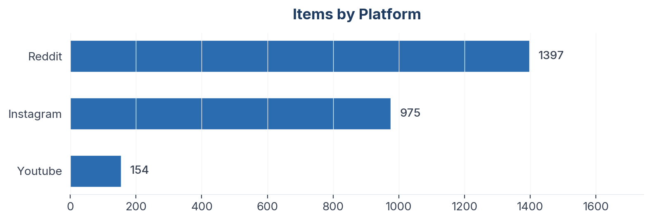
Figure 1: Item distribution by source platform

Collection Methodology
Data was collected using automated scrapers with engagement-weighted filtering applied per platform. Thread-level deduplication caps comments per thread to prevent over-indexing vocal threads. All items passed an LLM relevance classification step before analysis.

Sentiment & Emotion Analysis

Overall Sentiment Distribution
Net Sentiment Score (NSS): +22.9% | Positive: 899 (35.6%) | Negative: 320 (12.7%) | Neutral: 1098 (43.5%)
NSS is computed as (positive - negative) / total items. Range: -1.0 (all negative) to +1.0 (all positive). Neutral and mixed items remain in the denominator, anchoring the score to the full corpus rather than just polarised items. A positive NSS indicates net favourable sentiment; a negative NSS indicates net unfavourable.
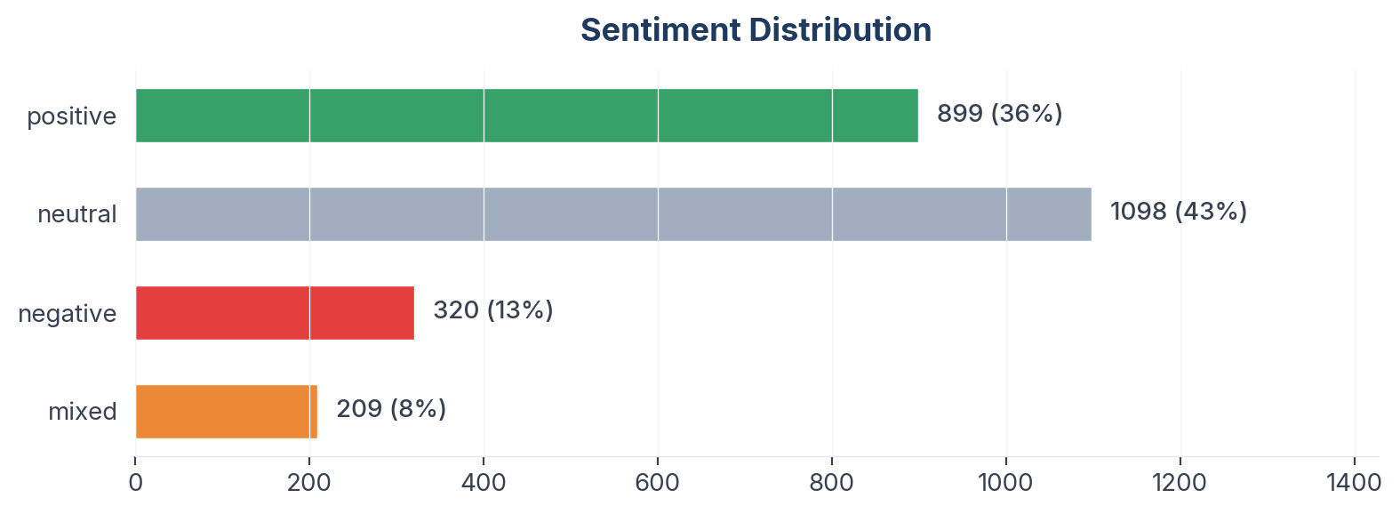
Figure 2: Sentiment distribution across 2,526 items

Emotion Profile (Plutchik 8-Emotion Model)
Emotion | Count
None | 1340
Trust | 429
Joy | 376
Sadness | 109
Anticipation | 93
Fear | 75
Disgust | 59
Surprise | 36
Anger | 9
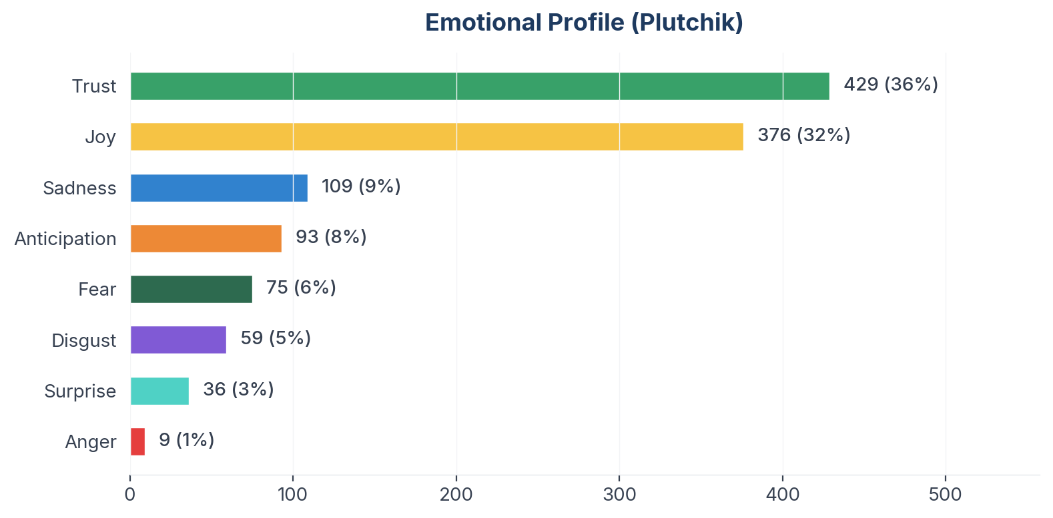
Figure 3: Plutchik emotion distribution

Aspect-Based Sentiment Analysis (ABSA)
Aspects with ≥10 mentions are shown below. NSS is statistically meaningful only at this threshold.
Aspect | Total | Positive | Negative | NSS
Efficacy | 634 | 284 | 75 | +33%
Accessibility | 389 | 122 | 68 | +14%
Doctor Guidance | 386 | 135 | 64 | +18%
Safety | 344 | 88 | 114 | -8%
Convenience | 300 | 140 | 29 | +37%
Cost | 258 | 71 | 43 | +11%
Taste Food | 169 | 83 | 17 | +39%
Emotional Impact | 62 | 29 | 3 | +42%

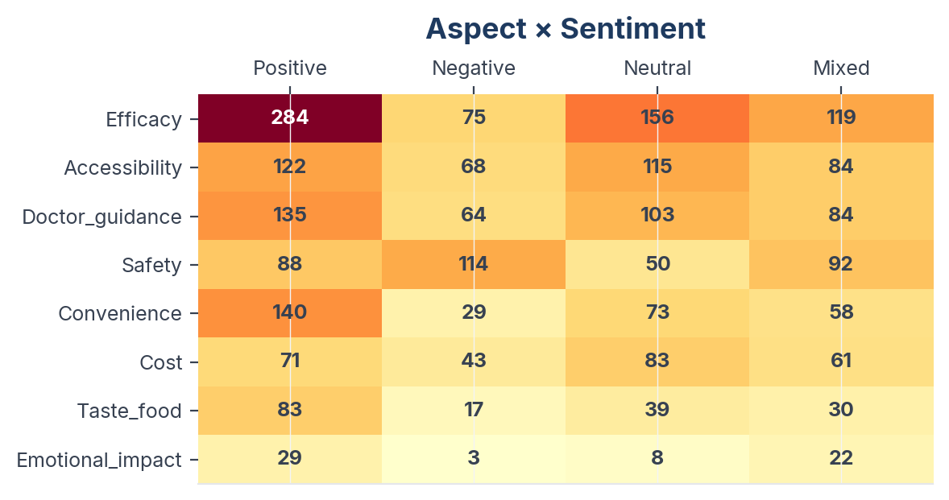
Figure 4: Aspect sentiment heatmap (aspects with ≥10 mentions)

Insight Landscape
15 insights were identified from 2,526 items using a two-pass extraction approach (stratified discovery sample + full-corpus mapping).
Insight | Items | Prevalence in Dataset | Signal Strength | Confidence Score | NSS
GLP-1 Drug Experiences & Journeys | 739 | 29.3% | 65% (Moderate) | 70% (Medium) | +14%
Protein, Supplements & Nutrition Science | 484 | 19.2% | 73% (Moderate) | 69% (Medium) | +37%
PCOS, Hormones & Medical Weight Issues | 416 | 16.5% | 66% (Moderate) | 65% (Medium) | +23%
Weight Loss Transformations & Motivation | 408 | 16.1% | 74% (Moderate) | 65% (Medium) | +48%
Exercise, Fitness & Active Lifestyle | 372 | 14.7% | 70% (Moderate) | 68% (Medium) | +36%
Indian Diet Plans & Calorie Management | 329 | 13.0% | 68% (Moderate) | 68% (Medium) | +35%
Cost, Access & Availability in India | 319 | 12.6% | 57% (Moderate) | 65% (Medium) | +11%
GLP-1 Side Effects & Safety Concerns | 286 | 11.3% | 63% (Moderate) | 63% (Medium) | -11%
Misinformation, Miracle Claims & Debunking | 203 | 8.0% | 63% (Moderate) | 62% (Medium) | +4%
Bollywood & Celebrity Weight Loss Speculation | 185 | 7.3% | 64% (Moderate) | 62% (Medium) | +20%
Food Industry, Junk Food & Ultra-Processed | 164 | 6.5% | 55% (Moderate) | 63% (Medium) | +23%
Stigma, Shame & the 'Shortcut' Debate | 143 | 5.7% | 60% (Moderate) | 58% (Medium) | +24%
Ayurveda, Traditional & Alternative Remedies | 134 | 5.3% | 67% (Moderate) | 61% (Medium) | +37%
Bariatric Surgery & Medical Procedures | 73 | 2.9% | 46% (Weak) | 56% (Medium) | +19%
Intermittent Fasting & Eating Patterns | 56 | 2.2% | 62% (Moderate) | 59% (Medium) | +39%
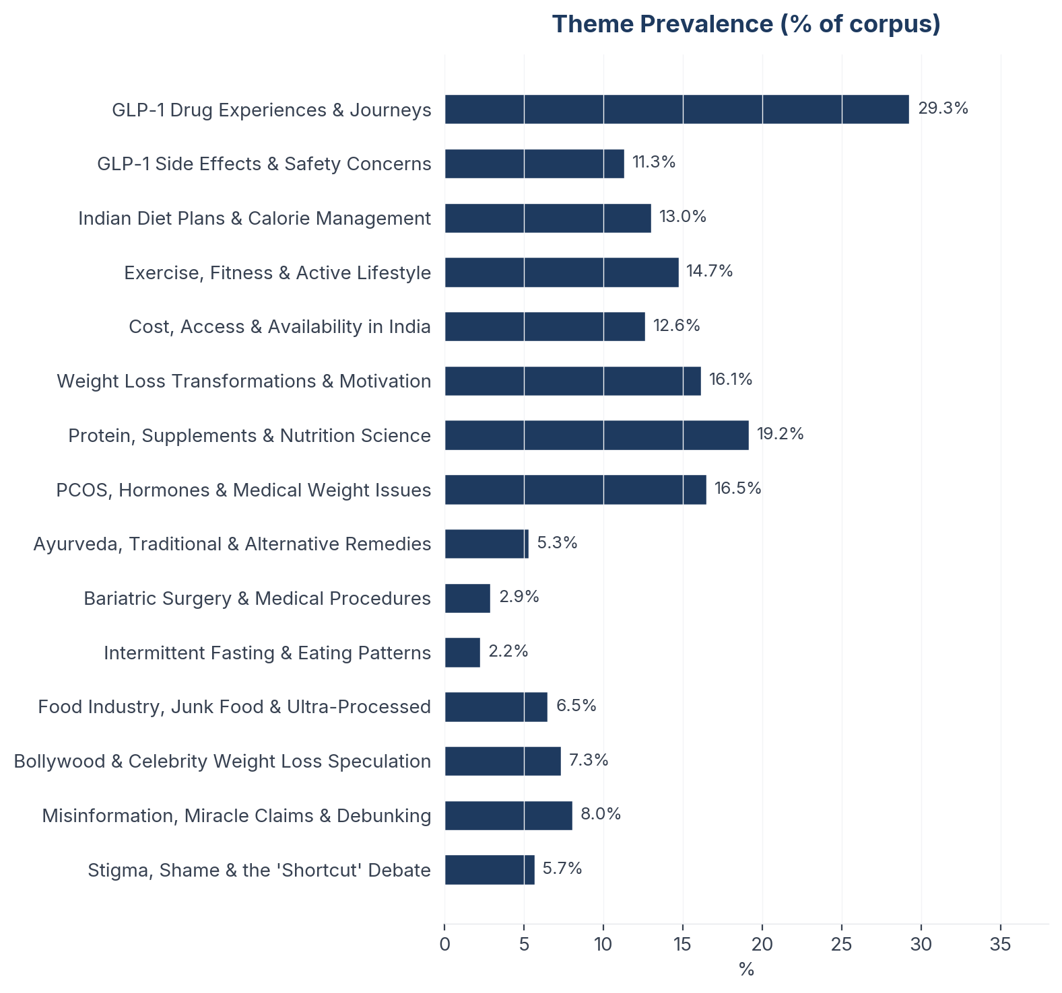
Figure 5: Insight prevalence (% of total corpus)

Insight Deep Dives
One insight per theme, ordered by confidence score. Each insight follows the framework: What the Data Shows, What it Means, Business Implication and Rationale, Recommendation, Further Validation.

01. GLP-1 Drug Experiences & Journeys
n=739 | Confidence: 70% (Medium) | Signal: 65% (Moderate) | 29.3% of Dataset | NSS: +14%
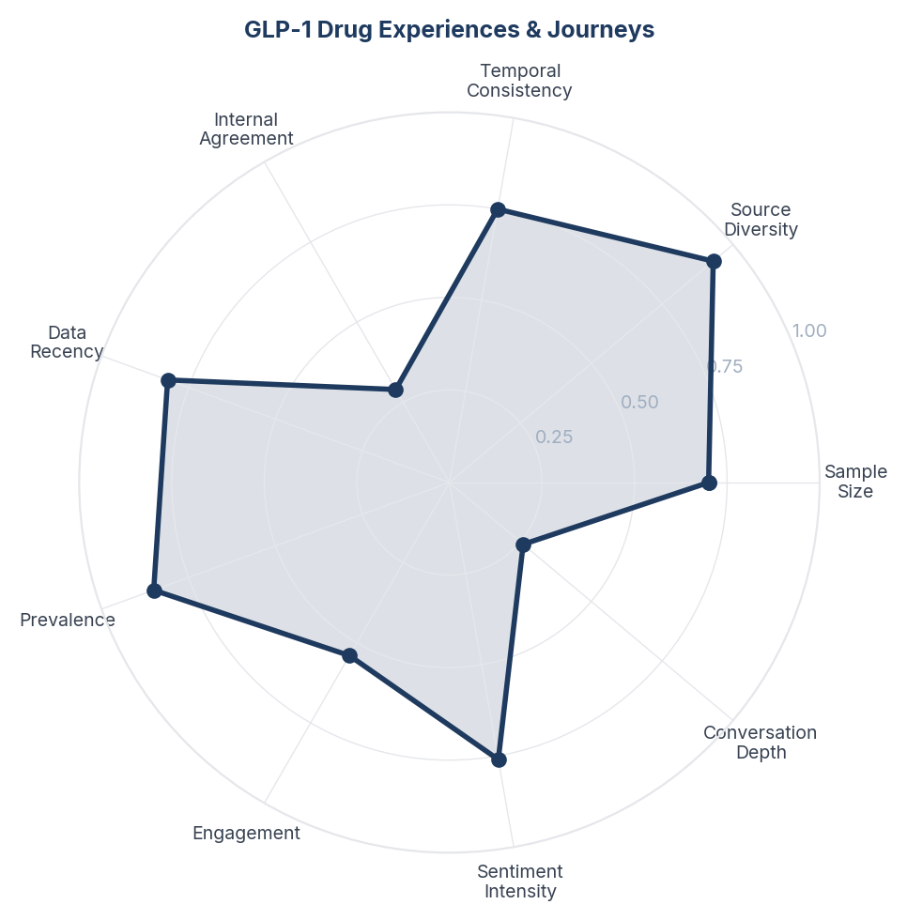
Score Breakdown: GLP-1 Drug Experiences & Journeys

What the Data Shows
GLP-1 receptor agonists dominate the weight loss conversation in India with 739 mentions (29.3% of all discussion), spanning personal journey updates on Instagram, medical explainers on YouTube, and experience-sharing on Reddit. Mounjaro and Ozempic are the most frequently named drugs, with growing awareness of next-generation oral options like orforglipron. Sentiment is net positive (+14%) but notably mixed - 30% of mentions are neutral (information-seeking) and 16% negative.

What it Means
Indian consumers are in an active discovery phase with GLP-1 medications - they are simultaneously fascinated by the dramatic results and cautious about committing. Unlike Western markets where GLP-1 adoption is more normalised, Indian users treat these drugs as a significant life decision requiring extensive peer validation before starting. The high volume of neutral (information-gathering) content signals that a large pool of potential users is researching but has not yet converted.

Business Implication & Rationale
The Indian GLP-1 market is at an inflection point between awareness and adoption. The consumer is educated enough to know these drugs exist and work, but needs reassurance on safety, cost, and medical supervision before starting. Brands that can bridge the trust gap - through doctor endorsements, transparent pricing, and realistic outcome expectations - will capture this converting audience.

Recommendation
Develop a 'first 90 days' content programme featuring Indian patients and endocrinologists documenting real GLP-1 journeys with honest side effect reporting. Partner with Indian healthcare influencers who already have trust (e.g., Dr. Pal, Dr. Balamurugan) rather than celebrity endorsements. Create a cost calculator tool showing monthly expense vs. outcomes.

Further Validation
Conduct a quantitative survey among the neutral/information-seeking segment to measure intent-to-adopt and specific barriers. Track conversion rates from awareness to prescription across tier-1 vs tier-2 Indian cities.

Representative Voices
"To the people commenting Ozempic. I am a doctor and in clinic we daily prescribe GLP1RA.
It's drug approved for diabetes and its side effect is Weight loss. But now doctors do use it to achieve weight loss in obese people who have comorbidities. It gives good protection against heart attack and protects kidney as well." - reddit
"🔥 Appetite coming back before your next GLP-1 dose? You’re not alone.
This is something I’ve experienced personally, and many patients say the same.
Here’s why it happens 👇
📉 These medications don’t stay at full strength all week
📈 After your injection, drug levels peak in 24-48 hours
⏳ Then level..." - instagram
"Additionally, Rybelsus is semaglutide orally. Comes in 3mg, 7mg, or 14mg once daily oral tablets for type 2 diabetes mellitus.
For reference on injectables: Ozempic for diabetes is *intended by manufacturer* to be 0.25mg/week x4 weeks then increase to 0.5mg/week x2+ weeks." - reddit

02. Protein, Supplements & Nutrition Science
n=484 | Confidence: 69% (Medium) | Signal: 73% (Moderate) | 19.2% of Dataset | NSS: +37%
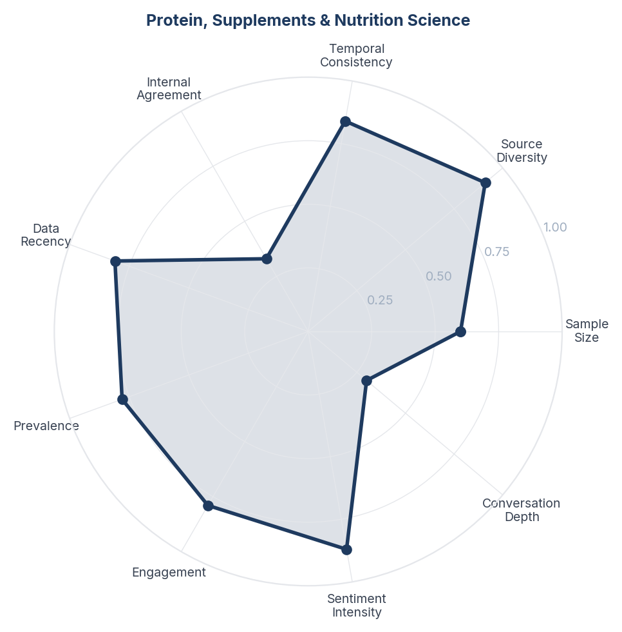
Score Breakdown: Protein, Supplements & Nutrition Science

What the Data Shows
Protein and nutrition science is the second-most discussed theme at 19.2% (484 mentions) with strong positive sentiment (+37.2%). Indian consumers actively discuss protein intake targets, whey supplements, and macronutrient balance. There is significant concern about protein deficiency in vegetarian Indian diets. Collagen, omega-3, and B12 supplementation are frequently mentioned alongside weight loss discussions.

What it Means
The Indian weight loss consumer has crossed a knowledge threshold - they understand that weight loss is not just about eating less but about eating differently, with protein as the anchor nutrient. This represents a fundamental shift from the traditional Indian diet (carb-heavy, protein-light) toward protein-first thinking. However, achieving adequate protein on a vegetarian Indian diet remains a practical challenge, creating a large market for protein supplementation.

Business Implication & Rationale
The convergence of weight loss awareness and protein consciousness creates a dual opportunity: protein-enriched versions of Indian staples (high-protein atta, protein-fortified dal) and targeted supplementation for the vegetarian majority. GLP-1 brands specifically need to address protein intake because muscle preservation during medication-induced weight loss requires increased protein consumption.

Recommendation
For GLP-1 brands: include protein intake targets (1.2-1.6g/kg) in all patient education materials. Partner with Indian protein supplement brands for co-branded starter kits. For food brands: develop high-protein versions of Indian staples that do not compromise on taste. Create content around 'vegetarian protein hacks' specific to Indian ingredients (paneer, soy chunks, chana, sprouts).

Further Validation
Survey actual protein intake among Indian GLP-1 users vs. recommendations. Measure the market size for protein-fortified Indian foods targeted at the weight-loss-aware consumer.

Representative Voices
"There's a youtube channel named "Trustified" run by Arpit who does blind testings on fitness supplements...even he found BigMuscles, Patanjali whey protein to be fraudulent" - reddit
"The side effects are nothing compared to the life improvement she would get by not being overweight. Just think India are one of the top nations with obese related diseases. Diabetes, hypertension, cardiac arrest etc." - reddit
"Go on YouTube and check this channel called trustified. They do blind testing for all major whey protein products and other supplements as well. They will also share the reports of the tests. I am a pro bodybuilder and I wish I knew about it sooner. I have saved thousands of rupees because of them." - reddit

03. Exercise, Fitness & Active Lifestyle
n=372 | Confidence: 68% (Medium) | Signal: 70% (Moderate) | 14.7% of Dataset | NSS: +36%
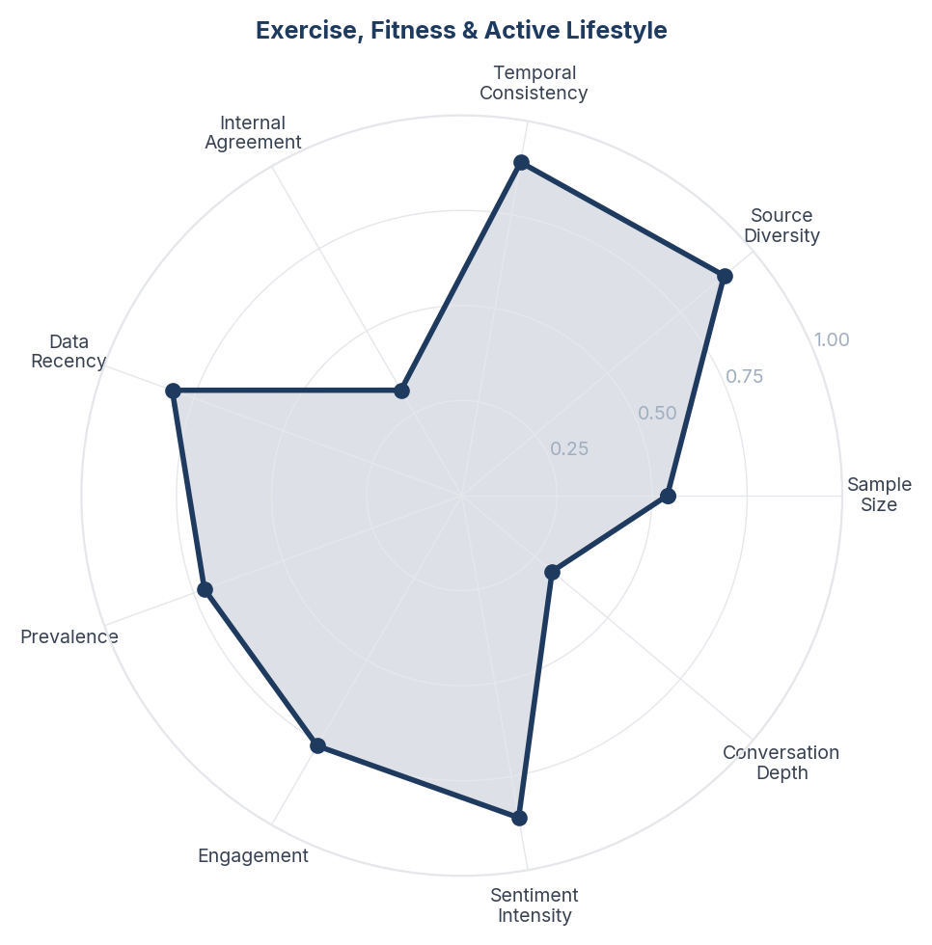
Score Breakdown: Exercise, Fitness & Active Lifestyle

What the Data Shows
Exercise and fitness content accounts for 14.7% of conversation (372 mentions) with strong positive sentiment (+35.8%). Walking and gym-based weight training dominate over cardio-only approaches. Users actively discuss combining exercise with diet or medication. Cult.Fit appears as a recognisable brand. There is practical sharing of routines adapted for Indian lifestyles - morning walks, yoga, and home workouts for those without gym access.

What it Means
Indian consumers increasingly view exercise not as optional but as the non-negotiable foundation of weight loss - even when using medication. The prominence of weight training discussions signals a maturity shift from 'just do cardio' to understanding body composition. However, the conversation reveals a practical accessibility gap - many users lack gym access or time, leading to walking and home workouts as the default mode.

Business Implication & Rationale
The Indian fitness market opportunity lies at the intersection of accessibility and effectiveness. Consumers know weight training is superior but many cannot access or afford gyms. Solutions that bring structured strength training into accessible formats (home, park, minimal equipment) have a large addressable market.

Recommendation
For GLP-1 brands: create mandatory exercise pairing guidance that addresses muscle preservation during weight loss. Partner with accessible fitness platforms (not just premium gyms) to reach tier-2 and tier-3 city consumers. Develop walking-plus-resistance band programmes as a minimum effective exercise protocol.

Further Validation
Measure the correlation between exercise-combined-with-medication users and sustained weight loss outcomes. Survey gym access rates across Indian city tiers to size the accessibility gap.

Representative Voices
"Bhai exercise karna chalu kar de. 18 ki umra me thodasa daudne se hi thak jana isn't good. Do some cardio and buy some weights to workout at home. Pushups aren't for beginners tbh so dw you'll get there. Aur protein khana chalu kar de bhai har meal me. It keeps that tummy in good shape." - reddit
"You definitely can. Stay in a calorie deficit, walk and do home workouts if possible." - reddit
"I went from 105 to 90 in 3-4 months during my Internship just by counting calories, running and maintaining a caloric deficit. You don't even need to go to the gym for that. It's definitely possible as long as you just start small and maintain consistency." - reddit

04. Indian Diet Plans & Calorie Management
n=329 | Confidence: 68% (Medium) | Signal: 68% (Moderate) | 13.0% of Dataset | NSS: +35%
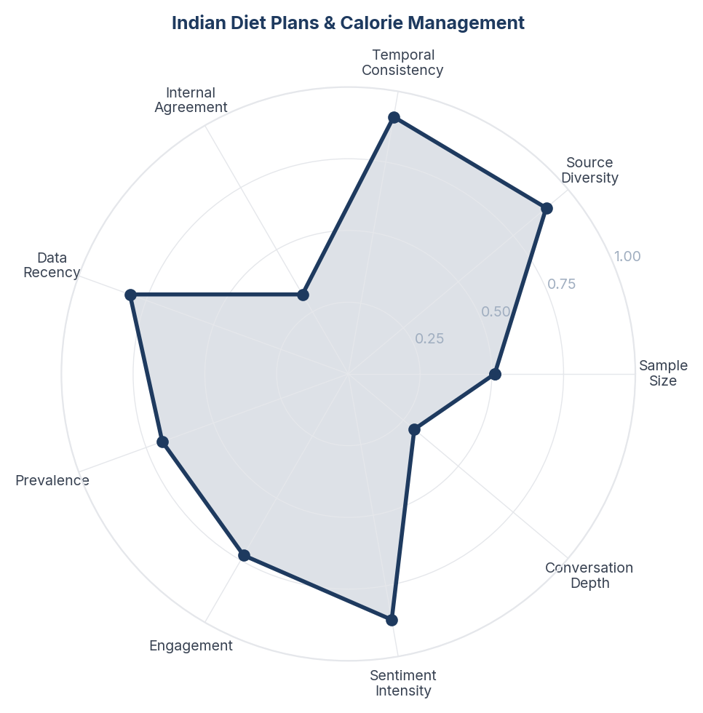
Score Breakdown: Indian Diet Plans & Calorie Management

What the Data Shows
Indian diet plans represent 13% of conversation (329 mentions) with strongly positive sentiment (+35.3%). The discussion centres on adapting weight loss to Indian staples - roti, dal, sabji, paratha, dosa, idli - rather than adopting Western diets. Calorie deficit awareness is high, with users sharing TDEE calculations and MyFitnessPal logs. YouTube doctors (Dr. Shikha Singh, Pooja Makhija) drive significant volume. Content spans Hindi, English, Tamil, and Telugu.

What it Means
The Indian weight loss consumer refuses to abandon their food culture for results. Unlike Western markets where diet plans often mean eliminating food groups, Indian consumers want to know how to make their existing rotis, dals, and rice work within a calorie deficit. This is not resistance to change - it is a sophisticated understanding that sustainable weight loss must be culturally embedded. The multilingual nature of this content shows it cuts across demographics.

Business Implication & Rationale
Any weight loss product or service that requires Indians to abandon their food culture will face adoption resistance. Conversely, solutions that work with Indian dietary patterns - helping consumers optimise their existing meals rather than replace them - have a significant market advantage.

Recommendation
Develop Indian-specific meal plans that show calorie-optimised versions of popular regional dishes (South Indian breakfast, Punjabi dinner, etc.). Create a macro calculator pre-loaded with common Indian foods and portion sizes. For GLP-1 brands, publish diet-while-on-medication guides featuring Indian food rather than Western meal plans.

Further Validation
Test whether Indian-food-specific diet content drives higher engagement and adherence than generic weight loss content. Survey regional food preferences to develop state-level meal plan templates.

Representative Voices
"Order tandoori roti / fulka instead of naans/paratha and refuse any butter/ghee on top
Avoid ordering gravies - try going for simpler dishes like aloo jeera or dal
Eat a side of chopped veggies for salad - most restaurants have this
Order and eat raita or curd with sugar - helps keep digestive ..." - reddit
"Eat more veggies. Eat less rice/roti/dosa/idli/whatever.
If possible eat raw/steamed veggies rather than stir-fried or deep-fried veggies." - reddit
"If you are in a south indian restaurant get curd rice. It will be good for your stomach. Get idli in instead of dosa or Vada. Rasam to drink would also be good.
In North Indian restaurant roti or rice with dal will be good. Or you can just do rice and raita. If you are in Mumbai you can get khichdi in restaurants." - reddit

05. PCOS, Hormones & Medical Weight Issues
n=416 | Confidence: 65% (Medium) | Signal: 66% (Moderate) | 16.5% of Dataset | NSS: +23%
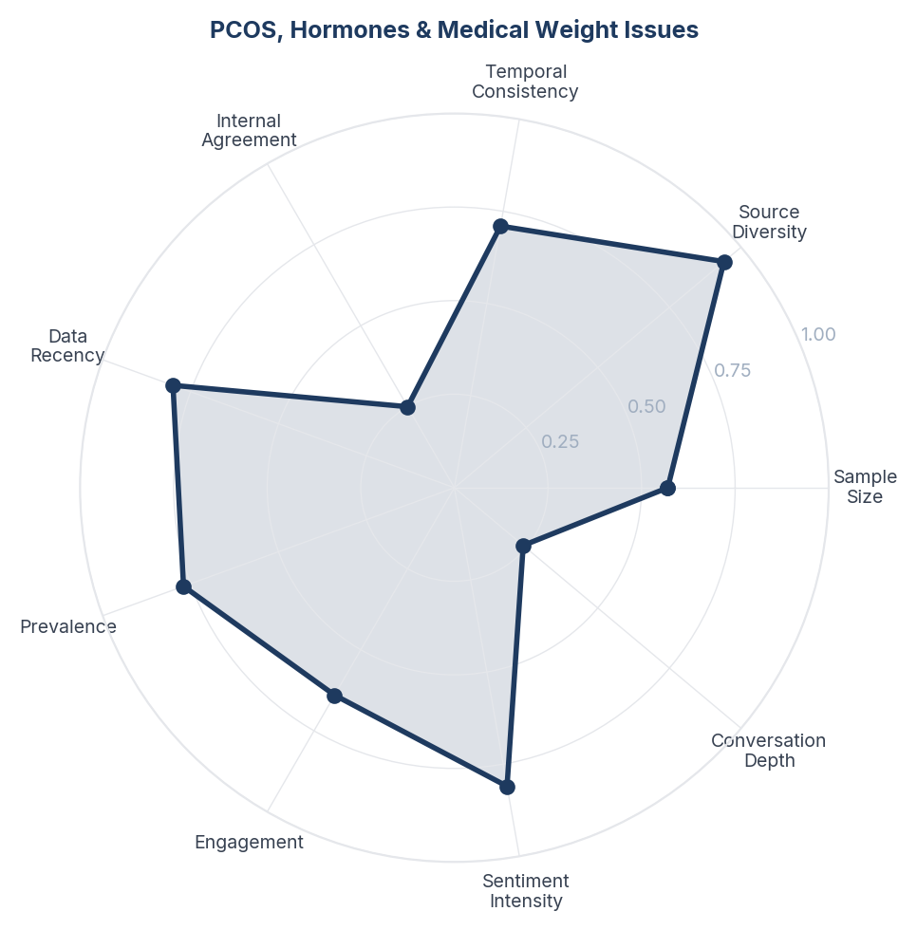
Score Breakdown: PCOS, Hormones & Medical Weight Issues

What the Data Shows
PCOS, hormonal, and medical weight issues account for 16.5% of conversation (416 mentions) with moderate positive sentiment (+22.6%). PCOS/PCOD is the most-discussed medical condition, followed by thyroid disorders, insulin resistance, and diabetes management. Women sharing personal PCOS weight struggles dominate Instagram, while Reddit and YouTube feature clinical discussions about metformin, hormonal treatment, and postpartum weight management.

What it Means
For a significant segment of Indian women, weight loss is not a lifestyle choice but a medical necessity entangled with reproductive health. PCOS affects an estimated 1 in 5 Indian women, and the weight-PCOS cycle (weight gain worsens PCOS, PCOS makes weight loss harder) creates a uniquely frustrating experience. These consumers are not looking for general weight loss advice - they need medically-informed solutions that address the hormonal root cause. The emotional intensity of this conversation (sadness, frustration) is notably higher than other themes.

Business Implication & Rationale
The PCOS-weight-loss segment is underserved by both the weight loss and pharmaceutical industries. Generic diet advice fails because it does not account for insulin resistance. GLP-1 drugs show particular promise here (dual action on weight and insulin sensitivity) but are not being marketed to this segment. Whoever builds the bridge between PCOS treatment and modern weight management will capture a loyal, medically-motivated audience.

Recommendation
Develop PCOS-specific weight management programmes that integrate GLP-1 medication with hormonal treatment, Indian dietary modifications, and cycle-aware exercise. Partner with gynaecologists (not just endocrinologists) as prescribing advocates. Create community support groups for women navigating the PCOS-weight cycle, with medical professional moderation.

Further Validation
Quantify the overlap between PCOS diagnosis and GLP-1 interest in the Indian market. Conduct clinical outcomes research on GLP-1 efficacy specifically in PCOS-related weight management among Indian women.

Representative Voices
"Go visit an endocrinologist, they'll help you out. GLP1s/ semaglutides are indeed available in India as we are thankfully one of the nations with the highest number of people with diabetes. However, you may not get "Ozempic" or it may cost you a lot as it's a name-brand product." - reddit
"Ozempic does have side effects but those who overdo it end up looking like this. Plus he is 50+ and severely underweight at this point. If used correctly, ozempic (glp1) doesn’t make one look this way. I can confirm, cuz i am on it (due to pcos and insulin resistance)." - reddit
"My husband and I are both diabetic. We have replaced white flour roti/naan and rice with quinoa and millet. I do millet pulao. Mainly we eat dal as soup. And subji we eat as stir fry or air fry. You don't have to eliminate carbs to lower blood sugar, you need to balance them with protein and fat and increase physical activity." - reddit

06. Weight Loss Transformations & Motivation
n=408 | Confidence: 65% (Medium) | Signal: 74% (Moderate) | 16.1% of Dataset | NSS: +48%
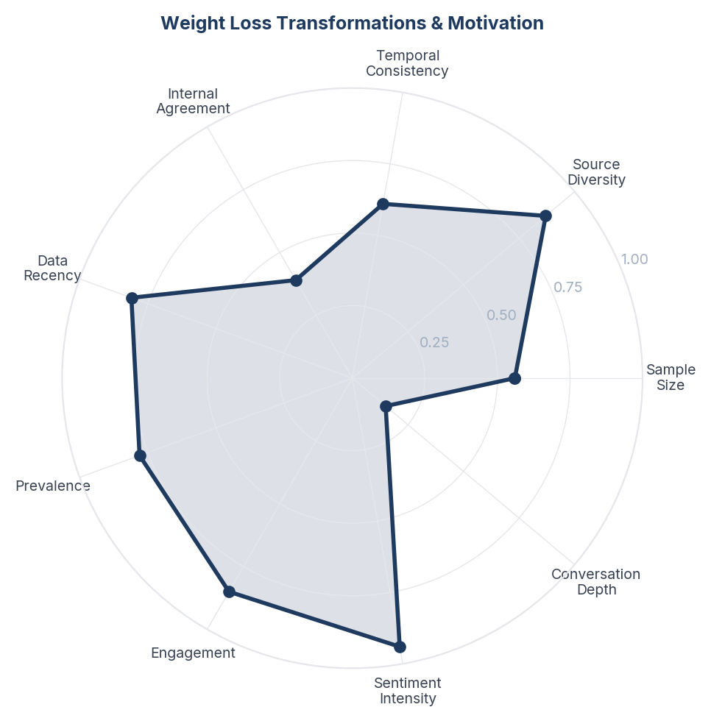
Score Breakdown: Weight Loss Transformations & Motivation

What the Data Shows
Transformation and motivation content has the highest positive sentiment in the dataset (+48.0%) with 408 mentions (16.2%). Before/after stories, progress updates, and motivational posts dominate Instagram. Celebrity weight loss (Tanmay Bhat, Anant Ambani) drives significant Reddit discussion. The content is aspirational but also practical - users share specific kg-lost numbers, timelines, and methods used.

What it Means
Transformation stories serve as the primary social proof mechanism in the Indian weight loss ecosystem. They function as peer-reviewed testimonials - consumers trust specific numbers ('lost 19 kgs in 5 months') from real people over clinical trial data. Celebrity transformations amplify this effect but also create unrealistic expectations. The Indian consumer needs to see someone like them succeed before they will commit to a method.

Business Implication & Rationale
User-generated transformation content is the most powerful marketing asset in this category. However, there is a credibility gap - consumers are increasingly sceptical of sponsored transformations and seek authenticity markers (specific timelines, honest setback reporting, real food shown). Brands that can curate authentic Indian transformation stories will outperform those relying on clinical messaging.

Recommendation
Build a structured transformation story programme featuring diverse Indian demographics (age, gender, city tier, starting weight, method used). Require honesty protocols - participants must report plateaus, side effects, and costs alongside results. Create a community platform where users can follow others at the same stage of their journey.

Further Validation
A/B test transformation-led content vs. clinical-evidence-led content in Indian digital advertising to measure conversion impact. Track whether transformation posts with specific numbers drive higher engagement than vague success stories.

Representative Voices
"You must break the pattern today or the loop will repeat tomorrow
(before and after weight loss weight loss journey transformation motivation fat to fit fitness inspiration obesity to fit body transformation health journey fitness motivation glow up) #weightloss #weightlosssupport #weightgainjourney #transformation" - instagram
"enjoy a sport
i used to love playing football
and lost 10kgs while also having a good time" - reddit
"She has taken ozempic. Good for her coz even after her crappy workouts , she wasnt showing progress and she is way too desperate to make it into the bollywood inner circle especially after her divorce hence resorting to ozempic and I respect that." - reddit

07. Cost, Access & Availability in India
n=319 | Confidence: 65% (Medium) | Signal: 57% (Moderate) | 12.6% of Dataset | NSS: +11%
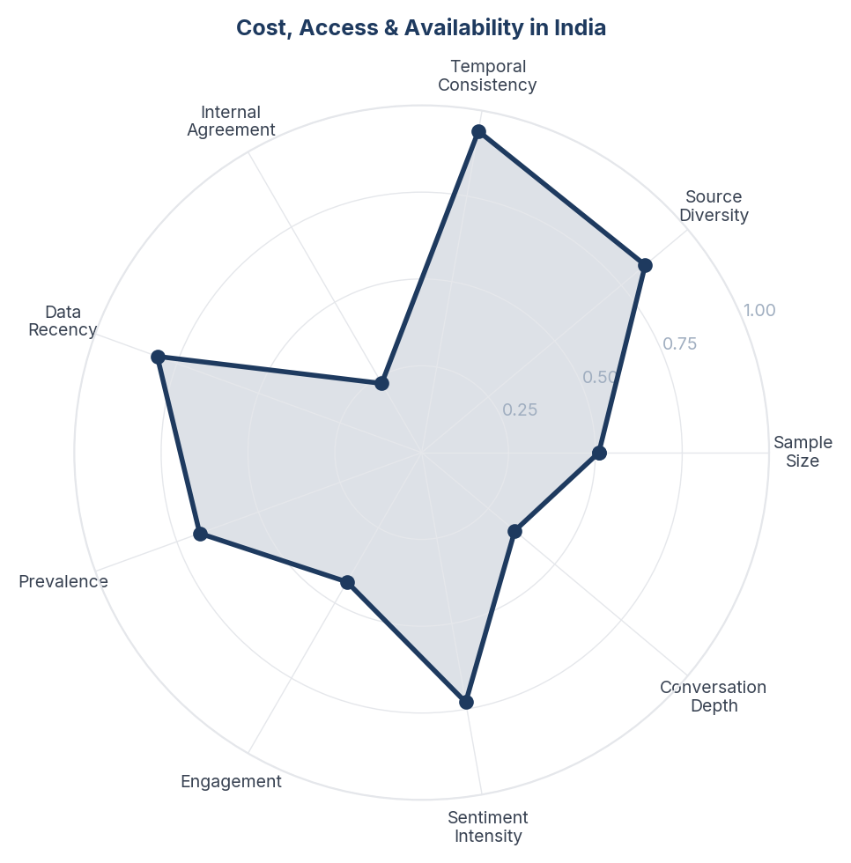
Score Breakdown: Cost, Access & Availability in India

What the Data Shows
Cost and access discussions comprise 12.6% of conversation (319 mentions) with cautious positive sentiment (+10.7%) - the lowest positive NSS among non-safety themes. Users compare drug prices between India and Western markets, discuss Natco Pharma's generic semaglutide potential, and note Mounjaro's India launch. Insurance coverage is a recurring concern. Compounding pharmacies and off-label prescriptions are discussed as workarounds.

What it Means
Cost is the silent gatekeeper of GLP-1 adoption in India. While consumers are aware that these drugs are cheaper in India than in the US, the monthly recurring cost (INR 5,000-15,000 for Mounjaro/Ozempic) is still prohibitive for most middle-income Indians. The active discussion of generics (Natco), compounding, and off-label use signals that demand exists but is price-constrained. The Indian consumer is not debating whether GLP-1 drugs work - they are calculating whether they can afford them long enough to get results.

Business Implication & Rationale
The Indian GLP-1 market will be won by the player that cracks affordability. Unlike Western markets where insurance subsidises cost, Indian consumers pay out-of-pocket. Generic entry (Natco) will dramatically expand the addressable market but also commoditise the category. First-movers on affordable pricing or subscription models will capture the price-sensitive majority.

Recommendation
Develop tiered pricing or subscription models that reduce the monthly out-of-pocket burden. Create transparent total-cost-of-treatment calculators that show 6-month and 12-month projections. Monitor Natco Pharma's generic semaglutide timeline closely - its launch will reshape the competitive landscape. Consider EMI or health financing partnerships to spread costs.

Further Validation
Conduct willingness-to-pay research across income segments. Model the market expansion potential of generic GLP-1 entry at various price points.

Representative Voices
"Houston weight loss clinic. $89 per visit once a month. They call in your prescription and you get it delivered. Price varies from 80-130 depending on the strength. That’s for 4 weeks of shots. 1 a week. They can also prescribe you the pills that help with the food cravings." - reddit
"(Article)
---
Until recently, Indians had few safe ways of joining the global craze for weight-loss drugs. Some smuggled them into the country when returning home from abroad; others chanced it with bootlegged versions from Dubai." - reddit
"The death toll from this insanity will be horrific. Couple unaffordable meds, insurance price spikes to cover the increases (with big ticket drugs being dropped from policies Jan 1st), and RFK's anti-health rampage, the US is gonna top the body count of Trump's first term.
PS: This will bankrupt Medicare." - reddit

08. GLP-1 Side Effects & Safety Concerns
n=286 | Confidence: 63% (Medium) | Signal: 63% (Moderate) | 11.3% of Dataset | NSS: -11%
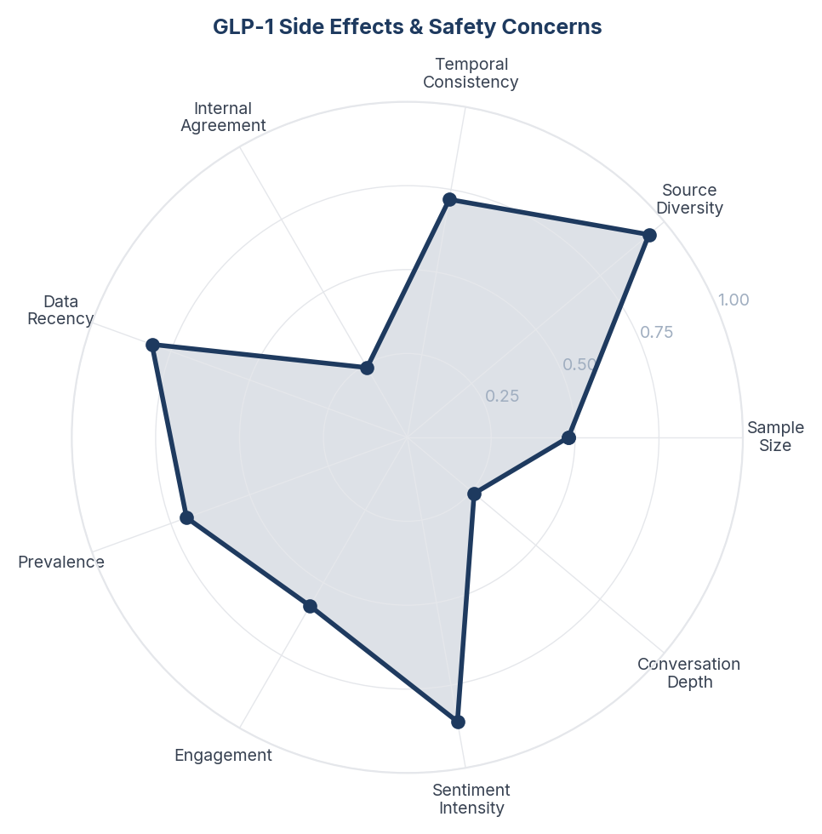
Score Breakdown: GLP-1 Side Effects & Safety Concerns

What the Data Shows
Safety concerns represent 11.3% of the conversation (286 mentions) with the only negative NSS in the dataset (-11.2%). Nausea, sulphur burps, fatigue, and muscle mass loss are the most frequently cited side effects. More alarming concerns about gastroparesis, pancreatitis, and 'Ozempic face' appear in Reddit threads. The conversation is notably cross-platform - Instagram users share personal side effect experiences, YouTube features doctors explaining risks, and Reddit hosts detailed clinical discussions.

What it Means
Indian consumers have a heightened fear-to-trust ratio with GLP-1 drugs compared to general weight loss topics. The safety conversation is not just about discomfort (nausea, bloating) but about fundamental body integrity - muscle loss and facial ageing (Ozempic face) are particularly alarming to a culture that values physical appearance and strength. The fact that doctors on YouTube are actively addressing these concerns suggests they are hearing them repeatedly from patients.

Business Implication & Rationale
Safety concerns are the primary conversion blocker for the Indian GLP-1 market. Consumers who have done their research are not worried about whether these drugs work - they are worried about what else these drugs do. Any brand communication that minimises side effects will lose credibility with this informed audience.

Recommendation
Create a transparent side effect guide in Hindi and English that ranks side effects by frequency and severity, with clear protocols for when to call a doctor. Develop content around 'GLP-1 + strength training' protocols to address the muscle loss fear directly. Never use language that dismisses side effects - acknowledge them and provide management strategies.

Further Validation
Conduct a fear-mapping study among prospective GLP-1 users to rank safety concerns by severity. Monitor whether muscle-loss and Ozempic-face concerns are increasing or stabilising over time.

Representative Voices
"Nausea and vomiting is the main side effects
But serious one is acute pancreatitis so medicine people" - reddit
"⚠️ The Dark Side of Ozempic: What You Should Know ⚠️
Ozempic (semaglutide) has gained massive popularity as a weight-loss aid, but it was originally designed as a medication for type 2 diabetes to help regulate blood sugar." - instagram
"Ozempic (semaglutide) is a medication used to treat type 2 diabetes and assist with weight management." - instagram

09. Food Industry, Junk Food & Ultra-Processed
n=164 | Confidence: 63% (Medium) | Signal: 55% (Moderate) | 6.5% of Dataset | NSS: +23%
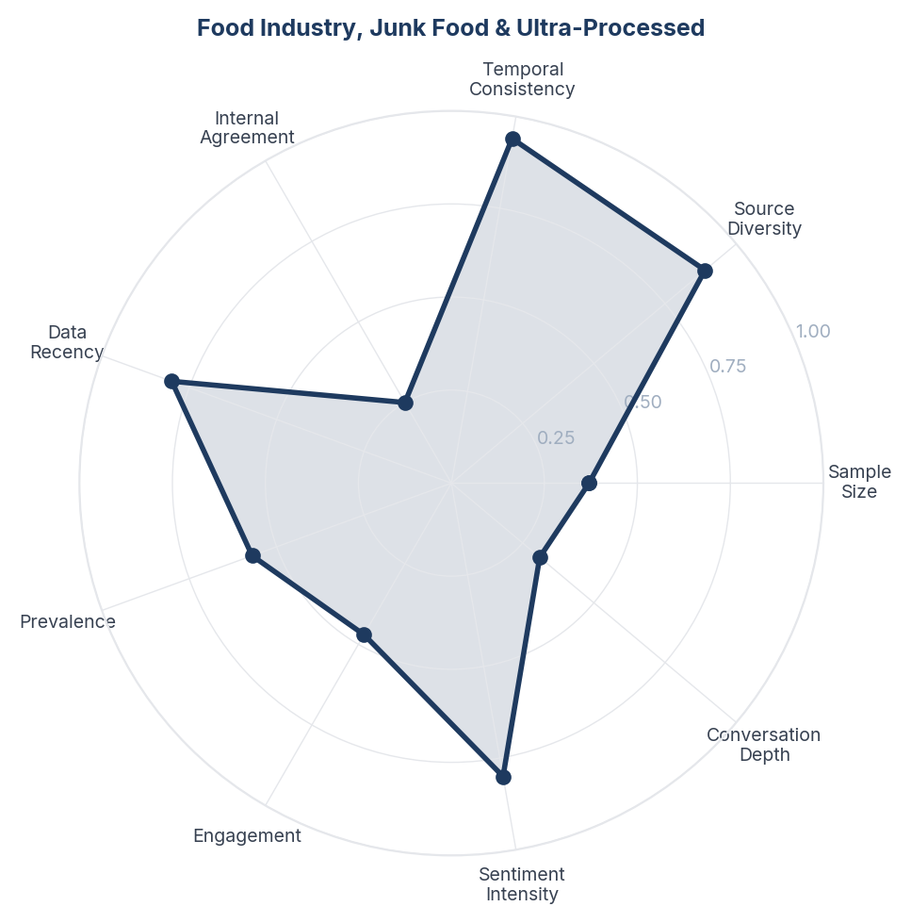
Score Breakdown: Food Industry, Junk Food & Ultra-Processed

What the Data Shows
Food industry and ultra-processed food discussions account for 6.5% of conversation (164 mentions) with moderate positive sentiment (+22.6%). The narrative centres on GLP-1 drugs disrupting junk food demand, food addiction as a root cause of obesity, and growing awareness of ultra-processed food harms. Swiggy and Zomato delivery culture is implicated as an enabler of unhealthy eating. The phrase 'food noise' (a GLP-1 term for reduced food obsession) appears as a revelatory concept.

What it Means
Indian consumers are beginning to reframe obesity from a willpower failure to a systemic problem created by food industry design and delivery-app convenience. The concept of 'food noise' - which GLP-1 users describe as the constant mental chatter about food that medication silences - is a breakthrough framing that resonates deeply with consumers who have tried and failed at willpower-based dieting. This represents a paradigm shift: the enemy is not the consumer's weakness but the food environment's strength.

Business Implication & Rationale
The 'food noise' concept is a powerful marketing and educational tool for GLP-1 brands because it shifts the weight loss conversation from blame to biology. Simultaneously, the growing anti-ultra-processed-food sentiment creates headwinds for packaged food companies and tailwinds for clean-label, whole-food brands. Delivery platforms (Swiggy, Zomato) face reputational pressure to offer healthier options.

Recommendation
For GLP-1 brands: lead with the 'food noise' concept in consumer education - it destigmatises medication use by framing weight gain as neurological rather than behavioural. For food companies: accelerate healthy product development before the regulatory and cultural pressure intensifies. For delivery platforms: create prominent 'healthy choice' categories and calorie-labelled menus to stay ahead of the backlash.

Further Validation
Measure consumer awareness and resonance of the 'food noise' concept in India. Track whether anti-ultra-processed-food sentiment is translating into actual purchasing behaviour shifts on delivery platforms.

Representative Voices
"I can personally attest to this. Struggled with alcoholism for the past few years and started Semaglutide 2 months ago. I don’t have the food noise or craving to consume alcohol anymore. And I’m losing weight. It’s been great." - reddit
"At this point we have to assume all ultra-processed foods (soft drinks, instant noodles, packed chips and sweets) have harmful ingredients in them and stay away from them as much as possible.
There is no better substitute for plant-based whole food diet." - reddit
"Wow, this is wild to me, but also confirms what I've always suspected. I've been on strict CICO (Calories in, calories out) for years now, and noticed that when those calories come from garbage food, they have MUCH more of an impact on my gains." - reddit

10. Bollywood & Celebrity Weight Loss Speculation
n=185 | Confidence: 62% (Medium) | Signal: 64% (Moderate) | 7.3% of Dataset | NSS: +20%
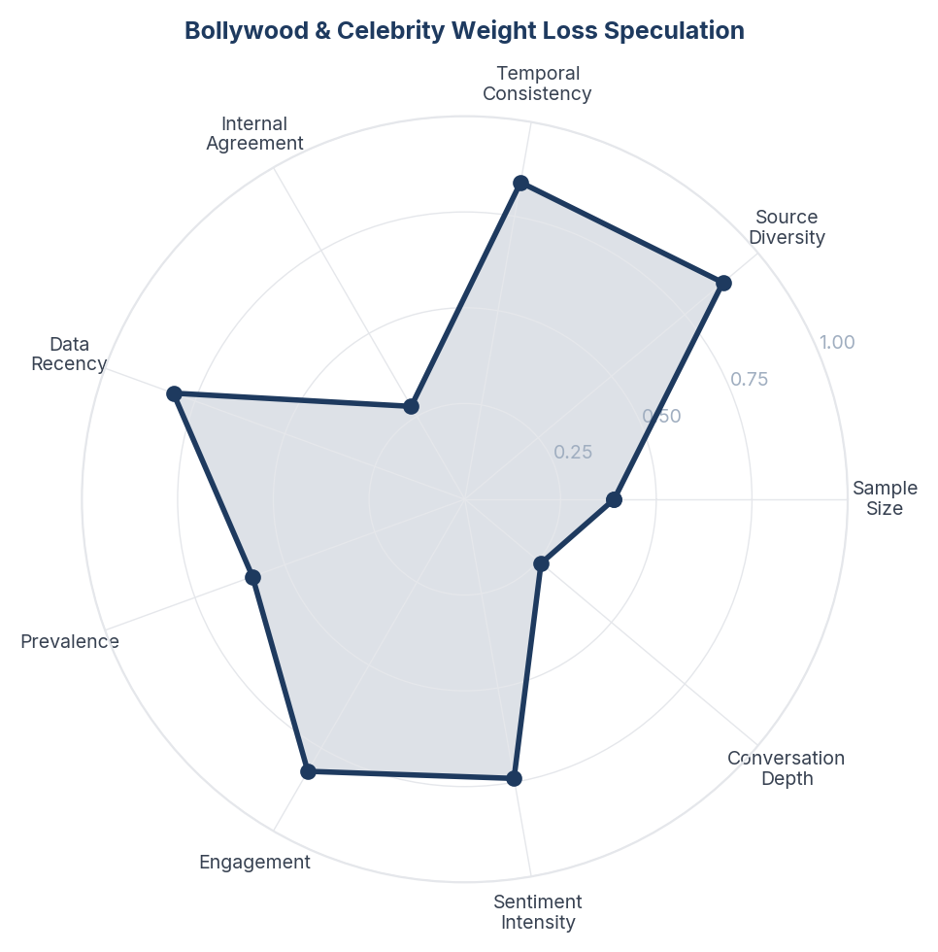
Score Breakdown: Bollywood & Celebrity Weight Loss Speculation

What the Data Shows
Celebrity weight loss speculation dominates 191 items (7.6% of corpus) across all 3 platforms with moderately positive sentiment. Reddit hosts heated debates about whether Karan Johar, Bhumi Pednekar, Kapil Sharma, and Vidya Balan used Ozempic. Instagram features celebrity-adjacent content (Bollywood diet routines, transformation reels). The dominant narrative is accusation - consumers believe most celebrity weight loss is drug-assisted and are frustrated by the lack of transparency.

What it Means
Bollywood celebrities have become the unwitting marketing vehicle for GLP-1 drugs in India - not through endorsement but through speculation. Every visible celebrity transformation triggers a cycle of 'definitely Ozempic' accusations, which simultaneously normalises awareness of these drugs and attaches stigma to using them. The Indian consumer has developed a sophisticated 'detection radar' for drug-assisted weight loss (sunken face, rapid timeline, lack of muscle definition) and applies it mercilessly to public figures. The paradox: celebrities who admit to Ozempic (like Oprah internationally) are respected for honesty, while those who deny it (most Bollywood) are mocked as dishonest.

Business Implication & Rationale
Celebrity weight loss is the single largest organic awareness driver for GLP-1 drugs in India, yet it operates entirely through suspicion rather than endorsement. This creates a unique brand challenge: the drugs are famous but carry a 'vanity' stigma. Any brand strategy that relies on traditional celebrity endorsement will backfire - the consumer already assumes celebrities use these drugs and will see paid endorsement as hypocritical confirmation.

Recommendation
Avoid celebrity endorsements for GLP-1 brands in India - the market has already priced in celebrity usage as assumed fact. Instead, create content addressing the transparency gap directly: 'Why people use GLP-1 and why that is okay.' Partner with celebrities who have been open about their methods (Tanmay Bhat, who is credited as genuinely working out) rather than those under suspicion. Use the Bollywood speculation as a cultural hook for educational content that redirects from gossip to science.

Further Validation
Track whether celebrity Ozempic speculation correlates with search volume spikes for GLP-1 drugs in India. Survey consumers on whether celebrity usage makes them more or less likely to consider these drugs themselves.

Representative Voices
"Nobody wants to know anyone’s medical history! The problem is with the elaborate lies woven during interviews.
The likes of Vidya Balan, KJo, Ram Kapoor, even Kusha - have been trolled for their weight practically forever." - reddit
"Its ozempic, its not something new everyone takes it including ram kapoor, kjo and vidya balan" - reddit
"Some Insider Tea About Ahaan Panday (Plus a Dash of Ibrahim Ali Khan & KJo Drama)
Some Insider Tea About Ahaan Panday (Plus a Dash of Ibrahim Ali Khan & KJo Drama)
Have some insider info about the behind the scenes of Ahaan’s launch and some industry thoughts, plus did my own research with some facts." - reddit

11. Misinformation, Miracle Claims & Debunking
n=203 | Confidence: 62% (Medium) | Signal: 63% (Moderate) | 8.0% of Dataset | NSS: +4%
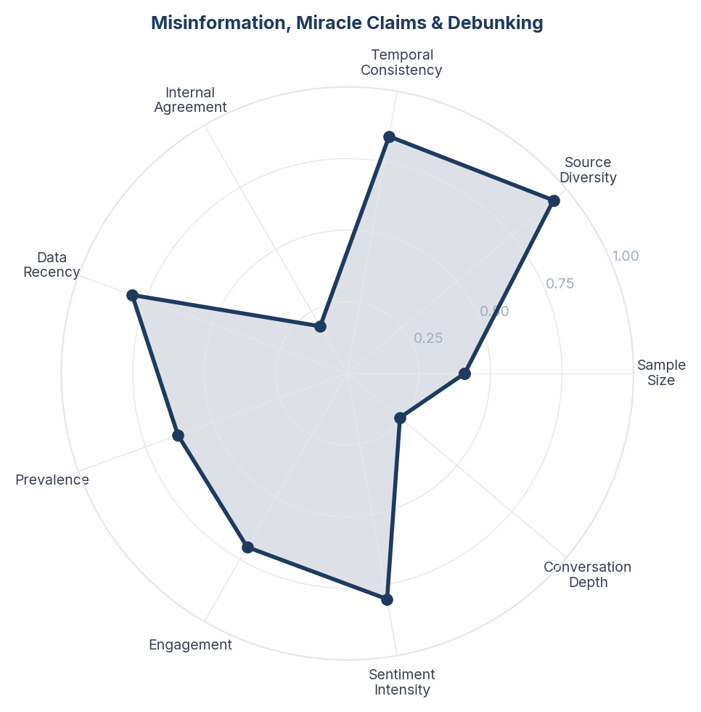
Score Breakdown: Misinformation, Miracle Claims & Debunking

What the Data Shows
Misinformation and miracle claims account for 217 items (8.6% of corpus) spanning fear-based content ('Ozempic destroys your body'), miracle framing ('lose 10kg in 10 days'), pseudoscience (Gila monster venom narratives), and fact-checking responses. The conversation is bifurcated: Instagram hosts the most misleading content (miracle claims from health influencers, unverified side effect horror stories), while Reddit and YouTube host the debunking (doctors correcting misinformation, users sharing evidence-based perspectives).

What it Means
The Indian weight loss information ecosystem is polarised between two competing content factories: Instagram's influencer-driven miracle-claim economy and Reddit/YouTube's evidence-based correction community. The misinformation is not random - it follows a predictable pattern. Step 1: An influencer frames a drug as a miracle or a danger (both drive engagement). Step 2: A doctor or informed user posts a correction. Step 3: The correction reaches a fraction of the original audience. The net effect is that the Indian consumer is simultaneously over-exposed to sensational claims and under-exposed to calibrated medical information.

Business Implication & Rationale
Misinformation is not just a public health concern - it is a direct commercial threat to GLP-1 brands. Fear-based misinformation (muscle wasting, permanent damage, venom-based) deters potential users. Miracle-framing (quick fix, no effort needed) attracts the wrong users who will be disappointed and generate negative word-of-mouth. Both distort the market conversation away from the drugs' actual clinical profile.

Recommendation
Fund an independent, doctor-led content initiative in Hindi and English that proactively addresses the top 10 misinformation themes. Create a 'myth vs fact' content series specifically for Instagram (where the misinformation is concentrated) using the same short-form, high-engagement format that spreads the misinformation. Partner with medical professionals who already have trust on YouTube (Dr. Pal, Dr. Balamurugan) to create corrective content that ranks alongside misleading videos.

Further Validation
Map the specific misinformation claims by volume and platform to prioritise debunking efforts. Track whether corrective content reduces fear-based objections in subsequent consumer conversations.

Representative Voices
"Yeah I’m aware of TheLiverDoc’s twitter post about Herbalife and all the other resources like Pune’s research papers on contamination, John Oliver’s debunking video, the Netflix documentary. I tried explaining all of that to many people, they just say they are all Big Pharma scams to defame Herbalife." - reddit
"Please no protinex! It has very less protein per serve and very high added sugar.
Try the Whole Truth protein powder, Optimum Nutrition (be careful about fakes, don't buy this from Flipkart or any unreliable seller)." - reddit
"Thank you for this post! Obviously healthy balanced eating is important for overall and skin health, but it gets taken to the extreme with these myths" - instagram

12. Ayurveda, Traditional & Alternative Remedies
n=134 | Confidence: 61% (Medium) | Signal: 67% (Moderate) | 5.3% of Dataset | NSS: +37%
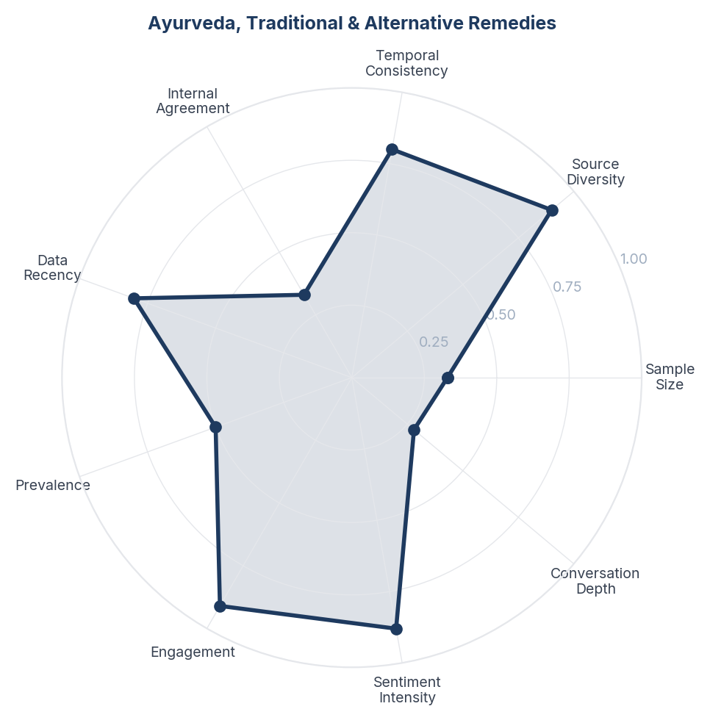
Score Breakdown: Ayurveda, Traditional & Alternative Remedies

What the Data Shows
Ayurveda and alternative remedies represent 5.3% of conversation (134 mentions) with surprisingly positive sentiment (+37.3%). However, the conversation is deeply polarised - passionate advocates promote turmeric, amla, ashwagandha, and triphala for weight loss while equally vocal critics call out Herbalife as a scam and AYUSH as dangerous pseudoscience. Detox drinks (green tea, jeera water, lemon water) occupy a middle ground as low-risk traditional practices.

What it Means
The Indian weight loss market operates on a dual-track belief system: modern medicine and traditional remedies are not seen as mutually exclusive but as complementary layers. Even consumers interested in GLP-1 drugs simultaneously consume turmeric milk and green tea. However, there is a growing sophistication gap - educated urban consumers are becoming vocally anti-pseudoscience (the Herbalife and AYUSH criticism) while still embracing evidence-backed Ayurvedic ingredients. The scam-awareness around MLM nutrition products (Herbalife) represents a broader trust erosion that affects all alternative health products.

Business Implication & Rationale
Brands entering the Indian weight loss market must navigate the traditional-vs-modern tension carefully. Dismissing Ayurveda alienates a large cultural audience; endorsing unproven remedies loses credibility with the evidence-seeking segment. The opportunity lies in 'evidence-based traditional' positioning - Ayurvedic ingredients with clinical backing.

Recommendation
Do not position modern weight loss solutions in opposition to traditional remedies. Instead, create 'complementary care' messaging that respects cultural practices while being transparent about what has clinical evidence and what does not. For Ayurvedic brands: invest in clinical trials for ingredients like ashwagandha and triphala to earn evidence-based credibility. Distance from MLM models which are damaging the category.

Further Validation
Conduct a belief-mapping study to understand which traditional remedies Indian consumers use alongside modern weight loss methods. Measure the sales impact of the anti-Herbalife/anti-MLM sentiment on legitimate traditional health products.

Representative Voices
"AIIMS doctors were against it.
Science and religion do not mix.
I have seen patients suffer the consequences.
Yoga has benefits.
Globally, homeopathy and ayurveda is banned except in countries like nepal and Germany (homeopathy )
Most AYUSH doctors prescribe modern medicines without adequate knowledge.
What studies are u talking about." - reddit
"COVID itself increases heart attack risk. I am a doctor, no AYUSH medicine saved people from COVID. My parents worked as doctors in rural area - they have seen it firsthand, they are NOT AYUSH doctors. Dont spread false information.
My colleagues have handled icu patients during peak Covid time. The scenes in the ICU were horrifying." - reddit
"Ayurveda is pseudoscience sure but atleast it's not thoroughly discredited like homeopathy" - reddit

13. Intermittent Fasting & Eating Patterns
n=56 | Confidence: 59% (Medium) | Signal: 62% (Moderate) | 2.2% of Dataset | NSS: +39%
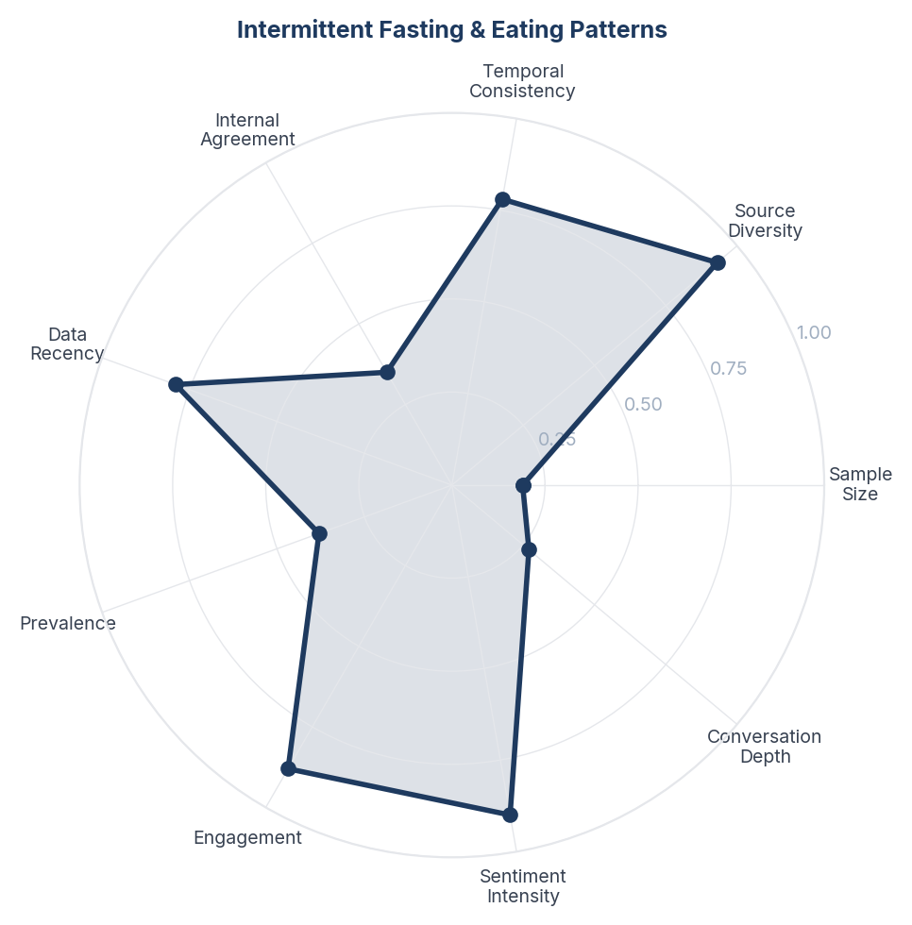
Score Breakdown: Intermittent Fasting & Eating Patterns

What the Data Shows
Intermittent fasting appears in 2.2% of conversation (56 mentions) with the highest positive sentiment of any method (+39.3%). 16:8 and OMAD are the most discussed protocols. Users describe IF as 'free' and 'simple' - requiring no products, no subscriptions, and no medical supervision. It is frequently combined with calorie deficit as a dual strategy.

What it Means
Intermittent fasting has captured the Indian cost-conscious, self-reliant weight loss consumer - the segment that wants results without spending money or depending on professionals. Its appeal is rooted in cultural familiarity (religious fasting practices like Navratri, Ramadan, Ekadashi are already normalised) and the practical reality that many Indian working professionals already skip breakfast or eat late. IF is not perceived as a 'diet' but as an 'eating schedule' - a framing that reduces psychological resistance.

Business Implication & Rationale
IF represents both a competitor and a complement to pharmaceutical weight loss solutions. It captures consumers who might otherwise consider GLP-1 drugs but cannot afford them. However, it also serves as an on-ramp - users who plateau on IF alone may graduate to medication. The cultural alignment with fasting traditions gives IF a unique advantage in India that it does not have in Western markets.

Recommendation
Do not position against intermittent fasting - it has strong cultural resonance. Instead, create content showing how IF can be combined with other approaches (GLP-1 medication, structured exercise) for enhanced results. For nutrition brands: develop IF-friendly products (breaking-fast meals, electrolyte supplements for fasting windows). Acknowledge the religious fasting connection explicitly in marketing.

Further Validation
Measure the overlap between IF practitioners and GLP-1-interested consumers. Survey whether IF users who plateau are open to pharmaceutical augmentation.

Representative Voices
"For some people intermittent fasting does not work, in return gives you bloating. So listen to your body and decide accordingly" - reddit
"Ok maybe controversial but my friend lost half her body weight with pcos. Yes, half. She did intermittent fasting over a long period of time. I was also losing weight at that point and we basically naturally lowered our portions together. We eat out at restaurants a lot and don’t shame each other for eating small portions." - reddit
"Fasting is amazing!!! I recommend the fast like a girl book! One thing with fasting is it curbs those mindless snacking and really makes you choose which foods you want to eat in your eating period" - reddit

14. Stigma, Shame & the 'Shortcut' Debate
n=143 | Confidence: 58% (Medium) | Signal: 60% (Moderate) | 5.7% of Dataset | NSS: +24%
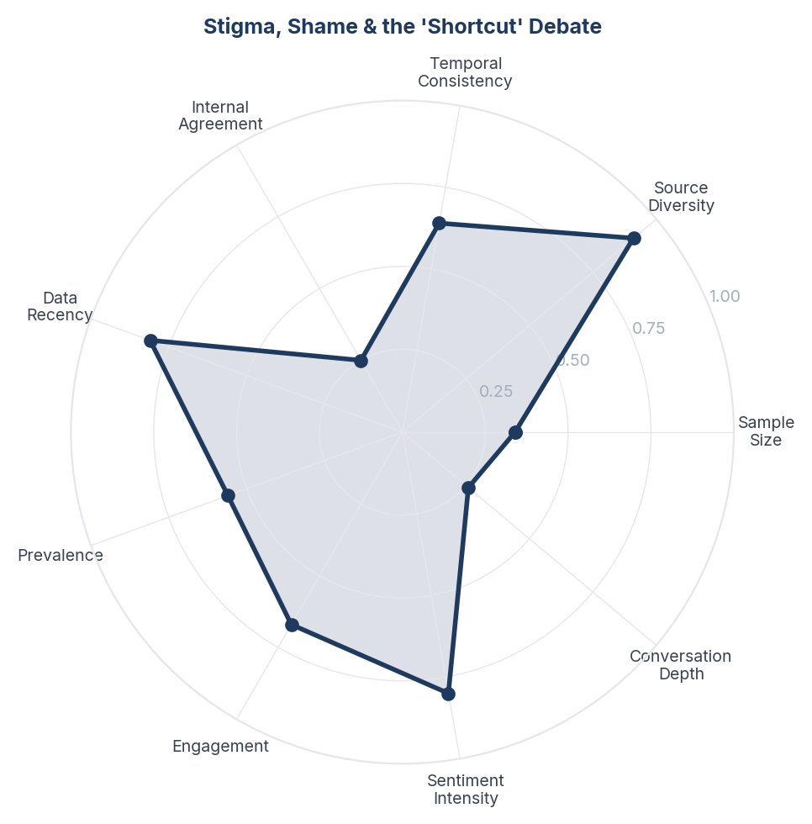
Score Breakdown: Stigma, Shame & the 'Shortcut' Debate

What the Data Shows
The 'shortcut' debate appears in 98 items (3.9% of corpus) with deeply mixed sentiment. Consumers are divided between those who view GLP-1 drugs as a legitimate medical tool ('is taking an antibiotic a shortcut for infection?') and those who frame it as moral failure ('lazy people who can not discipline themselves'). Body shaming and weight stigma permeate both sides. The debate intensifies when celebrities are involved - their perceived 'easy access' to drugs fuels resentment from consumers who struggle to afford or access the same medication.

What it Means
Indian consumers are caught between two cultural narratives about weight loss: the traditional 'discipline and willpower' narrative (reinforced by yoga culture, Ayurvedic traditions, and family pressure) and the emerging 'medical intervention is valid' narrative (supported by global medical consensus and GLP-1 clinical evidence). The shortcut debate is not really about drugs - it is about whether the Indian consumer gives themselves permission to seek help rather than suffer through willpower alone.

Business Implication & Rationale
The shortcut stigma is the invisible ceiling on GLP-1 adoption in India. Even consumers who want these drugs hesitate because of internalised shame - they have been told their entire lives that weight loss should come from discipline and willpower. The medical reframing (obesity as a metabolic condition, not a character flaw) has not yet reached mainstream Indian consciousness. Until this cultural barrier is addressed, a significant segment of potential users will suffer in silence rather than seek pharmaceutical help.

Recommendation
Reframe GLP-1 communication from 'weight loss drug' to 'metabolic health treatment' - this shifts the conversation from vanity to health. Create patient testimonial content that explicitly addresses the shame: 'I felt guilty about taking medication until my doctor explained that obesity is a disease, not a choice.' Partner with mental health professionals to address the psychological barriers to seeking treatment, not just the physical ones.

Further Validation
Conduct qualitative research (in-depth interviews) with Indian consumers who considered but did not start GLP-1 medication to understand the specific shame and stigma barriers. Measure whether medical reframing ('metabolic treatment' vs 'weight loss drug') changes willingness to adopt.

Representative Voices
"Thank you. I enjoy it more than a gym because I can work out alone and not feel judged, but just wish the instructor seemed a bit more realistic and relatable." - reddit
"I was a diehard evening workout person but I’ve had to change that recently with this job. Even if I’m not working in the evenings, I’m so drained mentally - zero willpower or discipline or motivation - that my workouts were just not happening. So I’ve shifted recently to mornings and I’m far more consistent that way." - reddit
"With due respect, this is a misleading generalisation.
Badshah’s transformation is the result of 3+ years of structured training and lifestyle changes, not shortcuts.
He has worked consistently with @thefit_ceo , and that effort deserves acknowledgment." - instagram

15. Bariatric Surgery & Medical Procedures
n=73 | Confidence: 56% (Medium) | Signal: 46% (Weak) | 2.9% of Dataset | NSS: +19%
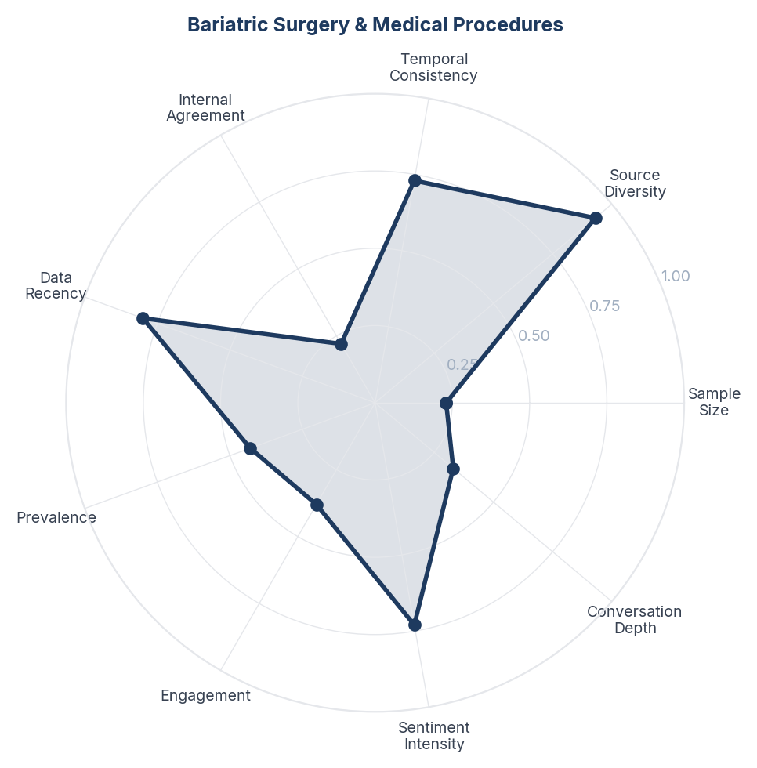
Score Breakdown: Bariatric Surgery & Medical Procedures

What the Data Shows
Bariatric surgery accounts for 2.9% of conversation (73 mentions) with cautiously positive sentiment (+19.2%). The discussion centres on surgery as a last resort for severe obesity (BMI >35-40). Doctors (Dr. Balamurugan, bariatric surgeons from South India) feature prominently on YouTube explaining procedures. Comparisons between bariatric surgery and GLP-1 medication are emerging, with consumers weighing permanent surgical intervention against long-term medication.

What it Means
Bariatric surgery occupies the 'nuclear option' position in the Indian weight loss hierarchy - consumers view it as effective but irreversible, and the decision process is lengthy and fear-laden. The emergence of GLP-1 drugs is creating a new decision fork: consumers who might have considered surgery are now evaluating medication as a less invasive alternative. This is reshaping the patient journey from 'fail at dieting then consider surgery' to 'fail at dieting then try medication then consider surgery'.

Business Implication & Rationale
The bariatric surgery market in India will be disrupted by GLP-1 adoption, but not eliminated. Surgery remains the superior option for severe obesity and has the advantage of being a one-time intervention vs. perpetual medication. The market will bifurcate: GLP-1 for moderate obesity, surgery for severe cases, with an overlapping contested middle ground.

Recommendation
For bariatric centres: develop clear patient decision frameworks that help consumers choose between medication and surgery based on BMI, comorbidities, and lifestyle factors. Do not position against GLP-1 drugs - offer them as part of a continuum of care. For GLP-1 brands: be transparent about the population for whom medication alone is insufficient and surgery may be more appropriate.

Further Validation
Track whether GLP-1 availability is reducing bariatric surgery consultation rates in Indian metros. Survey bariatric surgeons on how GLP-1 drugs are changing their patient pipeline.

Representative Voices
"This. I worked in an academic obesity & metabolism clinic. The dietitians shared an office with the endocrinologists and would directly discuss and coordinate care plans about patients. The nurses were virtually experts on educating patients about how to dose and inject their medications." - reddit
"Plastic surgery is addictive. Once you get it, there's no stopping you. You constantly want to be a little more 'perfect' and tweak your face again and again. It creates immense insecurity about natural features.
Fuckin Courteney Cox(who was drop dead gorgeous naturally) got insecure and ruined her face." - reddit
"Join some NZ based bariatric Facebook pages and you will get all of the information you will ever need. There is so much info that is searchable and you will get wayyyy more responses/info on Facebook vs Reddit." - reddit

Brand Health Score
Overall Brand Health Score: 81/100
Brand Health Score is a composite index built from five data-driven components. No subjective weighting is applied - all inputs are derived from the collected corpus.
Component | Score | Methodology
Sentiment Component (30%) | 61.5 | Derived from NSS across all items. Reflects the ratio of positive to negative consumer language.
Engagement Component (25%) | 97.4 | Average engagement (upvotes, likes, comments) normalised to platform benchmarks.
Advocacy Component (20%) | 100.0 | Proportion of items containing explicit recommendation or repurchase intent language.
Resilience Component (15%) | 97.3 | Sentiment consistency across platforms and time periods.
Conversation Component (10%) | 34.0 | Volume and depth of organic brand conversation (non-promotional threads).
Note: The Conversation Component (34/100) is the lowest-scoring factor. This reflects that most brand mentions occur in reaction to advertising, campaigns, and celebrity content rather than unprompted consumer-initiated discussion. Organic brand conversation is thin relative to engagement volume - a pattern consistent with a brand consumers transact with rather than one they actively champion.

Methodology

Pipeline Overview
- Stage 0 - Brief Structured research brief defines brand, competitors, geography, business objectives, and keyword seed list.
- Stage 1 - Collect Automated collection across Instagram, Reddit, Youtube. Engagement-minimum filters applied at collection time.
- Stage 2 - Normalize Thread-level deduplication (comments capped per thread). Deterministic SHA-256 item IDs prevent re-collection of duplicates across runs.
- Stage 3 - Filter LLM relevance classification (claude-sonnet-4-20250514). Each item classified as relevant/irrelevant with a reason. Multilingual support enabled.
- Stage 4 - Analyze Sentiment (positive/negative/neutral/mixed) + Plutchik 8-emotion classification in a single LLM call. ABSA: per-aspect sentiment extracted. Two-pass theme extraction: (a) discovery on stratified sample to identify candidate themes; (b) full-corpus mapping of all items to themes in batches.
- Stage 5 - Synthesize One insight per theme, mandated by prompt. Insight structure: Observation - Insight - Implication - Recommendation - Further Validation.
- Stage 6 - Score Fully data-driven scoring. Confidence: 5 factors (sample size, source diversity, temporal consistency, internal agreement, data recency). Signal Strength: 4 factors (prevalence, engagement, sentiment intensity, conversation depth). Brand Health Score: 5 components.
- Stage 7 - Report Google Doc-compatible DOCX with inline charts, block-quoted verbatims, and full data tables.

Scoring Formulas

Confidence Score
Confidence = (sample_size x 0.25) + (source_diversity x 0.25) + (temporal_consistency x 0.15) + (internal_agreement x 0.2) + (data_recency x 0.15)

Signal Strength Score
Signal = (prevalence x 0.35) + (engagement x 0.3) + (sentiment_intensity x 0.2) + (conversation_depth x 0.15)

Net Sentiment Score (NSS)
NSS = (positive_count - negative_count) / total_count. Range -1.0 to +1.0. Industry standard: Brandwatch, Sprinklr, YouGov.

Quality Gates
- Grounded (≥3 sources cited)
- Non-obvious (not derivable from common knowledge)
- Actionable (leads to a concrete business decision)
- Specific (not vague platitude)
- Falsifiable (could be proven wrong with additional data)

Data Provenance
All data is sourced from publicly available online conversations. No personally identifiable information (PII) is stored or reported.
Source | Content Type | Access Method | Items in Corpus
Reddit | Forum discussions, comments | Public JSON API | 1,397
Instagram | Posts, reels, comments | Platform API / external collection | 975
YouTube | Video descriptions, comments | YouTube Data API v3 | 154
Corpus composition: 837 posts and 1,689 comments. Each comment is treated as an independent item linked to its parent post for thread-level analysis.

Geographic Coverage
Primary: India. Content selected and filtered for relevance to the India market context. Items originating from other geographies are retained where they contribute relevant consumer perspective (e.g., diaspora experiences, cross-market comparisons).

Temporal Coverage
Data range: Feb 2024 - Feb 2026 (24 months). Items span the full collection period with no temporal exclusion applied at normalization.

Demographic Accuracy
This methodology explicitly documents platform-level composition so that interpretation accounts for known biases: Instagram skews female, urban, and 18-34 with strong influencer and health-creator content that shapes but does not represent consumer opinion; Reddit skews male, urban, and 18-34; YouTube is more balanced across gender but skews younger audiences; creator content dominates over consumer discussion. These biases are documented rather than hidden. For verified demographic breakdowns, commission a structured survey targeted to the same research questions, using this report's insights as the stimulus.

