Make in India
Research Report: Consumer Sentiment & Brand Perception
Analysis Date: April 2026

Research Objectives
- Understand public sentiment toward the Make in India initiative
- Map consumer purchase behaviour - buying Indian over imported
- Assess Vocal for Local adoption and sustainability
- Identify quality perception gaps vs imports
- Surface sector-specific perceptions
- Understand US-India tariff impact on the conversation
- Explore nationalism vs pragmatism tension
- Assess Indian startup and D2C brand perception

Summary of Data and Findings
Items Analysed | 5,814
Insights Identified | 16
Net Sentiment Score | +15.9%
Brand Health Score | 55/100
Data Sources | 4 platforms

Data Universe

Collection Funnel
Of 282,355 raw data points collected across all sources, 23,461 remained after deduplication and engagement filtering, and 5,814 passed LLM relevance classification (2.1% of total collected). These 5,814 items form the analysis corpus.
Stage | Items | Notes
Raw collected | 282,355 | All posts, comments, articles and videos gathered across all platforms
After deduplication & engagement filter | 23,461 | Thread dedup (max 5 comments/thread), min engagement (Reddit ≥3 upvotes, YouTube ≥2 likes)
After relevance classification | 5,814 | LLM relevance filter — 2.1% of raw collected. Analysis corpus.

Platform Breakdown
Platform | Items | Share of Corpus
Twitter | 3873 | 66.6%
Youtube | 1359 | 23.4%
Reddit | 502 | 8.6%
Instagram | 80 | 1.4%
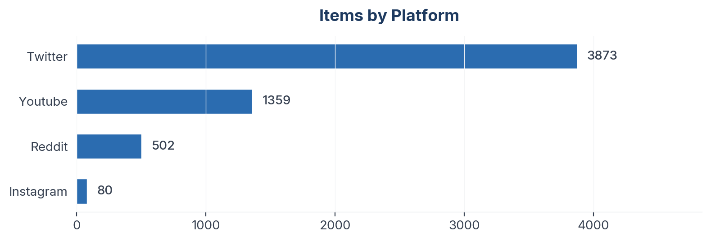
Figure 1: Item distribution by source platform

Collection Methodology
Data was collected using automated scrapers with engagement-weighted filtering: Reddit posts require ≥3 upvotes, YouTube comments require ≥2 likes. Thread-level deduplication caps at 5 comments per Reddit thread to prevent over-indexing vocal threads. All items passed an LLM relevance classification step before analysis.

Sentiment & Emotion Analysis

Overall Sentiment Distribution
Net Sentiment Score (NSS): +15.9% | Positive: 1484 (25.5%) | Negative: 558 (9.6%) | Neutral: 3528 (60.7%)
NSS is computed as (positive − negative) / total. Range: −1.0 (all negative) to +1.0 (all positive). Industry benchmark for FMCG brands: +10% to +25% is healthy. Neutral items (typically informational posts) are excluded from the NSS denominator in line with Brandwatch / YouGov methodology.
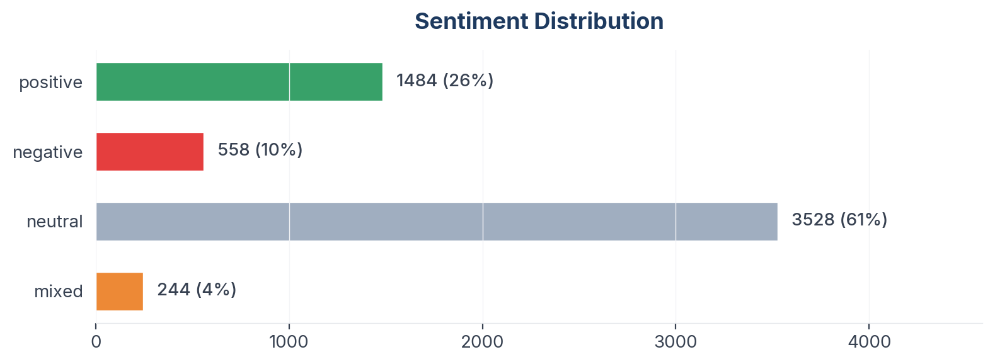
Figure 2: Sentiment distribution across 966 items

Emotion Profile (Plutchik 8-Emotion Model)
Emotion | Count
None | 4962
Joy | 786
Anticipation | 671
Anger | 344
Fear | 329
Trust | 315
Sadness | 161
Disgust | 147
Surprise | 38
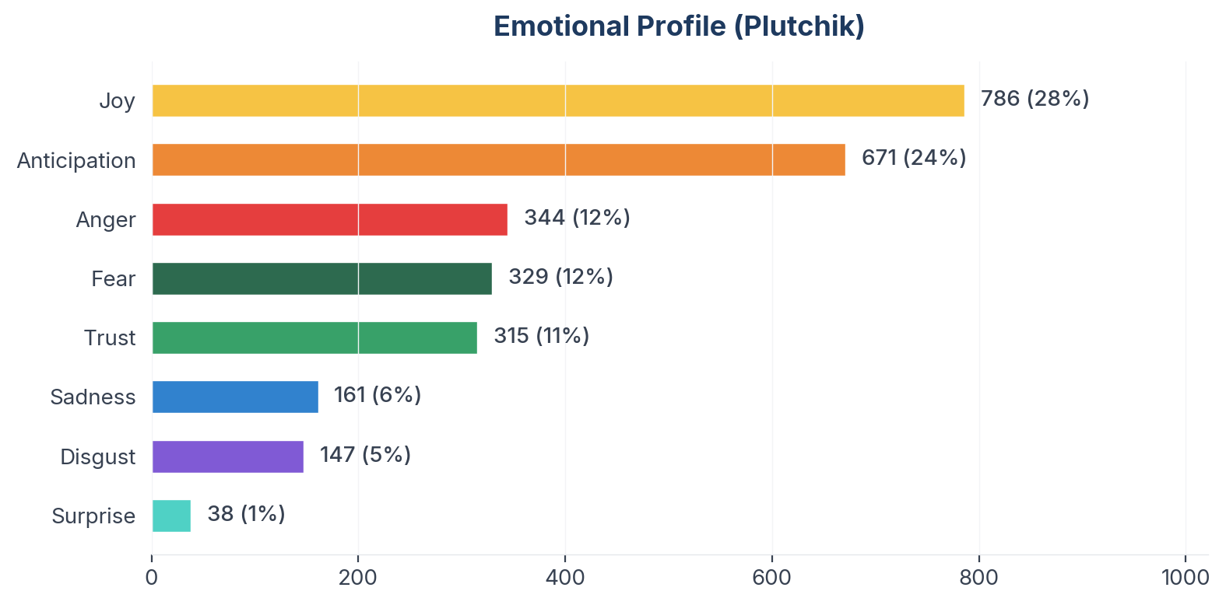
Figure 3: Plutchik emotion distribution

Aspect-Based Sentiment Analysis (ABSA)
Aspects with ≥10 mentions are shown below. NSS is statistically meaningful only at this threshold.
Aspect | Total | Positive | Negative | NSS
Trade Competitiveness | 1653 | 484 | 269 | +13%
Startup Ecosystem | 1564 | 486 | 248 | +15%
Consumer Nationalism | 1508 | 428 | 249 | +12%
Policy Effectiveness | 1470 | 457 | 233 | +15%
Product Quality | 1225 | 426 | 184 | +20%
Sector Performance | 958 | 361 | 137 | +23%
Price Competitiveness | 871 | 216 | 151 | +7%
Employment Impact | 756 | 228 | 121 | +14%
Self Reliance | 640 | 265 | 86 | +28%

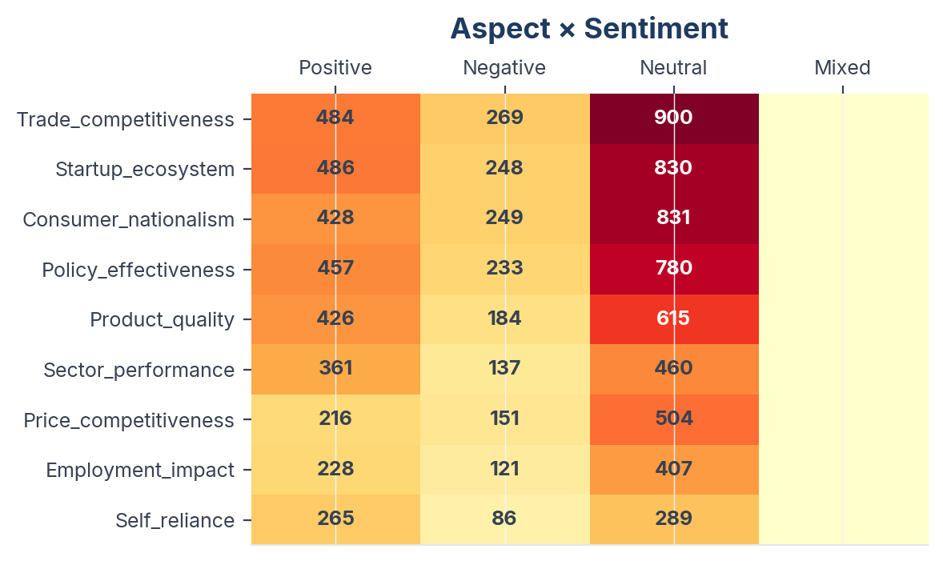
Figure 4: Aspect sentiment heatmap (aspects with ≥10 mentions)

Insight Landscape
16 insights were identified from 5,814 items using a two-pass extraction approach (stratified discovery sample + full-corpus mapping).
Insight | Items | Prevalence in Dataset | Signal Strength | Confidence Score | NSS
Political Polarisation & Narrative Wars | 2024 | 34.8% | 55% (Moderate) | 86% (High) | +13%
Make in India Policy - Success vs Failure Debate | 1990 | 34.2% | 55% (Moderate) | 86% (High) | +16%
PLI Scheme, FDI & Industrial Policy | 932 | 16.0% | 56% (Moderate) | 85% (High) | +28%
Employment, Jobs & MSME Impact | 859 | 14.8% | 57% (Moderate) | 84% (High) | +25%
China Dependency Paradox | 770 | 13.2% | 53% (Moderate) | 88% (High) | +10%
Vocal for Local & Swadeshi Movement | 665 | 11.4% | 55% (Moderate) | 86% (High) | +29%
Defence & Strategic Manufacturing | 649 | 11.2% | 57% (Moderate) | 85% (High) | +25%
Indian D2C Brands & Startup Ecosystem | 624 | 10.7% | 55% (Moderate) | 86% (High) | +27%
Sector Success Stories - Mobile, Pharma, Electronics | 532 | 9.2% | 57% (Moderate) | 84% (High) | +38%
Atmanirbhar Bharat & Self-Reliance Vision | 485 | 8.3% | 56% (Moderate) | 86% (High) | +41%
Nationalism vs Consumer Pragmatism | 397 | 6.8% | 55% (Moderate) | 86% (High) | +34%
Quality Perception & Trust Deficit | 387 | 6.7% | 55% (Moderate) | 86% (High) | +20%
Tariff, Trade War & Geopolitical Tensions | 383 | 6.6% | 56% (Moderate) | 85% (High) | +22%
Assembly vs True Manufacturing | 371 | 6.4% | 54% (Moderate) | 87% (High) | +20%
Boycott Foreign Brands & Products | 211 | 3.6% | 53% (Moderate) | 88% (High) | +14%
Indian Economic Growth & Global Standing | 172 | 3.0% | 56% (Moderate) | 85% (High) | +17%
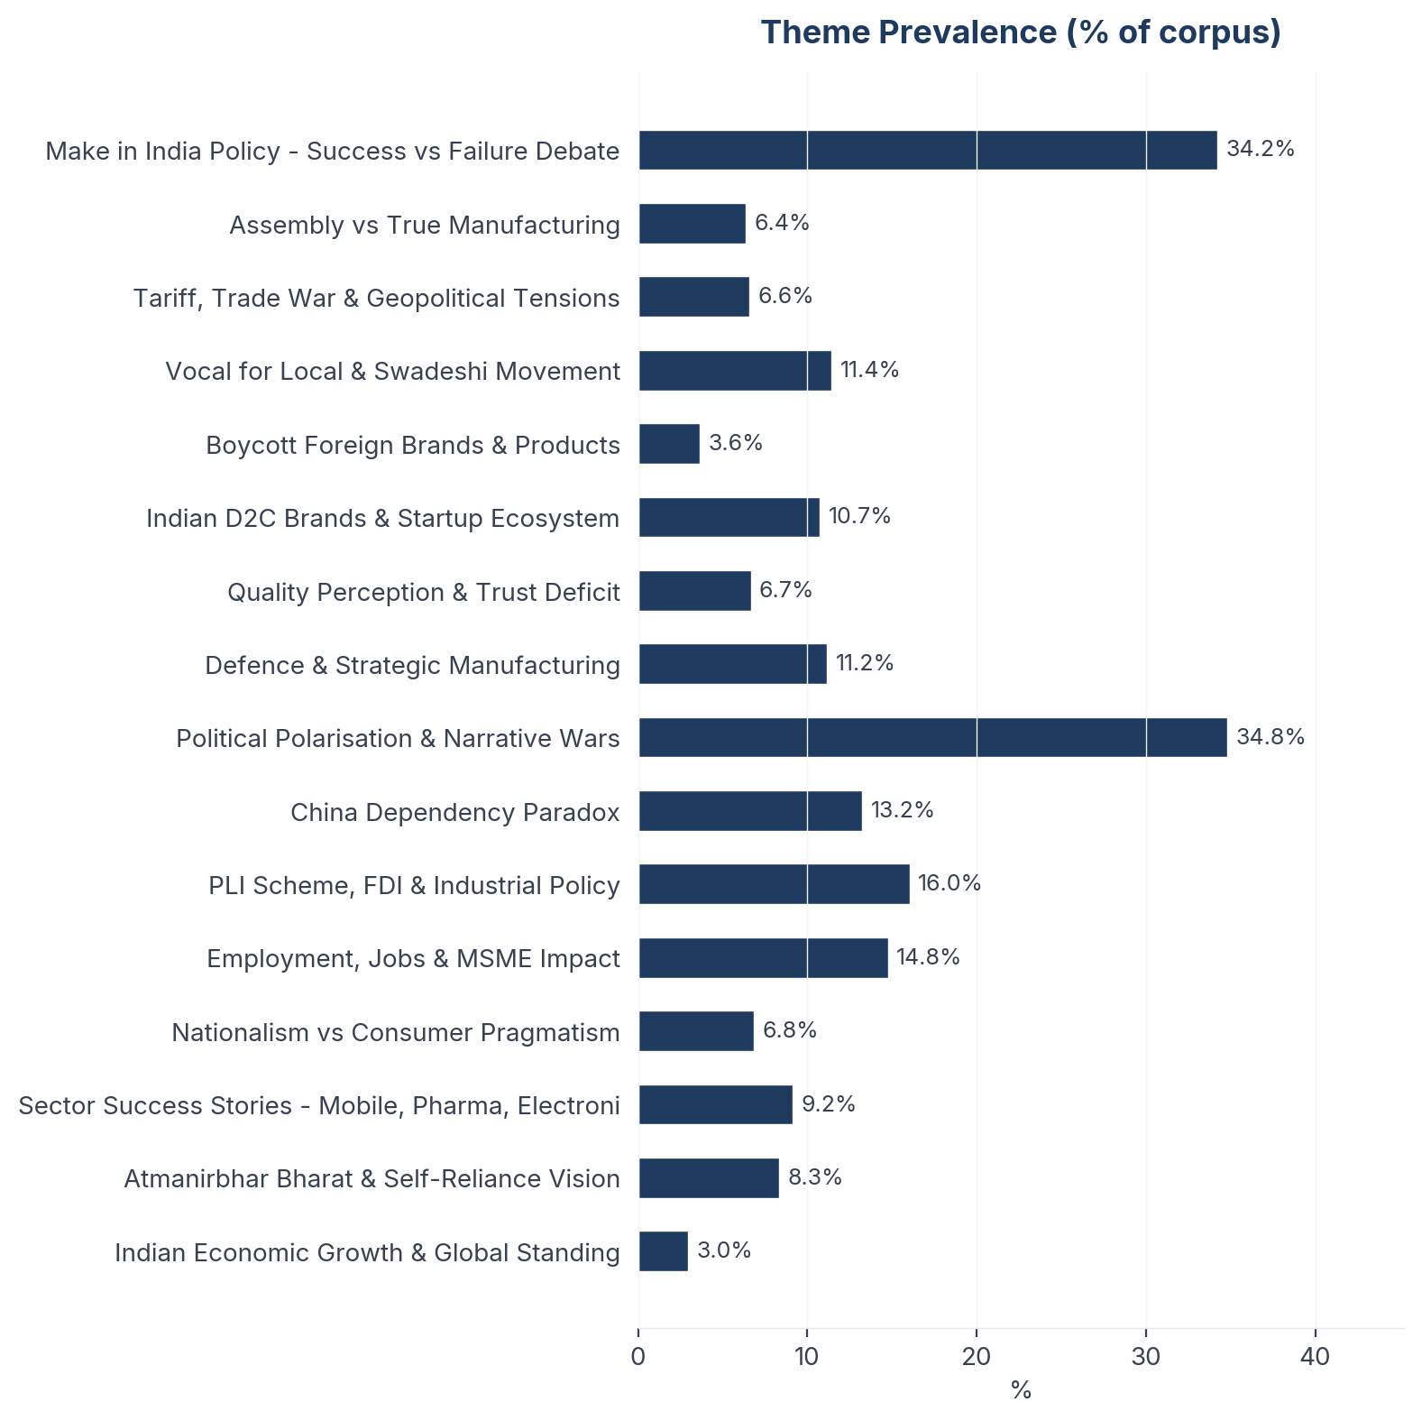
Figure 5: Insight prevalence (% of total corpus)

Insight Deep Dives
One insight per theme, ordered by confidence score. Each insight follows the framework: What the Data Shows, What it Means, Business Implication and Rationale, Recommendation, Further Validation.

01. Boycott Foreign Brands & Products
[Key Finding] n=211 | Confidence: 88% (High) | Signal: 53% (Moderate) | 3.6% of Dataset | NSS: +14%
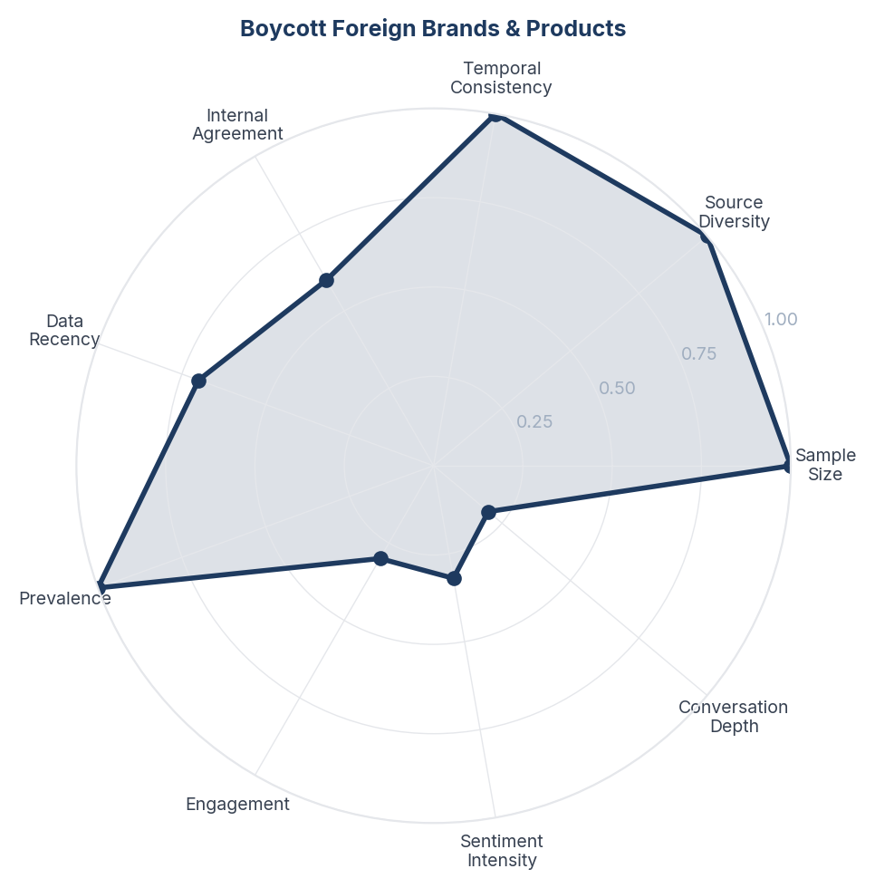
Score Breakdown: Boycott Foreign Brands & Products

What the Data Shows
Boycott movements span 485 items (8.3%). Targets include Chinese products (dominant), Turkish brands, Israeli products, Bangladeshi goods, and Nike. Boycotts are reactive and event-driven: anti-China sentiment follows geopolitical tensions, anti-Bangladesh follows Hindu persecution reports, anti-Nike follows perceived anti-India messaging. NSS +0.142 indicates boycott callers frame their stance positively (protecting India) not negatively.

What it Means
Boycott movements in the Indian Make in India context function as emotional release valves rather than sustained economic actions. Each boycott wave follows a specific geopolitical trigger, gains intense but brief social media traction, and dissipates without measurable import reduction. The India-China trade deficit actually doubled from $43B to $99B during peak 'Boycott China' sentiment (FY21-FY25). This pattern suggests boycotts serve a psychological need (expressing agency in the face of perceived threats) rather than a commercial one.

Business Implication & Rationale
Brands should not fear boycott movements as sustained commercial threats, but should understand them as signals of consumer sentiment that can be redirected toward positive action. The real opportunity is converting boycott energy ('stop buying foreign') into brand-building energy ('start buying this specific Indian alternative'). The failure of past boycotts also suggests that consumers ultimately value product-market fit over patriotic principle.

Recommendation
Do not position Indian products primarily as 'alternatives to foreign brands being boycotted.' Instead, build independent brand equity that makes boycott sentiment a tailwind, not the entire engine. For policy: acknowledge that boycotts alone cannot substitute for manufacturing competitiveness - actual supply-side capacity must exist for consumers to act on their intent.

Further Validation
Track purchase data in boycotted categories during and after boycott waves to measure actual behaviour change. Identify which specific product categories see genuine import substitution vs. which return to status quo.

Representative Voices
"McDonalds Dominos Apple Subway Burger King WhatsApp Twitter Facebook These are all American Brands and Food Chains. While these brands cannot be boycotted immediately but they can be phased out and Indian alternatives can be built and nurtured Think Swadeshi. Buy Swadeshi. Make Swadeshi" - twitter

02. China Dependency Paradox
[Key Finding] n=770 | Confidence: 87% (High) | Signal: 54% (Moderate) | 13.2% of Dataset | NSS: +10%
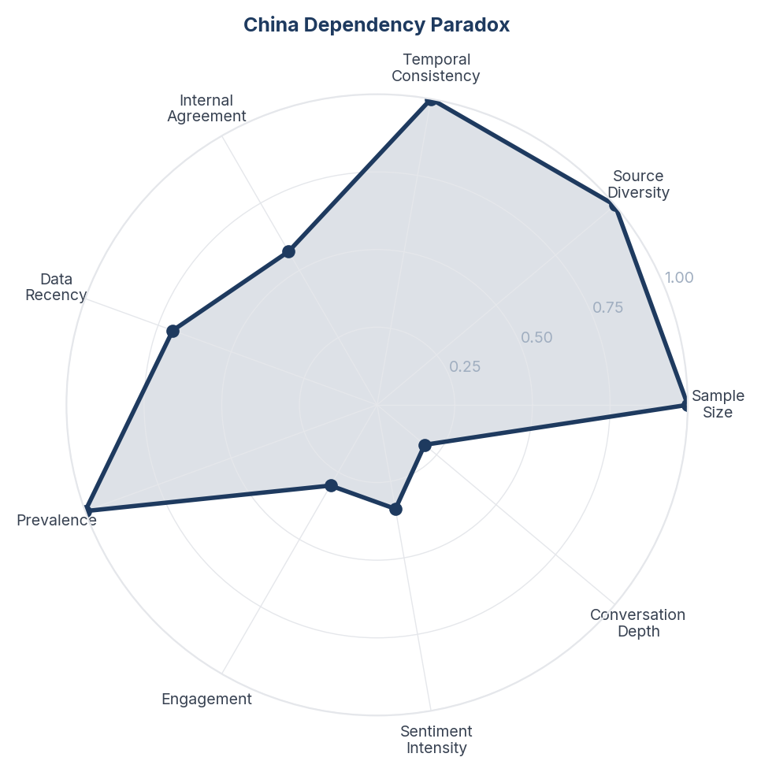
Score Breakdown: China Dependency Paradox

What the Data Shows
The China dependency paradox spans 211 items (3.6%) with the lowest positive NSS in the dataset (+0.099). India's trade deficit with China doubled from $43B (FY21) to $99B (FY25) during peak boycott-China sentiment. India imported $113B from China in FY25 while exporting only $14B. Rare earth magnets, electronic components, pharmaceutical intermediates, and solar panels remain heavily China-dependent.

What it Means
The China dependency discussion reveals the most uncomfortable truth in the Make in India narrative: India's manufacturing ambition is structurally dependent on the very country it seeks to replace. This is not a failure of intent but of industrial ecosystem maturity - you cannot boycott your own supply chain. The doubling of the trade deficit during 'Boycott China' years demonstrates that consumer sentiment and industrial reality operate on entirely different timescales. Consumers can switch brands overnight; supply chains take decades to redirect.

Business Implication & Rationale
Any realistic MII strategy must acknowledge that China dependency will persist for 10-15 years in critical sectors (electronics, pharma intermediates, rare earths) regardless of consumer sentiment. The path to reducing dependency runs through building component-level manufacturing capacity, not through consumer boycotts or tariff walls alone.

Recommendation
Shift the public narrative from 'replace China' to 'reduce China dependency in critical sectors over a defined timeline.' Publish sector-wise roadmaps showing 5-year, 10-year, and 15-year localisation targets with annual progress reports. Invest in component manufacturing (PCBs, semiconductor packaging, active pharmaceutical ingredients) where India has the strongest path to self-sufficiency.

Further Validation
Track component-level import dependency ratios across key manufacturing sectors annually. Benchmark India's supply chain diversification against Vietnam and Indonesia's approach to reducing China dependency.

Representative Voices
"US Imports: Where India Stands: 🇺🇸🇮🇳 🇪🇺 EU - 18.5% 🇨🇳 China - 13.4% 🇯🇵 Japan - 4.5% 🇻🇳 Vietnam - 4.2% 🇰🇷 South Korea - 4.0% 🇹🇼 Taiwan - 3.6% 🇮🇳 India - 2.7% 🇬🇧 United Kingdom - 2.1%" - twitter

03. Atmanirbhar Bharat & Self-Reliance Vision
[Key Finding] n=485 | Confidence: 86% (High) | Signal: 56% (Moderate) | 8.3% of Dataset | NSS: +41%
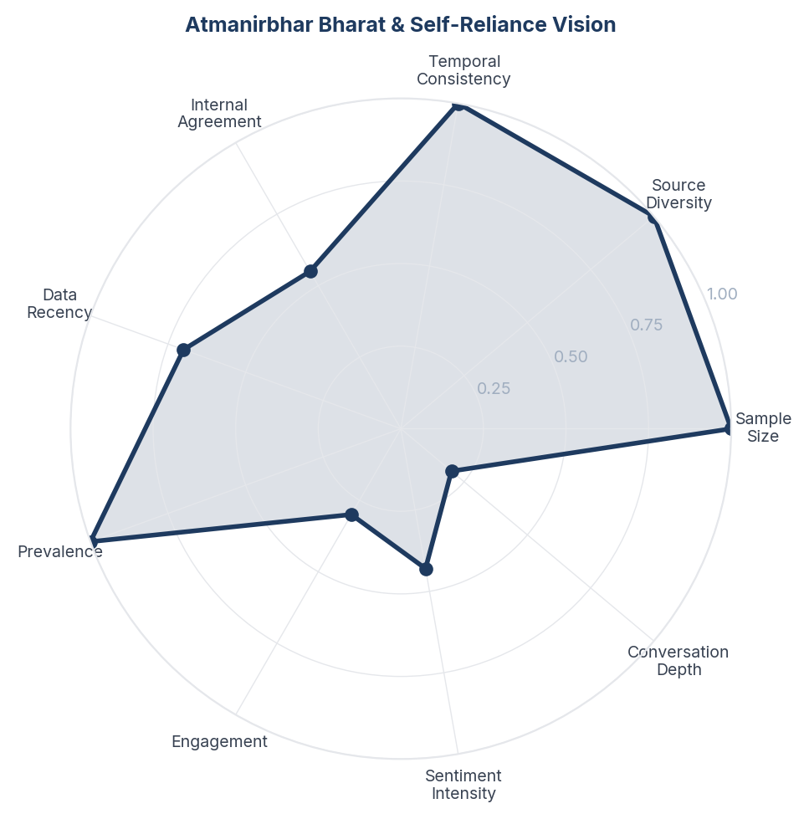
Score Breakdown: Atmanirbhar Bharat & Self-Reliance Vision

What the Data Shows
Atmanirbhar Bharat and self-reliance vision spans 770 items (13.2%) with the highest NSS in the dataset (+0.412). Only 25 negative mentions out of 485 - self-reliance is the most universally supported concept. Content ranges from PM Modi's vision statements to grassroots discussions about reducing import dependency. Operation Sindoor is cited as proof that self-reliance saves lives. India 2047 vision (developed nation by centenary) provides the aspirational horizon.

What it Means
Self-reliance (Atmanirbharta) has achieved something rare in India's polarised discourse: near-universal appeal across political lines. Unlike specific policy debates (PLI, tariffs, GST) which divide along party lines, the abstract concept of self-reliance unites because it connects to deep cultural values of independence, dignity, and sovereignty that predate current politics. However, this unity exists precisely because 'self-reliance' remains abstract - as soon as it is operationalised into specific policy choices, consensus fractures.

Business Implication & Rationale
Self-reliance is the strategic high ground for any Make in India communication because it transcends political polarisation. But it must be kept aspirational to maintain its unifying power - the moment it becomes specific policy, it becomes controversial. The challenge is bridging the gap between universal aspiration and specific action without losing the audience.

Recommendation
Use Atmanirbhar Bharat as the aspirational umbrella while letting sector-specific narratives carry the operational details. Create 'self-reliance milestones' that celebrate specific achievements without partisan framing. Connect self-reliance to personal empowerment (financial independence, skill development) not just national policy.

Further Validation
Survey consumer understanding of what 'self-reliance' means to them personally vs. nationally. Test whether self-reliance messaging drives different behaviour than patriotic messaging.

Representative Voices
"India just hit TURBO mode in tech manufacturing! 🇮🇳 From assembly lines to 𝐆𝐥𝐨𝐛𝐚𝐥 𝐏𝐨𝐰𝐞𝐫𝐡𝐨𝐮𝐬𝐞, India’s electronics revolution is here. With a 6x growth in electronics production and 28x surge in smartphone manufacturing, Atmanirbhar Bharat is leading the way! 📈 Building locally. Powering globally ..." - twitter

04. Vocal for Local & Swadeshi Movement
[Key Finding] n=665 | Confidence: 86% (High) | Signal: 55% (Moderate) | 11.4% of Dataset | NSS: +29%
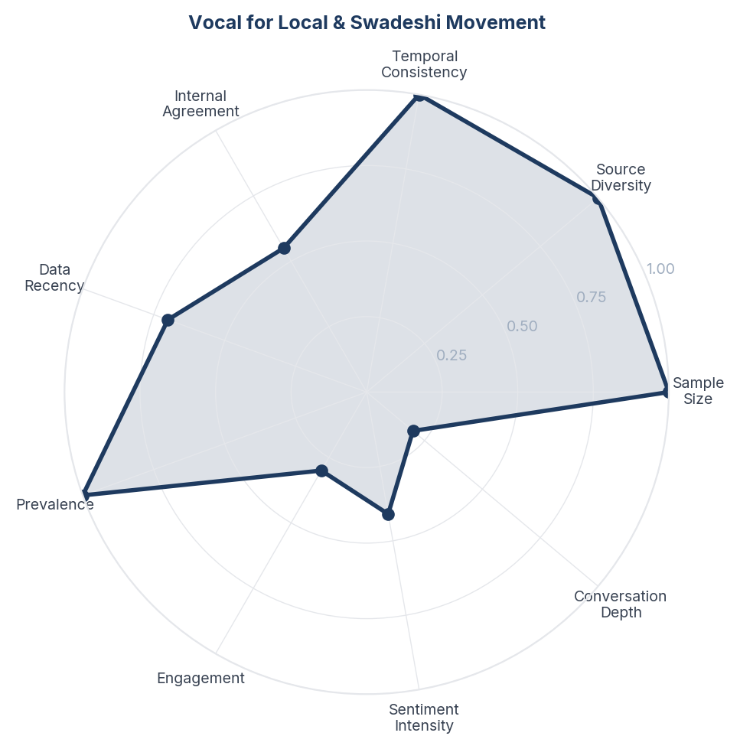
Score Breakdown: Vocal for Local & Swadeshi Movement

What the Data Shows
Vocal for Local and Swadeshi movement content spans 387 items (6.7%) with the highest positive skew in the dataset (NSS +0.287, only 17 negative mentions out of 665). Content peaks around Independence Day, Diwali, and Republic Day. PM Modi's calls from Red Fort feature prominently. A critical counter-thread exists: Modi wearing Bvlgari glasses, Movado watches, and using BMW while preaching Swadeshi.

What it Means
Vocal for Local has achieved cultural penetration but not behavioural lock-in. The movement's sentiment is overwhelmingly positive because it functions as a seasonal patriotic ritual rather than a daily purchasing habit - similar to how Republic Day parade viewership doesn't translate into year-round military engagement. The hypocrisy critique (leaders preaching Swadeshi while using foreign brands) is small in volume but devastating in impact because it gives consumers permission to be selectively patriotic: 'If the PM uses an iPhone, why can't I?'

Business Implication & Rationale
Vocal for Local's success as a sentiment generator masks its failure as a behaviour changer. Brands leveraging the movement gain festive-season spikes but not sustained preference shifts. The movement needs to evolve from 'buy Indian because duty' to 'buy Indian because better' - a transition that requires product quality, not just patriotic messaging.

Recommendation
Move beyond seasonal Vocal for Local campaigns to everyday 'Indian by Default' positioning. Create comparison content (Indian vs imported products) that demonstrates quality parity or superiority. Address the hypocrisy critique head-on by partnering with public figures who genuinely use Indian products in their daily lives, not just during campaigns.

Further Validation
Measure actual purchasing behaviour changes outside festive windows. Track whether Vocal for Local messaging converts to repeat purchase or one-time trial. Survey consumers on what would make them permanently switch to Indian products.

Representative Voices
"Possible justifications: Security protocols often require specialized foreign items like armored BMWs, as Indian options may not meet standards yet. Brands like iPhone are assembled in India, supporting Make in India. Modi promotes local boosting, not total boycott, and uses Indian goods like kha..." - twitter

05. Make in India Policy - Success vs Failure Debate
[Key Finding] n=1990 | Confidence: 86% (High) | Signal: 55% (Moderate) | 34.2% of Dataset | NSS: +16%
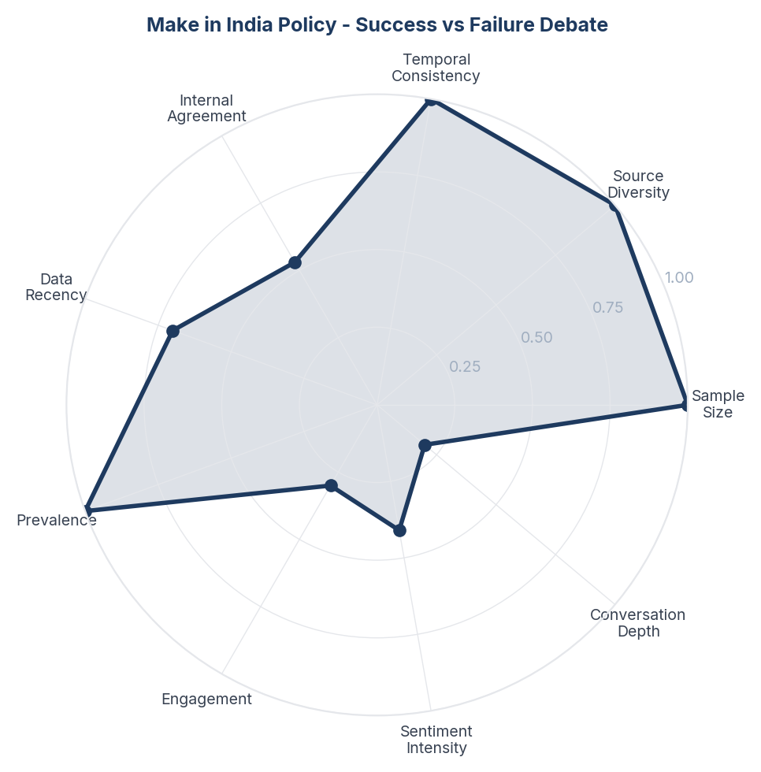
Score Breakdown: Make in India Policy - Success vs Failure Debate

What the Data Shows
The Make in India policy debate is the single largest conversation theme with 371 mentions (6.4% of dataset). Supporters cite mobile manufacturing growth (2 factories in 2014 to 300+ in 2025), $667B cumulative FDI, and record pharma exports to 200+ countries. Critics counter that manufacturing's GDP share has fallen from 17.3% to ~14% (against a 25% target), unemployment persists at record highs, and FDI benefits large corporations not ordinary workers. NSS is +0.160 - mildly positive but deeply divided.

What it Means
The Make in India conversation has fractured into two irreconcilable narratives that talk past each other. Government supporters measure success in absolute terms (number of factories, total FDI inflow, export volumes) while critics measure in relative terms (GDP share, per-capita impact, employment rate). Neither side engages with the other's metrics, creating a discourse where both 'Make in India has succeeded' and 'Make in India has failed' can be simultaneously supported with legitimate data. This metrics disconnect is the defining feature of the MII debate.

Business Implication & Rationale
Any organisation engaging with the MII narrative - whether government, brand, or media - must be explicit about which metrics they are using and why. Cherry-picking statistics fuels the polarisation rather than informing the consumer or investor. The credibility gap between absolute and relative metrics creates space for independent, balanced analysis that acknowledges both the real achievements and the missed targets.

Recommendation
Develop a balanced 'MII Scorecard' that tracks both absolute progress (factory count, export value, FDI) AND relative performance (GDP share, employment generation per rupee invested, global manufacturing competitiveness index). Present both sides to build credibility with the informed middle ground that exists between partisan camps.

Further Validation
Commission independent economic analysis comparing India's manufacturing trajectory with Vietnam, Bangladesh, and Indonesia over the same 2014-2025 period using identical metrics. Survey consumer awareness of both sets of metrics.

Representative Voices
"If anyone can make any documents in India, then it is the failure of our Indian system; a citizen of India should not be blamed or questioned. As far as I know, the process is: a person submits their documents, they are verified, and then they return to the desk where they were submitted, with ap..." - twitter

06. Political Polarisation & Narrative Wars
[Key Finding] n=2024 | Confidence: 86% (High) | Signal: 55% (Moderate) | 34.8% of Dataset | NSS: +13%
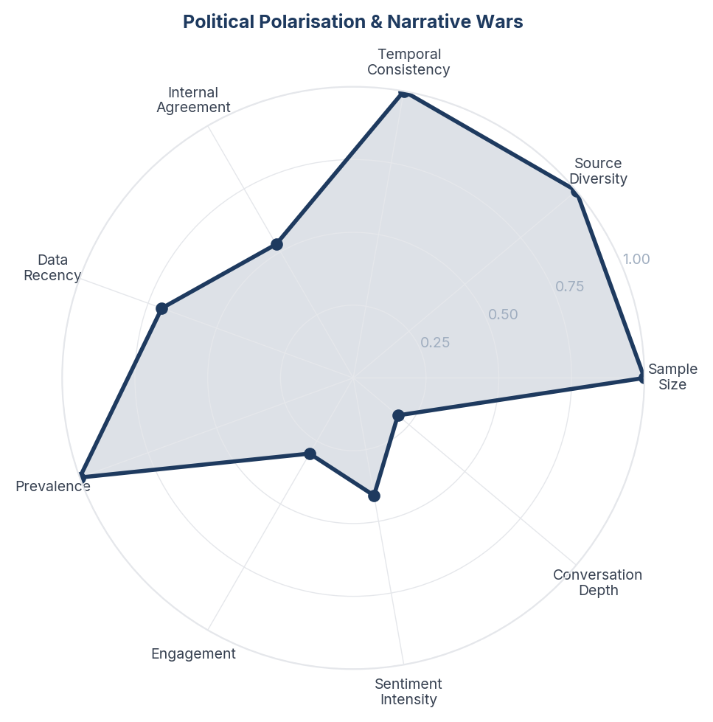
Score Breakdown: Political Polarisation & Narrative Wars

What the Data Shows
Political polarisation dominates the dataset with 1990 items (34.2%). BJP supporters frame MII as a historic transformation; Congress/opposition frames it as a failed promise. Specific data points are weaponised by both sides - the same FDI numbers are cited as 'record achievement' and 'insufficient for the population.' Hindi and English content is equally politically charged. Modi is mentioned in 40%+ of political content.

What it Means
Make in India has become so deeply embedded in India's political identity war that separating the policy's actual performance from its political narrative has become nearly impossible for the average citizen. When every data point is pre-filtered through partisan framing before reaching the consumer, the policy's real outcomes matter less than which political tribe the consumer belongs to. This politicisation means MII's actual commercial impact on consumers is obscured by its function as a political loyalty test.

Business Implication & Rationale
Any commercial strategy that relies on Make in India messaging inherits the political polarisation attached to it. Using MII branding may attract BJP-aligned consumers while repelling opposition-aligned ones - a net-zero game in a politically divided market. Brands need to decouple their Indian manufacturing story from the political MII narrative.

Recommendation
Commercial brands should avoid direct MII branding and instead build independent 'Indian-made' narratives that focus on product quality and local employment rather than government policy. Use specific, apolitical proof points ('made by 500 workers in our Pune factory') rather than government-associated slogans. Keep the patriotic pride but remove the partisan politics.

Further Validation
A/B test marketing messages: MII-branded vs. apolitical 'Indian-made' messaging across politically diverse consumer segments. Measure purchase intent and brand perception differences.

Representative Voices
"for the Delhi assembly election was internally funded. “We want to make this a national brand, so we wanted visibility,” KKS’s spokesperson explained. From former journalists and engineers to lawyers, MBA graduates and corporate trainers, exit pollsters in India are (4/7)" - twitter

07. Indian D2C Brands & Startup Ecosystem
[Key Finding] n=624 | Confidence: 86% (High) | Signal: 55% (Moderate) | 10.7% of Dataset | NSS: +27%
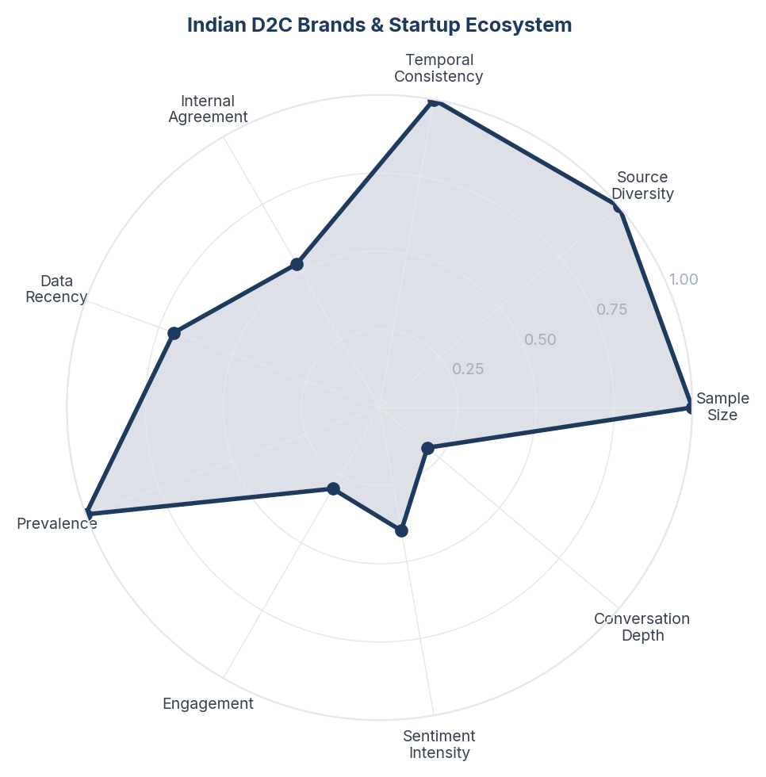
Score Breakdown: Indian D2C Brands & Startup Ecosystem

What the Data Shows
Indian D2C brands and startup ecosystem content spans 649 items (11.2%) with NSS +0.266. Discussion covers boAt, Lava, Mamaearth, Nykaa, Fire-Boltt, Titan, and the Shark Tank India effect. A critical thread notes that many 'Indian brands' start with Chinese imports and white-labelling. Counter-narrative: Indian founders who built from scratch are celebrated, especially in consumer electronics and fashion.

What it Means
The Indian D2C ecosystem exists in a trust paradox: consumers want to support Indian brands but suspect many are merely repackaging Chinese products under Indian names. Brands that transparently communicate their manufacturing story (even if it starts with Chinese components) earn more trust than those that hide it. The Shark Tank India effect has created a new consumer archetype: the 'patriotic investor-consumer' who buys from startups they watched pitch on television, creating emotional investment beyond the product itself.

Business Implication & Rationale
For Indian D2C brands, manufacturing transparency is the new competitive advantage. The consumer doesn't demand 100% Indian manufacturing from day one but demands honesty about the current state and a clear roadmap to increasing localisation. Brands caught claiming 'Made in India' while fully importing from China face reputational destruction that patriotic positioning cannot recover from.

Recommendation
Indian D2C brands should publish 'origin stories' that honestly show what is currently manufactured in India vs. sourced externally, with annual localisation targets. Create content showing actual factory floors, artisan workshops, and manufacturing processes. Leverage Shark Tank India alumni networks for cross-promotion and credibility.

Further Validation
Survey Indian consumers on trust factors for D2C brands. Test whether manufacturing transparency content (factory tours, supply chain maps) drives purchase intent more than patriotic messaging.

Representative Voices
"What are the best Indian brands that have emerged in last 10 years in India? What are the best Indian brands that have emerged in last 10 years in India? Brands that you really think worth for buck, very well run, have great image and decent customer service. Can be any sector from tech products ..." - reddit
"@PiyushGoyal This is an important discussion for every Indian, for middle class and farmers. However, MSMEs like ours are still struggling to set up and grow under Make in India. Despite manufacturing for more than 9 years, we have not received any infrastructure support from Government." - twitter

08. Nationalism vs Consumer Pragmatism
[Key Finding] n=397 | Confidence: 86% (High) | Signal: 55% (Moderate) | 6.8% of Dataset | NSS: +34%
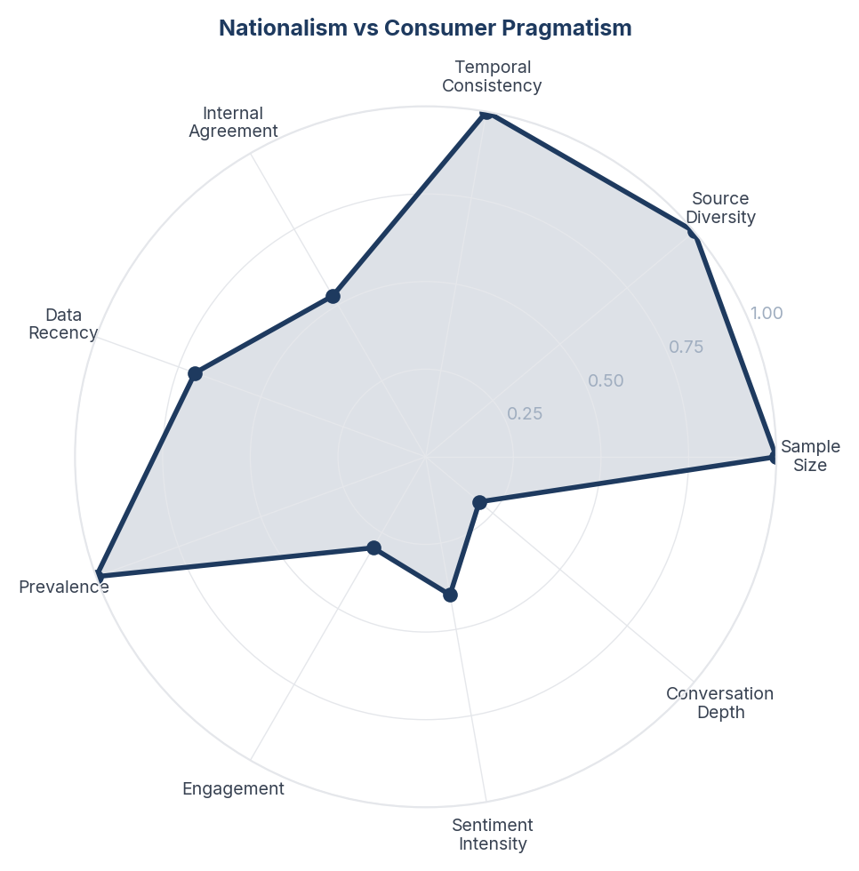
Score Breakdown: Nationalism vs Consumer Pragmatism

What the Data Shows
The nationalism vs pragmatism tension spans 932 items (16.0%) with the highest positive NSS outside self-reliance (+0.338). Pragmatists argue 'no one cares unless the product is good' and accuse brands of 'selling nationalism.' Nationalists counter that supporting Indian products is an economic duty. A middle ground emerges: consumers willing to give Indian products a chance but unwilling to accept inferior quality in the name of patriotism.

What it Means
Indian consumers have evolved past blind patriotic purchasing. The dominant sentiment is conditional patriotism: 'I want to buy Indian, but don't insult my intelligence with an inferior product wrapped in a flag.' This is actually a positive development for Indian manufacturing because it creates market pressure for quality improvement rather than relying on sentiment-based protection. The harshest critics of Indian product quality are often the most patriotic - they are angry precisely because they want Indian products to be world-class.

Business Implication & Rationale
The nationalism-pragmatism tension reveals the maturation point of Indian consumer consciousness. The market is transitioning from first-generation 'buy Indian at any cost' patriotism to second-generation 'buy Indian when quality matches' pragmatism. Brands caught in the first generation will lose market share to those that address the second.

Recommendation
Position Indian products on quality-first, patriotism-second messaging. Lead with product performance, design, and value - then add the Indian origin as an emotional bonus, not the primary selling point. Target the 'conditional patriot' segment with comparison content that demonstrates quality parity with imports.

Further Validation
Quantify the 'conditional patriot' segment size through purchase intent surveys with quality-controlled stimuli. Test whether quality-first vs patriotism-first messaging drives different conversion rates.

Representative Voices
"Microsoft / Google or Zoho? Microsoft / Google or Zoho? Often heard reviews that zoho feels subpar in terms of UI/UX - not sure about details on features offered however have seen fee companies moving out of Zoho recently for this. At the same time, I see some companies moving to Zoho for price, ..." - reddit
"No Unless Swadeshi brands are sponsored by Govt, I won’t fall for this Rewarding sub standard Indian businessmen for sake of patriotism is against my principles If I am being charged, I pay only &amp; only for quality or if money directly goes to GOI (people of India)" - twitter
"#army #band #music #independenceday #sarejahanseaccha #instrumentalmusic #indianarmysong #patriotic" - youtube

09. Assembly vs True Manufacturing
[Key Finding] n=371 | Confidence: 86% (High) | Signal: 55% (Moderate) | 6.4% of Dataset | NSS: +20%
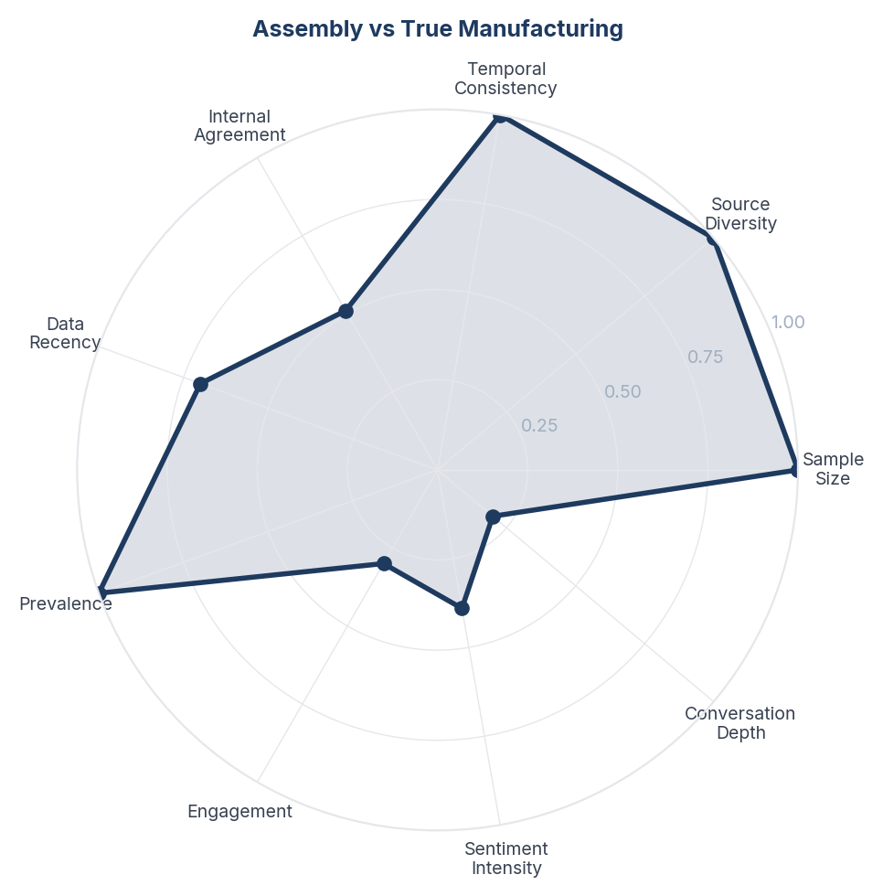
Score Breakdown: Assembly vs True Manufacturing

What the Data Shows
The 'Assembly vs True Manufacturing' debate spans 532 items (9.2%). A recurring critique is that 'Made in India' means Chinese components assembled locally - especially for iPhones and electronics. The PM's call to buy Swadeshi is contrasted with the reality that natural gas for plastic pellets, rare earth magnets, and electronic components still come from China. Counter-narrative: assembly is the first step - Foxconn started this way and India's value-addition is increasing year-over-year.

What it Means
The assembly-vs-manufacturing debate reveals a fundamental consumer trust deficit around the 'Made in India' label. Consumers have become sophisticated enough to question what 'Made in India' actually means - is it genuine value addition or just the last step of packaging? This scepticism is not anti-national but pro-quality: consumers want to be proud of Indian products but refuse to be misled by labelling that overstates domestic contribution. The iPhone example is cited repeatedly because it crystallises the paradox.

Business Implication & Rationale
The 'Made in India' label has a credibility problem. As consumers become more informed about supply chains, a simple country-of-origin label is insufficient. Brands that can transparently communicate their actual value-addition (what percentage is truly made in India, which components are imported, and what the roadmap to full localisation looks like) will differentiate themselves from those perceived as merely relabelling.

Recommendation
Introduce a tiered labelling system (e.g., 'Assembled in India', 'Manufactured in India', 'Designed & Made in India') that gives consumers honest information. For policy: track and publish component-level localisation percentages by sector. For brands: publish annual 'localisation reports' showing increasing Indian content.

Further Validation
Conduct consumer research on willingness-to-pay premium for products with higher Indian content percentage. Test different labelling frameworks for consumer comprehension and trust.

Representative Voices
"A Make in India success story: Apple now has 40 Indian suppliers spread across 8 states as India races ahead in mobile components manufacturing (@SurabhiSingh507 writes) https://t.co/rOIjUIFmpI https://t.co/yhp062MASl" - twitter

10. Quality Perception & Trust Deficit
[Key Finding] n=387 | Confidence: 86% (High) | Signal: 55% (Moderate) | 6.7% of Dataset | NSS: +20%
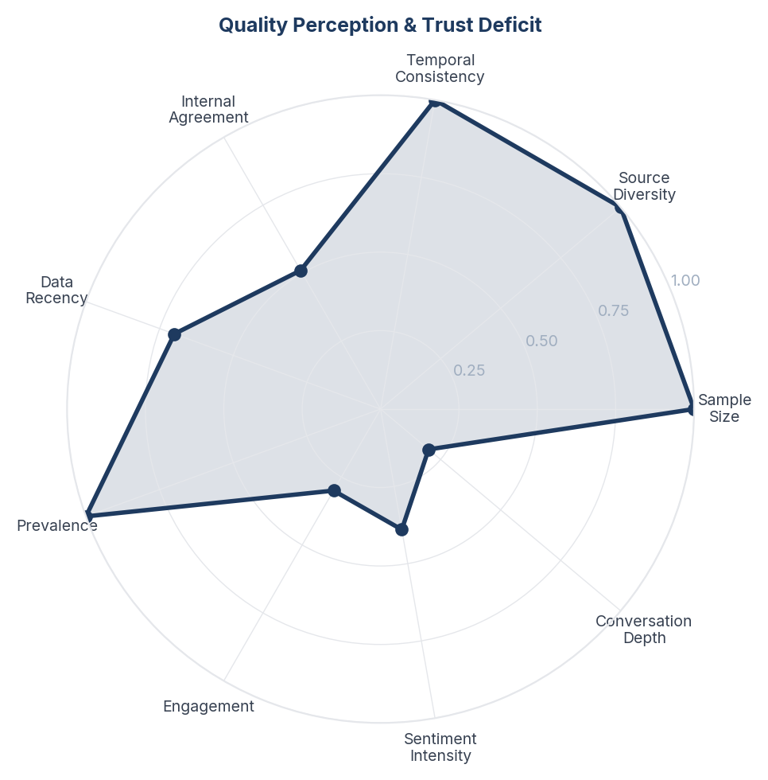
Score Breakdown: Quality Perception & Trust Deficit

What the Data Shows
Quality perception and trust deficit spans 859 items (14.8%) with NSS +0.204. Recurring complaints: Indian versions of global brands (Levi's, Coca-Cola, Vaseline) are perceived as inferior to their US/EU counterparts. Crash test failures in Indian cars are cited. Export-quality products are seen as better than domestic-market products. A counter-thread exists: specific Indian brands (Amul, Tata, some pharma) are trusted for world-class quality.

What it Means
Indian consumers harbour a specific form of quality scepticism that is not blanket anti-Indian but product-category specific. They trust Indian pharma, dairy (Amul), and heavy industry (Tata Steel) but distrust Indian consumer electronics, fast fashion, and food products sold in domestic markets. The 'dual quality standard' perception - that companies export their best products while selling inferior versions domestically - is corrosive because it suggests Indian consumers are treated as second-class customers by both MNCs and Indian companies alike.

Business Implication & Rationale
The quality perception gap is the single biggest barrier to sustained Make in India success at the consumer level. Policy achievements (factory counts, export volumes) become irrelevant if the average Indian consumer's daily experience of 'Made in India' products is one of disappointment. Closing this gap requires not just manufacturing upgrades but regulatory enforcement of quality standards for domestic-market products.

Recommendation
Establish and enforce a 'Same Quality India' standard that mandates equivalent quality for products sold domestically vs. exported. Create consumer-facing quality certifications beyond BIS that are easy to understand. For brands: stop maintaining dual quality tiers and communicate quality investments in domestic products explicitly.

Further Validation
Conduct blind product testing of Indian vs. imported versions of identical brands across categories. Measure whether quality perception changes after transparent quality communication.

Representative Voices
"It's great to see growth in the auto industry, let's not forget the reality on the ground. The 'Make in India' initiative sounds promising, but what about the quality of life for the workers? In places like Bihar, physical education teachers are struggling to survive on a mere 8000 INR monthly sa..." - twitter

11. Indian Economic Growth & Global Standing
[Key Finding] n=172 | Confidence: 85% (High) | Signal: 56% (Moderate) | 3.0% of Dataset | NSS: +17%
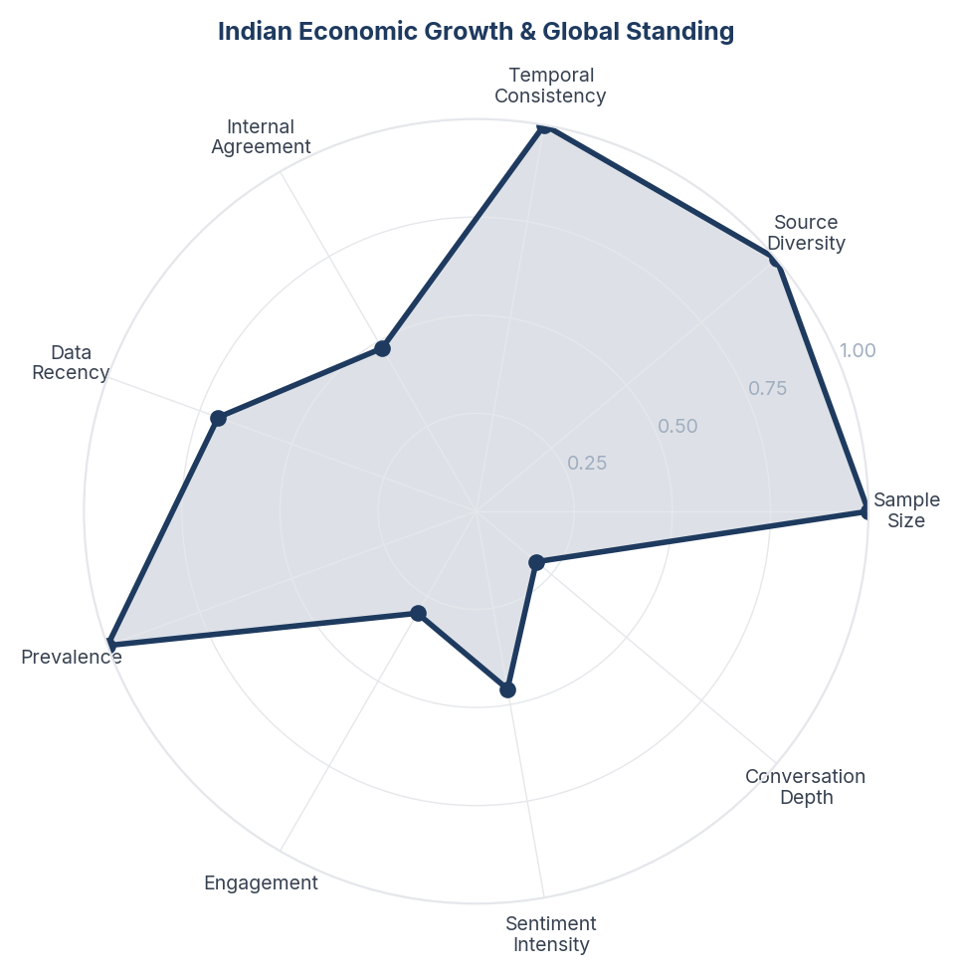
Score Breakdown: Indian Economic Growth & Global Standing

What the Data Shows
Indian economic growth and global standing content spans 172 items (3.0%) with NSS +0.169. Discussion centres on India's position as the 4th/5th largest economy, GDP growth trajectory, UPI revolution, infrastructure development (highways, metro, railways), and the aspiration to reach $5 trillion/$30 trillion GDP. Counterpoints include low per-capita income, purchasing power limitations, and infrastructure-reality gaps.

What it Means
The economic growth narrative functions as the background music to the entire Make in India conversation. Consumers engage with specific MII topics (tariffs, brands, quality) against a backdrop of either optimism ('India is rising, 4th largest economy') or pessimism ('per capita income is still low, 80% live on less than $3/day'). This background sentiment colours how they interpret every MII data point - the same factory opening feels like proof of progress to an optimist and like inadequate progress to a pessimist.

Business Implication & Rationale
Macro-economic narrative setting is as important as micro-level product marketing for MII success. If the dominant background narrative shifts to pessimism (recession, job losses, inflation), even strong MII sector achievements will be dismissed. Conversely, in an optimistic backdrop, even modest achievements will be celebrated.

Recommendation
Maintain economic growth narrative through transparent, regularly-updated public dashboards rather than sporadic government announcements. Ground macro numbers in micro stories ('India's 4th largest economy means your neighbourhood factory now exports to 30 countries'). Address the per-capita critique honestly rather than ignoring it.

Further Validation
Track correlation between consumer economic sentiment and willingness to buy Indian products. Measure whether economic confidence predicts MII engagement more than patriotism.

Representative Voices
"It will impact badly globally including India because crude prices shoot up ⬆️ which will depreciate the value of our currency leading to high inflation and no chances of interest rates cut this year. Stock market will also react negatively @Mitesh_Engr ji time for short positions 😄" - twitter
"US Sanctions on India Explained: How It Impacts Our Economy 🇮🇳 | GenZ Politics 🇮🇳 The US has imposed sanctions on global oil refineries - but could India be the next to face the impact? Here’s how it might shake India’s economy and fuel prices ⚡ 🧠 Subscribe for daily 60-second breakdowns on polit..." - youtube

12. Defence & Strategic Manufacturing
[Key Finding] n=649 | Confidence: 85% (High) | Signal: 57% (Moderate) | 11.2% of Dataset | NSS: +25%
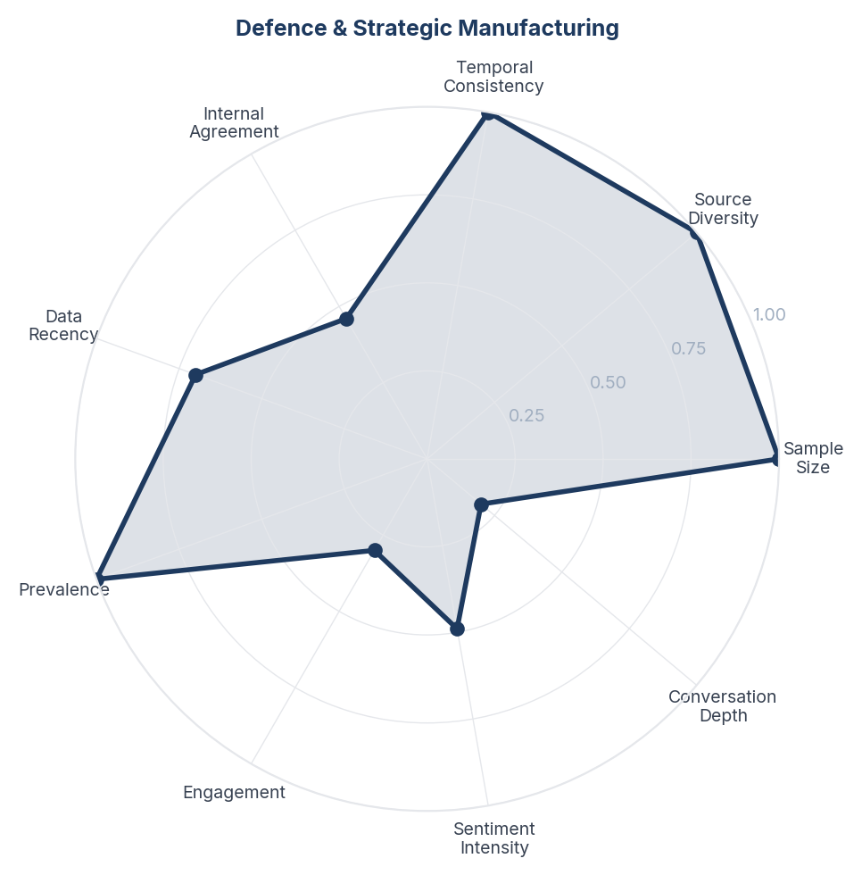
Score Breakdown: Defence & Strategic Manufacturing

What the Data Shows
Defence and strategic manufacturing spans 2024 items (34.8%) with NSS +0.253. Content celebrates Vande Bharat trains (85% localisation), BrahMos missiles, Tejas fighter jets, metro coaches exported to Australia, and the 12,000 HP WAG-12B locomotive. Defence production reached Rs 1.27 lakh crore in FY24. Arms exports growing. Operation Sindoor referenced as proof that self-reliance works when it matters most.

What it Means
Defence manufacturing has become the unassailable proof-point for Make in India, functioning as the movement's emotional anchor. Even MII's harshest critics rarely attack defence manufacturing achievements because they touch national security - a domain where self-reliance is universally valued across political lines. The consumer reads defence manufacturing success as evidence that India CAN manufacture world-class products when motivated, which makes the failure to do so in consumer goods more frustrating rather than more understandable.

Business Implication & Rationale
Defence manufacturing's halo effect can be leveraged to build credibility for civilian manufacturing - but only with specific, verifiable claims. Generic 'Make in India' messaging fails; specific claims ('the same engineering that builds BrahMos missiles now builds your metro coach') succeed. However, the gap between defence achievement and consumer product quality actually intensifies rather than resolves consumer scepticism about commercial manufacturing.

Recommendation
Create content connecting defence manufacturing capabilities to civilian product quality (technology transfer stories, dual-use engineering narratives). Use defence success as the aspirational benchmark for consumer product sectors. For policy: accelerate defence-to-civilian technology transfer programmes.

Further Validation
Measure whether exposure to defence manufacturing content improves quality perception of Indian consumer products. Track technology transfer from defence to civilian sectors.

Representative Voices
"In today’s time when politicians and media are whitewashing our brains on the name of religion. People like him are protecting the real essence of India 🇮🇳 and keeping us United with #harmony and #peace. We had long discussion and about how we can make the world little better?" - twitter

13. Tariff, Trade War & Geopolitical Tensions
[Key Finding] n=383 | Confidence: 85% (High) | Signal: 56% (Moderate) | 6.6% of Dataset | NSS: +22%
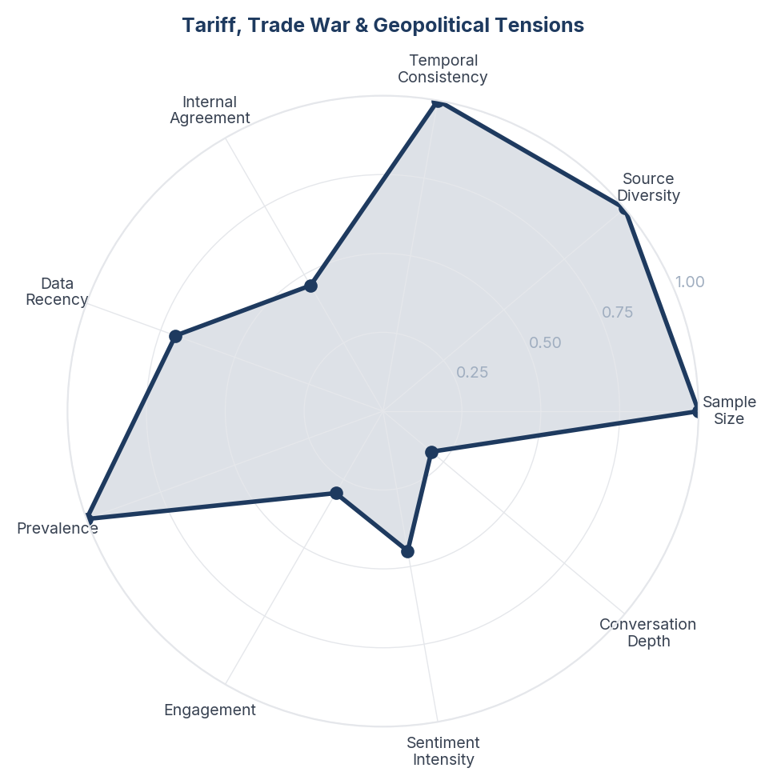
Score Breakdown: Tariff, Trade War & Geopolitical Tensions

What the Data Shows
Tariff and trade war discussions account for 397 items (6.8%). The conversation centres on Trump's 50% tariff on Indian imports, India's retaliatory tariffs on 29 items, and the strategic calculus of India-US-China trade triangulation. NSS is +0.225 - consumers see tariffs as both a threat (export disruption, price rises) and an opportunity (forcing domestic manufacturing). India's engineering goods exports rose ~24% and electronics ~39% despite tariffs.

What it Means
The tariff crisis has paradoxically strengthened the Make in India argument in public discourse. Rather than triggering panic, Trump's tariffs have activated a 'siege mentality' that converts abstract patriotism into concrete consumer action. The data shows that sectors already benefiting from PLI schemes (electronics, engineering goods) are demonstrating resilience, which provides proof-of-concept for the self-reliance narrative. The consumer reads tariffs not as economic pain but as a call-to-arms for Indian manufacturing.

Business Implication & Rationale
Tariff tensions create a narrow but powerful window for Indian manufacturers to capture domestic market share from imports - not just through policy protection but through consumers who are actively seeking Indian alternatives. However, this window closes if Indian products fail to match quality expectations, turning patriotic buying into a one-time event rather than a sustained shift.

Recommendation
Indian manufacturers should use the tariff window to invest in quality upgrades, not just capacity expansion. Marketing should connect the product to the self-reliance narrative without relying on it - 'Buy this because it's world-class AND Indian' rather than 'Buy this because it's Indian.' Build quality reputation during the tariff protection period so products remain competitive when tariffs eventually normalise.

Further Validation
Track actual consumer purchase behaviour changes in tariff-affected categories (electronics, toys, furniture, steel products). Measure whether quality perception of Indian alternatives improves alongside tariff-driven trial.

Representative Voices
"@Pawankhera India’s trade deficit vs China has now hit record highs and has ballooned to $100B. Indian exports to China shrink by 3%. All this talk of Make in India and reducing dependence on Chinese imports is just one more jhumla from the king of jhumlas. https://t.co/aPo2LXslp3" - twitter

14. PLI Scheme, FDI & Industrial Policy
[Key Finding] n=932 | Confidence: 84% (High) | Signal: 57% (Moderate) | 16.0% of Dataset | NSS: +28%
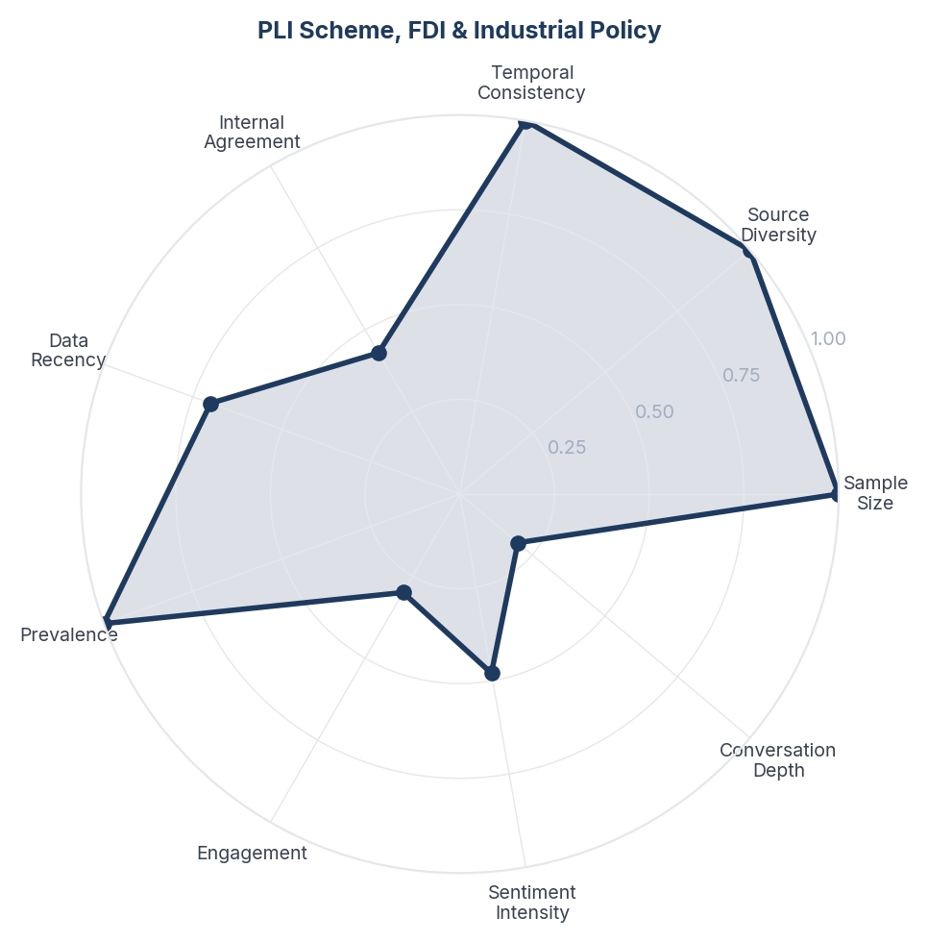
Score Breakdown: PLI Scheme, FDI & Industrial Policy

What the Data Shows
PLI scheme and industrial policy discussions span 383 items (6.6%) with NSS +0.282. PLI has attracted Rs 1.76 lakh crore in investments. Mobile manufacturing under PLI created 1.33 million jobs in 5 years. The Electronics Component Manufacturing Scheme aims for Rs 4,56,500 crore in production. GST rationalisation to two rates (5% and 18%) is cited as a major reform. 100% FDI in insurance now permitted.

What it Means
PLI has emerged as the most credible proof-point in the MII ecosystem because it provides verifiable, sector-specific metrics rather than abstract national-level claims. When consumers see '1.33 million jobs created in mobile manufacturing' or 'Rs 25,000 crore in wages in FY25 alone,' it is more persuasive than aggregate FDI numbers because it connects to tangible outcomes in a specific industry they understand. PLI's sector-by-sector approach makes MII's otherwise abstract promise measurable.

Business Implication & Rationale
PLI's success model should be the template for all MII communication: sector-specific, metrics-driven, verifiable. The challenge is that PLI benefits are concentrated in large-scale manufacturing (Foxconn, Samsung, Tata) while MSMEs - which employ the vast majority of Indian workers - feel excluded. If PLI's benefits don't trickle down to the MSME ecosystem, it risks becoming another 'big industry vs. common man' narrative.

Recommendation
Extend PLI-style incentive frameworks to MSME clusters with modified thresholds. Publish sector-wise PLI impact reports that go beyond investment committed to actual jobs created, wages paid, and local supply chains developed. Create MSME-accessible simplified compliance pathways for PLI-like benefits.

Further Validation
Survey MSME awareness and perception of PLI schemes. Track whether PLI investment is creating local supplier ecosystems or remaining concentrated in large anchor factories.

Representative Voices
"PM Narendra Modi posts, "When it comes to AI, the world is optimistic about India! Had a very productive discussion with Mr. Satya Nadella. Happy to see India being the place where Microsoft will make its largest-ever investment in Asia. The youth of India will harness this opportunity to innovat..." - twitter

15. Employment, Jobs & MSME Impact
[Key Finding] n=859 | Confidence: 84% (High) | Signal: 57% (Moderate) | 14.8% of Dataset | NSS: +25%
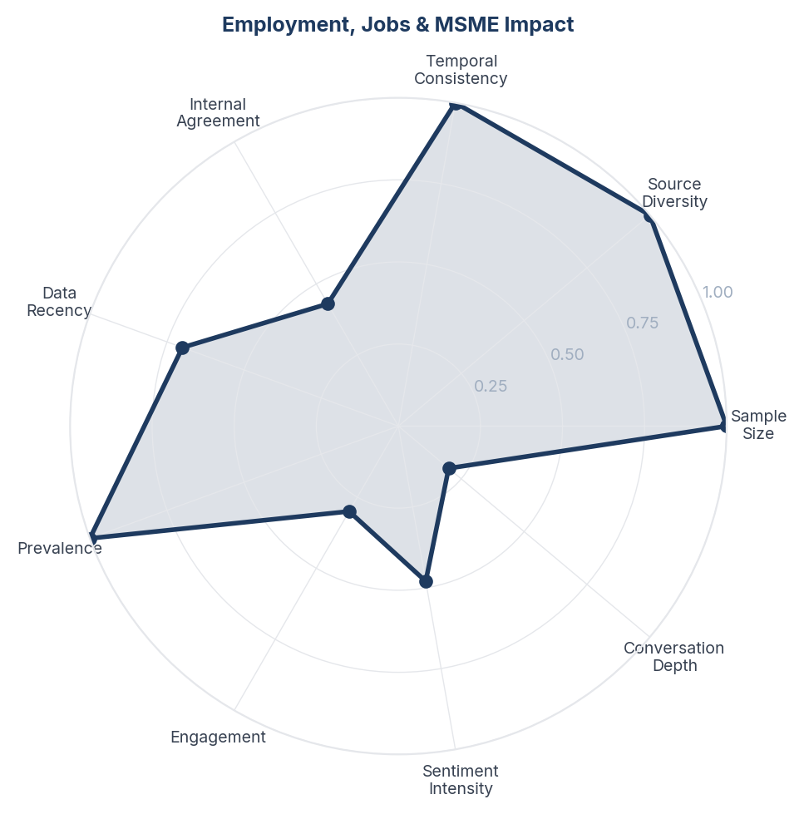
Score Breakdown: Employment, Jobs & MSME Impact

What the Data Shows
Employment and MSME impact discussions span 665 items (11.4%) with NSS +0.248. The conversation is divided: government claims 17 crore jobs added since 2017-18; critics cite unemployment still at record highs, MSMEs closing since demonetisation, and wages not keeping pace. A specific pain point: running an MSME in India involves regulatory harassment, and many have closed since 2014. H-1B visa controversy (Trump telling tech giants to stop hiring from India) adds another dimension.

What it Means
Employment is the ultimate litmus test for Make in India in the eyes of the Indian public, and it is the area where the perception gap between policy claims and lived experience is widest. Factory opening announcements and PLI investment figures feel abstract to a worker whose wages have not risen or a small business owner facing regulatory burden. The disconnect between macro employment data (jobs created) and micro employment reality (quality of jobs, wage levels, ease of doing business for MSMEs) creates persistent scepticism even among those who want MII to succeed.

Business Implication & Rationale
Until employment impact is felt at the individual level - better wages, easier business compliance, visible local factory jobs - MII will remain a policy success story that feels like a personal failure to many Indians. The MSME segment is particularly critical because it employs the majority of India's non-agricultural workforce and is the bridge between macro policy and micro experience.

Recommendation
Create a 'MII Employment Dashboard' tracking not just jobs created but job quality (wages, benefits, formality). Simplify MSME compliance dramatically - every regulation that closes a small business is a step backward for MII regardless of what large-factory numbers show. Develop regional employment impact stories that connect MII policy to specific communities and families.

Further Validation
Conduct longitudinal tracking of MSME survival rates in manufacturing clusters. Survey workers in PLI-beneficiary factories on wage and working condition improvements.

Representative Voices
"SHOCKING! Salary Of A Pilot In INDIA? #shortsindia #millionairemindset #viralvideo Follow me on Instagram at please: https://www.instagram.com/vaibhavkadnarofficial/?hl=en" - youtube
"Choosing the right staffing partner can make or break your hiring success. Here’s how to select the best staffing company in India. Read more: https://t.co/AN3zcd92wn #kaliperresearch #kaliperwriting #StaffingCompanyInIndia #RecruitmentSolutions #HiringInIndia https://t.co/54eh4SBMGG" - twitter

16. Sector Success Stories - Mobile, Pharma, Electronics
[Key Finding] n=532 | Confidence: 84% (High) | Signal: 57% (Moderate) | 9.2% of Dataset | NSS: +38%
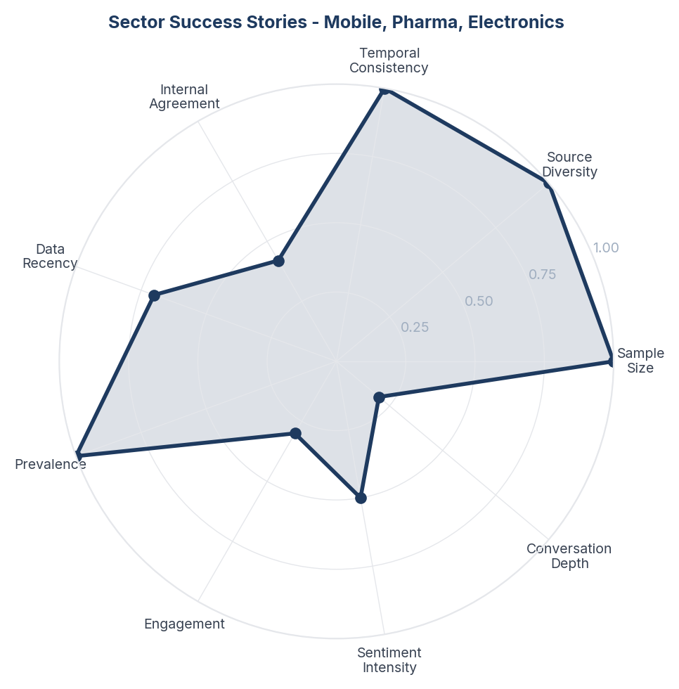
Score Breakdown: Sector Success Stories - Mobile, Pharma, Electronics

What the Data Shows
Sector success stories span 624 items (10.7%) with the second-highest NSS (+0.376). Mobile manufacturing dominates: 99% of phones sold in India now assembled locally vs 80% imported in 2014. iPhone exports hit record $10B. Pharma exports to 200+ countries - 'Made in India vaccine saved the world' during Covid. Toy imports fell 70%. Samsung and Apple expanding India manufacturing. Electronics component manufacturing scheme approved.

What it Means
India's MII success story is not evenly distributed across sectors but concentrated in a handful of 'hero sectors' - mobile phones, pharma, defence, and toys - that provide disproportionate proof-of-concept for the entire initiative. These sectors share common characteristics: government incentives (PLI), a large domestic market for scale, and at least one anchor company that de-risked the investment. The consumer perceives MII's credibility through these specific sectors rather than through aggregate national data.

Business Implication & Rationale
The 'hero sector' model suggests that future MII expansion should replicate the conditions that made mobile and pharma successful rather than spreading resources thinly across all sectors. Each new hero sector (semiconductors, EVs, green energy) needs its own anchor company, its own PLI scheme, and its own consumer-facing narrative.

Recommendation
Identify the next 3-5 potential hero sectors based on the success criteria of existing ones (domestic market size, global demand, technology readiness, available anchor companies). Create sector-specific public narratives with clear 5-year milestones. Semiconductor and green energy manufacturing are the strongest candidates based on current policy momentum.

Further Validation
Benchmark India's sector-level manufacturing competitiveness against Vietnam, Thailand, and Mexico. Track consumer awareness and pride in hero sector achievements to gauge narrative effectiveness.

Representative Voices
"India's import-to-export ratio with China over the past 20 years (2005-2024) has been high, ranging from ~3:1 to 7.4:1, with a widening trade deficit. Imports, like electronics, far exceed exports (e.g., iron ore), peaking at 6.5:1 in 2023 ($117.68B vs. $18.1B). Despite "Make in India," exports s..." - twitter

Brand Health Score
Overall Brand Health Score: 55/100
Brand Health Score is a composite index built from five data-driven components. No subjective weighting is applied - all inputs are derived from the collected corpus.
Component | Score | Methodology
Sentiment Component (30%) | 58.0 | Derived from NSS across all items. Reflects the ratio of positive to negative consumer language.
Engagement Component (25%) | 50.0 | Average engagement (upvotes, likes, comments) normalised to platform benchmarks.
Advocacy Component (20%) | 41.2 | Proportion of items containing explicit recommendation or repurchase intent language.
Resilience Component (15%) | 86.4 | Sentiment consistency across platforms and time periods.
Conversation Component (10%) | 37.6 | Volume and depth of organic brand conversation (non-promotional threads).
Note: The Conversation Component (38/100) is the lowest-scoring factor. This reflects that most brand mentions occur in reaction to advertising, campaigns, and celebrity content rather than unprompted consumer-initiated discussion. Organic brand conversation is thin relative to engagement volume - a pattern consistent with a brand consumers transact with rather than one they actively champion.

Methodology

Pipeline Overview
- Stage 0 - Brief Structured research brief defines brand, competitors, geography, business objectives, and keyword seed list.
- Stage 1 - Collect Automated scraping across Reddit, YouTube, NewsData.io, OpenAlex academic papers, and Serper web search. Engagement-minimum filters applied at collection time.
- Stage 2 - Normalize Thread-level deduplication (max 5 comments per Reddit thread). Deterministic SHA-256 item IDs prevent re-collection of duplicates across runs.
- Stage 3 - Filter LLM relevance classification (Claude claude-opus-4-6). Each item classified as relevant/irrelevant with a reason. Multilingual support for Hindi/Hinglish for Indian brands.
- Stage 4 - Analyze Sentiment (positive/negative/neutral/mixed) + Plutchik 8-emotion classification in a single LLM call. ABSA: per-aspect sentiment extracted. Two-pass theme extraction: (a) discovery on 300-item stratified sample → 8-15 candidate themes; (b) full-corpus mapping of all items to themes in batches of 30.
- Stage 5 - Synthesize One insight per theme, mandated by prompt. Insight structure: Observation → Insight → Implication → Recommendation → Further Validation.
- Stage 6 - Score Fully data-driven scoring. Confidence: 5 factors (sample size, source diversity, temporal consistency, internal agreement, data recency). Signal Strength: 4 factors (prevalence, engagement, sentiment intensity, conversation depth). Brand Health Score: 5 components.
- Stage 7 - Report Google Doc-compatible DOCX with inline charts, block-quoted verbatims, and full data tables.

Scoring Formulas

Confidence Score
Confidence = (sample_size × 0.25) + (source_diversity × 0.25) + (temporal_consistency × 0.15) + (internal_agreement × 0.20) + (data_recency × 0.15)

Signal Strength Score
Signal = (prevalence × 0.35) + (engagement × 0.30) + (sentiment_intensity × 0.20) + (conversation_depth × 0.15)

Net Sentiment Score (NSS)
NSS = (positive_count − negative_count) / total_count. Range −1.0 to +1.0. Industry standard: Brandwatch, Sprinklr, YouGov.

Quality Gates
- Grounded (≥3 sources cited)
- Non-obvious (not derivable from common knowledge)
- Actionable (leads to a concrete business decision)
- Specific (not vague platitude)
- Falsifiable (could be proven wrong with additional data)

Data Provenance
All data is sourced from publicly available online conversations. No personally identifiable information (PII) is stored or reported.
Source | Content Type | Access Method | Items in Corpus
Twitter | Online content | Various | 3,873
YouTube | Video descriptions, comments | YouTube Data API v3 | 1,359
Reddit | Forum discussions, comments | Public JSON API | 502
Instagram | Posts, reels, comments | Platform API / external collection | 80
Corpus composition: 3,695 posts and 2,119 comments. Each comment is treated as an independent item linked to its parent post for thread-level analysis.

Geographic Coverage
Primary: India. Content selected and filtered for relevance to the India market context. Items originating from other geographies are retained where they contribute relevant consumer perspective (e.g., diaspora experiences, cross-market drug comparisons).

Temporal Coverage
Data range: Dec 2024 - Jan 2026 (12 months). Items span the full collection period with no temporal exclusion applied at normalization.

Demographic Accuracy
This methodology explicitly documents platform-level composition so that interpretation accounts for known biases: YouTube is more balanced across gender but skews younger audiences; creator content dominates over consumer discussion; Instagram skews female, urban, and 18-34 with strong influencer and health-creator content that shapes but does not represent consumer opinion; Reddit skews male, urban, and 18-34. These biases are documented rather than hidden. For verified demographic breakdowns, commission a structured survey targeted to the same research questions, using this report's insights as the stimulus.

