Weight Loss Medication
Research Report: Consumer Sentiment & Brand Perception
Analysis Date: 7 July to 6 August 2026

Research Objectives
- What does UK weight loss medication conversation contain in the last 30 days, in what proportions, with what sentiment, and how much of it is about safety rather than results
- Has the conversation moved from injection to oral pill, and what do people believe about whether the pill works as well as the shot
- What almost stops people starting: the full objection and anxiety list, in their own words
- How is the rising death and severe-reaction coverage being discussed, and does it change intent or only sentiment
- How is hair loss discussed following the July study, and which side effects are talked about most
- How is cost discussed once decomposed past the word: price level, price uncertainty, affordability, and grey-market sourcing
- What is said about route to treatment: NHS eligibility, private pharmacy, supermarket pharmacy, and why people switch between them
- What vocabulary do people actually use for the treatment, the experience, and the dose, including community jargon
- How does stigma appear, and where does the conversation move to stay private
- Which themes are condition-led and therefore usable in UK marketing, and which are drug-led and therefore not

Summary of Data and Findings
Items Analysed | 10,890
Content Date Range | Jul 2026 - Aug 2026
Insights Identified | 15
Net Sentiment Score | +14.3%
Brand Health Score | 64/100
Data Sources | 3 platforms

Data Universe

Collection Funnel
12,450 items were collected across the four sources. 5 empty records were dropped at normalization, and 1,555 were rejected by the mechanical filter: 504 as junk and 1,051 as conversational glue. 10,890 items were admitted, 87.5% of what was collected, and all 10,890 are classified. The pipeline's LLM relevance filter was not run and no thread cap was applied; both are recorded in Stage 3 and in the deviations.
Stage | Items | Notes
Collected | 12,450 | 1,864 posts, threads and articles, plus 10,586 comments and replies
Entered normalization | 12,445 | 5 empty records dropped. Duplicates removed: 0. No thread cap: it was removed for this run
Admitted after filtering | 10,890 | 1,555 rejected by rule: 504 junk, 1,051 conversational glue. No LLM filter was run
Classified | 10,890 | 100% of admitted, 87.5% of collected. This is the analysis corpus

Platform Breakdown
Platform | Items | Share of Corpus
Mumsnet | 6668 | 61.2%
Reddit | 3822 | 35.1%
News | 400 | 3.7%
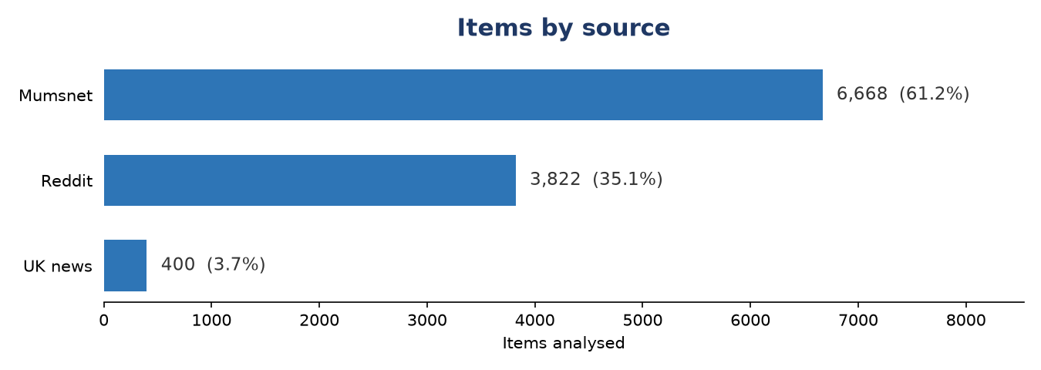
Figure 1: Item distribution by source platform

Temporal Distribution
The chart below shows when the analysed content was originally published, based on source timestamps. Percentages are of the full corpus. Items without a source timestamp are shown separately as 'Undated'.
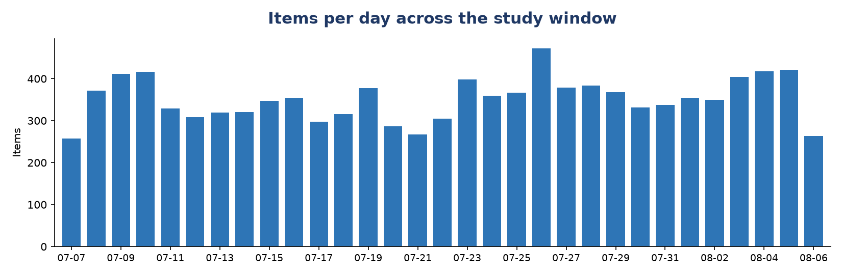
Figure 2: Content publication date by year (full corpus denominator)

Collection Methodology
Data was collected first-hand for this study on 6 and 7 August 2026, covering the 30 days from 7 July to 6 August 2026. Four sources, three collection routes.
Reddit. r/MounjaroUK and r/WegovyUK, via a hosted scraper (Apify actor fatihtahta/reddit-scraper-search-fast). Posts were collected as a census of the window; comments were then bought against the 180 posts with the highest theme match, so comment depth is deliberately concentrated on the study's questions rather than spread evenly. Result: 1,205 posts, 3,451 comments.
Mumsnet. The weight-loss-injections board plus weight-loss and general-health threads, via Mumsnet's public Talk JSON API, fetched by script at no cost. Result: 259 threads, 7,135 replies.
UK news. Google News RSS, when:30d, gl=GB, ceid=GB:en, eight queries. 567 articles returned, 167 removed before ingest with the removals recorded: 139 were programmatic SEO pages from a single Spanish sports title, all clustered in the final five days, and 28 were share-price coverage rather than consumer conversation. Result: 400 articles.
Google Trends. Seven manual exports from trends.google.com, UK, past month. Trends items are not in the corpus and are not counted anywhere in this report. Their role was to set the study's terms, described next.
Collection cost $9.70, all of it Reddit. Every other source was free. Analysis cost nothing: it ran in-context rather than through a metered API.

How the search terms were chosen
This pipeline documents its own first limitation as query framing bias: you find what you search for. Five seed terms were chosen from category knowledge and tested in Trends before anything was scraped. Three of the five were near-dead: weight loss injection scored 2 out of 100, weight loss jab 1, food noise 1. They were discarded.
The replacement list was derived from Trends' own Top and Rising related-query panels for three seeds (mounjaro, wegovy, weight loss): 150 queries collected, 284 on-topic rows after UK-wide breakout contamination was identified and removed. Those queries set the brief's twelve aspects and ten business questions.
One distinction came out of this and shaped the whole design. Search vocabulary is not conversation vocabulary. “Food noise” scoring 1 does not mean nobody says it, it means nobody googles it. The UK press word is “jab”, appearing 88 times across the 400 articles, while weight loss jab scores 1 in search. Trends was therefore used to size demand and set scope. It was not used to drive the conversation scrape, which ran against whole communities rather than keywords, so the corpus is not shaped by any keyword at all.
Themes were not taken from Trends. They were discovered inductively from the corpus. Six of the fifteen landed on territory Trends had flagged in advance: the pill pivot, hair loss, safety and deaths, eligibility and BMI gates, dose titration, and provider shopping. That convergence is a check on the study, not an input to it.

Sentiment & Emotion Analysis

Overall Sentiment Distribution
Net Sentiment Score (NSS): +14.3% | Positive: 3182 (29.2%) | Negative: 1625 (14.9%) | Neutral: 5024 (46.1%)
NSS is computed as (positive - negative) / total items. Range: -1.0 (all negative) to +1.0 (all positive). Neutral and mixed items remain in the denominator, anchoring the score to the full corpus rather than just polarised items. A positive NSS indicates net favourable sentiment; a negative NSS indicates net unfavourable.
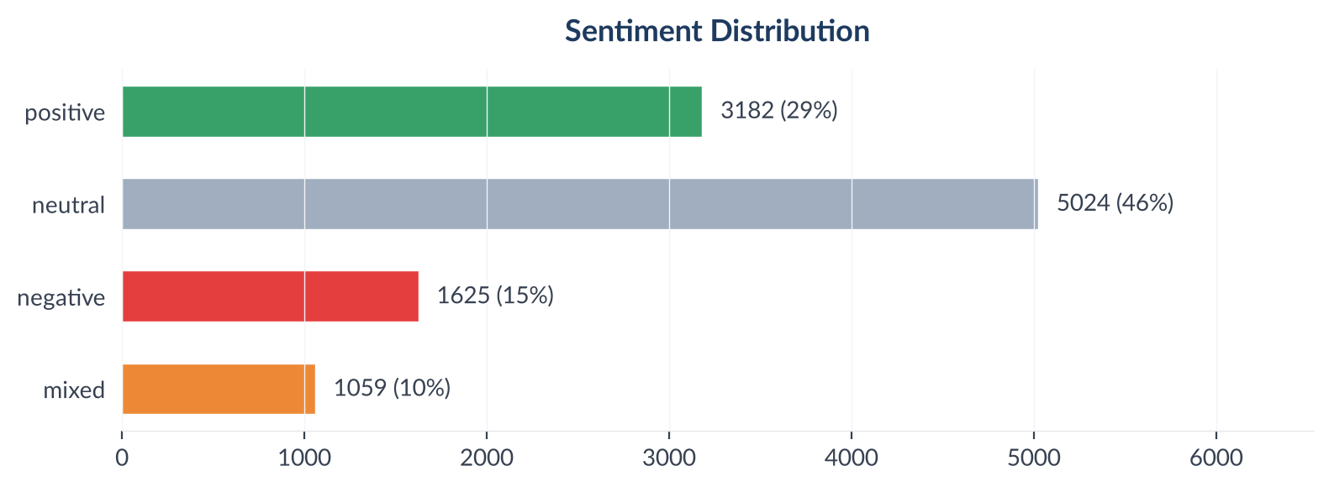
Figure 2: Sentiment distribution across 10,890 items

Emotion Profile (Plutchik 8-Emotion Model)
Emotion | Count
None | 5539
Joy | 1880
Trust | 1114
Sadness | 602
Fear | 554
Anticipation | 446
Anger | 319
Surprise | 280
Disgust | 156
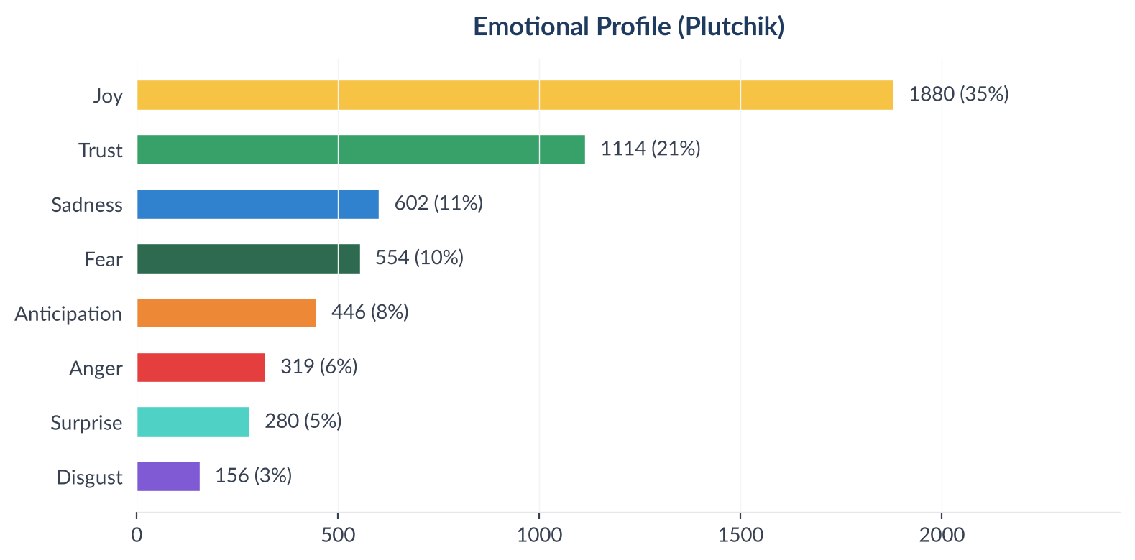
Figure 3: Plutchik emotion distribution

What each emotion sounds like
The chart above scores emotion; these are the items behind it. Two or three real examples of each, so the classification can be audited rather than trusted. All are public forum posts from inside the study window, 7 July to 6 August 2026. Usernames are removed and nothing is paraphrased.

Joy: 1,880 items (17.3% of corpus)
“Mid week weigh in, lost a bit but excitingly my body fat percentage is down more than 4% since I started in late June. Now at 50.1% so hopefully will drop below 50% before too long.”
Mumsnet, classified positive
“I am watching the Football, went to a BBQ today, enjoyed the food and now at home in bed, I may have a glass of wine in hand.”
Mumsnet, classified positive
“Omg! You look AMAZING!! Your legs are so toned. Good on you!! Your outfit is class”
Reddit, classified positive

Trust: 1,114 items (10.2% of corpus)
“Thank you. Knowing that you and others in our group are already doing this makes me feel safe to do this!”
Mumsnet, classified positive
“I suspect maintenance is going to be the hardest part for a lot of us, so well done on keeping it going so well.”
Reddit, classified positive
“It's normal, you're not going to lose every week, your body can have other ideas about it. Just keep going. Also, make sure that deficit isn't too big.”
Reddit, classified neutral

Sadness: 602 items (5.5% of corpus)
“Frustrating weigh in today, put on one pound. Food intake has been good but more alcohol recently, mostly still keeping to 1500 or less. Feeling disappointed.”
Mumsnet, classified negative
“That's your fifth dose. Use it or lose it. Actually, we've all just lost it.”
Reddit, classified negative
“That's how I felt yesterday and today too. I couldn't even finish my morning coffee!”
Mumsnet, classified negative

Fear: 554 items (5.1% of corpus)
“Had my first dose today, was scary injecting for the first time! When can I expect side effects to start? Also appetite suppression?”
Mumsnet, classified negative
“This is the thing that worries me the most as I work in a small office. I'm worried about needing the loo urgently or vomiting at work.”
Mumsnet, classified negative
“Are you worried about how you will get further supplies after such a long gap? I worry I won't get represcribed by anyone after such a long time.”
Mumsnet, classified negative

Anticipation: 446 items (4.1% of corpus)
“I'm on day 8 and so far I've had no side effects and a gentle reduction in hunger. I'd previously tried something else but had bad side effects. I'm hoping this stays better.”
Reddit, classified positive
“It's been really interesting following your first week so I'm looking forward to your weekly updates. Good luck for this coming week.”
Reddit, classified positive
“I'm hoping that if I'm still on it for maintenance, and that's more than likely, I could switch and maintain at a low dose.”
Mumsnet, classified positive

Anger: 319 items (2.9% of corpus)
“Oh goody, the old just eat less and move more brigade has joined the discussion.”
Mumsnet, classified negative
“Is anyone else experiencing very long delays between prescription approval and dispatch? I'm 15 days and counting. Missing a dose.”
Reddit, classified negative
“Stuff like this makes me so angry nowadays. And in a place of “health”! Ultra processed, ultra calorific food ads also annoy me now too.”
Reddit, classified negative

Surprise: 280 items (2.6% of corpus)
“It's so weird, isn't it, to discover something treat-y in the fridge or cupboard and wonder how on earth you could have forgotten about it.”
Mumsnet, classified positive
“I work from home a lot and was constantly grabbing food through the day. I just... don't do that anymore, it's so weird!”
Mumsnet, classified positive
“I came to visit my parents and they stopped me for lunch. I had 50 grams of pasta and I already feel full.”
Mumsnet, classified positive

Disgust: 156 items (1.4% of corpus)
“I just cooked a standard sized evening meal and I am so overstuffed. I hate this feeling.”
Mumsnet, classified negative
“It was just like morning sickness queasiness. It was unpleasant but short lived.”
Mumsnet, classified negative
“I can eat, I've had 1300 calories and 100g of protein. It's the nausea that's just horrible, and I get it when it's hot so double whammy tomorrow.”
Reddit, classified negative

Aspect-Based Sentiment Analysis (ABSA)
Aspects with ≥10 mentions are shown below. NSS is statistically meaningful only at this threshold.
Figure 4: Aspect sentiment heatmap (aspects with ≥10 mentions)

Insight Landscape
15 insights were identified from 10,890 items using a two-pass extraction approach (stratified discovery sample + full-corpus mapping).
Insight | Items | Prevalence in Dataset | Signal Strength | Confidence Score | NSS
The weekly ritual: weigh-ins, plateaus and stalls | 2280 | 20.9% | 68% (Moderate) | 71% (Medium) | +38%
Dose titration and click-counting economics | 2265 | 20.8% | 56% (Moderate) | 73% (Medium) | +6%
Side effects and their management | 2108 | 19.4% | 54% (Moderate) | 69% (Medium) | -8%
Provider shopping, prices and switching | 1435 | 13.2% | 54% (Moderate) | 70% (Medium) | -7%
Eating mechanics on the medication | 1418 | 13.0% | 53% (Moderate) | 68% (Medium) | +18%
Food noise and appetite psychology | 1069 | 9.8% | 57% (Moderate) | 66% (Medium) | +23%
Body image transformations and non-scale victories | 1007 | 9.2% | 69% (Moderate) | 70% (Medium) | +59%
Stopping, maintenance and regain fear | 971 | 8.9% | 62% (Moderate) | 66% (Medium) | +12%
Community ritual and mutual support | 949 | 8.7% | 62% (Moderate) | 65% (Medium) | +61%
Eligibility, BMI gates and verification | 645 | 5.9% | 56% (Moderate) | 65% (Medium) | +5%
The pill pivot: oral GLP-1s arrive | 622 | 5.7% | 45% (Weak) | 64% (Medium) | +7%
The business and policy layer | 455 | 4.2% | 48% (Weak) | 63% (Medium) | -10%
Stigma, secrecy and telling people | 261 | 2.4% | 59% (Moderate) | 57% (Medium) | -7%
Safety, deaths, counterfeits and the grey market | 222 | 2.0% | 50% (Weak) | 60% (Medium) | -41%
Hair loss | 113 | 1.0% | 34% (Weak) | 58% (Medium) | +3%
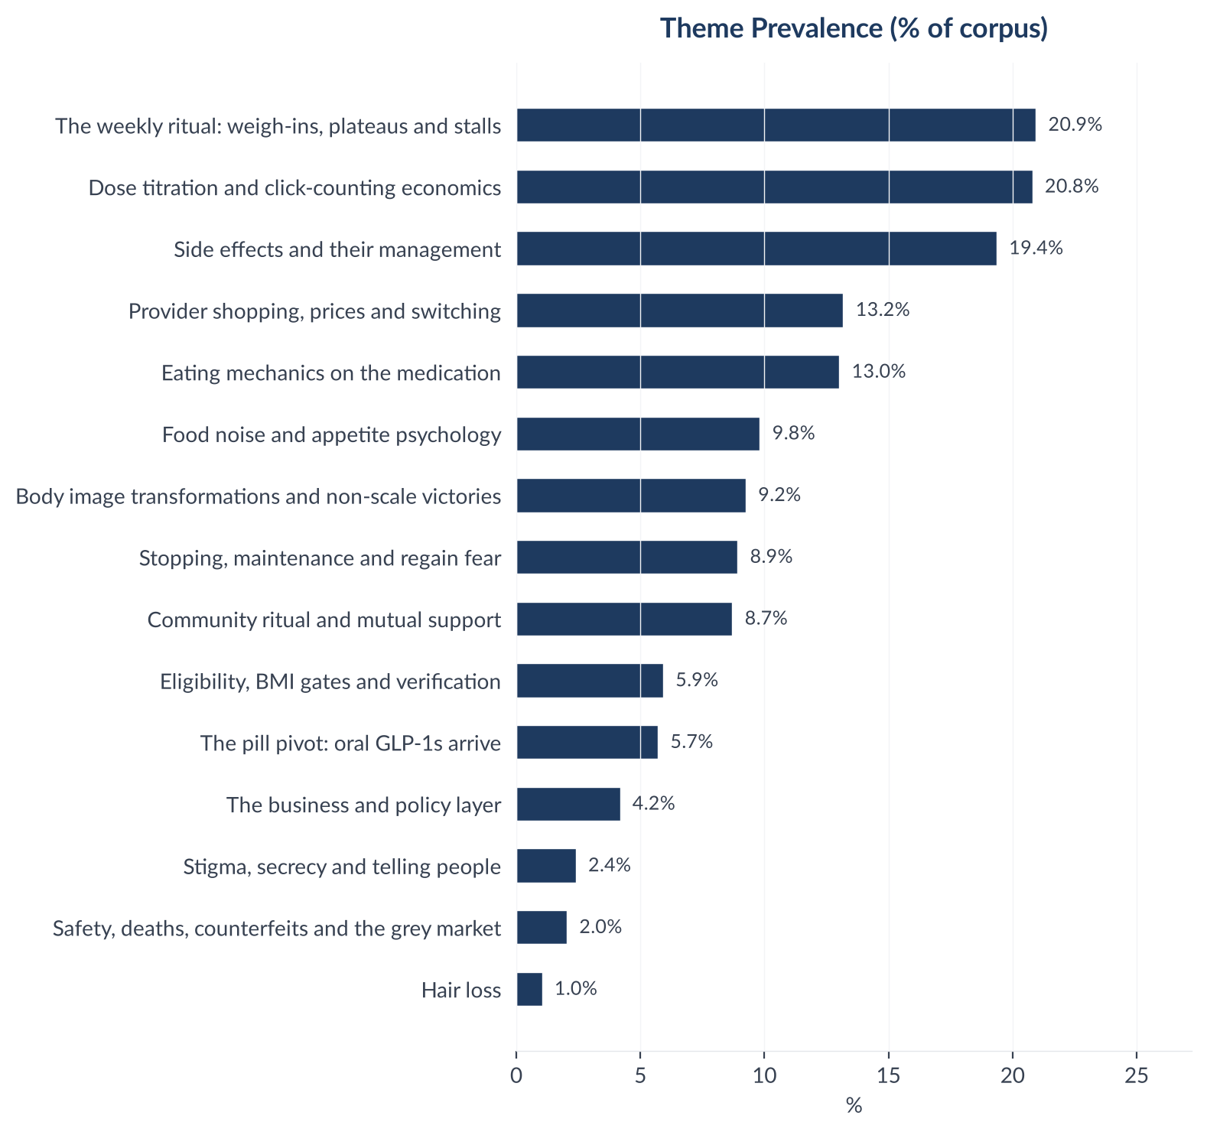
Figure 5: Insight prevalence (% of total corpus)

Insight Deep Dives
One insight per theme, ordered by conversation volume. Each insight follows the framework: What the Data Shows, What it Means, Business Implication and Rationale, Recommendation.

01. The weekly ritual: weigh-ins, plateaus and stalls
n=2280 | Confidence: 71% (Medium) | Signal: 68% (Moderate) | 20.9% of Dataset | NSS: +38%
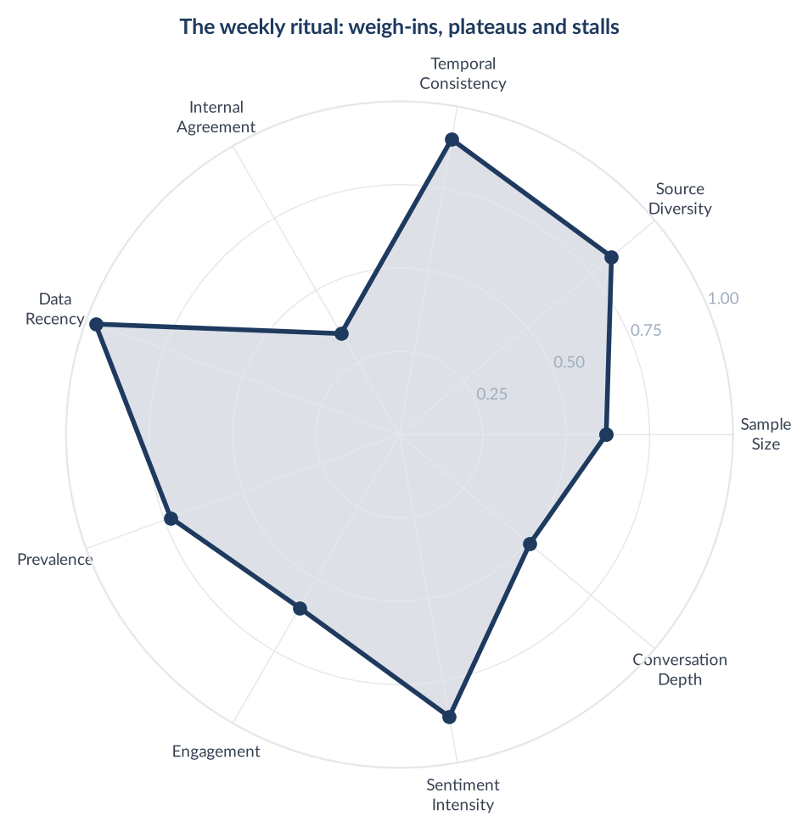
Score Breakdown: The weekly ritual: weigh-ins, plateaus and stalls

What the Data Shows
The weekly ritual of weigh-ins, plateaus and stalls is the largest theme in the study at 2,280 items, 20.94% prevalence, and it is strongly positive: 1,153 positive, 285 negative, 488 neutral, 354 mixed, net sentiment +0.3807, with joy in 820 items. Exactly 1 of the 2,280 items is news, so this is entirely a peer conversation. The rhythm is self-imposed and the stall is a public event: 'Weigh in day. Sadly the big loss over the weekend didn't stuck, and I bounced up again. However I have officially lost a more sensible 0.6kg this week.' Difficulty is posted as openly as success: 'Stuck and wondering whether to start coming down SW 15st 4lbs, CW 11st 12lbs. Target weight 11st.'

What it Means
The audience already keeps a weekly publishing schedule and honours it whether the week went well or badly. That is a content calendar the category did not have to create and cannot easily disrupt.

Business Implication & Rationale
This is the single largest audience moment in the category, it is condition-level, and it is legally open: non-linear weight loss and scale anxiety exist independently of any medicine. It is also the theme where creative most easily breaks the rules, because the native format is a number and a timeframe, and claims that people can lose precise amounts in a stated period are prohibited.

Recommendation
Build a weekly beat timed to the community's own weigh-in day, and make the plateau the subject rather than the loss. Carry no figures in creative and no medicine, which keeps the strongest slot in the category compliant by construction.

Representative Voices
"Finally at goal weight Started in October, hit my goal weight last weekend SW 250 GW 154 CW 152" - reddit
"Checking in too. Amazing updates from everyone! Loss is slowing down here, I was up and down on scales this week but weighed this morning and 1lb off so im taking that as my weekly weight. SW 13ST CW 9st 12 GW no idea I'm on 3.75mg and counting clicks from a 5mg, I lost count last week and took 5mg which strangely had no effect at all and I gained 2lb. So back to 3.75 as definitely more suppression" - web
"Stuck and wondering whether to start coming down SW 15st 4lbs, CW 11st 12lbs. Target weight 11st. Height 5ft 11” Just looking for some advice please on stalling. I’ve been on Mounjaro for 13 months now and am targeting 11st. I had gained the extra weight over 7 years, and had become pre diabetic and with insulin resistance so had found losing weight any other way pretty impossible. Looking at my tracker I’ve been on..." - reddit
"Weigh in day. Sadly the big loss over the weekend didn't stuck, and I bounced up again. However I have officially lost a more sensible 0.6kg this week, which does take me under 16 st. And edging closer to under 100kg. It's a good reminder for me to not pay too much attention to my daily fluctuations. SW 122.7 kg (19 st 4 lb) CW 101.1 kg (15 st 13 lb) GW 60kg?" - web

02. Dose titration and click-counting economics
n=2265 | Confidence: 73% (Medium) | Signal: 56% (Moderate) | 20.8% of Dataset | NSS: +6%
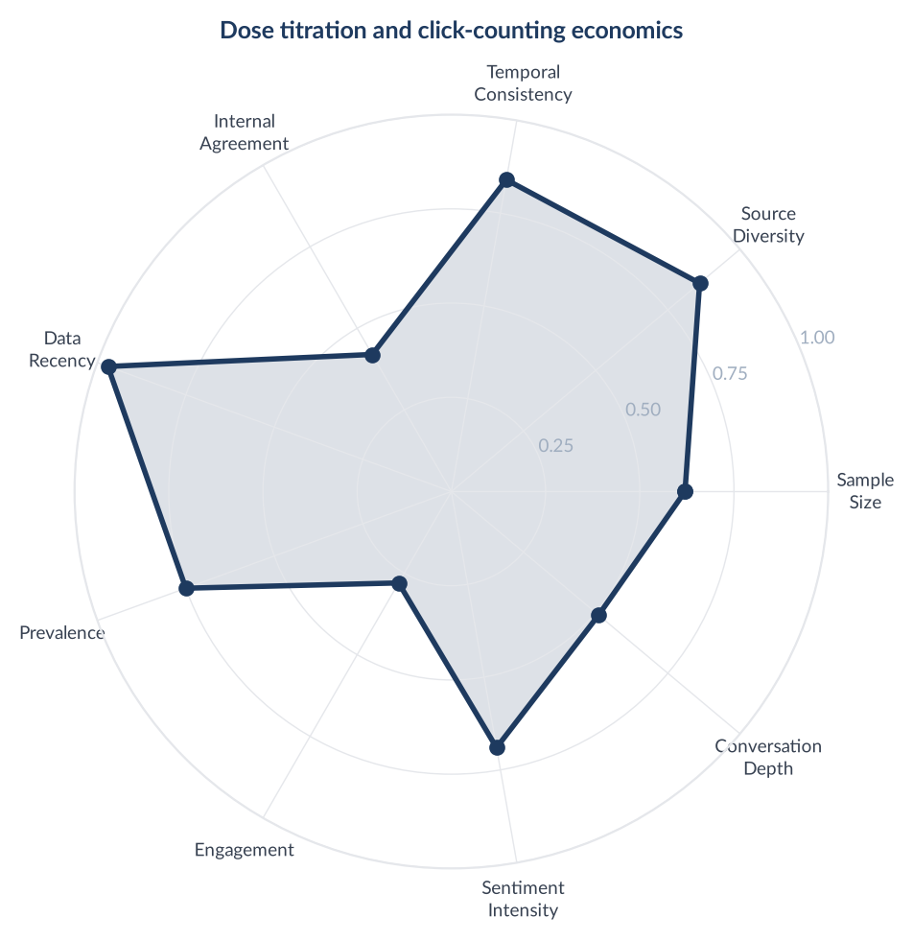
Score Breakdown: Dose titration and click-counting economics

What the Data Shows
Dose titration and click-counting economics is the second largest theme at 2,265 items, 20.8% prevalence, and it is the most emotionally inert large theme in the study: 419 positive, 291 negative, 1,372 neutral, 183 mixed, net sentiment +0.0565, with 1,413 items carrying no detectable emotion at all. The register is arithmetic. 'I had a stock of 10mg pens that I used to titrate down as it was easier to calculate the clicks. 45 for 7.5mg, 30 for 5mg, 15 for 2.5mg.' The community tracks pen hardware as closely as dose, and a change to the device is treated as a price rise: '10mg Pen - No golden dose. Just received my new 10mg MJ pen from Cloud Pharmacy (counting clicks for 7.5mg dose). It's a new style pen with no golden dose!!'

What it Means
Dose is being used as a cost instrument rather than a clinical one. Patients are not titrating toward an effect, they are stretching a pen across a month, and they have built a shared arithmetic to do it. The flat sentiment is the signature of a practical procedure, not indifference.

Business Implication & Rationale
This is the second largest block of conversation in the category and almost none of it can carry marketing. Dose-splitting content cannot exist without the medicine, so it fails the one test that matters: could this post exist if the company sold nothing but consultations. Its commercial value is diagnostic instead. Click-counting talk is a price-sensitivity signal at reorder, and it appears alongside provider switching in the same accounts.

Recommendation
Do not publish into this theme. Instrument it: count click-counting and golden-dose mentions per week as a leading indicator of price-driven churn, and route the underlying need to the one lane that is open, which is a titration conversation with a prescriber.

Representative Voices
"I had a stock of 10mg pens that I used to titrate down as it was easier to calculate the clicks. 45 for 7.5mg, 30 for 5mg, 15 for 2.5mg. I'm in maintenance and on 2.5 every 2-3 weeks." - web
"I got the 7.5mg pen last week but I did the 40 clicks on Sunday (my jab day) hoping I’d be staying on 5mg" - reddit
"Hello all! Checking in from holiday. I’m wearing short shorts and look nice in all the photos so far 😂 Such a fan of MJ. It really is revolutionary. I never thought I’d wear shorts in public, but here I am with my fake tan legs looking svelte. I’ve got 6lbs left to my goal and thinking I won’t need to be a high dose of MJ for much longer. Good job as my new 10mg pen (counting clicks for 7.5mg dose) that arrived last..." - web
"10mg Pen - No golden dose Just received my new 10mg MJ pen from Cloud Pharmacy (counting clicks for 7.5mg dose). It’s the bottom one in the photo… It’s a new style pen with no golden dose!! 😭 Sharing here for awareness. I would have ordered 12.5mg if I’d known they’d introduced new style pens for 10mg!!" - web

03. Side effects and their management
n=2108 | Confidence: 69% (Medium) | Signal: 54% (Moderate) | 19.4% of Dataset | NSS: -8%
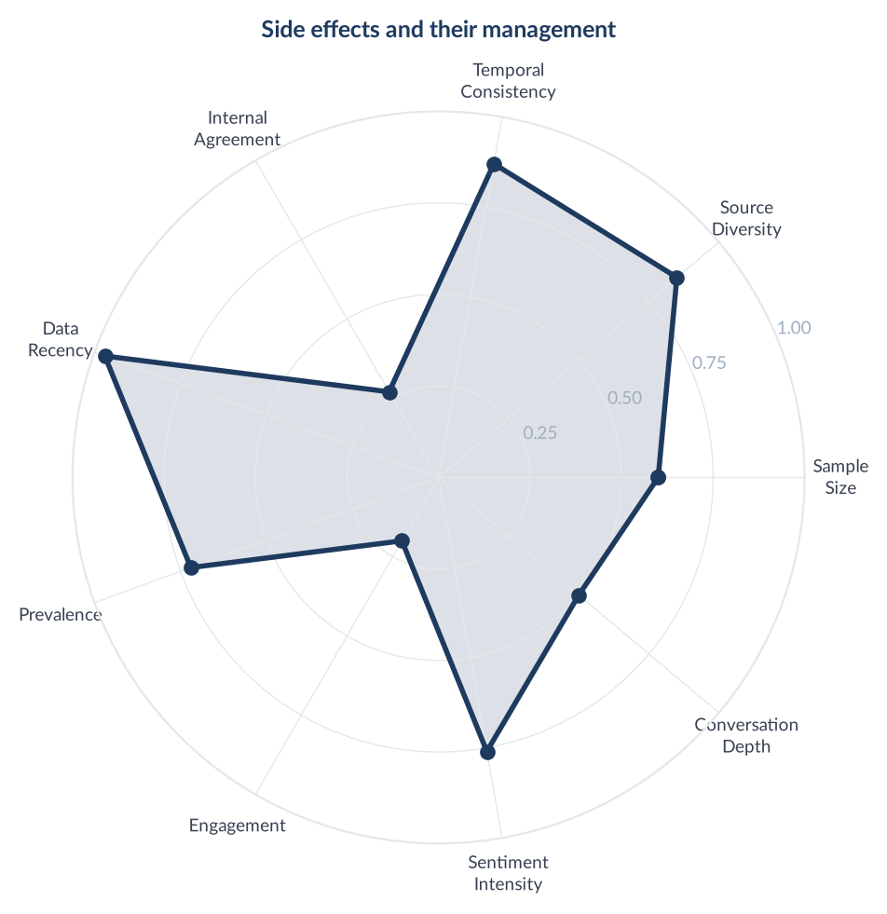
Score Breakdown: Side effects and their management

What the Data Shows
Side effects and their management is the third largest theme at 2,108 items, 19.36% prevalence, and only mildly negative: 398 positive, 559 negative, 821 neutral, 330 mixed, net sentiment -0.0764. Fear appears in 245 items, an 11.6% rate, the second highest in the study behind safety. The dominant register is peer troubleshooting rather than complaint: 'So a day after my 3rd 7.5mg I felt nauseous all day, & the thought of food was making me feel sick.' Anticipated side effects are rehearsed before they happen: 'I already have regular acid reflux so Im expecting Ill definitely get that side effect, Im emetophobic which has put me off so far with the jabs.'

What it Means
Side effects are managed socially long before they are managed clinically. The fear is concentrated at the start, in people who have not begun yet and are pre-negotiating with a symptom they have only read about.

Business Implication & Rationale
Nineteen percent of the conversation sits on a subject the category treats as untouchable and which is in fact discussable at condition level. Nausea, constipation and fatigue can be addressed as experiences of rapid weight change, provided no medicine is named or pictured. The commercial value is at the front of the funnel, where anticipated side effects are the last barrier before starting.

Recommendation
Build the pre-start reassurance content, addressed to symptoms rather than to a drug, and resolve it into a consultation rather than into advice. Deeper medicine-specific information belongs on pages the reader chooses to reach, never as an advertised destination.

Representative Voices
"Drinking alcohol on Wegovy and side effects Ok. So I am on the stater dose for about 3-4 weeks now and apart from a first few days of constipation the side effects have been minimal - some very infrequent nausea feelings which have passed after a few seconds. Anyway, today I have been violently ill. Think terrible sickness and vomiting. So last night I went out for dinner and had probably 1 1/2 small glasses of..." - reddit
"So a day after my 3rd 7.5mg I felt nauseous all day, & the thought of food was making me feel sick. This was yesterday and didn't sleep well because of it. Then this turned to diorreah. I've never had this, my normal side effects would be slight headache & feeling tired. Has anyone had nausea diorreah suddenly a day after jab? How long did it take to go? I introduced electrolytes yesterday but surely that can't have..." - web
"First week done! I did my first jab on Monday and after a pretty up and down week I’m happy to say I’ve survived week 1 🤣 I was very anxious about the side effects prior to starting, I have emetophobia so the possibility of vomiting this week was terrifying. I was pleasantly surprised the first couple of days - a little headache and constipation - but was eating very bland food (literally just plain chicken, rice..." - reddit
"I already have regular acid reflux so Im expecting Ill definitely get that side effect, Im emetophobic which has put me off so far with the jabs, but my fear is mostly about catching bugs and that awful relentless nausea and vomiting which Im trying to rationalise wont be the case, most likely some bouts of nausea, I have anti sickness tablets and pepto bismol ready just in case!" - web

04. Provider shopping, prices and switching
n=1435 | Confidence: 70% (Medium) | Signal: 54% (Moderate) | 13.2% of Dataset | NSS: -7%
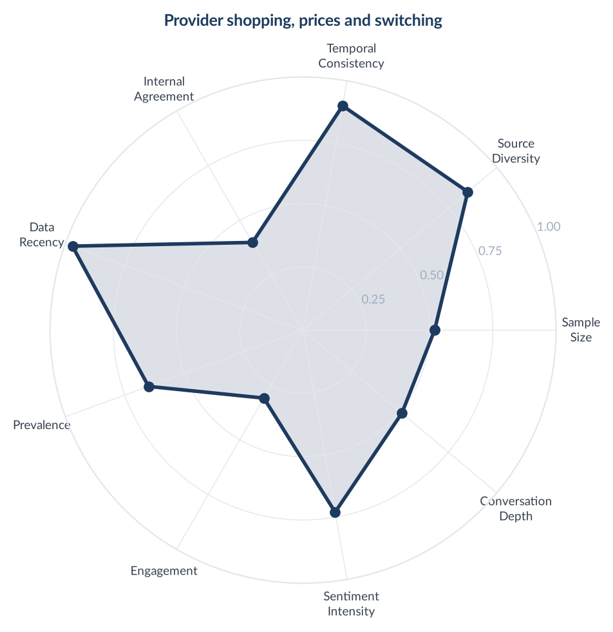
Score Breakdown: Provider shopping, prices and switching

What the Data Shows
Provider shopping, prices and switching is 1,435 items, 13.18% prevalence, net sentiment -0.0697: 204 positive, 304 negative, 825 neutral, 102 mixed. Anger appears in 156 items, the largest absolute count of anger anywhere in the 15 themes. The market is being priced in public through a third-party comparison site: 'There is a price comparison site called Monj which lists GPhC registered pharmacies with their prices for Mounjaro.' Switching is monthly and unsentimental: 'I've been ordering from a different supplier each month using Monj but this discount made a 7.5mg £180 including delivery, so £10 cheaper than cheapest option on Monj right now.' Service failure converts directly into a switch: 'Bad experience with Curely. Dispatched in the heatwave while I was away despite confirming they wouldn't, and then ignoring my emails.'

What it Means
Loyalty in this category is approximately one month long and is re-tendered at every reorder. An independent comparison site, not any brand, owns the moment of choice.

Business Implication & Rationale
This is a retention problem being read as an acquisition problem. It is also where the referral economics live, and where four upheld rulings in February 2026 landed on brands whose customers shared personal discount codes. A scheme survives only where the reward and the code attach to the service across the board rather than to a medicine, and the brand actively polices what members write. That is the same control model a paid creator programme needs, so the two are one system.

Recommendation
Treat the reorder, not the first order, as the contested moment. Compete on delivery reliability and continuity of supply, which is what the anger in this theme is actually about, and build the referral programme and the creator programme on one policed control layer rather than two.

Representative Voices
"People earn commission for sharing codes, that's why they gave you their medexpress code. https://monj.co.uk/discount-mounjaro-price-list/ All the prices are on here. They're all legit clinics and pharmacies registered with CQC/GPhC. Lotus are in lillydirect so they're very reputable. Boots are soooo expensive. Medexpress aren't the best, still haven't passed their inspection from April 25...." - reddit
"@Ozzwaldo cheap doesn’t mean unreliable or fake products as long as the pharmacy is registered with the GPhC and you’ve checked that you are on the legitimate website for that company. There is a price comparison site called Monj which lists GPhC registered pharmacies with their prices for Mounjaro. https://monj.co.uk/mounjaro-price-comparison-by-monj/ From the list on that site you’ll recognise big names like Asda,..." - web
"Bad experience with Curely - looking for new supplier I've had a poor experience with Curely - dispatched in the heatwave while I was away despite confirming they wouldn't, and then ignoring my emails - I've escalated with bank. So ... I'm looking for a new supplier and am "cost sensitive", in the ideal world it'd be somewhere I could pick up from (like Boots), but they seem a bit more pricey. I live in Crewe and..." - reddit
"Lloyds existing customer 30% off Ordered from Lloyds once a few months or so ago but had a random letter from them today with a 30% discount code. I’ve been ordering from a different supplier each month using Monj but this discount made a 7.5mg £180 including delivery, so £10 cheaper than cheapest option on Monj right now. Only taking my third dose this Friday but bought early to make a saving." - reddit

05. Eating mechanics on the medication
n=1418 | Confidence: 68% (Medium) | Signal: 53% (Moderate) | 13.0% of Dataset | NSS: +18%
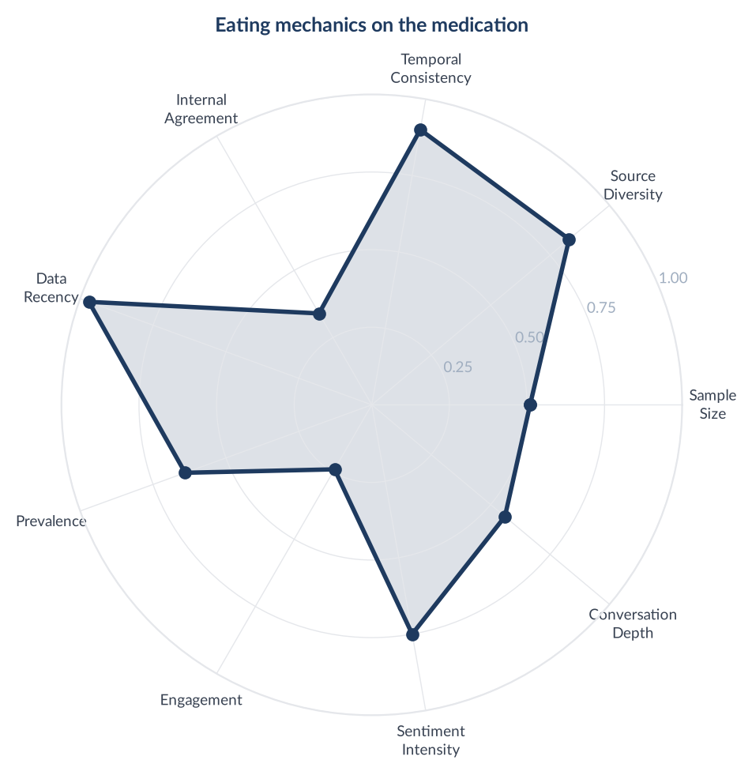
Score Breakdown: Eating mechanics on the medication

What the Data Shows
Eating mechanics on the medication is 1,418 items, 13.02% prevalence, net sentiment +0.1756: 422 positive, 173 negative, 697 neutral, 126 mixed. 828 items carry no detectable emotion, 58.4% of the theme, making it one of the flattest large themes in the study. The content is practical and specific: 'Go back to tracking your calories properly Focus on filling, protein and fibre packed meals'. The problem people actually have is getting enough in, not holding back: 'I am finding it hard during day 3 after my jab to eat enough and decided to try the black Huel. It is 35g protein, 7g fibre.'

What it Means
The eating problem inverts once appetite is suppressed. This is not restraint content, it is adequacy content, and the category is still writing as though the audience needs help eating less.

Business Implication & Rationale
Thirteen percent of the conversation is ordinary nutrition, which is the cheapest compliant content in the study to produce and the easiest to get wrong. It stays open only while it is detached from the medication frame; attached to it, protein targets become dosing-adjacent advice about a prescription medicine.

Recommendation
Own the adequacy angle, which nobody in the category is serving: protein and fibre when nothing appeals. Write it as nutrition for rapid weight change, never as nutrition on a medicine.

Representative Voices
"Go back to tracking your calories properly Focus on filling, protein and fibre packed meals I find now I need to eat a larger amount of food for the satiety and food noise reduction than I did at the start (I've never had supression) But if I plan and track everything i can eat those larger portions and still hit my deficit" - reddit
"Like @reluctantbrit I use Nutracheck to track calories, protein and fibre. I try not to eat my exercise calories but will take it as a bit of leeway if I need to guesstimate a meal out etc. ETA though if the meal is in a chain restaurant, Nutracheck has a lot of those in the app!" - web
"Drinking calories Hi! I am finding it hard during day 3 after my jab to eat enough and decided to try the black Huel. It is 35g protein, 7g fibre, full of vitamins + minerals, and slow-release carbs. I am actually finding that to be the most effective way of giving my body nutrients on my highest suppression days. Has anyone else tried Huel?" - reddit
"Unfortunately the food noise has died down so much I barely eat. I don't count calories. However I get weighed weekly at Slimming World so I'm accountable and try to eat low fat meals. However I've lost nearly all interest in what I eat, I'm happy to have tomatoes on toast or a bowl of cereal for my tea and that is enough whereas before we'd be talking four mini spring rolls, six hash browns, a battered frozen fish..." - web

06. Food noise and appetite psychology
n=1069 | Confidence: 66% (Medium) | Signal: 57% (Moderate) | 9.8% of Dataset | NSS: +23%
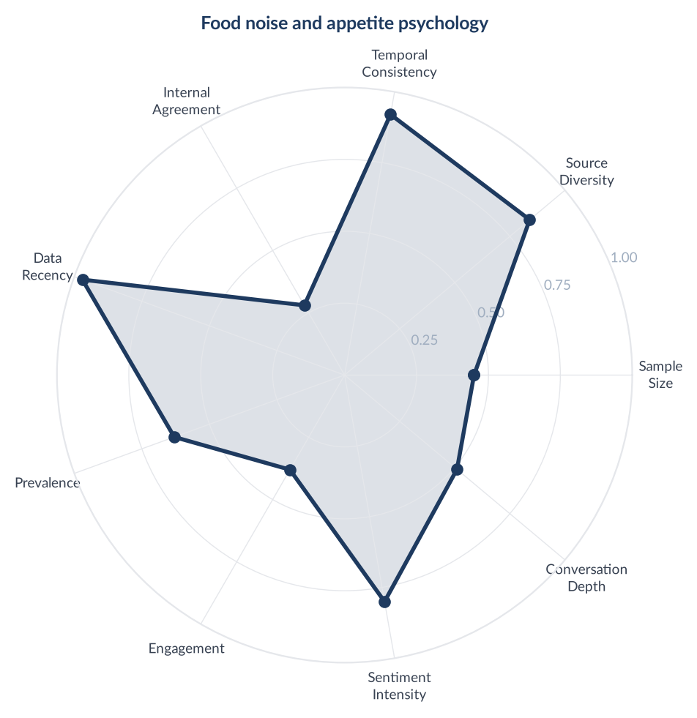
Score Breakdown: Food noise and appetite psychology

What the Data Shows
Food noise and appetite psychology is 1,069 items, 9.82% prevalence, net sentiment +0.2320: 420 positive, 172 negative, 324 neutral, 153 mixed. Surprise appears in 76 items, a 7.1% rate and the highest of any theme in the study. The vocabulary is the audience's own and it is used without explanation. Its return is reported as a loss: 'Food noise back I started Mounjaro a week ago (2,5mg). I had very good effects the first 2/3 days regarding appetite suppression and then the food noise / hunger between meals / bigger appetite suddenly came back.' The relief is described as an effect on the head rather than on the stomach: 'I found the first dose particularly effective at minimising my hunger and shutting off the food noise.'

What it Means
Surprise is the signature emotion here because the relief is not what people were sold. They expected to lose weight and instead report a quiet head, and they have coined a word for it that no brand supplied.

Business Implication & Rationale
This is the strongest compliant lane in the study. Food noise names an internal state, implies no product, and belongs to the audience rather than to any manufacturer. It carries the category's most distinctive emotional payload with none of its legal exposure, provided the relief is never resolved by a medicine.

Recommendation
Lead the brand's content here and use the audience's own term. Show the quiet, not the loss. The one line that closes the lane is any implication that a prescription is what makes it quiet.

Representative Voices
"You're barely on it yet, be patient as you up your dose. You don't have much to lose, I was the same, aiming for 1.5 stone. I stayed on 0.5mg, so have never really lost food noise and appetite suppression is much lower but the weight is still coming off. Slow weight loss is much less risky (gall bladder and pancreatic cancer), and needing some self control is healthy and will help you when you stop taking it. I'd..." - web
"I did actually. 7.5mg was the first dose that felt really effective through the whole week, and it stayed that way for more than a month. My response to 2.5 and 5mg was pretty good and I lost weight, but always noticed waning effects towards the end of the week (from about week 2 on 2.5mg and all through my one month on 5mg). All doses have helped me with food noise/ cravings and increased \*satiety\* - so that yes..." - reddit
"Food noise back I started Mounjaro a week ago (2,5mg). I had very good effects the first 2/3 days regarding appetite suppression and then the food noise / hunger between meals / bigger appetite suddenly came back. Still lost 2kgs (probably mostly water weight even though some of my face inflammation is gone). Today was my second injection and I just had the nausea without the appetite reduction / suppression effect..." - reddit
"Mounjaro and menstrual cycle Hello all - first time poster, but been lurking here a while. This community has been a great source of information and support for me as I've started taking Mounjaro three weeks ago. Still on the 2.5mg dose but I found the first dose particularly effective at minimising my hunger and shutting off the food noise. However, my period is coming within the next week I think and the food..." - reddit

07. Body image transformations and non-scale victories
n=1007 | Confidence: 70% (Medium) | Signal: 69% (Moderate) | 9.2% of Dataset | NSS: +59%
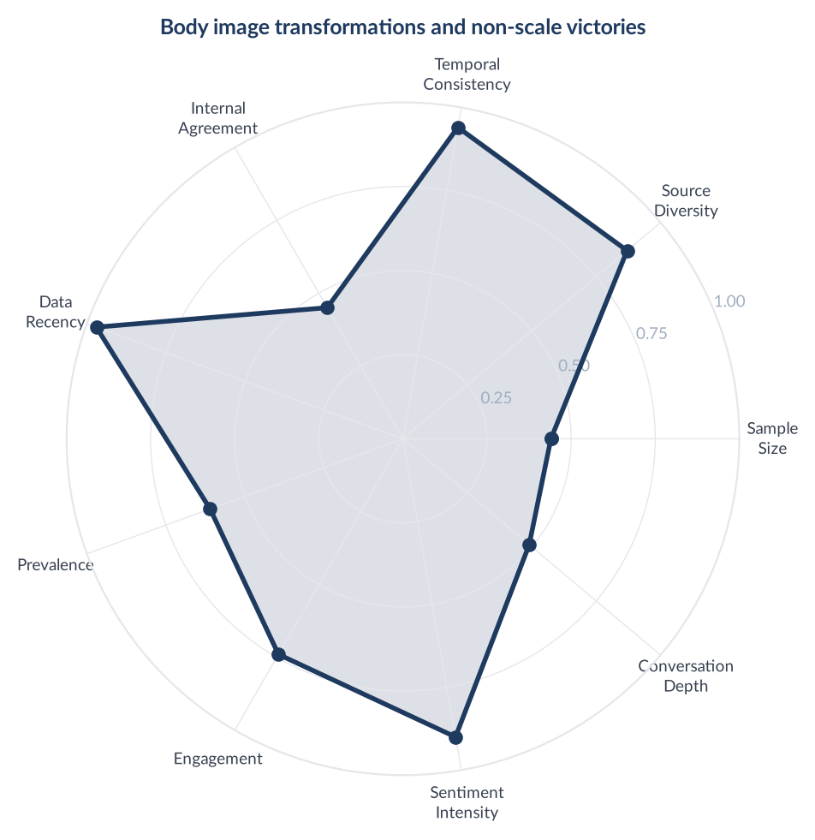
Score Breakdown: Body image transformations and non-scale victories

What the Data Shows
Body image transformations and non-scale victories is 1,007 items, 9.25% prevalence, and the second warmest theme in the study at net sentiment +0.5859: 650 positive, 60 negative, 149 neutral, 148 mixed. Joy appears in 552 items, a 54.8% rate, the highest concentration of joy anywhere in the corpus. The evidence is domestic and specific: 'Monumental NSV Bought a UK size 14 dress off the peg in a regular chain shop, perfect fit.' Self-perception lags the body: 'I know the feeling, im now a size 20 I still look inj the mirror at a size 26 but I also look at my clothes and they look tiny and they fit.'

What it Means
The victory being celebrated is almost never a number. It is a garment, a seatbelt, a chair. And the mirror is the last thing to update, which is why the mixed sentiment in this theme sits inside otherwise happy posts.

Business Implication & Rationale
This is the most emotionally powerful material in the corpus and the most tightly constrained. Before-and-after imagery is treated as an efficacy claim and is not permitted, precise loss figures in a stated period are prohibited, and insecurity-led framing has already produced an upheld ruling in this category. The lane survives on interior change only.

Recommendation
Build on the object, not the body: the dress that fits, the seatbelt that fastens. No before-and-after, no figures, and no framing that makes the previous body the reason to act.

Representative Voices
"Monumental NSV Bought a UK size 14 dress off the peg in a regular chain shop, perfect fit. That’s 2 sizes down which as someone who is 5’10” no small feat." - reddit
"I am 17lbs down in 13 weeks, slow and steady for me. My old summer clothes are fitting and I purchased a new swimsuit in the next size down as my current one had no support. I track my food and manage to get at least 60g of protein each day. I want to increase that and picked up a pack of Trek protein bars, to replace my morning breakfast bar. Well they are full of sugar, yes maybe more protein but not as healthy as..." - web
"A size 12 is just a rough guide as clothes are not made to a strict set of measurements as even within the same store, their dress sizes will vary considerably depending on the garment and where it was made. If you’re worried about it not fitting properly, you need to try it on now and decide whether it can be easily altered to fit you properly or buy something new. You’ve still got plenty of time to go shopping." - web
"I know the feeling, im now a size 20 I still look inj the mirror at a size 26 but I also look at my clothes and they look tiny and they fit..god knows what I will feel like at size 6 but I cant wait!" - reddit

08. Stopping, maintenance and regain fear
n=971 | Confidence: 66% (Medium) | Signal: 62% (Moderate) | 8.9% of Dataset | NSS: +12%
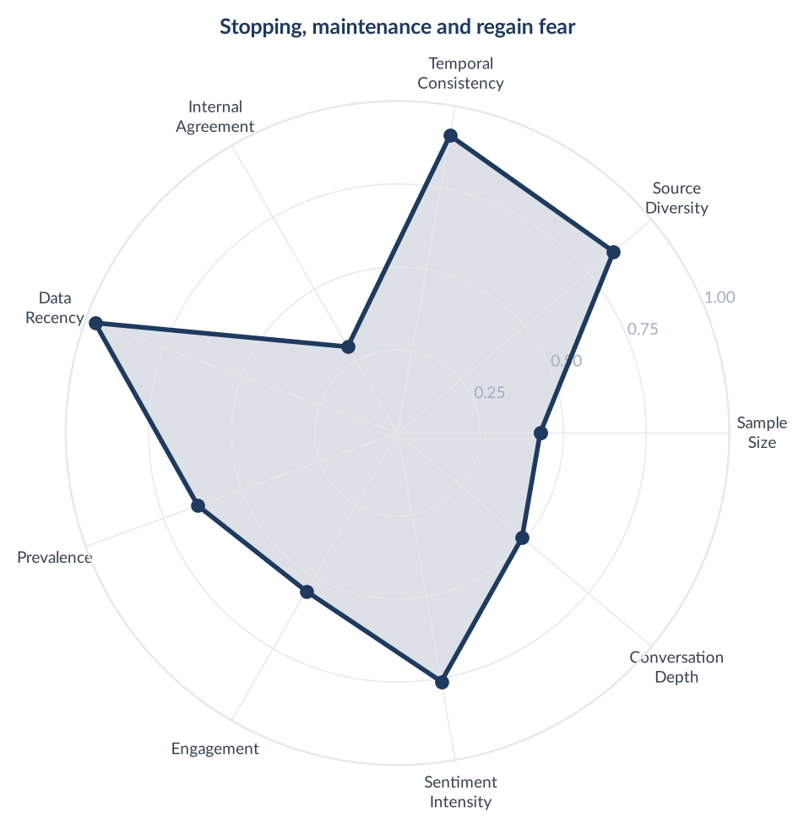
Score Breakdown: Stopping, maintenance and regain fear

What the Data Shows
Stopping, maintenance and regain fear is 971 items, 8.92% prevalence, net sentiment +0.1215: 261 positive, 143 negative, 417 neutral, 150 mixed, with trust in 131 items and sadness in 94. The community has reached a settled position rather than a fearful one: 'My perception from various threads on here is that most people who stop put significant amounts of weight back on. Some are successful in maintaining but they're a minority. I am on a maintenance dose, probably for life or thereabouts!' The exit is planned as a taper: 'Rather than stopping suddenly, I plan to taper down through the doses (10mg -> 7.5mg -> 5mg -> 2.5mg), giving my body time to adjust at each step.'

What it Means
Maintenance is not an afterthought to treatment, it is the destination, and the audience worked that out on its own. The calm in this theme is the calm of a decision already made.

Business Implication & Rationale
Nine percent of the conversation is about the phase that determines lifetime value, and it is a phase the category barely addresses. Providers are selected on maintenance terms by people who intend to stay for years. The one thing this fear cannot be answered with is more medication, which rules out the obvious response and leaves service design as the only available one.

Recommendation
Build and price an explicit maintenance offer, and let people plan the taper with a prescriber rather than in a forum. The commercial argument is retention across years, not conversion this month.

Representative Voices
"Read Weight Less by Dr Rocio Salazar-Whalen. It's unrealistic to expect WLI to cure obesity, a chronic disease for many people, when you come off them. Maybe for the few people who have gained weight unexpectedly after a short term issue. But for those of us who've always been fat, it's like stopping blood pressure meds and expecting to be cured. I'm nowhere near goal weight yet, but I'm expecting to be on a..." - web
"My perception from various threads on here is that most people who stop put significant amounts of weight back on. Some are successful in maintaining but they’re a minority. I am on a maintenance dose, probably for life or thereabouts!" - web
"I'm getting close to my own target, so I've been thinking about this too. Like you, I've bought a whole new wardrobe, and I'd rather not have to replace it again! My current plan is to spend some time on maintenance, build my calories back up, and then decide what to do next. Rather than stopping suddenly, I plan to taper down through the doses (10mg -> 7.5mg -> 5mg -> 2.5mg), giving my body time to adjust at each..." - reddit
"Like other medications Mounjaro only works whilst you take it. People who have a lifelong serious issue with eating ie no full switch are likely to need the medicine forever. I tried coming off and regained. Now accepted that I will need to stay on either Mounjaro or whatever comes along next for life. It isn’t simply a matter of changing habits, nor the ridiculous assumption that very big people don’t understand..." - web

09. Community ritual and mutual support
n=949 | Confidence: 65% (Medium) | Signal: 62% (Moderate) | 8.7% of Dataset | NSS: +61%
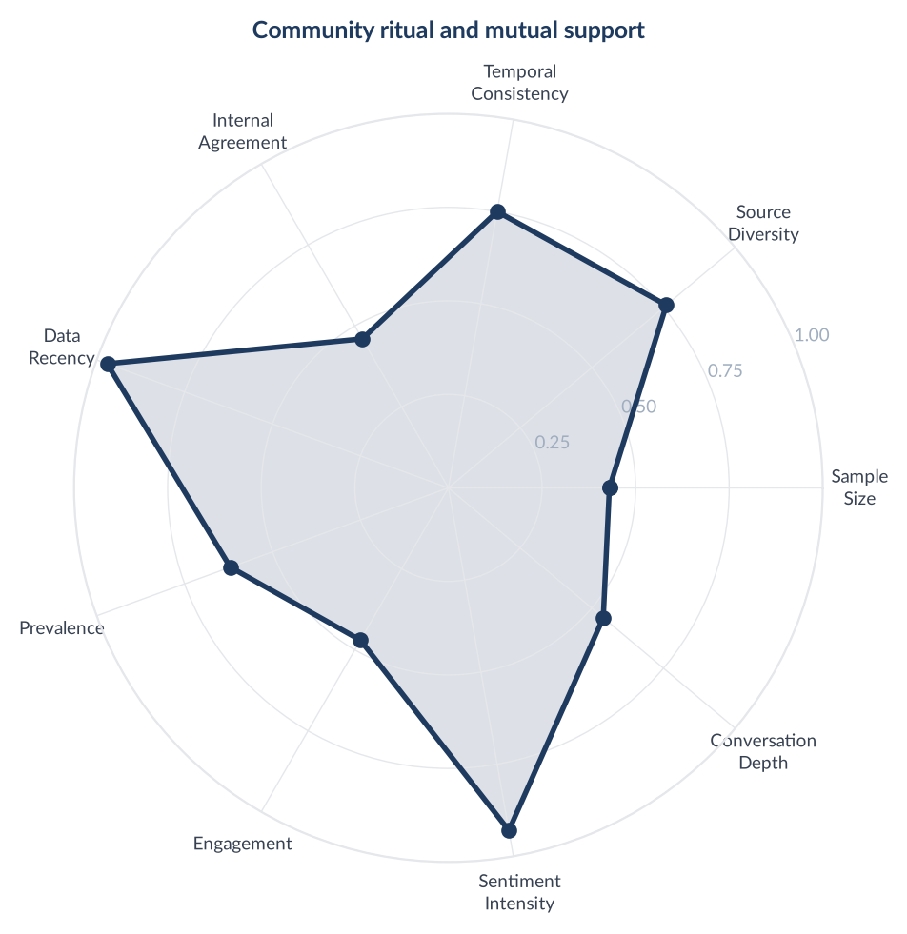
Score Breakdown: Community ritual and mutual support

What the Data Shows
Community ritual and mutual support is 949 items, 8.71% prevalence, and the warmest theme in the study at net sentiment +0.6101: 622 positive, 43 negative, 195 neutral, 89 mixed, with joy in 398 items and trust in 175, the highest trust rate of any theme. The infrastructure is explicit and self-organising: 'There is an August 2026 starters thread here as well if you are keen to join!' Cohorts persist for over a year: 'March 2025 Starters thread 8 the one where some of us are maintaining or nearing goal'.

What it Means
Adherence in this category is being produced by peers on a monthly cohort structure that no provider built, funds or can see. The starters thread is doing the job a patient support programme is supposed to do.

Business Implication & Rationale
The warmest, highest-trust conversation in the category is unbranded and structurally invisible to every provider in it. There is no product claim available inside it, which is exactly why it is legally safe, and no competitor is present. Its value is retention rather than acquisition.

Recommendation
Support the ritual rather than the medicine: cohort structure, weekly threads, milestone recognition. Any presence here must be service-level and openly disclosed, because a covert one destroys the trust that makes the theme worth entering.

Representative Voices
"Yay! Well done - I started a few days ago too and so far so good with minimal side effects. There is an August 2026 starters thread here as well if you are keen to join!" - web
"I think we all get a bit blind to the reality of big weight losses as we see them regularly on this Reddit thread but that is a life changing weight loss!!! 🎉🎉 Well done 👏 keep going if you need to or good luck with maintenance if that’s your future. Your body thanks you from the bottom of your heart" - reddit
"March 2025 Starters thread 8 the one where some of us are maintaining or nearing goal" - web
"If the thread is making you impatient, you don't have to post on it. Let alone post twice. Just skip it and go on with your day. @Jenasaurus delighted that the fit is OK and well done on your weight loss." - web

10. Eligibility, BMI gates and verification
n=645 | Confidence: 65% (Medium) | Signal: 56% (Moderate) | 5.9% of Dataset | NSS: +5%
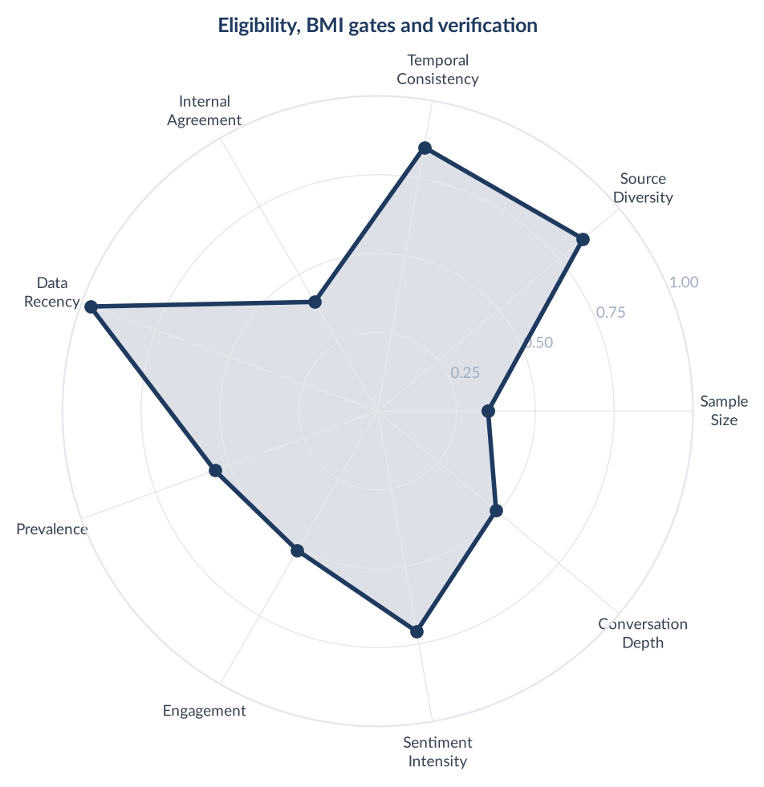
Score Breakdown: Eligibility, BMI gates and verification

What the Data Shows
Eligibility, BMI gates and verification is 645 items, 5.92% prevalence, net sentiment +0.0481: 128 positive, 97 negative, 364 neutral, 56 mixed, with anger in 31 items. The distinction between routes is understood precisely: 'Your BMI is eligible for private prescription (NHS has a much narrower prescribing criteria and BMI alone is not enough).' The anger is about cost rather than criteria: 'So GP says i don't meet criteria for nhs prescriptions i really don't think i can afford this now. Why is weightloss/healthy eating so damn expensive?' Patients also self-report to their GP unprompted: 'I did let my GP know I was getting this prescribed privately so that they have a record of it.'

What it Means
The gate people fail is affordability, not eligibility, and they know the difference. The NHS refusal is experienced as a bill rather than as a clinical judgement.

Business Implication & Rationale
The eligibility check is one of the few calls to action the regulator has explicitly declined to fault. What it does not permit is the destination: a link that requires no searching to reach named medicines has produced upheld rulings twice in this category, and shame-framing beside the same call to action produced a second breach in the same case.

Recommendation
Run the eligibility checker as the primary call to action and spend the effort on where it lands. Answer the affordability question directly, because that is the actual barrier, and keep any emotional framing away from the checker itself.

Representative Voices
"Answer the questions honestly. There is no need to lie Your BMI is eligible for private prescription (NHS has a much narrower prescribing criteria and BMI alone is not enough)" - reddit
"Just a small aside, but your county doesn't necessarily have to have a tier 3 weight loss service yet for GLP-1s to be prescribed. But this is down to whether the GP practices want to be responsible for people and want to prescribe. Having said that, you still wouldn't be eligible as you've only stated a BMI of just over 30 and prediabetes. Unfortunately your family history isn't relevant. The initial criteria from..." - reddit
"I went through Juniper and have had no problems at all with them. As I understand it, there are strict criteria for being prescribed on the NHS and you need to have several serious conditions before they’ll consider it - but I did let my GP know I was getting this prescribed privately so that they have a record of it, and they were fine about it (actually quite curious about how I’m getting along with it)." - web
"Affordability So GP says i don't meet criteria for nhs prescriptions i really don't think i can afford this now. Why is weightloss/healthy eating so damn expensive? So angry rn!!!" - reddit

11. The pill pivot: oral GLP-1s arrive
n=622 | Confidence: 64% (Medium) | Signal: 45% (Weak) | 5.7% of Dataset | NSS: +7%
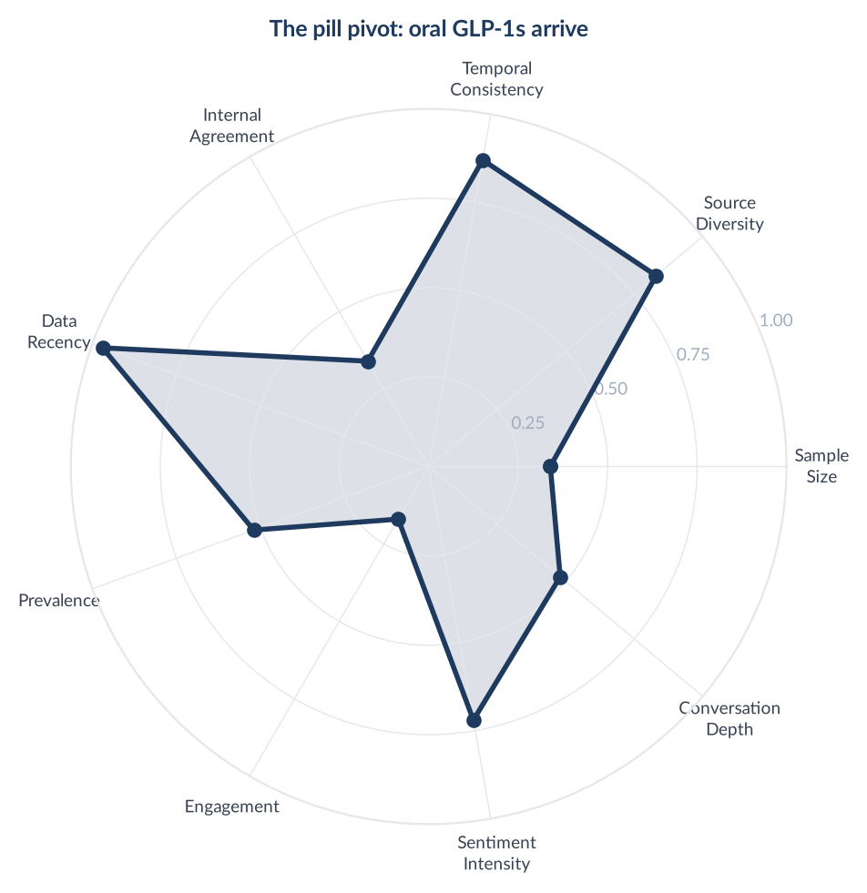
Score Breakdown: The pill pivot: oral GLP-1s arrive

What the Data Shows
The pill pivot is 622 items, 5.71% prevalence, net sentiment +0.0723: 134 positive, 89 negative, 305 neutral, 94 mixed. Anticipation appears in 94 items, a 15.1% rate and the highest of any theme in the study. 47 of its items are news, 7.6% of the theme. The lived experience is being logged in real time and it is mostly about taste and timing: 'Took my tablet at 6am, on an empty stomach of 8 hours, and with less than 120ml water. Didn't taste as vile to me today.' Adoption is reported as an experiment rather than a switch: 'They are here! Is anyone else trying the pills? Or have already?'

What it Means
The oral format is recruiting people the injection could not reach and is being evaluated on ritual friction, the water, the wait, the taste, rather than on efficacy.

Business Implication & Rationale
This is the highest-anticipation conversation in the category and it is close to unusable as marketing, because the audience's own vocabulary for it is the prohibited vocabulary. What travels legally is the reason people are drawn to it, which is needle avoidance, and that is a condition-level subject.

Recommendation
Watch this theme, do not publish into it. Prepare the needle-anxiety angle now, since it addresses the same audience without touching the format's name, and track taste and timing complaints as an early read on adherence.

Representative Voices
"Oral Wegovy Pill Now Available in UK: What You Need to Know About the New Weight Loss Tablet - London Daily News Oral Wegovy Pill Now Available in UK: What You Need to Know About the New Weight Loss Tablet London Daily News" - news
"Day 3 on Wegovy Pill for me Will update these daily for the first week, then will change to weekly. Took my tablet at 6am, on an empty stomach of 8 hours, and with less than 120ml water. Didn’t taste as vile to me today. Waited 30 mins only this morning and then had a cup of peppermint tea as I felt like I had indigestion (maybe following on from the heartburn last night) Today was strange, didn’t feel hungry at..." - reddit
"They are here! Is anyone else trying the pills? Or have already? ✨UPDATE 2✨ Day 17 ✨ - All is going well. I have lost 3lbs in first 8days but have been gaining and losing the same lb since then, appetite is way down. I could easily not eat the full day and not be feeling that pit in my stomach. But at the same time. I can easily overeat if I choose to! So strange. I've also been struggling to sleep. Heartburn is..." - reddit
"Took first tablet this morning. I’m an early riser so that’s fine. Never very hungry until about 9/10 so don’t mind waiting for food. It tastes very disgusting considering I swallowed the tiny pill very quickly. Couldn’t eat all of lunch but that might just be me thinking about it. Had a small dinner and a frozen margarita with a friend (im just living my life- barely drink anymore) I don’t feel hungry but there is..." - web

12. The business and policy layer
n=455 | Confidence: 63% (Medium) | Signal: 48% (Weak) | 4.2% of Dataset | NSS: -10%
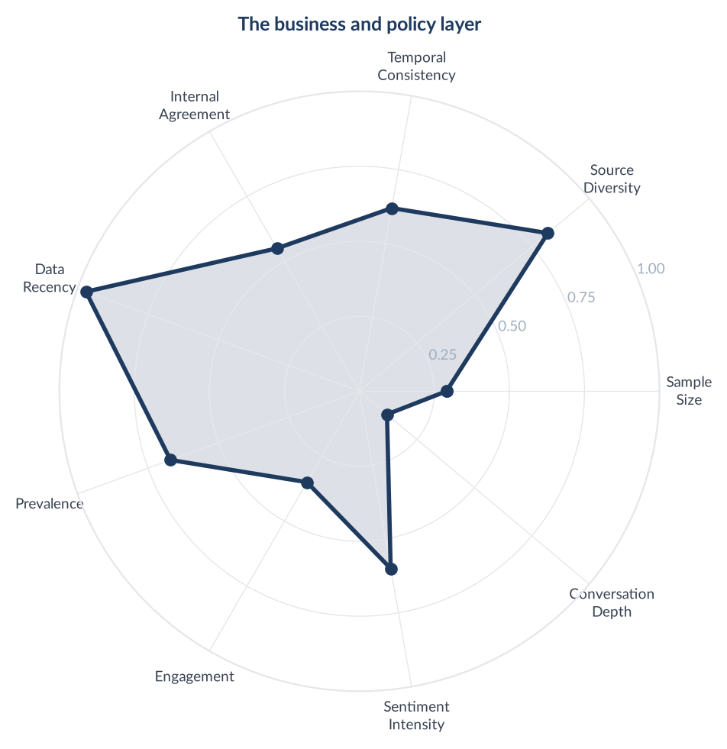
Score Breakdown: The business and policy layer

What the Data Shows
The business and policy layer is 455 items, 4.18% prevalence, net sentiment -0.0989: 25 positive, 70 negative, 356 neutral, 4 mixed. 341 of the 455 items are news and 385 carry no detectable emotion, 84.6% of the theme, making it the flattest theme in the study. Where patients do engage, they engage as a market: 'I think Eli Lilly are robbing us blind because we frankly have no other options but to deal with their prices.' Pipeline news is tracked for its effect on price and access: 'Hopefully, lets hope Cagrisema, Survodutide Eloralintide and Met097 all get FDA and MHRa approval in 2026/27 and the market will adjust.'

What it Means
Patients follow the manufacturer pipeline the way investors do, because competition is the only mechanism they expect to lower their monthly bill. Corporate news is read as a price forecast.

Business Implication & Rationale
This is a monitoring layer, not a content lane. Its value is timing: pipeline and pricing coverage moves the price sensitivity that shows up in provider shopping two themes above, and it is the earliest available signal of it.

Recommendation
Track it and publish none of it. Use approval and pricing news as a leading indicator for switching pressure, and prepare the retention response before the coverage lands.

Representative Voices
"What class action law suit is this @XiCi ? I can't see any consumer class action lawsuits listed against either Novo Nordisk or Eli Lilly at the moment." - web
"Novo outlook hike falls flat as Wegovy pill sales fail to impress - marketscreener.com Novo outlook hike falls flat as Wegovy pill sales fail to impress marketscreener.com" - news
"Hopefully, lets hope Cagrisema, Survodutide Eloralintide and Met097 all get FDA and MHRa approval in 2026/27 and the market will adjust. I think Eli Lilly are robbing us blind because we frankly have no other options but to deal with their prices. The only other thing i think will change is due to the demand places like india will make their own generics and people will travel to get the generic pens because that..." - reddit
"Limited Retatrutide rollout in US So, pre full FDA approval, Eli Lilly are undertaking a limited Retatrutide rollout to patients on top dose of Mounjaro who still remain obese and have min 2 associated health conditions. Nothing for UK yet, but one step closer." - reddit

13. Stigma, secrecy and telling people
n=261 | Confidence: 57% (Medium) | Signal: 59% (Moderate) | 2.4% of Dataset | NSS: -7%
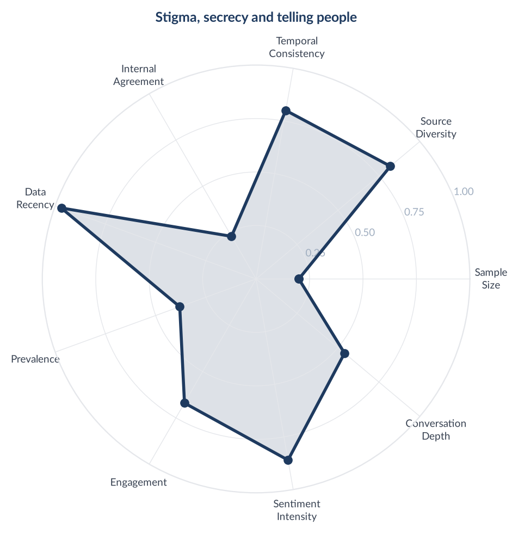
Score Breakdown: Stigma, secrecy and telling people

What the Data Shows
Stigma, secrecy and telling people is one of the smallest themes at 261 items, 2.4% prevalence, net sentiment -0.0728: 66 positive, 85 negative, 59 neutral, 51 mixed. Anger appears in 56 items, a 21.5% rate and the highest of any theme in the study. Concealment is domestic and specific: 'Stupid really, but I cant face the judgement from him indoors. And he'd probably tell his bloody mother, and then everyone would know!' The judgement is often secondhand and delivered as praise for someone else: 'Sister took great pleasure in telling my family that a friend of mine lost over 5 stone all on her own. She kept saying how hard she's worked and had no help.' A visible minority runs the other way: 'I tell anyone who's potentially interested. I'm keen to break down the stigma of taking it at a lower BMI.'

What it Means
The unit of stigma is a specific relationship, not society. People are not hiding from the public, they are hiding from a mother-in-law, a sister, a colleague. That is why the anger rate is the highest in the study while the theme itself is small.

Business Implication & Rationale
This is the most emotionally loaded and most legally dangerous theme in the corpus. Voicing shame as a shared experience is permitted; using it as a reason to act is what produced an upheld ruling on exploiting body-image insecurity in this exact category. The distance between those two is one sentence.

Recommendation
Voice the disclosure problem and never resolve it with a purchase. No call to action within the same beat, and no creative that positions the previous body as the thing to escape.

Representative Voices
"Stupid really, but I cant face the judgement from him indoors. And he'd probably tell his bloody mother, and then everyone would know!" - web
"I tell anyone who’s potentially interested. I’m keen to break down the stigma of taking it at a lower BMI, I think it’s going to change society (for the better!)" - web
"I have only told a few people that I am jabbing. Husband (who was a huge support and came with me to the Drs etc) a friend who is also jabbing, and then 3 others. I am not necessarily hiding it and if people ask I will tell them but otherwise just keeping it low key." - web
"People judging Sister took great pleasure in telling my family that a friend of mine lost over 5 stone 'all on her own'. She kept saying how hard she's worked and had 'no help'. She'd seen my friend's post on Facebook and even screenshot the post to show. My friend HAS taken mounjaro and has told me privately. As I'm sure she's told other people privately. I am NOT going to tell my sister, it's not my place to. I'm..." - reddit

14. Safety, deaths, counterfeits and the grey market
n=222 | Confidence: 60% (Medium) | Signal: 50% (Weak) | 2.0% of Dataset | NSS: -41%
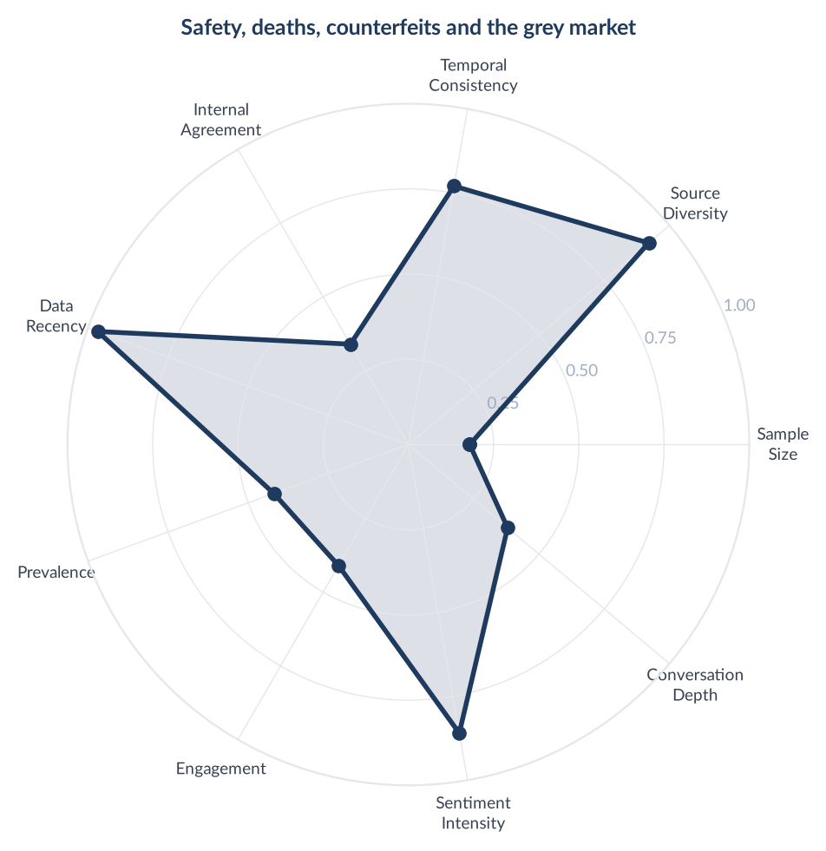
Score Breakdown: Safety, deaths, counterfeits and the grey market

What the Data Shows
Safety, deaths, counterfeits and the grey market is 222 items, 2.04% prevalence, and the coldest theme in the study at net sentiment -0.4099: 10 positive, 101 negative, 107 neutral, 4 mixed. Fear appears in 62 items, a 27.9% rate and the highest of any theme. The community actively corrects its own coverage: 'Despite all the lurid headlines and panicky posts, as expected the inquest has revealed that she had an undiagnosed, underlying medical condition which actually caused the death.' The unregulated lane is where the real fear sits: 'I personally wouldn't take anything unregulated.' Regulator language is quoted directly in the theme: 'If you're not eligible for a prescription for weight-loss medicines, don't be tempted to buy them from unregulated websites or social media sellers.'

What it Means
The audience distinguishes sharply between the regulated and the unregulated route and is more sceptical of alarmist coverage than of the medicine. The fear is about provenance, not pharmacology.

Business Implication & Rationale
This theme sets the tone constraint for everything else. It is also, contrary to how the category treats it, an open lane: counterfeit and grey-market warnings are service-level trust content, and a registered pharmacy is better placed to give them than anyone else in the conversation. What cannot be done is comparative safety claiming.

Recommendation
Publish provenance and supply-chain content under the pharmacy's registration, and make it the tonal floor for the month rather than a campaign. Nothing flippant ships while this theme is active.

Representative Voices
"2. Steer clear of fake weight-loss meds If you’re not eligible for a prescription for weight-loss medicines, don’t be tempted to buy them from unregulated websites or social media sellers. GLP-1 medicines authorised in the UK have only been shown to be safe and effective for people with a Body Mass Index (BMI) of 27 or more. Buying from rogue sellers is a huge risk. You can’t be sure what’s in the product, and some..." - web
"Coroner’s inquest report Some more info has come out at the Coroner’s inquest about the lady who sadly died whilst taking Mounjaro. Despite all the lurid headlines and panicky posts, as expected the inquest has revealed that she had an undiagnosed, underlying medical condition which actually caused the death. She had sought medical attention but they’d missed the medical condition that eventually killed her...." - reddit
"I have just had a call with a family member who has just found out a colleague in their 30s died yesterday. The cause is as yet unknown, it was sudden and at home. She never told me before that the colleague started taking illegal WLI obtained from a friend of a friend a few weeks ago as she knows it winds me up. She also said her colleague had been complaining about bad stomach pains the last 2-3 days. I am so..." - web
"You can't possibly know that everyone on reta ... I personally wouldn't take anything unregulated." - web

15. Hair loss
n=113 | Confidence: 58% (Medium) | Signal: 34% (Weak) | 1.0% of Dataset | NSS: +3%
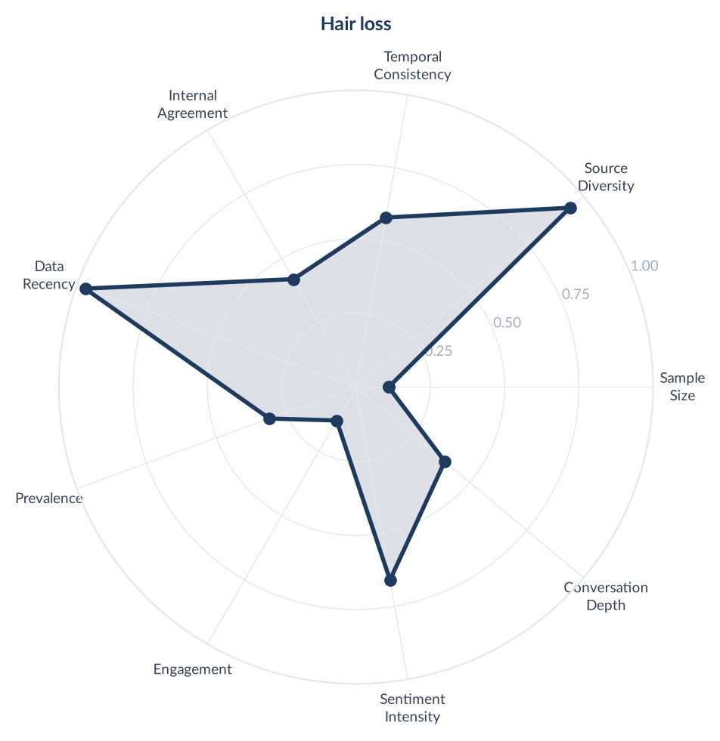
Score Breakdown: Hair loss

What the Data Shows
Hair loss is the smallest theme in the study at 113 items, 1.04% prevalence, net sentiment +0.0265: 18 positive, 15 negative, 68 neutral, 12 mixed. Fear appears in only 17 items and 78 of the 113 carry no detectable emotion. 28 of the 113 items are news, a 24.8% news share, the third highest in the study behind business and policy at 74.9% and safety at 26.1%, so a quarter of this small theme is press rather than patients. Where patients speak, they are self-prescribing a second product: 'Minoxidil is the only proven drug to decrease hair shedding. Biotin only helps if you're deficient to begin with.' The distress, where it exists, is concentrated and specific: 'The hair loss has become absolutely overwhelming. I feel like I can see small bald patches developing near my fringe/hairline.'

What it Means
This reads as a large problem in the press and a small, technical one in the community, where it has already been triaged into a solved category with a named remedy. The gap between coverage volume and conversation volume is the finding.

Business Implication & Rationale
A quarter of this theme being news means an adjacent market is being created by coverage rather than by demand, and the patient conversation has already routed around it. Shedding during rapid weight loss is a physiological fact and is discussable at condition level, but an unframed post will be read as a drug side effect by default given the coverage.

Recommendation
Treat this as low priority for content and useful for service: patients are buying a second product without advice. Address shedding as a consequence of rapid weight change, with the framing built in rather than assumed.

Representative Voices
"Minoxidil is the only proven drug to decrease hair shedding. Biotin only helps if you’re deficient to begin with, which almost nobody is. I started using 5% Minoxidil foam and it definitely worked (I have loads of new regrowth), but I’m really lazy and so have stopped using it. I bought three bottles and have only used ~50% of one bottle 🙈" - web
"Minoxidil for hair loss with Mounjaro Has anyone used minoxdil to manage hair shedding? Did it help? Should I go for the 2% or 5% version? The 5% seems advertised at men and the 2% women which is why I wasn't sure. Thanks!" - web
"I lost a lot of weight very quickly on MJ and experienced hair shedding. It eventually stopped. I take collagen and biotin and have lots of regrowth." - web
"Hair loss out of control. Good morning everyone. 22F with PCOS here. I started MJ at the end of April 2026 and I’m currently on 3.75mg as of July 2026. I have lost 2kg/3kg a month so far, so rather steady and healthy loss. The hair loss has become absolutely overwhelming. I feel like I can see small bald patches developing near my fringe/hairline, and it’s honestly terrifying. Before starting MJ, I never experienced..." - reddit

Press Agenda versus Patient Agenda
The 400 news articles are in the corpus to be compared against, not to be counted with. Every theme below carries two shares: the share of press output it takes up, and the share of patient conversation it takes up. Where those two disagree, the press is either manufacturing a concern patients do not hold, or ignoring one they do. Items are multi-label, so a post carrying three themes counts in three rows and the columns do not sum to 100.
Theme | News items | Conversation items | Share of press | Share of conversation | Gap
The business and policy layer | 341 | 114 | 85.2% | 1.1% | +84.1
Safety, deaths, counterfeits and the grey market | 58 | 164 | 14.5% | 1.6% | +12.9
The pill pivot: oral GLP-1s arrive | 47 | 575 | 11.8% | 5.5% | +6.3
Hair loss | 28 | 85 | 7.0% | 0.8% | +6.2
Stigma, secrecy and telling people | 2 | 259 | 0.5% | 2.5% | -2.0
Eligibility, BMI gates and verification | 2 | 643 | 0.5% | 6.1% | -5.6
Body image transformations and non-scale victories | 8 | 999 | 2.0% | 9.5% | -7.5
Stopping, maintenance and regain fear | 4 | 967 | 1.0% | 9.2% | -8.2
Community ritual and mutual support | 0 | 949 | 0.0% | 9.0% | -9.0
Food noise and appetite psychology | 1 | 1,068 | 0.2% | 10.2% | -10.0
Eating mechanics on the medication | 2 | 1,416 | 0.5% | 13.5% | -13.0
Provider shopping, prices and switching | 2 | 1,433 | 0.5% | 13.7% | -13.2
Side effects and their management | 19 | 2,089 | 4.8% | 19.9% | -15.1
Dose titration and click-counting economics | 3 | 2,262 | 0.8% | 21.6% | -20.8
The weekly ritual: weigh-ins, plateaus and stalls | 1 | 2,279 | 0.2% | 21.7% | -21.5

What the split shows
85.2% of press output is about companies, share prices, approvals and policy. That subject is 1.1% of patient conversation. UK coverage of this category is written for investors and policymakers, and patients read almost none of it.
The two largest things in patients' lives get almost no coverage. The weekly weigh-in ritual is 21.7% of conversation and 0.2% of press. Dose titration and click-counting is 21.6% of conversation and 0.8% of press. Peer support, the warmest theme in the study at 949 items, has zero articles.
Four themes run the other way. Business and policy, safety, the pill pivot and hair loss all take a larger share of press than of conversation. Hair loss is the clearest case: 7.0% of press output against 0.8% of patient talk, which is why it reads as a crisis in the papers and a solved technical problem in the communities.
Two uses follow. Any theme with a large positive gap is a concern arriving from coverage rather than from customers, and should be answered rather than amplified. Any theme with a large negative gap is unserved attention, since patients are spending their time there and nobody is publishing into it.

How to read the news column
News items are Google News RSS records, so each one is a headline and its outlet with no article body: 174 characters at the median against 317 for Reddit and 287 for Mumsnet. The comparison is therefore between what the press chose to put in a headline and what patients chose to write at length. No weighting is applied anywhere in this study: one item is one row, whether it is a headline or a 400-word reply.

Brand Health Score
Overall Brand Health Score: 64/100
Brand Health Score is a composite index built from five data-driven components. No subjective weighting is applied - all inputs are derived from the collected corpus.
Component | Score | Methodology
Sentiment Component (30%) | 57.1 | Derived from NSS across all items. Reflects the ratio of positive to negative consumer language.
Engagement Component (25%) | 50.0 | Average engagement (upvotes, likes, comments) normalised to platform benchmarks.
Advocacy Component (20%) | 100.0 | Share of items classified strongly positive, meaning positive sentiment at intensity 0.8 or above. Scored as that share multiplied by 5 and capped at 100, so any share at or above 20% returns 100. Does not measure stated recommendation or repurchase intent; no stage of this pipeline detects those. This corpus: 23.8% strongly positive. The component is at its ceiling and does not discriminate above this point.
Resilience Component (15%) | 72.5 | Sentiment consistency across platforms and time periods.
Conversation Component (10%) | 40.4 | Volume and depth of organic brand conversation (non-promotional threads).
Note: The Conversation Component (40/100) is the lowest-scoring factor. This reflects that most brand mentions occur in reaction to advertising, campaigns, and celebrity content rather than unprompted consumer-initiated discussion. Organic brand conversation is thin relative to engagement volume - a pattern consistent with a brand consumers transact with rather than one they actively champion.

Methodology

Pipeline Overview
- Stage 0, Brief. Hand-written: 12 aspects, 10 business questions, 13 competitors, geography GB, 30-day window. Aspects derived from the 284 Trends related queries, not from intuition.
- Stage 1, Collect. First-hand collection from four sources by three routes, documented above. 12,450 items collected, 12,445 entered normalization after 5 empty records were dropped.
- Stage 2, Normalize. Deterministic SHA-256 item IDs prevent duplicate admission across runs. The 30-day window was enforced in the mapping step, so no item dated outside 7 July to 6 August exists in the corpus. Duplicates removed: 0. Items dropped to the thread cap: 0, because the cap was removed for this run (see deviations).
- Stage 3, Filter. Relevance was measured, not assumed: a 60-item random-sample audit at seed 7 found 57 of 60 on-topic, the 3 misses conversational glue, zero wrong-topic items. It holds because both conversation corpora were collected from dedicated communities rather than by keyword match, so an off-topic item would have to be off-topic inside a weight-loss community. On that evidence the pipeline's LLM-per-item classifier was not run and filtering was mechanical: a junk pass removed 504 items (deleted bodies, bot and moderator furniture, link-only posts, anything under 15 characters), and a glue rule removed short items carrying no domain vocabulary. 1,555 items rejected in total, 10,890 admitted.
- Stage 4, Analyze. Sentiment (positive, negative, neutral, mixed) and Plutchik 8-emotion classification per item, plus per-aspect sentiment. Run in-context inside a Claude Code session and parallelised across sub-agents rather than through a metered API, which is why analysis cost nothing. Work was chunked and written per chunk, so interrupted runs resumed without re-classifying. All 10,890 admitted items carry a classification, 100% coverage. An earlier build of this report was short by 300 items: 200 had been classified but never merged into the results file, and 100 were a skipped batch concentrated on 12 and 13 July. Both were recovered on 13 August 2026 and every figure in this report is computed over the full 10,890.
- Stage 5, Synthesize. Themes discovered inductively from a stratified sample, then all items mapped to themes across the full corpus in batches. One insight per theme: Observation, Insight, Implication, Recommendation.
- Stage 6, Score. Confidence from 5 factors (sample size, source diversity, temporal consistency, internal agreement, data recency). Signal Strength from 4 (prevalence, engagement, sentiment intensity, conversation depth). Brand Health from 5 components. Source diversity carries a concentration penalty, so single-source insights are pushed down and cross-platform themes rewarded. All 15 themes here are multi-source.
- Stage 7, Report. DOCX with inline charts, verbatims and data tables. Two charts and the source labelling were corrected after generation (see deviations).

Scoring Formulas

Confidence Score
Confidence = (sample_size x 0.25) + (source_diversity x 0.25) + (temporal_consistency x 0.15) + (internal_agreement x 0.2) + (data_recency x 0.15)

Signal Strength Score
Signal = (prevalence x 0.35) + (engagement x 0.3) + (sentiment_intensity x 0.2) + (conversation_depth x 0.15)

Net Sentiment Score (NSS)
NSS = (positive_count - negative_count) / total_count. Range -1.0 to +1.0. Industry standard: Brandwatch, Sprinklr, YouGov.

Quality Gates
- Grounded (≥3 sources cited)
- Non-obvious (not derivable from common knowledge)
- Actionable (leads to a concrete business decision)
- Specific (not vague platitude)
- Falsifiable (could be proven wrong with additional data)

Documented Deviations from the Pipeline's Defaults
Four, all applied to this run's artifacts. None modified the repository's code, and the pre-adjustment scored file is preserved alongside the adjusted one.
1. The 5-comments-per-thread cap was removed. The rule keeps at most 5 comments per thread, chosen at random, so no single thread dominates. It was calibrated on Reddit-shaped data averaging 2.9 comments per post. Mumsnet threads average 27 replies and run past 700, and the rule discarded 82% of what was collected there, including the argument threads the study depends on. Consequence: deep threads carry more weight than the default allows. That was the intended trade.
2. The LLM relevance filter was replaced by rules plus an audit, as described in Stage 3.
3. Temporal consistency was rebased to the declared window. The factor scores how much of a year a corpus spans: log(1 + span_days) / log(1 + 365). Correct for the 24-month study this pipeline was built for; a category error for a 30-day study, where a corpus covering every single day of its own window still scores 0.582 and caps temporal consistency at 0.833. Span is now computed against the 30-day window. Evenness across quartiles is untouched, so a corpus clustered into a few days is penalised exactly as before. Effect: about +0.025 confidence per insight.
4. Sentiment strength is derived from emotion rather than flat. The brand-health advocacy component counts items that are positive and carry strength at or above 0.8. A flat 0.75 sits just below that line, so advocacy scored 0.0 and read as a finding about the category. It was not a finding, it was a constant. Strength is now 0.85 for a positive item carrying joy, trust or anticipation and 0.70 for a bare positive. On that basis 23.8% of the corpus is strongly positive. Brand Health moved from 45.4 to 64.5.
Post-generation corrections to the document. The platform chart and tables labelled Mumsnet as “Web”, the pipeline's enum value, and now name it; the temporal chart grouped by year and rendered a 30-day study as one bar, and is now plotted per day; both charts now count the analysed corpus rather than the admitted one, so they agree with the report text.

Data Provenance
All data is from publicly available online conversation. No personally identifiable information is stored or reported; usernames are stripped from every quoted verbatim.
One count appears throughout this report. 10,890 items were admitted and all 10,890 are classified, so the collection funnel, the tables and every sentiment, emotion, theme, insight and score figure are computed over the same corpus.
Composition of the admitted corpus: 1,825 posts and 9,065 comments. Each comment is an independent item linked to its parent thread for thread-level analysis.

Geographic Coverage
United Kingdom. Unlike a keyword-filtered study, both conversation sources are UK-specific by construction: r/MounjaroUK and r/WegovyUK are UK-only communities, and Mumsnet is a UK forum. News was collected with gl=GB. No platform provides verified geolocation, so a residual share of items will originate outside the UK, but the mechanism that usually causes it, a global keyword catching foreign posts, does not apply here. Findings describe UK-market conversation rather than verified UK residents.

Temporal Coverage
7 July to 6 August 2026, 31 days. The window was enforced at mapping, so no item outside it exists in the corpus. Every one of the 31 days is represented. Daily volume runs between 258 and 472 items on 30 of the 31 days; 12 July renders at 75 because of the skipped classification batch described in Stage 4, so that trough is a processing artifact rather than a quiet day.
Two consequences of a one-month window are accepted rather than corrected: rising and falling deltas are weaker than a multi-month study would produce, and the window contains four dated events (18 July children's eligibility coverage, 22 July hair-loss study, 3 August oral Wegovy launch, 4 to 6 August escalating death-toll reporting) that a longer window would average out. Those events are treated as findings, not noise.

Demographic Accuracy
The corpus is not demographically representative, and its two conversation sources lean in opposite directions. Mumsnet contributes 61.2% of the analysed corpus and is a UK parenting forum, skewing female, parent, and older. Reddit contributes 35.1% and skews male and 18 to 34. News contributes 3.7% and carries no demographic signal. The two leans partly offset, which is better than a single-platform study, but neither source was weighted and no verified demographic data exists for either. Prevalence figures should be read as share of this corpus, not share of UK opinion. For verified breakdowns, commission a structured survey against the same questions, using these insights as the stimulus.

News Is Press Supply, Not Audience Opinion
One news article counts as one item, the same weight as a Reddit post or a Mumsnet reply. At 400 items that is 3.7% of the analysed corpus. News carries no engagement score and no nested replies, so it never wins a verbatim slot and never sets a theme's depth, but it does enter prevalence, sentiment and the source-diversity factor on equal terms. An outlet's angle is an editorial choice rather than a patient's view, so that equality is worth declaring.
The effect was measured rather than assumed. Removing news entirely moves the corpus NSS from +14.3% to +15.2% and leaves twelve of the fifteen themes ranked exactly where they are. Three themes carry a meaningful news share: business and policy at 74.9%, safety and deaths at 26.1%, and hair loss at 24.8%. Every other theme sits at or below 0.9%, and the largest theme in the study contains exactly 1 news item. Two theme sentiment scores move: business and policy from -0.099 to -0.228, and safety and deaths from -0.410 to -0.372.
Read the report accordingly. Where news share is under 1%, which is twelve of the fifteen themes, the figures are patient conversation. For business and policy, and to a lesser extent safety and hair loss, treat news volume as evidence that coverage exists rather than as evidence of what patients feel.

Why No Insight Reaches High Confidence
After the two scoring adjustments, all 15 insights sit in the medium band, 0.568 to 0.726, and none crosses 0.75. The binding factor is not the window and not sample size. It is internal agreement, which scores how concentrated a theme's sentiment is, and which runs as low as 0.42 on the largest theme. Six of the fifteen themes are formally contested, meaning positive and negative opinion are close to evenly matched inside them. A UK weight-loss medication conversation in a month containing a hair-loss study, a children's-eligibility row, a product launch and an escalating death toll is genuinely divided. Read medium confidence here as “the evidence is solid and the opinion is split”, not “the evidence is thin”.
Source | Content Type | Access Method | Items in Corpus
Mumsnet | UK parenting forum, weight-loss boards | Various | 6,668
Reddit | Forum discussions, comments | Public JSON API | 3,822
NewsData.io | News articles | REST API | 400

