India Hair Colour
Research Report: Consumer Sentiment & Brand Perception
Analysis Date: April 2026

Research Objectives
- Understand consumer perceptions of hair colour products in India
- Identify key purchase drivers and barriers
- Map the competitive landscape from a consumer perspective
- Surface unmet needs and emerging trends

Summary of Data and Findings
Items Analysed | 4,314
Content Date Range | Jun 2016 - Jan 2026
Insights Identified | 21
Net Sentiment Score | +38.8%
Brand Health Score | 81/100
Data Sources | 5 platforms

Data Universe

Collection Funnel
Of 52,931 raw data points collected across all sources, 14,436 remained after deduplication and quality filtering, and 4,314 passed LLM relevance classification (8.2% of total collected). These 4,314 items form the analysis corpus.
Stage | Items | Notes
Raw collected | 52,931 | All posts, comments, articles and videos gathered across all platforms
After deduplication & quality filter | 14,436 | Thread dedup (max 5 comments/thread, random selection), empty/short text removed
After relevance classification | 4,314 | LLM relevance filter — 8.2% of raw collected. Analysis corpus.

Platform Breakdown
Platform | Items | Share of Corpus
Amazon | 1952 | 45.2%
Twitter | 1039 | 24.1%
Youtube | 862 | 20.0%
Reddit | 375 | 8.7%
Instagram | 86 | 2.0%
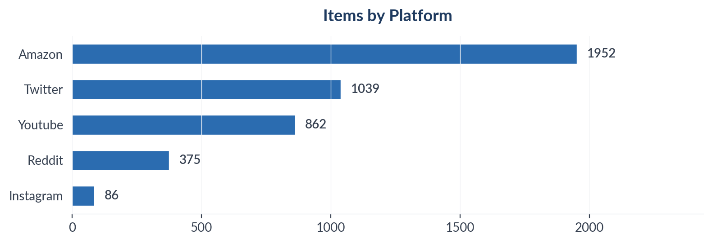
Figure 1: Item distribution by source platform

Temporal Distribution
The chart below shows when the analysed content was originally published, based on source timestamps. Percentages are of the full corpus. Items without a source timestamp are shown separately as 'Undated'.
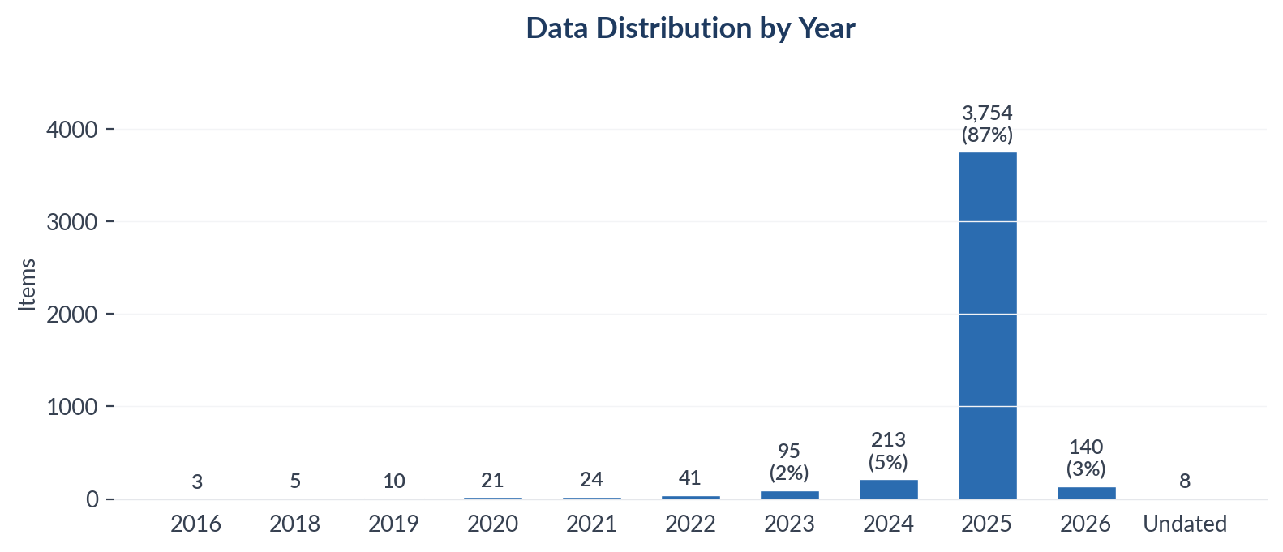
Figure 2: Content publication date by year (full corpus denominator)

Collection Methodology
Data was collected using automated scrapers with engagement-weighted filtering applied per platform. Thread-level deduplication caps comments per thread to prevent over-indexing vocal threads. All items passed an LLM relevance classification step before analysis.

Sentiment & Emotion Analysis

Overall Sentiment Distribution
Net Sentiment Score (NSS): +38.8% | Positive: 2276 (52.8%) | Negative: 602 (14.0%) | Neutral: 1200 (27.8%)
NSS is computed as (positive - negative) / total items. Range: -1.0 (all negative) to +1.0 (all positive). Neutral and mixed items remain in the denominator, anchoring the score to the full corpus rather than just polarised items. A positive NSS indicates net favourable sentiment; a negative NSS indicates net unfavourable.
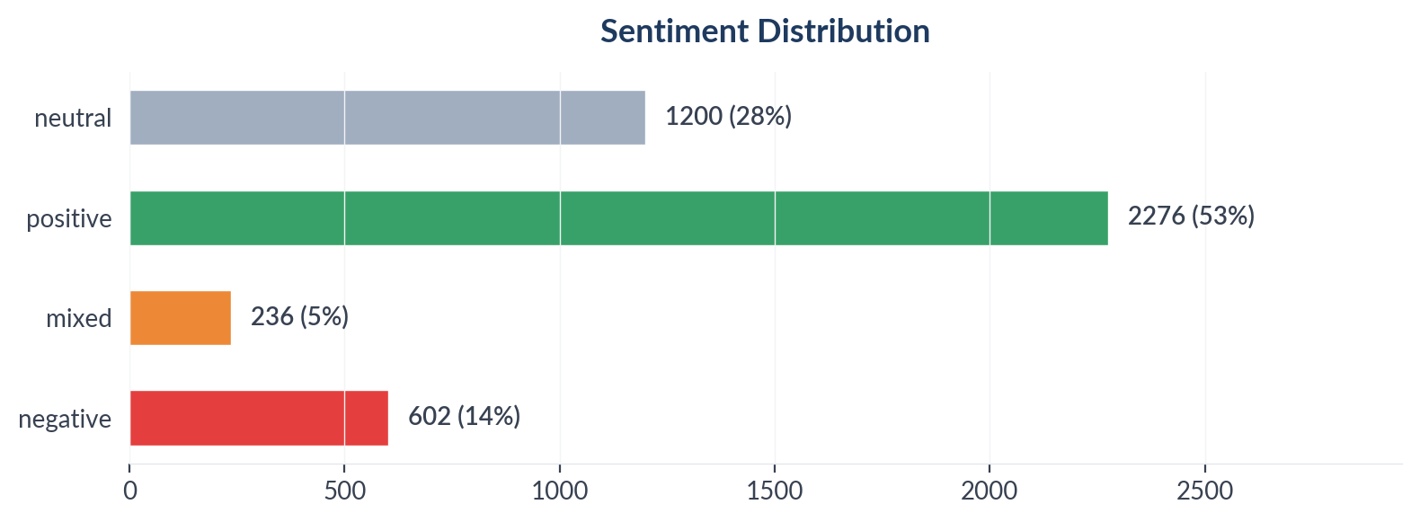
Figure 2: Sentiment distribution across 4,314 items

Emotion Profile (Plutchik 8-Emotion Model)
Emotion | Count
None | 3321
Joy | 364
Trust | 249
Fear | 95
Anger | 84
Disgust | 77
Surprise | 61
Sadness | 32
Anticipation | 31
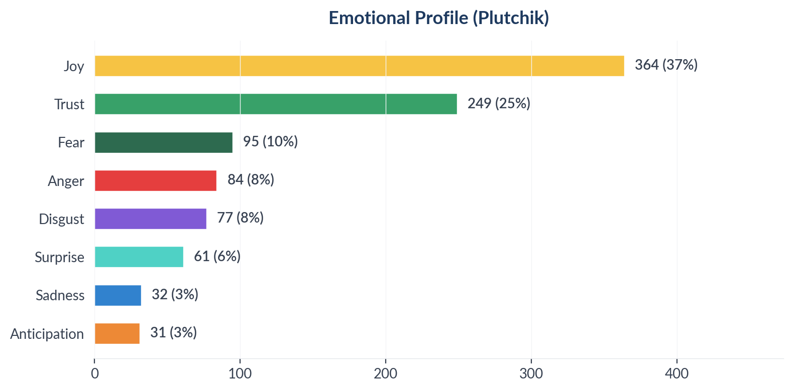
Figure 3: Plutchik emotion distribution

Aspect-Based Sentiment Analysis (ABSA)
Aspects with ≥10 mentions are shown below. NSS is statistically meaningful only at this threshold.
Aspect | Total | Positive | Negative | NSS
Color Quality | 2813 | 1421 | 313 | +39%
Ease Of Use | 1460 | 938 | 123 | +56%
Ingredients | 1088 | 836 | 68 | +71%
Longevity | 1031 | 564 | 100 | +45%
Hair Health | 754 | 496 | 96 | +53%
Price Value | 681 | 413 | 163 | +37%
Smell | 120 | 89 | 17 | +60%

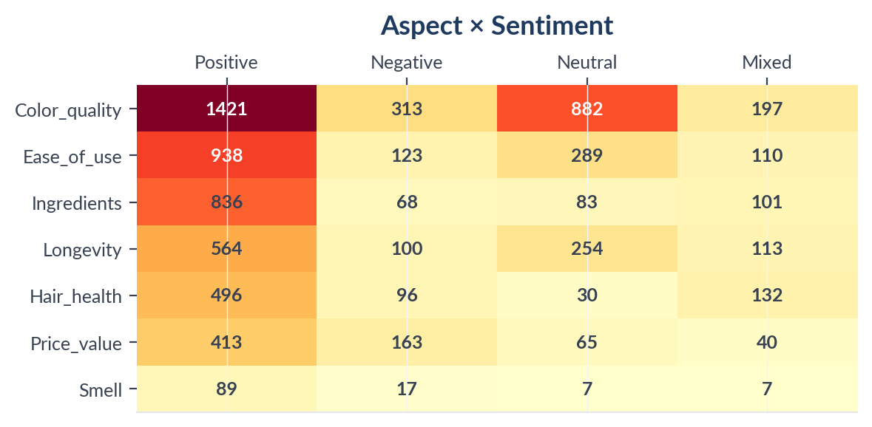
Figure 4: Aspect sentiment heatmap (aspects with ≥10 mentions)

Insight Landscape
21 insights were identified from 4,314 items using a two-pass extraction approach (stratified discovery sample + full-corpus mapping).
Insight | Items | Prevalence in Dataset | Signal Strength | Confidence Score | NSS
Ease of Use & Quick Application | 1717 | 39.8% | 62% (Moderate) | 60% (Medium) | +46%
Product Effectiveness & Results | 1635 | 37.9% | 68% (Moderate) | 58% (Medium) | +45%
Price & Value for Money | 1564 | 36.2% | 63% (Moderate) | 60% (Medium) | +43%
Hair Damage & Safety Concerns | 1275 | 29.6% | 66% (Moderate) | 58% (Medium) | +39%
Colour Trends & Self-Expression | 1162 | 26.9% | 65% (Moderate) | 57% (Medium) | +45%
Colour Longevity & Fading | 979 | 22.7% | 62% (Moderate) | 57% (Medium) | +42%
Natural & Chemical-Free Products | 827 | 19.2% | 64% (Moderate) | 59% (Medium) | +69%
Grey Hair Coverage | 787 | 18.2% | 59% (Moderate) | 57% (Medium) | +57%
DIY & Home Hair Colouring | 757 | 17.6% | 63% (Moderate) | 55% (Medium) | +47%
Brand Experience & Trust | 632 | 14.7% | 56% (Moderate) | 54% (Medium) | +41%
Beard & Mens Grooming | 499 | 11.6% | 54% (Moderate) | 54% (Medium) | +57%
Henna & Traditional Hair Colouring | 420 | 9.7% | 60% (Moderate) | 55% (Medium) | +63%
Misinformation, Miracle Claims & Debunking | 213 | 4.9% | 58% (Moderate) | 47% (Directional) | +33%
Misinformation, Miracle Claims & Debunking | 213 | 4.9% | 58% (Moderate) | 47% (Directional) | +33%
Misinformation, Miracle Claims & Debunking | 213 | 4.9% | 58% (Moderate) | 47% (Directional) | +33%
Bollywood & Celebrity Weight Loss Speculation | 80 | 1.9% | 51% (Moderate) | 44% (Directional) | +48%
Bollywood & Celebrity Weight Loss Speculation | 80 | 1.9% | 51% (Moderate) | 44% (Directional) | +48%
Bollywood & Celebrity Weight Loss Speculation | 80 | 1.9% | 51% (Moderate) | 44% (Directional) | +48%
Stigma, Shame & the 'Shortcut' Debate | 64 | 1.5% | 45% (Weak) | 47% (Directional) | +56%
Stigma, Shame & the 'Shortcut' Debate | 64 | 1.5% | 45% (Weak) | 47% (Directional) | +56%
Stigma, Shame & the 'Shortcut' Debate | 64 | 1.5% | 45% (Weak) | 47% (Directional) | +56%
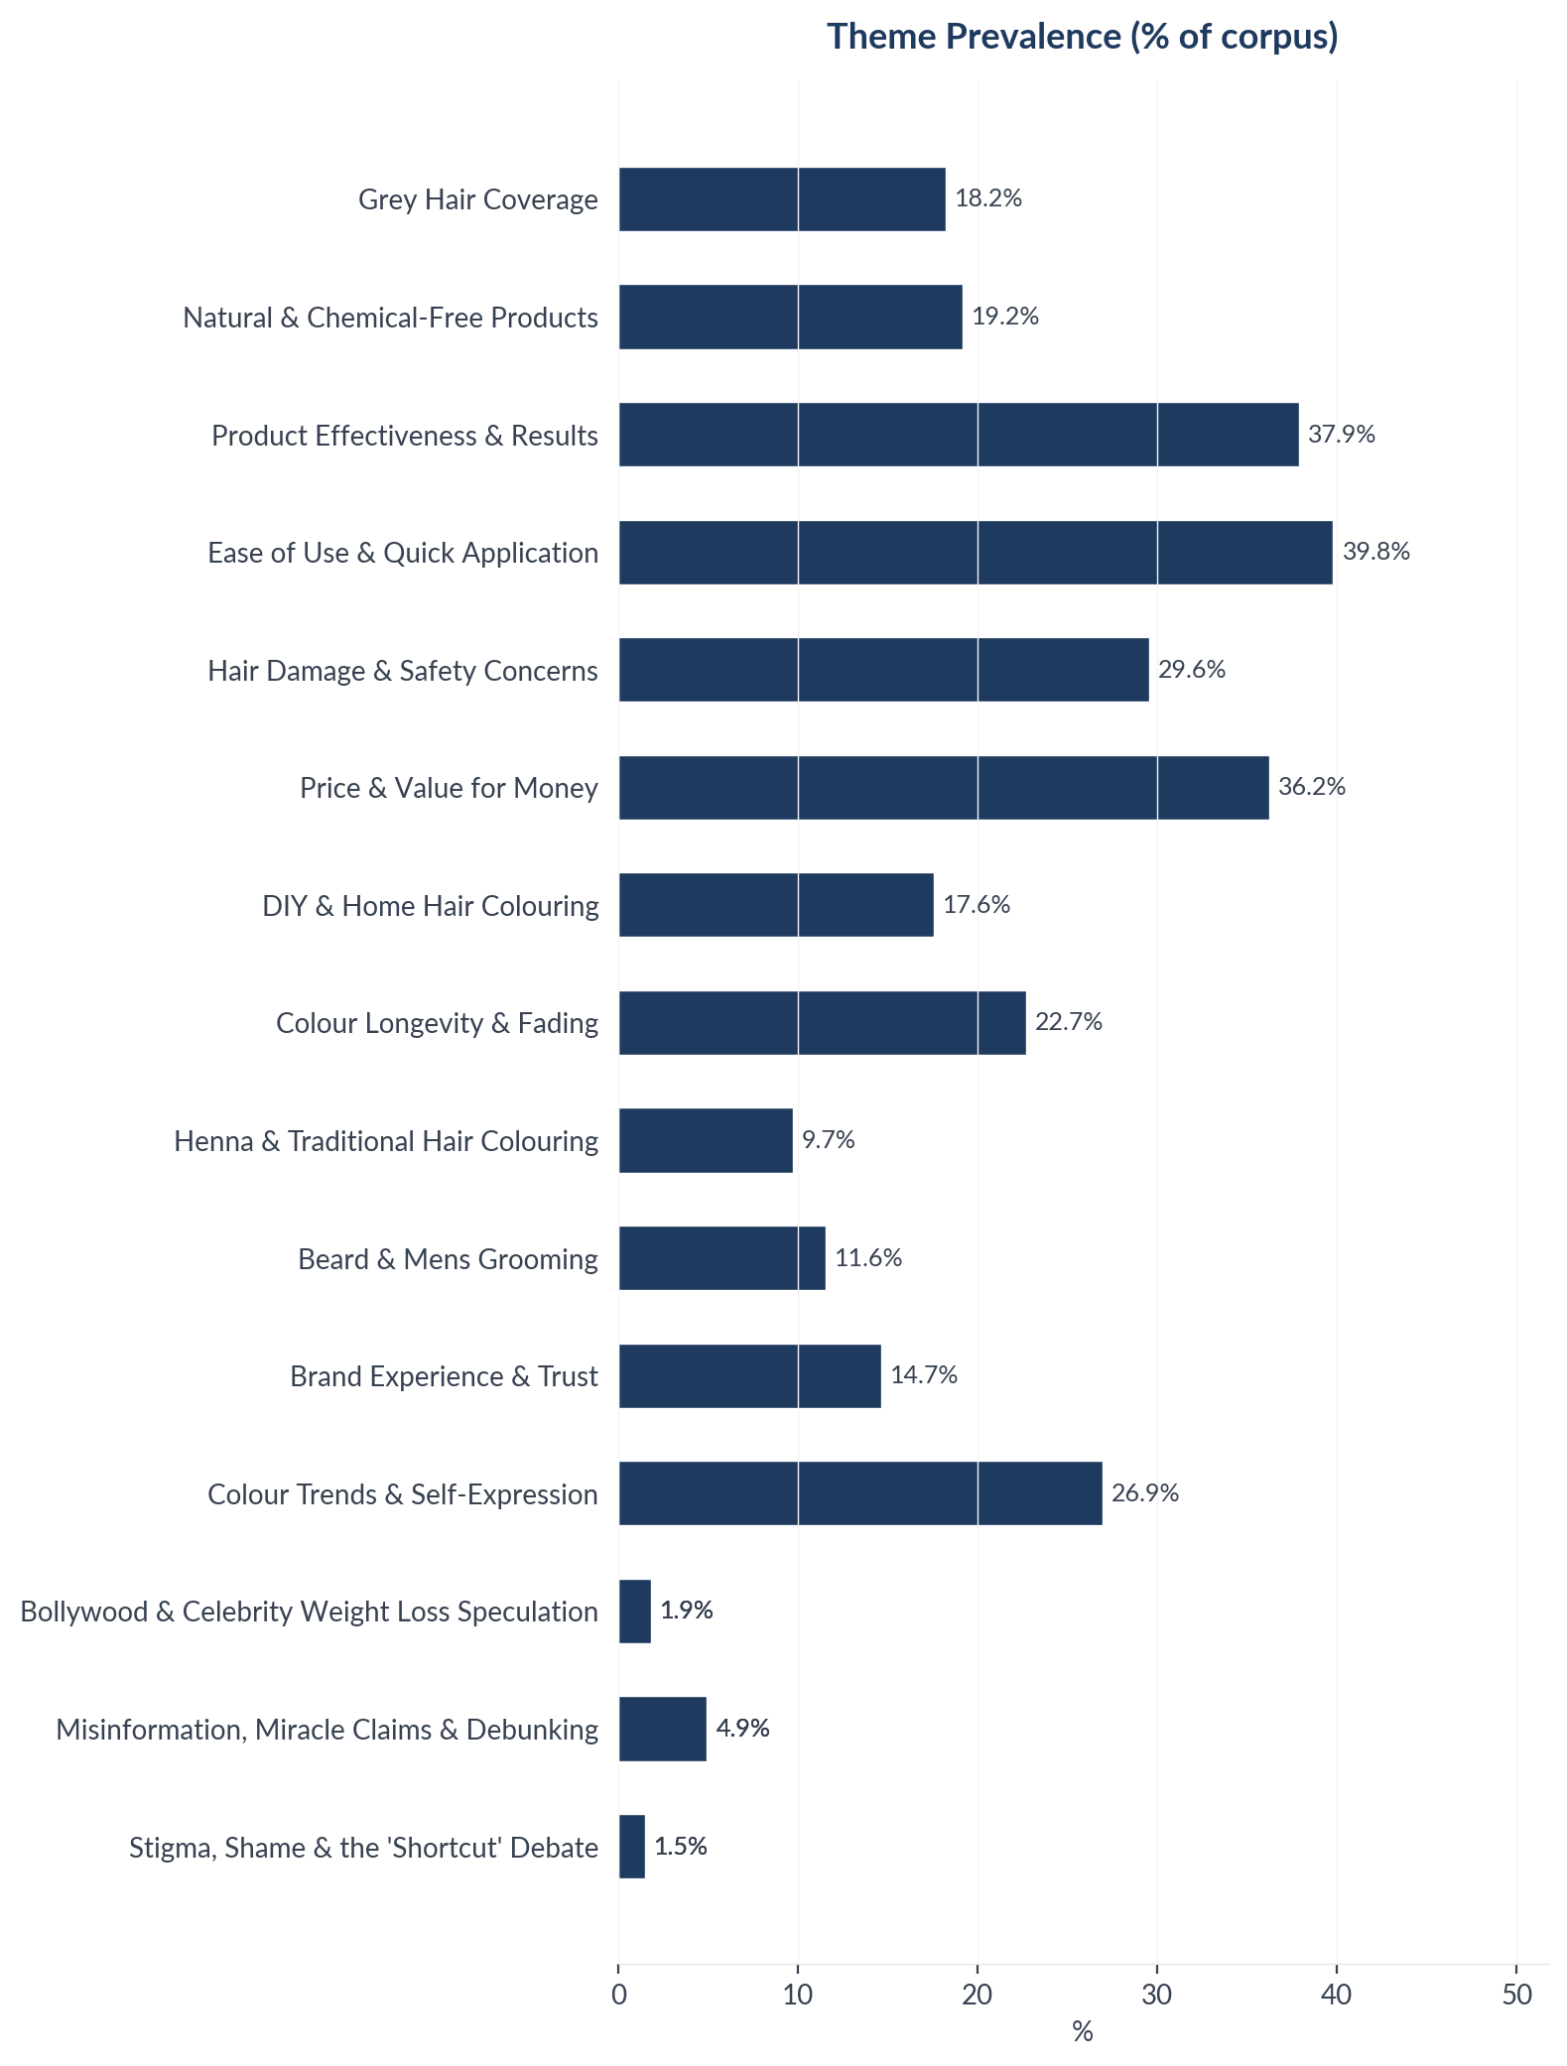
Figure 5: Insight prevalence (% of total corpus)

Insight Deep Dives
One insight per theme, ordered by confidence score. Each insight follows the framework: What the Data Shows, What it Means, Business Implication and Rationale, Recommendation, Further Validation.

01. Ease of Use & Quick Application
n=1717 | Confidence: 60% (Medium) | Signal: 62% (Moderate) | 39.8% of Dataset | NSS: +46%
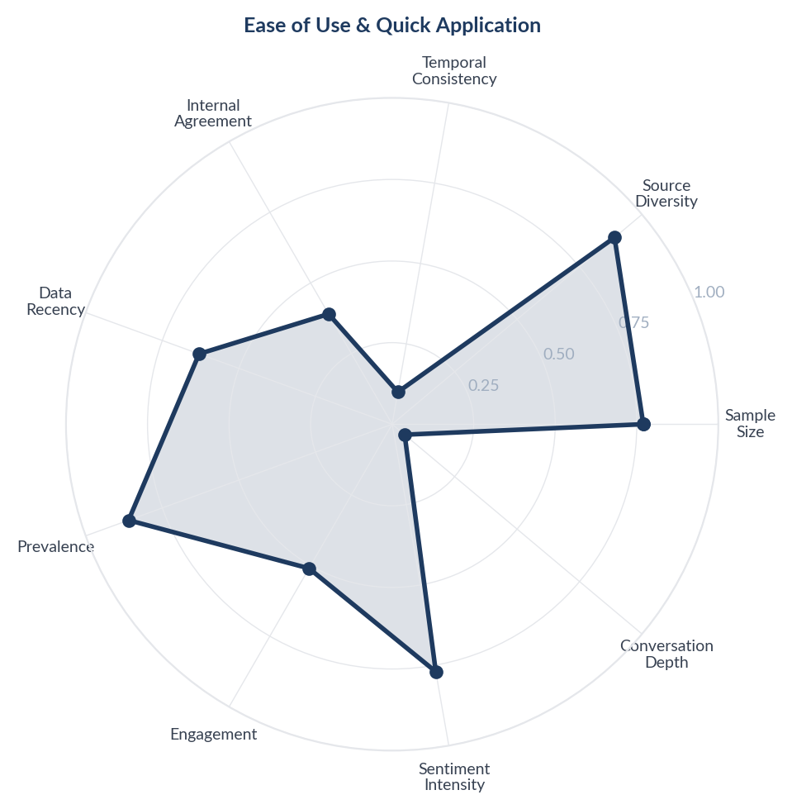
Score Breakdown: Ease of Use & Quick Application

What the Data Shows
Ease of use and quick application is the most prevalent theme with 1717 items (39.8% prevalence). Shampoo-based colours, instant colour sticks, spray-on products, and 5-10 minute application formats dominate discussions. Consumers repeatedly praise 'instant', 'quick', 'easy to apply', and 'mess-free' attributes.

What it Means
Indian consumers are migrating from traditional time-intensive hair colouring rituals (1-2 hour henna applications, multi-step chemical dyes) toward instant-format products. This shift is driven by urban lifestyle pressures, the desire for salon-like results at home, and the growing male grooming segment where simplicity is non-negotiable.

Business Implication & Rationale
The future of the Indian hair colour market belongs to convenience-first formats. Shampoo-based colours, colour sticks, and spray products are not just convenience segments - they represent a fundamental format shift that will erode traditional tube-and-developer products.

Recommendation
Expand the instant/shampoo-based colour portfolio with sachet formats for trial and travel. Invest in applicator innovation (built-in combs, no-drip formulas, single-use sachets). Price sachets at Rs 15-30 for impulse purchase in general trade.

Further Validation
Track format-level sales data (shampoo colour vs cream vs powder) quarter-over-quarter to quantify the format migration velocity.

Representative Voices
"I’m glad you had a good experience. I have friends who travelled and blended in(medium/dark skin and black coloured hair), and they took precautions and also had a good time." - reddit
"Anything but paradyes. Get it professionally done, use the colour protect shampoos, keep your hair nourished and moisturized after you get them coloured." - reddit
"Do not do a box dye. Go to sally beauty and get Demi permanent wella color that you like, developer 10, and a brush and the tub for dye. It’s inexpensive and easy." - reddit

02. Price & Value for Money
n=1564 | Confidence: 60% (Medium) | Signal: 63% (Moderate) | 36.2% of Dataset | NSS: +43%
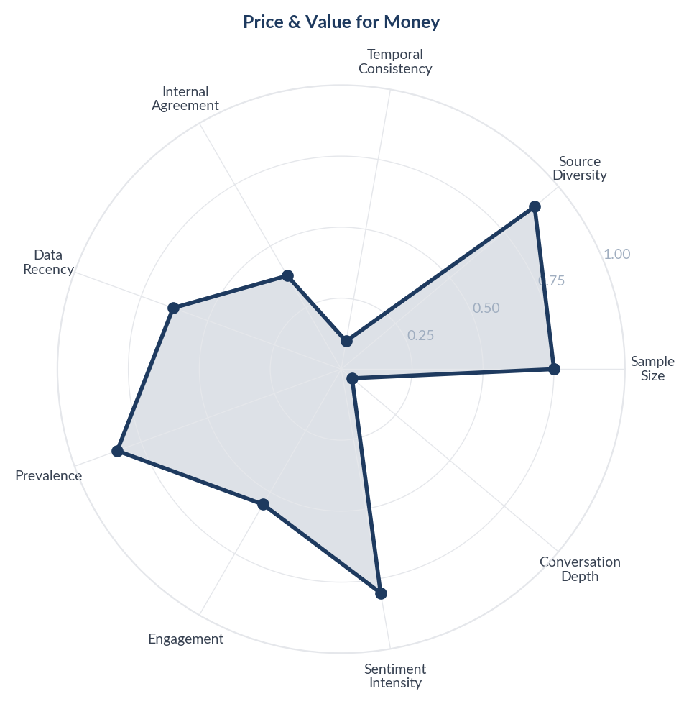
Score Breakdown: Price & Value for Money

What the Data Shows
Price and value discussions span 1564 items (36.25% prevalence). Consumers frequently evaluate products against salon costs, with home colouring explicitly framed as an economical alternative. Deal-hunting behaviour is prominent with consumers sharing discount codes, flash deals, and price comparisons. 'Value for money' and 'pocket-friendly' are recurring positive descriptors.

What it Means
Indian hair colour consumers are acutely price-sensitive and view the category through a salon-versus-home savings lens. The purchase decision is rarely about absolute price but about perceived value relative to a salon visit costing Rs 500-2000. Products priced under Rs 100 in sachet format capture impulse purchases, while Rs 200-400 range products must justify the premium through visible quality differentials.

Business Implication & Rationale
The Indian market rewards a dual pricing strategy: sachet formats for trial and general trade penetration, and larger formats for repeat purchasers who have validated effectiveness. Pricing above the Rs 400 threshold requires strong quality evidence or the product will be compared unfavourably to salon services.

Recommendation
Maintain a sachet SKU at the Rs 15-30 price point for general trade. For premium products, anchor pricing against salon visit costs (not against competitor products) in all communications. Bundle application tools (gloves, brush) to increase perceived value.

Further Validation
Conduct price elasticity research across metro, tier-2, and tier-3 cities to identify optimal price points by city tier and format.

Representative Voices
"Thank you! I just got a $4.99 box of Clairol Nice & Easy root touch up from my local discount chain Lot-Less. Hopefully Dollar Tree will get that or have B-Pure make a version. Brushing permanent color cream into your hair seems easier than spraying some on." - reddit
"Revlon Colorsilk box dye for years. And I’m still a licensed Cosmetologist. It’s under $4 and does the job. 👍🏼" - reddit
"I dyed my hair from about 50-65. It made a difference in how coworkers treated me. I let it grow out after I retired though and I wouldn't spend the money or the time to start dying it again. I'm glad that I did when I did though." - reddit

03. Natural & Chemical-Free Products
n=827 | Confidence: 59% (Medium) | Signal: 64% (Moderate) | 19.2% of Dataset | NSS: +69%
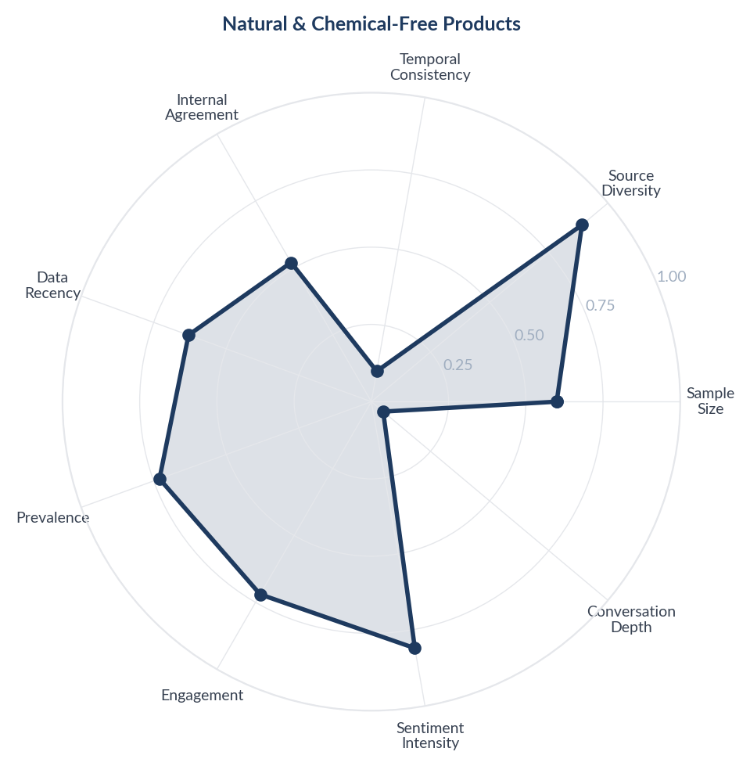
Score Breakdown: Natural & Chemical-Free Products

What the Data Shows
Natural and chemical-free products generate the highest positive sentiment in the corpus (NSS +69%), with 827 items (19.17% prevalence). Consumers actively seek ammonia-free, paraben-free, PPD-free, herbal, and organic formulations. Terms like 'chemical-free', 'natural ingredients', and 'no side effects' consistently drive purchase decisions across Amazon reviews and social media.

What it Means
Indian consumers carry a deep-rooted distrust of chemical hair colour formulations, driven by personal or familial experiences with allergic reactions, skin darkening, and hair damage. The 'natural' label functions as a trust signal - consumers equate natural ingredients with safety, even when the actual formulation science may not differ substantially.

Business Implication & Rationale
The natural/chemical-free positioning is not a niche premium segment but a mainstream expectation in India. Brands that cannot credibly claim natural credentials will face growing resistance, particularly among health-conscious urban consumers and the ayurveda-aware demographic.

Recommendation
Reformulate or reposition products with prominent 'ammonia-free', 'PPD-free', and 'dermatologist tested' claims. Invest in transparent ingredient communication on packaging and e-commerce listings. Consider launching an ayurvedic or plant-based sub-line for the Indian market.

Further Validation
Run a conjoint analysis testing willingness-to-pay for natural vs conventional formulations, segmented by metro vs tier-2/3 cities.

Representative Voices
"I did - 54F. My hair isn’t silver, just mousy with white and I had always kept it blonde. I honestly kinda hated my natural color and missed the texture that highlights gave my hair. I started with some natural highlights and then last week did a full foil, blindingly blond. Everyone loves it. The real me isn’t real - ha ha." - reddit
"To heck with privilege to age, my white hair gathers in side patches and I look SO DAMN OLD especially in photos I look like my grandma I swear! My advice if you don’t want to use box dye, is use henna. It’s super easy to use and is natural. I’m back to box dye now but I think I’ll go back to henna soon." - reddit
"There isn’t really a universal hair colour that works for all Desi’s (other than our natural hair colour). But if you want to find a hair colour that suits you best. Try to find out what your seasonal colour is then you will be able to see what hair colours suit you best." - reddit

04. Hair Damage & Safety Concerns
n=1275 | Confidence: 58% (Medium) | Signal: 66% (Moderate) | 29.6% of Dataset | NSS: +39%
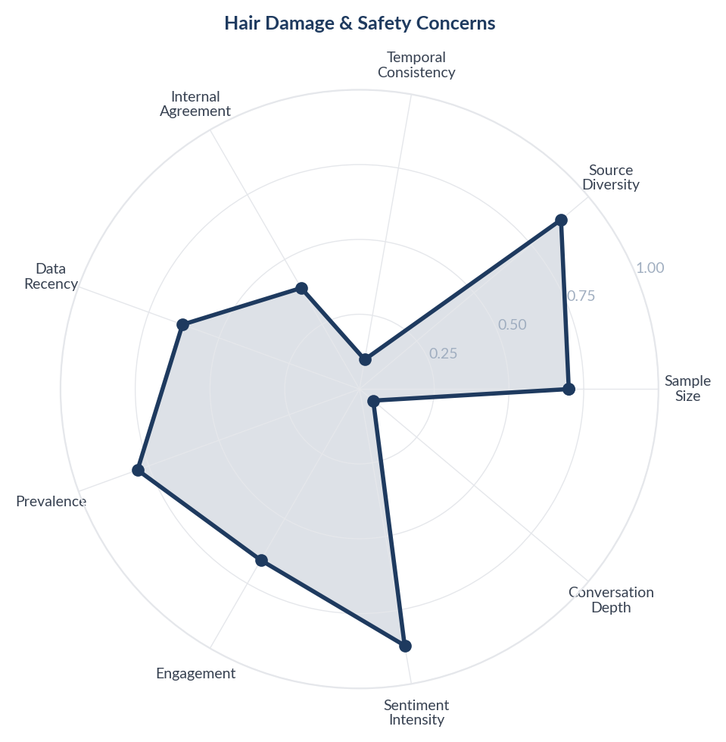
Score Breakdown: Hair Damage & Safety Concerns

What the Data Shows
Hair damage and safety concerns appear in 1275 items (29.55% prevalence). Despite an overall positive NSS (+39%), 218 items describe adverse experiences including severe allergic reactions, skin darkening around hairlines, chemical burns, hair loss, and products causing itching and irritation. Multiple consumers report requiring medical consultation after use.

What it Means
Safety concerns around hair colour are not hypothetical for Indian consumers - they are rooted in lived negative experiences. The tropical climate, combined with frequent reapplication needed for fast-growing dark hair, means Indian consumers face higher cumulative chemical exposure than Western counterparts. Reports of skin darkening are particularly concerning given Indian cultural sensitivity around skin tone.

Business Implication & Rationale
A single viral adverse reaction story can disproportionately damage brand trust in India, where word-of-mouth and family recommendations heavily influence purchase decisions. Safety is a competitive moat - brands that demonstrably invest in safety testing on Indian skin types will earn lasting loyalty.

Recommendation
Mandate and prominently display dermatological testing results specifically on Indian skin types. Include clear patch test instructions in local languages. Develop and market a post-colour conditioning treatment that addresses the dryness and damage consumers report.

Further Validation
Commission a dermatological study comparing allergic reaction rates across formulations on Indian skin types, particularly for PPD-containing vs PPD-free products.

Representative Voices
"They are all fine. The biggest thing to know is to only apply color to the regrowth. If you apply it all over, your hair will get brittle and dry.
If you find the ends need touching up, you'll go get a Demi-permanent (like nice and easy or anything that says it washes out in X number of washes) and apply that to the mid shaft and ends." - reddit
"Wait--I didn't know there was hype for this line. I love this line! Random day natry ko to kasi may stock sa cr namin. This is the only shampoo and conditioner na nagpagaan sa hair ko. My hair is less frizzy when I use this combo but what I like the most is that it's super gaan sa hair. Natutuyo agad hair ko dito." - reddit
"Streax professional. I have been colouring my hair since a long time. I used a few different brands but always cone back to streax. Affordable and good enough. My hair isn't damaged and I don't bleach unless I am going light." - reddit

05. Product Effectiveness & Results
n=1635 | Confidence: 58% (Medium) | Signal: 68% (Moderate) | 37.9% of Dataset | NSS: +45%
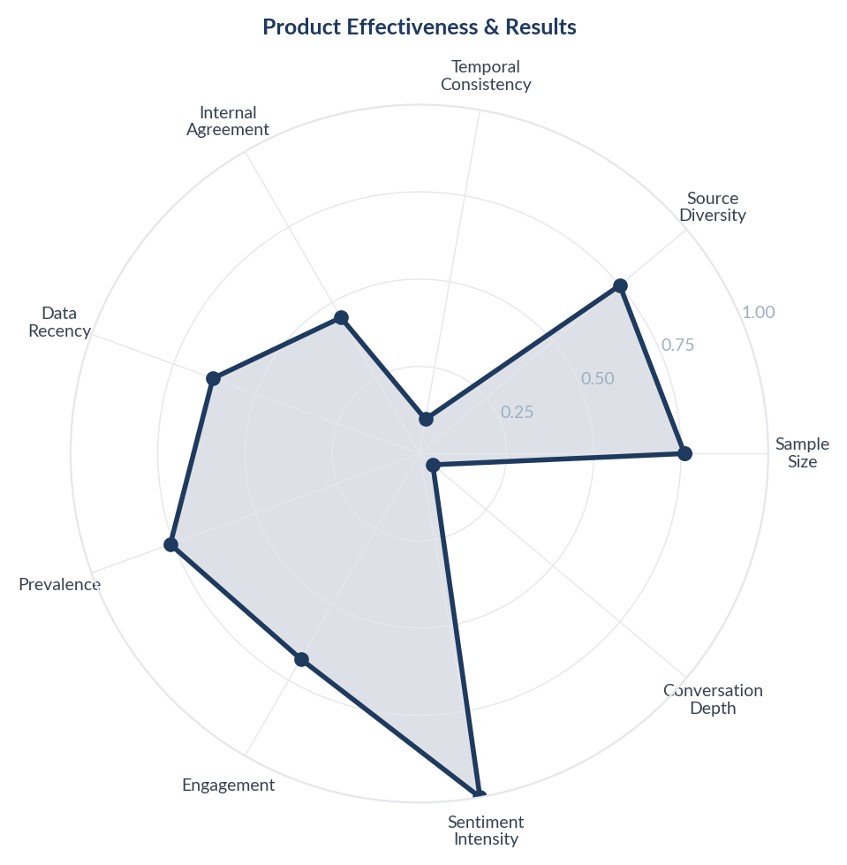
Score Breakdown: Product Effectiveness & Results

What the Data Shows
Product effectiveness discussions are the largest theme with 1635 items (37.9% prevalence), but carry a relatively lower NSS of +45%. While 65% of items are positive, 327 items express outright dissatisfaction with product claims not matching results - colour coming out different from the box, uneven coverage, and products that simply do not work.

What it Means
There is a significant expectations gap in the Indian hair colour market. Consumers purchase based on packaging claims and box colour swatches, but frequently receive different results. This gap is amplified for dark-haired Indian consumers where colour lift is inherently limited without bleaching - a nuance that packaging rarely communicates.

Business Implication & Rationale
Unmet expectations drive negative reviews, returns, and brand switching. The gap between marketing claims and actual results on Indian hair textures represents both a risk for incumbent brands and an opportunity for challengers who communicate honestly about expected outcomes on dark hair.

Recommendation
Include realistic before/after photos on Indian hair textures in marketing materials. Add QR codes on packaging linking to application videos showing results on similar hair types. Consider a shade-match guarantee or satisfaction programme.

Further Validation
Analyse return rates and negative review patterns by shade category to identify which specific colour claims have the highest expectation gap.

Representative Voices
"Spray on hair dye really changes the texture of your hair and transfers like crazy, so I don't think the hairdresser is going to want to touch your hair if you spray it first, let alone be able to style it." - reddit
"This is not an easy process and cannot be saved with box dye, but henna is a product that may be more sustainable than regular boxed hair dye. It is the “natural” alternative that comes to mind, however it requires multiple steps for grey coverage. I’d see if that’s an option for you.
Another option that comes to mind is letting it grow grey." - reddit
"The only thing you could even remotely use if your hair is brown and the character has white hair is a hair spray type of thing. That usually transfer all over the place and looks terrible. You'd be better off with a wig and spray it with some dry shampoo to take the shine down." - reddit

06. Colour Trends & Self-Expression
n=1162 | Confidence: 57% (Medium) | Signal: 65% (Moderate) | 26.9% of Dataset | NSS: +45%
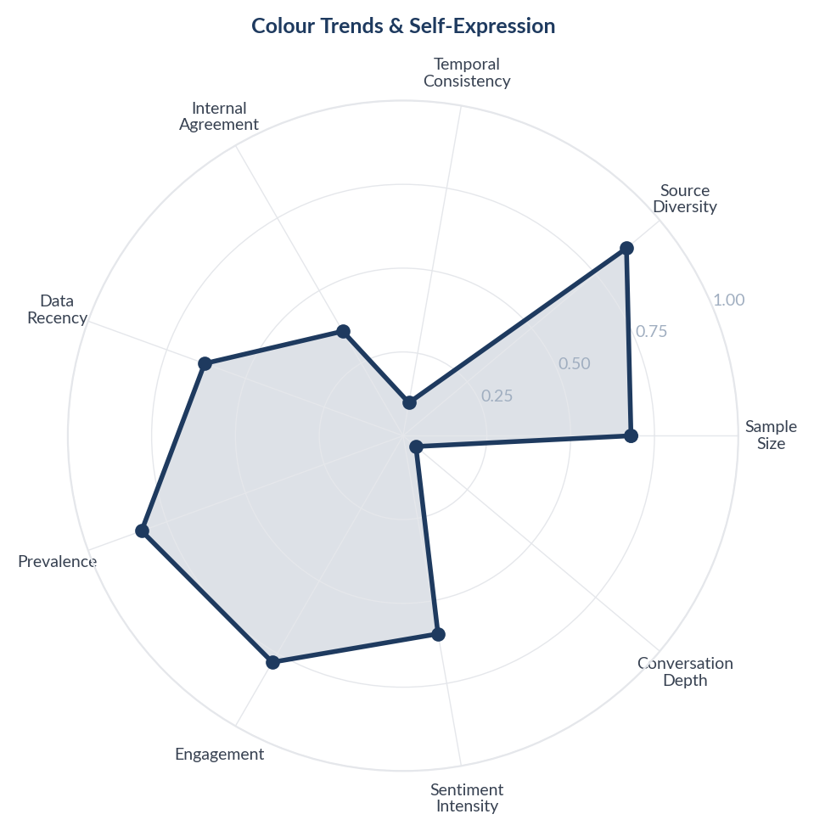
Score Breakdown: Colour Trends & Self-Expression

What the Data Shows
Colour trends and self-expression discussions span 1162 items (26.94% prevalence). Burgundy, copper, chocolate brown, highlights, balayage, and ombre are popular creative colour trends. A distinct segment discusses workplace acceptability of unconventional hair colours in Indian IT companies. Purple and red shades are the most sought-after fashion colours.

What it Means
A generational split is emerging in the Indian hair colour market: while older consumers use colour defensively (grey coverage), younger consumers aged 18-30 use it as a form of creative self-expression and identity signalling. Workplace norms in Indian IT and services sectors are loosening, creating permission for unconventional colours that were previously restricted to 'college only'. Burgundy and copper function as safe entry points to creative colour.

Business Implication & Rationale
The creative colour segment represents future market growth as India's young demographic enters peak spending years. However, the segment requires a fundamentally different go-to-market: trend-driven limited editions, social media-first marketing, and influencer partnerships rather than traditional TV advertising.

Recommendation
Launch seasonal limited-edition creative colour collections (3-4 shades per season). Create a social media campaign encouraging consumers to share hair colour transformations. Position burgundy and copper as 'professional-friendly' creative colours for the workplace-conscious segment.

Further Validation
Track social media trend velocity for specific hair colour shades in India to identify emerging colours before they peak, enabling faster product development cycles.

Representative Voices
"Here is what i have seen personally... Girls don't mind coloured hair on anyone, but guys have a tendency to criticize every minute thing. One of my friends dyed her hair light brown. She is gorgeous, so it looked great on her, but still i heard some boys discussing how she looks like an "aunty"." - reddit
"Just a warning from someone who dyes their hair religiously: blue is hard to get out of hair so even though it’s “semi permanent” it will most likely stain. If she can’t have colors for school I would try just doing the ends of her hair so you can cut it off before school starts if it doesn’t fade out completely" - reddit
"Pro - A deposit only demi permanent color a shade or two lighter that your natural. It will blend them and have a slight highlighted look" - reddit

07. Colour Longevity & Fading
n=979 | Confidence: 57% (Medium) | Signal: 62% (Moderate) | 22.7% of Dataset | NSS: +42%
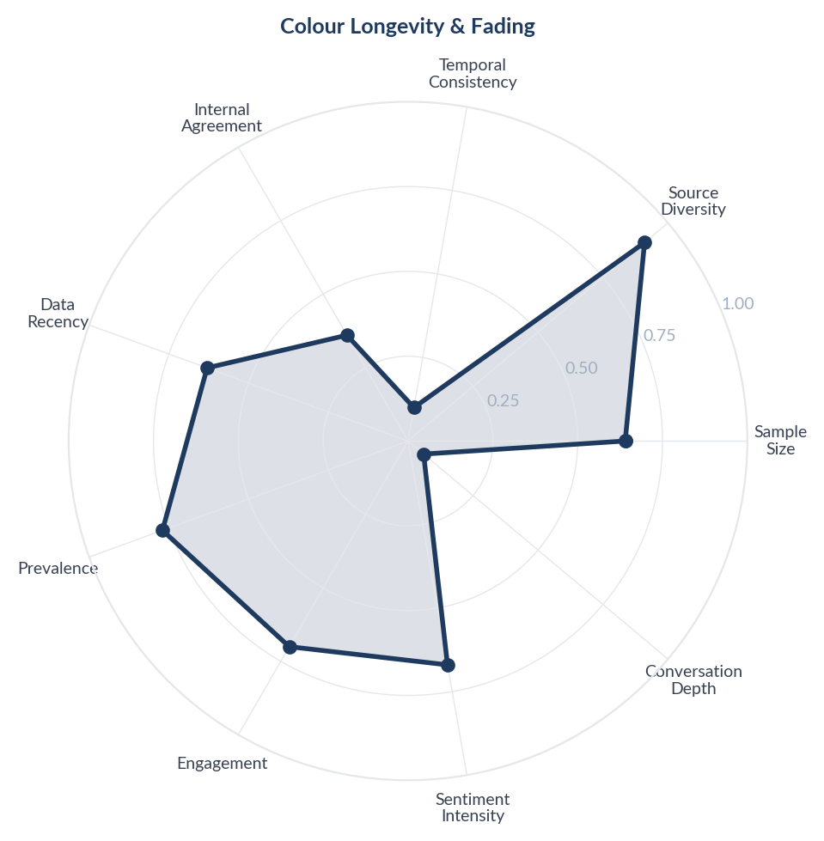
Score Breakdown: Colour Longevity & Fading

What the Data Shows
Colour longevity and fading discussions span 979 items (22.69% prevalence). Consumers consistently report that colour fades faster than expected - within 1-2 weeks for many products, particularly shampoo-based colours and temporary sprays. The tension between wanting damage-free temporary colour and wanting long-lasting results is a recurring frustration.

What it Means
Indian consumers face a structural paradox in hair colour: they want chemical-free products that are also long-lasting, but gentle formulations inherently fade faster. The hot, humid Indian climate accelerates fading further. Consumers do not fully understand this trade-off, leading to dissatisfaction when 'gentle' products wash out quickly and 'long-lasting' products damage hair.

Business Implication & Rationale
Managing the longevity expectations gap is critical. Brands that explicitly communicate expected duration (number of washes, not weeks) and provide maintenance products (colour-protect shampoo, touch-up sticks) will reduce post-purchase dissatisfaction and drive repeat purchases through the maintenance product ecosystem.

Recommendation
State colour longevity in 'number of washes' rather than 'weeks' on packaging. Launch a colour-maintain product line (colour-protect shampoo + conditioner) as a cross-sell. Offer touch-up sachets as refill products between full applications.

Further Validation
Lab-test colour retention across formulations in humid conditions simulating Indian climate to set honest longevity benchmarks.

Representative Voices
"Hair chalk from my experience is SO much messier than just getting temporary hair dye. I'm gonna dye mine's purple cuz she's obsessed with Rumi. Go for it!" - reddit
"Use semi permanent dye. It looks good for the same amount of time as permanent but you don't get an ugly colour line as it grows out and it's easier to fix mistakes" - reddit
"Just so you know, the third photo isn't "faded." It's oxidized. The bright orange only lasts for a few days until the henna oxidizes in your hair.
I'm really surprised that 50 grams was enough for your long hair! It looks great." - reddit

08. Grey Hair Coverage
n=787 | Confidence: 57% (Medium) | Signal: 59% (Moderate) | 18.2% of Dataset | NSS: +57%
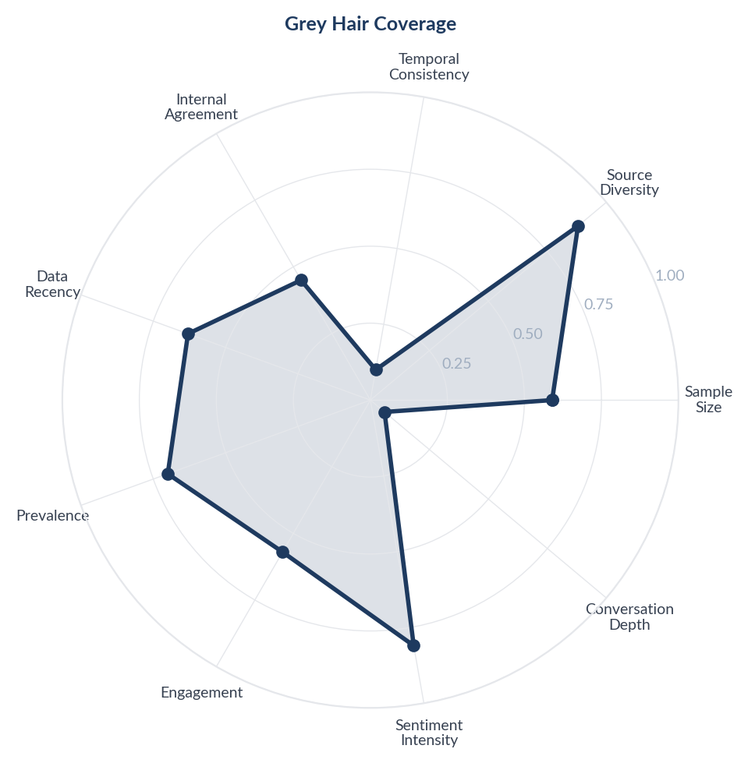
Score Breakdown: Grey Hair Coverage

What the Data Shows
Grey hair coverage dominates consumer motivation for hair colour use, with 787 items (18.24% of corpus) discussing grey coverage. Sentiment is strongly positive (NSS +57%) with consumers actively seeking quick, effective solutions. Root touch-up products and instant coverage sticks feature prominently across all platforms.

What it Means
For Indian consumers, hair colouring is primarily functional rather than aspirational - covering grey hair is a grooming necessity tied to social perception and professional appearance. The dominant need is not creative expression but managing visible ageing, making speed and effectiveness the primary purchase drivers rather than shade variety.

Business Implication & Rationale
Brands that position hair colour as a grey management solution rather than a fashion statement will capture the largest segment of the Indian market. The functional framing allows for premium pricing if speed and reliability are demonstrably superior.

Recommendation
Launch or expand a dedicated grey coverage sub-brand with messaging centred on time savings (5-minute claims), natural appearance, and reliability. Position grey coverage products at eye level in retail and as the default category entry point in e-commerce listings.

Further Validation
Conduct a quantitative survey segmenting consumers by age cohort (25-35, 36-45, 46+) to measure the relative importance of grey coverage vs creative colour by demographic.

Representative Voices
"Hey yes, some suggestions are henna and then Indigo, two step routine. Otherwise Shesha Ayurveda Nilini. I have used both two step routines and Nilini as well. However, I would first suggest you to visit a doctor regarding covering your nutritional deficiencies to arrest the grey from increasing. I have almost 70% grey hair now." - reddit
"Vit B12 check kar ekda. I had this issue in my teens caused by B12 deficiency. 30% gray hair now all black at 33.
To answer your question - It does impact your dating prospects for sure. But there are some women who might be fine with it." - reddit
"Did this and it did not cover grays at all just refreshed the existing color. After research it looks like you need permanent with 20 vol to penetrate through gray hair" - reddit

09. DIY & Home Hair Colouring
n=757 | Confidence: 55% (Medium) | Signal: 63% (Moderate) | 17.6% of Dataset | NSS: +47%
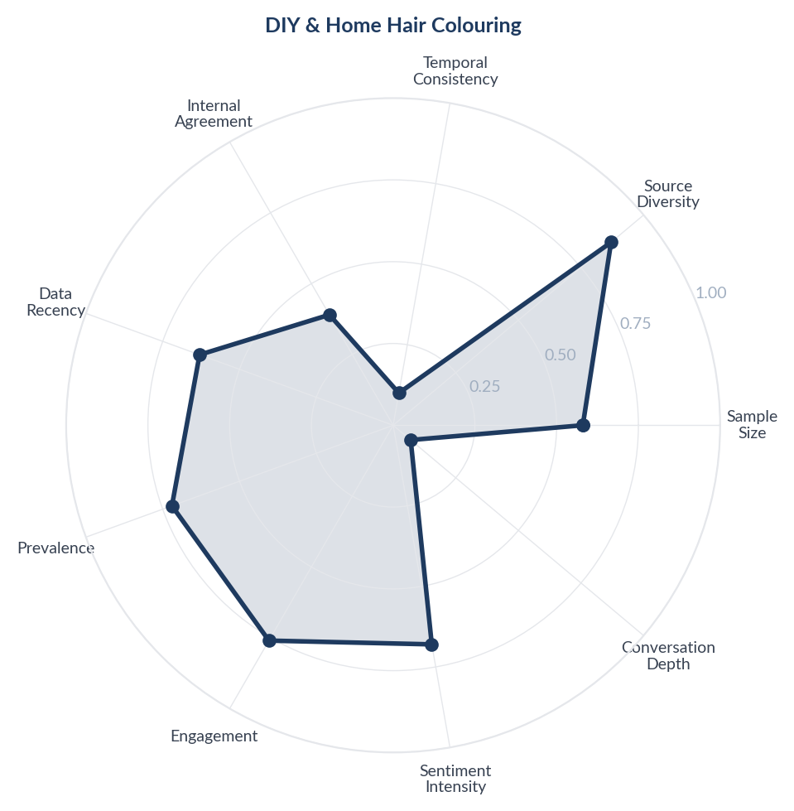
Score Breakdown: DIY & Home Hair Colouring

What the Data Shows
DIY and home hair colouring discussions cover 757 items (17.55% prevalence) with positive NSS (+47%). Consumers share application techniques, brand comparisons, and tips for achieving salon-like results at home. First-time users seek guidance while experienced home colourers recommend specific brands and techniques.

What it Means
Home hair colouring in India is evolving from a budget compromise to an empowered lifestyle choice. Consumers - particularly younger women in metro cities - view DIY colouring as a form of self-reliance, not just cost savings. Reddit and YouTube function as peer-to-peer salons where technique knowledge is shared freely, reducing dependence on professional stylists.

Business Implication & Rationale
The shift to home colouring creates a direct-to-consumer opportunity but also raises the skill bar that products must accommodate. Products that simplify the application process will win in this channel, while brands that rely on salon-professional distribution will face channel erosion.

Recommendation
Create branded tutorial content for YouTube and Instagram showing step-by-step home application on Indian hair. Partner with beauty micro-influencers for authentic home colouring demonstrations. Include QR-linked video tutorials on every box.

Further Validation
Survey home colourers to understand the trigger for first home application (cost, convenience, pandemic habit) and what would make them switch back to salon.

Representative Voices
"it’s not sus at all. she did you a solid.
you pushed your appointment back a whole hour and she was able to accommodate you - 10min colour is not more damaging. it is, however, more expensive. so she accomdated you and made less.
also, i’m not sure where you’re getting all box dyes taking 10 minutes from, that is not at all the case" - reddit
"I need you to hold my hand when I tell you this... You are not going to get this color at home.
Unless you have some knowledge of hair color and bleach, it's not going to happen." - reddit
"Since it's a casual cosplay, and a rave, instead of trying to colour your hair you could always just braid blue wefts or yarn into your own hair. With the costume, it would make it clear what character you're going for, and would be a lot easier to manage." - reddit

10. Henna & Traditional Hair Colouring
n=420 | Confidence: 55% (Medium) | Signal: 60% (Moderate) | 9.7% of Dataset | NSS: +63%
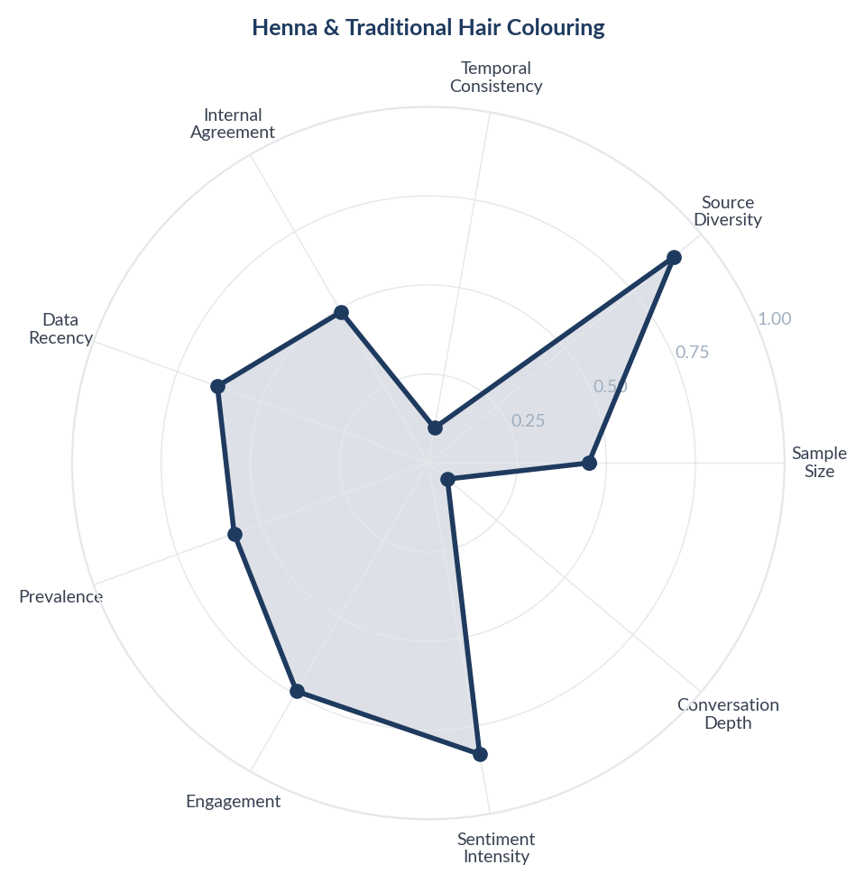
Score Breakdown: Henna & Traditional Hair Colouring

What the Data Shows
Henna and traditional hair colouring methods are discussed in 420 items (9.74% prevalence) with the second-highest positive sentiment (NSS +63%). Henna-indigo combinations for achieving natural black, traditional mehndi preparation methods, and ayurvedic hair colour recipes are shared across YouTube (regional language content) and Reddit (advice-seeking posts).

What it Means
Henna is not just a hair colouring method in India - it is a cultural heritage practice carrying deep trust that no modern brand has been able to fully replicate. Consumers who use henna view it as simultaneously colouring, conditioning, and nourishing hair - a holistic hair treatment rather than just a dye. The willingness to endure 2-3 hours of application time signals how deeply trusted the henna proposition is.

Business Implication & Rationale
Pure henna users represent a segment that modern brands struggle to convert because they view chemical products as fundamentally inferior, not just different. However, the pain point of long application time creates an opportunity for henna-hybrid products that deliver the trust of traditional ingredients with modern convenience.

Recommendation
Develop a rapid-henna format (30-minute application with henna + indigo pre-mixed). Partner with ayurvedic brands for co-branded credibility. Use regional language content marketing to reach henna users who consume content in Hindi, Tamil, Telugu, and Malayalam.

Further Validation
Ethnographic research with traditional henna users across north and south India to understand what conditions would make them trial a henna-hybrid product.

Representative Voices
"Hey, thankyou so much for the reply..I have visited the doctors, I do take supplements. It's all stress. Also does henna and indigo combination turn hair completely black or there remains the shade of orange?" - reddit
"I hate to break it to you but washing henna and indigo without shampoo is very unpleasant because hair becomes really really rough after that but this is the only solution
Also I realized a long time ago that diet isn't gonna help me reverse my greys because most of the time premature greying is ge..." - reddit
"https://preview.redd.it/35brp4l47mif1.jpeg?width=2448&format=pjpg&auto=webp&s=cef23fa2ad5074523a5fa4ef4392abfd02110ba7
I get this color with Henna! This pic was taken a month after henna was applied. I have black hair with many greys! All the greys have turned into ruby red!! I use pure henna and make paste out of it with tea decoction." - reddit

11. Beard & Mens Grooming
n=499 | Confidence: 54% (Medium) | Signal: 54% (Moderate) | 11.6% of Dataset | NSS: +57%
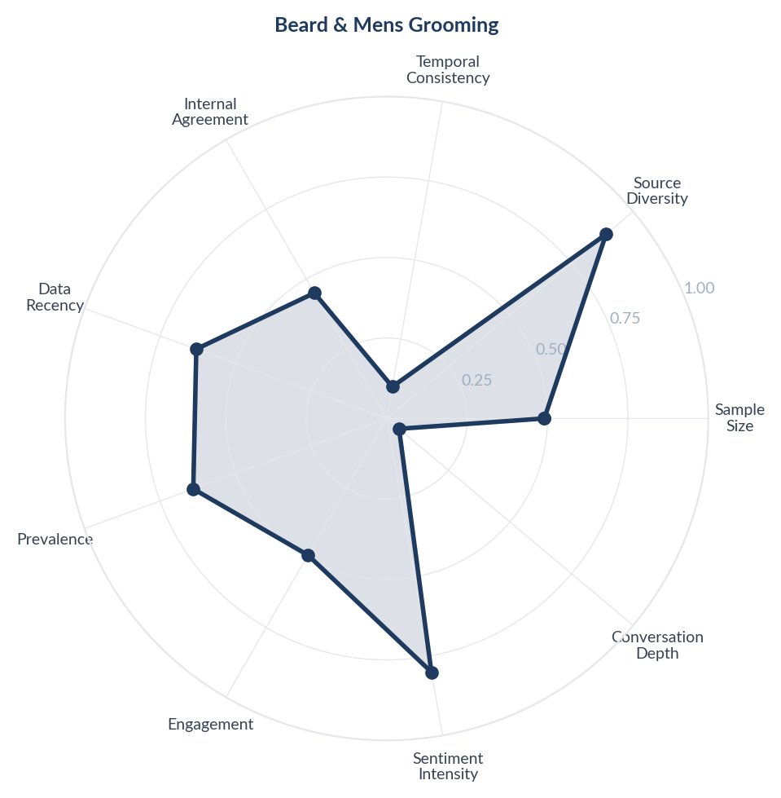
Score Breakdown: Beard & Mens Grooming

What the Data Shows
Beard and mens grooming colour products are discussed in 499 items (11.57% prevalence) with a strongly positive NSS (+57%). Beard colour shampoos, instant beard black products, and grey beard coverage dominate. Products like Beardo Blackout Powder and beard colour shampoos are frequently discussed. Men prioritise speed (under 5 minutes), no mess, and natural appearance.

What it Means
The Indian male grooming colour segment is rapidly maturing from a niche to a mainstream category, driven by workplace grooming norms and dating culture among urban men aged 25-40. Unlike women who may tolerate complex application processes, men demand extreme simplicity - if a product takes more than 5 minutes or stains the sink, it is rejected. The beard colour segment specifically is growing as facial hair grooming becomes a distinct male beauty ritual.

Business Implication & Rationale
The mens hair colour segment in India is underserved relative to demand. Most male-targeted products are simply repackaged womens products. Brands that develop male-specific formulations, packaging, and retail placement will capture an expanding category with less competition than the womens segment.

Recommendation
Launch a dedicated mens hair and beard colour range with male-specific packaging, 3-minute application claims, and pharmacy/general trade distribution. Target communication at normalising male grey coverage as routine grooming, not vanity.

Further Validation
Survey urban Indian men aged 25-45 on grey coverage attitudes, current product usage, and willingness to pay for male-specific products vs using family/unisex products.

Representative Voices
"i would highly recommend just getting a wig! tis the season! bust out the pink party city wig and leave your beautiful hair color alone!" - reddit
"I don't think dying your hair means you aren't aging gracefully. I'm 37 and I think I have 1 gray hair (it's genetics). And I like to experiment and dye my hair all different colors." - reddit
"I dye them. I don't care if other people think I'm aging gracefully or not. *I* think I look better with my greys coloured.
I have seen beautiful women "embracing their greys" but the big difference between those women and me is that they also take a lot of time with their make-up and hairstyling. I don't do that and don't want to." - reddit

12. Brand Experience & Trust
n=632 | Confidence: 54% (Medium) | Signal: 56% (Moderate) | 14.7% of Dataset | NSS: +41%
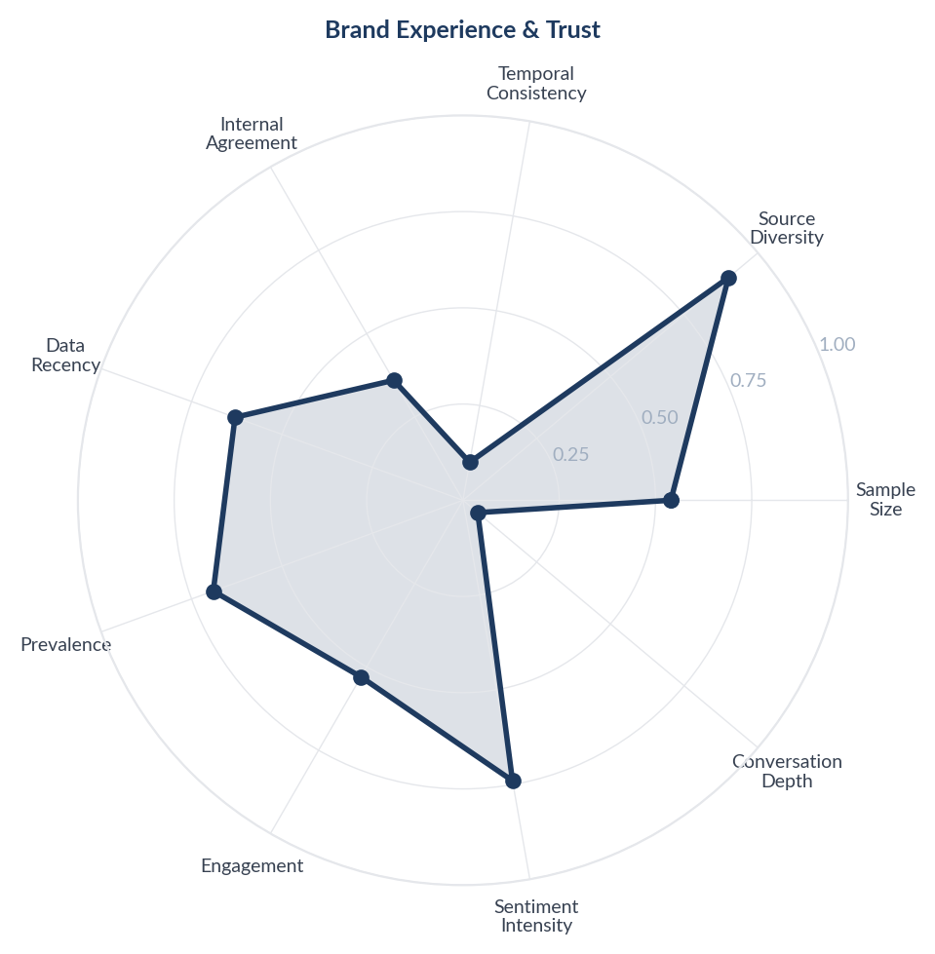
Score Breakdown: Brand Experience & Trust

What the Data Shows
Brand experience and trust discussions cover 632 items (14.65% prevalence). Garnier, L'Oreal, Godrej, Streax, Paradyes, Schwarzkopf, Bigen, Kokila, and Wella are frequently mentioned. Concerns about counterfeit/fake products on Amazon and Flipkart are a recurring pain point, with multiple consumers reporting receiving products that do not match the original formulation they previously purchased.

What it Means
Trust in the Indian hair colour market is fragile and platform-dependent. Consumers who had positive experiences with a brand in physical retail report receiving 'different' or 'fake' products when purchasing the same brand online. This erodes not just e-commerce trust but brand trust itself, as consumers cannot distinguish between genuine product quality decline and counterfeit infiltration.

Business Implication & Rationale
E-commerce counterfeiting is a brand equity crisis, not just a supply chain problem. Every fake product sold under a brands name generates a negative review that damages the brand permanently in search rankings and consumer memory. The cost of inaction exceeds the cost of authentication systems.

Recommendation
Implement QR-based authentication on all products sold through e-commerce channels. Partner with Amazon and Flipkart for Brand Registry and report counterfeit sellers aggressively. Include authenticity verification messaging in packaging ('Scan to verify genuine product').

Further Validation
Mystery shop own brands on Amazon/Flipkart to quantify counterfeit prevalence and identify specific seller accounts distributing fake products.

Representative Voices
"I did it, honestly don’t regret it. Hair will grow anyway. I did paradyes hair colour again recently, it gives my hair a nice burgundy shade." - reddit
"I think Schwarzkopf makes the best hair color.
Second choice would be John Frieda Precision Foam. It’s really easy to use and does pretty well.
You’re going to want level 3 permanent color." - reddit
"I agree - I rarely hear people talk about, or recommend, this brand. And I love it as well! I use the color care shampoo and conditioner, trauma treatment and the hair oil. All so good. Sometimes I rotate with pureology but I always came back to it. Haven’t found anything that performs as good." - reddit

13. Misinformation, Miracle Claims & Debunking
n=213 | Confidence: 47% (Directional) | Signal: 58% (Moderate) | 4.9% of Dataset | NSS: +33%
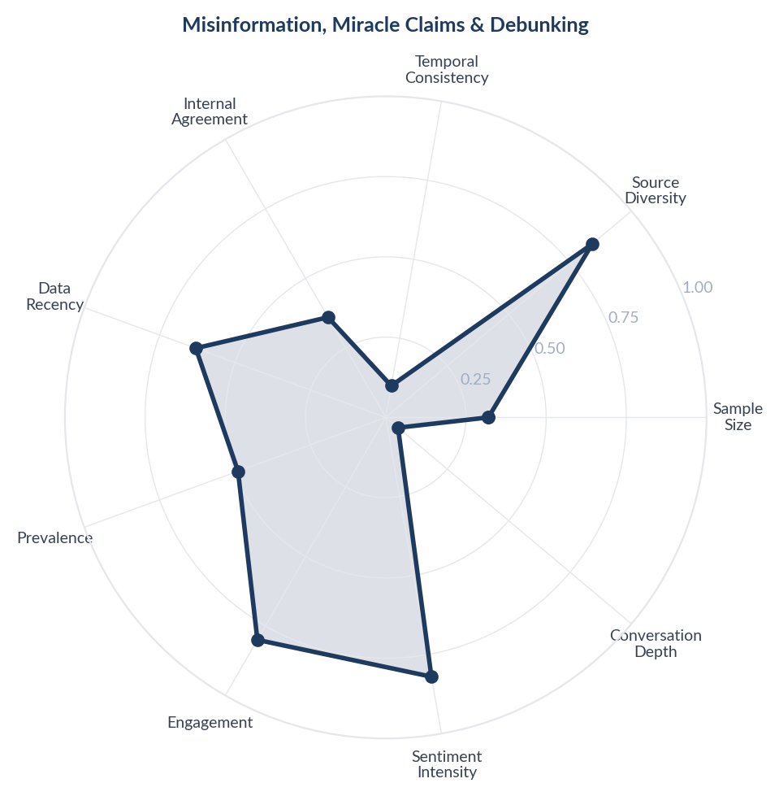
Score Breakdown: Misinformation, Miracle Claims & Debunking

What the Data Shows
Misinformation and miracle claims account for 217 items (8.6% of corpus) spanning fear-based content ('Ozempic destroys your body'), miracle framing ('lose 10kg in 10 days'), pseudoscience (Gila monster venom narratives), and fact-checking responses. The conversation is bifurcated: Instagram hosts the most misleading content (miracle claims from health influencers, unverified side effect horror stories), while Reddit and YouTube host the debunking (doctors correcting misinformation, users sharing evidence-based perspectives).

What it Means
The Indian weight loss information ecosystem is polarised between two competing content factories: Instagram's influencer-driven miracle-claim economy and Reddit/YouTube's evidence-based correction community. The misinformation is not random - it follows a predictable pattern. Step 1: An influencer frames a drug as a miracle or a danger (both drive engagement). Step 2: A doctor or informed user posts a correction. Step 3: The correction reaches a fraction of the original audience. The net effect is that the Indian consumer is simultaneously over-exposed to sensational claims and under-exposed to calibrated medical information.

Business Implication & Rationale
Misinformation is not just a public health concern - it is a direct commercial threat to GLP-1 brands. Fear-based misinformation (muscle wasting, permanent damage, venom-based) deters potential users. Miracle-framing (quick fix, no effort needed) attracts the wrong users who will be disappointed and generate negative word-of-mouth. Both distort the market conversation away from the drugs' actual clinical profile.

Recommendation
Fund an independent, doctor-led content initiative in Hindi and English that proactively addresses the top 10 misinformation themes. Create a 'myth vs fact' content series specifically for Instagram (where the misinformation is concentrated) using the same short-form, high-engagement format that spreads the misinformation. Partner with medical professionals who already have trust on YouTube (Dr. Pal, Dr. Balamurugan) to create corrective content that ranks alongside misleading videos.

Further Validation
Map the specific misinformation claims by volume and platform to prioritise debunking efforts. Track whether corrective content reduces fear-based objections in subsequent consumer conversations.

Representative Voices
"Man here I go... as a caucasian dude we never have enough melanin to rock a solid color beard without it looking fake as shit. My friend, facial hair grows so fast it's impossible to keep up with it. Silver hair marks your time and wisdom." - reddit
"In my twenties I dyed my hair all the time. I turned allergic to it my ears got so inflamed to the size of baseballs and I shaved my head off in order to get the poison off my head." - youtube
"this is my favourite hair colour now its magic in a bottle I absolutely love it I bought two off Amazon ❤❤❤❤" - youtube

14. Misinformation, Miracle Claims & Debunking
n=213 | Confidence: 47% (Directional) | Signal: 58% (Moderate) | 4.9% of Dataset | NSS: +33%

Score Breakdown: Misinformation, Miracle Claims & Debunking

What the Data Shows
Misinformation and miracle claims account for 217 items (8.6% of corpus) spanning fear-based content ('Ozempic destroys your body'), miracle framing ('lose 10kg in 10 days'), pseudoscience (Gila monster venom narratives), and fact-checking responses. The conversation is bifurcated: Instagram hosts the most misleading content (miracle claims from health influencers, unverified side effect horror stories), while Reddit and YouTube host the debunking (doctors correcting misinformation, users sharing evidence-based perspectives).

What it Means
The Indian weight loss information ecosystem is polarised between two competing content factories: Instagram's influencer-driven miracle-claim economy and Reddit/YouTube's evidence-based correction community. The misinformation is not random - it follows a predictable pattern. Step 1: An influencer frames a drug as a miracle or a danger (both drive engagement). Step 2: A doctor or informed user posts a correction. Step 3: The correction reaches a fraction of the original audience. The net effect is that the Indian consumer is simultaneously over-exposed to sensational claims and under-exposed to calibrated medical information.

Business Implication & Rationale
Misinformation is not just a public health concern - it is a direct commercial threat to GLP-1 brands. Fear-based misinformation (muscle wasting, permanent damage, venom-based) deters potential users. Miracle-framing (quick fix, no effort needed) attracts the wrong users who will be disappointed and generate negative word-of-mouth. Both distort the market conversation away from the drugs' actual clinical profile.

Recommendation
Fund an independent, doctor-led content initiative in Hindi and English that proactively addresses the top 10 misinformation themes. Create a 'myth vs fact' content series specifically for Instagram (where the misinformation is concentrated) using the same short-form, high-engagement format that spreads the misinformation. Partner with medical professionals who already have trust on YouTube (Dr. Pal, Dr. Balamurugan) to create corrective content that ranks alongside misleading videos.

Further Validation
Map the specific misinformation claims by volume and platform to prioritise debunking efforts. Track whether corrective content reduces fear-based objections in subsequent consumer conversations.

Representative Voices
"Man here I go... as a caucasian dude we never have enough melanin to rock a solid color beard without it looking fake as shit. My friend, facial hair grows so fast it's impossible to keep up with it. Silver hair marks your time and wisdom." - reddit
"In my twenties I dyed my hair all the time. I turned allergic to it my ears got so inflamed to the size of baseballs and I shaved my head off in order to get the poison off my head." - youtube
"this is my favourite hair colour now its magic in a bottle I absolutely love it I bought two off Amazon ❤❤❤❤" - youtube

15. Misinformation, Miracle Claims & Debunking
n=213 | Confidence: 47% (Directional) | Signal: 58% (Moderate) | 4.9% of Dataset | NSS: +33%

Score Breakdown: Misinformation, Miracle Claims & Debunking

What the Data Shows
Misinformation and miracle claims account for 217 items (8.6% of corpus) spanning fear-based content ('Ozempic destroys your body'), miracle framing ('lose 10kg in 10 days'), pseudoscience (Gila monster venom narratives), and fact-checking responses. The conversation is bifurcated: Instagram hosts the most misleading content (miracle claims from health influencers, unverified side effect horror stories), while Reddit and YouTube host the debunking (doctors correcting misinformation, users sharing evidence-based perspectives).

What it Means
The Indian weight loss information ecosystem is polarised between two competing content factories: Instagram's influencer-driven miracle-claim economy and Reddit/YouTube's evidence-based correction community. The misinformation is not random - it follows a predictable pattern. Step 1: An influencer frames a drug as a miracle or a danger (both drive engagement). Step 2: A doctor or informed user posts a correction. Step 3: The correction reaches a fraction of the original audience. The net effect is that the Indian consumer is simultaneously over-exposed to sensational claims and under-exposed to calibrated medical information.

Business Implication & Rationale
Misinformation is not just a public health concern - it is a direct commercial threat to GLP-1 brands. Fear-based misinformation (muscle wasting, permanent damage, venom-based) deters potential users. Miracle-framing (quick fix, no effort needed) attracts the wrong users who will be disappointed and generate negative word-of-mouth. Both distort the market conversation away from the drugs' actual clinical profile.

Recommendation
Fund an independent, doctor-led content initiative in Hindi and English that proactively addresses the top 10 misinformation themes. Create a 'myth vs fact' content series specifically for Instagram (where the misinformation is concentrated) using the same short-form, high-engagement format that spreads the misinformation. Partner with medical professionals who already have trust on YouTube (Dr. Pal, Dr. Balamurugan) to create corrective content that ranks alongside misleading videos.

Further Validation
Map the specific misinformation claims by volume and platform to prioritise debunking efforts. Track whether corrective content reduces fear-based objections in subsequent consumer conversations.

Representative Voices
"Man here I go... as a caucasian dude we never have enough melanin to rock a solid color beard without it looking fake as shit. My friend, facial hair grows so fast it's impossible to keep up with it. Silver hair marks your time and wisdom." - reddit
"In my twenties I dyed my hair all the time. I turned allergic to it my ears got so inflamed to the size of baseballs and I shaved my head off in order to get the poison off my head." - youtube
"this is my favourite hair colour now its magic in a bottle I absolutely love it I bought two off Amazon ❤❤❤❤" - youtube

16. Stigma, Shame & the 'Shortcut' Debate
n=64 | Confidence: 47% (Directional) | Signal: 45% (Weak) | 1.5% of Dataset | NSS: +56%
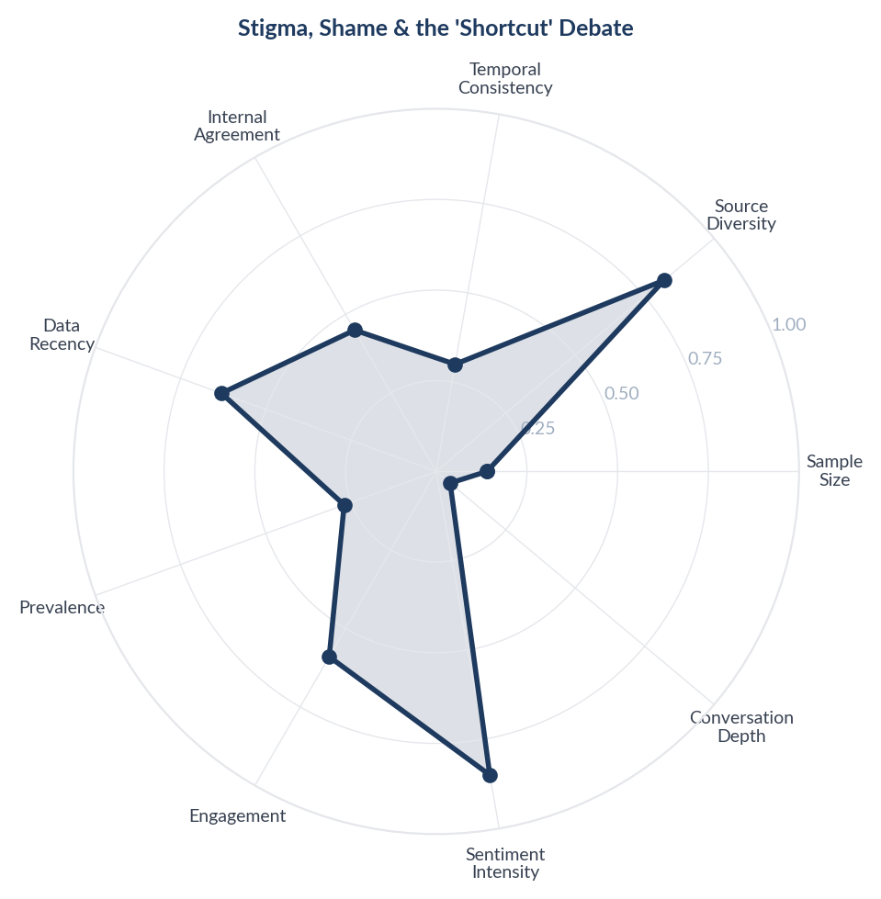
Score Breakdown: Stigma, Shame & the 'Shortcut' Debate

What the Data Shows
The 'shortcut' debate appears in 98 items (3.9% of corpus) with deeply mixed sentiment. Consumers are divided between those who view GLP-1 drugs as a legitimate medical tool ('is taking an antibiotic a shortcut for infection?') and those who frame it as moral failure ('lazy people who can not discipline themselves'). Body shaming and weight stigma permeate both sides. The debate intensifies when celebrities are involved - their perceived 'easy access' to drugs fuels resentment from consumers who struggle to afford or access the same medication.

What it Means
Indian consumers are caught between two cultural narratives about weight loss: the traditional 'discipline and willpower' narrative (reinforced by yoga culture, Ayurvedic traditions, and family pressure) and the emerging 'medical intervention is valid' narrative (supported by global medical consensus and GLP-1 clinical evidence). The shortcut debate is not really about drugs - it is about whether the Indian consumer gives themselves permission to seek help rather than suffer through willpower alone.

Business Implication & Rationale
The shortcut stigma is the invisible ceiling on GLP-1 adoption in India. Even consumers who want these drugs hesitate because of internalised shame - they have been told their entire lives that weight loss should come from discipline and willpower. The medical reframing (obesity as a metabolic condition, not a character flaw) has not yet reached mainstream Indian consciousness. Until this cultural barrier is addressed, a significant segment of potential users will suffer in silence rather than seek pharmaceutical help.

Recommendation
Reframe GLP-1 communication from 'weight loss drug' to 'metabolic health treatment' - this shifts the conversation from vanity to health. Create patient testimonial content that explicitly addresses the shame: 'I felt guilty about taking medication until my doctor explained that obesity is a disease, not a choice.' Partner with mental health professionals to address the psychological barriers to seeking treatment, not just the physical ones.

Further Validation
Conduct qualitative research (in-depth interviews) with Indian consumers who considered but did not start GLP-1 medication to understand the specific shame and stigma barriers. Measure whether medical reframing ('metabolic treatment' vs 'weight loss drug') changes willingness to adopt.

Representative Voices
"I’m soon to be 35 and have like 20 gray hairs in my beard total. I kinda wish I had more so it wasn’t just a few stragglers. I’m excited for the grays, not hiding from it.
Everyone is different, but personally, I’d never consider dying my beard." - reddit
"Please experiment as much as you want but take good care of your hair. Do research on that. This is the age for you to have fun. People will find some other reason to judge you so who cares!
I spent over a decade of my life colouring my hair in the most outrageous of colours and owned it!" - reddit
"IPL at home worked very very well for me (bikini + armpit + abdomen and hands). I only fo touchups every 3/4 months now.
I suppose your epilator might not depilate much now it's old, but rather cut the hair." - reddit

17. Stigma, Shame & the 'Shortcut' Debate
n=64 | Confidence: 47% (Directional) | Signal: 45% (Weak) | 1.5% of Dataset | NSS: +56%

Score Breakdown: Stigma, Shame & the 'Shortcut' Debate

What the Data Shows
The 'shortcut' debate appears in 98 items (3.9% of corpus) with deeply mixed sentiment. Consumers are divided between those who view GLP-1 drugs as a legitimate medical tool ('is taking an antibiotic a shortcut for infection?') and those who frame it as moral failure ('lazy people who can not discipline themselves'). Body shaming and weight stigma permeate both sides. The debate intensifies when celebrities are involved - their perceived 'easy access' to drugs fuels resentment from consumers who struggle to afford or access the same medication.

What it Means
Indian consumers are caught between two cultural narratives about weight loss: the traditional 'discipline and willpower' narrative (reinforced by yoga culture, Ayurvedic traditions, and family pressure) and the emerging 'medical intervention is valid' narrative (supported by global medical consensus and GLP-1 clinical evidence). The shortcut debate is not really about drugs - it is about whether the Indian consumer gives themselves permission to seek help rather than suffer through willpower alone.

Business Implication & Rationale
The shortcut stigma is the invisible ceiling on GLP-1 adoption in India. Even consumers who want these drugs hesitate because of internalised shame - they have been told their entire lives that weight loss should come from discipline and willpower. The medical reframing (obesity as a metabolic condition, not a character flaw) has not yet reached mainstream Indian consciousness. Until this cultural barrier is addressed, a significant segment of potential users will suffer in silence rather than seek pharmaceutical help.

Recommendation
Reframe GLP-1 communication from 'weight loss drug' to 'metabolic health treatment' - this shifts the conversation from vanity to health. Create patient testimonial content that explicitly addresses the shame: 'I felt guilty about taking medication until my doctor explained that obesity is a disease, not a choice.' Partner with mental health professionals to address the psychological barriers to seeking treatment, not just the physical ones.

Further Validation
Conduct qualitative research (in-depth interviews) with Indian consumers who considered but did not start GLP-1 medication to understand the specific shame and stigma barriers. Measure whether medical reframing ('metabolic treatment' vs 'weight loss drug') changes willingness to adopt.

Representative Voices
"I’m soon to be 35 and have like 20 gray hairs in my beard total. I kinda wish I had more so it wasn’t just a few stragglers. I’m excited for the grays, not hiding from it.
Everyone is different, but personally, I’d never consider dying my beard." - reddit
"Please experiment as much as you want but take good care of your hair. Do research on that. This is the age for you to have fun. People will find some other reason to judge you so who cares!
I spent over a decade of my life colouring my hair in the most outrageous of colours and owned it!" - reddit
"IPL at home worked very very well for me (bikini + armpit + abdomen and hands). I only fo touchups every 3/4 months now.
I suppose your epilator might not depilate much now it's old, but rather cut the hair." - reddit

18. Stigma, Shame & the 'Shortcut' Debate
n=64 | Confidence: 47% (Directional) | Signal: 45% (Weak) | 1.5% of Dataset | NSS: +56%

Score Breakdown: Stigma, Shame & the 'Shortcut' Debate

What the Data Shows
The 'shortcut' debate appears in 98 items (3.9% of corpus) with deeply mixed sentiment. Consumers are divided between those who view GLP-1 drugs as a legitimate medical tool ('is taking an antibiotic a shortcut for infection?') and those who frame it as moral failure ('lazy people who can not discipline themselves'). Body shaming and weight stigma permeate both sides. The debate intensifies when celebrities are involved - their perceived 'easy access' to drugs fuels resentment from consumers who struggle to afford or access the same medication.

What it Means
Indian consumers are caught between two cultural narratives about weight loss: the traditional 'discipline and willpower' narrative (reinforced by yoga culture, Ayurvedic traditions, and family pressure) and the emerging 'medical intervention is valid' narrative (supported by global medical consensus and GLP-1 clinical evidence). The shortcut debate is not really about drugs - it is about whether the Indian consumer gives themselves permission to seek help rather than suffer through willpower alone.

Business Implication & Rationale
The shortcut stigma is the invisible ceiling on GLP-1 adoption in India. Even consumers who want these drugs hesitate because of internalised shame - they have been told their entire lives that weight loss should come from discipline and willpower. The medical reframing (obesity as a metabolic condition, not a character flaw) has not yet reached mainstream Indian consciousness. Until this cultural barrier is addressed, a significant segment of potential users will suffer in silence rather than seek pharmaceutical help.

Recommendation
Reframe GLP-1 communication from 'weight loss drug' to 'metabolic health treatment' - this shifts the conversation from vanity to health. Create patient testimonial content that explicitly addresses the shame: 'I felt guilty about taking medication until my doctor explained that obesity is a disease, not a choice.' Partner with mental health professionals to address the psychological barriers to seeking treatment, not just the physical ones.

Further Validation
Conduct qualitative research (in-depth interviews) with Indian consumers who considered but did not start GLP-1 medication to understand the specific shame and stigma barriers. Measure whether medical reframing ('metabolic treatment' vs 'weight loss drug') changes willingness to adopt.

Representative Voices
"I’m soon to be 35 and have like 20 gray hairs in my beard total. I kinda wish I had more so it wasn’t just a few stragglers. I’m excited for the grays, not hiding from it.
Everyone is different, but personally, I’d never consider dying my beard." - reddit
"Please experiment as much as you want but take good care of your hair. Do research on that. This is the age for you to have fun. People will find some other reason to judge you so who cares!
I spent over a decade of my life colouring my hair in the most outrageous of colours and owned it!" - reddit
"IPL at home worked very very well for me (bikini + armpit + abdomen and hands). I only fo touchups every 3/4 months now.
I suppose your epilator might not depilate much now it's old, but rather cut the hair." - reddit

19. Bollywood & Celebrity Weight Loss Speculation
n=80 | Confidence: 44% (Directional) | Signal: 51% (Moderate) | 1.9% of Dataset | NSS: +48%
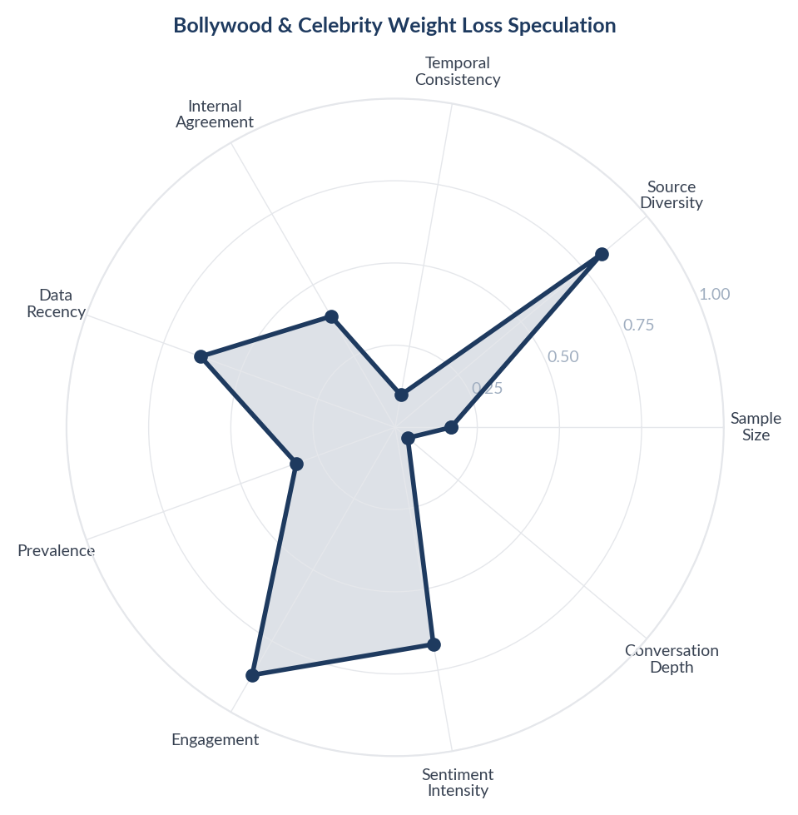
Score Breakdown: Bollywood & Celebrity Weight Loss Speculation

What the Data Shows
Celebrity weight loss speculation dominates 191 items (7.6% of corpus) across all 3 platforms with moderately positive sentiment. Reddit hosts heated debates about whether Karan Johar, Bhumi Pednekar, Kapil Sharma, and Vidya Balan used Ozempic. Instagram features celebrity-adjacent content (Bollywood diet routines, transformation reels). The dominant narrative is accusation - consumers believe most celebrity weight loss is drug-assisted and are frustrated by the lack of transparency.

What it Means
Bollywood celebrities have become the unwitting marketing vehicle for GLP-1 drugs in India - not through endorsement but through speculation. Every visible celebrity transformation triggers a cycle of 'definitely Ozempic' accusations, which simultaneously normalises awareness of these drugs and attaches stigma to using them. The Indian consumer has developed a sophisticated 'detection radar' for drug-assisted weight loss (sunken face, rapid timeline, lack of muscle definition) and applies it mercilessly to public figures. The paradox: celebrities who admit to Ozempic (like Oprah internationally) are respected for honesty, while those who deny it (most Bollywood) are mocked as dishonest.

Business Implication & Rationale
Celebrity weight loss is the single largest organic awareness driver for GLP-1 drugs in India, yet it operates entirely through suspicion rather than endorsement. This creates a unique brand challenge: the drugs are famous but carry a 'vanity' stigma. Any brand strategy that relies on traditional celebrity endorsement will backfire - the consumer already assumes celebrities use these drugs and will see paid endorsement as hypocritical confirmation.

Recommendation
Avoid celebrity endorsements for GLP-1 brands in India - the market has already priced in celebrity usage as assumed fact. Instead, create content addressing the transparency gap directly: 'Why people use GLP-1 and why that is okay.' Partner with celebrities who have been open about their methods (Tanmay Bhat, who is credited as genuinely working out) rather than those under suspicion. Use the Bollywood speculation as a cultural hook for educational content that redirects from gossip to science.

Further Validation
Track whether celebrity Ozempic speculation correlates with search volume spikes for GLP-1 drugs in India. Survey consumers on whether celebrity usage makes them more or less likely to consider these drugs themselves.

Representative Voices
"@kirawontmiss Sure - women do it with makeup, wigs, hair color, hair extensions, breast implants, BBLs, liposuction, heels, tanning booths, spray tans, Ozempic, bronzer, Botox, eyelashes, eyelash extensions, lip fillers, tummy tucks, facelifts, laser hair removal, etc." - twitter
"☀️: There are two advantages to bleaching my hair. First, this hair color gives me a slight celebrity-like effect. The second advantage is that since I have good healthy hair, when I have black hair, it looks composed. However, my straight hair lacks volume, which is why it tends to droop." - twitter
"The below is from ‘Expecting Better’ by Emily Oster. She cites a number of studies in that part, which she posits add up to it being OK to get your hair dyed.
1. Ibid.; Jennifer Connelly and Mark Malkin, “Environmental Risk Factors for Brain Tumors,” Current Neurology and Neuroscience Reports 7, no. 3 (2007): 208-14.
2. L." - reddit

20. Bollywood & Celebrity Weight Loss Speculation
n=80 | Confidence: 44% (Directional) | Signal: 51% (Moderate) | 1.9% of Dataset | NSS: +48%

Score Breakdown: Bollywood & Celebrity Weight Loss Speculation

What the Data Shows
Celebrity weight loss speculation dominates 191 items (7.6% of corpus) across all 3 platforms with moderately positive sentiment. Reddit hosts heated debates about whether Karan Johar, Bhumi Pednekar, Kapil Sharma, and Vidya Balan used Ozempic. Instagram features celebrity-adjacent content (Bollywood diet routines, transformation reels). The dominant narrative is accusation - consumers believe most celebrity weight loss is drug-assisted and are frustrated by the lack of transparency.

What it Means
Bollywood celebrities have become the unwitting marketing vehicle for GLP-1 drugs in India - not through endorsement but through speculation. Every visible celebrity transformation triggers a cycle of 'definitely Ozempic' accusations, which simultaneously normalises awareness of these drugs and attaches stigma to using them. The Indian consumer has developed a sophisticated 'detection radar' for drug-assisted weight loss (sunken face, rapid timeline, lack of muscle definition) and applies it mercilessly to public figures. The paradox: celebrities who admit to Ozempic (like Oprah internationally) are respected for honesty, while those who deny it (most Bollywood) are mocked as dishonest.

Business Implication & Rationale
Celebrity weight loss is the single largest organic awareness driver for GLP-1 drugs in India, yet it operates entirely through suspicion rather than endorsement. This creates a unique brand challenge: the drugs are famous but carry a 'vanity' stigma. Any brand strategy that relies on traditional celebrity endorsement will backfire - the consumer already assumes celebrities use these drugs and will see paid endorsement as hypocritical confirmation.

Recommendation
Avoid celebrity endorsements for GLP-1 brands in India - the market has already priced in celebrity usage as assumed fact. Instead, create content addressing the transparency gap directly: 'Why people use GLP-1 and why that is okay.' Partner with celebrities who have been open about their methods (Tanmay Bhat, who is credited as genuinely working out) rather than those under suspicion. Use the Bollywood speculation as a cultural hook for educational content that redirects from gossip to science.

Further Validation
Track whether celebrity Ozempic speculation correlates with search volume spikes for GLP-1 drugs in India. Survey consumers on whether celebrity usage makes them more or less likely to consider these drugs themselves.

Representative Voices
"@kirawontmiss Sure - women do it with makeup, wigs, hair color, hair extensions, breast implants, BBLs, liposuction, heels, tanning booths, spray tans, Ozempic, bronzer, Botox, eyelashes, eyelash extensions, lip fillers, tummy tucks, facelifts, laser hair removal, etc." - twitter
"☀️: There are two advantages to bleaching my hair. First, this hair color gives me a slight celebrity-like effect. The second advantage is that since I have good healthy hair, when I have black hair, it looks composed. However, my straight hair lacks volume, which is why it tends to droop." - twitter
"The below is from ‘Expecting Better’ by Emily Oster. She cites a number of studies in that part, which she posits add up to it being OK to get your hair dyed.
1. Ibid.; Jennifer Connelly and Mark Malkin, “Environmental Risk Factors for Brain Tumors,” Current Neurology and Neuroscience Reports 7, no. 3 (2007): 208-14.
2. L." - reddit

21. Bollywood & Celebrity Weight Loss Speculation
n=80 | Confidence: 44% (Directional) | Signal: 51% (Moderate) | 1.9% of Dataset | NSS: +48%

Score Breakdown: Bollywood & Celebrity Weight Loss Speculation

What the Data Shows
Celebrity weight loss speculation dominates 191 items (7.6% of corpus) across all 3 platforms with moderately positive sentiment. Reddit hosts heated debates about whether Karan Johar, Bhumi Pednekar, Kapil Sharma, and Vidya Balan used Ozempic. Instagram features celebrity-adjacent content (Bollywood diet routines, transformation reels). The dominant narrative is accusation - consumers believe most celebrity weight loss is drug-assisted and are frustrated by the lack of transparency.

What it Means
Bollywood celebrities have become the unwitting marketing vehicle for GLP-1 drugs in India - not through endorsement but through speculation. Every visible celebrity transformation triggers a cycle of 'definitely Ozempic' accusations, which simultaneously normalises awareness of these drugs and attaches stigma to using them. The Indian consumer has developed a sophisticated 'detection radar' for drug-assisted weight loss (sunken face, rapid timeline, lack of muscle definition) and applies it mercilessly to public figures. The paradox: celebrities who admit to Ozempic (like Oprah internationally) are respected for honesty, while those who deny it (most Bollywood) are mocked as dishonest.

Business Implication & Rationale
Celebrity weight loss is the single largest organic awareness driver for GLP-1 drugs in India, yet it operates entirely through suspicion rather than endorsement. This creates a unique brand challenge: the drugs are famous but carry a 'vanity' stigma. Any brand strategy that relies on traditional celebrity endorsement will backfire - the consumer already assumes celebrities use these drugs and will see paid endorsement as hypocritical confirmation.

Recommendation
Avoid celebrity endorsements for GLP-1 brands in India - the market has already priced in celebrity usage as assumed fact. Instead, create content addressing the transparency gap directly: 'Why people use GLP-1 and why that is okay.' Partner with celebrities who have been open about their methods (Tanmay Bhat, who is credited as genuinely working out) rather than those under suspicion. Use the Bollywood speculation as a cultural hook for educational content that redirects from gossip to science.

Further Validation
Track whether celebrity Ozempic speculation correlates with search volume spikes for GLP-1 drugs in India. Survey consumers on whether celebrity usage makes them more or less likely to consider these drugs themselves.

Representative Voices
"@kirawontmiss Sure - women do it with makeup, wigs, hair color, hair extensions, breast implants, BBLs, liposuction, heels, tanning booths, spray tans, Ozempic, bronzer, Botox, eyelashes, eyelash extensions, lip fillers, tummy tucks, facelifts, laser hair removal, etc." - twitter
"☀️: There are two advantages to bleaching my hair. First, this hair color gives me a slight celebrity-like effect. The second advantage is that since I have good healthy hair, when I have black hair, it looks composed. However, my straight hair lacks volume, which is why it tends to droop." - twitter
"The below is from ‘Expecting Better’ by Emily Oster. She cites a number of studies in that part, which she posits add up to it being OK to get your hair dyed.
1. Ibid.; Jennifer Connelly and Mark Malkin, “Environmental Risk Factors for Brain Tumors,” Current Neurology and Neuroscience Reports 7, no. 3 (2007): 208-14.
2. L." - reddit

Brand Health Score
Overall Brand Health Score: 81/100
Brand Health Score is a composite index built from five data-driven components. No subjective weighting is applied - all inputs are derived from the collected corpus.
Component | Score | Methodology
Sentiment Component (30%) | 69.4 | Derived from NSS across all items. Reflects the ratio of positive to negative consumer language.
Engagement Component (25%) | 99.3 | Average engagement (upvotes, likes, comments) normalised to platform benchmarks.
Advocacy Component (20%) | 100.0 | Proportion of items containing explicit recommendation or repurchase intent language.
Resilience Component (15%) | 80.5 | Sentiment consistency across platforms and time periods.
Conversation Component (10%) | 36.3 | Volume and depth of organic brand conversation (non-promotional threads).
Note: The Conversation Component (36/100) is the lowest-scoring factor. This reflects that most brand mentions occur in reaction to advertising, campaigns, and celebrity content rather than unprompted consumer-initiated discussion. Organic brand conversation is thin relative to engagement volume - a pattern consistent with a brand consumers transact with rather than one they actively champion.

Methodology

Pipeline Overview
- Stage 0 - Brief Structured research brief defines brand, competitors, geography, business objectives, and keyword seed list.
- Stage 1 - Collect Automated collection across Amazon, Instagram, Reddit, Twitter, Youtube. Engagement-minimum filters applied at collection time.
- Stage 2 - Normalize Thread-level deduplication (comments capped per thread). Deterministic SHA-256 item IDs prevent re-collection of duplicates across runs.
- Stage 3 - Filter LLM relevance classification (claude-sonnet-4-20250514). Each item classified as relevant/irrelevant with a reason. Multilingual support enabled.
- Stage 4 - Analyze Sentiment (positive/negative/neutral/mixed) + Plutchik 8-emotion classification in a single LLM call. ABSA: per-aspect sentiment extracted. Two-pass theme extraction: (a) discovery on stratified sample to identify candidate themes; (b) full-corpus mapping of all items to themes in batches.
- Stage 5 - Synthesize One insight per theme, mandated by prompt. Insight structure: Observation - Insight - Implication - Recommendation - Further Validation.
- Stage 6 - Score Fully data-driven scoring. Confidence: 5 factors (sample size, source diversity, temporal consistency, internal agreement, data recency). Signal Strength: 4 factors (prevalence, engagement, sentiment intensity, conversation depth). Brand Health Score: 5 components.
- Stage 7 - Report Google Doc-compatible DOCX with inline charts, block-quoted verbatims, and full data tables.

Scoring Formulas

Confidence Score
Confidence = (sample_size x 0.25) + (source_diversity x 0.25) + (temporal_consistency x 0.15) + (internal_agreement x 0.2) + (data_recency x 0.15)

Signal Strength Score
Signal = (prevalence x 0.35) + (engagement x 0.3) + (sentiment_intensity x 0.2) + (conversation_depth x 0.15)

Net Sentiment Score (NSS)
NSS = (positive_count - negative_count) / total_count. Range -1.0 to +1.0. Industry standard: Brandwatch, Sprinklr, YouGov.

Quality Gates
- Grounded (≥3 sources cited)
- Non-obvious (not derivable from common knowledge)
- Actionable (leads to a concrete business decision)
- Specific (not vague platitude)
- Falsifiable (could be proven wrong with additional data)

Data Provenance
All data is sourced from publicly available online conversations. No personally identifiable information (PII) is stored or reported.
Source | Content Type | Access Method | Items in Corpus
Amazon | Product reviews | Web scraping | 1,952
Twitter / X | Tweets, replies, quote tweets | Platform API / external collection | 1,039
YouTube | Video descriptions, comments | YouTube Data API v3 | 862
Reddit | Forum discussions, comments | Public JSON API | 375
Instagram | Posts, reels, comments | Platform API / external collection | 86
Corpus composition: 2,040 posts and 322 comments and 1,952 other items. Each comment is treated as an independent item linked to its parent post for thread-level analysis.

Geographic Coverage
Primary: India. Content selected and filtered for relevance to the India market context. Items originating from other geographies are retained where they contribute relevant consumer perspective (e.g., diaspora experiences, cross-market comparisons).

Temporal Coverage
Data range: Jun 2016 - Jan 2026 (114 months). Items span the full collection period with no temporal exclusion applied at normalization.

Demographic Accuracy
This methodology explicitly documents platform-level composition so that interpretation accounts for known biases: Twitter/X skews male, urban, politically engaged, and 25-44; high-follower accounts dominate visibility while ordinary consumer voices are underrepresented; YouTube is more balanced across gender but skews younger audiences; creator content dominates over consumer discussion; Amazon reviews skew toward verified purchasers but demographics are unknown; Instagram skews female, urban, and 18-34 with strong influencer and health-creator content that shapes but does not represent consumer opinion; Reddit skews male, urban, and 18-34. These biases are documented rather than hidden. For verified demographic breakdowns, commission a structured survey targeted to the same research questions, using this report's insights as the stimulus.

