**COLIN BARLOW RIA FOUNDATION (CBR)**

***“Empowering Communities”***

**ANNUAL REPORT 2023**

**INTRODUCING The COLIN BARLOW RIA FOUNDATION (CBR)**

The ***Colin Barlow Ria Foundation (CBR)*** is an Indonesian based not for profit organisation, inspired by the **Nusa Tenggara Association (NTA),** ACT, Australia (https://www.nta.org.au/), established by the late Dr Colin Barlow, in 1992 alongside Dr Ria Gondowarsito to support poverty alleviation in the rural areas of Eastern Indonesia’s poorest province, Nusa Tenggara Timur (NTT). In response to the late Colin Barlow’s wish, the CBR was officially established in **March 2023,** with activities starting from January in Atambua, the capital of Belu District, NTT, as the CBR’s Headquarters.

**MISSION AND VISION**

Poverty alleviation through community initiatives and innovations, for and by the people in the sanitation, education, and agriculture sectors.

**PROJECT AREAS OF THE CBR**

The Districts of **Belu**, **Malaka**, and **North Central Timor (TTU)** cover the project activities, through their town capitals as follows (***see map***)

**a.Atambua** of Belu, is about 20 km from the border of ***Timor L’Este (TLE).*** The influx of TLE refugees started in 1999 which quickly made Atambua a big town, the second largest on West Timor behind Kupang, and the fourth largest in NTT.

**b. Betun**, borders with Belu District in the northern part, with TTU and TTS on the western part. In the southern part Malaka borders with the Timor Sea and on the eastern part, with TLE and therefore also recipient of TLE refugees.

**c.Kefamenanu,** the capital of North Central Timor (***TTU in Indonesian***), borders with the enclave of TLE in Oekusi/Ambeno. The city hosts less TLE refugees except in the areas closest to the TLE border. Its topography consists of both mountainous and flat areas.

All the three Districts above are recipients of TLE Refugees, where Roman Catholics represent around 90% of the population, with Protestant, Muslim, Hindu, and Buddhist as the minority religions.

The average daily income is approximately AUD2.00 per day. Rainy months are from December to March, with a total of around 140 days, with temperatures ranging from 21C to 35C.

**Priority areas and entry point.** The project started in the village of Haliwen which is among the poorest villages near Atambua town in the District of Belu. Haliwen is located by the airport and is a centre that hosts TLE refugees. Provincial and local governments offered refugees titles to parcels of land that have limited to no access to public water infrastructure.

With the initial success in building water tanks in Haliwen (Belu District), CBR has identified several locations in dire need of water in the neighbouring Districts of TTU and Malaka. The entry point is not limited to distributing the 15,000 Lt ferro-cement water tanks, but above all, the **transfer of technology** to all beneficiaries in surrounding villages.

1. **Rationale of the project activities**

The community-driven development approach has been successfully implemented in the communities of Atambua in Belu, Betun in Malaka and Kefamenanu in TTU to improve their living standards by building on their social capital, their traditions of self-help support and their strong relationships based on affinity, mutual trust, and accountability. CBR intends to replicate them in the above-mentioned three Districts, beyond their town capitals.

**Access to water**. CBR initiated by helping people invest on what would make an immediate difference in their lives which is improving their access to clean water supply. The lack of access to clean water is responsible for the high incidence of water borne diseases, child malnutrition, underweight, stunting and mortality that are twice the national average. All these three districts are extremely dry due to lack of rain for 7-9 months.

During the dry season, people rely on river springs and a limited number of wells. These water sources dry up quickly. As a temporary measure, people dig 1.5 m to obtain naturally filtrated water from the side of the river. This is a short-term solution for water supply. When all water sources are consumed, people resort to purchase water that fill their 20 litres containers for IDR5,000 per day for survival.

**PROJECT AREAS OF COLIN BARLOW RIA FOUNDATION**

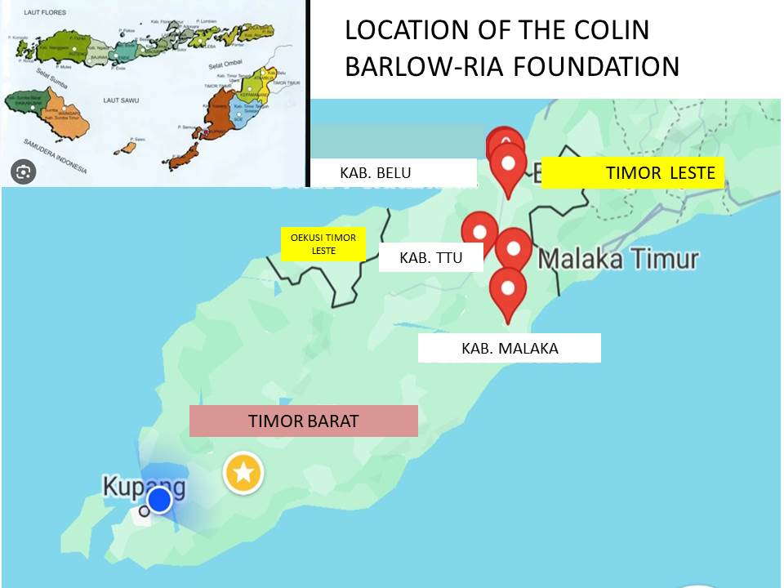

1. **Proposed approach**

CBR’s field assessments have indicated that,

**(1)** there is clearly the genuine need and strong demand for water.

**(2)** the network of solidarity among and within groups, mutual support and cooperation is widespread amongst the target beneficiaries;

**(3)** both the local church and government are capable of strong leadership and social mobilisation in favour of the project; and

**(4)** there is considerable affinity and homogeneity amongst the beneficiaries – a fact that will facilitate cooperation and the establishment of relationship of fruitful collaboration under the project.

For this reason, our proposal is to engage the local population in a project starting with 15,000Lt ferro cement water tanks – constructed above and below ground *-* with expertise offered initially by a technical advisor of the NTA-Indonesia, until the beneficiaries are self-reliant and competent in creating the water tanks autonomously. The quality standards that the facilitators will train the communities on will comply with the SPHERE standards, and respond to the humanitarian needs of the people, and ensure the respect of their basic human rights and dignity.

1. **Project management**

The Foundation comprises of Rev. John Naihati, SVD, as the CBR Head who oversees all the project activities, Dr. Yulianes Hosang Evert, as the CBR Deputy Head and Agriculture Specialist, Aloysius Noya, as the Technical Coordinator, and Hubertina Niat as the Administrative Officer.

Overall activities are under the guidance of Dr Ria Gondowarsito as chairperson from Australia, who is responsible for funding, regularly supervised by an in-country Indonesian - Kupang and Atambua based Board comprising of Agriculture, Livestock, Education, and Water & Sanitation Specialists. Board Members and donors from Australia visit the project locations as a team twice yearly, in March and September, especially during the dry season, with regular updates through various communication means and the Foundation’s Annual Report.

Devoted Community Facilitators have been identified in all three districts. They support communities in the establishment of the water tanks, who are familiar with the community structures that will oversee the upscaling of project activities in the future. Due to the urgent water needs, people are extremely keen to mobilise and organise the construction of their own water tanks and assist their neighbours as an expression of gratitude for the help they provided when it was their turn. This system has revealed particularly effective in terms of social mobilisation in the target areas.

1. **Achievements in 2023**

By December 2023, the CBR has delivered **36** (thirty-six) **15,000 Lt ferro cement water tanks**, in all three districts, namely: ***28 in Atambua***, ***4 in Melaka****,* and ***4 in TTU***, as pilot projects in preparation for the effective future scaling-up of several sustainable initiatives. These have been responsibly facilitated by the CBR Head and the Technical Coordinator throughout the Districts of Belu, Melaka, and TTU.

In cooperation with the Local Education Department and a reputable NTT trainer from the Universitas Kristen of Kupang, the first two-day of Elementary School Teacher’s Training took place in October 2023, in Atambua. This covered character forming and the use of multimedia for teaching and learning.

All this was made possible owed to the donations received from Melbourne. Rome and Jakarta. CBR distributed materials to families who offer their labour and participate in building the 15,000 Lt ferro-cement water tanks. On average one tank takes 5-7 days to build, inclusive of the initial training. Beneficiaries collect local materials and digging holes where the tanks will be established in anticipation of the tank distribution. At the end of the construction, the project provides agricultural extension services and relevant training to maximise the benefits that the tank recipients obtain from their tanks.

1. **Future activities**

Based on experience, the demand for sanitation will arise after water tanks are installed and CBR will respond to this demand by fielding an assessment on the most appropriate sanitation systems that the communities are able to manage, aligning with GEDSI (Gender Equality, Disability and Social Inclusion) guidelines. This will lead to the preparation of a separate project proposal relating to the sanitation component solely, with communities contributing their labour and local materials as required.

As a rule, most new projects comprise multiple small segments that are finite outputs per se such as the pig enterprise which is planned for implementation in the next 3 years, each revolving around the establishment of single pig pens. This approach, we found the most appropriate one to the development context in NTT which relies on the organisation capacities of tiny farm family units. This also allows donors a wide choice in terms of size and type of project to be supported.

It is anticipated that CBR will prioritize on building water tanks in the next two years. To magnify the impact of the water tanks, the Project will support communities in adapting their agricultural and livestock rearing practices to climate change, to ensure they are drought resilient and apply nature-based solutions wherever possible. This will increase the resilience and sustainability of their livelihood systems and decrease their exposure to shocks and crises, thus their vulnerability to adverse weather events and other natural disasters.

Field assessments have verified the need for 2,400 water tanks in the districts of Belu, Malaka and North Central Timor which is expected to take between 2 and 3 years. Besides water tanks the CBR intends to initiate other activities in the sectors of agriculture, livestock rearing and education.