Address

<https://www.w3schools.com/tags/tag_address.asp>

Background Image – fixed position -CSS

<https://www.w3schools.com/css/css_background.asp>

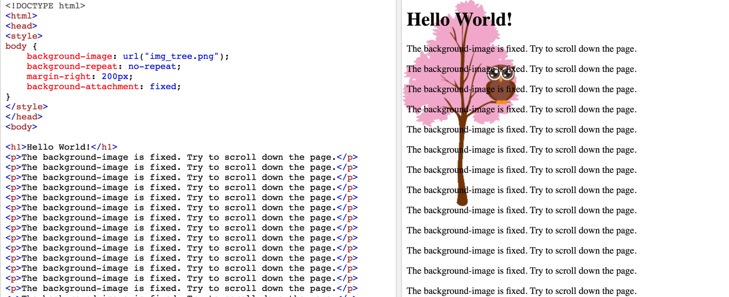

background image – margin between text and image

<https://www.w3schools.com/css/tryit.asp?filename=trycss_background_shorthand>

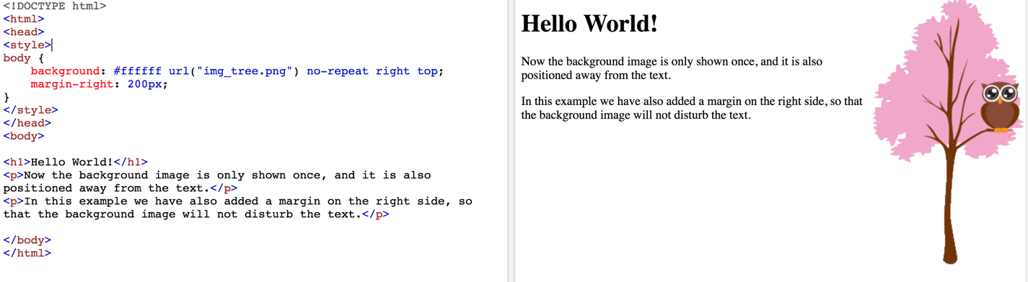

Menu—horizontal lists

https://www.w3schools.com/html/html_lists.asp

<https://www.w3schools.com/html/tryit.asp?filename=tryhtml_lists_menu>

<http://www.runoob.com/try/try.php?filename=trycss_float5>

<http://www.runoob.com/try/try.php?filename=trycss_navbar_horizontal_float_advanced>

<https://c.runoob.com/codedemo/3165>

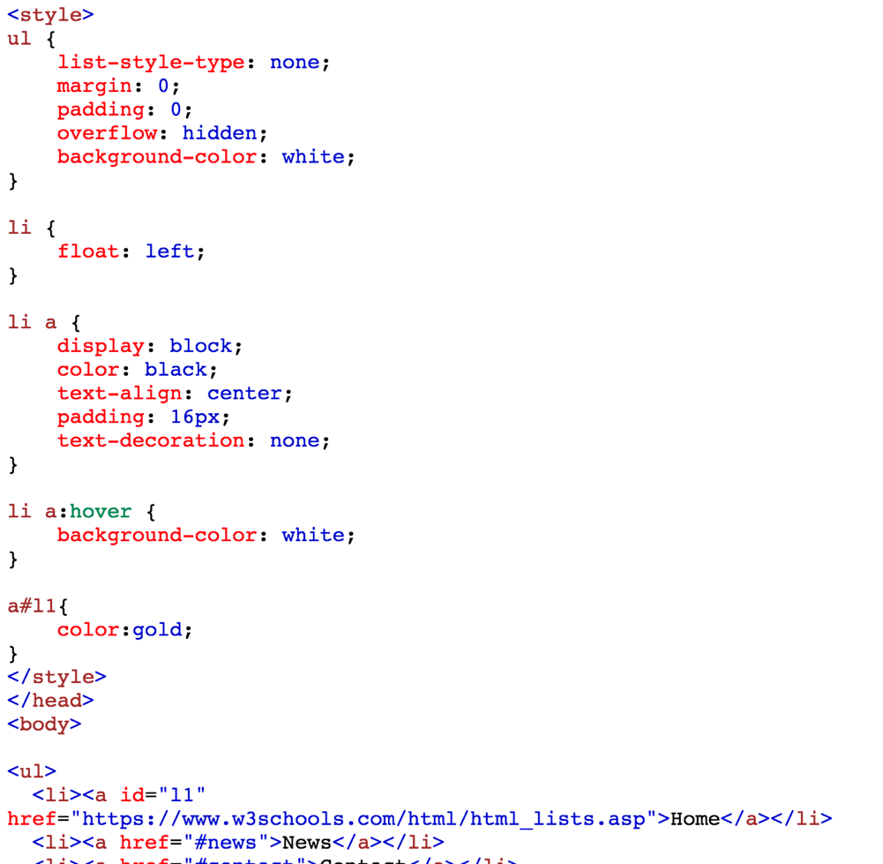

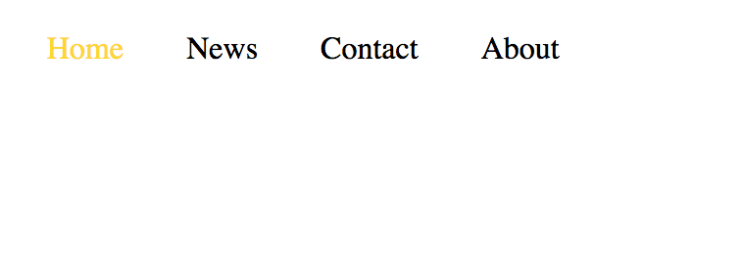

问题：一旦有div剧中后，如何修改左右边界的问题

Sample 网页

<http://www.runoob.com/try/try.php?filename=trycss_float6>