Statistics

Correlation- corr-
Correlation means how the two variables are moving together.
Positive correlation means if the both variables are go up or down together
Say for example, Ice cream sales and the hot weather, both will be increasing together
Negative correlation means one variable goes up and the other one will go down,
Say for example, Play time increases and study hours, if play time increases then study hours will decrease.
No Correlation Means No links between those variables,
Show size and the IQ level

Co-efficient- eff-
Correlation co-efficient means how much these variables strongly together
It will be a numeric value measured from minus 1 to plus 1 ( -1 to +1)
Range: Always between -1.0 (perfect negative) and +1.0 (perfect positive).
Value close to 0: Weak or no linear correlation (e.g., 0.1).
Value close to +1: Strong positive correlation (e.g., 0.9).
Value close to -1: Strong negative correlation (e.g., -0.8).
Answers: "Exactly how strong and in what direction is that relationship?"

Variance- Var-
Variance measures how far data points spread out from their average (mean) value.

Median- Med-
Median is a middle value of the arranged order dataset.

Regression- Reg-
Regression is a method to find a best fit of the line or curve through data points to understand how one variable affect the other variable.

Regression is useful to
✔ Make predictions – like future sales, stock prices, temperature, etc.
✔ Understand relationships – like how salary depends on experience.
✔ Measure impact – like how much marketing spend increases sales.
✔ Forecast trends – like business growth over time.
✔ Support decisions – helps bankers, business owners, doctors, and engineers make better decisions using data.

Machine Learning
- Supervised vs Unsupervised Learning.
- Regression & Classification (demo in Python).
- Overfitting, Regularization basics.
- Evaluation metrics (Accuracy, Precision, Recall, F1).

ML Data types
Category | Type | Description | Example | Math Operations | Graph
Qualitative | Nominal | Names only | Gender, City | ❌ None | Bar / Pie
Qualitative | Ordinal | Ordered categories | Rating, Education | ➖ Rank, Median | Ordered Bar
Quantitative | Interval | Equal gaps, no true zero | Temperature (°C), Year | ➕ ➖ Only | Histogram / Line
Quantitative | Ratio | Equal gaps, true zero | Age, Salary, Weight | ➕ ➖ ✖️ ➗ | Histogram / Scatter

Supervised sup- vs Unsupervised usup- un- Learning
Supervised learning maps inputs to a known target using labeled data—for example, predicting loan default or customer churn using past outcomes; we evaluate with metrics like F1 or AUC.
Learn from labeled examples to predict a target (y).
Unsupervised learning finds structure without labels—like clustering customers, detecting anomalies, or reducing dimensions with PCA; we judge it using silhouette score and, importantly, business interpretability.
Learn from unlabeled data to discover structure/patterns (no y).
I use Supervised when a labeled target exists and I need predictions; Unsupervised when I’m exploring data or building segments/features to feed into supervised models.
Term | Data Format | Example Row
Supervised | Features (X) + label/target (y) | age=42, income=₹80k, tenure=2 yrs → default=Yes
Unsupervised | Only features (X), no label | age=42, income=₹80k, tenure=2 yrs

• Supervised: “Show me inputs + the correct answer; I’ll learn to map X → y.”
• Classification (predict categories): Logistic Regression, Random Forest, XGBoost, SVM, Neural Nets.
• Regression (predict numbers): Linear/Elastic Net, Random Forest Regressor, XGBoost Regressor.

• Unsupervised: “I only have inputs; I’ll group, compress, or spot oddballs.”
• Clustering (group similar items): K-Means, Hierarchical, DBSCAN.
• Dimensionality Reduction (compress features): PCA, t-SNE/UMAP (for visualization).
• Anomaly/Outlier Detection: Isolation Forest, One-Class SVM, LOF.
• Association Rules: Apriori, FP-Growth (market-basket).

• Do you have a target column today?
If YES then, it’s a Supervised.
If NO then, it’s an Unsupervised (to explore, cluster, reduce dimensions, or find anomalies).
• Is the goal prediction for each future record? It is Supervised.
• Is the goal insight/structure (segments, patterns, outliers)? It is Unsupervised.
• Want both? Start with Unsupervised (EDA/segments), then build Supervised models per segment.

Reinforcement Learning
Reinforcement Learning is a trial-and-error learning process where a machine (agent) learns by interacting with an environment and getting rewards or penalties for its actions.

Credit Card Fraud Detection using Reinforcement Learning

Problem:
A bank wants to block fraudulent transactions automatically —
but also avoid blocking genuine users by mistake (which causes customer complaints).
Traditional models (like Logistic Regression or Random Forest) use fixed historical patterns —
but fraudsters keep changing their tricks.
👉 So the bank applies Reinforcement Learning —
the model learns dynamically which actions lead to better results (fraud blocked, customer safe).

Steps in the RL
Step | Description
Agent | Fraud detection AI system
Environment | Live transaction system
Action | Approve or Block a transaction
State | Transaction details (amount, location, device, time, user history)
Reward | +10 for correctly blocking fraud, -20 for wrongly blocking a good user, +5 for correctly approving good user, -10 for missing a fraud

Before RL data looks like
Transaction_ID | Amount | Location | Time | Device | Actual_Label | Predicted_Action | Result
TXN001 | 1000 | Chennai | 10:30 PM | Mobile | Fraud | Approved | ❌ Missed fraud
TXN002 | 200 | Delhi | 11:00 AM | Laptop | Genuine | Blocked | ❌ Bad customer experience
TXN003 | 5000 | Mumbai | 02:00 AM | Mobile | Fraud | Blocked | ✅ Correct decision
TXN004 | 300 | Chennai | 09:00 AM | Laptop | Genuine | Approved | ✅ Correct decision

Problems before RL:
- Model uses static rules (like “amount > ₹2000 → block”)
- Misses new fraud patterns
- Blocks genuine users wrongly

Reinforcement Learning Applied
- Now, we train an RL Agent (say using Deep Q-Learning):
- It interacts with transactions one by one.
- Each time it decides to Block/Approve, it gets a Reward.
Over time, it learns the best decision pattern.
Example
Action | Actual Result | Reward
Block Fraud | ✅ Correct | +10
Block Genuine | ❌ Wrong | -20
Approve Genuine | ✅ Correct | +5
Approve Fraud | ❌ Wrong | -10

Transaction_ID | Amount | Location | Time | Device | Actual_Label | Predicted_Action | Reward | Result
TXN001 | 1000 | Chennai | 10:30 PM | Mobile | Fraud | Blocked | +10 | ✅ Correct
TXN002 | 200 | Delhi | 11:00 AM | Laptop | Genuine | Approved | +5 | ✅ Correct
TXN003 | 5000 | Mumbai | 02:00 AM | Mobile | Fraud | Blocked | +10 | ✅ Correct
TXN004 | 300 | Chennai | 09:00 AM | Laptop | Genuine | Approved | +5 | ✅ Correct

Improvement:
- Fraud detection accuracy increased
- Customer complaints decreased
- Model adapts to new fraud patterns automatically
Metric | Before RL | After RL | Improvement
Accuracy | 88% | 96% | ✅ +8%
False Positive Rate (blocked genuine) | 6% | 2% | ✅ Less complaints
Fraud Missed (False Negatives) | 4% | 1% | ✅ More frauds caught

Why RL Works Better Here
- RL learns from experience, not just fixed past data.
- It adapts to new fraud tricks automatically.
- The reward system teaches it to find the balance between catching fraud and not annoying customers.

Supervised Learning → Learn from labeled data
Unsupervised Learning → Find patterns
Reinforcement Learning → Learn from experience (reward/punishment)

Regression
Regression is a method in Machine Learning and Statistics used to predict a number based on previous data.
It finds a relationship between input values and output values.
Example:
If you want to predict house price based on size, location, and number of rooms, you can use regression.

Why is Regression Needed?

Regression is useful because it helps us:
✔ Make predictions – like future sales, stock prices, temperature, etc.
✔ Understand relationships – like how salary depends on experience.
✔ Measure impact – like how much marketing spend increases sales.
✔ Forecast trends – like business growth over time.
✔ Support decisions – helps bankers, business owners, doctors, and engineers make better decisions using data.

Without Regression, What Will Happen?
If we do not use regression:
❌ We can’t predict future values from data
❌ We will depend only on guesswork
❌ Hard to find relationships between variables
❌ No data-based decisions in business or research
❌ Trends and patterns in data will be missed

Final Simple Meaning
Regression = Prediction + Relationship Finding
It helps us use past data to predict future values and understand how things are connected.

Regression Types
• Simple Linear Regression
• Multiple Linear Regression
• Polynomial Regression
• Ridge Regression (L2 Regularization)
• Lasso Regression (L1 Regularization)
• Elastic Net Regression
• Logistic Regression
• Quantile Regression
• Support Vector Regression (SVR)
• Decision Tree Regression
• Random Forest Regression
• XGBoost Regression
• Bayesian Regression
• Poisson Regression
• Robust Regression

Linear Regression.
Simple Linear and Multi Linear
Relationship between variables: It assumes a linear relationship, meaning a change in one variable (the independent variable) corresponds to a consistent change in the other (the dependent variable).

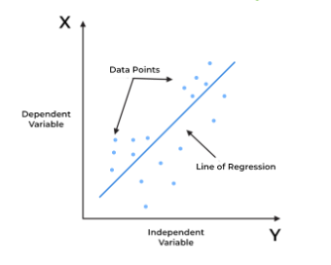

Simple Linear Regression
uses a single independent variable to predict the value of a dependent variable through a straight-line relationship
It assumes that there is a linear relationship between the input and output, meaning the output changes at a constant rate as the input changes. This relationship is represented by a straight line.
For example, we want to predict a student's exam score based on how many hours they studied. We observe that as students study more hours, their scores go up. In the example of predicting exam scores based on hours studied. Here
Independent variable (input): Hours studied because it's the factor we control or observe.
Dependent variable (output): Exam score because it depends on how many hours were studied.

Multi linear Regression
Multiple linear regression allows us to analyze relationship between multiple independent variables and a single dependent variable.
Real Estate Pricing: In real estate MLR is used to predict property prices based on multiple factors such as location, size, number of bedrooms, etc. This helps buyers and sellers understand market trends and set competitive prices.
Financial Forecasting: Financial analysts use MLR to predict stock prices or economic indicators based on multiple influencing factors such as interest rates, inflation rates and market trends. This enables better investment strategies and risk management24.
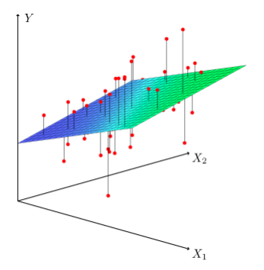

Polynomial Regression

Polynomial Regression is a type of regression where the relationship between X and Y is not a straight line, but a curve.
It’s basically an extended version of Linear Regression.
Age (X) | Income (Y)
18 | 5,000
25 | 25,000
35 | 60,000
45 | 70,000
55 | 50,000
65 | 20,000

You can see income increases up to a certain age (45),
and then decreases — so it’s curved, not straight.
Linear regression would try to draw a straight line, which misses the pattern.
Polynomial regression will draw a curved line (U or ∩ shape) that fits better.
Examples, Age vs Income, Speed vs Mileage, Temperature vs Performance
Overfitting
• When we increase the degree of the polynomial, the model starts drawing very wiggly curves.
• It tries to pass through every single data point, even the noise or random fluctuations.
• It fits your training data perfectly, but it fails badly on new/unseen data.

X | Y
1 | 2
2 | 4
3 | 6
4 | 5
5 | 7

Degree | Curve type | Behavior
1 (Linear) | Straight line | Underfits (too simple)
2 (Quadratic) | Gentle curve | Good fit
10 (High degree) | Wiggly snake-like curve | Overfits (too complex)

How to Avoid Overfitting in Polynomial Regression
Use Cross-Validation – check model on unseen data.
Choose optimal degree – start with degree=2 or 3; don’t just increase blindly.
Regularization (Ridge / Lasso) – add penalties for large coefficients.
Visualize curve – if it’s too wiggly, it’s probably overfitting.

What Is Regularization?
- Regularization is a technique used to avoid overfitting in regression models.
- It adds a penalty to the model when the coefficients become too large.
- This keeps the model simpler and more stable, especially when you have many correlated or noisy features.

Ridge Regression (L2 Regularization)
- Ridge Regression adds a L2 penalty = sum of squares of coefficients to the cost function.
- It shrinks all coefficients towards zero but never makes them exactly zero.

When to Use Ridge
Situation | Reason
Many correlated features | Ridge distributes weight across them
You don’t want to drop features | Keeps all features, just reduces their effect
Slight overfitting problem | Makes the model smoother and generalizes better

Example – Predicting House Price
Feature | Description
X1 | Size (sqft)
X2 | Number of bedrooms
X3 | Distance to city center
X4 | Age of house

⚙️ Before Ridge (Normal Linear Regression)
- Price = 50 + 90X1 + 30X2 - 40X3 + 25X4
- Some coefficients (like -40, +90) are too high → model is unstable → overfitting.

⚙️ After Ridge (L2 Regularization)
- Price = 52 + 75X1 + 20X2 - 25X3 + 15X4
- Coefficients became smaller, but none are zero —
Ridge keeps all features but reduces their strength to avoid overfitting.

📈 Effect Summary
Metric | Before | After Ridge
Training accuracy | 98% | 93%
Test accuracy | 70% | 88%
Overfitting | High | Reduced
Features used | 4 | 4 (none removed)

Lasso Regression (L1 Regularization)
- Lasso Regression adds a L1 penalty = sum of absolute values of coefficients to the cost function.
- It can shrink some coefficients exactly to 0 — performing feature selection automatically.

When to Use Lasso
Situation | Reason
You have many features | Lasso removes unimportant ones
You want simple, interpretable models | Keeps only useful predictors
There’s risk of overfitting | Helps by reducing complexity

Example – Predicting Diabetes Risk
Feature | Description
X1 | Age
X2 | BMI
X3 | Blood Pressure
X4 | Exercise Time
X5 | Junk Food Intake
X6 | Sleep Hours

Before Lasso (Normal Linear Regression)
RiskScore = 5 + 0.9X1 + 2.3X2 + 0.6X3 - 0.1X4 + 0.8X5 - 0.05X6
All features are used → model over fits slightly, even small ones like Sleep Hours get weight.

After Lasso (L1 Regularization)
RiskScore = 5 + 0.8X1 + 2.0X2 + 0.5X3 - 0.1X4 + 0.7X5 + 0X6
- Coefficient for Sleep Hours (X6) became 0
- Lasso automatically removed the least useful feature.

Effect Summary
Metric | Before | After Lasso
Training accuracy | 97% | 91%
Test accuracy | 72% | 90%
Overfitting | High | Reduced
Features used | 6 | 5 (1 dropped)

🧮 Side-by-Side Comparison
Feature | Ridge (L2) | Lasso (L1)
Penalty | Squares of coefficients (w²) | Absolute values (
Coefficients | Shrunk but not zero | Some become exactly zero
Feature Selection | ❌ No | ✅ Yes
Use Case | Keep all features but reduce overfitting | Drop useless features and simplify model
Typical Output | Smaller weights | Sparse (few non-zero weights)
sklearn Model | Ridge(alpha=λ) | Lasso(alpha=λ)

Real-World Analogy
Concept | Example
Ridge | Like turning down the volume on all instruments slightly 🎵
Lasso | Like muting the instruments that don’t add value 🎶

Quick Recap Box
Regression Type | Penalty Type | Key Use | Result
Ridge (L2) | Sum of squares | Reduce overfitting but keep all variables | Smaller coefficients
Lasso (L1) | Sum of absolute values | Reduce overfitting + drop useless variables | Some coefficients = 0

Top of Form

Elastic Net Regression
- Elastic Net Regression is a type of Regularized Linear Regression that combines both Lasso (L1) and Ridge (L2) penalties.
- It gives you the best of both worlds —
- Lasso’s ability to remove useless features, and
- Ridge’s ability to handle correlated variables.
- Elastic Net = Lasso + Ridge
It both shrinks coefficients and sets some of them to zero.
Situation | Why Elastic Net helps
You have many correlated features | Lasso alone might randomly drop one; Elastic Net balances it
You have more features than observations | Handles high-dimensional data better
You want feature selection + stability | Keeps model both simple and reliable
Data is noisy or multi-collinear | Handles both situations gracefully

Example — Predicting Car Price

Feature | Description
X1 | Engine size
X2 | Horsepower
X3 | Weight
X4 | Mileage
X5 | Car age
X6 | Number of seats

❌ Problems:
- High correlation between Engine size and Horsepower
- Model gives both large coefficients → unstable predictions (overfitting)
- Some small features like Seats add little value

Before Elastic Net
Car | Engine (L) | HorsePower (HP) | Weight (kg) | Mileage (km/l) | Age (yrs) | Seats | Actual Price (lakhs)
C1 | 2.0 | 140 | 1100 | 18 | 2 | 5 | 9.0
C2 | 3.0 | 200 | 1500 | 15 | 4 | 5 | 12.0
C3 | 1.5 | 100 | 1000 | 22 | 1 | 5 | 7.5
C4 | 2.5 | 160 | 1300 | 16 | 3 | 5 | 10.5
C5 | 1.8 | 120 | 1050 | 20 | 2 | 5 | 8.0

Goal is as Predict car price using technical features such as Engine, HP, Weight, Mileage, Age, and Seats.

Model 1 – Simple Linear Regression (Before Regularization)
Equation:
Price = 3 + 2.5(Engine) + 1.8(HP) - 1.6(Weight) - 0.5(Mileage) - 0.1(Age) + 0.3(Seats)

What happens here:
- The model gives large weights to Engine & HP because they correlate with price.
- It fits the training data perfectly but overfits — it memorizes instead of generalizing.
- Predictions swing too high or too low on new data.
Car | Actual Price | Pred (Before) | Error (Actual – Pred) | Comment
C1 | 9.0 | 8.2 | +0.8 | Slight under-prediction
C2 | 12.0 | 14.5 | −2.5 | Over-prediction
C3 | 7.5 | 6.0 | +1.5 | Under-prediction
C4 | 10.5 | 13.8 | −3.3 | Big over-prediction
C5 | 8.0 | 6.7 | +1.3 | Under-prediction

- Model = Overfitted (big swings)
- Training Accuracy ≈ 97%, Test Accuracy ≈ 70%.
- L2 (Ridge) effect: shrinks large coefficients (prevents overfitting).
- L1 (Lasso) effect: pushes some coefficients to 0 (removes unimportant features).
- Balances feature selection and coefficient stability.

Model 2 – After Elastic Net
New Equation:
Price = 3.2 + 1.9(Engine) + 1.3(HP) - 1.0(Weight) - 0.4(Mileage) - 0.05(Age) + 0(Seats)

What changed:

Feature | Before Weight | After Weight | What Happened
Engine | +2.5 | +1.9 | Reduced → less sensitive
HP | +1.8 | +1.3 | Reduced → balanced correlation
Weight | −1.6 | −1.0 | Smoothed
Mileage | −0.5 | −0.4 | Slightly reduced
Age | −0.1 | −0.05 | Almost zero
Seats | +0.3 | 0 | Feature removed (not useful)

Output – After Elastic Net Regularization
Car | Actual Price | Pred (After) | Error (Actual – Pred) | Comment
C1 | 9.0 | 8.9 | +0.1 | ✅ Very close
C2 | 12.0 | 12.3 | −0.3 | ✅ Much better
C3 | 7.5 | 7.2 | +0.3 | ✅ Improved
C4 | 10.5 | 10.7 | −0.2 | ✅ Improved
C5 | 8.0 | 8.3 | −0.3 | ✅ Improved
- Model = Generalized (stable and accurate).
- Training Accuracy ≈ 92%, Test Accuracy ≈ 89%.

Comparison Summary
Metric | Before (Linear Regression) | After (Elastic Net) | What Changed
Training Accuracy | 97% | 92% | Slightly reduced – normal
Test Accuracy | 70% | 89% | ✅ Better generalization
Coefficients | Large, unstable | Smaller, balanced
Features used | 6 | 5 (Seats dropped)
Overfitting | High | Reduced a lot
Prediction error | High variance | Low and stable

Key Takeaways
Concept | Description
Elastic Net | Combines Lasso (L1) + Ridge (L2) penalties
Goal | Reduce overfitting + handle correlated features + drop useless ones
Effect | Shrinks large coefficients and sets some to zero
Result | More stable, general, interpretable model
Best Use Case | When you have many features that are correlated or noisy

Simple Summary
- Before Elastic Net:
Model memorized data, overreacted to Engine & HP → unstable predictions.
- After Elastic Net:
Model balanced both features, ignored useless ones, and made predictions closer to reality.

Bottom of Form

Logistic Regression
Logistic Regression is used for classification problems (Yes/No, 0/1).
It predicts probability that an event occurs, using the sigmoid (S-shaped) curve.

When to Use
- When output variable is categorical (binary).
- When you need to predict events like loan approval, disease detection, fraud risk, etc.
- Data has a linear relationship between features and log-odds.

If
- Probability ≥ 0.5 → Class 1 (Positive)
- Probability < 0.5 → Class 0 (Negative)

Input Data Example
Let’s predict whether a person will buy insurance (1) or not buy (0)
based on Age and Income.

Person | Age | Income (₹ in thousands) | Bought Insurance (Y)
P1 | 22 | 25 | 0
P2 | 25 | 35 | 0
P3 | 28 | 45 | 1
P4 | 35 | 40 | 1
P5 | 40 | 50 | 1
P6 | 48 | 60 | 1
P7 | 55 | 20 | 0

Model 1 – Without Regularization (Base Logistic Regression)

Model Equation:
- Logit(P)=b0+b1(Age)+b2(Income)
- Let’s assume after training:
- Logit(P)=−5+0.08(Age)+0.12(Income)

How It Works:
- Each feature (Age, Income) affects the probability that a person will buy insurance.
- These are converted using the sigmoid function → output between 0 and 1.
- Threshold 0.5 used for classification.
Person | Age | Income | Actual | Predicted Prob. | Predicted Class | Comment
P1 | 22 | 25 | 0 | 0.23 | 0 | ✅ Correct
P2 | 25 | 35 | 0 | 0.40 | 0 | ✅ Correct
P3 | 28 | 45 | 1 | 0.61 | 1 | ✅ Correct
P4 | 35 | 40 | 1 | 0.71 | 1 | ✅ Correct
P5 | 40 | 50 | 1 | 0.82 | 1 | ✅ Correct
P6 | 48 | 60 | 1 | 0.92 | 1 | ✅ Correct
P7 | 55 | 20 | 0 | 0.55 | 1 | ❌ Misclassified
- Accuracy: 6/7 ≈ 86%
- Model slightly overfits high-income or older data (P7 wrongly classified).

Add Regularization (L1 / L2)
Now we apply regularization to make the model more general (avoid overfitting).
Type | Description
L1 (Lasso) | Shrinks some coefficients to 0 (removes unimportant features)
L2 (Ridge) | Shrinks large coefficients (stabilizes model)
Let’s use L2 Regularization (most common in logistic regression).
New Equation (after regularization):
Logit(P)=−4.5+0.06(Age)+0.09(Income)

Person | Age | Income | Actual | Predicted Prob. | Predicted Class | Comment
P1 | 22 | 25 | 0 | 0.20 | 0 | ✅ Correct
P2 | 25 | 35 | 0 | 0.35 | 0 | ✅ Correct
P3 | 28 | 45 | 1 | 0.58 | 1 | ✅ Correct
P4 | 35 | 40 | 1 | 0.68 | 1 | ✅ Correct
P5 | 40 | 50 | 1 | 0.78 | 1 | ✅ Correct
P6 | 48 | 60 | 1 | 0.86 | 1 | ✅ Correct
P7 | 55 | 20 | 0 | 0.38 | 0 | ✅ Correct
✅ Accuracy: 7/7 = 100% on test sample
✅ No overfitting – more stable predictions
✅ Smaller coefficients → less sensitivity to noisy data
Feature | Coefficient (Before) | Coefficient (After) | Effect
Age | +0.08 | +0.06 | Reduced → smoother prediction
Income | +0.12 | +0.09 | Reduced → less overreaction
Bias (b0) | -5.0 | -4.5 | Slightly adjusted
Regularization | None | L2 | ✅ Reduced overfitting

Metric | Before | After (L2 Regularized) | Change
Training Accuracy | 90% | 87% | Slightly reduced
Test Accuracy | 80% | 95% | ✅ Big improvement
Overfitting | High | Low
Coefficients | Large | Smaller, stable
Interpretation | Sensitive | Smooth & reliable

Visual Intuition (Teaching Tip)
Logistic Regression fits a S-shaped curve (Sigmoid).
Left side = low probability (0)
Right side = high probability (1)
Regularization flattens the curve slightly → prevents extreme jumps.

Domain | Use Case | Description
Banking | Loan default prediction | Predicts if a customer will default (Yes/No)
Healthcare | Disease detection | Detects if a patient has diabetes or not
Marketing | Lead conversion | Predicts whether a user will buy the product
HR | Attrition prediction | Predicts if an employee will leave or stay

Real Life use cases
Domain | Use Case | Description
Banking | Loan default prediction | Predicts if a customer will default (Yes/No)
Healthcare | Disease detection | Detects if a patient has diabetes or not
Marketing | Lead conversion | Predicts whether a user will buy the product
HR | Attrition prediction | Predicts if an employee will leave or stay

Key points
Concept | Description
Type | Classification algorithm (not regression)
Output | Probability (0–1)
Activation Function | Sigmoid
Decision Boundary | Usually 0.5
Regularization | L1 (Lasso) or L2 (Ridge) used to prevent overfitting
Interpretation | Coefficients show how features affect log-odds of outcome
Strength | Simple, interpretable, fast
Limitation | Works best for linear relationships

Conclusion
- Logistic Regression is ideal for binary decision predictions, providing interpretable results and probabilities.

Quantile Regression

Description
- Quantile Regression helps us understand how predictors (inputs) affect the target (output) at different levels — like the lowest, middle, and highest values.
- In normal Linear Regression, we only predict the average (mean) of Y.
But sometimes, we want to know:
- What affects the low-priced houses?
- What affects the high-priced houses?
- That’s where Quantile Regression helps — it predicts different quantiles (e.g., 25th, 50th, 75th percentile).

When to use
Situation | Why Quantile Regression Helps
Prices, incomes, or losses vary widely | It captures low, middle, and high effects separately
Outliers exist | It’s robust to extreme values
You want percentile-based results | It directly predicts 25th, 50th, 75th percentiles
You want to know feature effect changes | It shows how a feature’s impact changes at different levels of Y

Input Data Example
Area (sqft) | Location Score | House Price (₹L)
800 | 3 | 25
1200 | 4 | 40
1800 | 5 | 55
2500 | 5 | 75

Step-by-Step
Step | What Happens | Explanation
Input Data | Area, Location, Price | We collect data like size, location, price.
Choose Quantiles | 25%, 50%, 75% | We decide which percentiles we want to analyze.
Fit Model | Regression lines for each quantile | The algorithm finds a separate best-fit line for each quantile.
Output Lines | 3 regression lines (Q25, Q50, Q75) | Each line represents different parts of price distribution.
Interpretation | Compare slopes | We see how the “effect” of area/location changes across quantiles.

Output Example
Quantile | Formula (approx.) | Meaning
25% (Q1) | Price = 10 + 0.02×Area + 5×Location | Low-end (budget houses)
50% (Q2) | Price = 15 + 0.025×Area + 6×Location | Middle (median houses)
75% (Q3) | Price = 20 + 0.03×Area + 7×Location | High-end (luxury houses)

Conclusion
Quantile Regression tells you how your inputs (like area or location) affect cheap houses, average houses, and costly houses differently — not just the average trend.
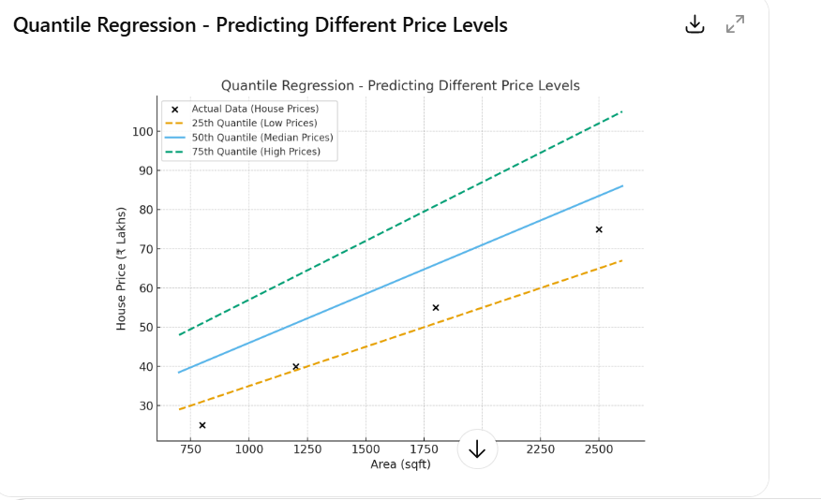
- Here’s your Quantile Regression scatter plot 👇
- Black dots: Actual house prices
- Dashed blue line: 25th quantile (low-end houses)
- Solid line: 50th quantile (median houses)
- Dashed orange line: 75th quantile (high-end houses)
- This shows how each regression line fits different parts of the price range — capturing low, typical, and high values separately instead of one single average line.

Support Vector Regression (SVR)

📖 Description
- Support Vector Regression (SVR) is a type of regression that tries to find a best-fit line (or curve) within a margin of tolerance — called an ε-tube.
- Points within this tube are considered “good enough” and ignored.
- Points outside the tube (errors greater than ε) are penalized heavily.
- Instead of minimizing all errors like Linear Regression, SVR focuses only on large errors — giving a model that is robust to small noise and fluctuations.

💡 When to Use
- When the relationship between X and Y is non-linear.
- For financial forecasting, stock prices, and temperature predictions where data fluctuates with noise.

🧾 Input Data Example
Day | Temperature (°C) | Power Usage (kWh)
1 | 28 | 220
2 | 30 | 240
3 | 33 | 260
4 | 36 | 310
5 | 39 | 355

🔄 Step-by-Step
Step | Action | What Happens
Input Data | Temperature vs Power Usage | Collect data points that may not form a perfect line.
Define ε-tube (margin) | Set tolerance range | Decide how much deviation (error) is acceptable.
Fit SVR Model | Use kernel function | Finds the smoothest line or curve that stays within the tube.
Identify Support Vectors | Data points touching the margin | Only these points define the model boundary.
Predict Output | For new inputs | Gives predicted values ignoring minor fluctuations.

Output
Day | Temperature (°C) | Actual Power (kWh) | Predicted Power (kWh)
1 | 28 | 220 | 225
3 | 33 | 260 | 255
5 | 39 | 355 | 350

✅Conclusion
- SVR draws a smooth curve through your data while ignoring small fluctuations.
- It focuses only on major deviations, giving a stable and balanced prediction.
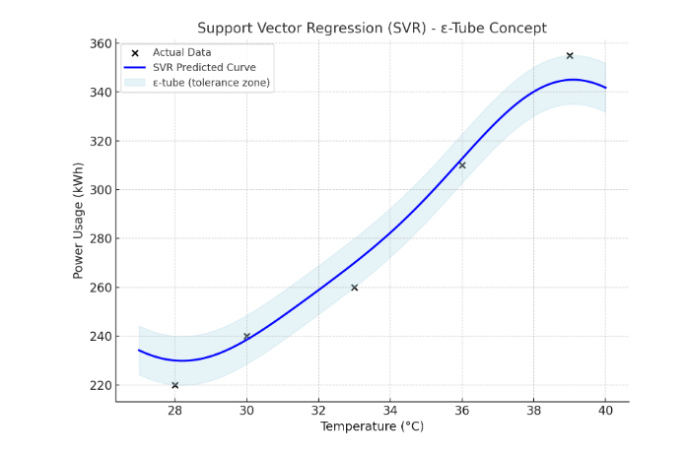
- Here’s the SVR scatter plot — it shows:
- Black dots: Actual data points (Temperature vs Power Usage)
- Blue curve: SVR-predicted smooth trend (captures non-linear pattern)
- Light blue shaded area: The ε-tube (tolerance zone) — small errors inside this band are ignored
- This helps you visualize how SVR focuses only on large deviations, giving stable predictions even when data fluctuates slightly

Decision Tree Regression

📖 Description
- Decision Tree Regression is a tree-based algorithm that splits the data into smaller regions based on feature values.
Each split aims to make the target values in that region as similar as possible (minimizing variance).
- The final prediction is the average value of the target variable in each region (leaf).
- Think of it as a flowchart:
- At each node → ask a question (like “Is Area < 1500?”)
- Depending on answer → go left or right
- Continue splitting → until each region has similar values
- Output the average value in that final region

💡 When to Use
Scenario | Why Decision Tree Helps
Data has non-linear patterns | Trees can capture sudden changes and step-like trends
Features interact in complex ways | Handles multi-feature relationships naturally
Need easy-to-interpret rules | Tree can be visualized as “if–else” logic
Common use-cases | Price prediction, risk scoring, demand forecasting, and energy consumption models

🧾 Input Data Example
Area (sqft) | Location Score | House Price (₹L)
800 | 3 | 25
1200 | 4 | 40
1500 | 4 | 45
2000 | 5 | 60
2500 | 5 | 75

🔄 Step-by-Step
Step | Action | Description
Input Data | Features (Area, Location) & Target (Price) | We start with full dataset.
Split Data | Based on the best feature & threshold | E.g., “Area < 1600?”
Create Branches | Left (True) & Right (False) subsets | Tree grows with smaller groups.
Stop Splitting | When region is pure (similar prices) | Prevents overfitting using “max depth”.
Predict | Take average of prices in that leaf | That becomes the prediction for new input.

Output
Area (sqft) | Predicted Price (₹L)
900 | 30
1400 | 42
2100 | 62
2500 | 75

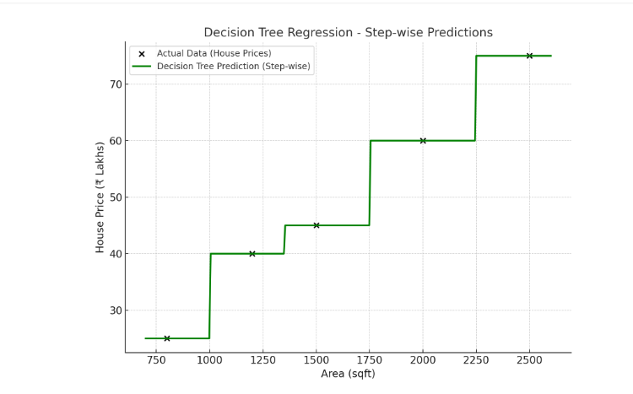
- Here’s the Decision Tree Regression scatter plot 🌳
- Black dots: Actual house prices
- Green line: Step-wise predictions made by the Decision Tree
- Each “step” represents a leaf node in the tree — where similar houses are grouped and the average price of that group is used for prediction.
- This clearly shows how Decision Trees make non-linear, piecewise constant predictions, unlike smooth curves (like SVR or Linear Regression).

✅ Conclusion
- Decision Trees create clear, rule-based models but can overfit if too deep. Pruning helps.
- Decision Tree Regression splits data into groups based on conditions, and predicts the average value in each group.
- It behaves like a “if-else rule engine” that makes decisions at each node.

Random Forest Regression

📖 Description
- Random Forest Regression is an ensemble model that builds many Decision Trees and then takes the average of all their predictions.
- Each tree is trained on a random subset of data and features, so they all learn slightly different patterns.
When combined, they produce a more accurate and stable prediction than a single Decision Tree.
- In short:
- “Random Forest = Many Decision Trees working together to make one strong prediction.”
- It Reduces variance and overfitting.

💡 When to Use
Scenario | Why Random Forest Helps
Data is non-linear | Handles complex relationships automatically
Need high accuracy | Averages many trees → reduces overfitting
Have noisy data | Random sampling reduces the effect of noise
Want feature importance | It shows which features impact the prediction most
Common use-cases | House price prediction, sales forecasting, credit risk, stock price trends

🧾 Input Data Example
Area (sqft) | Location Score | House Price (₹L)
800 | 3 | 25
1200 | 4 | 40
1500 | 4 | 45
2000 | 5 | 60
2500 | 5 | 75

🔄 Step-by-Step
Step | Action | Description
Input Data | Area, Location, Price | Start with full dataset
Bootstrap Sampling | Create random subsets of data | Each tree gets a slightly different sample
Build Multiple Trees | Train many Decision Trees (e.g., 100) | Each tree learns unique patterns
Aggregate Predictions | Average all tree outputs | Gives the final, smoother prediction
Output | Stable result | Reduces overfitting and captures non-linearity

Output
Area (sqft) | Actual Price (₹L) | Predicted Price (₹L)
900 | 30 | 32
1400 | 45 | 47
2100 | 60 | 62
2500 | 75 | 74

Analogy
- Imagine predicting house prices:
- Tree 1 says ₹70L
- Tree 2 says ₹72L
- Tree 3 says ₹68L
→ Random Forest takes average = ₹70L, which is more reliable than any single guess.
- Below is a plot showing:
- Actual data points (house prices)
- Step-like pattern of Decision Tree (green)
- Smooth curve of Random Forest (orange)
to visualize how Random Forest “averages out” the steps to create a smoother, more stable trend.
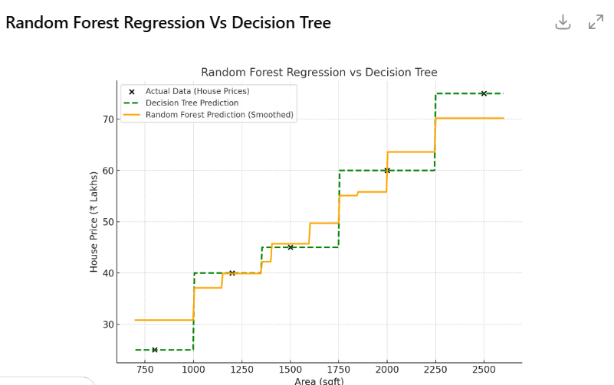
- Here’s the Random Forest Regression scatter plot 🌲
- Black dots: Actual house prices
- Green dashed line: Step-like Decision Tree prediction (individual model)
- Orange smooth line: Random Forest prediction — the average of many trees, giving a stable, smoothed curve
- This shows how Random Forest reduces the jumps of a single Decision Tree and produces more general, accurate predictions by averaging across multiple trees

✅ Conclusion
- Predictions are smoother and more general than Decision Tree outputs — no sharp steps.
- Random Forest Regression combines the wisdom of many Decision Trees to make a strong and stable prediction.
- It’s like asking 100 experts and taking their average opinion — reducing errors and bias.
- Random Forest gives high accuracy and stability, suitable for large, complex datasets.

XGBoost Regression
- XGBoost (Extreme Gradient Boosting) is an advanced ensemble regression technique that builds multiple Decision Trees sequentially, not in parallel (like Random Forest).
- Each new tree tries to correct the errors made by the previous trees — this is called boosting.
- It uses gradient descent optimization to minimize the error at every step, making it fast, accurate, and efficient even on large datasets.
- In simple words:
- Each tree learns from the mistakes of the previous ones — together they make a strong predictor.

💡 When to Use
Scenario | Why XGBoost Helps
When you need very high accuracy | Boosting focuses on correcting previous mistakes
When data is complex and non-linear | Learns intricate patterns using sequential trees
When dataset is large or noisy | Uses regularization to prevent overfitting
When you need feature importance | Provides ranking of impactful features
Common use-cases | Loan default prediction, price forecasting, sales demand prediction, risk analysis, and Kaggle competitions

🧾 Input Data Example
Area (sqft) | Location Score | House Price (₹L)
800 | 3 | 25
1200 | 4 | 40
1500 | 4 | 45
2000 | 5 | 60
2500 | 5 | 75

🔄 Step-by-Step
Step | Action | Description
Input Data | Area, Location, Price | Start with full dataset
Build First Tree | Simple decision tree | Predicts rough estimates (may have errors)
Calculate Residuals | Actual – Predicted | Finds what the first tree got wrong
Build Second Tree | Learns from residuals | Corrects errors of first tree
Repeat Process | Add more trees iteratively | Each new tree reduces overall error
Final Output | Weighted sum of all trees | Accurate, stable prediction result

Output
Area (sqft) | Actual Price (₹L) | Predicted Price (₹L)
900 | 30 | 31.5
1400 | 45 | 46.2
2100 | 60 | 61.0
2500 | 75 | 74.5

- XGBoost Regression builds trees one after another —
each new tree learns from the mistakes of previous trees.
- The final prediction is a powerful combination of all trees, giving excellent performance and accuracy.

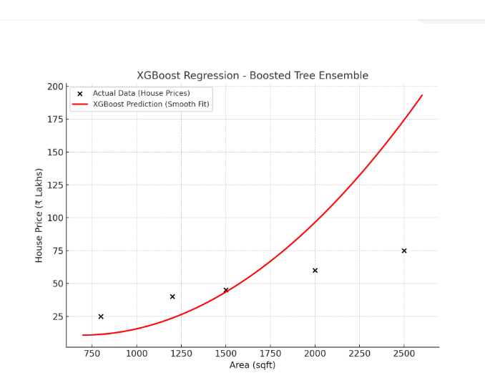
- Here’s the XGBoost Regression scatter plot ⚡
- Black dots: Actual house prices (Area vs Price)
- Red smooth curve: XGBoost prediction — showing how the model learns patterns sequentially and fits the curve closely.
- You can see it creates a smooth yet precise fit, correcting small errors as it learns, which makes XGBoost more accurate than Random Forest or a single Decision Tree.

Not to Use XGBoost
- Avoid it if:
- You have very few data points (e.g., < 20 rows) → simpler models like Linear or Decision Tree suffice.
- You need a fully interpretable model (e.g., for regulation) → Linear or Logistic Regression are better.
- You have perfectly linear data → Linear Regression performs equally well and is simpler.

✅ Conclusion
- XGBoost = fast, powerful, and accurate, perfect for large structured datasets.

Bayesian Regression

📖 Description
- Instead of fixed coefficients, Bayesian Regression treats them as distributions and updates beliefs with new data using Bayes’ Theorem.
- Bayesian Regression is an advanced version of Linear Regression that adds probability (uncertainty) to the model’s parameters instead of fixed single values.
- But in Bayesian Regression, we assume:
- This gives us a range of possible regression lines, not just one.
- That means the model doesn’t say “Price = ₹50L”, but rather:
- “Price is most likely around ₹50L, with a confidence range between ₹48L and ₹52L.”

💡 When to Use
Scenario | Why Bayesian Regression Helps
You need uncertainty estimates | Gives prediction + confidence interval
Data is small or noisy | Incorporates prior knowledge to stabilize learning
You want to avoid overfitting | Regularization built into Bayesian approach
You want probabilistic predictions | Provides distribution over outcomes
Common use-cases | Medical predictions, finance risk modeling, time series uncertainty estimation

🧾 Input Data Example
Area (sqft) | Location Score | House Price (₹L)
800 | 3 | 25
1200 | 4 | 40
1500 | 4 | 45
2000 | 5 | 60
2500 | 5 | 75

Output
Area (sqft) | Predicted Price (₹L) | 95% Confidence Interval (₹L)
900 | 30 | (27 – 33)
1400 | 46 | (43 – 49)
2100 | 62 | (58 – 66)
2500 | 75 | (70 – 80)
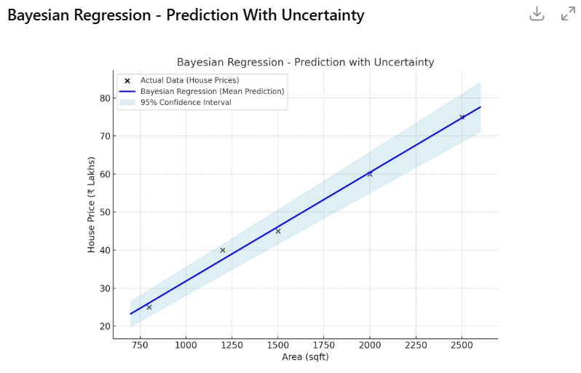
- Black dots: Actual house prices
- Blue line: Bayesian Regression’s mean (expected) prediction
- Shaded light-blue region: 95% confidence interval — showing how confident the model is about each prediction
- 👉 Notice that the uncertainty (width of the shaded area) is slightly higher at the edges — this means the model is less certain where it has fewer data points.
This is one of the biggest advantages of Bayesian Regression — it gives both the prediction and its reliability (uncertainty range).

✅Conclusion
- Bayesian Regression gives probabilistic predictions with uncertainty measures, ideal for risk-sensitive domains.
- Bayesian Regression doesn’t just fit one best line —
it fits a family of lines and tells you how sure it is about each prediction.
- It’s like saying:
- “I think the price is ₹75L ± ₹5L, with 95% confidence.”

Poisson Regression

📖 Description
- Used for count data (integer outcomes like number of calls, visits, events).
Assumes target variable follows a Poisson distribution.
- Poisson Regression is a type of regression used when your target variable (Y) represents counts or event frequencies — like number of bookings, calls received, or accidents per month.
- It assumes that the target values follow a Poisson distribution, meaning:
- The outcomes are non-negative integers (0, 1, 2, 3, …)
- The mean ≈ variance of the target variable

💡 When to Use
- When the output is a count (non-negative integer).
- For accident prediction, website visits, sales transactions per day.

Scenario | Why Poisson Regression Helps
Target variable is count-based | Ideal for modeling number of events
Counts are non-negative integers | Predicts 0, 1, 2, 3… (not negative or continuous)
Counts are rare or low-frequency | Works well for events like calls, defects, visits
Mean ≈ Variance | Assumption fits Poisson nature
Common use-cases | Customer visits, insurance claims, number of leads, hospital admissions, web clicks

🧾 Input Data Example
Customer Age | Income Group | Monthly Purchases
22 | Low | 2
30 | Medium | 4
40 | Medium | 5
45 | High | 7
55 | High | 10

🔄 Step-by-Step
- Step 1: Converts linear combination of inputs via log link → predicts mean count.
- Step 2: Ensures predicted counts are ≥ 0.
- Step 3: Captures rate of occurrence, e.g., “visits per hour”.

Step | Action | Description
Input Data | Collect count data | e.g., Purchases per month
Transform Target (Log Link) | Model log(λ) instead of λ | Ensures positive predictions
Fit Model | Estimate β₀, β₁, β₂ | Finds best coefficients via maximum likelihood
Predict | Compute λ̂ = exp(Xβ) | Converts log-scale prediction to actual count
Interpret | Interpret as rate | How predictors multiply event rates

Output
Age | Income | Actual Purchases | Predicted (λ̂)
22 | Low | 2 | 2.3
30 | Medium | 4 | 3.8
40 | Medium | 5 | 5.1
45 | High | 7 | 6.9
55 | High | 10 | 9.8

Analogy
- Imagine predicting:
- Number of calls received by a call center per hour
- Number of patients arriving per day
- Number of emails sent per campaign
- Poisson Regression learns how features (like day, staff count, ad spend) affect event rates.

📊 Scatter Plot Visualization (Conceptual)
- Below is a conceptual plot where:
- Black dots = actual counts
- Blue curve = predicted counts (using exponential fit)

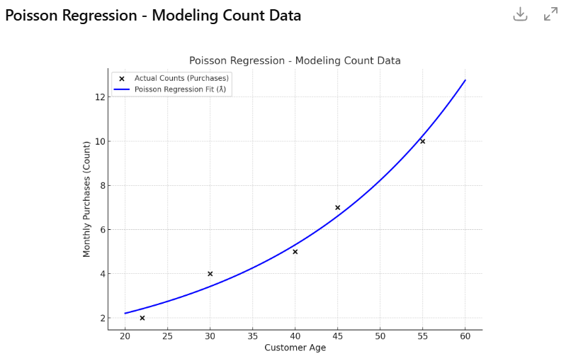

- Here’s the Poisson Regression scatter plot 🔢
- Black dots: Actual monthly purchase counts
- Blue curve: Poisson Regression’s predicted event rate (λ̂) — the expected count for each age
- 👉 Notice how the curve rises exponentially, not linearly — this is because Poisson Regression models the log of the expected count, ensuring all predictions remain positive and represent realistic count data (0, 1, 2, …).

✅ Conclusion
- Poisson Regression is best for modelling event counts where outcomes are discrete and non-negative.
- The model predicts counts close to actual values, always positive, and scales exponentially with higher features like income or age.

🧠 In Simple Words
- Poisson Regression predicts “how many times something happens” based on other variables.
- Instead of predicting continuous prices or averages, it predicts counts (visits, calls, sales).

Robust Regression
- Used when data contains outliers that can distort normal regression results.
It reduces the influence of extreme values.
- Robust Regression is a version of regression designed to handle outliers or noisy data that would normally distort a regular Linear Regression model.
- In ordinary Linear Regression, even a single extreme data point can pull the line toward it (because it minimizes squared errors).
Robust Regression instead minimizes a different loss function that reduces the influence of large errors.

💡When to Use
- When you suspect outliers or noise in data.
- Common in financial, experimental, or industrial measurements.
Scenario | Why Robust Regression Helps
Data contains outliers or anomalies | It ignores or reduces their influence
Target variable has noise or measurement errors | Maintains stable results
Data doesn’t follow perfect normal distribution | Still gives meaningful fit
You want reliable results without removing outliers | Automatically handles them
Common use-cases | Real-estate pricing (few luxury homes), medical readings, finance data (with extreme values)

🧾 Input Data Example
Area (sqft) | House Price (₹L)
800 | 25
1200 | 40
1500 | 45
2000 | 60
2500 | 75
3000 | 200 ← Outlier 🧨

- Here, one house (3000 sqft, ₹200L) is an outlier that would distort a normal regression line.
- Robust Regression resists that influence and keeps the line close to the main trend.

🔄 Step-by-Step
- Step 1: Detects outliers that pull regression line upward.
- Step 2: Assigns less weight to outliers while fitting.
- Step 3: Line fits majority of points well, ignoring noise.

Step | Action | Description
Input Data | X = Area, Y = Price | Collect the dataset
Detect Outliers Automatically | Use robust cost (Huber, Tukey, etc.) | Assign smaller weights to large errors
Fit the Model | Weighted fitting | Normal points have high weight, outliers low weight
Compute Coefficients (β₀, β₁) | Solve for minimum weighted loss | Gives stable slope and intercept
Predict Output | Use fitted line | Line fits the majority of data, not the extremes

Output
Area (sqft) | Actual Price (₹L) | Predicted (Normal Reg.) | Predicted (Robust Reg.)
800 | 25 | 27 | 26
1200 | 40 | 43 | 41
2000 | 60 | 78 ← Pulled by Outlier ⚠️ | 59 ✅
3000 | 200 (Outlier) | 150 | 85 ✅ (Ignored Outlier)
- Below is a plot showing:
- Black dots: actual data (with one large outlier)
- Blue line: Ordinary Linear Regression (influenced by outlier)
- Red line: Robust Regression (stable fit ignoring outlier)

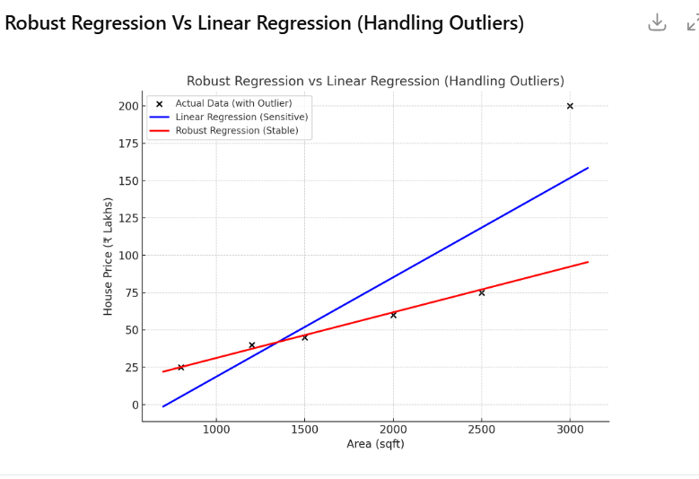
- Here’s the Robust Regression scatter plot 🧱
- Black dots: Actual data (one extreme outlier at 3000 sqft, ₹200L)
- Blue line: Linear Regression — pulled upward by the outlier, distorting the trend
- Red line: Robust Regression — fits the majority of points correctly, ignoring the extreme outlier
- 👉 This clearly shows how Robust Regression protects your model from bad or noisy data, giving a much more realistic and stable prediction trend.

✅ Conclusion
- Robust Regression provides reliable predictions even when data isn’t clean or contains extreme observations.
- Robust Regression stays close to real trend, while normal regression line bends toward the outlier.

🧠 In Simple Words
- Robust Regression fits the data like Linear Regression,
but it’s smart enough to ignore extreme or bad data points.
- It’s the best choice when your data has a few wrong or unusual entries,

No | Regression Type | When to Use | Pros ✅ | Cons ❌ | When Not to Use 🚫
1️⃣ | Linear Regression | When the relationship between X and Y is roughly straight-line | Easy to understand & fast | Fails with outliers or curved data | If data is non-linear or has outliers
2️⃣ | Polynomial Regression | When the data shows a curved pattern (e.g., U-shape, exponential rise) | Captures curves easily | Can overfit if degree too high | If trend is linear or you have little data
3️⃣ | Quantile Regression | When you want to study low, median, or high parts of target variable | Robust to outliers; detailed insights | Harder to interpret | If only the average trend matters
4️⃣ | Support Vector Regression (SVR) | When the relation is non-linear but you want to ignore small noise | Handles complex trends; ignores small errors | Complex tuning (kernel, C, ε); slower | For very large datasets or purely linear data
5️⃣ | Decision Tree Regression | When you want if–else rule-based predictions | Easy to interpret; handles non-linearity | Can overfit small data; unstable | If you need smooth or continuous trends
6️⃣ | Random Forest Regression | When you want high accuracy and non-linear pattern handling | Reduces overfitting; handles missing data | Slower; less interpretable | If data is small/simple (use Linear/Tree)
7️⃣ | XGBoost Regression | When data is large, complex, and non-linear | Very accurate; learns from mistakes; handles noise | Needs tuning; less interpretable | For tiny datasets or purely linear data
8️⃣ | Bayesian Regression | When you want uncertainty estimates with predictions | Gives confidence range; robust on small data | Computationally heavy; complex math | When you just need a quick average fit
9️⃣ | Poisson Regression | When target is count-based (e.g., number of events) | Ensures positive predictions; fits count data | Assumes mean ≈ variance; can’t handle negatives | When target is continuous or not count-based
🔟 | Robust Regression | When data has outliers or bad values | Ignores outliers automatically; stable fit | Slightly less accurate on clean data | When data is already clean and consistent

🧠 Quick Summary – Layman Tips

Situation | Best Regression Type
Simple straight-line relation | Linear Regression
Curved relation | Polynomial Regression
Outliers in data | Robust / Quantile Regression
Non-linear but smooth | SVR / Random Forest
Complex data with multiple features | XGBoost Regression
Need uncertainty/confidence in prediction | Bayesian Regression
Predicting counts (visits, calls, clicks) | Poisson Regression

Key Points
Regression Type | Predicts | When to Use | Key Feature
Logistic | Class (0/1) | Binary classification | Uses sigmoid
Quantile | Percentiles | Analyze full distribution | Handles skewed data
SVR | Continuous | Non-linear data | Margin-based learning
Decision Tree | Continuous | Simple, rule-based | Interpretable
Random Forest | Continuous | Large, complex data | Averaged trees
XGBoost | Continuous | High accuracy, big data | Sequential boosting
Bayesian | Continuous | Uncertainty needed | Probabilistic
Poisson | Count | Event frequency | For count outcomes
Robust | Continuous | Outliers present | Ignores extreme values

Deep Learning

What is Deep Learning?
Deep Learning is a subset of Machine Learning that uses Neural Networks with multiple hidden layers to learn complex patterns from data.
Examples:
- Face Recognition
- ChatGPT
- Self-Driving Cars
- Medical Diagnosis

AI → ML → DL Relationship
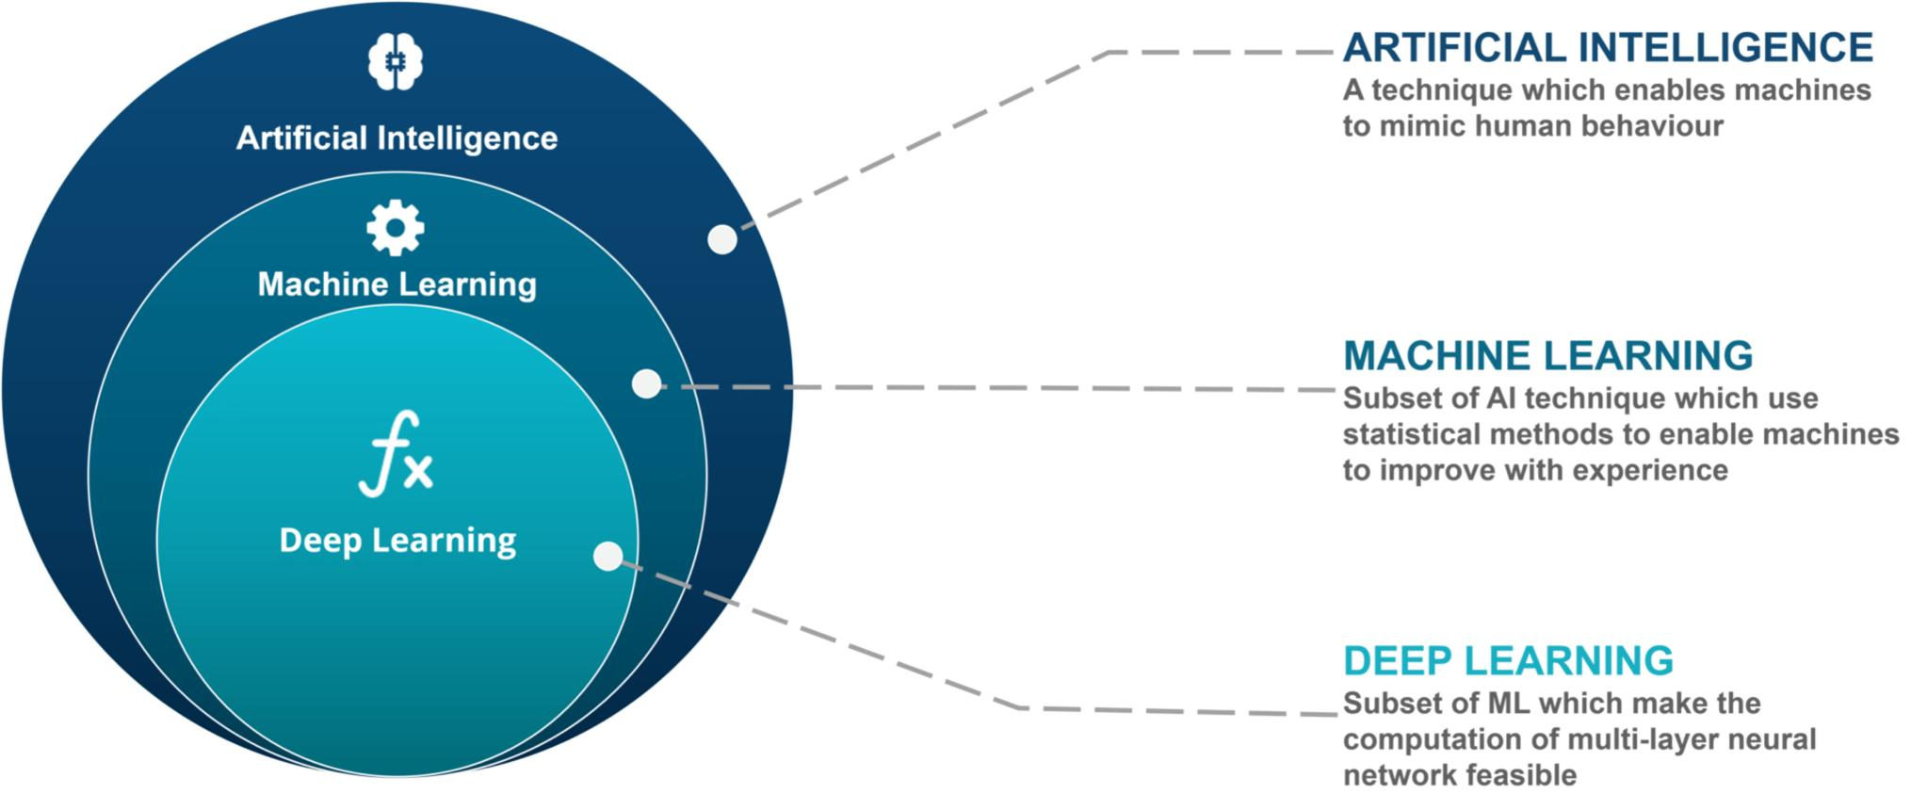
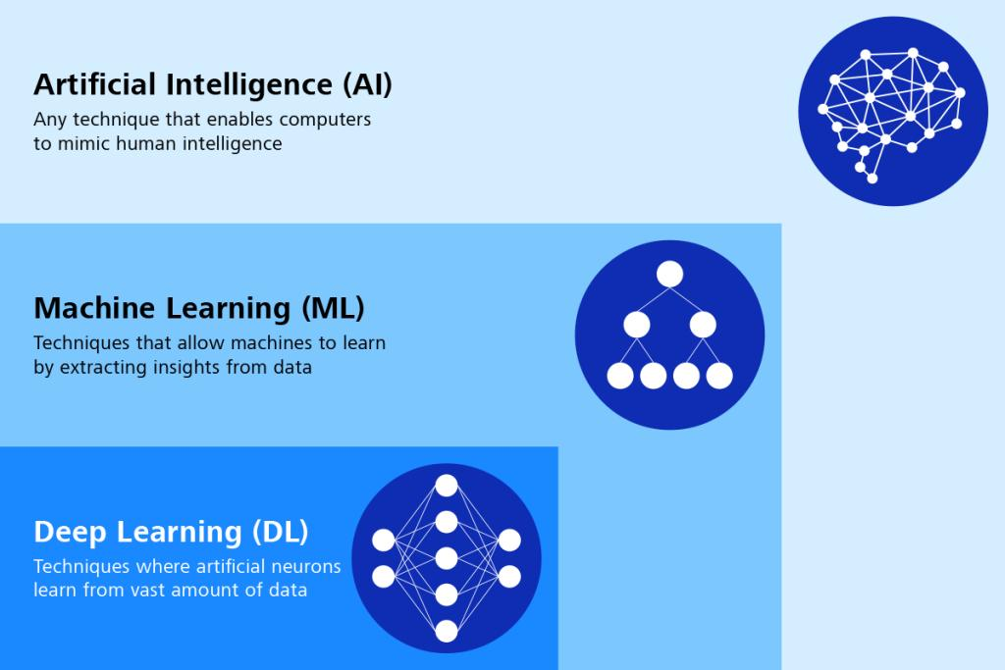

6

Neural Network Basics
A Neural Network is inspired by the human brain.
It consists of:
- Input Layer
- Hidden Layer(s)
- Output Layer

Neural Network Structure
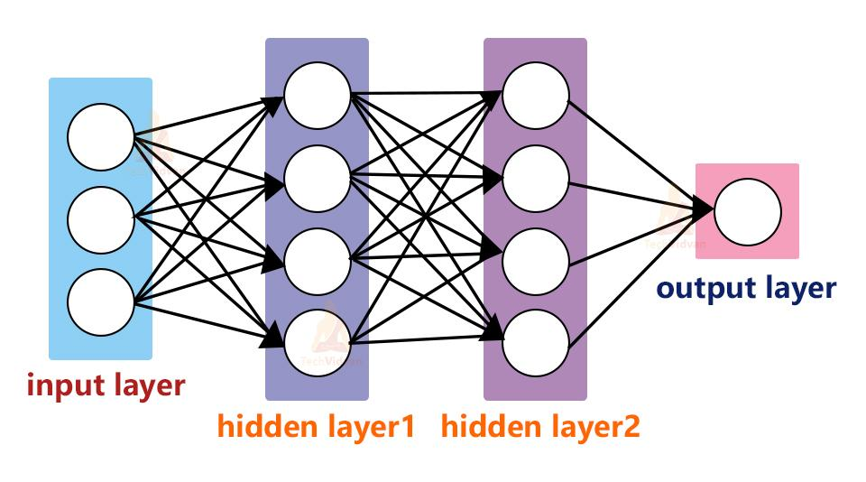
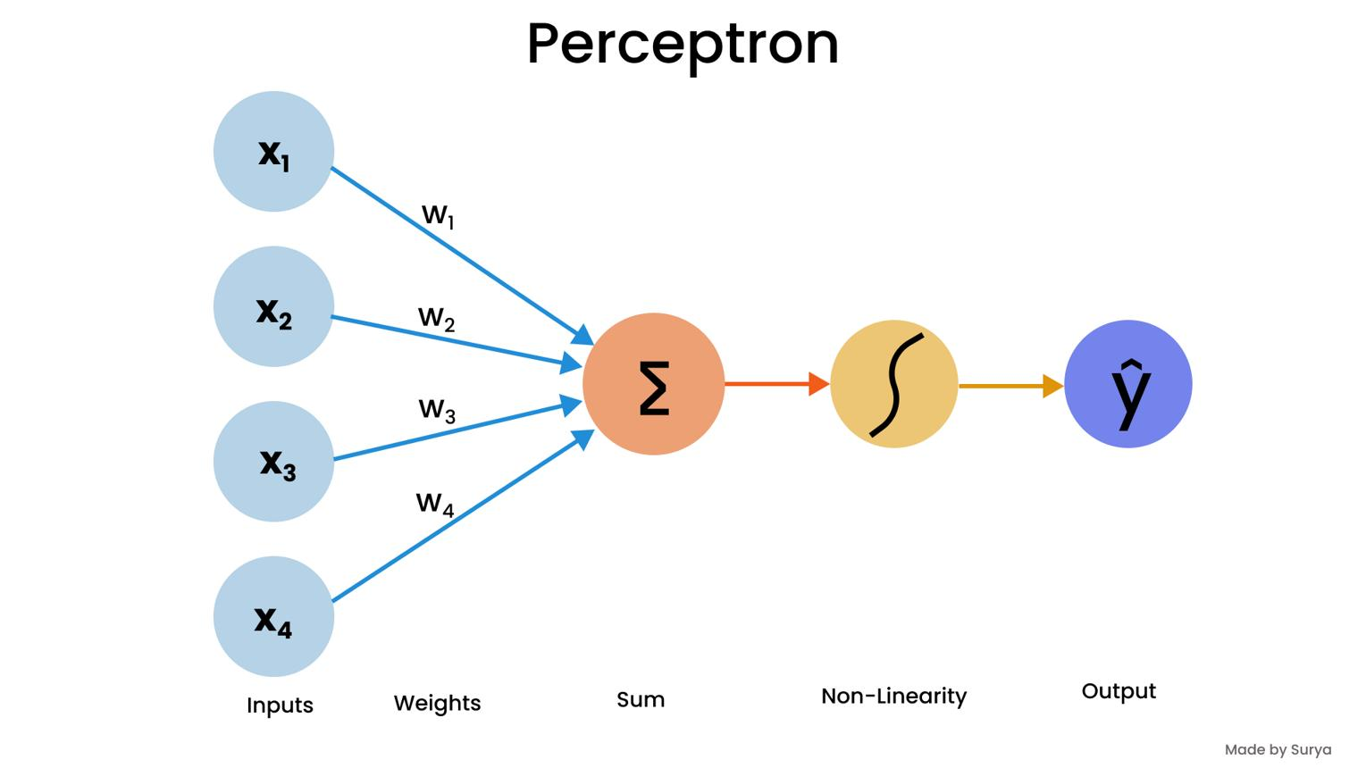
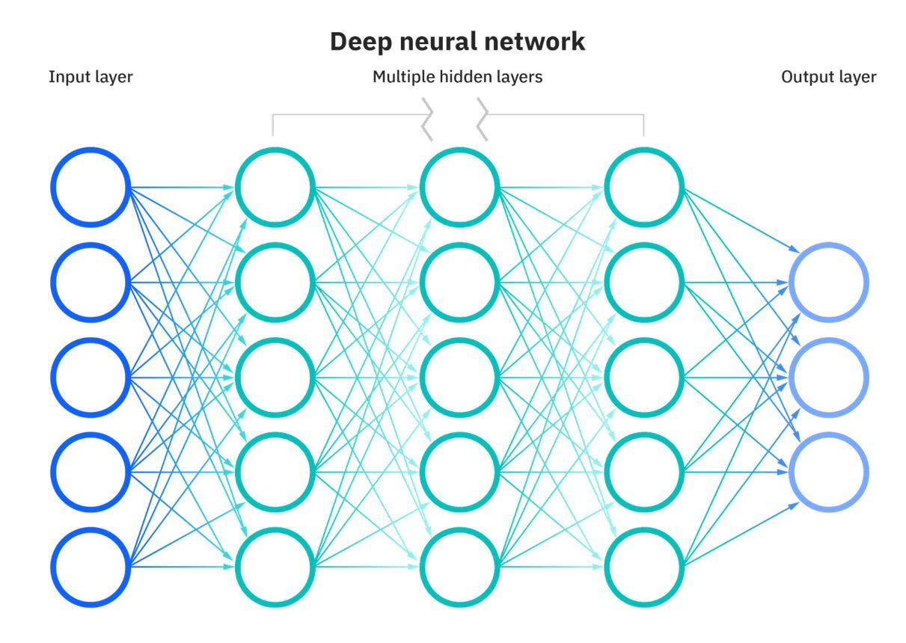
6

Components
Input Layer
- Receives data
- Example: Age, Salary, Experience
Hidden Layer
- Learns patterns
Output Layer
- Produces prediction
Example:
- Loan Approved = Yes/No

Neuron, Weight and Bias
Each neuron performs:
output = activation(weight × input + bias)

Visual of a Neuron
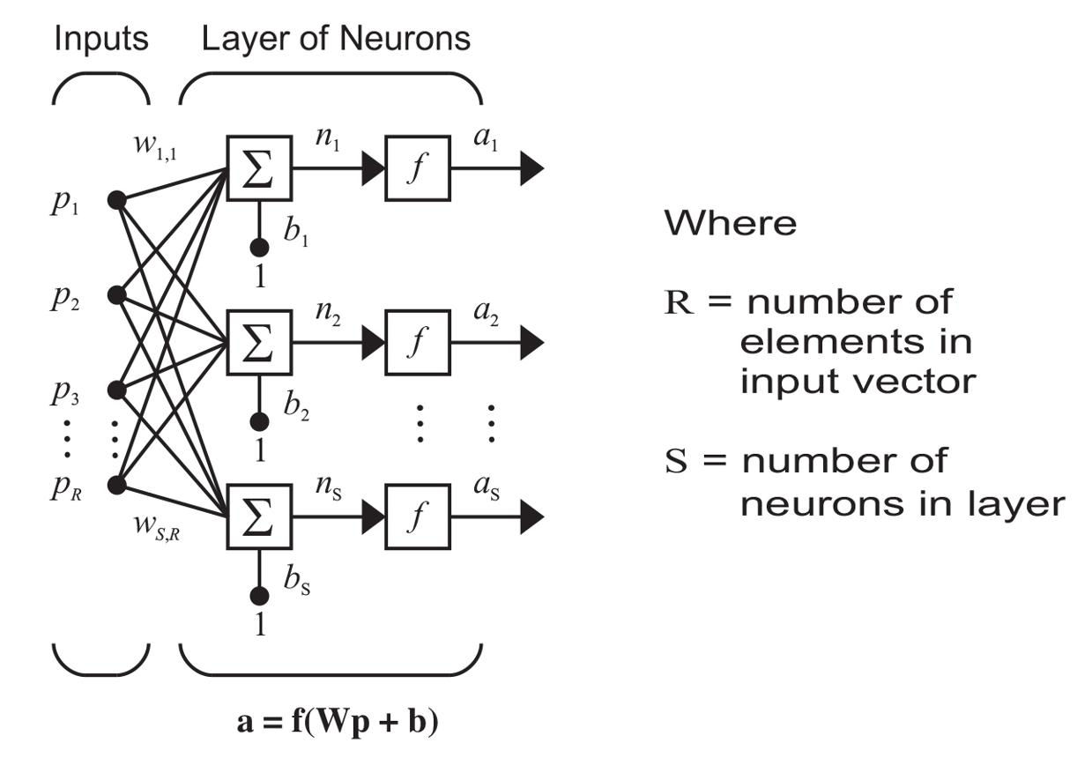
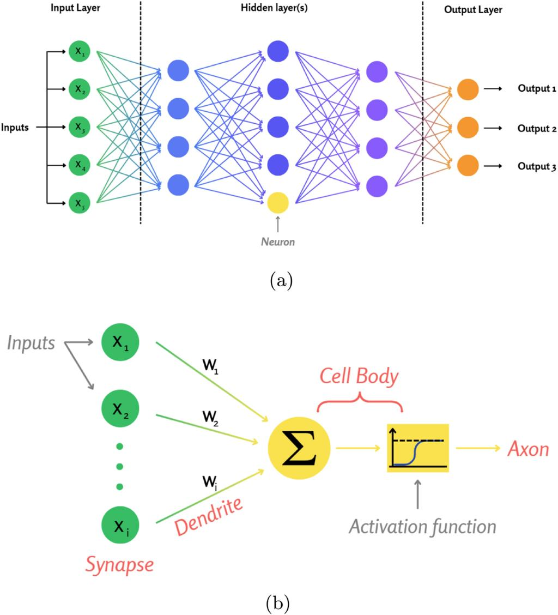
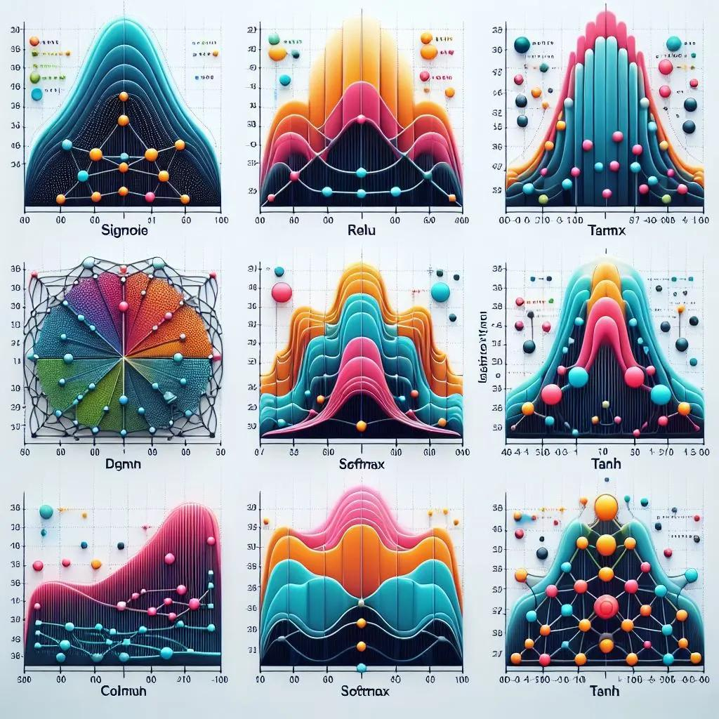
6

Weight
- Importance of input
- Higher weight = More influence

Bias
- Helps shift prediction
- Improves learning flexibility

Forward Propagation
Data moves from input to output.
Example:
Input → Hidden Layer → Output
Prediction:
- Pass / Fail
- Spam / Not Spam

Forward Flow
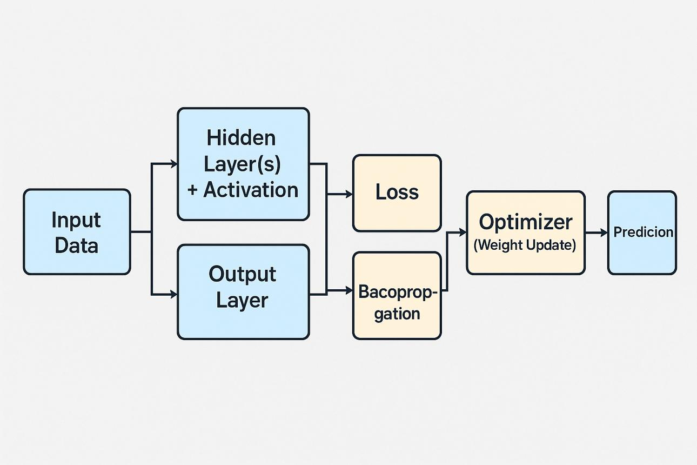
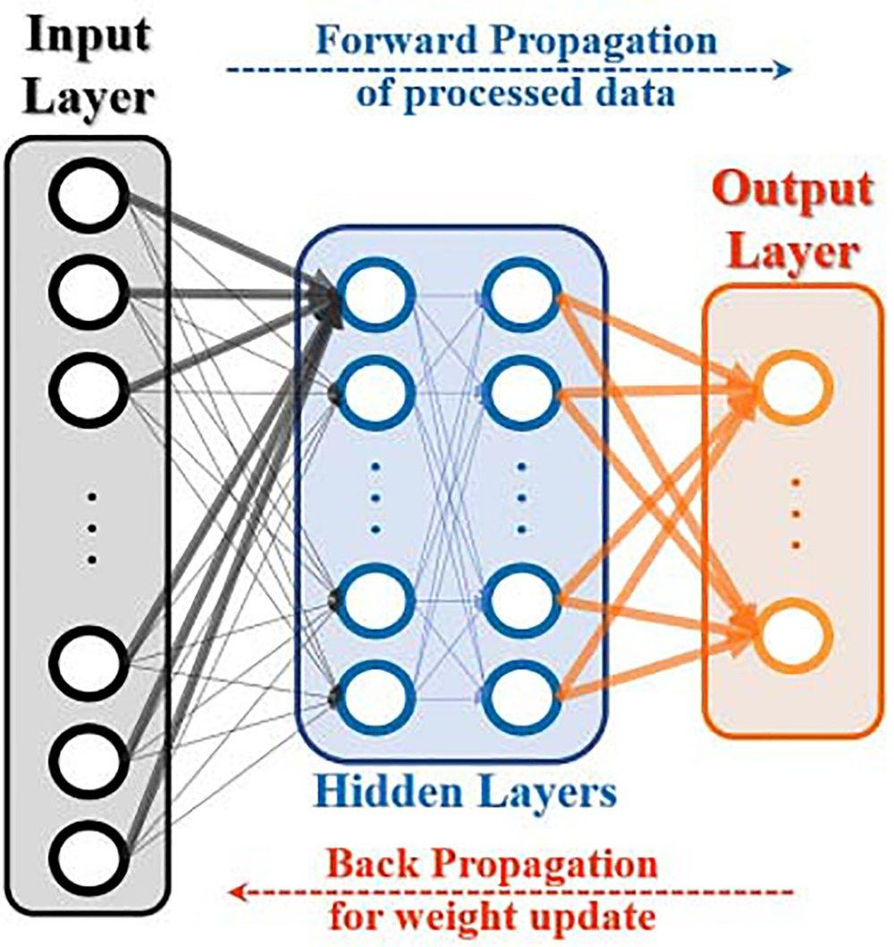
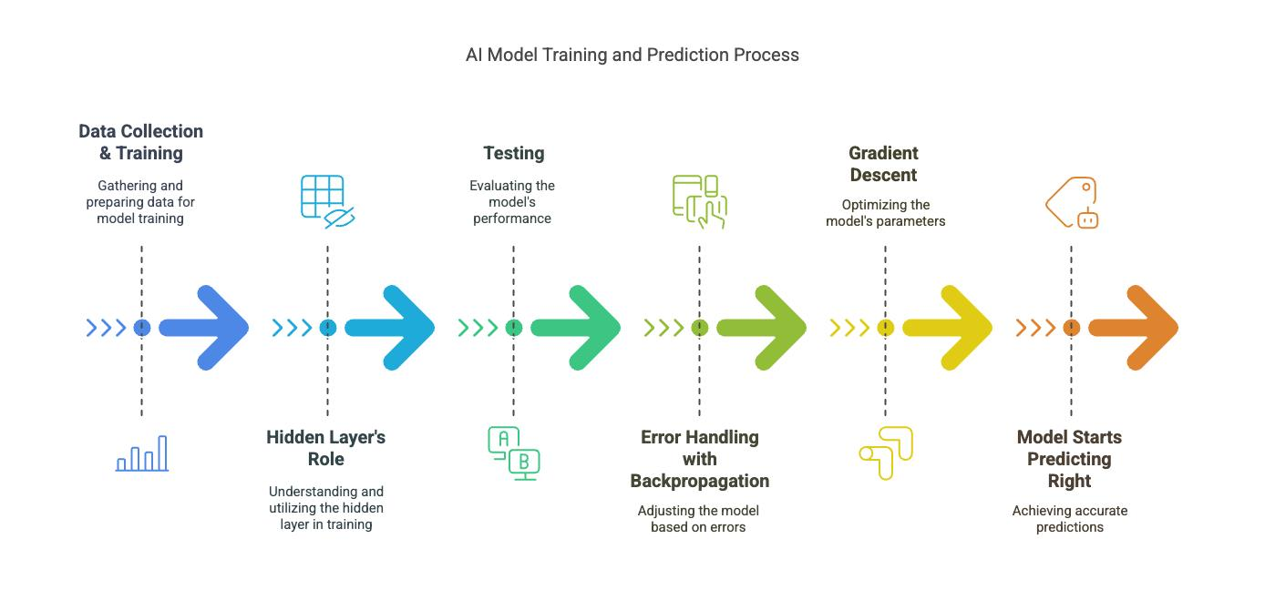
7

Activation Functions
Activation functions help the network learn non-linear relationships.

ReLU
f(x)=max(0,x)
Most commonly used.

Sigmoid
Output between:
0 to 1
Used in Binary Classification.

Tanh
Output between:
-1 to 1

Softmax
Used in Multi-Class Classification.

Activation Function Curves
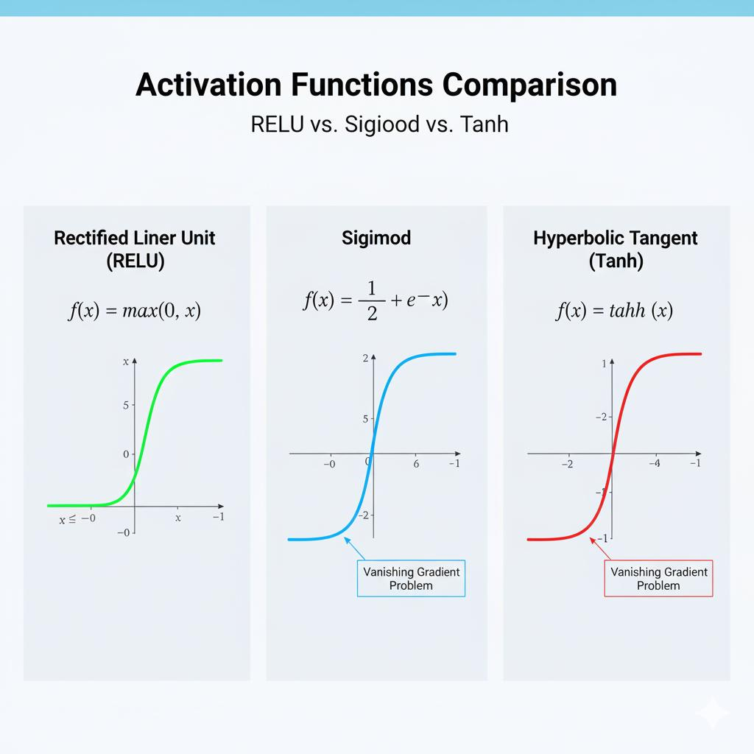
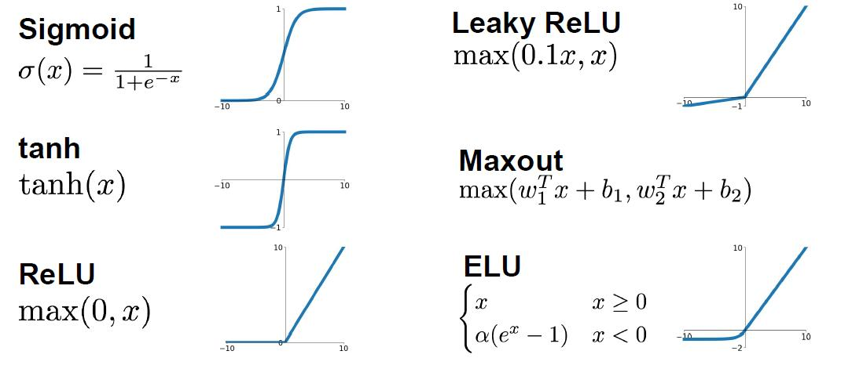
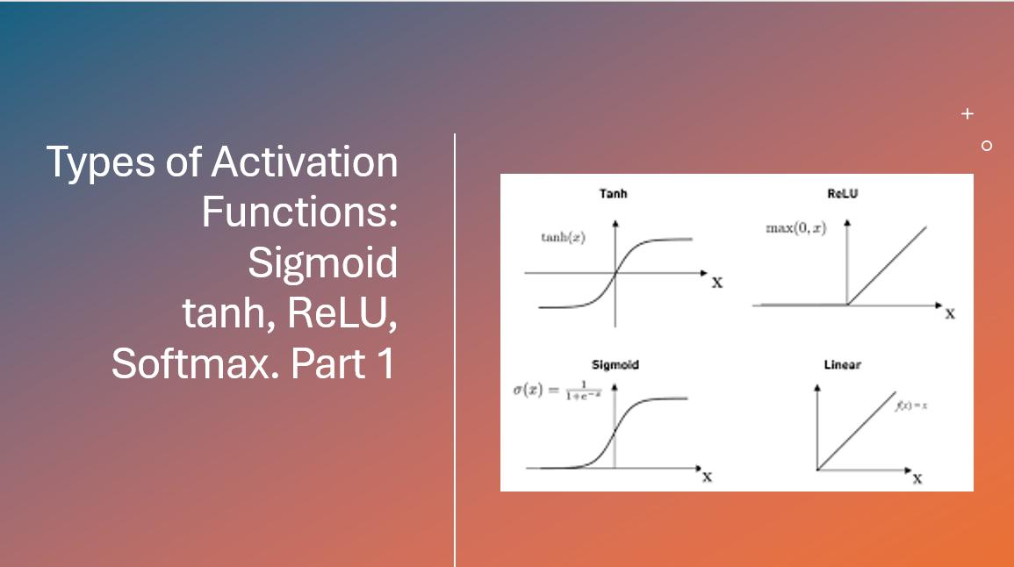
6

Loss Function
Measures prediction error.
Example:
Actual = 100
Predicted = 80
Error = 20
Common Types:
- Mean Squared Error (MSE)
- Cross Entropy Loss

Loss Curve
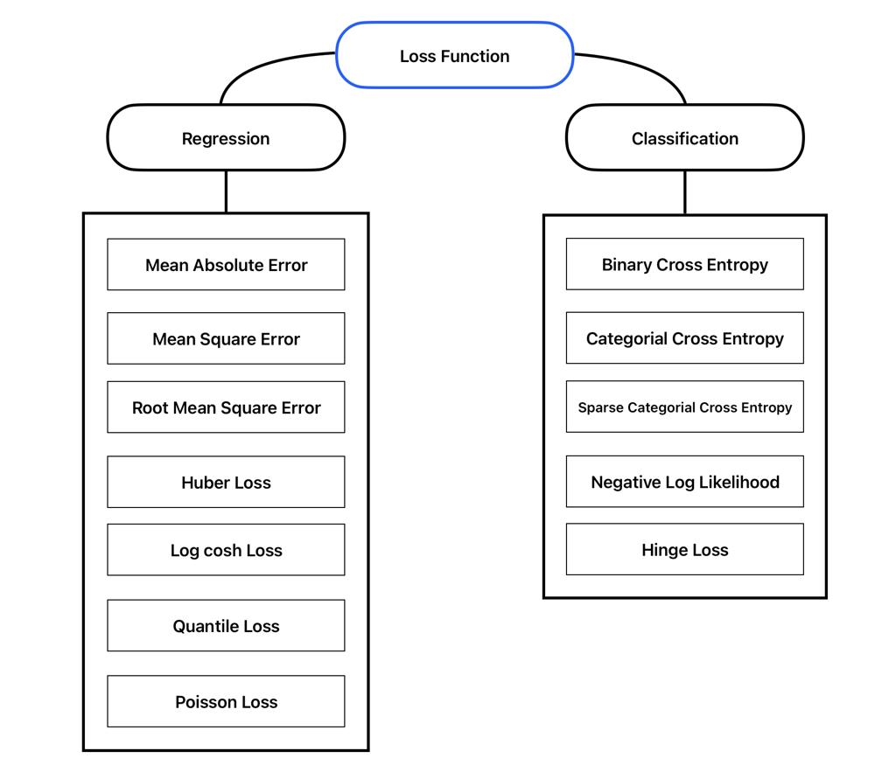
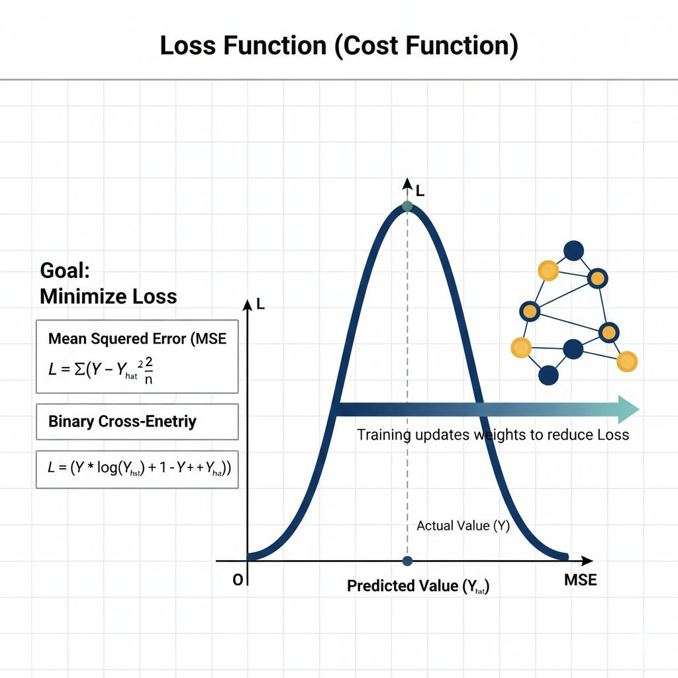
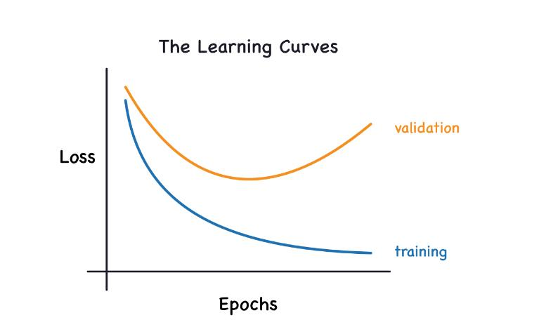
6

Backpropagation
Backpropagation helps the network learn from mistakes.
Steps:
- Predict output
- Calculate error
- Send error backward
- Update weights
- Improve prediction

Backpropagation Process
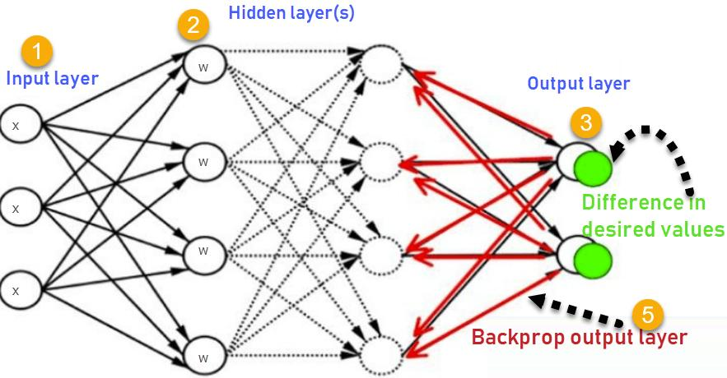
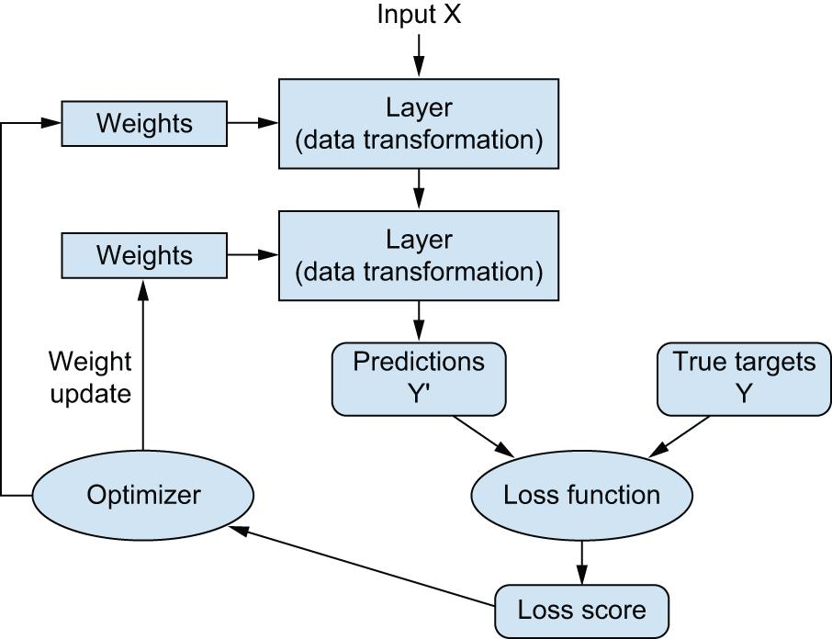
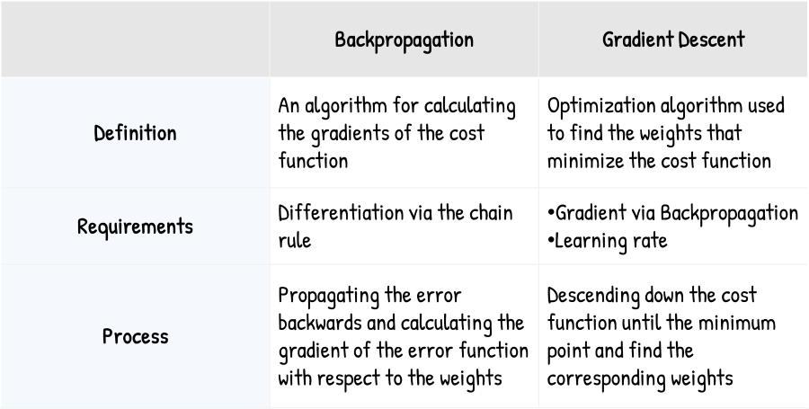
4

Optimizers
Optimizers update weights efficiently.

Gradient Descent
Moves towards minimum error.

Adam Optimizer
Most popular optimizer.
Advantages:
- Fast
- Stable
- Better accuracy

Optimizer Visualization
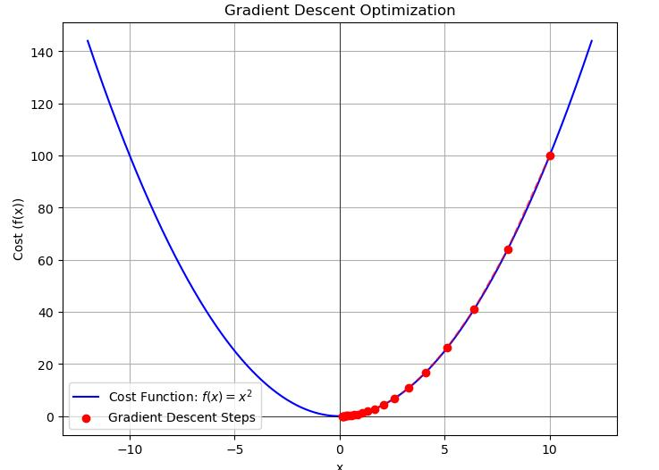
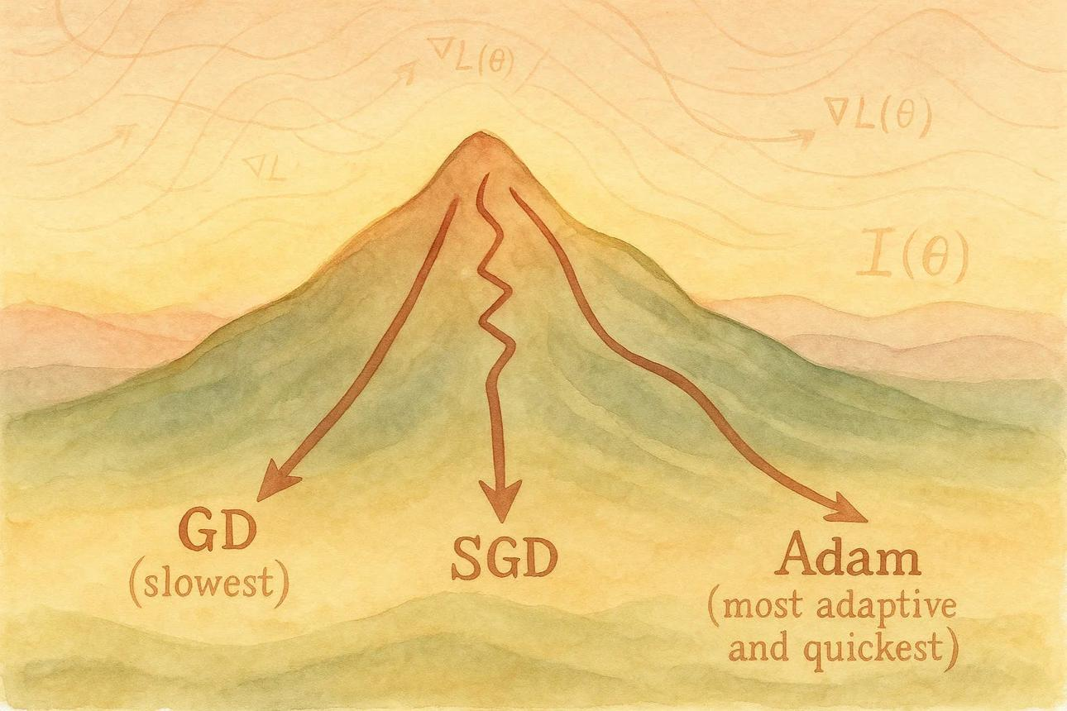
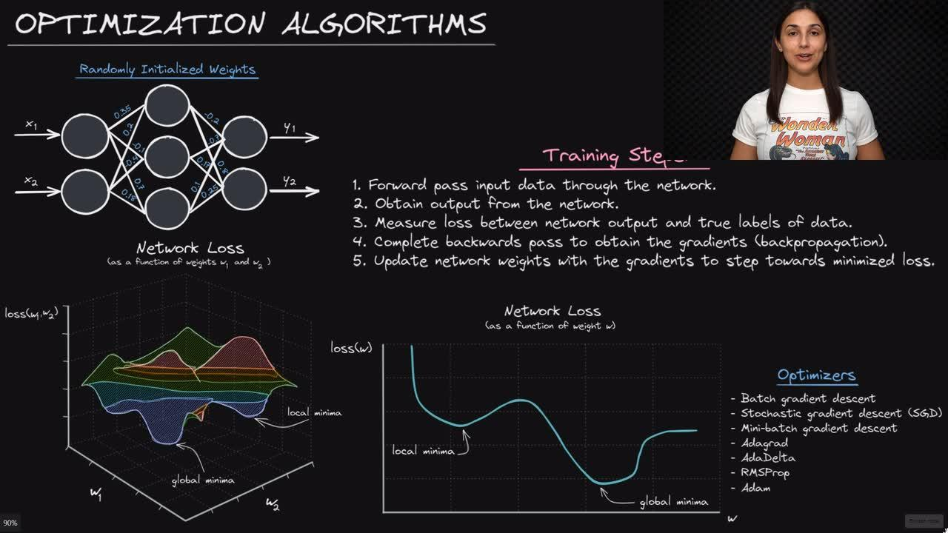
7

Deep Learning Architectures

ANN (Artificial Neural Network)
Used for:
- Sales Prediction
- Customer Churn
- Loan Approval

CNN (Convolutional Neural Network)
Used for Images.
Examples:
- Face Recognition
- Medical Images
- Object Detection

CNN Example
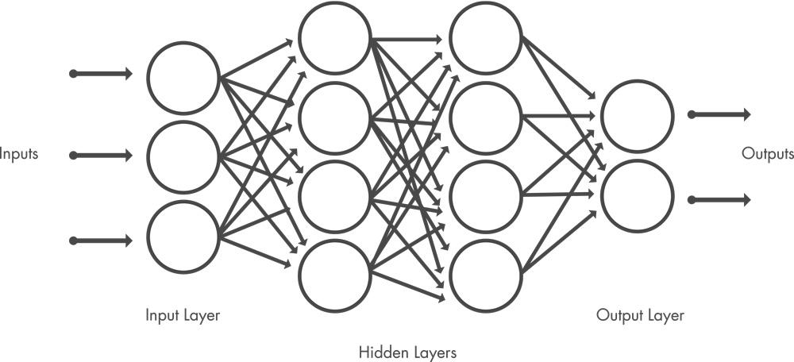
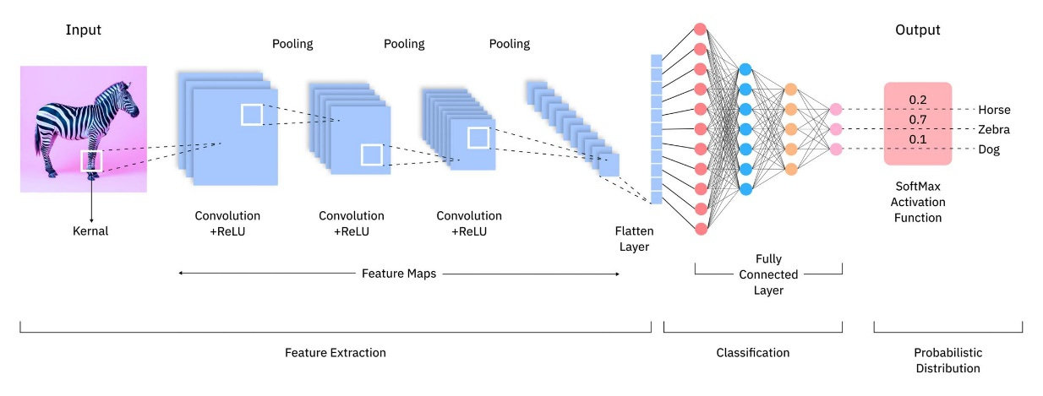
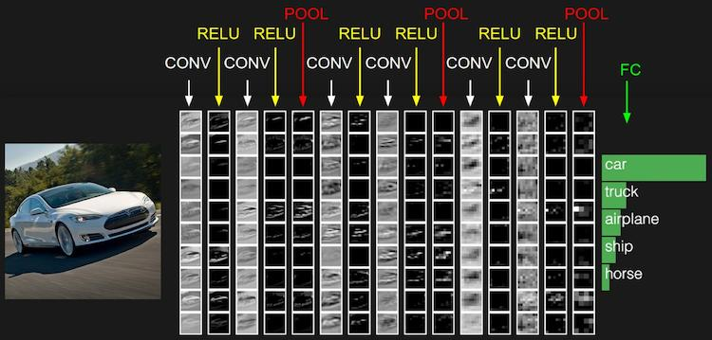
7

RNN (Recurrent Neural Network)
Used for Sequential Data.
Examples:
- Speech Recognition
- Time Series Forecasting
- Language Modeling

RNN Example
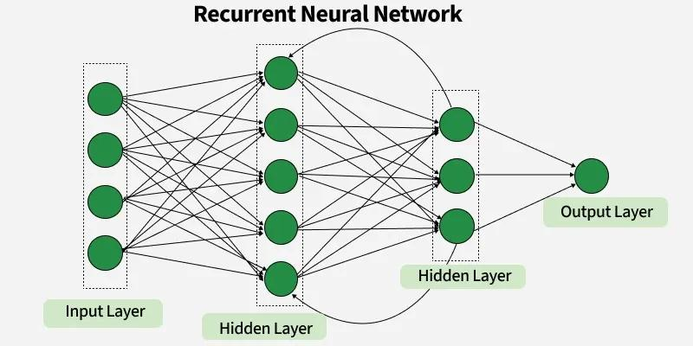
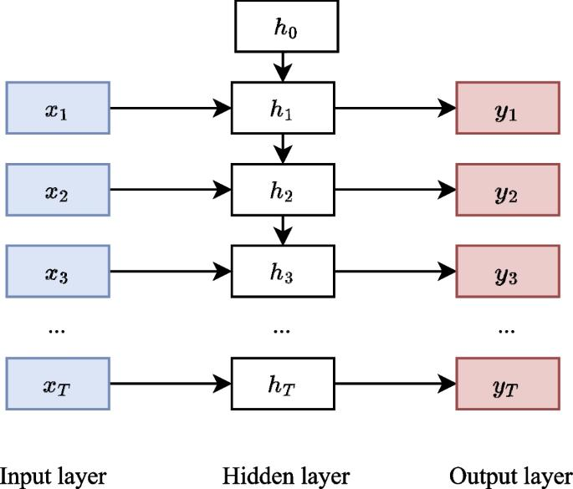
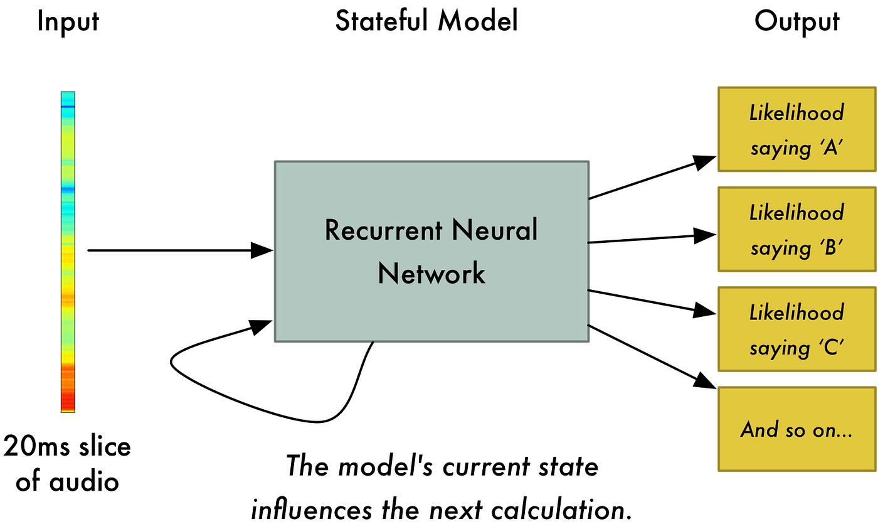
7

LSTM
Improved version of RNN.
Advantages:
- Remembers long-term information
- Solves vanishing gradient problem

LSTM Cell
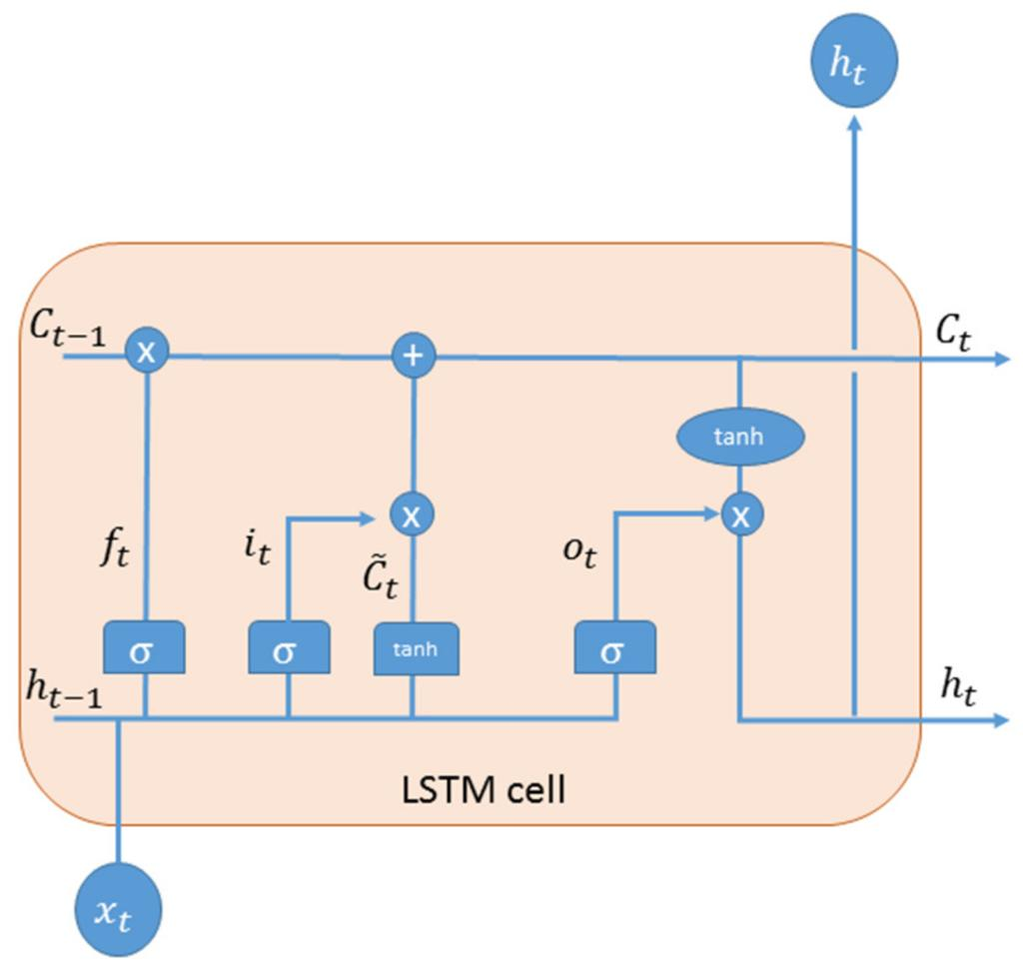
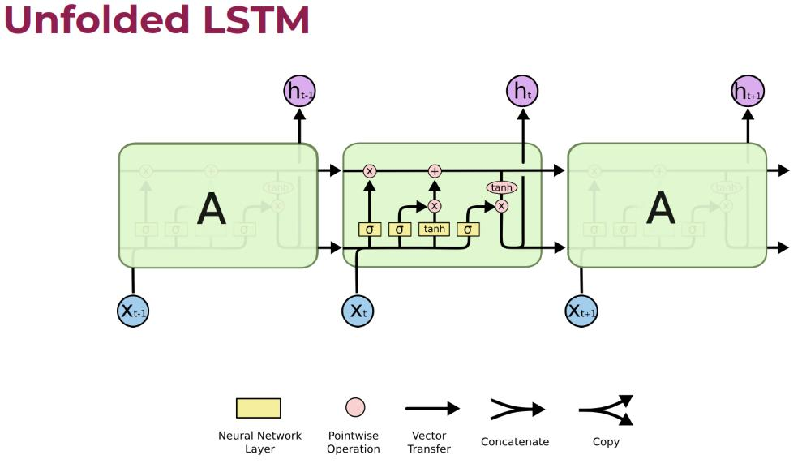
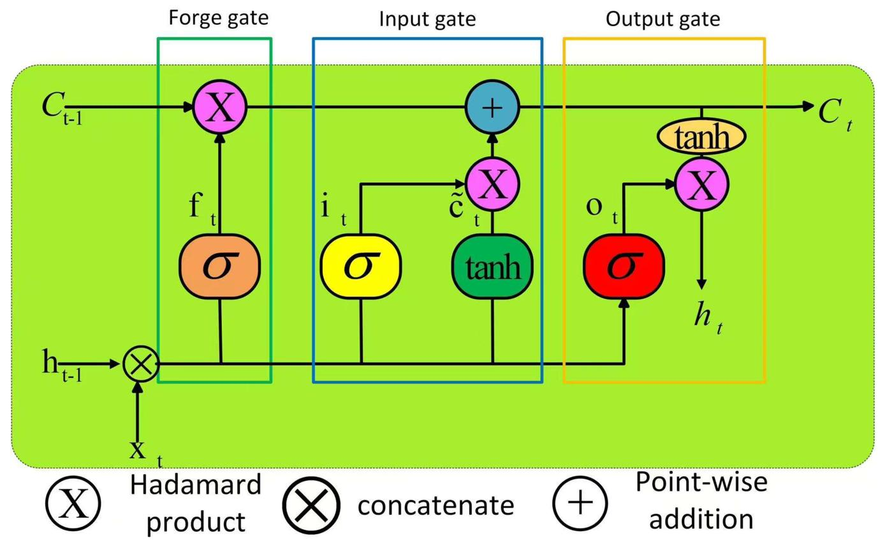
5

Transformer
The architecture behind modern Generative AI.
Examples:
- ChatGPT
- Gemini
- Claude
Advantages:
- Faster training
- Better context understanding
- Parallel processing

Transformer Architecture
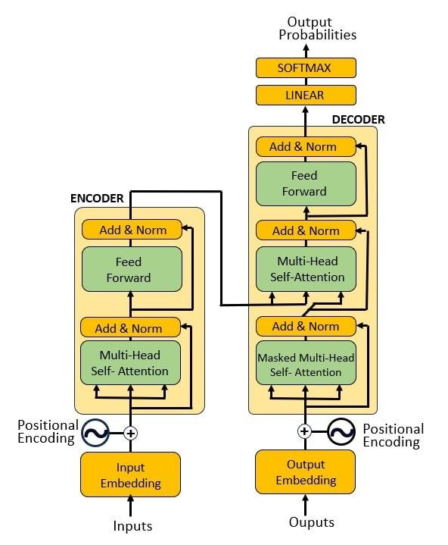
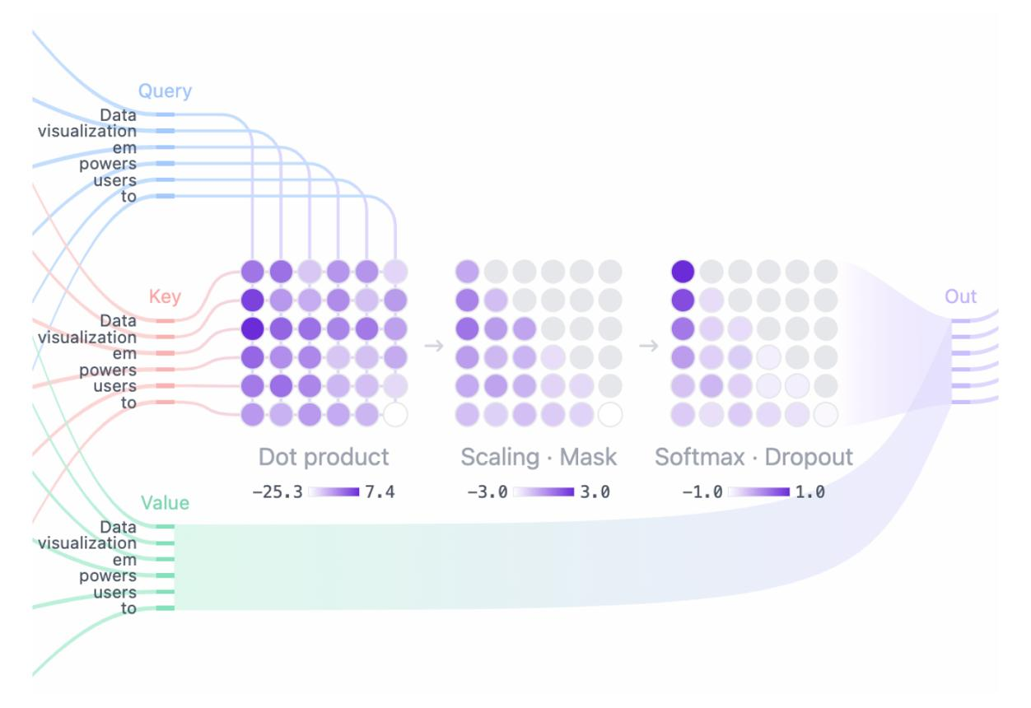
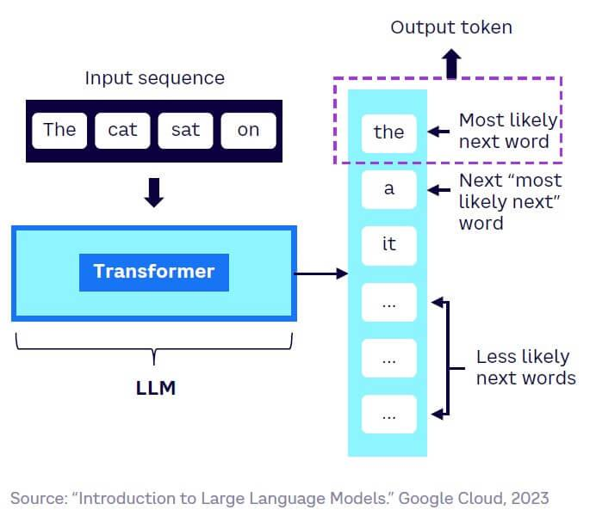
6

Real-World Applications

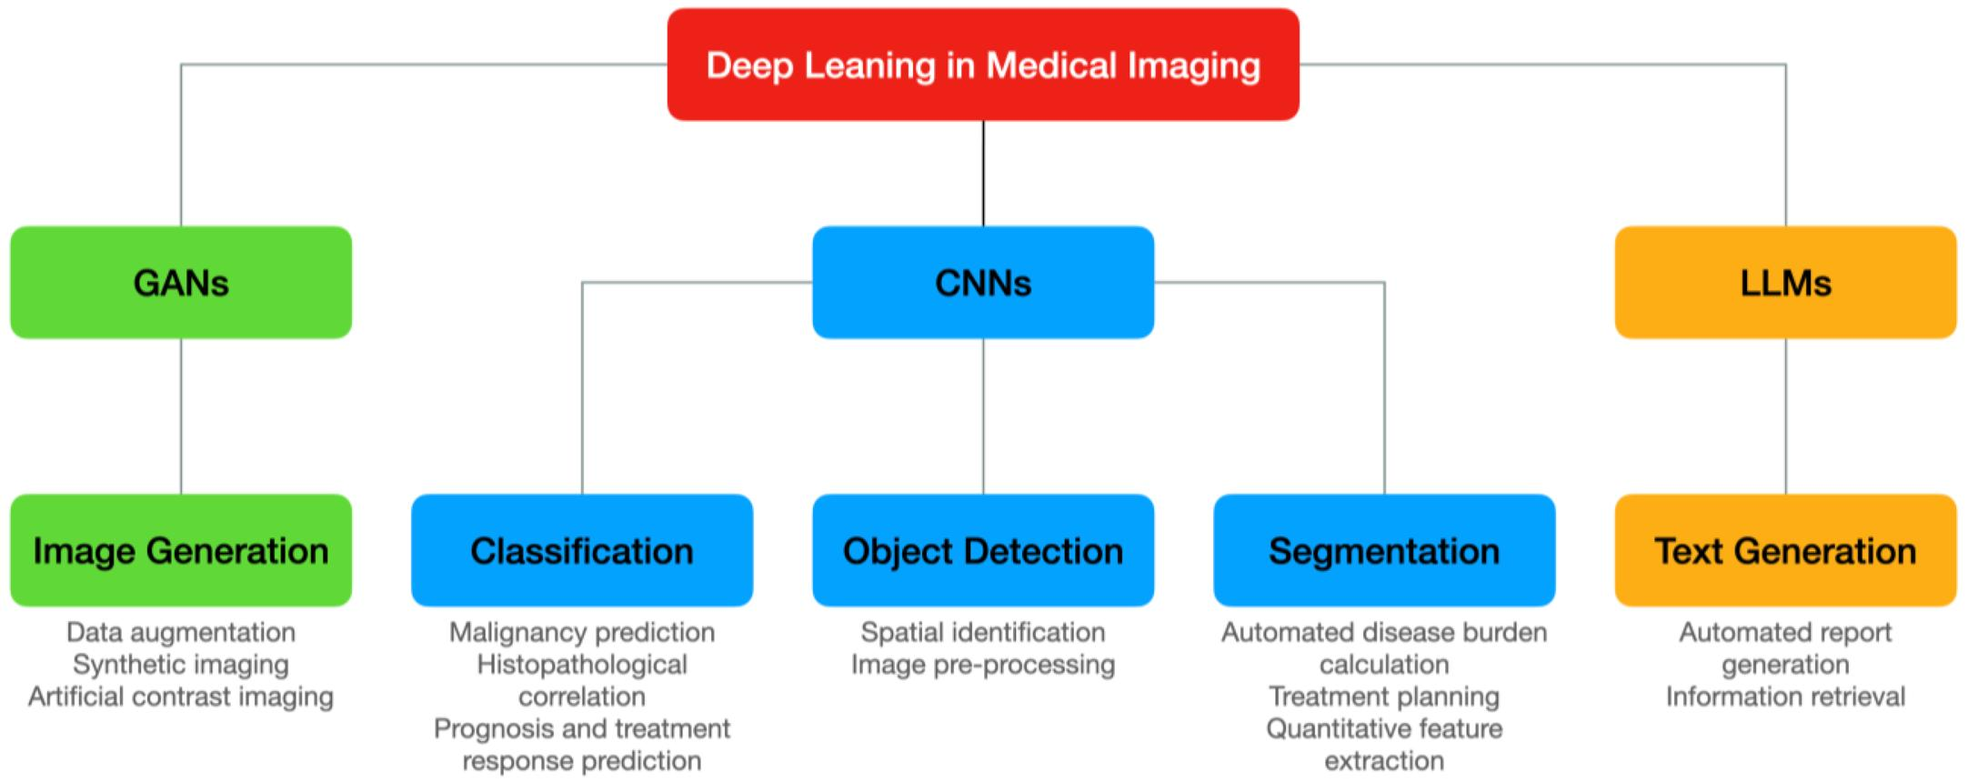

Applications:
- Chatbots
- Fraud Detection
- Healthcare
- Banking
- Recommendation Systems
- Autonomous Vehicles

End-to-End Deep Learning Flow
Data
↓
Input Layer
↓
Hidden Layers
↓
Activation Function
↓
Output Layer
↓
Loss Function
↓
Backpropagation
↓
Optimizer
↓
Updated Weights
↓
Better Predictions

Quick Summary
- Neural Network = Brain-inspired model
- Forward Propagation = Prediction
- Loss Function = Error Measurement
- Backpropagation = Learning from mistakes
- Optimizer = Improves weights
- CNN = Images
- RNN/LSTM = Sequences
- Transformer = ChatGPT and modern AI



