Zenith v3
Architecture Reference — Production v3.0

Document classification: Internal Engineering
Owner: Sebastian Vogel, Director of Platform
Effective: May 1, 2026
Revision: 3.0 (supersedes 2.7)

1. System Overview
Zenith v3 is the production order-processing platform for our European and North American operations. It replaces Zenith v2 (decommissioned March 2026) and consolidates 23 microservices behind a single GraphQL edge layer hosted on AWS region us-east-2.
Engineering ownership is shared across 4 teams: Platform (lead: Sebastian Vogel), Order Pipeline (lead: Akiko Tamura), Identity (lead: Devon Cole), and Reporting (lead: Mira Chen). The combined team headcount is 38 engineers as of May 2026.

1.1 Key Facts
Headline metrics for Zenith v3:
- 23 microservices in production — Up from 17 in v2; split for clearer ownership
- AWS us-east-2 (Ohio) — Single-region deployment; multi-AZ within the region
- PostgreSQL 16 + TimescaleDB — Operational store; TimescaleDB extension for time-series telemetry
- Apache Kafka — Event streaming backbone; 4 brokers, 96 partitions per topic typical
- End-to-end p50 latency 47 ms — Measured at edge, May 2026
- p95 latency 180 ms — SLO target: 200 ms
- 99.97 % availability over past 90 days — Above our 99.95 % SLO

2. Service Categories
Of the 23 microservices, the largest category by count is the order pipeline (7 services), reflecting the complexity of multi-tenant order routing, fulfillment, and reconciliation. The figure below breaks down service ownership by functional area.
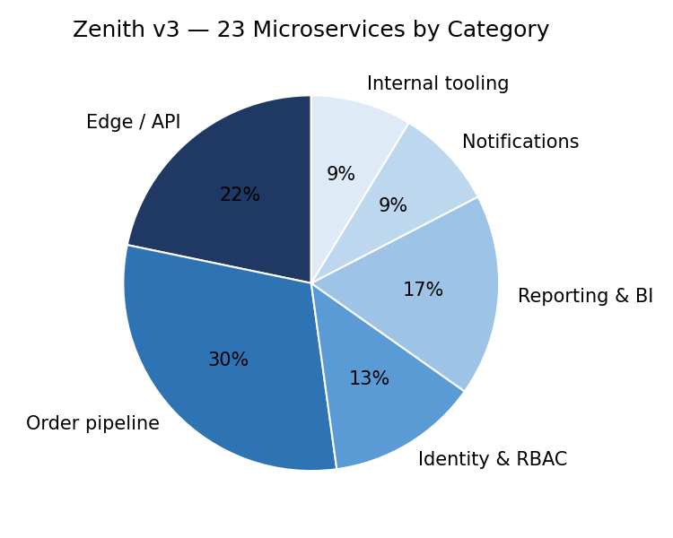
Figure 1 — Microservice distribution by category. Order pipeline (7) is the largest; reporting (4) is second.

3. Data Architecture
The primary operational data store is PostgreSQL 16 with the TimescaleDB 2.14 extension. PostgreSQL handles transactional order data; TimescaleDB hosts hypertables for telemetry, audit, and metric ingestion at roughly 280,000 rows per minute peak.

3.1 Schema Layout
Schema | Purpose | Owning team
orders | Order header + line items + status | Order Pipeline
identity | Users, roles, tenants, sessions | Identity
billing | Invoices, payment events, refunds | Order Pipeline
inventory | Stock levels, reservations, holds | Order Pipeline
reporting | Materialised views, dashboards | Reporting
telemetry | Time-series TimescaleDB hypertables | Platform
audit | Append-only event log | Platform

All schemas are owned by exactly one team. Cross-schema queries are permitted only via materialised views in the reporting schema, which are refreshed every 5 minutes by an Airflow DAG named 'zenith_reporting_refresh_v3'.

4. Latency Profile
Measured end-to-end at the GraphQL edge, from request ingestion through service composition to response. The chart below shows the full distribution captured during the week of May 5–11, 2026 from production traffic (12.4 million requests).
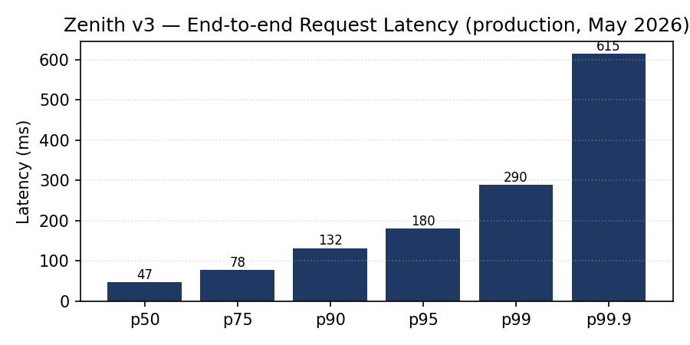
Figure 2 — Latency distribution. p50 47 ms; p95 180 ms; p99 290 ms.

4.1 SLO Status
Our service-level objectives are: p50 ≤ 50 ms, p95 ≤ 200 ms, p99 ≤ 350 ms. All three are met for the reporting period. The next review is scheduled for July 14, 2026.

5. Reference Code
Canonical example of how a service consumes order events from Kafka. Topic is 'orders.committed.v3'; consumer group naming convention is '<service-name>.orders.committed.v3'.
from kafka import KafkaConsumer
import json
consumer = KafkaConsumer(
'orders.committed.v3',
bootstrap_servers='kafka-prod-01.zenith.local:9092',
group_id='reporting.orders.committed.v3',
enable_auto_commit=False,
auto_offset_reset='earliest',
value_deserializer=lambda b: json.loads(b.decode('utf-8'))
)
for msg in consumer:
handle_order(msg.value)
consumer.commit() # at-least-once delivery

5.1 GraphQL query example
query OrderById($id: ID!) {
order(id: $id) {
id
status
customer { name email tenantId }
lineItems {
sku
quantity
unitPriceCents
}
createdAt
fulfilledAt
}
}

6. Deployment Topology
Zenith v3 deploys to Amazon EKS in region us-east-2, using two EKS clusters: 'zenith-prod-blue' and 'zenith-prod-green', behind an ALB that switches traffic during rolling deploys. Cutover between blue and green is gated by a synthetic health probe; the switch completes in under 90 seconds when no canary alarms trip.

6.1 Instance Footprint
Node group | Instance type | Count (peak)
Edge / API | m6i.2xlarge | 8
Order pipeline | c6i.4xlarge | 14
Identity & RBAC | m6i.xlarge | 6
Reporting & BI | r6i.2xlarge | 8
Notifications | m6i.large | 4
Internal tooling | m6i.large | 4
Kafka brokers | m6i.4xlarge | 4
PostgreSQL primary | r6i.4xlarge | 1
PostgreSQL replicas | r6i.4xlarge | 2

7. Security Posture
All inter-service communication uses mTLS issued by an internal Vault PKI engine. Certificate rotation is automated every 14 days, with a 48-hour overlap window for the previous certificate.
External API authentication uses OAuth 2.1 with PKCE; bearer tokens are JWTs signed by Auth0, validated at the GraphQL edge with a 5-minute key cache.

7.1 Secrets Management
Application secrets live in HashiCorp Vault, with namespace per tenant. The Vault leader's address is internal-only: vault-prod.zenith.local:8200. Production access requires hardware MFA (YubiKey).

8. Observability
Logs route to Datadog via the Fluent Bit DaemonSet, partitioned by service name and severity. Traces use OpenTelemetry with the Datadog exporter; sample rate is 5% baseline, 100% for any request tagged with error=true or trace-debug=true.

8.1 Key dashboards
- ZENITH-OVERVIEW (high-level platform health, ~32 panels)
- ZENITH-ORDERS-FLOW (end-to-end order journey)
- ZENITH-DB-PERFORMANCE (PostgreSQL + TimescaleDB)
- ZENITH-KAFKA-HEALTH (broker / topic / consumer-lag)
- ZENITH-SLO-BURN (multi-window SLO burn-rate alarms)

9. On-Call & Runbooks
Primary on-call rotation is managed in PagerDuty under schedule 'zenith-prod-primary'. Escalation path is: primary → secondary (7 min) → engineering manager (15 min) → director (Sebastian Vogel, 30 min).
All critical-path runbooks live in the 'zenith' Confluence space under /Runbooks. Each runbook MUST be reviewed quarterly; the next review window is July 6–17, 2026.

10. Forward Roadmap
Quarter | Initiative | Owner
Q3 2026 | Multi-region active/active (add eu-central-1) | Sebastian Vogel
Q3 2026 | Replace Auth0 with internal Identity v4 | Devon Cole
Q4 2026 | Order pipeline rewrite in Rust (services 12/23) | Akiko Tamura
Q4 2026 | TimescaleDB 2.16 upgrade | Platform
Q1 2027 | ML-driven order routing (replace static rules) | Mira Chen

This document supersedes the v2 architecture reference dated October 2024. The next scheduled revision is November 2026.

