Atlas Networks — FY2026 Board Update
Prepared by the CEO's office for the May 18, 2026 board meeting. Atlas Networks operates a fleet-management SaaS platform serving 4,200 customers across 23 countries. CEO: Larissa Verma. CFO: Hideo Tanaka.

1. Active Accounts Trend
Active accounts (paid logos) grew from 82,400 in July 2025 to 89,700 in March 2026 — a 9-month sequential growth of 8.9%. The chart below shows the trajectory.
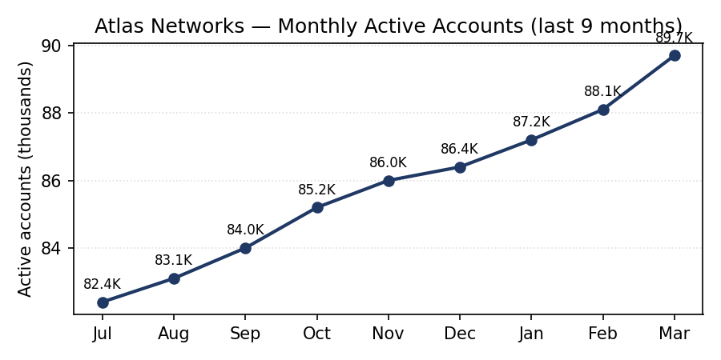
Figure 1 — Monthly active accounts. Jul 2025: 82.4K. Mar 2026: 89.7K.

2. ARR Composition
FY2026 ARR totals $248M, up 18.4% year-on-year. The split by product line is shown in Figure 2.
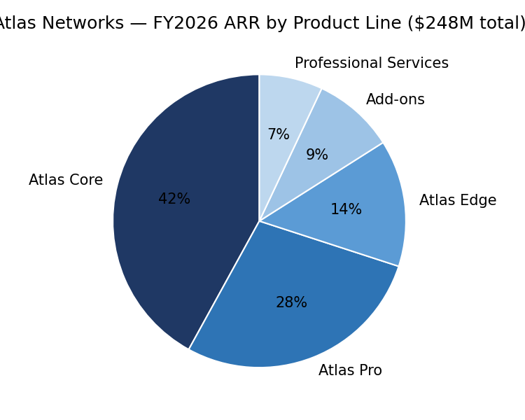
Figure 2 — Atlas Core remains the largest line at 42% of ARR. Professional Services contributes the smallest share at 7%.

3. Anchor Numbers
Active accounts: 89,700 (March 2026). Total ARR: $248M. ARR YoY growth: +18.4%. Atlas Core ARR share: 42%. Customer count: 4,200 across 23 countries.

