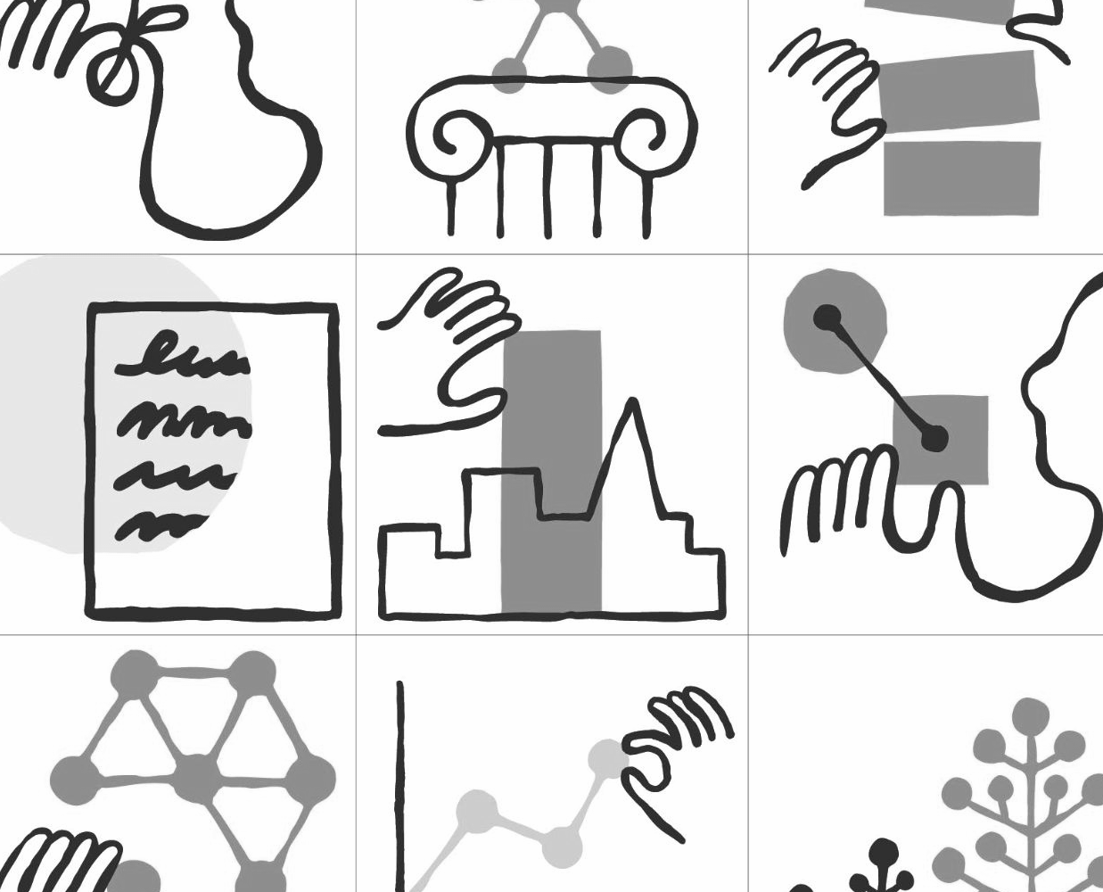

Anthropic
Tenant Suite Alterations
08.13.2025 (Revised 09.11.2025)
─
Clune Construction
Conor Brandquist, SVP
1919 Gallows Rd, Suite 350
Vienna, VA 22182
Oliver Studios
PO Box 6054
Alexandria, VA 22306
(703) 638-9315
I am pleased to submit this proposal on behalf of Oliver Studios (“Designer”) to provide design services to you, Clune Construction and your client, Anthropic, (collectively referred to herein as the “Owner”) in connection with the following Project:

Overview
This project includes the full design, documentation, permitting and construction administration services for the modifications to the finished tenant suite 900A/B on Level 9 of The Homer Building, 601 13th Street NW, Washington DC. The modifications include the following items:
- All new furniture with associated LV cabling and power
  - Sit/stand workstations (typical is 2 data drops per desk)
  - Conference tables and chairs
  - Ancillary soft seating
  - Single occupancy phone booths (TBD whether we need to tie them in), preferred booth is the Herman Miller Bay Pod. Coordination for location and associated power. Sprinkler tie-ins, if required.
- Network
  - Bring fiber to suite
  - IDF set up
  - WAPs and associated cabling
  - Additional power, if required
- AV conferencing set ups in meeting rooms
  - LV cabling: typically 2 drops behind monitor, 2 drops at table
  - The AV vendor can advise power
- Security
  - Access control, security cameras
  - Card readers required at IDF, storage dedicated to IT or Security, and entry doors
- New entry doors
  - Anthropic security required electrified mortise locks
  - Anthropic will advise security requirements
- Accent paint
  - 1 color in open office area
  - 1 color in meeting rooms - one wall per room
  - Anthropic will provide the paint spec
- Plants
  - Loose terracotta planters in open office area and meeting rooms
- Collab Space
  - Enclose open Collab Space (9004) w/ glass door/front to match conference rooms.
This contract will be directly with the Owner. The Designer will execute all services outlined in this proposal. Any changes to the deliverables, project schedule or scope as defined in this proposal may result in additional services between the Designer and Owner.

Scope of Services
We agree to provide you design services on the following basis:

Programming & Design
Timeline: 5 weeks duration (including Client review & sign-off)
The Designer will conduct a site visit to survey and to verify the existing documentation provided by the landlord.
The Designer will hold a meeting with the Anthropic to go over the intended use of the space and design requirements.
The details gathered from the meeting will be used to develop a preliminary floor plan, including layout, power requirements and design intentions, for the Anthropic’s approval.
The Design Package will include the following items:
- Floor Plan
- Ceiling Plan
- Power/Data Plan
- Elevations as Needed
- Proposed Finishes
Meetings (3):
(1) Site Visit for surveying existing conditions
(1) Programming meeting to confirm intended functionality and design of space
(1) Plan review meeting to review and approve documents
Deliverable: Floor Plan & Design Package

Documentation
Timeline: 2 weeks duration
The approved Design Package will serve as the basis for documentation and will be distributed to the engineering consultants to finalize their scope and fees. Following this, the engineers will conduct a field survey to verify existing conditions and confirm the available power supply.
The documentation phase includes coordination with all engineering disciplines and the development of construction documents required for permitting and contractor pricing. To ensure design consistency, all base finishes, lighting, and MEP systems will be specified to match the existing conditions.
The documentation will include the following items:
- Floor Plan
- Reflected Ceiling Plan & Lighting Schedule
- Elevations (as needed)
- Finish Plan & Finish Schedule
- Furniture Plan & Schedule
- Detailing of finishes on floor, wall, and special conditions
- Electrical Drawings
- Final Furniture Package and Purchase Order
The final Documentation will be virtually submitted to the Owner & Anthropic.
(1) Site visit will be conducted as needed.
Assumptions: The parameters are set assuming that the Landlord will supply as-built Architecture & MEP drawings, and the furniture package for reference.
Deliverable: 100% Documentation

Bid & Permit Submission
Timeline: 5 weeks duration (estimated)
The 100% Documentation will be provided to the General Contractor for the final Bid. The General Contractor will prepare a bid based on the Documentation for Tenant’s approval.
All documentation required for permitting will be collected and formatted by the Designer and submitted to permit RAMCO or permit expeditor of Owner’s choice to obtain the building permit. The Designer will continue to work with the permit expeditor through the full process of reviews and comment responses needed to secure the permit.
Deliverable: Building Permit

Furniture Specification
Timeline: 3 weeks duration (simultaneous w/ Design & Documentation)
Furniture specifications will be developed based on the approved Design Package. Existing furniture and any applicable standards will be reviewed and incorporated into the new design where appropriate.
Furniture selection will include identifying suitable pieces for all areas of the suite, ensuring each item aligns with the design vision, functionality and project timeline. Once selections are approved by Anthropic, finishes and fabrics will be chosen to coordinate with the overall interior scheme. Physical material samples will be presented for Anthropic to review and approval.
The Designer will coordinate closely with EvensonBest to confirm product pricing, availability, and lead times. Support will be provided throughout the procurement process including reviewing final purchase orders.
The Designer will oversee delivery and installation. Any issues will be addressed promptly, and a final walk-through with the Owner, Anthropic, and dealer will confirm that all furniture is installed correctly and meets expectations.
Meetings (1):
(1) Furniture review meeting to review and approve selections
Deliverable: Furniture Package

Construction Administration
Timeline: 12 weeks duration (estimated)
The Designer will attend a construction kick-off meeting and weekly construction meetings led by the General Contractor to review the work in progress and to consult with Anthropic and the Contractor during the construction phase.
The services during the Construction Administration Phase include the following:
- a review of Contractor’s submittals (i.e. shop drawings), but only for the limited purpose of checking for conformance with the design concept expressed in the Contract Documents
- preparation of change orders and change directives
- a review of any requisitions and a recommendation of amounts owed to Contractor based on site observations and an evaluation of Contractor’s application for payment
- recommendation to Anthropic of the rejection of work observed which does not conform to the Contract Documents.
(1) Final Punch List will be conducted upon request from the General Contractor at substantial completion. The Designer will identify any deficiencies or unfinished work to be completed by the General Contractor.
(1) Final Walk Through will be conducted when all final punch list items have been completed. This will close out the project for the Designer.

Timeline and Costs

Schedule & Fees
The anticipated start date for design work is August 25th, 2025. The above outlined scope of work will require a total of (24) normal working weeks to complete after authorization to proceed. The anticipated duration for each sequential phase and associated fee is as follows.
 | Fees |  | Duration
 | Interior Design | Elec. & FP | Duration
Programming & Design | $4,810 | - | 5 weeks
Documentation | $4,040 | $11,000 | 2 weeks
Permit Submission | $1,960 | - | 5 weeks (est.)
Accelerated Plan Review | $1,500 | $1,500 | 5 weeks (est.)
Furniture Specification | $3,820 | - | 3 weeks (sim.)
Construction Administration | $5,215 | - | 12 weeks (est.)
Total | $21,345 | $12,500 | 24 weeks
Lump Sum Fee | $33,845 |  | 24 weeks
*Electrical scope, fee and contract will be finalized after the Programming & Design phase.
Estimated Reimbursable Expenses - $800
Timelines for permitting & construction are estimated. General Contractor to provide accurate construction timelines during the bid process.
The scope and fees presented are for work performed by Oliver Studios and GHT Ltd. (MEP Engineer) only. Any additional consultants needed to complete the project will be contracted directly by the Anthropic.
If the Designer is delayed or prevented from performing services for any reason beyond their control, they shall be granted an extension equivalent to the period of delay in which to complete their services and their compensation shall be equitably adjusted. Anthropic agrees to render decisions timely as necessary for the Designer to provide services within this schedule.

Additional Services
If requested and authorized by Anthropic, Designer will provide Additional Services for the Project to the Owner. Any service not specifically included under Scope of Services, is considered an Additional Service.
Additional Interior Design services include, but are not limited to, the following:
- Floor Plan and/or Ceiling Plan changes
- New lighting, finish and/or furniture selections
- Design revisions after the Documentation phase has begun
- As-built drawings
The following services are specifically excluded from this Agreement:
- Work to the building core, shell or common spaces
- Additional certifications such as LEED
- Project management
- Value engineering
- Renderings
- Separate specifications in addition to the schedules in the documentation
- Staging or decorations are not included in the furniture package

Designer’s Compensation
- For the Scope of Services above the fee shall be billed as follows:
LUMP SUM: The total fee for Scope of Services will be a lump sum of $30,845 billed monthly and based on the percentage of work completed.
- For any Additional Services required under Section II above, Designer shall provide a modified fee for approval.
- Expenses incurred by Designer in relation to this Project shall be billed to Owner at 1 times the amount expended by Designer and are separate from Designer's fee (“Reimbursable Expenses”). Expenses include, but are not limited to, the following:
- Printing for Project coordination, authority reviews, bidding or construction or Owner requests
- Reproducible drawings, photocopies, documentation photographs
- Messenger and express courier deliveries
- Mileage at the current IRS rate
- Permit fees, survey documents, estimating fees, etc., as requested by Anthropic
- Fees and expenses shall be billed monthly and payable within thirty days of receipt of invoice for services rendered to date. Amounts unpaid 30 days after the invoice date shall bear simple interest at the rate of 1.5 percent (1.5%) per annum.
- Inquiries and questions regarding any invoice shall be made within 14 days of receipt of the invoice. Failure to notify Designer within this time period shall constitute a waiver of any claim with respect to the content or accuracy of the invoice as well as acceptance of the services provided.
- Owner agrees to pay reasonable attorney's fees, agency fees and other expenses or losses, prior to and through any trial and subsequent proceedings, incurred by Designer in the event Designer employs the services of an attorney or agency to collect sums due hereunder or to enforce any terms contained herein.
- If the services covered by this Agreement have not been completed by January 2025, compensation for Designer's services beyond that time shall be appropriately adjusted.

Terms and Conditions
Incorporated by reference as part of this Agreement between Owner and Designer are the “Standard Terms and Conditions” attached hereto as Exhibit A.
This Agreement and the attached Standard Terms and Conditions represent the entire and integrated Agreement between the parties and supersede all prior negotiations, representations or agreements, written or oral. This Agreement may be amended only by written instrument signed by all the parties.
If Owner directs Designer to perform services as set forth in this Agreement without signing the Agreement, such verbal direction constitutes acceptance by Owner of the terms of this Agreement including the Standard Terms and Conditions attached hereto.

Client Agreement
Oliver Studios is excited to build their relationship with the Anthropic project team and to work on customizing the new space to meet your needs. If the Owner agrees with all details set in this document, please sign below and return to farihah@oliverstudios.com to acknowledge acceptance.
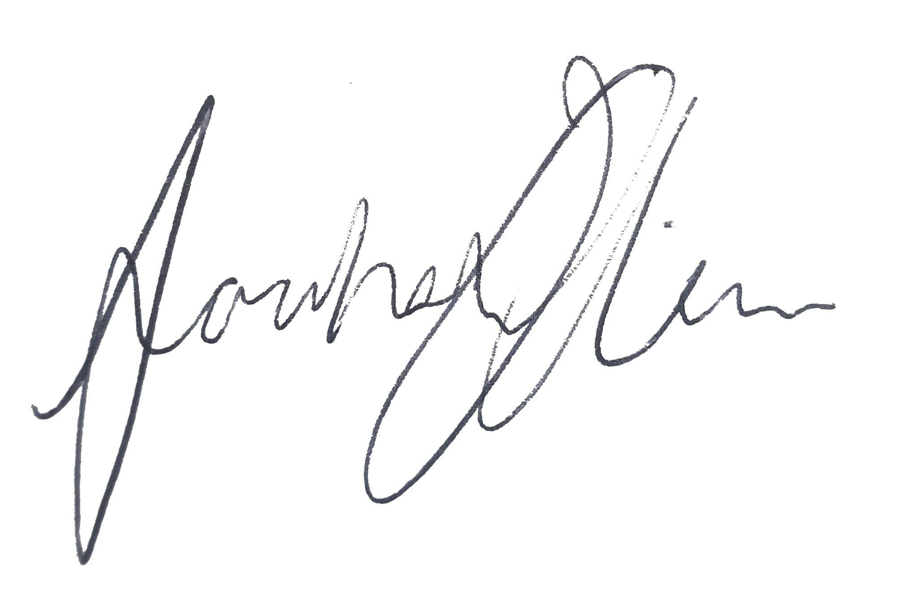
Sincerely,

Farihah Oliver
Founder & Principal

Client Signature
Name:_____________________________

Signature:_________________________

Date:______________________________

This agreement may be executed with digital or electronic signatures.

