# Hardware

The infrastructure of the tracking system consists of detectors, asset tags, proxies and a server, as shown in Figure below

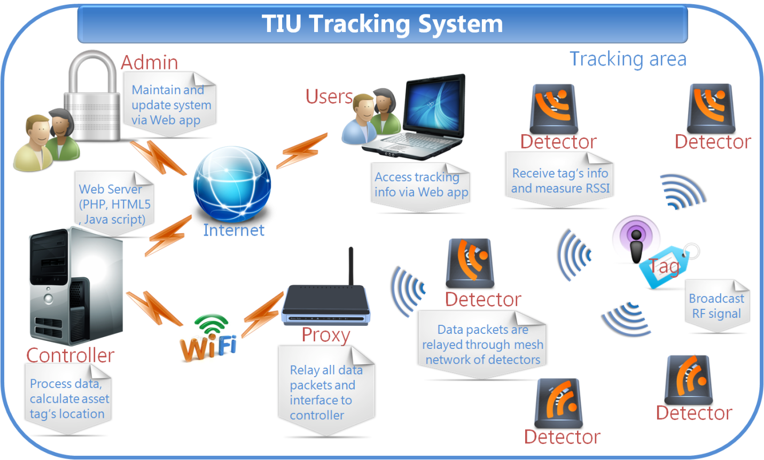

## Detectors

A detector consists of two major parts: a microcontroller, and a RF transceiver. The microcontroller controls the RF transceiver. The RF transceiver is responsible for communicating information to the system.

### Functionality

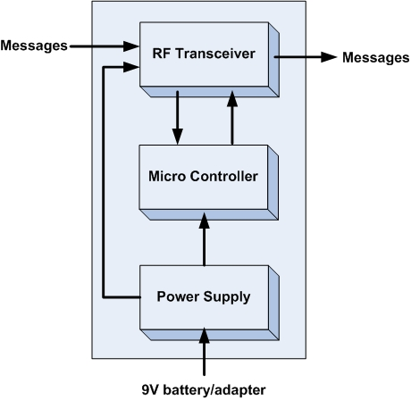

**Figure 1**: Detector functionality

|  |  |
| --- | --- |
| Module | Detectors |
| Inputs | * Power supply: 3.3V DC * Messages from asset tags and other detectors |
| Outputs | * Messages from asset tags and other detectors |
| Functionality | A detector consists of two major parts: a microcontroller, and a RF transceiver. The microcontroller controls the RF transceiver. The RF transceiver is responsible for communicating information to the system. |

### What is on the board

* A power switch on/off
* A 3.3V power regulator which accepts up to 16V as external power source.
* An ATMega328p MCU by Atmel with 8MHz
* A 6pins SPI connector for programming.
* A RFM12B wireless RF module for 434MHz ISM band by Hope RF.
* A LED with jumper (on/off) for checking power.
* A LED with jumper (on/off) for checking signal transmission.

### Advantage

* By including a 3.3V regulator, the detector can be powered a DC power adapter, or various types of 3.6 … 16V batteries.
* The RFM12B module is a low cost option with sufficient power and range to provide reliable communication around the lab - a basic packet protocol can be implemented in just 2..3 Kb of C code.
* Had 2 LEDs for debugging power and signal transmission.
* Small size 1” x 3.5”.
* There are many possible microcontrollers we could use to implement a solution. The ATmega 328p is a good choice because they are the Arduino technology platform.
* FR12B transceiver is a good choice because of low price, good support and low power consumption.

### Schematic

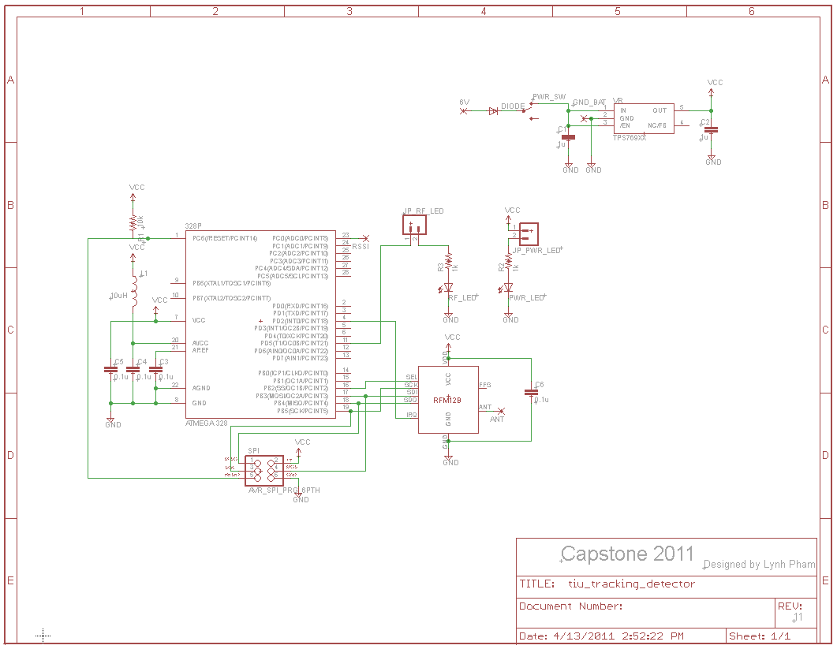

## Board layout

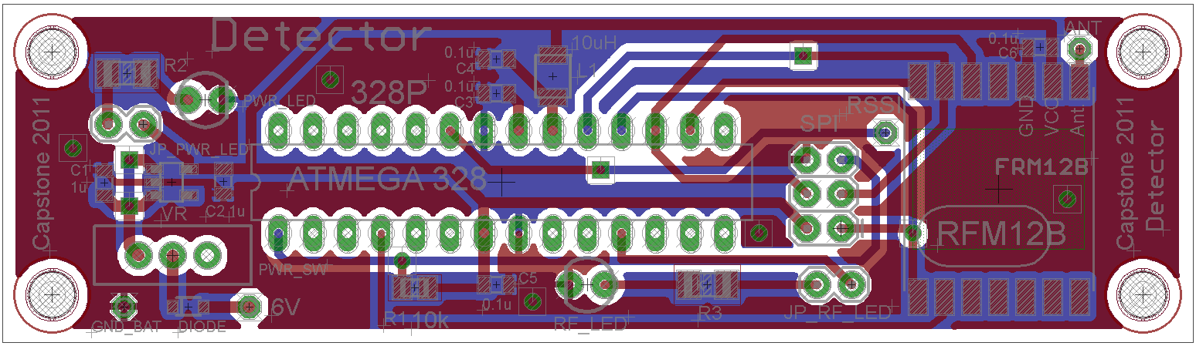

## Real Board

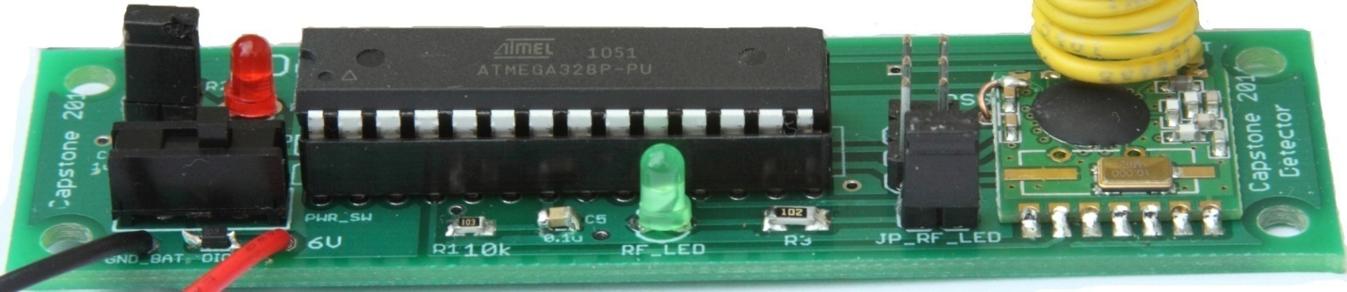

### Port/Pin Mapping

#### ATMage328p – 28pins

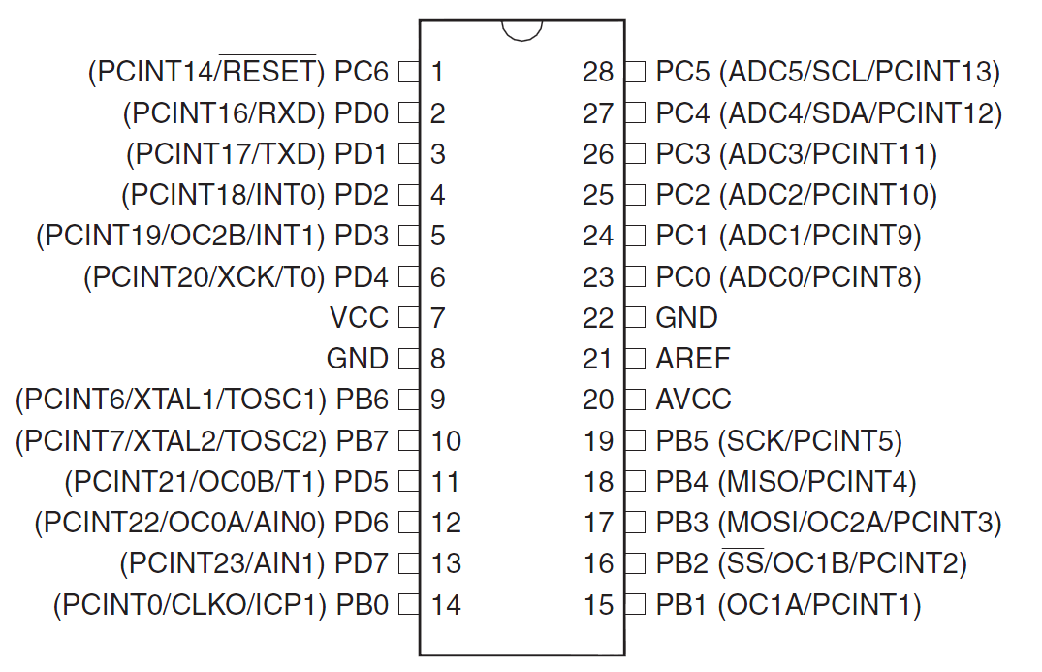

|  |  |  |
| --- | --- | --- |
| Pin | Name | Description |
| 1 | PC6 | RESET/PCINT14 |
| 2 | PD0 | PCINT16/RXD |
| 3 | PD1 | PCINT17/TXD |
| 4 | PD2 | PCINT18/INT0 |
| 5 | PD3 | PCINT19/OC2B/INT1 |
| 6 | PD4 | PCINT20/XCK/T0 |
| 7 | VCC | VCC |
| 8 | GND | GROUND |
| 9 | PB6 | PCINT6/XTAL1/TOSC1 |
| 10 | PB7 | PCINT7/XTAL2/TOSC2 |
| 11 | PD5 | PCINT21/OC0B/T1 |
| 12 | PD6 | PCINT22/OC0A/AIN0 |
| 13 | PD7 | PCINT23/AIN1 |
| 14 | PB0 | PCINT0/CLKO/ICP1 |
| 15 | PB1 | OC1A/PCINT1 |
| 16 | PB2 | SS/OC1B/PCINT2 |
| 17 | PB3 | MOSI/OC2A/PCINT3 |
| 18 | PB4 | MISO/PCINT4 |
| 19 | PB5 | SCK/PCINT5 |
| 20 | AVCC | AVCC |
| 21 | AREF | AREF |
| 23 | GND | GROUND |
| 23 | PC0 | ADC0/PCINT8 |
| 24 | PC1 | ADC1/PCINT9 |
| 25 | PC2 | ADC2/PCINT10 |
| 26 | PC3 | ADC3/PCINT11 |
| 27 | PC4 | ADC4/SDA/PCINT12 |
| 28 | PC5 | ADC5/SCL/PCINT13 |

#### SPI connector

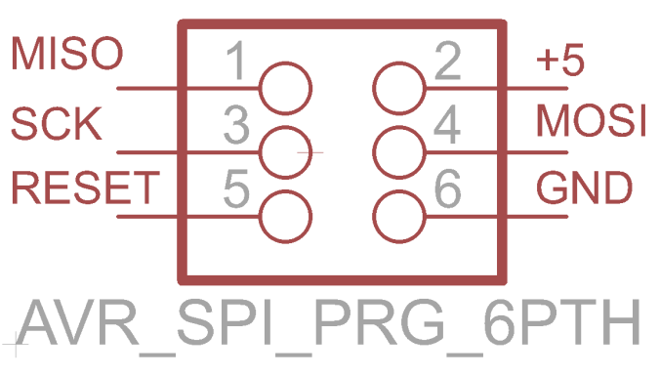

|  |  |  |
| --- | --- | --- |
| Pin | Name | Description |
| 1 | MISO | master in / slave out |
| 2 | +5V | Regulated +5V |
| 3 | SCK | SPI clock |
| 4 | MOSI | master out / slave in |
| 5 | RESET | Reset |
| 6 | GND | ground |

#### RFM12B

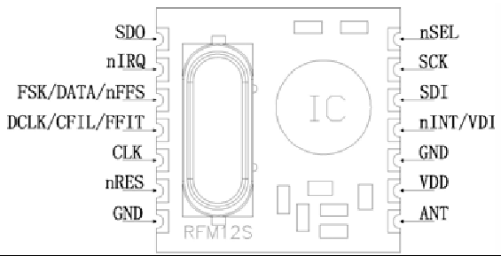

|  |  |  |
| --- | --- | --- |
| Pin | Name | Description |
| 1 | SDO | Serial data output |
| 2 | nIRQ | Interrupts request output |
| 3 | FSK/DATA/nFFS | Transmit FSK data input/Received data output/FIFO select |
| 4 | DCLK/CFIL/FFIT | Clock output/Extrenal filter capacitor/FIFO interrupts |
| 5 | CLK | Clock output for external microcontroller |
| 6 | nRES | Reset output |
| 7 | GND | Ground |
| 8 | ANT | Antenna |
| 9 | VDD | VCC |
| 10 | GND | Ground |
| 11 | nINT/VDI | Interrupt input |
| 12 | SDI | SPI data input |
| 13 | SCK | SPI clock input |
| 14 | nSEL | Chip select |

### Part list

|  |  |  |
| --- | --- | --- |
| Part | Value | Details |
| ATMega328 | Atmel's ATMega328 | Atmel's ATMega328 8-Bit Processor in 28 pin DIP |
| RFN12B | RFM12B-S2 | RFM12B-S2 Wireless Transceiver |
| Socket IC | Socket for ATMega328p | Socket IC open frame 28Pos 0.3” |
| SPI | SPI 6 pins connector | 6 POS connector header |
| PWR_SW | Power switch | SPDT Mini Power Switch |
| VR | Voltage regulator 3.3V | IC VREG LDO 3.3V |
| DIODE | Diode | DIODE SBR 1A 30V SOD-323 |
| C1, C1 | 1uF | CAP CERM 1UF 25V Y5V 0805 |
| C3, C4, C5, C6 | 0.4uF | CAP CERM .10UF 50V 5% 0805 SMD |
| L1 | 10uH | INDUCTOR 10UH 10% SA TYPE SMD |
| R1 | 10K | RES 10K OHM 1/4W 5% 0805 SMD |
| PWR_LED | Power LED 3mm | Power LED 3mm |
| RF_LED | LED 3mm | LED for signal transmission |
| JP_RF_LED | 2 pins male header | 2 pins male header |
| JP_PWR_LED | 2 pins male header | 2 pins male header |

## Asset Tags

An asset tag consists of two major parts: a microcontroller, and a RF transceiver. The microcontroller controls the RF transceiver. The RF transceiver is responsible for communicating information to the system.

### Functionality

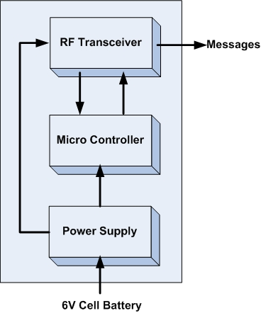

**Figure 2**: Asset tag functionality

|  |  |
| --- | --- |
| Module | Asset Tags |
| Inputs | Power supply: 3.3V DC |
| Outputs | Messages containing tag’s ID |
| Functionality | An asset tag consists of two major parts: a microcontroller, and a RF transceiver. The microcontroller controls the RF transceiver. The RF transceiver is responsible for communicating information to the system. |

### What is on the board

* A power switch on/off
* A 3.3V power regulator which accepts 2.2V to 6V as external power source.
* An ATMega328p MCU by Atmel with 8MHz
* A 6pins SPI connector for programming.
* A RFM12B wireless RF module for 434MHz ISM band by Hope RF.
* A jumper which connect to DP3 pin of ATMega328p for debug/mode.
* 2x7pins headers female for connecting with RFM12B breakout board.

### Advantage

* Designed from the ground up to support very low-power use with batteries.
* The RFM12B module is a low cost option with sufficient power and range to provide reliable communication around the lab - a basic packet protocol can be implemented in just 2..3 Kb of C code.
* Very small size 1” x 1”
* Very low power consumption
* There are many possible microcontrollers we could use to implement a solution. The ATmega 328p surface mount packet is a good choice because they are the Arduino technology platform and very small size.
* FR12B transceiver is a good choice because of low price, good support and low power consumption

### Battery life

* Capacity of coin cell: 240mAh
* Transmission time: 3ms every 1 seconds
* Active current: 30mA (RF transceiver + MCU)
* Sleep current:  0.0425mA

Then, the approximate battery life is

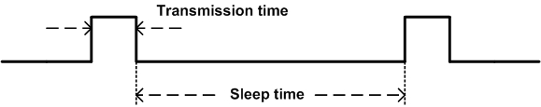

### Schematic

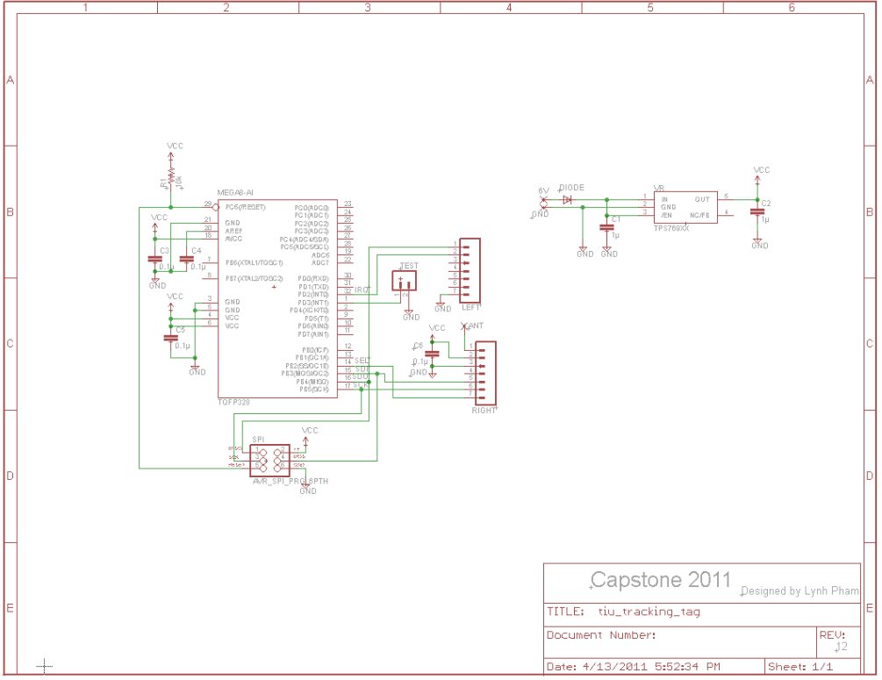

### Board Layout

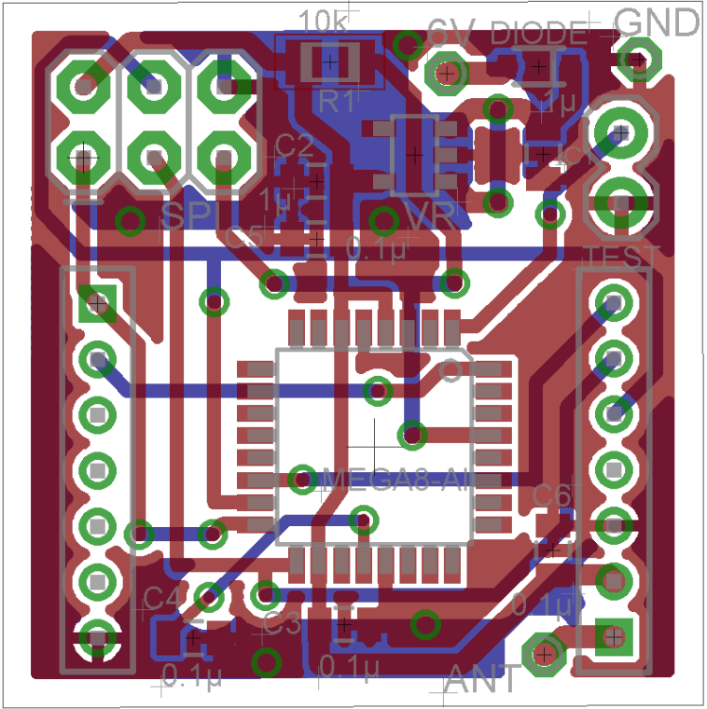

### Real Board

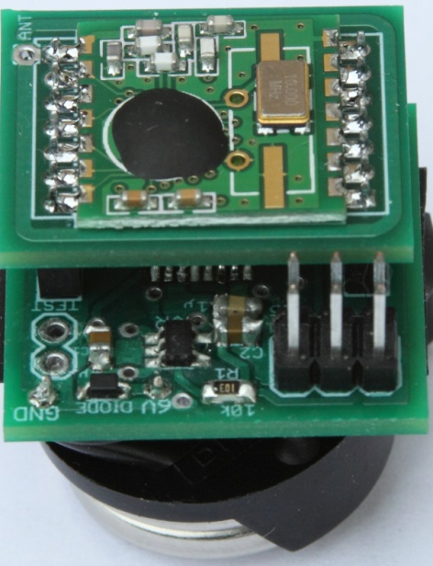

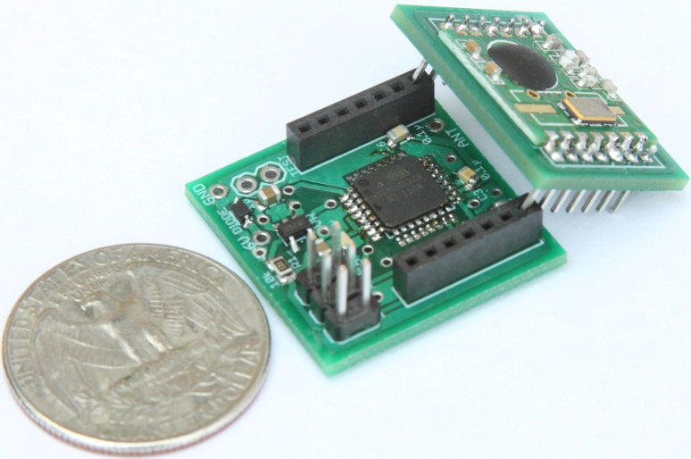

### Port/Pin Mapping

#### ATMage328p – 32pins

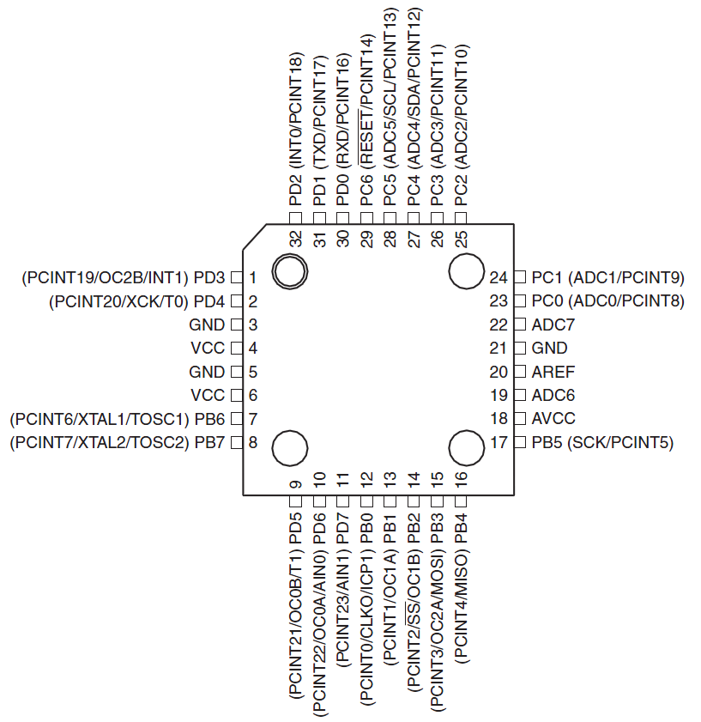

|  |  |  |
| --- | --- | --- |
| Pin | Name | Description |
| 1 | PD3 | PCINT19/OC2B/INT1 |
| 2 | PD4 | PCINT20/XCK/T0 |
| 3 | GND | GROUND |
| 4 | VCC | VCC |
| 5 | GND | GROUND |
| 6 | VCC | VCC |
| 7 | PB6 | PCINT6/XTAL1/TOSC1 |
| 8 | PB7 | PCINT7/XTAL2/TOSC2 |
| 9 | PD5 | PCINT21/OC0B/T1 |
| 10 | PD6 | PCINT22/OC0A/AIN0 |
| 11 | PD7 | PCINT23/AIN1 |
| 12 | PB0 | PCINT0/CLKO/ICP1 |
| 13 | PB1 | OC1A/PCINT1 |
| 14 | PB2 | SS/OC1B/PCINT2 |
| 15 | PB4 | MOSI/OC2A/PCINT3 |
| 16 | PB4 | MISO/PCINT4 |
| 17 | PB5 | SCK/PCINT5 |
| 18 | AVCC | AVCC |
| 19 | ADC6 | ADC6 |
| 20 | AREF | AREF |
| 21 | GND | GROUND |
| 22 | ADC7 | ADC7 |
| 23 | PC0 | ADC0/PCINT8 |
| 24 | PC1 | ADC1/PCINT9 |
| 25 | PC2 | ADC2/PCINT10 |
| 26 | PC3 | ADC3/PCINT11 |
| 27 | PC4 | ADC4/SDA/PCINT12 |
| 28 | PC5 | ADC5/SCL/PCINT13 |
| 29 | PC6 | RESET/PCINT14 |
| 30 | PD0 | PCINT16/RXD |
| 31 | PD1 | PCINT17/TXD |
| 32 | PD2 | PCINT18/INT0 |

### Part list

|  |  |  |
| --- | --- | --- |
| Part | Value | Details |
| ATMega328 | IC MCU AVR 32K FLASH 32TQFP | IC MCU AVR 32K FLASH 32TQFP |
| SPI | SPI 6 pins connector | 6 POS connector header |
| VR | Voltage regulator 3.3V | IC VREG LDO 3.3V |
| DIODE | Diode | DIODE SBR 1A 30V SOD-323 |
| C1, C1 | 1uF | CAP CERM 1UF 25V Y5V 0805 |
| C3, C4, C5, C6 | 0.4uF | CAP CERM .10UF 50V 5% 0805 SMD |
| R1 | 10K | RES 10K OHM 1/4W 5% 0805 SMD |
| LEFT | 2mm 7-pin Socket | 2mm 7-pin Socket |
| RIGHT | 2mm 7-pin Socket | 2mm 7-pin Socket |
| TEST | 2-pins header | 2-pins header |
| Battery | Coin Cell battery 20mm 240mAh | Coin Cell battery 20mm 240mAh |

## RFM12B Breakout Board

### What is on the board

* A RFM12B wireless RF module for 434MHz ISM band by Hope RF.
* An antenna.

### Advantage

* The breakout board for the RFM12B which gives you access to the pins.
* Easy to solder. And implement.
* Had an antenna on it.
* Very small size 0.8” x 0.9”

### Schematic

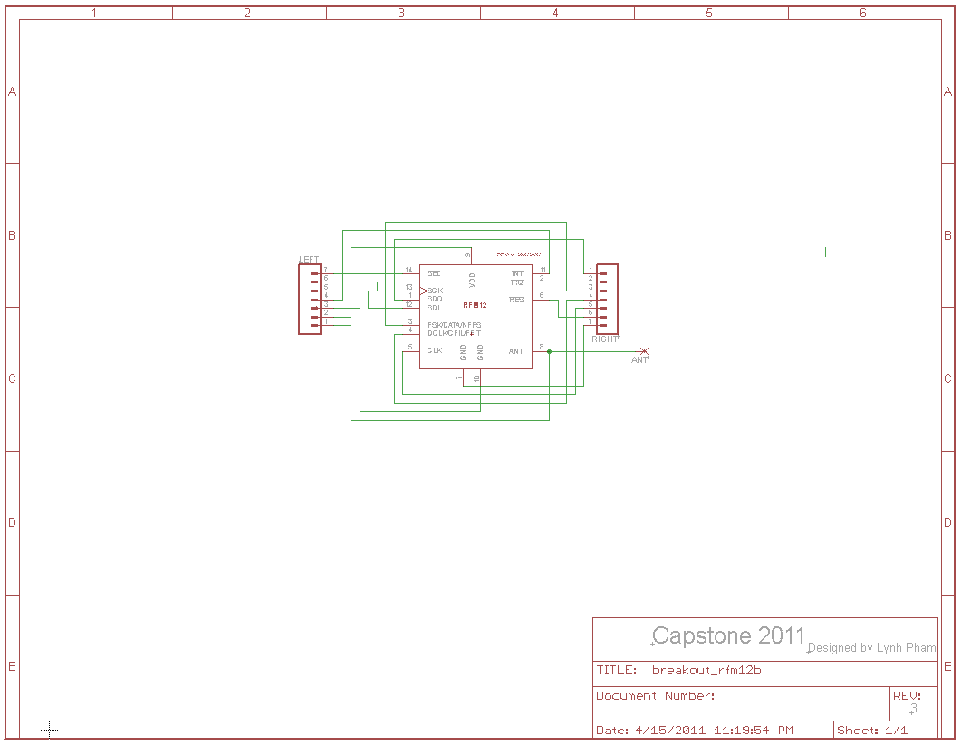

### Board Layout

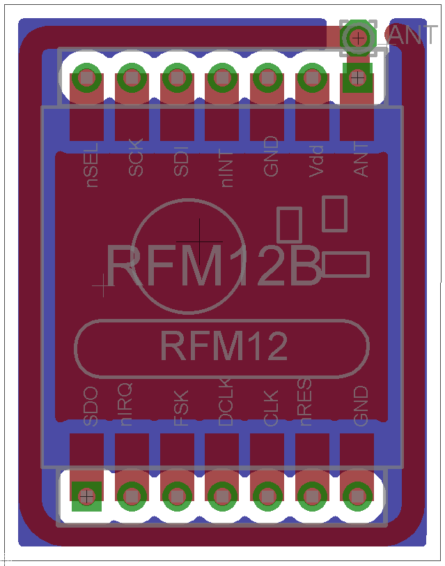

### Real Board

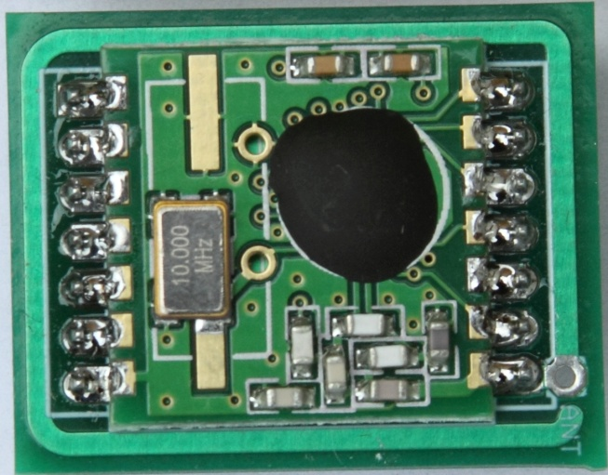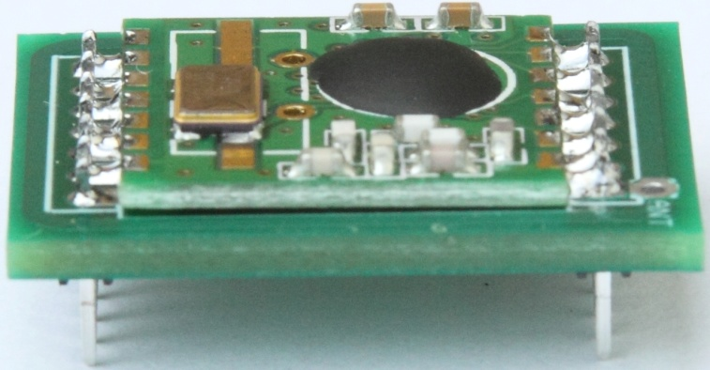

### Part List

|  |  |  |
| --- | --- | --- |
| Part | Value | Details |
| RFN12B | RFM12B-S2 | RFM12B-S2 Wireless Transceiver |
| LEFT | 2mm 7-pin male header | 2mm 7-pin male header |
| RIGHT | 2mm 7-pin male header | 2mm 7-pin male header |