mwBTFreddy_Subset 1 - Overview
This is a subset of a larger dataset that contains 696 images from Chilobwe, Malawi, an area severely affected by flash floods caused by Cyclone Freddy in 2023. The full dataset consists of 348 images from a date pre-disaster and 348 instances of post-disaster images. Each image has its associated json file which contains coordinates for each image and for all the labeled buildings with their classification. All buildings contained in images are labeled with polygons and classified according to the presence of damage. The images were captured directly from Google Earth Pro and the JSON files were generated using python scripts in QGIS. The xBD Methodology was used to add status/classify the buildings.

This subset of the full dataset contains 20 images: 10 images pre-Freddy and 10 images post-Freddy.

Geographic Coverage
The subset focuses on a specific area within Chilobwe, Blantyre, Malawi, with the following bounding coordinates. You can view the area on Google Earth Pro using the included kml file.

Corner | Coordinates
top_left | (-15.832122336611954, 35.00606294413626)
top_right | (-15.832126233141805, 35.010078445997465)
bottom_right | (-15.838142920506781, 35.01008128215014)
bottom_left | (-15.838135143156807, 35.006062860414254)

You can see the area under study in the image below bounded by the yellow pins.
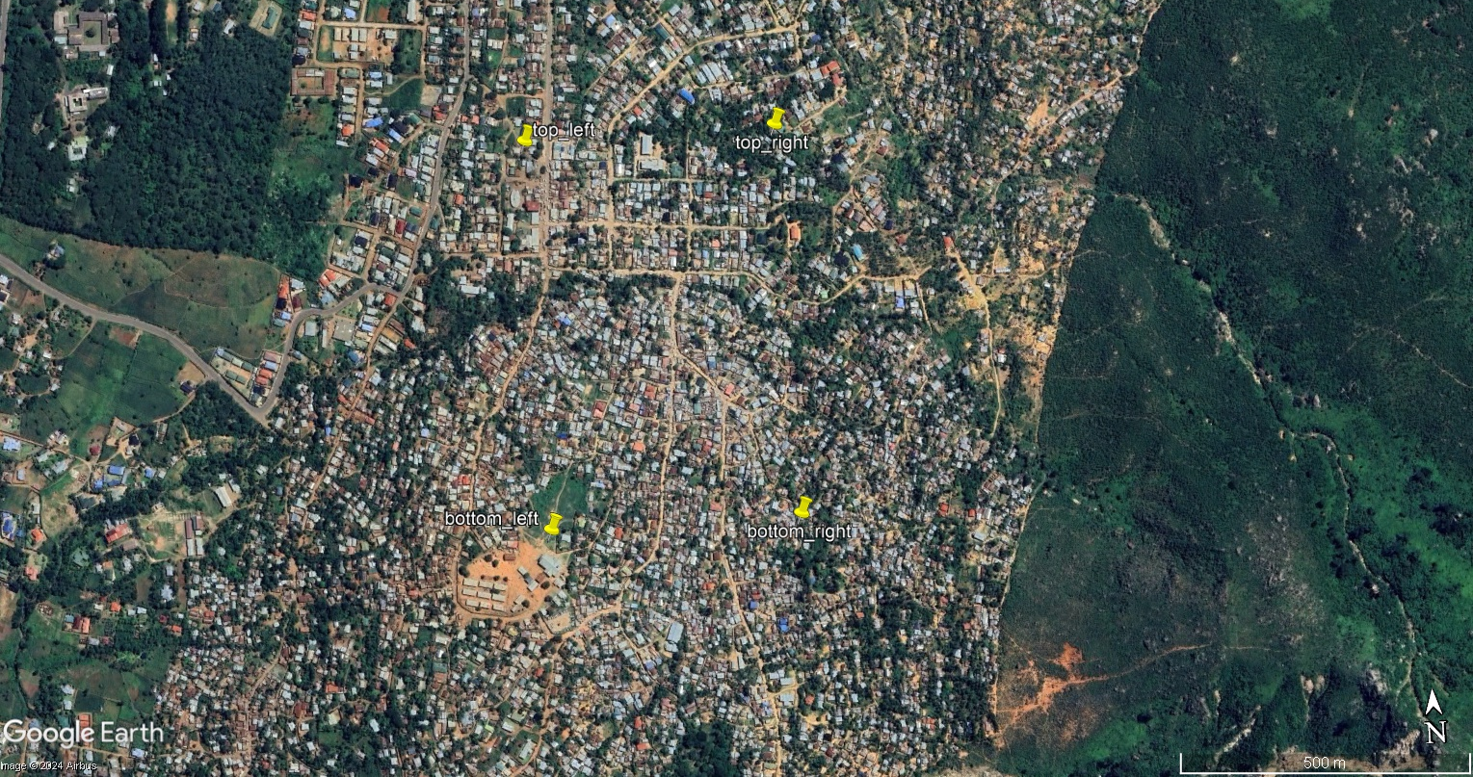

Datset FIles

Detailed coordinates for each individual image in the subset are documented in the Excel file named ”Focus Area, Image Coordinates and Metadata”. The file also contains enumeration of the number of buildings classified per each damage class in the tab “Metadata”.

The images are in the folder “images” and the json files are in the folder “json”.
The image naming convention in our dataset follows the xBD format: pre-disaster images are labeled as `"malawi-cyclone_00000000_pre_disaster.tif"` and post-disaster images as `"malawi-cyclone_00000000_post_disaster.tif"`. Each image pair is assigned a unique eight-digit number to distinguish them. JSON files accompanying each image are named identically to match the corresponding image, ensuring consistent reference across files.

