Data Glossary Sample Subset 1

- Data Element Name: mwBTFreddy

- Data Type: The dataset includes two types of files:
  - Images (.tif) : Georeferenced Google Earth images of the focus area
  - JSON files : Building labels for each image

- Description: The dataset includes images and JSON files. Each image pair consists of 'pre' and 'post' satellite shots of Cyclone Freddy. Each image is georeferenced, and buildings within it are labeled to indicate damage, producing the corresponding JSON files.

- Length/Size: The complete dataset contains 696 images with corresponding JSON files, while the subset includes 20 images with their corresponding JSON files.

- Data Source:
Google Earth was used to capture the images. The images were georeferenced and cropped in QGIS to remove borders, then labeled in QGIS to classify building damage.

- Data Ownership: The dataset was created and is owned by Kuyesera AI Lab at the Malawi University of Business and Applied Sciences in Malawi.

- Usage Notes: Data set can be used for:
- Object Detection: Identifying and locating buildings and other structures within the images.
- Damage Classification: Assessing and classifying damage to buildings.
- Environmental Visualization: Visualizing flood damage across the entire landscape.
- Urban Planning: Supporting decisions on relocation, the development of drainage systems, and other infrastructure improvements.

- Dependencies: N/A

- History and Changes: This is the first version of the dataset.

- Data Lineage: We used Google Earth Pro to capture high-resolution, pre- and post-cyclone images of selected areas, organized by gridlines to prevent overlap. Images were georeferenced in QGIS, cropped, resized, and systematically labeled following the xBD methodology to classify building damage. This process produced a comprehensive dataset of georeferenced images with associated JSON files.

The following diagram shows the steps of the automated pipeline we developed to generate these images. Annotation and labelling were done manually.
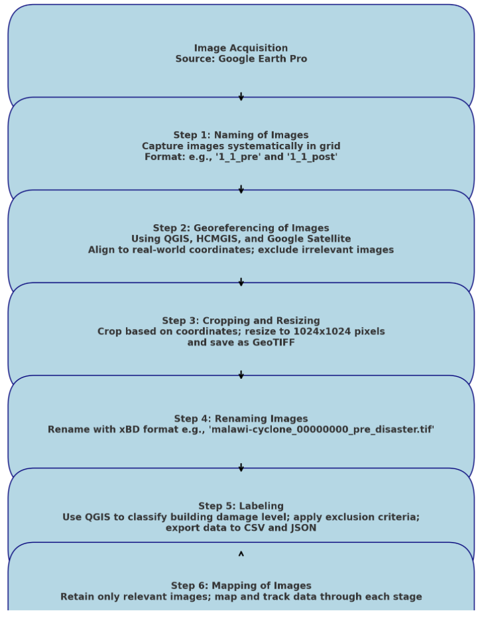
Figure 1 Pipeline for generating and annotating images.

