Visualizing Rumor Propagation in the PHEME Dataset
By Chuhan Ni
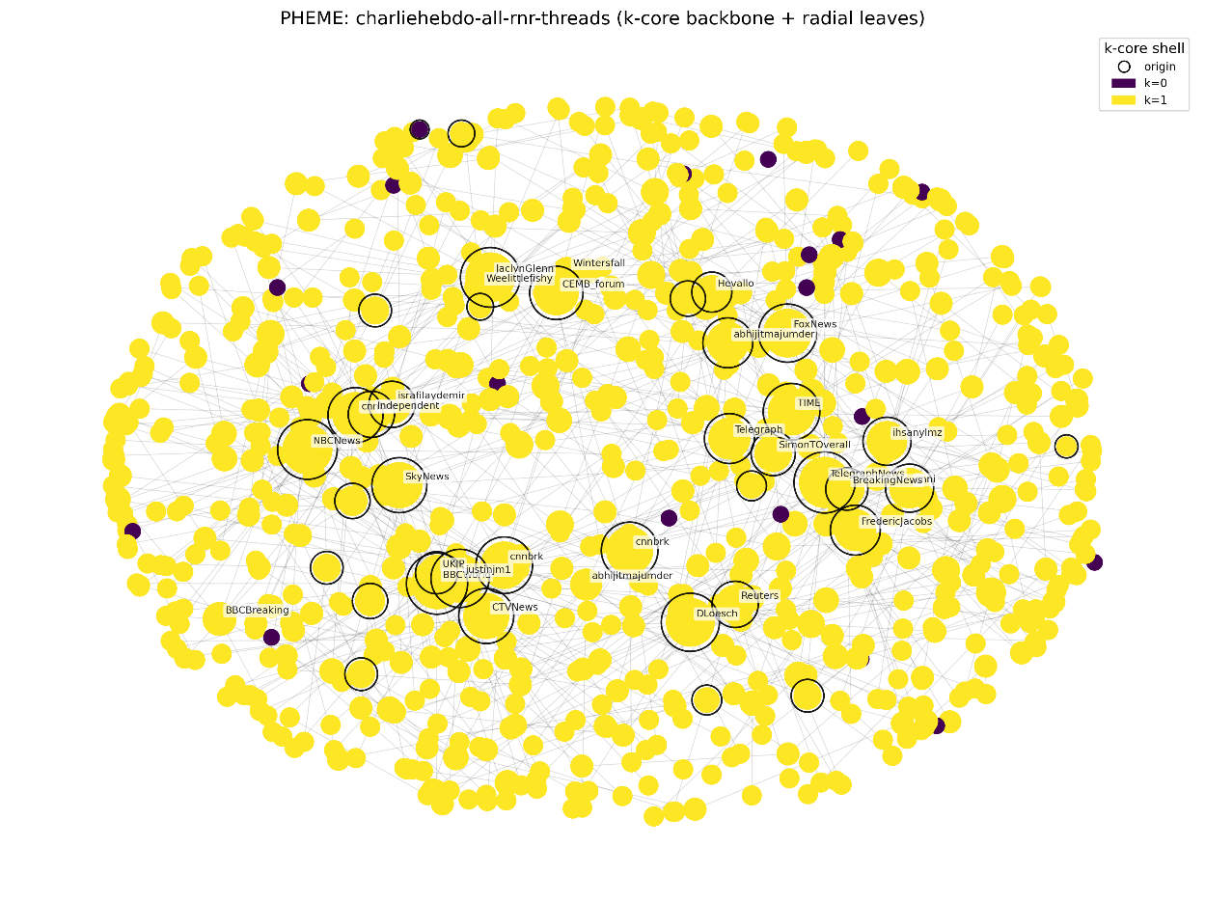
Nodes: represent individual Twitter users participating in the discussion.
Edges: show reply or retweet relationships between users.
Node Size: proportional to the number of connections (degree) — larger nodes indicate higher engagement or influence.
Node Color: represents k-core shell position: Bright yellow are inner, more connected core users. Dark purple are outer, peripheral users.
Black outline: marks the origin tweets — the first posts that started each conversation thread.
Layout: spring-based placement for the k-core backbone; peripheral users positioned radially around it for clarity.
The network forms a core–periphery structure: media outlets such as BBCBreaking, CNN, Reuters, and SkyNews dominate the central region. Multiple origins indicate that several independent tweets triggered parallel discussions rather than a single viral chain. The core users act as information hubs, while most peripheral users simply retweet or reply — amplifying central voices without generating new subthreads. The k-core pattern shows strong network resilience: even if outer nodes are removed, the inner core remains densely connected. This structure reveals how news diffusion in major events spreads through a few key broadcasters surrounded by a large, reactive audience.
Data source: https://figshare.com/articles/dataset/PHEME_dataset_of_rumours_and_non-rumours/6392078

